UWTSD

Course: BUSINESS MANAGEMENT
Module: INTERNATIONAL BUSINESS COMMUNICATON

Developing country China

Student ID: 1908497
Lecturer: Rexon Nting
Submission Date: 09.05.2022

Table of Contents
Introduction 2
Introduction to developing nation 3
Cultural differences 6
Power distance 7
Individualism 7
Masculinity 7
Uncertainty avoidance 8
Long term orientation 8
Indulgence 8
Cultural sensitivity 8
Communication barriers and challenges 9
Limitation of translation applications 9
Chinese negotiation tactics 9
Lack of transparency and trust 10
Styles of communication 10
Cultural difference 10
Communication strategies and recommendations 10
Open communication and employment of local people with translation capabilities 10
Digital communication strategy 11
Slow and deliberate whenever entering the new markets 11
Conclusion 11
Bibliography 13

Introduction
International business and communication is the important context which results within the basic understanding about the conditions in which organization and communication is taking place and different types of elements which lead to influence the communication and business that become quite significant in this respect (Dignen, McMaster, 2013). International business and communication ensures to introduce the business from different types of angles. These are communication, marketing, social responsibility, and international economics. It includes the important option with deeper view into the global business work, analysis of different activities, resolutions of real organizations, and many more. International business and communication includes analysis of challenge, expression of different ideas, and communication at proactive level. International business and communication refers holistic view about the different types of requirements and resolutions encompassing the good range of operational specialisms (Bailey, 2015).
This report will include the include explanation about the development nation China. It will present the different theories of international and intercultural communication on China nation. This will present critical analysis evaluation of cultural sensitivity when doing the operations of business in China with examples. It will present the evaluation of different communication barriers experienced through foreign organizations in China with examples. It will include appropriate communication strategies as well as recommendations to enable the organization to succeed in China. There are many reasons behind the selection of China in compare to other nations for Triumph Company.
In case of movement to production in region like India Triumph Company can face the product challenges such as imperfect industrialization standard system, weak innovative capabilities, and low level of core talents. In case of movement to production in region like Indonesia Triumph Company can face the product challenges such as ineffective unit labor output, poor digital infrastructure construction, and low added value. Triumph Company in region like China will be incredibly efficiency, worldwide shipping, low cost of manufacturing, and many more.

Introduction to developing nation
As per the newest data provided through National Bureau of China Statistics in January, China population amounted to almost 1.41 billion individuals in year 2021. Number of child born in year 2020 and 2021 was lower than anticipated because of the pandemic.
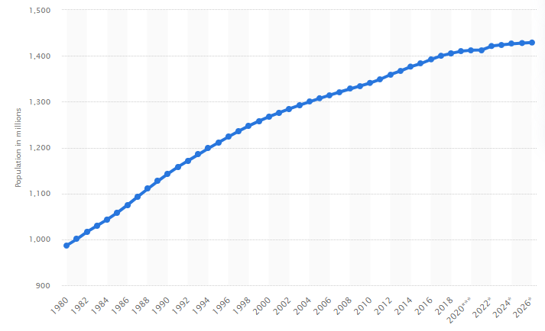 (Textor, 2022)
Culture of China is recognized as one of the oldest cultures in world, tracing back to many years ago (Stunningtours, 2019). It features the abundance of material values as well as spiritual values not changed over the millennia. Culture of China preserved the individuality and unique identity. Different accomplishments of mankind date back to civilization of Chinese. Moreover civilization of Chinese is considered historically the dominant East Asia culture. Significant Chinese culture components are ceramics, music, literature, visual arts, religion, and philosophy (Zimmermann, 2017).
Mandarin Chinese is recognized as common speech. This has been an official Chinese language since 1930 when this nation developed as it has standard dialect as well as started pushing in relation to ensure it as the nationwide reality. Point of all it is that Mandarin is one of the dialects which are significant to understand necessarily diversity at necessary level of dialects in China. Linguists have split people of China between seven to ten specific language groups (Bolotnikov, 2022). These are Mandarin, Wu, Min, and Yue, and every group has sub-dialects.
Economy of China is recognized as the second biggest economy whenever measured through the nominal GDP. It is the biggest economy of World since 2014 when measured through the purchasing power parity. This has been the second biggest measured through the nominal GDP. It has been referred through the forecast that it will become the biggest economy in nominal GDP through 2028. GDP of China reached to US$17.7 trillion in year 2021 which is presenting the improvement of almost US$3 trillion in compared to past year with 8.1% growth (Zhou, 2022).
China is recognized as the technically advanced nation which supplanted the USA as the top high-technical manufacture at international leading to produce more than 250 computers, 25 million cars, and 1.5 billion phones in past year (Pan, 2021). China provides the technical innovators massive market domestically which enable to become eventually global leadership in technology. It is ensuring the technological innovation through the focus on artificial intelligence, 5G, semiconductors, green energy, biotechnology, and quantum information science.
Quarterly registered rate of unemployment within the China urban region from fourth quarter of year 2016 to fourth quarter of Year 2021. Almost 3.96% of Chinese urban force had been not employed. Monthly surveyed rate of unemployment rate within the region like China is higher than registered rate of unemployment ranged at 5.1% in December 2021.
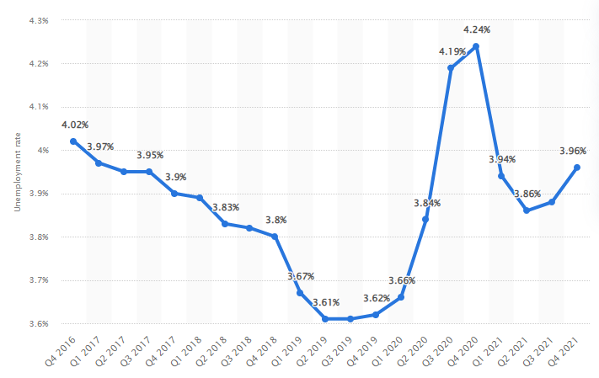 (Textor, 2022)
Chinese labour force refers to people aged 16 and more and capable enough of working, specifically stood almost 784 million in year 2020. Employed people in year 2021 out of employed people number in year 2021 were almost 467.7 million individuals were employed within the urban areas while 278.8 million individuals were working within the rural areas (Textor, 2022).
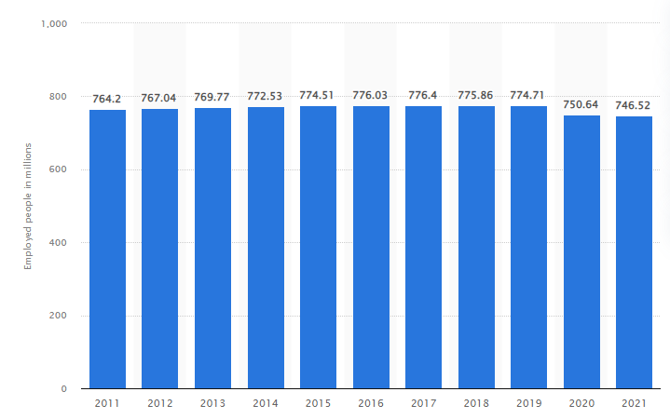 (Textor, 2022)

Cultural differences
Hofstede cultural dimension theory is recognized as the important framework in relation to ensure cross cultural communication (Deresky, 2013). This was developed through Geert Hofstede which presents the impact of society culture on all values of members and these values link to behavior with utilization of structured derived from analysis of factor.
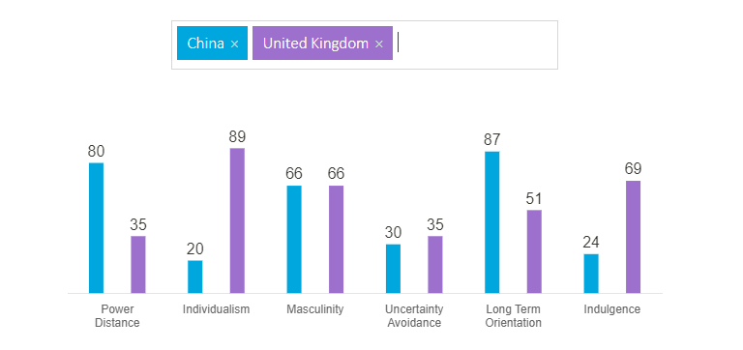 (Hofstede-Insights, 2022)

Power distance
This is referred as an extent to less powerful organizations members in a nation anticipate and accept as power is unequally distributed. China at 80 sites within the higher PDI rankings as society believes that inequalities amongst all people are acceptable. UK at 35 sites within the lower PDI rankings as society believes that inequalities amongst individuals should be minimized.

Individualism
Fundamental challenge addressed through a dimension is independence degree a society specifically maintains among all of the members. China score 20 which is collectivist culture highly in which individuals work within the group interest and not necessarily of them. With the 89 score the region like UK is amongst high individualist scores beaten through some of commonwealth nations it spawned such as Australia and United States of America.

Masculinity
The high score on the masculine dimension refers that a society specifically will be driven through accomplishment, success, and competition with success being explained through the best within the field. Feminine with low score on this dimension refers that dominant values within the society are caring specifically for individuals and life quality. At 66 regions like China is the masculine society which is success oriented as well as driven (Country Comparison, 2022). UK score at 66 which present it as the masculine society which is success oriented and driven at high level.

Uncertainty avoidance
It presents the extent to members of the culture feel more threatened through ambiguous or unknown conditions and have crafted beliefs as well as institutions which ensure to avoid these which are reflected within the score on specifically uncertainty avoidance (Dignen, McMaster, 2013). At 30 regions like China has low level of score on the uncertainty avoidance. UK region is restrained society which can be looked within the low score of 24 within the measurement.

Long term orientation
Long time orientation presents how each society has to ensure and maintain the links with the own past while regularly dealing with the challenges of present time and future time, and priorities of societies these existential objectives differently. China region scores 87 within the dimension that is a very pragmatic culture. With the intermediate score of almost 51 within the dimension this dominant preference within the culture of United Kingdom cannot be determined (Hofstede, 2022).

Indulgence
Indulgence dimension is presented as an extent to which individuals prefer to control the desires and impulses relied on a way which was raised. Moreover societies with low level of score within the dimension have affinity to pessimism as well as cynicism. 69 as the high score presents that region like UK is one which is classified as the indulgent.

Cultural sensitivity
Culture in business of China is influenced through Confucianism. At primary level Confucian concept in relation to Guanxi implies that network of relationship is critical and relied on the different values of solidarity, loyalty, courtesy, and modesty. Hierarchy within the China for organizational and privacy is vertical at pure and respected at high level. Cultural sensitivity is supportive at incredible level for the organizations in China as it supports to work with the right marketing practices. For the organization like Triumph in relation to ensure the appropriate operations within the China region it will be important to ensure the right move with production. There should be power message which will support to resonate with people being enough sensitive to local culture which is of paramount significant. Misunderstanding the culture or the failure in relation to cultural shifts at specific level can result within the tarnishing of brand image ore worse gaining kicked out the market (Santandertrade, 2022).
People of China are risk averse. Strict process exists for a procedure of decision making. For examples, decisions are made through the relevant individuals after many meetings and organizational subordinates are not anticipated to express the opinion. Makers of decision considers the challenges, alternatives, and resolutions on the long time social perspective as the result of which a procedure may be perceived like the slow moving. Necessarily deciding at quick level should be frowned upon (Carte, Fox, 2008). For example, differences at hierarchical level through the organizations in China should be respected and focused to circumvent them will retard the procedure of decision making.

Communication barriers and challenges
Doing business in china is a barrier or challenge for the experienced professional. Following discussion will present the communication barriers and challenges big organization such as Triumph could face in China through moving the production practices.

Limitation of translation applications
One of the main barriers in relation to accessible communication within the market of China for the organization like Triumph will be lack of precision within the applications of translation. For example, business like Tesco in China cannot be relied on for delicate communications while translation application has come specifically a long way in past time. People of China are considered being almost 80% to 90% right on Google Translate and while it may look good but this is far specifically from what is needed in relation to develop a website or campaign of advertising with any confidence degree for Triumph Company.

Chinese negotiation tactics
Blatant emotional displays are looked down in culture of China and it may lead to cause the organization to negotiate unfavorably (Ordorica, 2021). For example, Marks and Spencer in China faces the huge detriment due to low research about the taboos, preferences, language, and social norms of region in China. This kind of practice leads to influence the image of brand at negative level.

Lack of transparency and trust
This is difficult at extreme level to converse anything due lack of transparency as well as trust for the organizations working in region like China. For example, employees of Apple Company in China believes organization is holding something back which remain critical to process their attempt and make to converse with them and meet the deadline of all specific works (Shonk, 2022).

Styles of communication
One of the main challenge or barrier in communication is recognized as the styles of communication. For example, everyone has the own style of communication. Some of the people own direct communication approach while other prefers the more indirect communication approach. One individual occasionally is entrenched within the communicating way these find it typical in relation to converse with others that relies on the different style (Giang , 2012).

Cultural difference
This is typical to understand the cultural difference within the communication. For example, employees within the cultural difference people within the business works with the different attitudes to conflict, different practices to completing the work, different styles of decision making, different types of attitudes to disclosure, and different types of approaches to talking organizations faces the challenge.

Communication strategies and recommendations

Open communication and employment of local people with translation capabilities
Triumph Company to ensure the success within the market of China should take enough time in relation to develop the translation capabilities by employment of local people or employees with the good experience within the nation. It will support the organization to avoid cultural misunderstanding like making offensive and culturally insensitive messaging. Digital communication strategy will support the organization to ensure and attract the customers through the open communication practices (Kharouf, et al., 2020).

Digital communication strategy
Triumph Company is required to take time in relation to work with the research about the language, preferences, taboos, and social norms of every region to attract the customers. This should attempt to remain neutral emotionally throughout their proceedings as well as avoid any direct criticisms. It will be important to tray and extend necessarily negotiations past all of the agreed deadlines and gain the enough concessions. Digital communication strategy will support the organization to eliminate gape in communication with easiness for customer’s everytime (Hasanaj, 2017).

Slow and deliberate whenever entering the new markets
Region like China is recognized as the big as well as complicated place and language within the nation is just one important element employees of organization like Triumph should master in relation to ensure the every operation successful. It will support to move the practices of production into the region easily. It will be important to ensure and present the one chance positive as enable to make the first impression positive (Agarwal, and Garg, 2012). This will be important to ensure and learn everything before the application with rely on proven specialists with experience within the procedure will be the best.
Effective level of communication can be one of the important hurdles for the organization like Triumph entering China. The lack of appropriate skills can lead to hind the performance within the market and it can cost the time as well as money and could eventually be a main reason organization could not be capable to find the feet in region like China. Organization through looking at these barriers and challenge can ensure to resolve the challenges and go ahead with positive approach.

Conclusion
In the limelight of the discussion it can be concluded that big organization like Triumph in China will accomplish success through moving the lines of production but it is required to consider the different types of challenges and barriers with appropriate strategies. Further this report has presented detail discussion with introduction to development region such as China. It has presented the cultural differences within the region like China and United Kingdom. This report has ensured to present the discussion about the cultural sensitivity for the organization within the China region. It has listed the communication barriers and challenges for the Triumph Company in region like China. These are limitation of translation application, Chinese negotiation tactics, lack of transparency and trust, communication styles and cultural difference. This report has presented communication strategies and recommendations. These are open communication and employment of local people with translation capabilities, digital communication strategy, slow and deliberate whenever entering the market of China for Triumph Company. These kinds of strategies will support the organization to resolve the business challenges in China region and work with the right appropriate. It will enable the company to maintain the competitive position within the China region easily.

Bibliography
Agarwal, S. and Garg, A., 2012. The importance of communication within organizations: A research on two hotels in Uttarakhand. IOSR Journal of Business and Management, 3(2), pp.40-49.
Bailey, S. (2015) Academic Writing for International Students of Business. 2nd Edition, London, Routledge
Bolotnikov, K., 2022. The Many Dialects of China. [Online]
Available at: https://asiasociety.org/china-learning-initiatives/many-dialects-china#:~:text=Mandarin%20Chinese%20is%20known%20as,make%20this%20a%20reality%20nationwide.
[Accessed 30 03 2022].
Carte, P., Fox, C., (2008) Bridging the Culture Gap: A Practical Guide to International Business Communication, London, Kogan Page
Country Comparison, 2022. Hofstede Insight. [Online]
Available at: https://www.hofstede-insights.com/country-comparison/the-uk/
[Accessed 30 03 2022].
Deresky, H. (2013) International Management: Managing Across Boarders and Cultures, London, Pearson.
Dignen, B., McMaster, I., (2013) Communication for International Business: The secrets of excellent interpersonal skills, Collins, London
Dignen, B., McMaster, I. (2013) Collins Effective International Business Communication, London: Collins
Giang , V., 2012. The Reason So Many Business Deals Go Wrong In China. [Online]
Available at: https://www.businessinsider.com/language-barriers-are-costing-companies-tons-of-money-2012-5?IR=T
[Accessed 31 03 2022].
Hofstede, 2022. Comparison of nation. [Online]
Available at: https://www.hofstede-insights.com/country-comparison/the-uk/
[Accessed 30 03 2022].
Hofstede-Insights, 2022. Country Comparison. [Online]
Available at: https://www.hofstede-insights.com/country-comparison/china,the-uk/
[Accessed 30 03 2022].
Hasanaj, R., 2017. Importance of communication during change: A case of the municipality of Vlora. European Journal of Multidisciplinary Studies, 2(1), pp.15-19.
Kharouf, H., Biscaia, R., Garcia-Perez, A. and Hickman, E., 2020. Understanding online event experience: The importance of communication, engagement and interaction. Journal of Business Research, 121(08), pp.735-746.
Ordorica, S., 2021. Three Barriers Business Leaders Often Face When Expanding To China. [Online]
Available at: https://www.forbes.com/sites/forbesbusinesscouncil/2021/07/01/three-barriers-business-leaders-often-face-when-expanding-to-china/?sh=337c993e5b47
[Accessed 31 03 2022].
Pan, C., 2021. US-China tech war: China to overtake America in core 21st century technologies within next decade, Harvard report predicts. [Online]
Available at: https://www.scmp.com/tech/tech-war/article/3159107/us-china-tech-war-china-overtake-america-core-21st-century
[Accessed 30 03 2022].
Shonk, K., 2022. Cultural Barriers and Conflict Negotiation Strategies: Apple’s Apology in China. [Online]
Available at: https://www.pon.harvard.edu/daily/dispute-resolution/dispute-resolution-in-china-apple-apologizes-for-warranty-policies/
[Accessed 31 03 2022].
Stallings, W., (2012) Business Data Communications: International Version, London, Pearson
Stunningtours, 2019. Chinese Culture-a short introduction. [Online]
Available at: https://stunningtours.com/chinese-culture-html/#:~:text=Chinese%20culture%20is%20one%20of,visual%20arts%2C%20philosophy%20and%20religion.
[Accessed 30 03 2022].
Textor, C., 2022. Number of employed people in China 2011-2021. [Online]
Available at: https://www.statista.com/statistics/251380/number-of-employed-persons-in-china/#:~:text=The%20labor%20force%20of%20China,were%20working%20in%20rural%20areas.
[Accessed 30 03 2022].
Textor, C., 2022. Quarterly unemployment rate in China Q4 2016-Q4 2021. [Online]
Available at: https://www.statista.com/statistics/226141/unemployment-rate-in-china-by-quarter/
[Accessed 30 03 2022].
Textor, C., 2022. Total population of China from 1980 to 2021 with forecasts until 2026. [Online]
Available at: https://www.statista.com/statistics/263765/total-population-of-china/#:~:text=According%20to%20newest%20data%20provided,effects%20of%20the%20coronavirus%20pandemic.
[Accessed 30 03 2022].
Zhou, Q., 2022. China’s Most Productive Provinces and Cities as per 2021 GDP Statistics. [Online]
Available at: https://www.china-briefing.com/news/chinas-2021-gdp-performance-a-look-at-major-provinces-and-cities/
[Accessed 07 03 2022].
Zimmermann, K. A., 2017. Chinese Culture: Customs & Traditions of China. [Online]
Available at: https://www.livescience.com/28823-chinese-culture.html
[Accessed 30 03 2022].

