ASSIGNMENT 2: WRITTEN ASSIGNMENT
Programme: BA Business Management
Module Code: LCBB5004
Lecturer: Nishi Ramsurrun
Name and student ID: Alice-Ana-Maria Casota (2117332)
Table of Contents
Introduction 2
1) Analysis of causes and effects of employee attrition within Nursing Industry in UK 2
2) Identification of five monetary and five non-monetary existing retention schemes used by NHS for nursing professionals through research and critical evaluation of those 4
3) Short and long-term Recommendations to improve nurse retention to lower nurse attrition rate in UK 6
Conclusion 8
References 10

Introduction
Employee attrition refers to departure or leaving of employees, from organisations due to “voluntary” or “involuntary” reasons. This study sheds light on employee attrition issues within nursing industry of UK, pivoting around “National Health Service (NHS)". Both monetary and non-monetary retention schemes are explained in this study which is utilised by NHS UK to ensure employee retention.

1) Analysis of causes and effects of employee attrition within Nursing Industry in UK
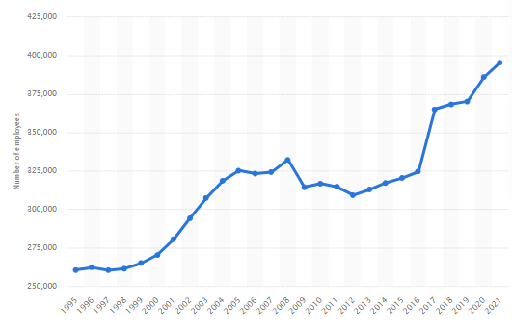
Figure 1: Number of Nurses in NHS from 1995 to 2021
(Source: As inspired by Michas, 2022)
“National Health Services (NHS)" is the largest healthcare provider in UK which provides good quality treatment to people free of cost or half of original prices to ensure equal treatment for all. NHS is a publicly funded organisation which supports “local integrated care systems (ICS)” and qualified doctors and nurses serve people to ensure well being of patients (NHS, 2023). Regional teams like “NHS organisations”, “primary care professionals”, “local councils”, “social care providers”, “community sector”, “voluntary sector” and “social enterprise sector” are included in NHS. Michas (2022) has imposed importance on recruitment of nurses in NHS and explained that more than “396,000 nurses”, “ambulance staff” and “midwives” have been employed by NHS as of 2021. Workforce planning is one of important measures through which employee retention can be ensured which is directly linked with organisational excellence. On contrary, Waitzman (2022) focused on employee attrition and explained that a shortage of nearly "50,000 nurses and midwives” in NHS has been reported by “Nuffield Trust” in 2022. This represents an adverse situation faced by NHS in terms of employee attrition which imposed a negative impact on overall performance.
Causes of employee Attrition in NHS
Issues of employee attrition have been caused by several reasons which are analysed by this organisation and have highlighted “lack of long-term workforce plan”, “Brexit”, “Concerns over pay” and “Job pressures” (Waitzman, 2022). Process of providing good quality treatment and ensuring the well-being of people has been affected by issues of staff shortage.
Lack of long-term workforce planning
Long-term planning to acquire a skilled workforce is beneficial for organisations to increase efficiency and NHS has faced issues in this regard. “Strategic planning”, “Analysis of need to appoint staff”, “Assessing skills of candidates” and “Offering benefits and perks to candidates” are effective strategies to develop workforce planning (Crasii and Nawar, 2022). As per a report published by NHS, UK, “inability to forecast length of time for training staff” is explained as reason for an inability to develop workforce planning (Waitzman, 2022). Therefore, it can be said that workforce planning is an important reason for employee attrition in nursing sector.
Brexit
Brexit has impacted nursing sector of NHS in a negative aspect as a large number of employees coming from European Union (EU) have left this organisation because of Brexit restrictions. However, Baker (2022) showed that more than “70,000 staff" of NHS are "EU nationals” which constitutes “5.3% of total employees” as of 2022. As a result of imposing regulations relating to Brexit, which imposed negative impacts, existing staff of NHS were forced to leave NHS and an overall issue of staff shortage took place.
Payment Concerns
Pressures in terms of “Cost of Living” resulted in attrition of employees in nursing sector of NHS. Yearly “rate of inflation” has reached “11.1%” in 2022 which accelerates issues of “Cost of living” in UK (Devine et al. 2023). It has been observed by NHS, nurses are more likely to leave NHS for better jobs which pay higher than NHS. This can be considered as another reason for staff attrition in NHS.
Job pressures
High workload and pressure are found to be significant factors causing employee attrition in nursing sector of NHS. “Chronic excessive workload" was identified by NHS as a key reason for "burnout” and “employee attrition" which increased a number of employee attrition within an organisation (PARLIAMENT, 2022). Thus, huge work pressure needs to be addressed by "Executive Leaders" of NHS to facilitate employee retention to improve quality of service. Overall quality of service provided by NHS has deteriorated by employee attrition and workload on existing employees has been increased. As a result of leaving organisations, workload on existing staff has been increased and they are required to take on multiple responsibilities within an organisation to maintain performance.
Well-being of patients as well as health standards of people is affected by employee retention which developed concerns for managerial heads of NHS in terms of resolving staff shortages. This has caused a significant impact on finance structure of NHS which affected overall business performance. It has been observed in a statistical report that approximately a "10-12% turnover rate" is associated with "3,000 nurses” belonging to “NHS trust” (NHS, 2020). From this statistical data, a clear image of negative financial impact of employee attrition can be obtained which has imposed a negative impact on NHS and its business functions.
Effects of employee-attrition in NHS
As a significant issue, employee shortage has been addressed to be faced by NHS which has affected overall performance of this organisation. In this context, Waitzman (2022) focused on negative impact of employee retention which includes “deterioration of living standards among nurses" "demoralising existing staff” and “increase in sickness absences". Furthermore, the author has analysed that rate of sickness has increased from "4.37% to 5.20%” in between 2020 to 2022.

2) Identification of five monetary and five non-monetary existing retention schemes used by NHS for nursing professionals through research and critical evaluation of those
Monetary schemes
Increasing payment structure: Amount of wages, provided by NHS to nurses, has fallen to "7%” in last 10 years which raises amount of staff shortage (THEGUARDIAN, 2021). On contrary, Ashton and Farhat (2023) showed that payment structure of newly hired nurses has been estimated to rise to “£2,750" from 2023 to 2024. This can be considered an effective monetary staff retention scheme which is quite beneficial to retain existing nurses in NHS.
Reimbursement policies: Reimbursement policies are quite helpful in terms of employee retention as they provide financial reimbursement to nurses which would increase their financial standing. This has been adopted by this organisation after facing issues of staff shortage and employee attrition.
Providing incentives: It has been observed from a report published by NHS, an initiative to provide incentives to nurses has been adopted by this organisation (NHS, 2023). This is one of great monetary employee retention schemes which have potential to reduce employee attrition from NHS.
Providing bonus: Stewart and Bawden (2023) claimed that a bonus of “8.2%” has been provided by NHS as a result of strikes conducted by staff and nurses of this organisation. This represents an effective measure of monetary employee retention scheme by NHS which has potential to motivate nurses to stay within NHS and continue serving this organisation.
Policies of pension: NHS has taken a pension scheme for staff working within this organisation which provides financial support to staff and nurses (NHSEMPLOYERS, 2022). Through this, flexible retirement and willingness to work within organisations can be facilitated among nurses NHS.
Non-Monetary schemes
Occupational health and employee assistance programme
An employee assistance programme has been initiated by NHS through which nurses get guidance about their responsibility and pattern of work (NHSBT, 2023). This can be considered a beneficial non-monetary scheme by which employee retention can be facilitated.
Learning and training
Despite “constant pressures” and “chronic shortages”, number of staff and nurses leaving NHS has been reduced in recent years. Contradictory to it, Holmes (2022) analysed that more than a "25%” increase in employee attrition has been noticed in NHS and “younger nurses" are more likely to leave an organisation. In this measure, providing constant learning and training to nurses is an effective non-monetary retention scheme which has potential to reduce employee attrition from NHS.
Communication
Facilitating communication among employees is quite helpful to address issues faced by employees within organisations (Kim, 2020). It has been observed that NHS has taken initiative to communicate with nurses to conceptualise reasons for which they are leaving NHS.
Providing inclusive work culture
NHS has arranged for an inclusive work culture for their employees by whom employees can be motivated and can feel accepted as well as valued. In this way, employee attrition can be reduced and an exciting talented workforce can be retained within organisation.
Motivating employees
Leaders and managers of NHS have arranged for face-to-face meetings with employees through which nurses can be motivated and get a chance to share their issues with leaders. In this non-monetary way, NHS has improved their employee retention programme to reduce employee attrition.

3) Short and long-term Recommendations to improve nurse retention to lower nurse attrition rate in UK
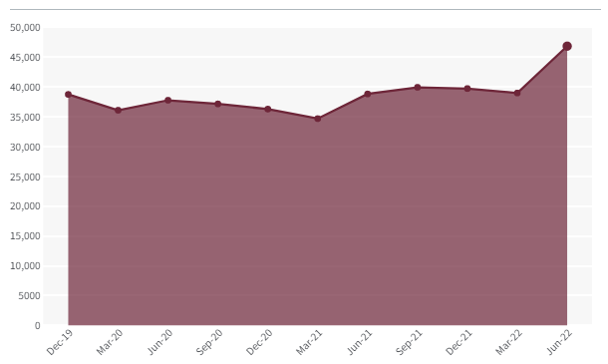
Figure 2: Vacant NHS nursing posts from 2019 to 2022
(Source: As inspired by Holmes, 2022)
Nurse attrition level in NHS has increased which has imposed a huge negative impact on organisational performance of NHS. Analysing vacancy rates are perfect measures to get a clear image of nurse attrition rate for which positions of nurses are left vacant within this organisation. As analysed by Holmes (2022), more than “34,000 nurses" have left NHS in 2021. This has called for action by UK Government and authorities of NHS to develop both short and long-term nurse retention strategies.
Short terms retention strategies
Employee retention refers to a specific process through which organisations offer attractive benefits to employees intending to retain existing workers to utilise skills and talents. However, as mentioned by Woolf et al (2023), NHS is currently facing issues regarding employee shortage, especially in the nursing sector which has impacted quality of service negatively provided by NHS. In this scenario, at times, organisations need to retain their employees for a short period before recruiting new staff which is considered "Short term employee retention”. “Arranging for focus group meetings”, “Mentorship programs”, “Wellness offerings” and “Communication” are significant strategies which can be utilised as measures to retain employees for a short period (Harcus and Snaith, 2019). Through focus group meetings, issues faced by nurses can be conceptualised by HR department of NHS which would bring in opportunities to develop potential strategies. Apart from this, communication is one of interconnected factors with focus group meetings which have sufficient potential to provide inclusive work culture and motivate employees. Mentorship programs are to be arranged by NHS through which skills of existing nurses can be improved and process of “learning from workflow” can be facilitated. Besides this, wellness offerings include measures like offering benefits and perks like health insurance and flexibility of working to employees (Day et al. 2022). These are quite effective measures to retain nurses and stop them from switching organisations in terms of employee retention.
Long-term retention strategies
Long-term retention strategies include "Constant training”, “Considering Feedback of employees” and “Offering rewards” can be adopted by NHS to retain existing nurses. As explained by Buchan et al. (2019), Constant training is quite effective for improving skills of existing nurses by which they would be provided with beneficial aspects to improve their professional qualities. On other hand, an operational team of NHS needs to consider feedback from employees so that they can get a clear idea about issues faced by nurses. In this way, nurses would be able to rely on leaders of NHS which would increase employee engagement towards values and objectives of NHS. On other hand, Nyashanu et al (2022) have imposed importance on providing rewards to employees to recognise their achievements which is an effective measure to motivate employees within organisations. NHS needs to arrange for reward programmes where achievements accomplished by nurses would be recognised as well as encouraged.
Work Engagement Theory of Kahn
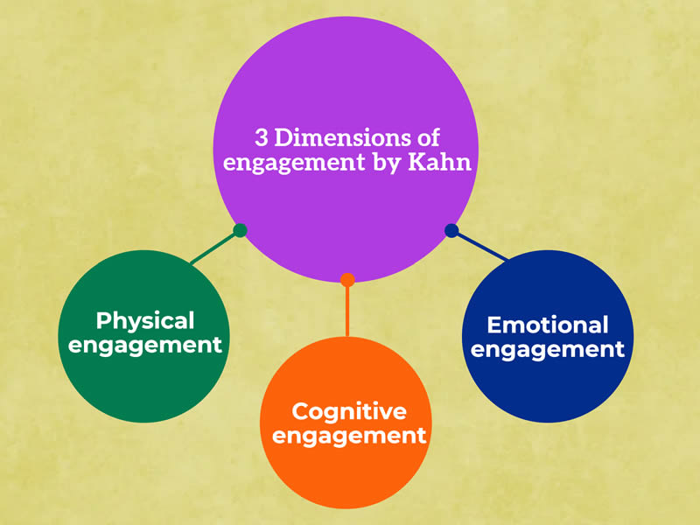
Figure 3: Work Engagement Theory of Kahn
(Source: As inspired by Huang et al. 2022)
“Work Engagement Theory of Kahn” highlights integration between “self-preference” and “job responsibilities” in terms of employee engagement within workplace. As facilitated by Huang et al. (2022), three major aspects, such as “Physical”, “Cognitive” and “Emotional” engagements are included in Work Engagement Theory. Application of this theory needs to be executed by NHS to understand needs of nurses and increase engagement of employees. Through this, employee retention would be increased and nurses attrition can be reduced which would improve overall performance of NHS. Hence, significance of Work Engagement Theory can be understood which has potential to facilitate retention of nurses within the NHS.

Conclusion
In this study, it has been seen that NHS has faced issues of employee attrition and a large number of nurses have left this organisation. High work pressure, less payment, and Brexit regulations are found as important reasons behind employee attrition. Hence, it can be concluded that both monetary and nonmonetary employee retention schemes, initiated by NHS are quite beneficial for retaining existing nurses which would improve overall performance of this organisation.

References
Ashton, E and Farhat, E, A (2023). “UK Offers Nurses 5% Pay Rise in Bid to End Most NHS Strikes”. Available at: https://www.bloomberg.com/news/articles/2023-03-16/uk-nhs-agrees-to-5-pay-rise-offer-for-nurses-ambulance-staff#:~:text=In%20its%20statement%2C%20DHSC%20said,this%20year%2C%20the%20department%20said. [Accessed on: 20th March, 2023]
Baker, C., (2022). “NHS staff from overseas: statistics”. Available at: https://commonslibrary.parliament.uk/research-briefings/cbp-7783/#:~:text=Over%2095%2C000%20are%20Asian%20nationals,is%20correct%20at%20June%202022. [Accessed on: 20th March, 2023]
Buchan, J., Charlesworth, A., Gershlick, B. and Seccombe, I., (2019). A critical moment: NHS staffing trends, retention and attrition. London: Health Foundation.
Crasii, O. and Nawar, Y.S., (2022). Exploring the Effect of Business Strategy on Employees’ Retention During Pandemic and After Brexit: The case Home Care Sector in UK. The Business & Management Review, 13(2), pp.134-144.
Day, G., Robert, G., Leedham‐Green, K. and Rafferty, A.M., (2022). An outbreak of appreciation: A discursive analysis of tweets of gratitude expressed to the National Health Service at the outset of the COVID‐19 pandemic. Health Expectations, 25(1), pp.149-162.
Devine, B, F., Harari, D., Keep, M., Bolton, P., Barton, C., Wilson, W., (2023). “Consumer goods and energy prices pushing inflation higher”. Available at: https://commonslibrary.parliament.uk/research-briefings/cbp-9428/#:~:text=The%20cost%20of%20living%20increased,2023%20to%2010.4%25%20in%20February. [Accessed on: 20th March, 2023]
Harcus, J.W. and Snaith, B., (2019). Expanding training capacity for radiographer reporting using simulation: evaluation of a pilot academy project. Radiography, 25(4), pp.288-293.
Holmes, J, (2022). “The NHS nursing workforce – have the floodgates opened?”. Available at: https://www.kingsfund.org.uk/blog/2022/10/nhs-nursing-workforce. [Accessed on: 20th March, 2023]
Huang, S. Y. B., Huang, C. H., and Chang, T. W. (2022). “A New Concept of Work Engagement Theory in Cognitive Engagement, Emotional Engagement, and Physical Engagement”. Available at: https://www.ncbi.nlm.nih.gov/pmc/articles/PMC8886307/#:~:text=Work%20Engagement%20Theory%20of%20Kahn,investment%20(Kahn%2C%201990). [Accessed on: 20th March, 2023]
Kim, Y., (2020). Organizational resilience and employee work-role performance after a crisis situation: exploring the effects of organizational resilience on internal crisis communication. Journal of Public Relations Research, 32(1-2), pp.47-75.
Michas, F (2022). “Number of nurses including health visitors, midwives and ambulance staff in the NHS Hospitals and Community Health Service (HCHS) workforce England from 1995 to 2021”. Available at: https://www.statista.com/statistics/679976/number-of-nurses-nhs-hchs-workforce-england/ [Accessed on: 20th March, 2023]
Michas, F (2022). “Total headcount of the NHS Hospitals and Community Health Service (HCHS) workforce in England as of February 2022, by staff group”. Available at: https://www.statista.com/statistics/679898/number-of-nhs-hchs-workforce-by-staff-group-england/ [Accessed on: 20th March, 2023]
NHS (2020). “Workforce Analytics”. Available at: https://www.sbs.nhs.uk/article/16949/Workforce-Analytics#:~:text=High%20levels%20of%20attrition%20amongst,of%20between%2010%2D12%25. [Accessed on: 20th March, 2023]
NHS (2023). “Guidance on the aligned payment and incentive approach”. Available at: https://www.england.nhs.uk/wp-content/uploads/2021/12/22-23NT_Dt-Guidance-on-aligned-payment-and-incentive-approach.pdf [Accessed on: 20th March, 2023]
NHS (2023). “What we do”. Available at: https://www.england.nhs.uk/about/what-we-do/#:~:text=Through%20our%20seven%20integrated%20regional,enterprise%20sector%20%E2%80%93%20to%20improve%20the. [Accessed on: 20th March, 2023]
NHSBT (2023). “Employee Assistance Programme (EAP)”. Available at: https://peoplefirst.nhsbt.nhs.uk/Wellbeing/employee-assistant-programme-eap.htm. [Accessed on: 20th March, 2023]
NHSEMPLOYERS (2022). “NHS Pension Scheme”. Available at: https://www.nhsemployers.org/pensions#:~:text=The%20NHS%20Pension%20Scheme%20continues,to%20work%20and%20retire%20flexibly. [Accessed on: 20th March, 2023]
Nyashanu, M., Pfende, F. and Ekpenyong, M.S., (2022). Triggers of mental health problems among frontline healthcare workers during the COVID‐19 pandemic in private care homes and domiciliary care agencies: Lived experiences of care workers in the Midlands region, UK. Health & social care in the community, 30(2), pp.e370-e376.
PARLIAMENT (2022). “Workforce burnout and resilience in the NHS and social care”. Available at: https://committees.parliament.uk/publications/6158/documents/68766/default/. [Accessed on: 20th March, 2023]
Stewart, H and Bawden, A ( 2023). “Health unions hail victory after government’s new pay offer for NHS staff in England”Available at: https://www.theguardian.com/society/2023/mar/16/government-confirms-new-pay-offer-for-nhs-staff-in-england [Accessed on: 20th March, 2023]
THEGUARDIAN (2021). “Low-paid NHS workers deserve better than this paltry offer”. Available at: https://www.theguardian.com/society/2021/jul/27/low-paid-nhs-workers-deserve-better-than-this-paltry-offer. [Accessed on: 20th March, 2023]
Waitzman, E., (2022). “Staff shortages in the NHS and social care sectors”. Available at: https://lordslibrary.parliament.uk/staff-shortages-in-the-nhs-and-social-care-sectors/#:~:text=Discussing%20evidence%20that%20it%20had,over%2050%2C000%20nurses%20and%20midwives. [Accessed on: 20th March, 2023]
Woolf, K., Papineni, P., Lagrata, S. and Pareek, M., (2023). Retention of ethnic minority staff is critical to resolving the NHS workforce crisis. bmj, 380.

