

MODULE CODE: Digital Skills for Personal Development and Business Growth BMSW4008
ASSESSMENT COMPONENT: PORTFOLIO
STUDENT NAME: BAHAUDDEEN ALAMIN
STUDENT NUMBER: 2513598
LECTURER: SCOTT JAMES
DATE: 16 MARCH 2026

Contents
Task 1 3
Assessment of Digital Skills 3
References 3
Task 2 4
LinkedIn Learning Certificates for Office 365 4
Task 3 5
Essay on Relevance of Excel in professional and personal life. 5
References 5
Task 4 6
5 Minute Reflective Presentation 6
References 6

AI Acknowledgement Statement:
I confirm that I have not presented any AI-generated materials as my own work.
I confirm that I have copies of my drafts, notes, and other resources I used, which I may be asked to provide in evidence.
I acknowledge the use of Grammarly (https://www.grammarly.com/) on 08/03/2026 to check my work using the prompt(s):
I use the following prompt: -
- Help me structure my assessment,
- Help me check my writing for clarity and academic tone.
- Confirm my paragraph for grammatical words and clarity.

Task 1

Assessment of Digital Skills

Importance of Digital Skills:
Digital skills are essential today because they affect how people learn, work, communicate, and engage in modern communities. They have become a core part of everyone's needs, personal development, employability, and everyday life. (Jisc,2024)
In the modern world, technology has become indispensable and influences every aspect of life. In this context, digital skills are no longer optional; they are crucial for students, professionals, and businesses alike. Digital competence enables individuals to communicate effectively, boost productivity, and excel in higher education, which relies on digital tools to access online research and learning platforms. It also unlocks a broader range of career opportunities. (Usman Ghani, 2025).
The world is experiencing rapid growth, which creates a gap in digital talent and hampers global economic progress. Consequently, the demand for digital skills such as AI literacy, data competence, and general technologies is rising swiftly. This makes digital skills vital for individuals, organisations, and national economies.
(World Economic Forum, 2025)

Overview of the JISC Digital Capability Tool:
The JISC Digital Capability Tool, often called the discovery tool, is an online self-assessment resource designed to help learners and staff reflect on their digital skills and confidence levels. It guides users through reflective questions that raise awareness of their current digital strengths and identify areas for development.
Personal and professional growth are supported by the Jisc Digital Capability Framework, which evaluates current abilities and identifies strengths and areas for improvement (Jisc, 2026).

Summary of JISC Results:
The results show that I have a balanced digital profile, with abilities spread across the Developing, Capable, and Proficient categories. This reflects both existing skills and clear opportunities for further growth, aligning with the expectations of a modern digital learner. The report showed that I am proficient in digital communication, meaning I can communicate effectively across different platforms and adapt my style to different audiences, and engage confidently in online environments.
However, the report also identifies several areas where I am still developing, including Media Literacy, Data Literacy, Digital Collaboration, Digital Participation, Digital Learning Activities, and Problem Solving. These categories highlight where I need to strengthen my confidence and competence. (Jisc, 2026)

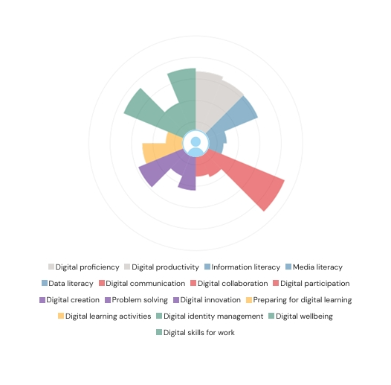

Strengths in Digital Skills:
One of my strengths occurs in the report, which is Digital communication, which is an essential skill in higher education and professional environments.
Digital communication includes a wide range of methods such as email, social media, websites and instant messaging. Email remains one of the most effective channels for professional communication and marketing, with organisations frequently using email newsletters to engage customers and share updates (Litmus, 2024).
I usually use email, WhatsApp, and Microsoft Teams to communicate with my lecturers and my colleagues in the classroom for any information and group work for assessment. This suggests that I can communicate effectively using a variety of digital platforms, adapt my communication style to different audiences, and engage confidently in online environments.
Another strength shown in the JISC report is the strong use of digital tools and the strong ability to use digital platforms (Moodle, online research, Canva, document editing tools) to support my learning and produce academic work.
One area of my weakness, as shown in the JIS report, is limited confidence in digital problem-solving. I found challenges in solving technical issues such as resolving software errors, navigating unfamiliar digital tools and managing device settings (JISC,2023).
I also have another area of weakness, which is managing data literacy and evaluating online information critically (JISC,2023).

Action Plan Using SMART Goals:
I have come up with the following SMART plan to improve my areas of weakness:
- S- specific: I will strengthen my ability and capability to evaluate online information, check credibility, and manage digital data effectively.
- M- measurable: I will practice evaluating online sources as many as ten sources using a credibility checklist (such as the CRAAP test) and apply it in my learning and assignments.
- A- achievable: I will improve my evaluation skills by using the university library and JISC digital literacy materials, as well as academic search tools.
- R- relevant: by improving my information literacy skills, my academic writing, referencing and research will improve and meet high standards.
- T- time-bond: My time bond is to complete this goal in 12 weeks.

Reflection and Conclusion
My JISC Digital Capability results provide a clear and structured understanding of my current digital strengths and areas for development. The report shows that I have a solid foundation across most digital skill categories. By improving these skills, I will be able to help myself and support my academic study and future career
Overall, this reflection has strengthened my understanding of digital capability as an ongoing journey. With clear goals and consistent practice, I am well-positioned to continue developing the digital skills I need for success in both my studies and future professional life.

References
Kumar, R.S. & O’Donoghue, O. (2025) emphasise that skills development is essential for closing the global digital talent gap. World Economic Forum. Available at: https://www.weforum.org/stories/2025/12/bridging-the-digital-talent-crisis (Accessed: 4 March 2026).
Jisc (2025). Overview of the JISC Digital Capability Tool. Available at: https://digitalcapability.jisc.ac.uk (Accessed: 4 March 2026).
Jisc (2026) Digital Capability Report – Higher Education Student Question Set. Jisc Discovery Tool. Available at: https://digitalcapability.jisc.ac.uk (digitalcapability.jisc.ac.uk in Bing) (Accessed: 7 March 2026).
Examples.com (2025) 99+ Digital Communication Examples. Litmus (2024). 16 Ways to Integrate Social Media with Email in Marketing. The Knowledge Academy (2025). Digital Communication: Definition, Types & Importance.
The Knowledge Academy (2025). Digital Communication: Definition, Types & Importance.
Jisc (2023) Building Digital Capability: The Six Elements. Available at: https://digitalcapability.jisc.ac.uk (digitalcapability.jisc.ac.uk in Bing) (Accessed: 10 March 2026).

Task 2

LinkedIn Learning Certificates for Office 365
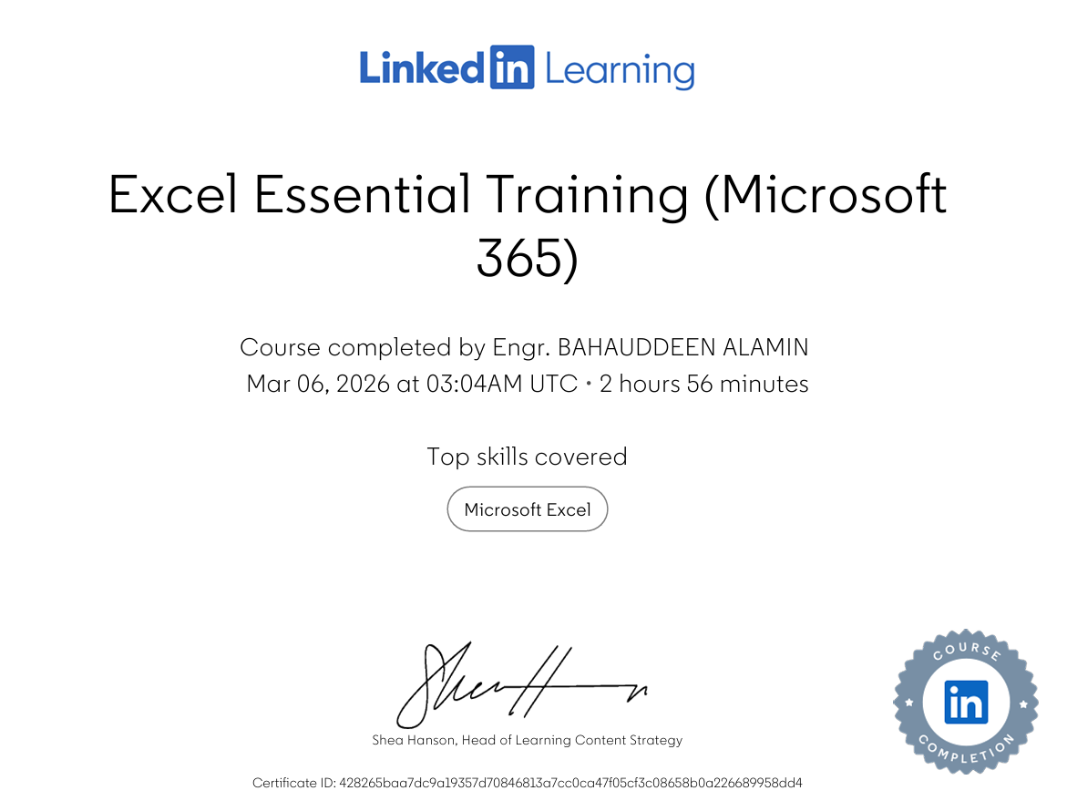

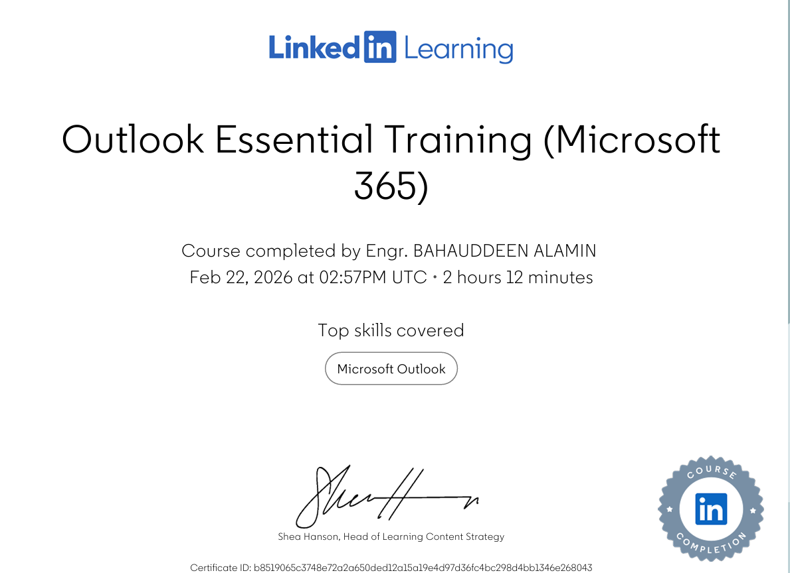

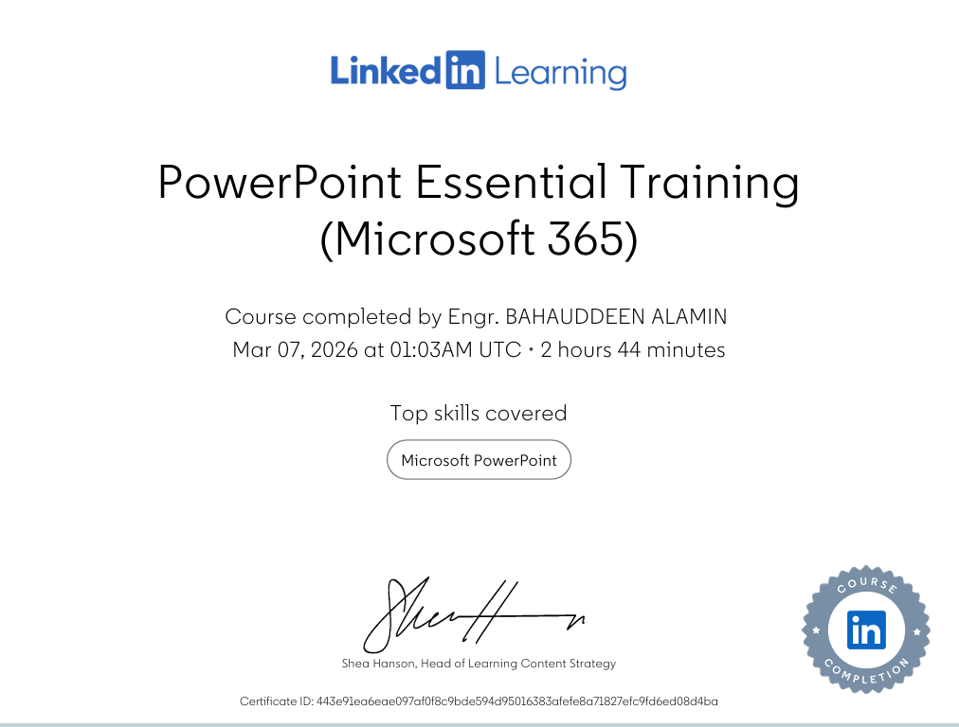

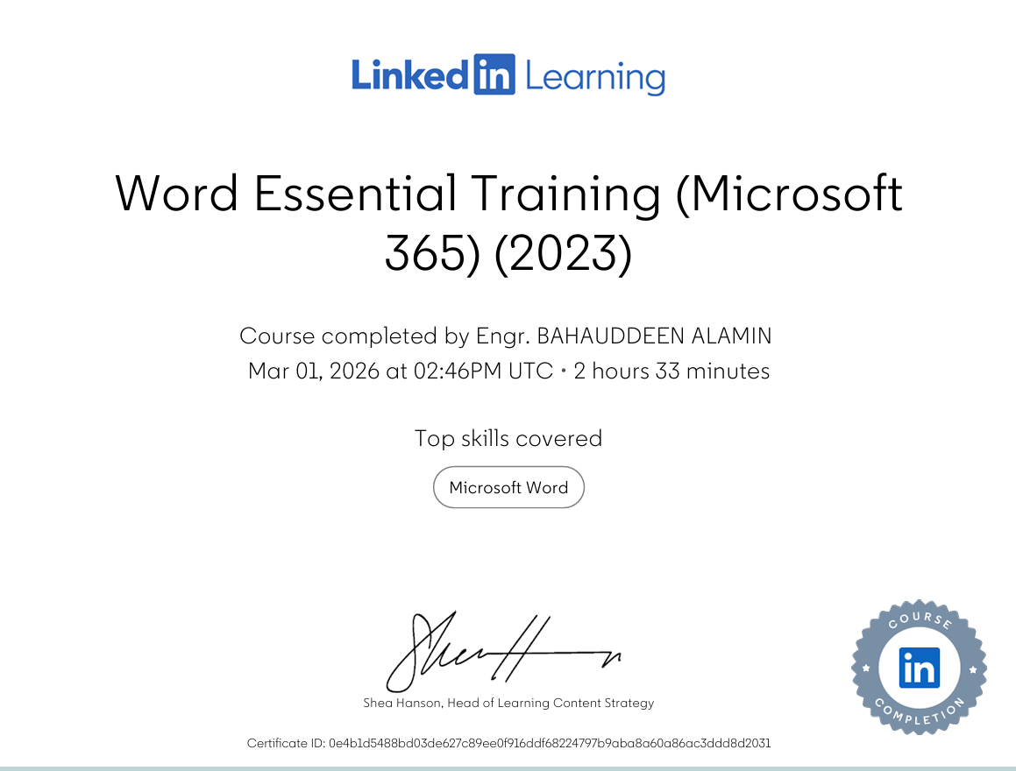

Task 3

Relevance of Excel in professional and personal life.
Microsoft Excel is one of the most widely used digital tools worldwide, supporting millions of individuals in both professional and personal contexts. Despite the emergence of new technologies and automated systems, Excel remains essential due to its flexibility, analytical capabilities, and accessibility. Its relevance spans across industries, education, business operations, and daily life, making it a fundamental digital skill for the modern world. This essay examines the importance of Excel, its applications in data analysis, budgeting, reporting, and decision-making, and its value in personal and professional growth.
Microsoft Excel plays a vital role in modern workplaces because it enables professionals to manage, analyse, and present data efficiently. Its powerful features—such as formulas, pivot tables, charts, and automation tools—support a wide range of tasks, including financial planning, project management, inventory tracking, and performance monitoring (GeeksforGeeks, 2025).

Use of Microsoft Excel:

Data analysis
Microsoft Excel is a powerful tool for supporting and analysing data, using formulas, pivot tables, and charts. It turns raw data into actionable insights, supporting data-driven decision-making. With Excel, employees can create reports that are both insightful and visually appealing. (GeeksforGeeks, 2025).
Functions used to calculate data and build formulas, such as SUM, AVERAGE, COUNT, MIN, and MAX, enable operators to perform essential calculations quickly and accurately. These are particularly useful in academic settings when analysing research results or numerical case studies. More advanced tools such as IF functions, VLOOKUP/XLOOKUP, and conditional formatting, allow users to automate processes and identify trends within datasets. Using these functions will increase the digital skills of students in higher education and enhance critical thinking and digital literacy both in higher education and employment. Meanwhile, university learners increasingly rely on Excel for tasks such as statistical analysis, budgeting, project planning, and data visualisation, making it a foundational tool across disciplines. These same skills directly enhance employability, as employers consistently identify spreadsheet proficiency as one of the most in-demand competencies in a workplace. (OECD, 2023).

Budgeting and Financial Management
Elsewhere, calculations and budgeting in Excel play a key role in reporting and decision-making. Direct information or data can't be translated and presented clearly; therefore, Excel provides tools that use visualisations such as bar charts, pie charts, line graphs, pivot tables, and dashboards to translate numerical data into understandable insights.
Excel also demonstrates strong support for businesses in data management, reporting, forecasting, and operational decision-making across industries. Managers usually use Excel to monitor profitability, sales growth, and productivity. (Business Excel Insights, 2023).

Practical Spreadsheet Task
The household income and expenditure spreadsheet task illustrates how Excel can be applied to real-life financial management by organising financial information clearly and systematically. The spreadsheet records different income sources and categories of spending, enabling automatic calculations of total income, total expenses, and the remaining balance through functions such as SUM, subtraction formulas, and cell referencing. This demonstrates how Excel supports accuracy and efficiency by reducing manual calculations. Visual tools, such as pie charts and bar charts, further enhance understanding by showing spending patterns and highlighting areas where costs may be higher than expected. Beyond technical skills, the task promotes financial awareness by encouraging users to analyse their spending habits and make informed decisions. Recent research emphasises that financial literacy is essential for long-term wellbeing and responsible money management (OECD, 2023). Completing this task also strengthens transferable digital competencies—including formula creation, formatting, and data visualisation—which are valuable in academic work and highly relevant to workplace expectations (Williams, 2024).

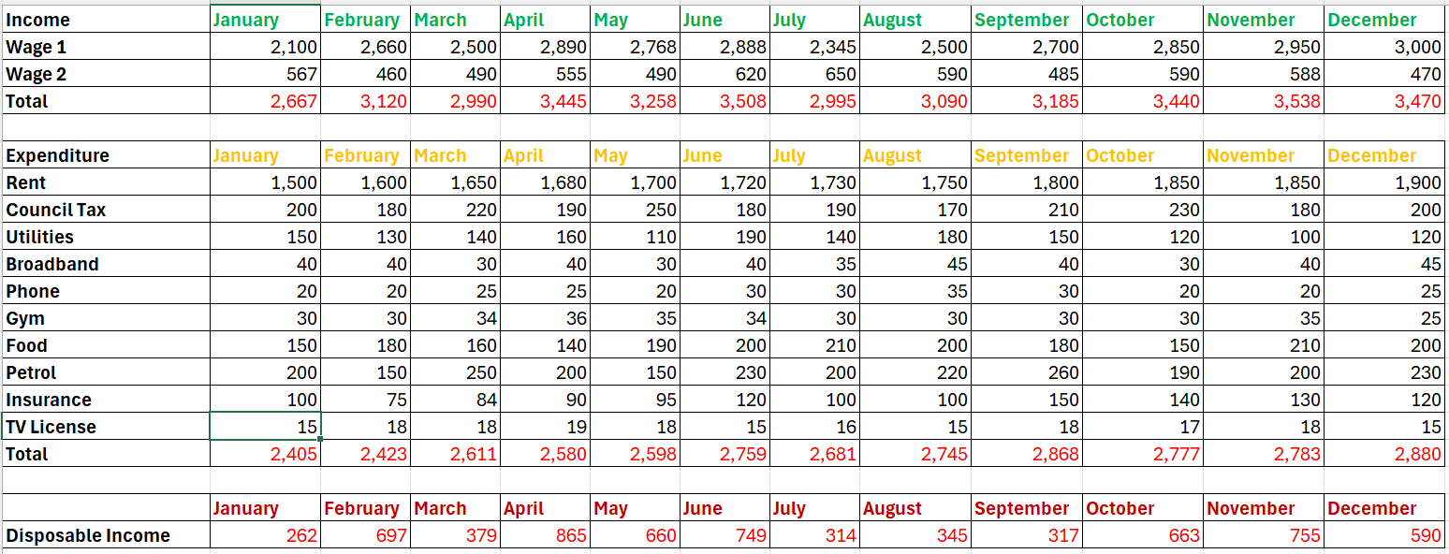

Reflection and Conclusion
Microsoft Excel remains an essential digital tool in both professional and personal life, despite rapid technological advancement such as formulas, pivot tables, charts and automation. Excel also extend across higher education and business operations. Students develop analytical thinking and digital confidence when they learn how to use Excel effectively.
In the table above, the household income and expenditure spreadsheet task demonstrates how Excel can be applied to real-world scenarios by combining technical skills with financial awareness, supporting both digital capability and personal responsibility.
Microsoft Excel is not only a spreadsheet application, but it's also a skill that supports me and helps me in my academic career and performance. It will enhance my future and prepare me for a professional environment were truth.

References
GeeksforGeeks (2025). Importance of Microsoft Excel in the Workplace (With Real-World Examples). Available at: https://www.geeksforgeeks.org/excel/importance-of-microsoft-excel-in-workplace/ (Accessed: 12 March 2026).
Plan Assist (2026) Excel vs EPM. Available at: https://theplanassist.com/excel-vs-epm (Accessed: 13 March 2026).
Santos, R. and Silva, P. (2022) ‘Spreadsheet literacy and student performance in higher education’, Journal of Digital Learning, 15(3), pp. 45–59.
Kavanagh, M. and Johnson, P. (2021) ‘Digital competencies for graduate employability: The role of Excel skills’, International Journal of Work-Integrated Learning, 22(4), pp. 321–335.
OECD (2023) Skills for the Digital Economy: Preparing Learners for Data-Driven Work. Paris: OECD Publishing.
Williams, T. (2024) ‘Spreadsheet proficiency as a core employability skill in modern organisations’, Business and Technology Review, 12(1), pp. 18–30.
Business Excel Insights (2023). Importance of Microsoft Excel in Business: 10 Reasons. Available at: https://www.example.com (Accessed: 13 March 2026).
AdvantEdge Training & Consulting (2024) Leveraging Excel for Data-Driven Decision Making. Available at: https://www.advantedgetraining.com (Accessed: 13 March 2026).

Task 4

5 Minute Reflective Presentation
Create a PowerPoint presentation using techniques learned in class, reflecting on the module and what you have learned.
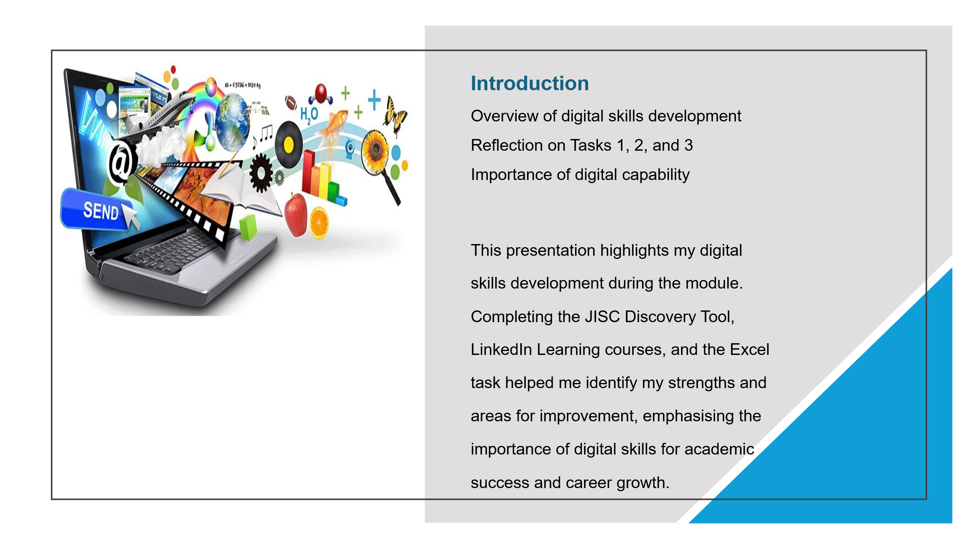
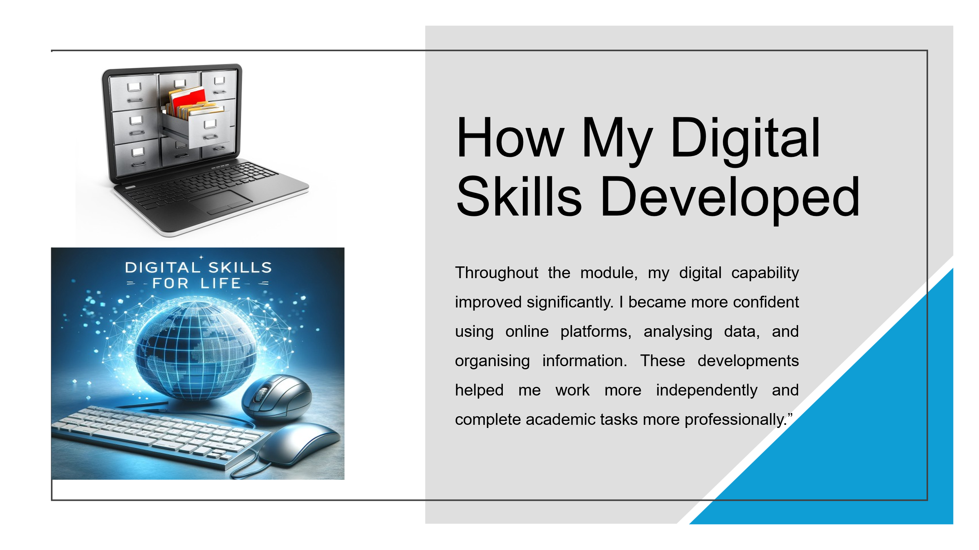
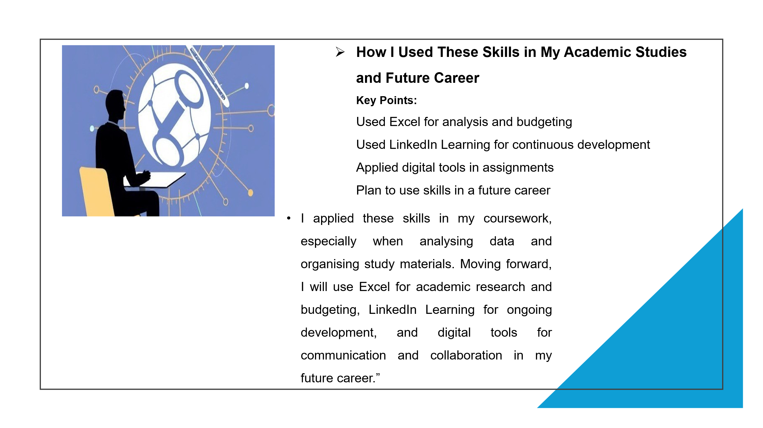
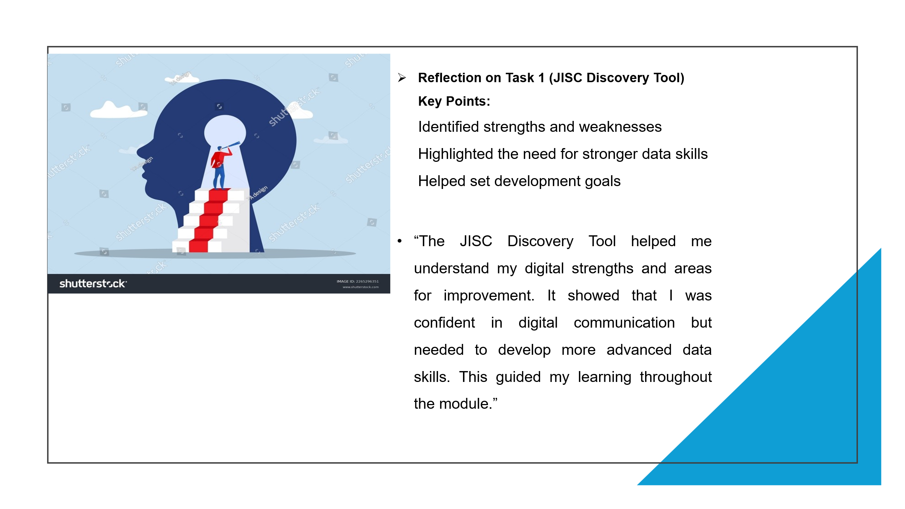
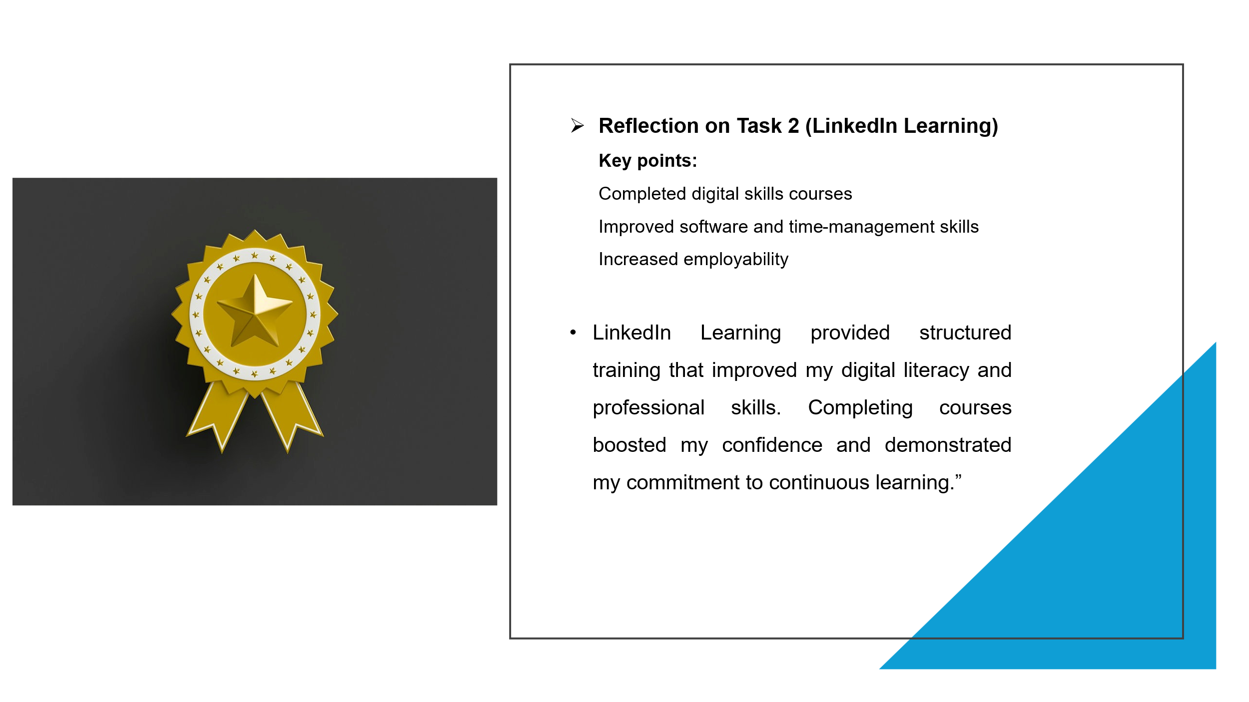
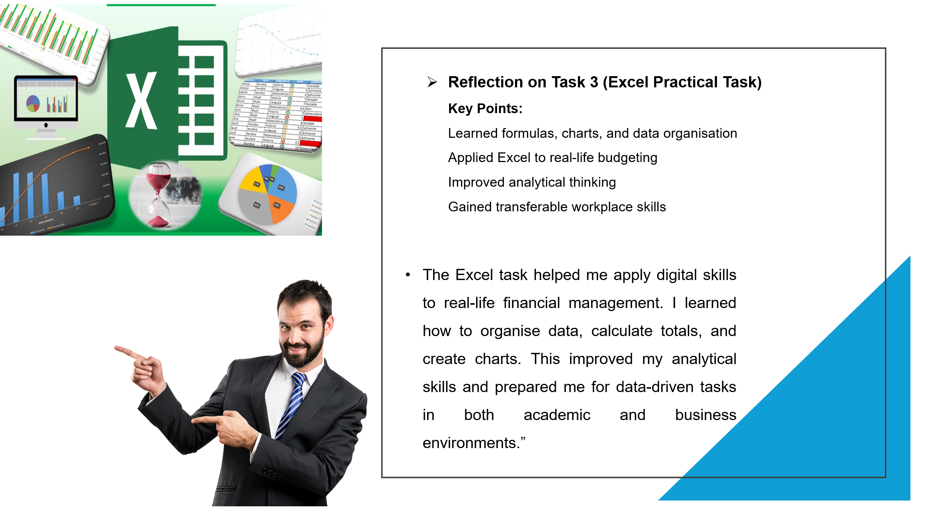
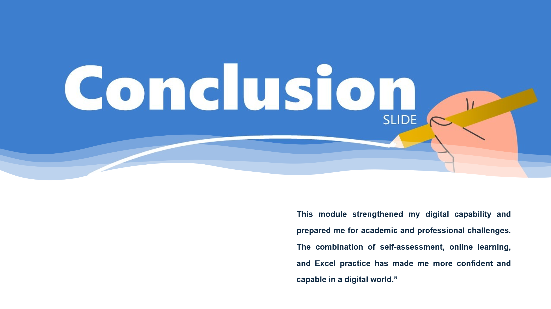
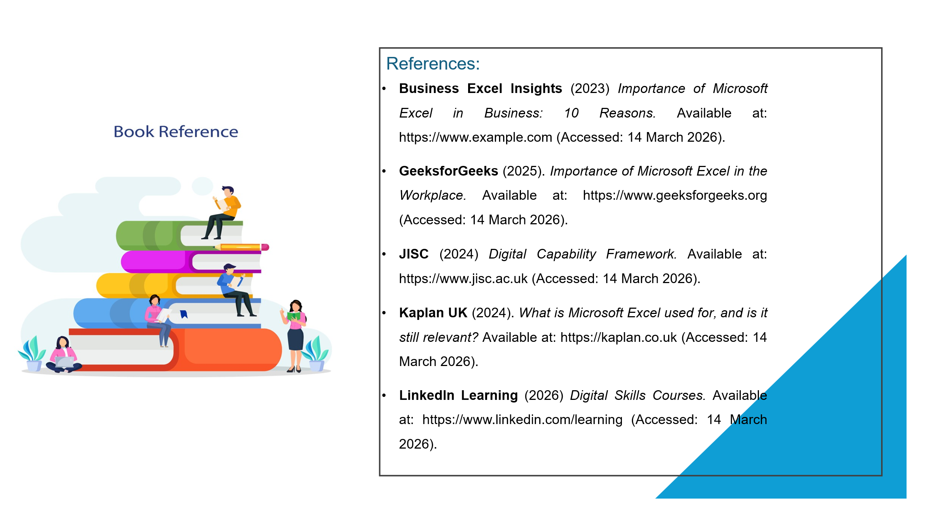
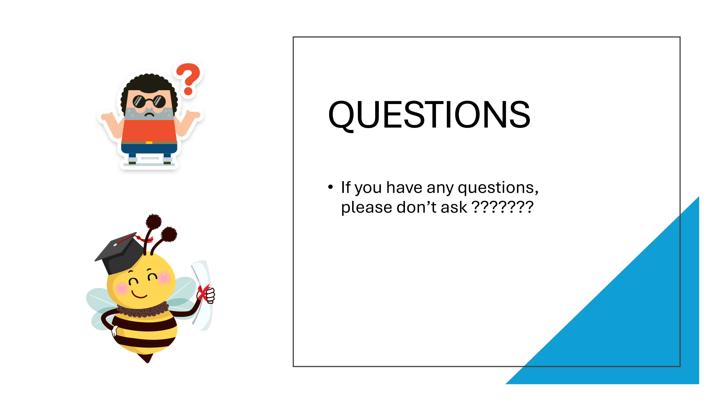
Embed PowerPoint here

References
- Business Excel Insights (2023) Importance of Microsoft Excel in Business: 10 Reasons. Available at: https://www.example.com (Accessed: 14 March 2026).
- GeeksforGeeks (2025). Importance of Microsoft Excel in the Workplace. Available at: https://www.geeksforgeeks.org (Accessed: 14 March 2026).
- JISC (2024) Digital Capability Framework. Available at: https://www.jisc.ac.uk (Accessed: 14 March 2026).
- Kaplan UK (2024). What is Microsoft Excel used for, and is it still relevant? Available at: https://kaplan.co.uk (Accessed: 14 March 2026).
- LinkedIn Learning (2026) Digital Skills Courses. Available at: https://www.linkedin.com/learning (Accessed: 14 March 2026).

