UNIVERSITY OF WALES TRINITY SAINT DAVID

Apple Inc.
Essay
On Global Business Environment( LCBB4005)
Student name: ANDREEA MAGOS
10/23/2020
Lecturer name: ERIC OSEI

Table of Contents

1.0 Introduction 2
1.1 History 2
1.1 Apple`s IPhone evolution 3
2.0 Business structure 4
3.0 Apple`s micro environment 4
4.0 Apple`s value chain 5
4.1 Primary activities 6
4.2 Support activities 7
5.0 Business globalization and PESTLE analysis 7
6.0 Deduction 10
7.0 Bibliography 11

APPLE INC.

1.0 Introduction

The purpose of this report is to explain in brief the historical backdrop of Apple Inc. what's more, investigate the inner and outer environment and hierarchical culture of Apple Inc. This report will also include a PESTLE analysis of the business and will point out its value chain.

1.1 History

Apple Inc. (AAPL) is a multinational, world’s leading electronics and phone brand. It has been founded in 1976 by Steve Jobs, Wozniak and Ronald Wayne and it is known for its size and revenue. Cook joined Apple in March 1998 as a senior vice president for worldwide operations, and then occupied the executive vice president position, for worldwide sales and operations. He has been promoted as chief executive on August 24, 2011, after Jobs' death in October of that year. Since 2011, Cook doubled the company’s revenue and profit, and increased Apple`s value on market from $348 billion to $1.9 trillion.
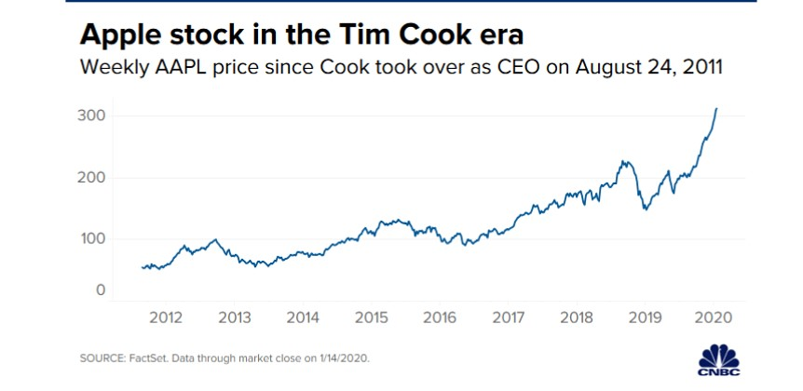
Fig.1 Source: FactSet

It has limited but out class products and designed with innovative technology. The most known products in their product line are: IPhone, Mac, IPad and other accessories. Apple also designs software and iOS operating system to improve its devices.
(Salazar, and Lunsford, 2014)

1.1 Apple`s IPhone evolution

The iPhone speaks to a significant crossroads in both the short history of versatile media and the long history of social advances. Like the Walkman of the 1980s, it denotes a crossroads where thoughts about personality, independence, way of life and sociality require re-articulation.( Hjorth, L., Burgess, J. and Richardson, I., 2012. )
IPhone’s operating system was released in 2007 under the name OS. It was the first operating system that used a multi touch interface and started the industry trend for touch only mobile devices but it did not support any third party applications. In 2008 the developers from Apple introduced the new Software Development Kit, which allowed the users to download and install free and paid applications and also allowed developers publish their Apps. Usage of mobile devices industry has changed since then and smartphones were no longer seen as devices used only by business people. IPhone became a mass market device which could be customized and upgraded to the latest technologies using the App Store applications.
In 2010, IPhone decided to change the name of its operating system from OS to IOS and it is currently used on to all range of products that Apple has on the market.
From 2007 and 2011, Apple has spent $647 million to advertise IPhone only in U.S.
In January 2012, Apple made 53% of its revenue by selling over 37 million IPhones worldwide.
Years that followed were successful for Apple as they released each year 2 or 3 phone generations with same technologies but different features, such as bigger touch screens, extra cameras, etc.
In 2017 with the launch of IPhone X they dubbed their facial recognition with another technology, “Face ID” (facial tracking). (Hjorth, L., Burgess, J. and Richardson, I., 2012.)

2.0 Business structure

Apple Inc. has a hierarchical organizational structure, with divisional elements and a weak functional matrix. The progression is a customary auxiliary element in business associations. The divisional qualities allude to the item based gathering inside Apple, for example, for iOS and macOS. The powerless practical lattice includes between divisional joint efforts, while the progression is saved. Apple’s business structure helps supporting business performance to ensure leadership in the industry, especially regard its competition: Samsung, Google Microsoft, and many other firms. The qualities of Apple's corporate structure:
-spoke and wheel hierarchy
-weak functional matrix
-product based divisions
Spoke and wheel hierarchy: The upper level (deepest level in the spoke-and-wheel hover) of the corporate structure has worked based gathering, which a component is gotten from the utilitarian sort of capacities. For instance, Apple has a senior VP for retail, and a senior VP for overall advertising. In this auxiliary element, the organization's top chiefs address business needs regarding business work regions.
Weak functional matrix: Apple Inc.’s. frail utilitarian network alludes to the community associations among different segments of the business. In a feeble useful grid, top administration decides venture bearing, while venture heads have restricted power and control. For instance, the corporate structure permits equipment groups to work together with programming groups. Thusly, the organization encourages data scattering that is vital for development measures. This basic component adds to viable and fast advancement measures, which are significant business quality.
Product based divisions: The upper and lower levels of Apple's corporate structure have item based divisions, which a component is gotten from the divisional kind of authoritative structure. There are senior VPs and VPs for various yields or items. For instance, Apple has a Senior Vice President for Software Engineering (iOS and macOS), a Senior Vice President for Hardware Engineering (Mac, iPhone, iPad and iPod), and a Senior Vice President for Hardware Technologies (equipment parts)
(Meyer, 2019)

3.0 Apple`s micro environment

Being one of the most valuable companies in the world, Apple uses Michael Porter`s Five Forces framework, which is a strategic management tool used to evaluate the forces that affect an organization: clients, providers, substitutes, new contestants, rivalry
Apple concentrates their efforts on 2 external factors to keep its leadership: competition and bargain power of buyers.
These forces can limit the firm’s revenue, profitability or market shares, including the business potential of development.
Based on Porter`s framework we can identify the following:
• Competitive contention or rivalry (Strong power)

- Has dodged esteemed based contention up to this point by remaining unendingly of low end markets

- Products never go set apart down

• Bargaining intensity of purchasers or clients (Strong power)

• Bargaining intensity of providers (Weak power)

- diminished the power of chip makers by making their own chip

- decreased force of producers, by buying manufacturing gear and simply allowing the equipment to be used for Apple things figuratively speaking.

- decreased the force of traders by expecting command over retailers and thing benefits through Apple Store.

• Threat of substitutes or replacement (Weak power)

- Mitigates the effect by explicitly making things which may replace iPhones or MacBook's.

• Threat of new path or new area (Moderate Force)

- Apple has a strong brand picture, progression and customer care, making it difficult for new hopefuls to battle with.

- Tim Cook's deftly chain authority is a mind boggling shield against low end break from new way. New path will encounter issues to battle or to beat the deftly chain cost structure. (Ferguson, 2019)

4.0 Apple`s value chain

Value chain is a strategic framework that can help a business to identify its activities that create can create value and competitive advantage to the business.(Porter,1985).

In Fig 2 we can observe and understand better Apple`s value chain: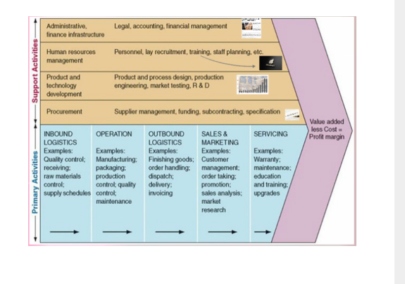
Fig.2
Source: Perpetualtravellers.com

4.1 Primary activities
- Inbound logistics:
With a very large supply chain, Apple benefits of a high bargain power by ensuring that quality standards are maintained. Its top 200 suppliers include component providers which represents 97% of its procurement expenditure. Most of its providers are located in China and Japan. Apple has also acquired methods to reduce storage demands and speed up the procurement procedure.

- Operations:
Manufacturing process is made especially in China where products are assembled, but it also take place is several other countries. Apple has also engaged in discussions with Indian government and production could possibly start there as well.
The cost of labour has been lower in Asian countries which reduced the cost of manufacturing. Beside this, Apple reduced its toxic substance usage and recyclable materials are used instead.
- Outbound logistics:
Apple`s distribution channel is composed by its direct and indirect channels from retail stores to online stores and also its own branded stores. Apple is known for eliminating wastage and using green packaging.
- Marketing and sales:
During all these years, Apple acquired a remarkable brand loyalty by its advertising strategy and creativity. Its marketing campaigns are posted not only via televisions and commercials but also on social media by creating different ads.
- Products and services:
Apple offers a vary range of products, services and support for customers. Most products are sold with a 90 day complementary support and 1 year warranty. Customers cans also chat with experts or call Apple for guidance. All products can be repaired at a local service provider authorized by Apple or in any of the brand stores.

4.2 Support activities

- Technology/Research development
Being a brand that is known for technological innovation it`s known that Apple spends large amounts of money on research and development. Since 2014, Apple has increased its research and development expenditure by higher than 5 billion.
- Human Resource Management
Apple is focused on hiring the best workforce and compensates its valuable employees with high wages. This has been the norm that Steve Jobs implemented, however on Cooks management, he has brought several changes, apart from inclusion and diversity, into the human resource policy and aimed to change Apple reputation.
- Procurement
Suppliers are required to provide the workers with safe working conditions and to provide high standard products and services.
- Infrastructure
The better the administration of firm`s foundation the higher the capacity of creating profit is one of Cooks visions. (Dudovskiy J., 2019)

5.0 Business globalization and PESTLE analysis

Globalization of economy has an impact on all countries by determining the expanding and distribution of technologies between all nations. Production and distribution of goods, use of labour and investments play an important part of the globalization of a business. The fundamental favourable circumstances of globalization are advancement of neighbourhood development by invigorating generally speaking development, making of higher levels of common trust, and advancement of worldwide money related framework. Then again, there are hardly any burdens of globalization, specifically it gives organizations more capacity to impact common government; it eliminates the accentuation of neighbourhood societies, less created nations are overlooked by created economies.( Nyamekye, R. and Tul, S.I., 2020.).
To demonstrate the factors that influence Apple`s macro environment, a PESTLE analysis is required. This framework is used to assess the effect of different factors such as:
-political
-monetary
-social
-technological
-ecological or environmental factors
-legal
(Rastogi, N.I.T.A.N.K. and Trivedi, M.K., 2016).

- Political factors
The recent trade war between China and US represents a political threat that affects Apple`s performance and market shares on Far East market. It can also affect Chinese consumer demand for smartphones and other services and products.
After a long lawsuit with Irish Government, Apple had to pay more than £5 billion in fines and taxes. Such political issues can affect a business financial performance. Political instability could also negatively influence Apple sales and supply chain.
- Economic factors
Economic growth rates in Asian countries are a great opportunity for Apple revenue and market share.
Apple production and profitability could be affected by increased labour costs; also the US dollar exchange rates could negatively affect the firm.
Pricing is one of the economic factors that affect Apple. By being a high end product market it is impossible to effectively enter on Asian markets like its competitors Samsung and Huawei which are offering relatively same technologies but lower on price.

- Social factors
Increasing mobile trends and social media also represents both opportunities and challenges to Apple.
Because of the tension between US and China, the brand image could be affected. Urbanization represents another favourable factor for Apple by increasing its sales and brand image as well.
- Technological factors
Most of Apples competitors are offering advanced tech products at affordable prices which negatively affects company`s brand image and financial status.
- Legal factors
Regulatory compliance is compulsory for Apple image or it can face lawsuits and fines for not complying with a nation laws.
By offering financial services Apple could face litigation lawsuits.
Apple Music use a vast range of products covered by intellectual property laws and the company is vulnerable to piracy.
- Environmental factors
Pollution is one of the side effects from manufacturing facilities from China, which is raising many concerns because of the increased environmental and health regulations. Usage of fossil fuel could increase China`s electricity rates and manufacturing costs for Apple.
Climate change represents another threat for Apple because it could affect or disrupt the overseas shipping.
Despite these challenges Apple should be able to thrive as it has demonstrated during the years its adaptability inside and outside its premises. (Khan, U.A., Alam, M.N. & Alam, S., 2015 pp.955-961)

6.0 Deduction

Apple has proved over the years that is one of the leading worldwide companies that adapt and designs new technologies by using their most valuable weapon: professional workforce and human resources. Despite all the challenges that recent condition such as COVID19 and the tensions between US and China ,Apple is still launching new products on the market with innovative designs and improved technologies and features. Even though its competition has better pricing, IPhone was able to create his own operating system loyalty base according to the latest market shares. (Appleinsider, 2020)

7.0 Bibliography

Appleinsider, 2020. Apple's Ios Sees Highest Share Of US Activations Since 2016, Report Says | Appleinsider. [online] AppleInsider. Available at: <https://appleinsider.com/articles/20/04/10/apples-ios-sees-highest-share-of-us-activations-since-2016-report-says> [Accessed 23 October 2020].
Dudovskiy, J., 2019. Apple Value Chain Analysis - Research-Methodology. [online] Research-Methodology. Available at: <https://research-methodology.net/apple-value-chain-analysis/> [Accessed 23 October 2020].
Ferguson, E., 2019. Apple Inc. Five Forces Analysis (Porter’S Model) - Panmore Institute. [online] Panmore Institute. Available at: <http://panmore.com/apple-inc-five-forces-analysis-porters-model-case-study#:~:text=Five%20Forces%20Analysis%20of%20Apple%20Inc.,-%E2%80%93%20Overview&text=Competitive%20rivalry%20or%20competition%3A%20Strong,or%20new%20entry%3A%20Moderate%20force> [Accessed 23 October 2020].
Hjorth, L., Burgess, J. and Richardson, I. eds., 2012. Studying mobile media: Cultural technologies, mobile communication, and the iPhone. Routledge.
Khan, U.A., Alam, M.N. and Alam, S., 2015. A critical analysis of internal and external environment of Apple Inc. International Journal of Economics, Commerce and Management, 3(6), pp.955-961.
Meyer, P., 2019. Apple Inc.’S Organizational Structure & Its Characteristics (An Analysis) - Panmore Institute. [online] Panmore Institute. Available at:<http://panmore.com/apple-inc-organizational-structure-features-pros-cons#:~:text=Apple%20Inc.%20has%20a%20hierarchical,as%20for%20iOS%20and%20macOS.> [Accessed 20 October 2020].
Nyamekye, R. and Tul, S.I., 2020. THE POSITIVE AND NEGATIVE INFLUENCE OF GLOBALIZATION ON THE ACTIVITIES OF INTERNATIONAL BUSINESS (BASED ON APPLE INC.).
Porter, M.E., 1985. Value chain. The Value Chain and Competitive advantage: creating and sustaining superior performance.
Rastogi, N.I.T.A.N.K. and Trivedi, M.K., 2016. PESTLE technique–a tool to identify external risks in construction projects. International Research Journal of Engineering and Technology (IRJET), 3(1), pp.384-388.
Salazar, F.J. and Lunsford, R., 2014. Onshoring: An i-Opener for Apple, Inc. International Journal of Trends in Economics Management & Technology (IJTEMT), 3(2).

