Data Analysis and visualisation
ACCB4002

Assessment 1

Lecturer: Student:
Koushik Modak Eduard Stefan
(2114821)

Contents
1. Introduction 3
2. Information presented on the infographic 3
3. Identifying the message 4
4. The way colours are used 4
5. The way text is used 4
6. Suitability of the graph 4
7. The way graphics are incorporated 4
8. Cognition 5
9. Improving the infographic 5
References 6

Introduction

Data analysis is a science of extracting insights from raw data. To better apply skills gained in this course we need to step out of the circle and look from a normal person point of view by keeping on eye on the best practices of infographics development process. An infographic purpose is to deliver information that are easy to digest for brains. Some studies have shown that you only have 5 to 7 seconds to capture someone’s attention so developing a good infographic has become a big challenge.
In this task I will analyse how an infographic is perceived by the audience, what visual impact has on the targeted viewers and how the message or the story of this infographic will change what people may think around the subject, if best practices of Data Visualization are in place and to provide ideas to improve.

Information presented on the infographic

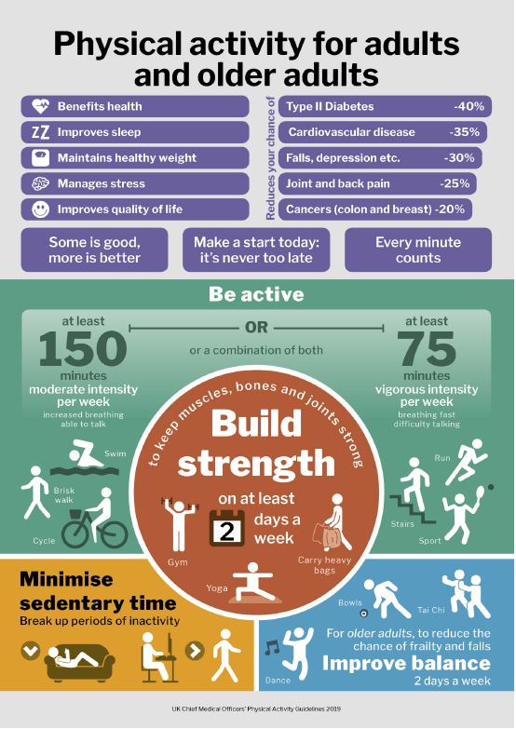
The infographic main title is Physical activity for adults and older adults and all information we find is related to this, benefits, disease impact, recommendations among with some minimum requirements to remain an active person and to bring positive results for personal health.

Identifying the message

In the infographic we have information about the health benefit of the physical activity, some minimum recommendations to achieve a positive impact over our bodies and ideas of activities to keep your active time on track. The target audience, adults and older adults, is presented in the title and all the information presented are related to this category. The information is the most important part of the infographic and developing and design with a balance between appeal and clarity it is the art of infographics.

The way colours are used

A number of 10 colours are used on this poster. They are well grouped and the fact that are not mixed over the whole poster makes data more readable. The variables are displayed in the same colour and some information have contrast colour used for better reading. Positive information should be presented in green, and text should have the same colour. Some graphics with same information category are displayed in different colours and can create confusion. Text colour should be kept the same or in the same colour range.

The way text is used

All the text is readable in A3 print format. The fonts and sizes of the text should be more varied, keeping the same or too similar font for the whole poster can be seen as a mistake. Valuable information should be in bigger size and for the same information text fonts must be slightly different using some contrast fonts.

Suitability of the graph

The graphs are easy to read mainly because they are well placed on the poster. The visual impact could be more powerful and attract the eye of any viewer before they realise if they are interested in the story presented or not. Colour used are not the recommended ones and using bar charts with horizontal orientation is not the most recommended practice. Also to make date more readable the informational text of percentage should be on the chart not inside.

The way graphics are incorporated

All graphics are providing information but even so some are blocking the information others are trying to provide by the way the were designed. The point of the infographic is informational first and design second. Looking at the poster we don’t have to spend time to look for the message, it is easily identifiable. Missing from the top or bottom is the logo of the owner. A logo can create a powerful impact over the message. The overall design is poor but using international sign of some sport activities can be a good manner to cross over cultural and language barriers.

Cognition

The information presented in the infographic doesn’t rise any unnecessary questions. Everything is presented in a good way to make it meaningful to readers. The power of infographics is that it keeps things short [1]. Instead of presenting your message in 3 or 4 pages of text the infographic can do the same in one page in few seconds. In the left top we have presented the list of benefits nearby charts representing chances to reduce some of the common diseases around the world. Worth knowing about the subject are the recommendation of how to stay active followed in the second section of the poster. Having only the minimum values doesn’t help without presenting the impact that not being active can create. The story has a narrative flow that carries the reader from one point to the next and the graphics are relatively designed according to how a reader proceed through the information.

Improving the infographic

A poor design could:
- Be visually unappealing
- Visualize data incorrectly
- Fail to visualize the relevant information
- Confuse the reader with too many visualizations
- Highlight the wrong attributes for the desired position
- Use an inappropriate design tone (such as, a fun, light-hearted design style when applying for a serious role)
- Not print correctly if not designed to fit standard paper sizes [2]

Identifying the message is the simplest and well managed part of the infographic. On all other categories is there something to improve. Starting with used colours on the chart bars. The infographic needs a theme of colours to be fit in but having charts, especially the positive ones should be in green. On the second section of the page using faded green and white text it leaves everything without contrast making information hard to read. On the other hand, in the left bottom section the text for the same kind of information is black creating confusion and using the same colour for the title and the information on the poster should be avoided. Using different font and sizes of the text is a good idea but not randomly spread over the poster without fallowing any pattern. The graph should be vertical oriented with some different colour according to the positive data presented. Information like percentage should be out of the chart and put it on the top of the chart. Graphics are poorly incorporated in the poster. The big brown circle being in middle makes the viewer think that he might find the most valuable information of the poster but is not the case. Missing a logo of the owner is another mistake. Having a logo of UK Chief Medical Officers will bring valuable credibility to the message that the infographic must provide. Any interested viewer would like to find some contrast information on the subject. Having only the good part can be meaningless if you don’t present in the same manner what is the outcome of not considering the message that the infographic must provide. The challenge for designers that want to make their infographics easy to understand is to include the data and information needed to communicate and support the key message, but eliminate everything else. [2]

References

[1] | J. Beegel, Infographics for Dummies, John Wiley & Sons, 2014.
[2] | R. Krum, Cool Infographics: Effective Communication with Data Visualization and Design, John Wiley & Sons, 2014.
[3] | J. R. R. C. Jason Lankow, Infographics: The Power of Visual Storytelling, John Wiley & Sons, 2012.
[4] | T. Murphy, Infographics Powered by SAS: Data Visualization Techniques for Business Reporting, SAS Institute, 2018.
[5] | M. Nigam, Data Analysis with Excel, BPB Publications, 2019.
[6] | H. H. G. S. Min Chen, Foundations of Data Visualization, Springer, 2020.

