Dafydd Whittington
ADAD4010

I will research three artists Nina Lindgren, Adela Andea and Amanda Tulacz as the work that they each will contribute will meet the regulations of my vision for the rationale, the impact humans have on earth. The concept will be an art exhibition on the moon to show showcase ‘out of this world art’. I will take pieces from my chosen artists that are extremely abstract, extraordinarily futuristic and include a space age critique. I have chosen to create an experience that will leave visitors, irrelevant of age, gender, creed or colour, questioning their own mortality and leave with the urgency and the drive to question they part that they play in Earth’s destruction. Furthermore, to convey a sense obligation to understand how those resources are used or abused and how they are then disposed of to uphold human and natures wellbeing. My motivation and rationale in selecting the moon, as a location, is to create a symbolic meaning by depicting the beauty of a virgin planet, still uncorrupted and pure. In contrast, looking back to earth, the planet we all call home, desperately dying, with its natural resources disappearing. The focus of my vision will be to create an emotive art exhibition, motivated by the causes and effects of our troubled fading planet. The intent and objective are to educate the audience whilst provoking subconscious thought and discussion at the awe-inspiring venue and arousing setting. This idealistic location will perfectly showcase the unique, futuristic, space age critique of many eclectic pieces. It is a fact, if we continue to extract and burn the fossil fuels from the heart of our planet, we will have to look for a new home. Many believe that we should be looking into outer space.
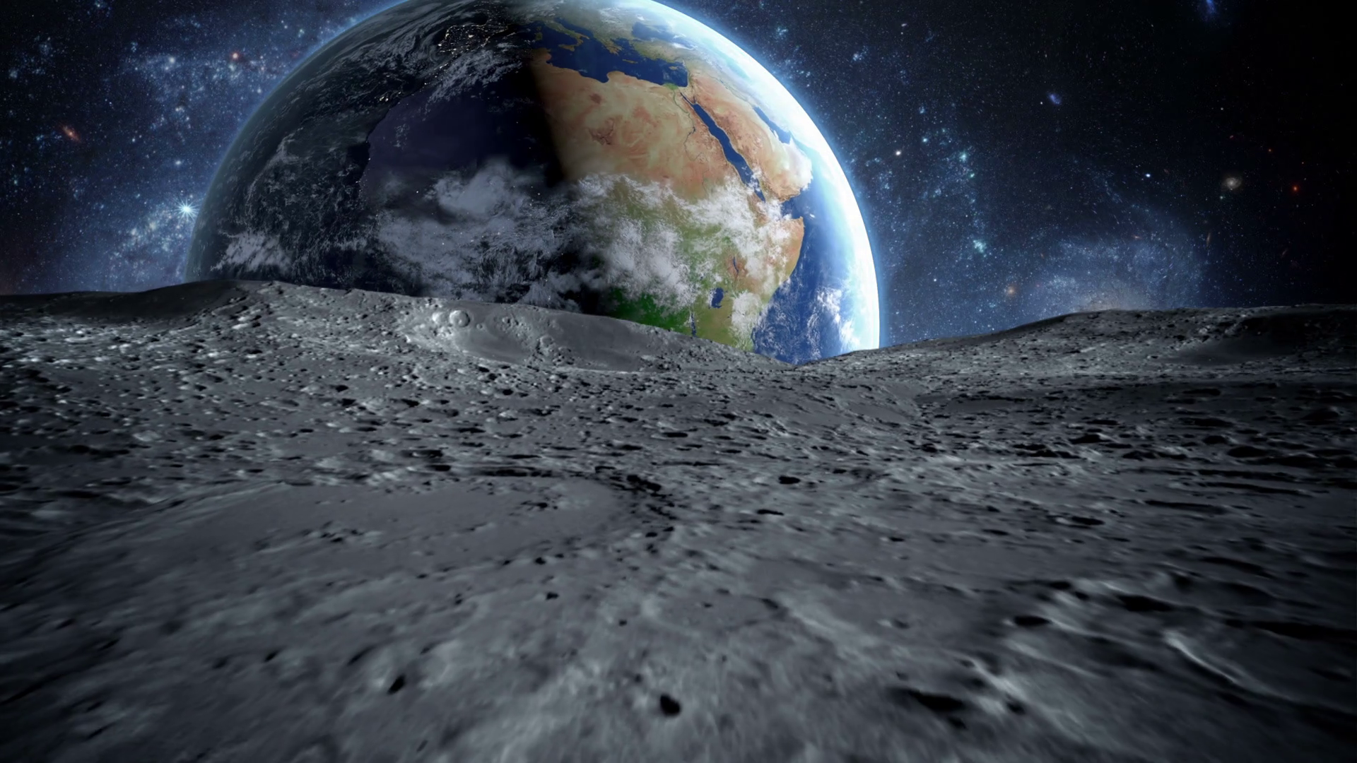

‘
Out of this world’.
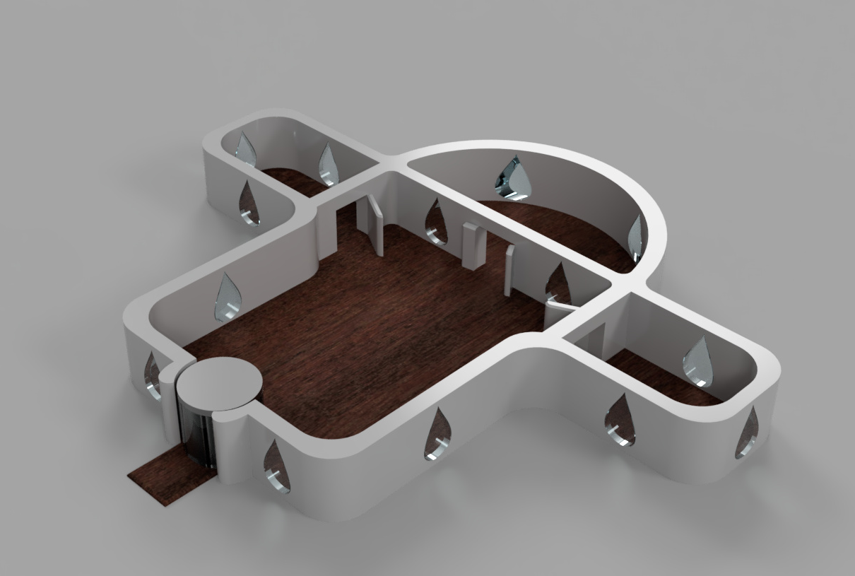
I have chosen the Moon as the perfect place as I believe this offers the visitors the ultimate, definitive view of earth.

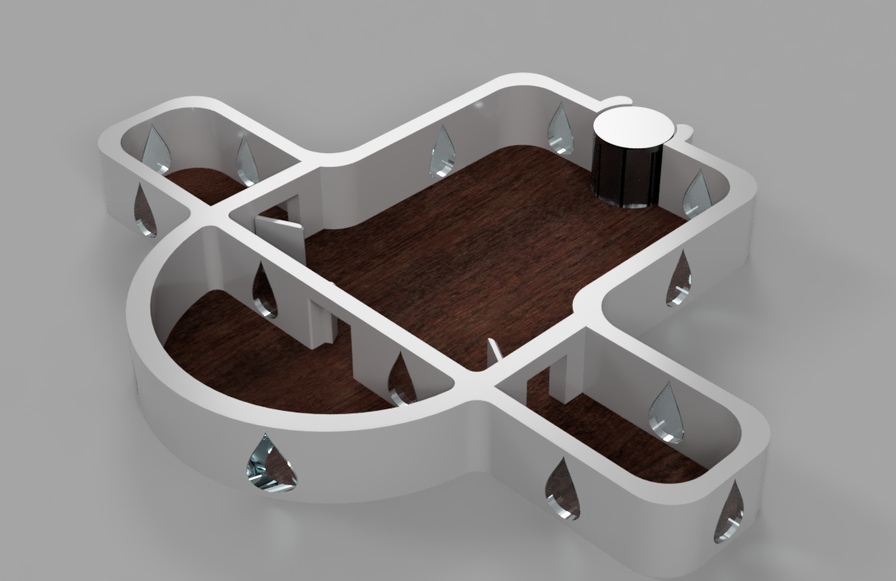

The structure housing the art exhibition will have
a central chamber enveloped by large significant tear drop glass windows. This will allow each and every visitor to view the Earth, at any given time, as the Moon orbits it.

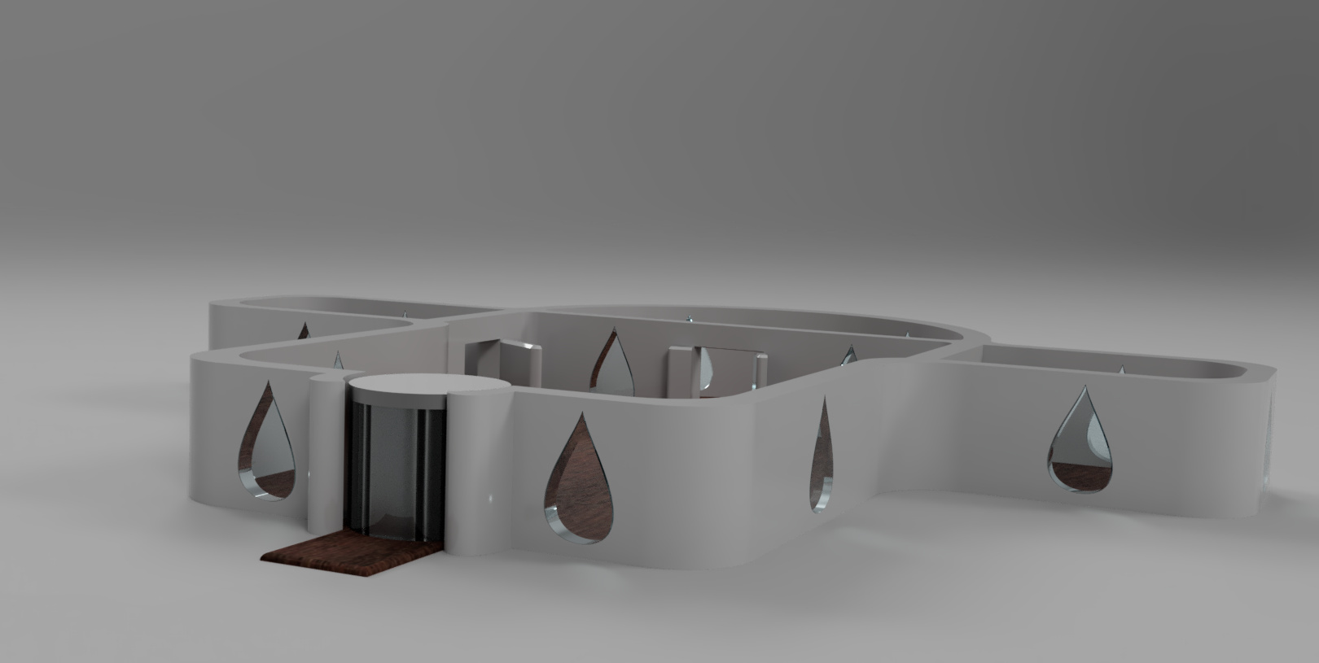
The tear drop windows provide a passionate symbol of the sorrow
of Earth’s demise and economic crisis. Many environmentalists,
researchers and scientists have
proven that Global Warming
is already a real predicament in today’s world. More worryingly they confidently predict with conviction that we are creating a catastrophic legacy for future generations.

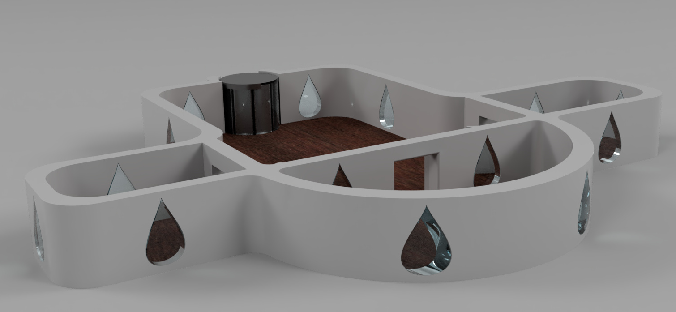
The Floor will be laid with recycled plastic painted to emulate oak. This is a powerful message that man is literally walking all over the very things we should be banning and protecting. Plastic in our oceans is disastrous, and throughout history the oak has always been portrayed as a tower of strength and wisdom.

It is all too easy for each individual to adopt the “I’m alright Jack” attitude. After all, the
issues of Global Warning won’t fully affect us. However, we each have a duty to future generations, just as our forefathers fought wars to protect us and give us a future, the decedents they would never know, we must fight Global Warming for our descendants.
To have a successful impact and achieve the desired results, advocates for Global
Warming need justifications and intentions beyond scientific facts to convince
the habitual unenlightened public.

Facts
Global temperature increasing by 0.8°C since 1880.

NASA records show increase in sea level by 3.3mm every year.

A typical passenger vehicle emits about 4.6 metric tons of carbon dioxide annually.
https://www.nasa.gov/

NASA’s First Crew For Commercial Space Travel
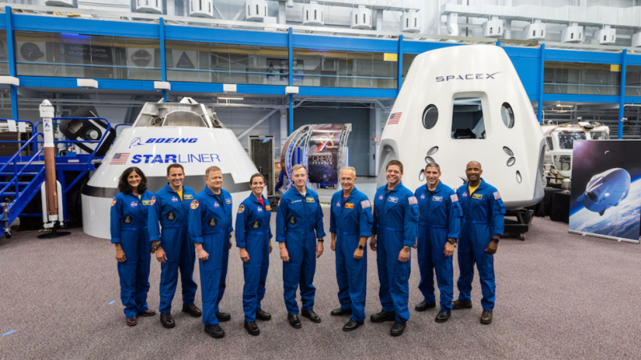
Photo of the space x crew accessed on the 1/4/19
https://www.google.com/search?biw=1440&bih=789&tbm=isch&sa=1&ei=pNa9XMv8MaKEjLsPxZ2R6AQ&q=space+x+commercial+travel&oq=space+x+commercial+travel&gs_l=img.3..0i10i24.14857.22198..22559...7.0..0.139.1326.25j1......1....1..gws-wiz-img.......0j0i10j0i8i10i30j0i8i30j0i10i30j0i30.0S-Vufrhs-o#imgrc=KJKdutI94bmHrM:

After years of training and preparation 2018 saw NASA reveal its first commercial crew program. This will enable private companies’ such as the Space Launch Systems and SpaceX
to explore their own space flight capabilities. In 2002, the South African-born American entrepreneur and businessman, Elon Musk founded SpaceX.

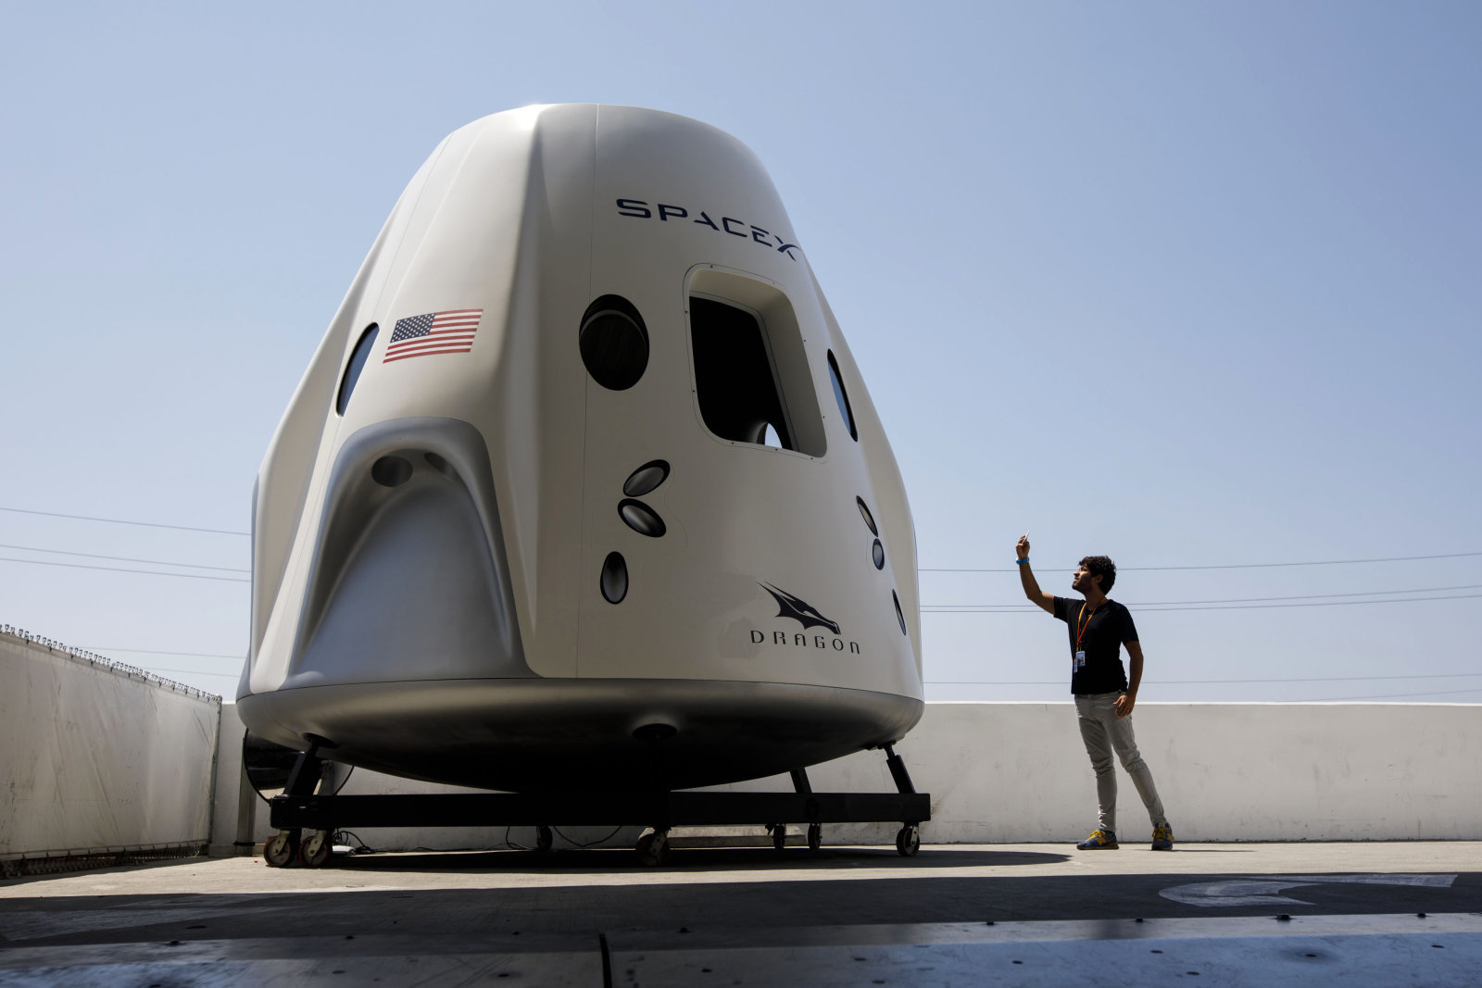
Elon Musk’s vision for the future of the space programme was to offer everyone, the accessibility and the realistic means to travel to or live on any planet they desire. At SpaceX his engineers have designed and made reality a free flying spacecraft that they have called the ‘Dragon’. The space craft is specifically engineered to transport passengers and cargo to any given location. Uniquely, the Dragon is the only spacecraft able to return to Earth with adequate amounts of cargo and not just passengers.

Photo of the space X dragon accessed on 1/4/19
https://www.wired.com/story/this-year-spacex-made-us-all-believe-in-reusable-rockets/

Visitors to my art exhibition will be able to pre-book and then embark on a SpaceX Taxi at several designated large cities around Britain, that will then take them directly to the launch site of the Dragon.

SpaxeX’s technology systems that can deliver, and transport explorers and scientist will energise innovation and inspire imaginations. They have the ingenuity and resourcefulness
to address any challenges in order to see the human race habitat the moon. Pushing further to see the seemingly elusive mission to also land on Mars a reality. The current success of the International Space station has proven that with a common interest we can effectively and fruitfully co-operate on a global level.

The prospect of holidaying on Mars excites and entices the next generation of enthusiastic budding students, keen to excel at maths and the sciences so they can be the at the cutting edge of environmental and space revolution and discovery. Is this enough however to convert mankind’s rational to leave their home planet and embrace intergalactic exploration, the premise of Sci-Fi films, to reap the possibilities of a new sustainable future civilization.

The history of space travel’s disputes and debates generate copious perspectives of the argument. In particular, the lack of a coherent, convincing, clear proposal for human exploration and habitation of Mars the Moon and beyond. Much of the focus is on the scientific reasons for going or not going. In reality science will have a restricted influence on human quest and thirst for knowledge and exploration.

The American aerospace engineer Robert Zubrin criticizes the capabilities of robots and is an established activist of human exploration of Mars, over the fact that robots provide a significant degree of scientific return, are far more cost effective and with no risk to human life. Mars, being the closest planet to Earth, has always been a source of inspiration and inquisitive need for explorers and scientists. It is well documented that robotic missions have successfully found water on Mars, and that it has many qualities and a chronological account similar to Earth's, yet they have still failed to prove without doubt that human life could be sustained there. Conversely though there are noticeable anomalies still to be figured out.

It must also be remembered the utter cost involved for commercial human exploration of Mars. “You know, point out some of the riches on Mars to me, if you would,” Zubrin said. “I’m at a loss as to know what we could bring back that would begin to compensate for the cost of going to get it.”

The quest for more will never leave us, our own morality and curiosity will continue to drive us to explore the undiscovered, drive the restrictions of science and then drive beyond. As humans we are still uneasy and apprehensive about our insignificant status in the momentous Universe and many theologists dismiss the simple basis of the history of our solar system based on science. Overcoming the challenges faced in human space exploration are conceiving greater technology ideas, establishing new industries, and nurturing connections through race creed and religion.

Artists that I have chosen for the exhibition and why I believe they will offer a significant and relevant contribution.

The silent film of 1927 “Metropolis” gave
“Metropolis” by Nina Lindgren.
Nina Lindgren, is an illustrator, printmaker
and artist, the vision and creativity to build this floating structure from cardboard. It
resembles the futuristic urban hillside dystopia, with internal auxiliary lighting to be representative of habitation.

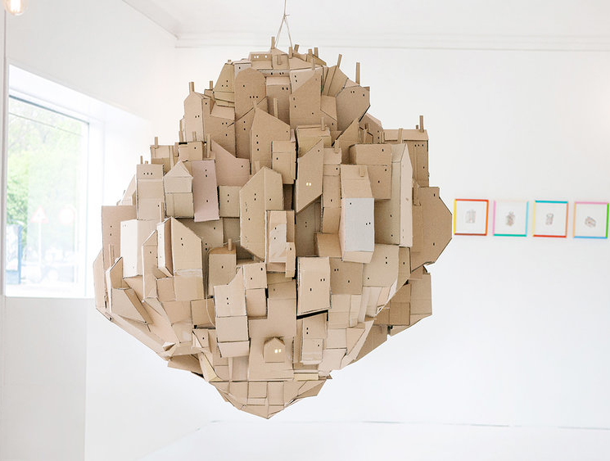

Photo of Nina Lindgren’s artwork accessed on the 1/04/19
https://inhabitat.com/nina-lindgrens-cardboard-floating-city-looks-like-a-futuristic-movie-cityscape/

All her resources and materials are entirely recycled, salvaged and free from toxins.
Nina created this design in the present inspired by the past to represent the future.
This epitomises, symbolises and embodies the ethos of my exhibition.

Explosive Light-Based Installation art by Adela Andea

Romanian artist Adela creates revolutionary, futuristic light installations. This imposing piece

in particular emerges effortlessly, yet explosively from above. Her manipulation and fusion

of LED lights, magnifying lenses, and flex neon, tumble seemingly haphazardly into space. Although Adela utilises modern man-made sources to power her conceptions, each element

is attentively inspired by natures spectacles and wonders such as bioluminescent sea life, melting icebergs, and cosmological events. These are the very essence of the things that the

art exhibition is try to preserve and safe.

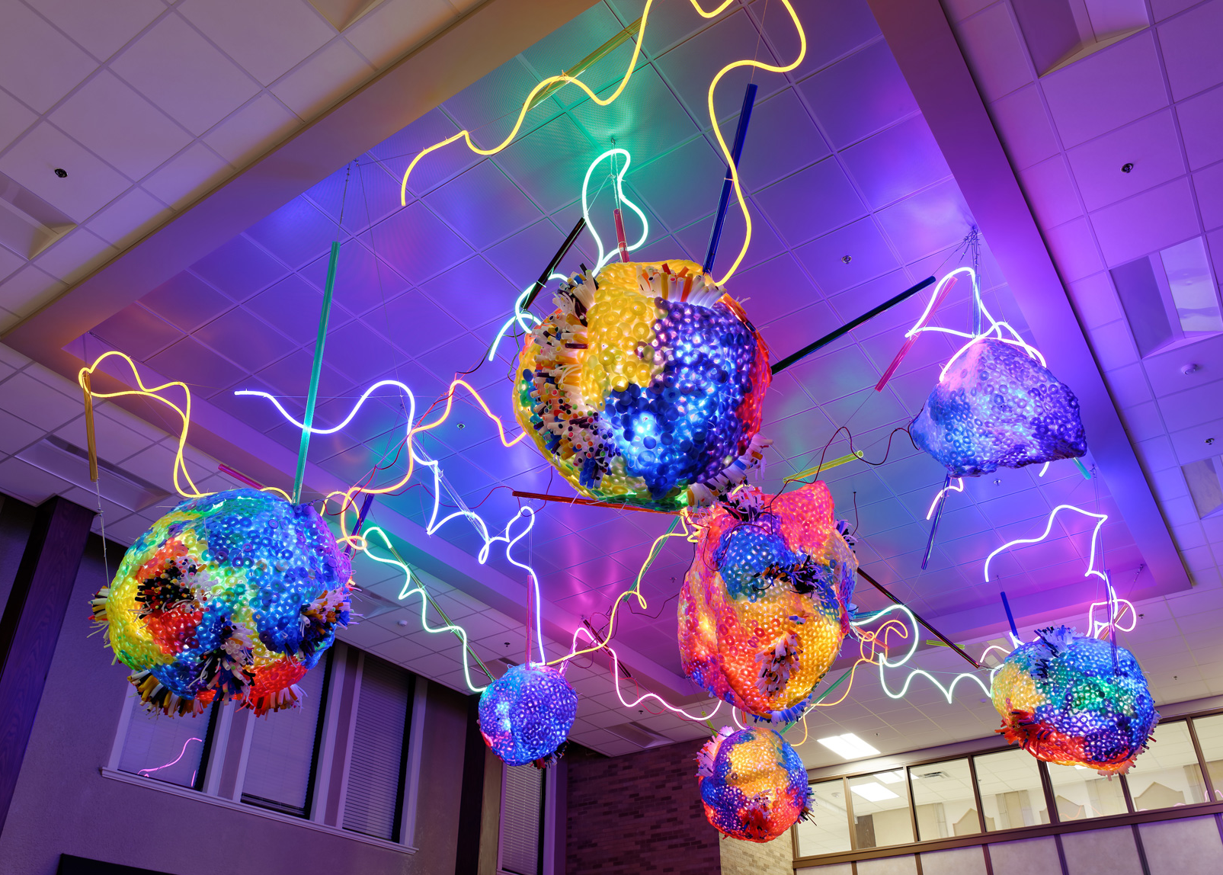
Photo of Adela Andea’s artwork accessed on the 1/04/19
https://www.google.com/imghp?hl=EN

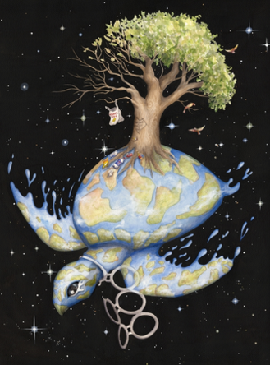

Amanda Tulacz

Amanda is an American artist and illustrator. She produces various pieces of works in every medium, from traditional to digital and currently favours acrylic paint. She is an idyllic artist to exhibit at my exhibition as her work is layered with interpretable, symbolic, representational elements that incite the viewer to contemplate and question, what they are seeing and why.

This piece perfectly demonstrates the depth of her passion and understanding of the current state of our planet. Her ethos and spirit make her a perfect artist to contribute to my exhibition

Photo of Amanda Tulacz’s artwork accessed on the 1/04/19
https://www.amandatulacz.com/

In conclusion I want to create an experience that will leave everyone that attends, irrelevant of age, gender, creed or colour, with the urgency and the drive to question where our resources come from and go to and to uphold human and natures wellbeing.
I will just leave you with this thought to consider;

Do we need to look after our own planet before we go and destroy another?

Biblography

Jeff Foust- http://www.thespacereview.com/article/98/2
https://www.spacex.com/dragon
https://www.amandatulacz.com/
https://www.redbubble.com/people/thecosmicartist/works/25378509-endangered-global-warming-and-climate-change?cat_context=u-prints&finish=metallic&grid_pos=6&p=photographic-print&rbs=a3244f97-9d4c-4829-873d-9d7f592a3c7e&ref=shop_grid&searchTerm=save%20the%20planet%20prints&size=x_large
http://www.thespacereview.com/article/98/2
https://www.nasa.gov
https://climate.nasa.gov/causes/

