
Reflection Report
BMSW4005 Re-Work Professional Career Development Component 1

June 12, 2020
University of Wales Trinity Saint David

ALEXANDRU-GEORGE GHITA
1912879

Executive Summary

The purpose of the report is to share my reflection on what I learned from the professional career development module. The report will include my understanding of the course, how I can advance in my professional career, how I can apply the teachings during the course at work but at the same time how I can apply them in everyday life. What SMART goals I identified? What learning styles questionnaires I used?
Why employability skills are important and how can I use them to develop my professional career?
Employability skills are important for my journey in the development of my professional career climbing the hierarchical ladder of the company because it develops my skills, improving my knowledge, understanding and performance at work but also how to analyse a situation and implement a solution.

Table of Contents
Executive Summary 1
Terms of Reference 3
Procedure 4
Introduction 5
Findings 6
Conclusion 9
References/Bibliography 10
Appendices 11

Terms of Reference

The report was requested by the evaluation committee of University of Wales Trinity Saint David Cardiff on 12 of June 2020.
The purpose of the report is to share my reflection on what I learned from the professional career development module. The report will include my understanding of the course, how I can advance in my professional career, how I can apply the teachings during the course at work but at the same time how I can apply them in everyday life. What SMART goals I identified? What learning styles questionnaires I used?
The report was compiled by Alexandru-George Ghita, student of University of Wales Trinity Saint David in Cardiff.

Procedure

The procedure I used to prepare this report was through an in-depth understanding of the multitude of information accumulated throughout the module, through various techniques and learning style questionnaires, but also through the information accumulated from books, websites and journals.

Introduction

In the introduction, I will present a brief explanation about what I think professional career development is and why I think it is important.
And also, I will discuss why employability skills are important.
I will start with a definition of what I believe to be professional career development and why it is important in my journey for professional advancement.
In my opinion, professional career development is a set of abilities acquired and improved over time through different situations encountered, training, but which can also be improved through courses.
This abilities set is also called employability skills.
Employability abilities are those abilities which will help you to be good at what you do as an employee and which will help you advance in your career.
This set of abilities is increasingly sought after, both by employers who want their employees to be as beneficial and efficient as possible for and within the company, and by employees who already work within the company to promote professionally and by future employees who will bring a plus to the companies by exempting them from investing their time and money.
This set of abilities is important for my journey in the development of my professional career climbing the hierarchical ladder of the company because it develops my s abilities, improving my knowledge, understanding and performance at work but also how to analyse a situation and implement a solution.

Findings

During the professional career development module, I learned a lot of useful things about myself and put names on things that I already knew about myself. But I also learned how to develop my abilities by improving my knowledge, understanding and performance at work but also how to analyse a situation and implement a solution.
During the module, I learned different styles and tactics that will help me progress in the future as an employee, improving my employability abilities can help me better understand the business environment. How can innovative thinking help you make a successful business? How do you exploit the sales market and the labour market? How can you improve it? What are you looking for? What pluses can you add to be successful? What are you looking for today? Where can you expand to be more successful without competitors?
This being the main purpose of my participation in this module and in the Skills for the Workplace course.
I will begin by talking about the first tools learned in this module. These are used to identify learning styles.
I will start by talking about the first tools learned in this module, these are the VARK learning questionnaire and the Honey and Mumford learning questionnaire.
After completing two learning style questionnaires, I found out what learning style I prefer and what they are called.
I will now discuss the first learning style questionnaire called Honey and Mumford.
This questionnaire is composed of four characteristics: Activist, Reflector, Theorist and Pragmatist.
After completing the questionnaire, my dominant learning style is Reflector.
A reflective person is a person who does not want to stand out in a group. Who likes to listen, observe and analyse the situation from several perspectives. Reflectors are people who appreciate working with experienced people from whom they can learn. They are not in a hurry to make hasty decisions until they have all the information and think about it in all perspectives ahead.
Knowing what type of learner, I am I realize why in a group and even in a classroom, I prefer to sit in the back,
Another learning style questionnaire is VARK, which is short for Visual, Auditory, Read/Write and Kinesthetic.
After completing the questionnaire, my dominant learning style is Kinesthetic. Result that did not surprise me at all. I prefer to learn through practice.
Next, I will talk about two other tools that have been useful to me, these are SWOT analysis and Smart criteria.
SWOT is the abbreviation for strengths, weaknesses, opportunities and threats.
Smart is the abbreviation from specific, measurable, assignable, realistic and time-based.
Next, I will talk about two other tools that have been useful to me, these are SWOT analysis and Smart criteria.
SWOT is the abbreviation for strengths, weaknesses, opportunities and threats.
Smart is the abbreviation from specific, measurable, assignable, realistic and time-based.
After using SWOT analysis to identify threats, I created a personal development plan to improve my threats using Smart criteria.
Below I will highlight the swot analysis.
My strengths: I am a good team worker, a fast learner, a good listener, reliable person and digital competences.
My weaknesses: I have poor communication skills; I am self-critical and disorganized.
Opportunities: with the digital era growing and more dependent on technology my digital competencies are increasingly sought after.
Threats: my biggest threat is speaking in public.
Before I jump to the personal development plan using SMART analysis I would like to talk about my threat.
At the beginning of this module, when I learned what smart analysis is and what it is used for, I had the false idea that public speaking is just a weakness of mine and not a threat.
In the skills for the workplace course, in the Academic and Employability Skills module which is a module connected to the Professional career development module, one of the assignments was to write a report and a summary of the report about a study case using the PowerPoint presentation in class.
For the PowerPoint presentation, we were assigned to work in teams, although we were a team each one was marked individually for their own work, this being good because, for example, if a team member did not do his or hers work did not pull the whole team down.
In the morning with the PowerPoint presentation, we made a copy of the PowerPoint presentation for lecturers for an easier follow-up of us, this assignment resulted in marking our presentation.
I took only one copy with me, thinking that I would use it during the presentation because I had put the presentation on a USB stick.
Before the presentation began, the lecturers asked for copies, then I started to get agitated, but not scared because I had read the summary at home and made drafts to get an idea in case something unforeseen could happen, which it did.
However, until it was our turn, I was not scared by public speaking because I was repeating in my mind the key points I had put on my drafts.
I can say that I was lucky because my team and I were the fourth or fifth team to present the case study.
Seeing that the time was approaching for our team to pass in front of the class and make the presentation of the case study, I began to tremble, more hands and feet, to blush in the face when the last member of the previous team finished the presentation and we had to go and we make the presentation in front of the class I barely managed to get up from the chair because I could no longer feel my legs.
My luck was with a colleague, although he also had emotions. His approach to this situation was through jokes, this helped me to control my emotions and to be able to continue.
Arriving in front of the class with the team, I was "lucky" to be the first to start the presentation, this did not help because the accumulated emotions overwhelmed me, I started sweating, blushing in my face, due to panic caused by the presentation of the case study in front of the class and the Lecturers for a few seconds I felt like I could not breathe anymore, I started to see black, my legs started to let go and I actually got stuck, I forgot everything I had learned at home from the drafts.
Once again I was lucky with my colleague who, although he was also petrified by emotions, saw that I was getting stuck, started talking to me and even gave me an elbow to get me out of the state that had taken over me, this helped me a lot.
Following the threat identification, I devised a personal development plan to remove public speaking from the threat list, using SMART.
The purpose of this plan for the beginning is to make public speaking no longer a threat.
So that this threat is no longer a threat, I will take the following actions: I will start by repeating in front of the mirror, family and friends and I will ask them for feedback. I will try to have more confidence in myself.
Good resources to become more confident and reduce the panic of public speaking are friends and family. Thus, other resources are online research and books. Engage more in talking to people.
A well-developed plan must contain a specific time, just like a job: so, I decided to spend twice a week, Monday morning and Tuesday evening, spending half an hour in front of mirrors repeating.
And I decided to make a presentation in front of the family four times a month, on Sunday.
This plan is designed for six months, during which time I can improve my public speaking.
Reaching my goal, I can advance both personally and professionally.
One thing that I find funny and worrying is the fact that, after graduating from high school, I became unemployed for six months, but in order to benefit from financial assistance, the condition was to choose a field and make a qualification. Because my qualification at the end of high school was in IT, I could not choose another course offered by the Job center in the same field and I chose customer relationship. It seems that although I have a qualification in this field, it did not matter much.

Conclusion

In conclusion, I would like to emphasize that due to the events and the fact that this course helps me to improve my employability skills, I decided to do something about the threats that may prevent me from advancing on the hierarchical path as an employee.
With the help of the tools provided in the module, I can have the chance to improve my qualities as an employee and to strengthen my confidence.
During this module but also in the other modules included in the Skills for the workplace course, I was able to assess my personal character along with my strengths and weaknesses, but I was able to develop the necessary skills and knowledge that are sought and that are constantly changing. This module helps me adjust and improve my skills in such a way that I can adapt faster because it gives me a perspective on the future.
The knowledge gained in the module gives me a unique inner perspective, this being useful in the future when I open my own business.
With the help of SWOT analysis, I was able to identify my strengths, opportunities, weaknesses and threats.
Using SMART objectives provided me with an opportunity to transform the threat into weakness at first and in time will become a strength, by conceiving a plan that will help me personally as well as professionally.
The lesson I learned by neglecting a weakness that turned into a threat, made me review the other weaknesses identified following the SWOT analysis. I will continue to study and develop a plan for each weakness that will help me develop professionally.

As an old Latin proverb says "Repetitio mater studiorum est", meaning "Repetition is the mother of learning".

References/Bibliography

- Source: Albert S. Humphrey in the 1960s, American business and management consultant who specialised in organisational management and cultural change
- Belbin,R. Meredith, Management Teams: Why They Succed or Fail. Butterworth Heinemann, 3rd ed., 2010
- Cohen, L., Manion, L. and Morrison, K., 2013. Research methods in education. routledge.
- Easterby-Smith, M., Thorpe, R. and Jackson, P.R., 2012. Management research. Sage.
- Belbin, R.M., 2012. Team roles at work. Routledge.
- Cassidy, K., 2007. Tuckman revisited: Proposing a new model of group development for practitioners.
- Senior, C., Cubbidge, R., Riebe, L., Roepen, D., Santarelli, B. and Marchioro, G., 2010. Teamwork: effectively teaching an employability skill. Education+ Training.
- Stuart, F.I., 1991. Purchasing in an R&D environment: effective teamwork in busines. International Journal of Purchasing and Materials Management, 27(4), pp.29-34.
- Youth Employment Review UK. (2017) A review of frameworks, common terms and research currently being used to define and determine employability skills in the UK.
- Yorke, M. (2004) Employability in Higher Education: what is it – what is not. 1st edn. UK: The Higher Education Academy and The Enhancing Student Employability Co-ordination Team.
- Harvey, L., Moon, S., and Geali, V. with Bower R. (1997) Graduates’ work: organisation change and students’ attributes. Birmingham: Centre for research into Quaity together with the Association of Graduate Recruiters.

Appendices
In this report I use SMART objectives, SWOT analysis, The VARK questionnaire, Honey and Mumford questionnaire.

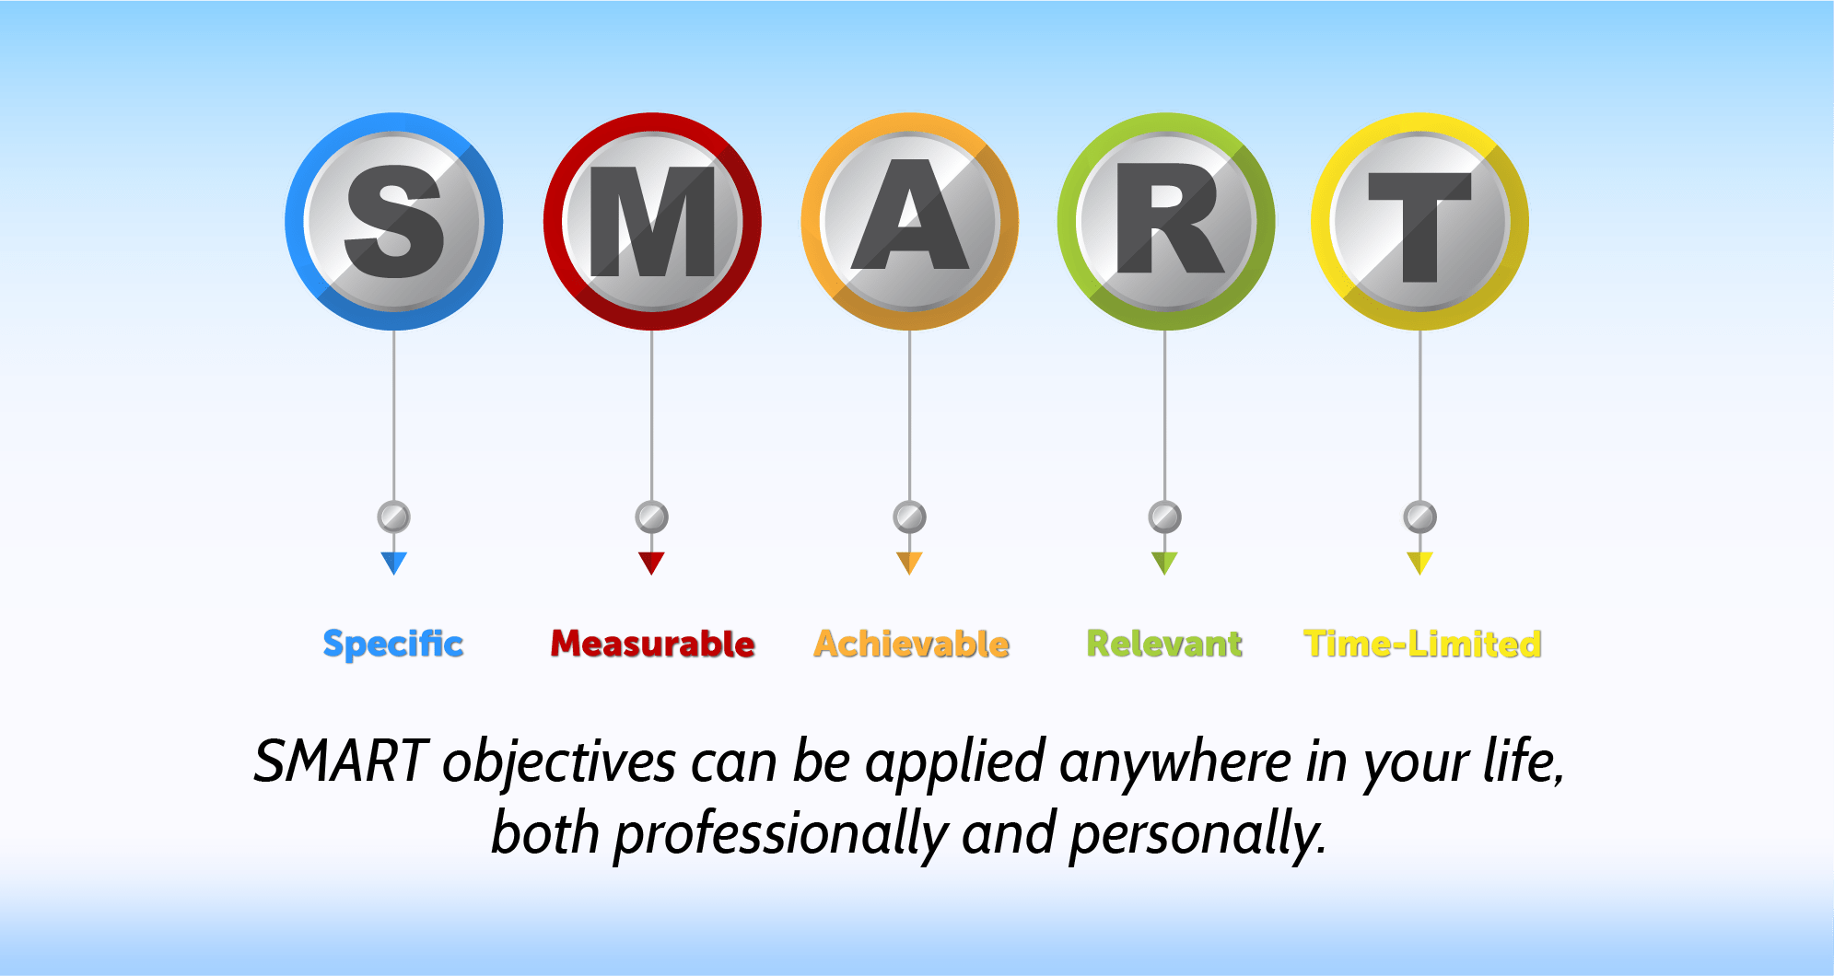

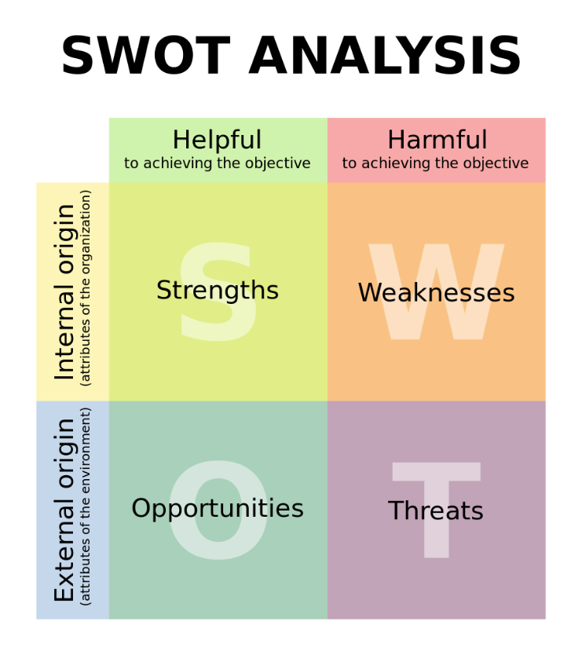
Source: Albert S. Humphrey in the 1960s
American business and management consultant who specialised in organisational management and cultural change

