Certificate of Higher Education in Skills for the Workplace
Rosen Agushev
1818403
BMSW4004 Problem Solving and Decision Making
Lecturer: Yajesh Kumar
Date: 22/04/2020

Table of Contents
1. Introduction 3
Part 1: Problem at Workplace 3
1.1 Chosen Problem 3
1.2 Reasons of the problem 3
1.3 Advantages/disadvantages of your chosen problem 3
1.4 How to overcome/resolve the problem 4
1.5 My experience of the problem at workplace 4
1.6 Seven steps to problem solving 4
Part 2: Decision Making 5
2.1 Types of decisions 5
2.2 Factors affecting decision making 5
2.3 Ingredients of good decision making 5
2.4 Fishbone Diagram 6
2.5 SWOT Analysis 6
Part 3: Solution 7
3.1 Proposed Solution 1 7
3.2 Proposed Solution 2 7
3.3 Evaluation of the proposed solutions 7
Part 4: Implementation 7
4.1 Implementation plan for the proposed solution 7
4.2 Monitor and review of implementation plan 7
Conclusion 8
References 9
Power Point Presentation 10

1. Introduction
The purpose of this report is to find a specific problem in a given work environment and how it can be solved by performing some of the problem-solving techniques. The specific work environment that will be discussing in this report is Retail. This report will examine the given situation and suggest variety of solutions that can help resolve the raised problem. Some of the techniques that are discussed in this report are Fishbone analysis, SWOT Analysis, Force Field Analysis and Brainstorming.

Part 1: Problem at Workplace

1.1 Chosen Problem
One of the main problems that is faced in many workplaces are Shortage of staff. This problem has a major impact on the success and performance of all businesses. The most struggling industry with this issue is the retail industry. In the retail industry it is essential to have enough staff present to avoid losing sales and to deal with theft.

1.2 Reasons of the problem
Shortage of staff is a very fundamental problem faced by retail businesses and it needs to be dealt effectively for the businesses to do well and sustain in the market. The main goal of any business is to make profit and to make profit they need to have enough sales. Therefore, it is crucial to have enough staff to represent the company and to be able to provide an exceptional service to customers, as this helps with sales and clientele, which leads to making profit. Also, not having enough staff to cover the shop floor, gives shop lifters an opportunity to steal, which of course can lead to business losing on profits. In many, companies’ short of staff often leads to uncompleted daily tasks, which also affects the business’s overall performance. Hence, it is essential for business to have enough people working in order for it to be able to make profit.

1.3 Advantages/disadvantages of your chosen problem
Shortage of staff has advantages and disadvantages for the company. One of the advantage of having small staff turnover is it’s cost saving, as companies are able to save on recruitment process which can cost a company time and money which can be invested in the business for a greater turnover in sales. Another, advantage is that companies can solve the problem strategically, for example in retail they can move around staff to the area which makes better sale than the area which has a lower sale, this helps staff with learning new skills by moving around and saves company money by not hiring more staff. Many businesses do compromise this aspect of the business in order to have more budget available for other propositions of the business. It leads to many disadvantages for the company. The biggest disadvantage of understaffing is that the product and service quality suffer. As small number of staff is expected to do many tasks in a small amount of time which can lead to errors, poor quality over time devalues a company’s reputation and drives away customers. Another, disadvantage of small staff turnover is that it can lead to low morale among employees as present employees are faced with increased workload which can add stress and lead to poor performance.

1.4 How to overcome/resolve the problem
Shortage of staff is a problem that can be resolved without causing businesses any loss. As, we know hiring more staff means payroll costs increases which can lead to company not making any profit or to break-even. One of the ways that a company can have enough staff without increasing the cost is by offering internships to young people. This is a cost-effective way as many young people like to gain experience and are willing to do it for free sometimes, This is beneficial in a long run for the company because internees can be used to fill future positions in the company and as they are already part of the company, it saves company money in recruitment.

1.5 My experience of the problem at workplace
In my experience I have also dealt with staff shortage at my workplace and I have seen how it affects so negatively on individuals as well as the business. It has led to a lot of stress in the team members as tasks are uncompleted, which leads to staff staying behind after working hours and not getting paid. Staff is not only who suffers from shortage, customers are also affected as there are not enough people present to serve them which causes frustration in some customers, which makes them cause drama by taking their anger out on staff or either they don’t go ahead with the sale as they are not provided with the service which they expect. This has happened many times at my workplace and has caused negative sales.

1.6 Seven steps to problem solving
The first step to solve a problem is to identify it. Once the problem has been identified, then it is time to move to the next step which is understanding everyone’s interests. The second step is very important because all individual opinions should be taken in account to find a solution that works for everyone. The third step is to list the possible solutions. In the fourth step options are evaluated and weighed by looking at the pros and cons of them. In the fifth step the best option/s that works in everyone’s interest is carefully chosen. The sixth step is to document the selected option/s by writing it down. The final seventh step is to agree on contingencies, monitoring and evaluation which can help with making sure the problem does not occur again and to monitor if some adjustments need to be made. (Hicks, 2018)

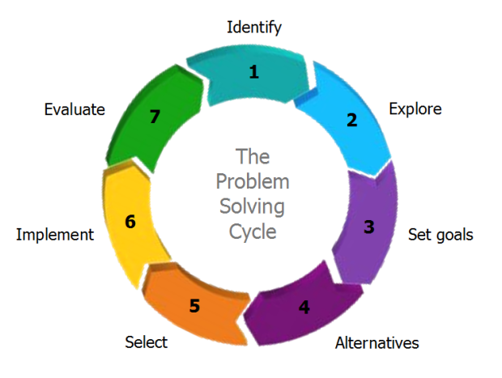

Part 2: Decision Making

2.1 Types of decisions
There are 3 main types of decisions. The first type of decision is strategic. Strategic decisions are the decisions that concern the whole firm including the operation, resources and the employees. (Juneja, 2017) The second type of decision is tactical. Tactical decisions are usually medium-term decision that last up to 1 year. They are usually planned to fulfil and implement the strategic decisions (Balaman, 2019). The third main type of decision is operational. They are made to manage day to day business (Bhasin, 2017).

2.2 Factors affecting decision making
Some of the factors that affect decision making are past experiences, age and individual differences. In decision making past experience is an important factor, as people tend not to repeat things in which they have not succeeded in the past, therefore past failures can be future successes. Age is also a factor in decision making, as younger people tend to make quick and spontaneous decisions without examining the situation fully whereas older individuals can make more cautious and wise decisions due to their experiences. Another factor is individual differences, as many people who work together come from different experiences and work ethics, this can cause problems as different people have different visions of the things, which can sometimes create a challenge with taking the right decision. (Dietrich, 2010)

2.3 Ingredients of good decision making
Some of the ingredients for good decision making are high-quality data, access to advanced systems, confirmation and flexibility. High-quality data is important because the better data acquired the easier it is to make good decisions accordingly. When using advanced systems, a person is prompt to obtain even more high-quality data that can help make the right decision. Confirmation is an essential ingredient when making good decisions as more opinions the bigger the chances are of making the right decision. Finally, flexibility is an important ingredient as the world changes, we have to adapt with it to make better suited decisions. (Elliott, 2007)

Decision making pyramid (Srinivas, 2015):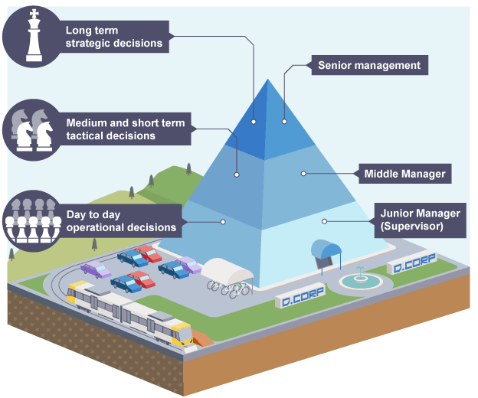

2.4 Fishbone Diagram
Cause
Effect
Profit
Lower pay
Annual leave
Recruitment cost
Cut down payroll cost
Sudden resignations
Poor management of rotas
Less hiring to reduce the cost.

Shortage of staff

2.5 SWOT Analysis

SWOT

Strengths
- Increases profit
- More money available for different ventures
- Less time spent in hiring

Weaknesses
- Lower Morale in staff
- Lower customer satisfaction
- Errors in tasks

Opportunities
- Staff can learn more skills
- Business expansion with more profits

Threats
- Resignations
- Stress among team members
- Sales loss

Part 3: Solution

3.1 Proposed Solution 1
The first solution that can help solve the situation with the shortage of staff in retail is to hire more people who can support the departments. When hiring experienced people that can perform multiple tasks at once will make the work process easier. However, hiring more staff members might be exceeding the budget, but it is going to contribute to the overall success, and it will also boost sells, as more employees will be able to engage with their clients. This will also create a more friendly and welcoming environment as employees will not be put under pressure.

3.2 Proposed Solution 2
The second solution that will help with the lack of team members is to create an internship. This will help with the situation, but the risk is higher as the people wanting the job will not be as experienced due to lack of work experience. On the other hand, it is the better option if the business is low on budget as internship wages are lower than normal salaries. However, a lot of student and young people will be interested as this helps them attain the desirable experience, they want to pursue their dream careers.

3.3 Evaluation of the proposed solutions
Both options will work well and will support the success of the business. The first solution is safer than the second one, but the second option may be the right one, as some of the people that will want to do the internship might one day decide to stay in the company and if they do they will be already qualified and experienced. In my opinion the second solution is the better option as it is an investment in the company.

Part 4: Implementation

4.1 Implementation plan for the proposed solution
The proposed solution can be implemented by opening an internship vacancy for students and people with no experience who are trying to get into the retail industry. The vacancy will be posted online and also emailed to universities in which students study fashion, this way it will be easier to find the right people for the job. Assessment centres will be carried out to find people who will be passionate about the job and also able to integrate in the work environment. When someone is successful at the assessment centre, they will be called for a one to one interview, in which they will have to prove that they really want the job and also get familiar with managers. Be conducting the one to one interview managers will be able to get to know the people applying for the job.

4.2 Monitor and review of implementation plan
The implementation plan can be monitored by receiving feedback from customers and also more experienced members of the staff to ensure that internship staff gets on with their tasks and meet department targets. Their performance will be reviewed monthly by the line manager to ensure that they are meeting department targets. Reviewing their performance will be carried out by completing evaluation forms. Another procedure that will be done is to give the internship employees a 3-month probation period in which they will have to prove to the management that they can handle the stressful work environment.

Conclusion
In conclusion staff shortage is a massive problem within the retail industry, but it can be resolved easily with the right action plan. By performing some of the problem-solving techniques it will simplify the problem and make it easier to find the right solution. It is essential to make the right decision when solving problems as wrong decisions can make the situation even worse, which can lead to money loss and it can also affect the reputation of the company.

References

Balaman Sebnem (2019) Science Direct Available at: https://www.citethisforme.com/ (Accessed 27 April 2020)

Bhasin Hitesh (2017) Marketing91 Available at: https://www.marketing91.com/operational-decisions/ (Accessed 27 April 2020)
Dietrich Cindy (2010) INQUIERIES Available at: http://www.inquiriesjournal.com/articles/180/decision-making-factors-that-influence-decision-making-heuristics-used-and-decision-outcomes (Accessed 27 April 2020)
Elliot Timo (2007) Timo Elliott’s Blog Available at: https://timoelliott.com/blog/2007/09/the_5_ingredients_of_good_deci.html (Accessed 27 April 2020)
Hicks Tom (2018) Mediate Available at: https://www.mediate.com/articles/thicks.cfm (Accessed 27 April 2020)

Juneja Prachi (2017) Management Study Guide
Available at: https://www.managementstudyguide.com/strategic-decisions.htm (Accessed 27 April 2020)

Srinivas Hari (2015) CDRC Research Available at: http://www.gdrc.org/decision/pyramid.html (Accessed 29 April 2020)

Power Point Presentation




