Contents Page

Page number | Contents
1 | Contents Page
2 | Task 1
3 | Promoting Welsh planning sheet
4 | Task 2
4-7 | Task 3
8 | Appendix
9-10 | Bibliography

Task One

The lesson was based upon the text ‘Hwyl yn y parc yn y haf’, a level three book in the Fflic and Fflac series of resources aimed primarily at teaching Welsh as a second-language (LearnCymru, 2018). It was presented to a year two class in an English-medium school.

The book was selected as it contains a suitable ability level of Welsh-language text for their linguistic attainment. It enables the children to ‘progressively develop’ their Welsh-language skills by ‘building upon and increasing’ their ‘previous knowledge and experiences’ from the Foundation Phase (WAG, 2015, p.36). Furthermore, I had observed children were very engaged with the books and characters from previous titles in the series.

The learning objective of the reading session was to be able to discuss a Welsh-language book using Welsh. A priority of the school’s Welsh development plan is to increase reading levels of Welsh-language texts within each year group (TreUchafPrimarySchool, 2019). The text was used to introduce whole-class guided reading with Welsh-language texts. Vygotsky (Bates, 2016) would support the use of this structure to scaffold learners as the class were familiar with the strategy from regular English-medium sessions. The children’s Welsh reading, oracy, listening and thinking skills will be extended further following the story through an role-play Welsh-language conversation focus task based upon the text.

Firstly, throughout the session the trainee will use an audio-lingual style approach by asking questions about the text using the school’s Year two language patterns alongside incidental Welsh to support language learning and retention (Cook, 2008). The Foundation Phase Framework (WAG, 2015, p.36) supports this approach stating ‘children should listen to Welsh being spoken and respond appropriately in familiar situations’. Secondly, the sandwich method will be used at times to ensure children understand what is spoken whilst maintaining a high-level of exposure to the Welsh language. Furthermore, elements of a Total Physical Response (TPR) style approach, which connects speech with a physical action, will be used by introducing movements or actions to support language acquisition (Richards and Rodgers, 2001).
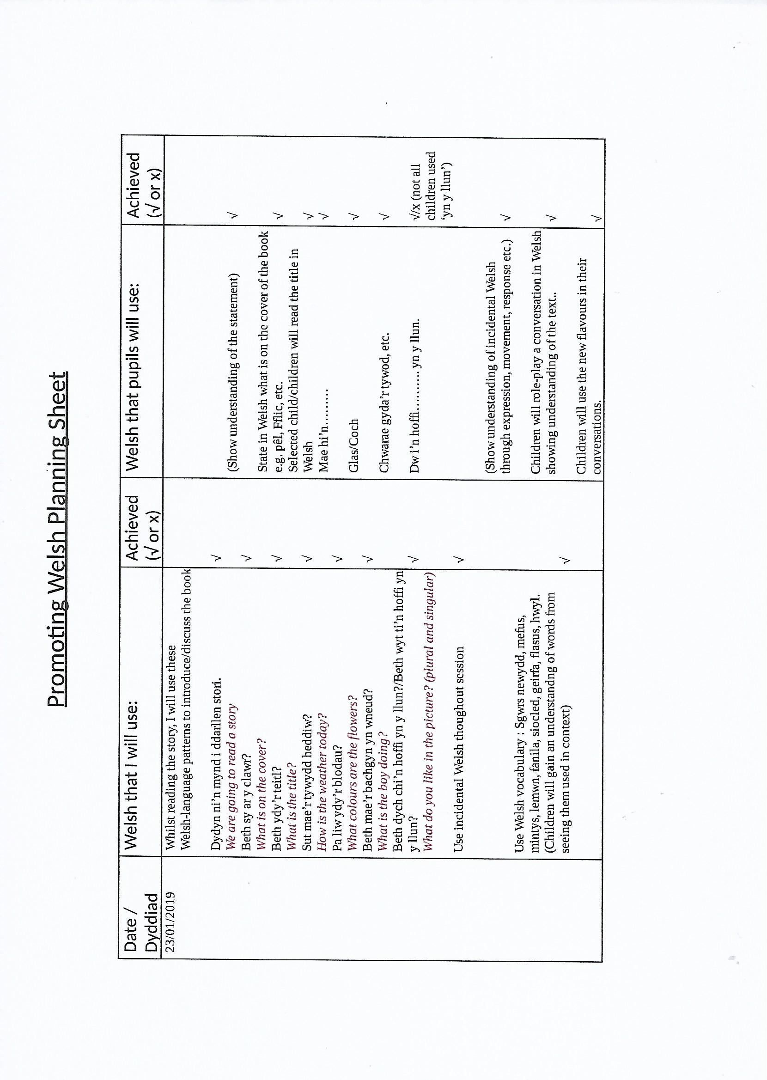

Task Two
Video is available at the link below:
https://youtu.be/qasOWWUIrQE

Task Three

Firstly, prior to the task I prepared a PowerPoint presentation (Appendix 1) to support the lesson with questions and images of the text’s pages. The purpose was to present written Welsh to the children to promote Welsh-language reading and increase familiarity with questions and furthermore ensure that all children could see the pages of the book. Fleming’s VARK model (Bates, 2016) would support this strategy as it caters for a variety of learning styles namely; visual, auditory and reading. Moreover, the Powerpoint presentation supported my own language teaching and the audio-lingual structure of the session.

There was a small typographical error on the Powerpoint presentation that I wasn’t aware of during the session. The children’s exposure to this was minimised as I was able to correctly model the question orally however, this is not acceptable and it is vital I check all my work thoroughly before it is used with the children.

Upon reflection, the Powerpoint was an effective resource and the children were engaged and interacted with it throughout the session. However, I feel the Powerpoint could have been improved further by including sentence substitution patterns on the slide to help scaffold and structure their answer and develop Welsh reading skills further. Palmer (Cook, 2008, p264) supports the use of a substitution style strategy as it ‘allows the students to create new sentences’. I observed that all of the children during the session were able to answer the questions demonstrating a good understanding of both the text and teacher question. However, many children were unable to answer in full sentences without teacher support. By including the sentence substitution patterns for the answers I believe their answers would have been more independent and learners would gain a greater sense of accomplishment. This scaffolding would be temporary support that could be removed or adapted as the learner gains confidence through exposure.

Secondly, for my focus task activity I prepared differentiated individual role-play conversation scripts and ice-cream cone resources and used toy money to progress the learning. Social constructivism theory (Bates, 2016) would support this learning approach as the children’s Welsh language knowledge will be further enhanced through their interaction with others. Their Welsh reading skills were developed during the role play conversation as pupils had to read and role play a conversation from a script whilst offered linguistic support from the trainee. During the role-play conversation, the children needed some teacher support with using the props at the correct time although this improved as the session went on. This indicated to me a lack of understanding of the text at first. On reflection, I could have supported the children by including images alongside the new vocabulary in the script, such as a coin image by the word arian to promote more active learning. Cook (2008, p57) supports this audio-visual approach highlighting this method can help organise new vocabulary and link it to ‘existing information in the mind’ The use of approach would have supported the children’s word association language development children without the use of an English translation, increased understanding and whilst giving a visual representation to the new vocabulary.

During the session, children were asked guided reading style questions about the text. Guided reading is when teacher provides support to the learners to ‘guide them through the text’ to highlight important and helpful features (Hobsbaum, Gamble and Reedy, 2002, p.2). The aim is to develop Welsh reading skills that can be used during independent reading. The children were already familiar with similar guided reading style questions from regular English-language sessions although this was not previously used in Welsh due to class teacher confidence. Given there was a wide range of abilities within the class, Assessment for Learning strategies were vital to ensure an inclusive approach. I used effective differentiated questioning and used their responses to assess their learning and understanding. This assessment is essential to inform future planning of future sessions.

Throughout the task, I used the Sandwich method of language teaching by saying a phase in Welsh, then English then Welsh again. Dodson (1972) supports this method of bilingual language teaching as it ensures the children understand whilst maintaining a high level of Welsh-language exposure; English is then gradually removed over time. However, Dodson (1972) further highlights learner may become reliant upon their mother tongue. I will have to ensure a range of kinaesthetic active language learning experiences such as TPR alongside the sandwich method to ensure the children develop their Welsh effectively and to minimise English reliance.

During the session, I used elements of Asher’s (Richards and Rodgers, 2001) TPR style approach. I used some actions whilst reading the text, such as rubbing my stomach when saying ‘Mae’n flasus’. During the task, I observed that this approach helped the children remember and understand the meaning of the vocabulary. Furthermore, it supported my language teaching without the need for English translation. Upon reflection, I feel this approach could be expanded upon to support Welsh-language learning further. If I were to read the book to the children again, to move the learning on I would introduce more actions and movements for the various words and phases which would help engage the children and support story understanding and retention. Corbett (2019, p.1) supports the use of a similar kinaesthetic approach when reading to help learners ‘internalise the text’ enabling them to use its elements in their extended work such as their writing.

Through careful planning, the learning was made purposeful by relating it to everyday situations in which the children could use the language. Donaldson (2015, p.108) highlights there should be a ‘greater focus’ on children’s ‘ability to communicate confidently in everyday settings in the Welsh language’. By learning how to to expressing likes, comment upon the weather or ask for something the children will grow in confidence and gain transferable skills that can potentially be use at home, in the community or their future workplace. Furthermore, these skills will continue to be developed daily at school through the use of drilling during ‘Helpwr heddiw’ and ‘slot drilio’ sessions to support automatic recall (Cook, 2008).

During the lesson, whilst reading the book one of the children pointed at the colour wheel on my Powerpoint presentation and incorrectly called it mefus. I was able to correct him with ease from my own knowledge of Welsh vocabulary and realise that he meant enfys (rainbow). However I feel I could have supported this learning further by adding a small song, such as lliwiau’r enfys, in to support the retention of the vocabulary. Hallam (2010, p272) highlights that the use of singing and music supports the learners ‘encoding and identification’ transfer of both speech sounds and patterns automatically and contributes to both language and literacy development. However, I was aware that the time on the carpet was already lengthy and I did not want the children to get restless. On reflection, I could have planned an interactive songtime using the song ‘Lliwiau’r Enfys’ with them regularly at the end of the day to support their learning. Watson’s theory (Bates, 2016) supports using repetition to support both recall and retention as it gives children time to process and restructure information.

In conclusion, prior to the session I felt well-prepared and resourced for the lesson. I ensured I had full understanding of the text and related vocabulary to support my teaching. Upon reflection, during the session I used a significant amount of Welsh within my linguistic ability confidently and purposefully and I was able to react spontaneously with both individual and groups. Furthermore, I used a wide range of incidental Welsh throughout my lesson and practice to increase the children’s Welsh-language exposure and promote best practice (ESTYN, 2012). I utilised the ‘Promoting Welsh Planning Sheet’ to effectively plan the use of the Welsh-language for both myself, additional adults and the children. Throughout my practice in both Foundation Phase and Key Stage Two, I found my Welsh from University lectures and my own personal research throughout my practice was recalled quickly in a natural manner. The S.2 Qualified Teaching Standards (WAG, 2009) further highlights the importance of teacher confidence and a clear understanding of the subject they are going to teach. However, I recognise that my own Welsh language development is an ongoing continuum and currently does limit my Welsh-language teaching. I will continue to strive to improve my Welsh language levels and pedagogical knowledge which will improve my lessons and help me to support learners along their own Welsh-language continuum in the future (Welsh Government, 2017).

Word Count: 1755 words overall

Appendix 1

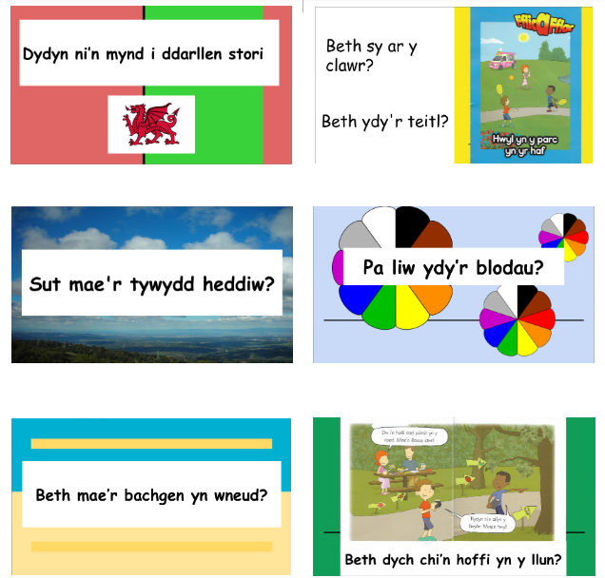

Bibliography
Bates, B. (2016) Learning theories. London: Sage Publications.

Dodson, C. J. (1972) Language teaching and the bilingual method. London: Pitman.

Cook, V. (2008) Second Language Learning and Language Teaching. 4th Ed. London: Hodder Education.

Corbett, P. (2019) About talk for Writing. Available at: https://www.talk4writing.co.uk/about/ (Accessed: 12th March 2019).

Donaldson, G. (2015) Successful futures. Available at: https://dera.ioe.ac.uk/22165/2/150225-successful-futures-en_Redacted.pdf (Accessed: 3rd March 2019).

ESTYN (2012) Welsh second language comes first. Available at https://www.estyn.gov.wales/effective-practice/welsh-second-language-comes-first (Accessed on: 4th March 2019).

ESTYN (2016) Inspection Report. Available at: https://www.estyn.gov.wales/sites/default/files/documents/Tre%20Uchaf%20Primary%20School_1.pdf (Accessed: 6th March 2019).

Hallam, S. (2010) ‘The power of music: Its impact on the intellectual, social and personal development of children and young people’, International Journal of Music Education, 28(3), pp. 269-289.

Hobsbaum, A., Gamble, N. and Reedy, D. (2002) Guided Reading. London: Institute of Education.

LearnCymru (2018) Fflic and Fflac puppets. Available at: https://www.learn.cymru/screen/product/fflic-fflac-puppets/language/en (Accessed: 12th March 2019).

Richards, J.C. and Rodgers, T.S. (2001) Approaches and Methods in Language Teaching. 2nd Ed. Cambridge: Cambridge University Press.

TreUchafPrimarySchool (2019) School Development Plan. Available at: https://tre-uchaf-primary-school1.j2webby.com/?page_id=690 (Accessed: 10th March 2019).

WAG (2009) The Qualified Teacher Status Standards Wales 2009. Available at:
https://gov.wales/docs/legislation/inforcenonsi/education/030709qtsstandardseng.doc (Accessed: 12th March 2019).

WAG (2015) Foundation Phase Framework. Available at: https://beta.gov.wales/sites/default/files/publications/2018-02/foundation-phase-framework-revised-2015.pdf (Accessed: 12th March 2019).

Welsh Government (2017) Welsh in Education Action Plan 2017-2021. Available at: https://beta.gov.wales/sites/default/files/publications/2018-02/welsh-in-education-action-plan-2017%E2%80%9321.pdf (Accessed: 12th March 2019).

