University of Wales Trinity Saint David
School of Engineering


Title of report
Workshop & Practice ACHA4011

Jac Evans
2305578
20/11/2023

Contents
1 Introduction 2
2 Chapter 1 - Health & Safety with Risk Assessments 3
3 Chapter 2 - Engineers Role in Society 5
4 Chapter 3 - Problem Solving 6
5 Chapter 4 - Team Structure 9
6 Chapter 5 - Personal Development Plan 11
7 Conclusion 13
8 Reference list 14

Introduction
This report consists of 5 different chapters. The first chapter being Health & Safety with Risk Assessments. The purpose of this chapter is to analyze and research a task that I have completed including any PPE required, any relevant legislations and risk assessments that should have been completed. Chapter 2 is about an engineer’s role in society. This module includes researching 2 organizations that publish the code of conduct for engineers in the respect of sustainability and environmental issues for motorsport. Problem solving is the topic of chapter 3. The purpose of this chapter is to research into the problem-solving options a team of engineers could use if while developing a new product there is an issue found during development, an issue on the market or a supplier issue in the production process. I have used flow charts to simplify the process. For chapter 4 I will be discussing a time when I worked as a team. I have discussed what team structure was used and positive and negative aspects of this. At the end I also researched what team structure would have been more suitable. In chapter 5 I have added my personal development plan which includes my short term and long-term goals.

Chapter 1 - Health & Safety with Risk Assessments
In the university workshop it is mandatory to wear basic PPE such as steel toe boots, but when doing other tasks with different types of equipment the amount and type of PPE required changes. An example of a task which requires extra PPE is when using brake cleaner to clean components. The dangers of using brake cleaner are that it is flammable, dangerous to the environment and is a serious health hazard if ingested. By law, these COSHH symbols must be put on brake cleaners. ‘Once the hazardous properties of a substance or mixture have been identified, they need to be classified accordingly.’ (European Chemicals Agency). On the back of the product, you will see the symbols pictured below. Also, on the back of some products they add pictograms of the PPE that are required while using brake cleaner. In the pictograms below it shows that you must wear safety glasses, gloves and a mask when using brake cleaner. The legislation that covers any substances that may be hazardous is the Control of Substances Hazardous to Health (COSHH). The legislation shows you how you can find out what PPE you should wear while using hazardous substances. ‘You can prevent or reduce workers exposure to hazardous substances by:
- finding out what the health hazards are
- deciding how to prevent harm to health (risk assessment)
- providing control measures to reduce harm to health.
- making sure they are used.
- keeping all control measures in good working order
- providing information, instruction and training for workers and others
- providing monitoring and health surveillance in appropriate cases
- planning for emergencies’ (HSE Website)’
Another piece of legislation which covers this is Reporting of Injuries, Diseases and Dangerous Occurrences Regulations (RIDDOR) 2013. This legislation covers what happens if the COSHH guidelines are not followed and one of the following incidents happens. In the legislation it states what incidents are reportable these include ‘The death of any person, specified injuries to workers, over 7-day incapacitation of workers, over 3-day incapacitation of workers, non-fatal accidents to non-workers, occupational diseases, dangerous occurrences, and Gas incidents’ (HSE Website).

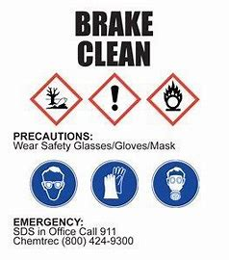(AutoRisk Website)

Risk assessment matrix.
 |  | IMPACT
 |  | Minimal | Medium | Severe
PROBOBILITY | Low | Damaged Clothing | Getting | Getting in eyes with goggles on
PROBOBILITY | Medium | Causing Dry skin | Getting Brake Clean into a cut | Ingesting
PROBOBILITY | High | Getting in contact with gloves | Getting in contact with skin | Getting in eyes without goggles on
This risk assessment matrix shows the probability of a risk against the severity of a risk when using brake clean.

Chapter 2 - Engineers Role in Society
The two organizations which publish the Engineers code of conduct are ‘Engineers Council’ and ‘Society of Operations Engineers’. The ‘Society of Operations Engineers’ state the 4 codes which are ‘’ Honesty and integrity: Engineering professionals have a duty to uphold the highest standards of professional conduct including openness, fairness, honesty and integrity, Respect for life, law, the environment and public good, Accuracy and rigour, Leadership, and communication.’’ (Society of Operations Engineers) The principles don’t directly correlate to sustainability but the way they are worded means that they can be interpreted into any sector. There is one principle which is to do with sustainability directly which is where it mentions the environment. The code of conduct outlines that when engineers are developing a product, they must take all the above into consideration. This is especially important in motorsport as the product or biproduct could have a detrimental effect on life, the environment, safety and the public good. For example, a roll cage. A roll cage’s sole purpose is to protect the passengers inside the car in the event of a crash. If that roll cage is faulty or designed wrong, it will have a high likelihood of having a detrimental effect on the life of the passengers in the event of a crash or roll. This code of conduct is a very important piece of information in the motorsport sector as it assures the customer that the product they are buying is of quality and if not, then there is something they can do about it.

Chapter 3 - Problem Solving
Engineers encounter problems on a regular basis, during development, after it’s been put on the market, or a supplier issue found during production. As every engineer is different there are many ways that engineers solve problems. As a starting point to any problem solving, the first step is to diagnose the problem. Once the problem is diagnosed, you can create a plan to resolve it. To simplify the process a flow diagram is often used.

3.1 A problem discovered during development.
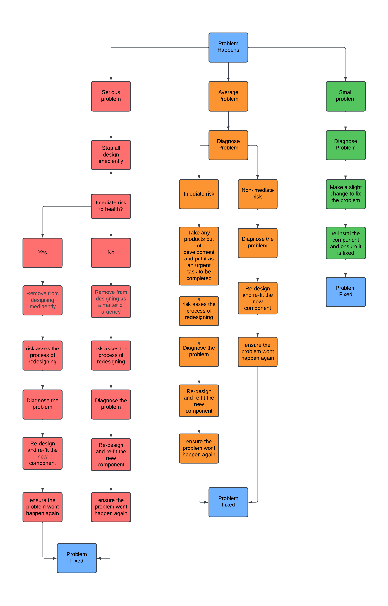
This flowchart shows the process of diagnosing and solving a problem during product development. It details the steps depending on the severity. If the problem is minimal, it involves a minimal number of steps to resolve the problem. The more severe the problem the larger number of steps it takes to solve the problem. This is also true for the following problems. (Flowchart made using Mural)

3.2 A problem discovered after a product has been put on the market.
Problems which are discovered after a product has been put on the market are usually more severe and need to be resolved faster as they can be a risk to the public. Problems can range from being minimal risk to being life threatening, therefore there are many ways these problems are solved. A flow chart has been used to simplify the process.
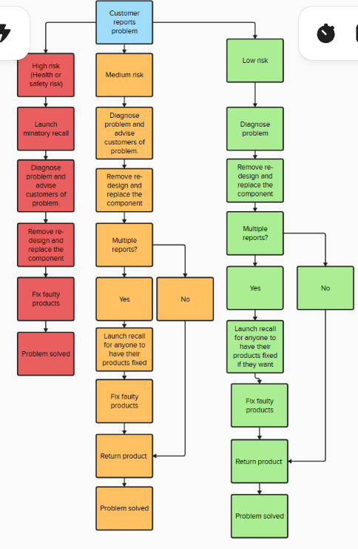
(Flowchart made using Mural)

3.3 A supplier issue in the production process
This is again a problem which could have many factors. The factors could range from a broken piece of equipment on the suppliers end to a material issue. The flowchart below outlines a way to solve the problem of a material issue.
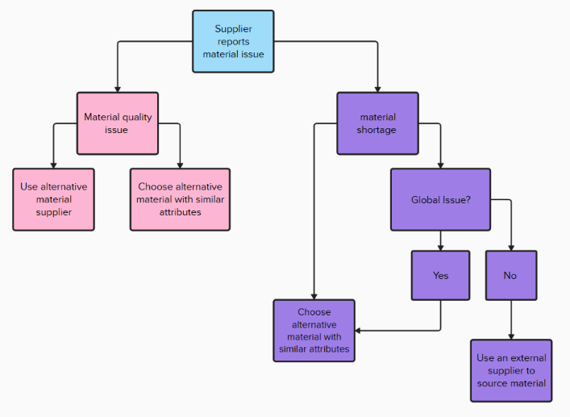
(Flowchart made using Mural)

Chapter 4 - Team Structure
Through the course of life everyone will come across a time when they must work as part of a team. In my previous place of employment, I regularly had to work as part of a team whether that was leading the team or being under management. I was involved in many different types of team structures, for example the main structure of the establishment was a manager to oversee everything and direct everyone, an assistant manager to assist the manager in his role and to take on some of the workload, a set of team leaders to take charge of small teams of people and assistants which were under the guidance of the team leaders to accomplish the workload. In my experience, this was a well-structured team able to efficiently distribute the workload to get it done in a more time-efficient manner. Each team was delegated a section, the team leader was delegated a list of tasks by the manager to be completed by the end of the day which they would distribute amongst the team according to their best attributes. It was then the assistant manager’s role to oversee every team to ensure everything was being done right.
There is a quote from an article written about the structure of team learning by Henrik Bresman and Mary Zellmer-Bruhn which states ‘’team-level structure is associated with more internal learning as well as more external learning’’ this quote is also relevant when working as part of a team. When learning as a team it motivates you to do more and ignites the competitiveness in you to do more than your teammates which in turn makes them want to do more as well which elevates morale and the amount of work done.
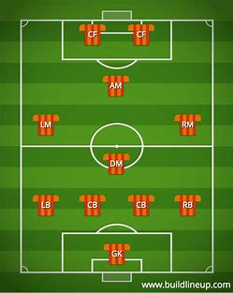
Another example of a team structure is a football team. It all starts with a coach. The coach trains his players in their roles, advises players, and makes all executive decisions. Then you have the captain, he is responsible for the actions of his teammates on the field. Also, all communication between the referee and the team goes through him. Then the players. The goalkeeper. His role in the team is to cover for the teams’ mistakes by saving goals. He is also responsible for distributing the ball to the rest of his team to allow them to succeed. Defense is the next part of the team. The defenders are responsible for stopping the opposition team getting through on goal. If they succeed in this then it helps the team win in the long run. The midfield is the heart of the team. They are the link between the defense and the attack. Without them the team wouldn’t be as strong in either department as they are both. The attacking players score the goals. They are the ones who make the hard work of the rest of the team count. The principle of this team is that the team cannot succeed unless everybody fulfills their role.

Chapter 5 - Personal Development Plan
Personal Development Plan
Name – Jac Evans.
Degree – Motorsport Engineering.
Previous Qualifications – A-level Engineering, Design and Technology and Electronics.
Previous Experience – Service technician and personal mechanical experience.
Long Term Goals (5 to 10 years)
Work at a rally team as a race engineer.
Start my own rally car building/parts development company.

Short Term Goals (0 to 5 years)
Pass My Degree.
Build a reliable and competitive rally car.

Goal | Objective | Resources Required | Measurement | Target Date
Work at a rally team as a race engineer. | Work at a rally team such as Msport, Toyota etc. as a race engineer travelling the world | Passing my degree and gaining in-field experience. | Be employed by one of the big teams. | 2028
Start my own rally car building/parts development company. | Start my own rally car building/parts development company and make a living from it. | Passing my degree and gaining in-field experience with a race team/development team to be able to put into practice in my own business. I am also going to need extensive amounts of time, equipment and most importantly money. Also, I will need a premises to work out of. | Sell or develop my first car/part. | 2040
Pass My Degree. | Pass My Degree with good marks to be able to progress in my career. | Passing all the modules and assignments. | Graduate | 2026
Build a reliable and competitive rally car. | Turn my current Ford Puma project into a reliable and competitive road rally car | I will need an array of parts, lots of time, knowledge, and tools to complete this task along with assistance from more knowledgeable people. | Compete in, finish, and get good results in multiple rally races. | 2025

NOTE - Add more rows if necessary.

Conclusion
The purpose of this report is to highlight the importance of many things in the engineering industry. The importance of abiding by rules but also using your initiative and morals as an engineer, how vital working efficiently as a team is to achieve your goal and the importance of setting goals to motivate yourself. Writing this report has helped me put goals in place for my future to help me get through university and achieve long-term success in motorsport and more.

Reference list
European Chemicals Agency Labeling and packaging. [Online] Available at Labelling and packaging - ECHA (europa.eu) (Accessed 20th of November 2023)

HSE (2002) COSHH Basics, What you have to do. [Online] Available at COSHH basics - COSHH (hse.gov.uk) (Accessed 20th of November 2023)

HSE (2013) Types of reportable injuries. [Online] Available at Reportable incidents - RIDDOR - HSE (Accessed 21st of November 2023)

Autorisk labels: Picture

Society of Operations Engineers (2019) Code of Professional Conduct. [Online] Available at SOE :: Code of Professional Conduct (Accessed 27th of November 2023)

Engineers’ Council (2023) Statement of Ethical Principals. [Online] Available at Engineering Council (engc.org.uk) (Accessed 27th of November 2023)

Bresman.H. Zellmen.B, (2013) ‘Structural Context of Team Learning’ Effects of Organizational and Team Structure on Internal and External Learning vol.24 no. 4, p.1120

aashe.net: Picture 2

