


Network Security (NS)

Tutorial 7

Faculty of Architecture, Computing & Engineering
School of Applied Computing
I.Q Building Room 205
Swansea
SA1 8EW

- INTRODUCTION AND OBJECTIVES OF THE Exercises
In the lecture, you learnt about Web Applications threats and attacks, which is an essential factor in successfully protecting Internet access and the network environment. Apply your understanding and knowledge from what you have learnt in the lecture and the lab about these topics as well as conduct research using text books, library databases, and/or the Internet to do the following questions:

- Outline the process of how web application works

- Name the vulnerability stack and give examples for each.

- The below diagrams are the list of web application threats that attackers used to compromised business landscape mainly Internet Businesses.

  - Discuss and describe the attacks from the list that was not explained in the lecture. Give examples and outline how they work.

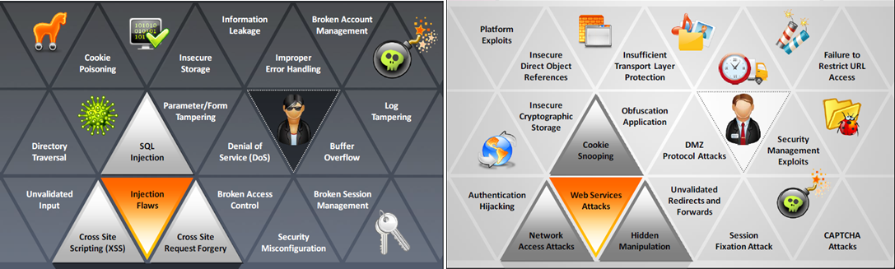

- What are the key security misconfiguration? Give examples.

- How Lightweight Directory Access Protocol (LDAP) injection works? Diagram may be used.

- As it relates to web application, describe denial of service attack examples may be used.

- Discuss some web application countermeasures.

- Research on types of web application hacking tools that was not mentioned in the lecture, describe them and how they work.

- With the use of a flow diagram outline the process of a web application Pen Testing.

