University Of Wales Trinity Saint David

Certificate of Higher Education, Skills for Workplace

BMSW4001 ACADEMIC AND EMPLOYABILITY SKILL’S

Modul leader: Sylvia Hoffmann
Student name: Andreea Simion
Student Id 2120568

Submission date :29/04/2022

Table of Contents
Task 1: Presentation 3
Introduction 3
Employability skills required in restaurant 4
The skills I have are 5
The skills that I need to develop (PDP) 6
My scope of employability in this domain (SWOT analysis) 11
Conclusion 13
References 14

Task 1: Presentation

Introduction 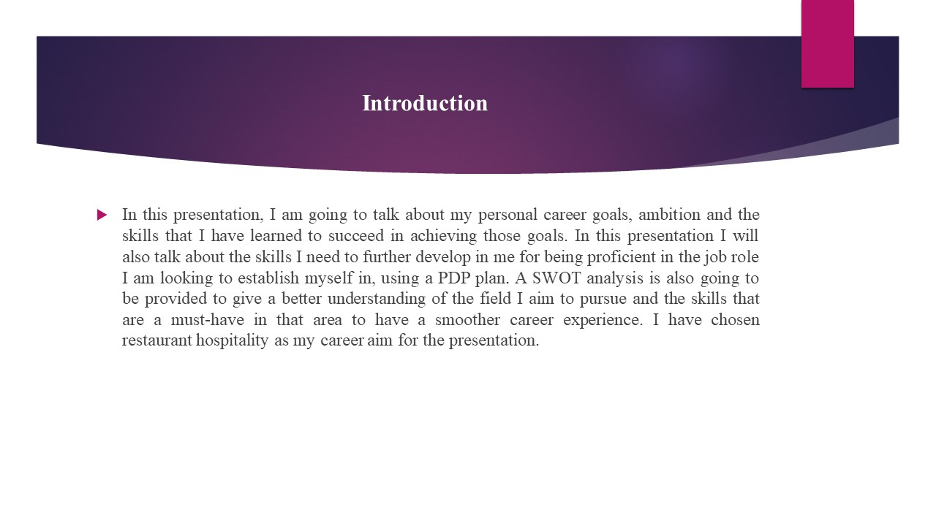
In this presentation, I am going to talk about my personal career goals, ambition and the skills that I have learned to succeed in achieving those goals. In this presentation I will also talk about the skills I need to further develop in me for being proficient in the job role I am looking to establish myself in, using a PDP plan. A SWOT analysis is also going to be provided to give a better understanding of the field I aim to pursue and the skills that are a must-have in that area to have a smoother career experience. I have chosen restaurant hospitality as my career aim for the presentation.

Employability skills required in restaurant
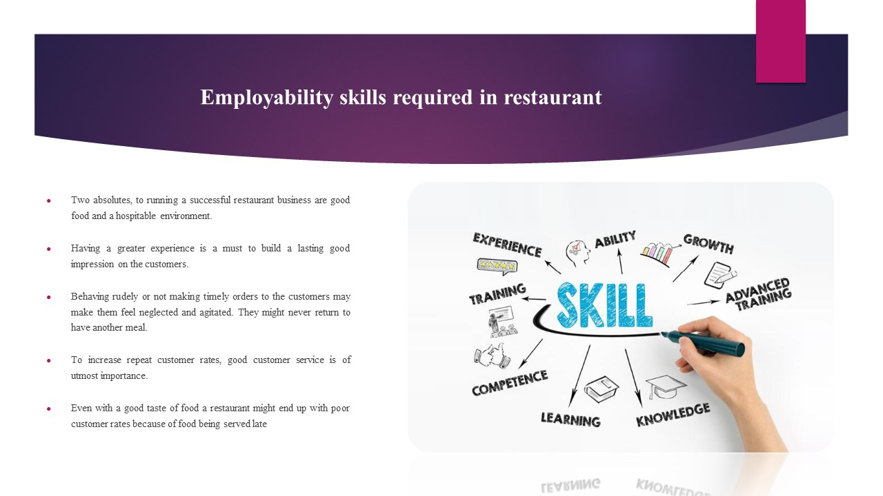
- Two absolutes, to running a successful restaurant business are good food and a hospitable environment.
- Having a greater experience is a must to build a lasting good impression on the customers.
- Behaving rudely or not making timely orders to the customers may make them feel neglected and agitated. They might never return to have another meal.
- To increase repeat customer rates, good customer service is of utmost importance.
- Even with a good taste of food a restaurant might end up with poor customer rates because of food being served late
For a restaurant, two things are an absolute must for them to have a successful business. That is having a good food taste and the other is their hospitality towards the customers (Kenayathulla etal., 2019). It is this aspect of a restaurant that helps leave a lasting impression among the customers of their business. Even with a good taste of food a restaurant might end up with a poor customer rate because of food being served late if the waiter or the receptionist behaves rudely or not very politely with the customers (Nisha and Rajasekaram, 2018). This would leave a bad taste in their mind. So, a good hospitality staff and management is a key to getting a higher repeat customer rate.

The skills I have are
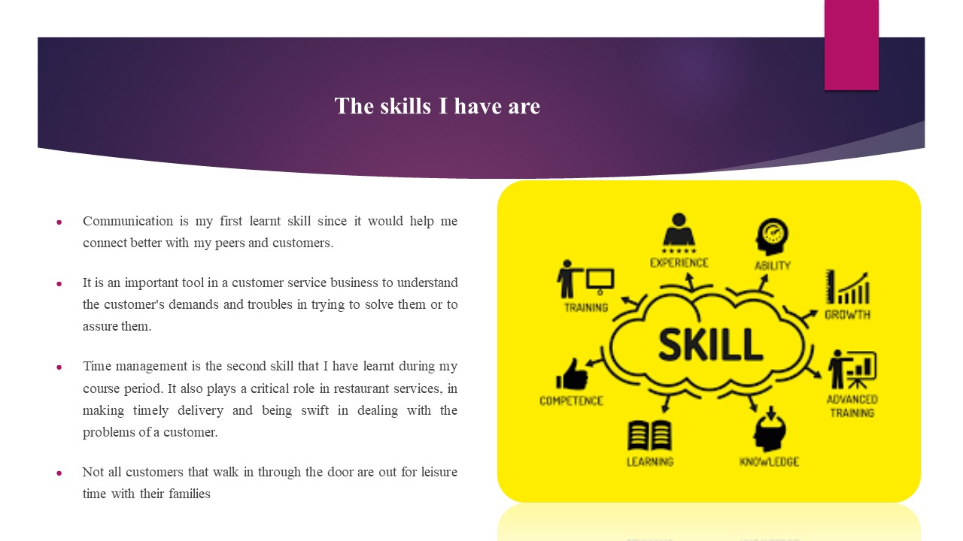
- Communication is my first learnt skill since it would help me connect better with my peers and customers.
- It is an important tool in a customer service business to understand the customer's demands and troubles in trying to solve them or to assure them.
- Time management is the second skill that I have learnt during my course period. It also plays a critical role in restaurant services, in making timely delivery and being swift in dealing with the problems of a customer.
- Not all customers that walk in through the door are out for leisure time with their families
Communication- is the first skill that I inculcated in myself, as it is the primary and crucial skill needed in a service laden sector (Di et al., 2019). Being able to communicate with customers properly to understand their desires and recognise problems if any faced by them. It is also important in establishing a good relationship with my fellow staff and senior management.
Time management- is the second skill that I picked up when preparing for my career prospects. In restaurants where there is always a rush of customer inflow and outflow. It plays a pivotal role, being quick on feet and catering for the customers so that they are content with the service (Suleman, 2018). Not all customers that walk in through the door are out for leisure time with their families, some are in a rush to get a quick meal and are in a rush to go to their office. With this skill, I can quickly meet their needs and provide them relief by not risking being late at their office or any meeting.

The skills that I need to develop (PDP)
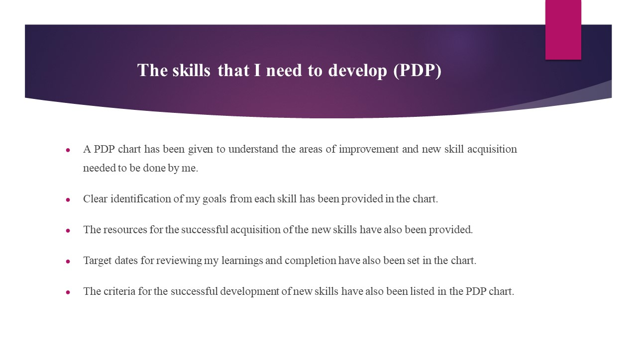
- A PDP chart has been given to understand the areas of improvement and new skill acquisition needed to be done by me.
- Clear identification of my goals from each skill has been provided in the chart.
- The resources for the successful acquisition of the new skills have also been provided.
- Target dates for reviewing my learnings and completion have also been set in the chart.
- The criteria for the successful development of new skills have also been listed in the PDP chart.
Identified Goals | What do I need to learn? | What will I do to achieve this? | What resources or support do I need? | What will the success criteria be? | Target Dates for Review & Completion
To better understand the customers.  To help them reach higher levels of satisfaction  To help them feel more comfortable. | Interpersonal skills | To achieve these I would first try working as an intern in a small restaurant that has a higher conversion rate in terms of having actual customers. By having more and more conversations with different types of customers I will take note of different customer behaviour patterns and the best replies to them. | The basic communication skills that I possess. Secondly, a bustling restaurant filled with customers. | Being able to think creatively, have a higher patience level, and make successful negotiations. | 12 months
To increase the efficiency of work speed  To have a healthy work environment  To build strong connections | Teamwork | Talk with staff and peers regarding regularly, and be more open to them.  Try to find similar grounds to hold long conversations, and always be an active listener of everything they teach. | Be in a restaurant that has a staff group of at least 5 people to have group conversations.  Have seniors that I could take pointers from and follow their example. | My colleagues are open to me when having conversations.  Having formed a close bond with them.  A higher level of coordination is reached. | 12 months
To be able to quickly figure out the issue faced by the customers.  Providing quick responses and solutions to those issues.  Provide positive assurance to the customers regarding the issue raised. | Problem-solving | Be at the forefront and observe my seniors in the scenario and learn from their behaviour toward the customers and the numerous challenges that they overcome.  Also often take initiative and apply those observations in dealing with a few customers daily to see the results of my observations. | An environment where many customers are coming daily.  Seniors are willing to help me learn to deal with various customer profiles. | Being able to think of a solution quickly.  Successfully providing and assuring a customer that the problem will be dealt with.  Customer appreciation of my quick-witted judgement. | 12 months
To follow proper safety regulations when in. Kitchen duty.  Maintaining good hygienic conditions for customers. | Hazards awareness | First I would take note of the guidelines of the restaurant regarding safety measures they follow and practise them daily to make it a habit.  Always make sure the tables, chairs and utensils are clean. Also, ensure that the kitchen is regularly taken care of and pest control is done every month. | A restaurant that has laid down guidelines on safety measures.  A restaurant has hygiene as the core principle behind providing quality service to the customers. | A clean dining area with utmost hygiene maintenance.  Safety measures are being placed to make sure mishaps do not take place. | 7 months

My scope of employability in this domain (SWOT analysis)
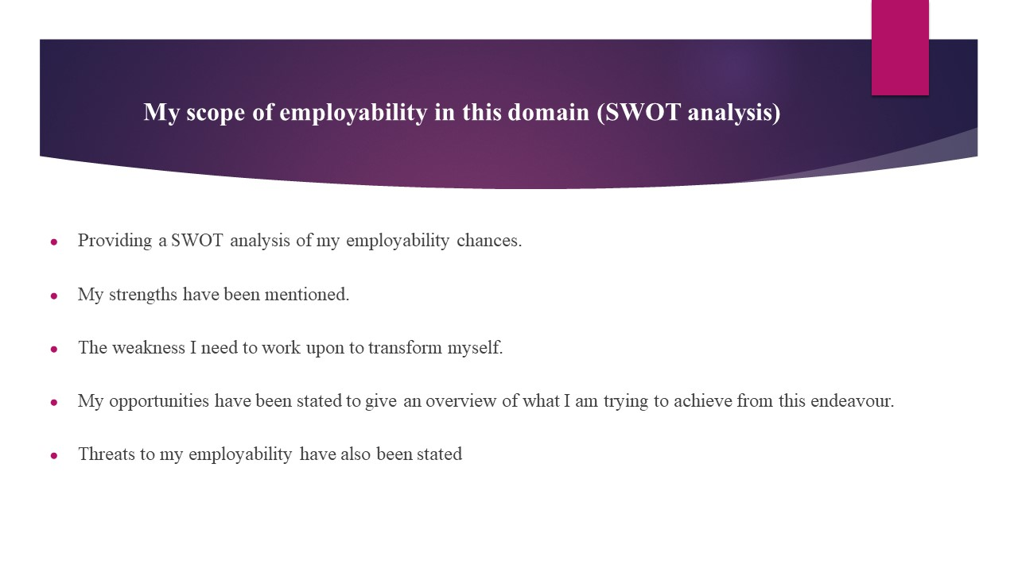
- Providing a SWOT analysis of my employability chances.
- My strengths have been mentioned.
- The weakness I need to work upon to transform myself.
- My opportunities have been stated to give an overview of what I am trying to achieve from this endeavour.
- Threats to my employability have also been stated
Strengths | Weaknesses
- Communication and time management skills that I developed priorly during my course period.  - Self-control and calmness when dealing with people.  - humble and inquisitive by nature keeps I am always motivated to learn more from my peers and seniors. | - Lacking practical experience in the field  - Weak in team play.
Opportunities | Threats
- To better scale my customer dealing abilities  - To have a dream job at one of my favourite restaurants shortly and realise my ambition of being in one of the most prestigious restaurants. | - My lack of practical experience in the field can cause me to lose my opportunities to get started.  - Me being a slow learner, makes a restaurant feel hesitant to hire me.

Conclusion
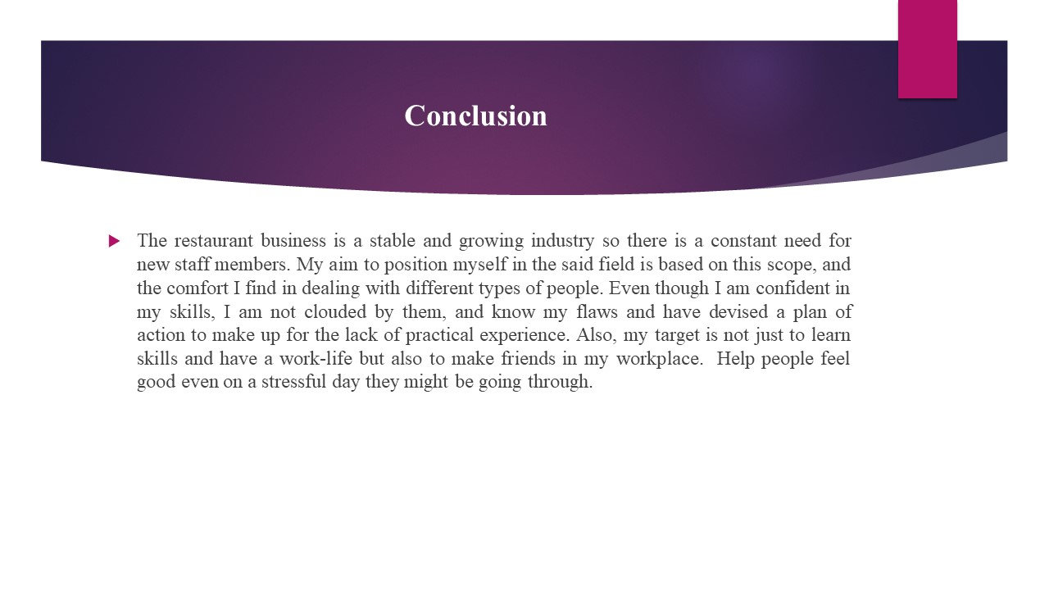
The restaurant business is a stable and growing industry so there is a constant need for new staff members. My aim to position myself in the said field is based on this scope, and the comfort I find in dealing with different types of people. Even though I am confident in my skills, I am not clouded by them, and know my flaws and have devised a plan of action to make up for the lack of practical experience. Also, my target is not just to learn skills and have a work-life but also to make friends in my workplace. Help people feel good even on a stressful day they might be going through.

References
Task 1
Di Gregorio, A., Maggioni, I., Mauri, C. and Mazzucchelli, A., (2019). Employability skills for future marketing professionals. European management journal, 37(3), pp.251-258.
Fajaryati, N. and Akhyar, M., (2020). The employability skills needed to face the demands of work in the future: Systematic literature reviews. Open Engineering, 10(1), pp.595-603.
Kenayathulla, H.B., Ahmad, N.A. and Idris, A.R., (2019). Gaps between competence and importance of employability skills: evidence from Malaysia. Higher Education Evaluation and Development.
McGunagle, D. and Zizka, L., (2020). Employability skills for 21st-century STEM students: the employers' perspective. Higher education, skills and work-based learning.
Nisha, S.M. and Rajasekaran, V., (2018). Employability skills: A review. IUP Journal of Soft Skills, 12(1), pp.29-37.
Suleman, F., (2018). The employability skills of higher education graduates: insights into conceptual frameworks and methodological options. Higher Education, 76(2), pp.263-278.
.

