

Name: Christina Owusu
Student ID:2329700
Module Code: (LCHS4003_BIRM)
Module: Health and Social Care
Lecturer: Dr Aishat Bakre

ijdfijsdfijai
jnfujesngus

IFHH
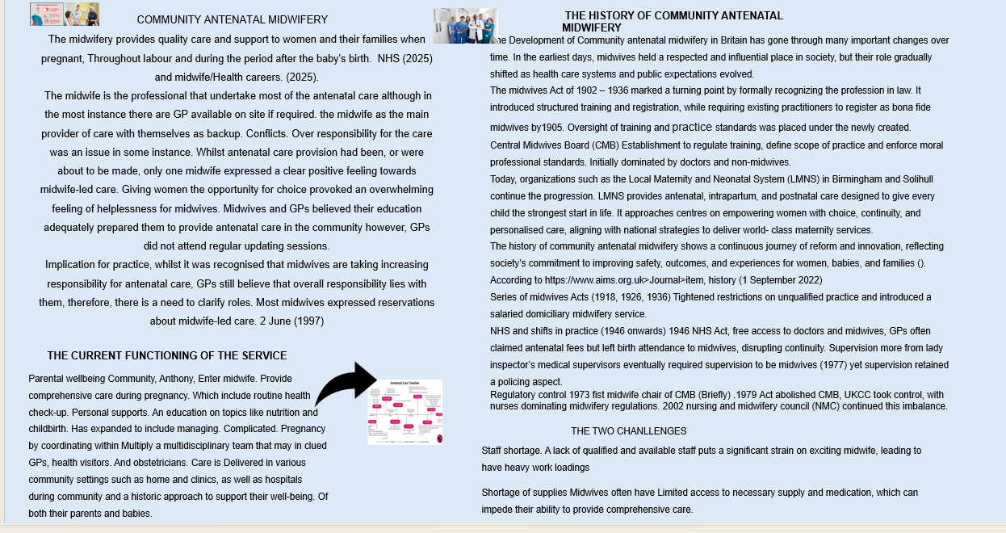
The midwifery provides quality care and support to women and their families when pregnant, Throughout labour and during the period after the baby's birth. Conclusion
Midwifery education force major workforce challenges. Without education standards and care quality may fall.

The National Health Service
The National Health Service (NHS) is the collective name for the four publicly funded healthcare systems operating across the United Kingdom: NHS England, NHS Scotland, NHS Wales, and Health and Social Care in Northern Ireland (often called “the NHS” locally, even though it was established separately). These services were originally founded in 1948 as part of post–Second World War social reforms, with NHS Wales becoming a distinct organisation in 1969. The system was officially launched at Park Hospital in Davy Hulme, near Manchester (now Trafford General Hospital). Its founding principles were that healthcare should be comprehensive, available to all, and free at the point of use. Each of the four services delivers a wide range of medical care without charge to UK residents, though dental treatment and eye care usually incur fees 6 June (2016). In England, patients who do not qualify for exemptions must also pay prescription charges. Because of their scale, the services wield significant buying power when purchasing supplies such as medicines, often helping to keep international prices lower. In some cases, the organisations purchase products jointly through shared contracts. Several other countries also use UK evaluations to guide decisions on public drug funding.

History

Ideas for a national health system go back to the early 1900s. In 1909, the Royal Commission on the Poor Law suggested a “unified medical service. The Second World War helped make this change possible. The Emergency Medical Service, set up to prepare for bombing casualties, had already shown that a single national hospital system could work. Bevan’s NHS was built on the idea that healthcare should be free for all, funded by the state, and owned by the public. Conservatives supported free care but wanted hospitals to stay under local control. Their amendments failed, and Labour went ahead with full national ownership. Over time, however, later governments introduced partnerships with the private sector, such as private finance initiatives. The NHS officially began on 5 July 1948, based on three principles:
- It should meet the needs of everyone,
- It should be free at the point of delivery,
- It should be based on need, not ability to pay.
Eligibility for Treatment
Some NHS services are available to everyone at no cost, including:
- Accident and emergency care,
- Registering with and visiting a GP,
- Treatment for certain infectious diseases,
- Compulsory psychiatric care,
- Some family planning services.
All people living in the UK can use NHS services without paying the full cost. However, there are standard charges for dental and eye care. In England, most adults must also pay for prescriptions, unless they qualify for exemptions. People who are not normally resident in the UK (even British citizens living abroad) may need to pay for some services, although there are exceptions for refugees. Those who do not qualify for free care are usually required to pay upfront or sign an agreement to pay later. Some groups are exempt from
residence rules, including certain government workers, members of the armed forces stationed overseas, and missionaries linked to UK organisations.

Funding
The NHS receives its funding primarily through general taxation and National Insurance contributions, with approximately 1% coming from patient charges for certain services. In the 2022/23 financial year, the Department of Health and Social Care allocated £181.7 billion to healthcare services in England, with over 94% of that expenditure directed toward staff salaries and medications. For the 2024/25 period:
Wales allocated £11.74 billion to health and social care, representing 49% of its total budget.
Scotland set aside £19.5 billion for health and social care.
Northern Ireland earmarked £7.3 billion for healthcare services.
Certainly! Here's a reworded version of the passage that maintains the original meaning while improving clarity and flow’s funding has long been a key issue during UK elections and came under intense scrutiny during the Covid-19 pandemic. In July 2022, The Telegraph reported findings from the think tank Civitas, which estimated that health spending in the UK amounted to approximately £10,000 per household. According to Civitas, this represented the third highest share of GDP among European nations. They argued that the UK operates one of the most expensive healthcare systems while delivering comparatively poor outcomes. These findings were published before the government implemented a significant increase in health funding through a 1.25% rise in National Insurance contributions in April 2022. Civitas also noted that UK health spending had surged more than in any other country, despite a decline in national income during the pandemic. Following the 2024 general election, the newly elected Labour government declared that the "NHS is broken." They commissioned an immediate review of the system’s current pressures, led by Labour peer Lord Ara Darzi. This review is intended to inform the creation of a new "10-year plan" to replace the NHS Long Term Plan introduced in 2019.Meanwhile, research has highlighted the growing financial demands of social care. Professor Helen Stokes-Lampard of the Royal College of General Practitioners remarked that while increased life expectancy is a testament to advances in medical research and the NHS, it is essential to ensure that people live longer with a good quality of life. Achieving this, she said, requires a well-funded and well-staffed health and social care system—where general practice, hospitals, and social care services collaborate effectively to deliver safe and coordinated care for all patients.

-

Issues

In 2022, a think tank (Civitas) estimated that the NHS cost roughly £10,000 per UK household, one of the highest shares of GDP in Europe. They argued the system was expensive and had poor outcomes compared to other countries. In 2024, the Labour government declared the “NHS is broken” and launched a review led by Lord Ara Darzi, planning a new 10-year strategy to replace the 2019 Long Term Plan. Rising social care costs are a concern. Experts call for better integration between hospitals, GP services, and social care to ensure longer, healthier lives for patients.

1. "NHS Identity Guidelines | NHS logo". www.england.nhs.uk. Retrieved 11 November 2021.
2. "Health funding in Northern Ireland – Northern Ireland Affairs Committee – House of Commons".
3. Choices, NHS. "The principles and values of the NHS in England". www.nhs.uk. Archived from the original on 17 March 2010. Retrieved 23 November 2016.
4. "NHS entitlements: migrant health guide – Detailed guidance". UK Government. Retrieved 6 June 2016.
5. "Who can get free prescriptions". NHS. 9 November 2020. Retrieved 5 January 2022
6. www.nhs.uk2025

References
www.nhs.uk (2025)
https://memorisofnursing.uk/articles/midwifery-in-britain-in-the-twentieth-century.
https://www.scienedirect.com
https://www.healthcarres.nhs.uk midwife/Health careers. (2025).
https://www.aims.org.uk >Journal>item, history (1 September 2022)
Midwifery - Wikipedia 14 January 2025
https://www.myhsn.co.uk/top-tip/what-is-a-community-midwife/
https://www.uhb.nhs.uk/services/maternity/

NHS references

"NHS Identity Guidelines | NHS logo". www.england.nhs.uk. Retrieved 11 November 2021.
https://publications.parliament.uk/pa/cm201919/cmselect/cmniaf/300/30004.htm
Choices, NHS. "The principles and values of the NHS in England". www.nhs.uk. Archived from the original on 17 March 2010. Retrieved 23 November 2016.
"
https://www.gov.uk/guidance/nhs-entitlements-migrant-health-guide NHS entitlements: migrant health guide – Detailed guidance".UK Government. Retrieved 6 June 2016.
"Who can get free prescriptions". https://www.nhs.uk/nhs-services/prescriptions-and-pharmacies/who-can-get-free-prescriptions/ NHS. 9 November 2020. Retrieved 5 January 2022.
https://web.archive.org/web/20100317212745/http://www.nhs.uk/NHSEngland/thenhs/about/Pages/nhscoreprinciples.aspx "NHS entitlements: migrant health guide – Detailed guidance".UK Government. Retrieved 6 June 2016.
https://www.theguardian.com/society/2016/jan/18/10-truths-about-britains-health-service?CMP=share_btn_tw 10 truths about Britain's health service". Guardian. 18 January 2016. Retrieved 19 January 2016.
https://digital.nhs.uk/data-and-information/publications/statistical/nhs-workforce-statistics/january-2024 NHS Workforce Statistics - January 2024

