TOPIC: EFFECTIVENESS OF PREFABRICATED HOUSING PROJECTS IN THE UK DESIGN INDUSTRY

1. Introduction
The UK design industry is constantly evolving and there is an increasing need for sustainable, affordable and efficient housing solutions. Due to the faster construction time, reduced environmental impact and cost-effective manner of production, prefabricated housing projects have gained traction as a potential solution [1]. On the success of prefabricated housing projects, including their design quality, construction efficiency, price, and user happiness, there is, nevertheless, an absence of study in the UK design sector. In order to comprehend the possible advantages and difficulties of prefabricated housing projects, it is necessary to research and assess their performance in the UK design sector [2].
The following research will conduct a systematic literature review on the topic of the effectiveness of prefabricated housing projects in the UK design industry by identifying relevant literature on the topic and utilising the information properly evaluate the information. It will also provide a brief overview of the mythology that will be applied for conducting the research project along with information about data collection and data analysis strategy. Identifying possible findings from the literature review, the overall research project will be summarised to reflect on the experience of the research process and how the information on this topic can further contribute to the improvement of the design industry in the UK.

2. Aim and Objectives of Project

2.1 Aim
The aim of the project is to evaluate the effectiveness of prefabricated housing projects in the UK design industry with a focus on their design quality, construction efficiency, affordability, sustainability and user satisfaction.

2.2 Objectives
The following objectives will help to achieve the aim of the research project:
- To evaluate the design quality of prefabricated housing projects in the UK design industry in terms of their functionality and aesthetics.
- To assess the construction efficiency of prefabricated housing in the UK design industry in terms of assembly accuracy, speed and manufacturing effectiveness.
- To analyse the affordability of prefabricated housing projects in the UK design industry in terms of cost of production, transportation and installation and long-term operational costs.
- To develop an effective system for measuring user satisfaction with prefabricated housing projects in the UK design industry.

3. Literature Review Topic
Introduction
The project management and evaluation demand sustainable quality assurance of the project. Developing stability in the project work is essential to receive a sustainable outcome of the project. Furthermore, deriving a solution for cost-effective project planning can make the project influential and accessible to the general public. The current study is focusing on understanding the construction design of prefabricated housing projects in the UK. Along with this, the application of strategic solutions to develop affordable housing projects will also be discussed within the study along with the theoretical application of the study.
Evaluation of the design quality of the prefabricated housing Projects
Project design and quality can influence the working possibility of the companies in respect of sustainable business solutions. Working on the agile project methodology helps companies to improve the quality of the project [3]. Furthermore, the agile project methodology helps to develop strategic outcomes based on project design in the project work in terms of managing the quality of the project. The prefabricated housing projects of the UK are developed focusing on the evaluation of cost-effective project design. It can be derived from BBC News that more than 65% of the UK construction industry is incorporating prefabricated housing projects in the local market in consideration of cost-effectiveness [4]. The major reason behind choosing the location in the UK is the cost-effective supply chain, which helps the companies to deliver a resource-dependent perspective in the project work.

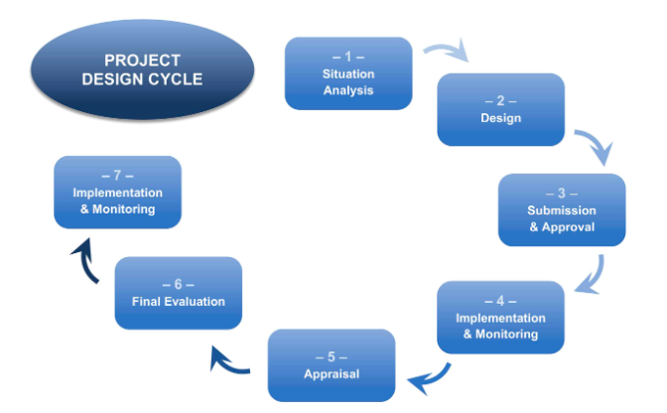
Figure 1: The project designing cycle
[Source: 5]

The efficiency of the project work of the UK-based prefabricated housing projects has been increased through the four stages of project design. The first stage of the project design focuses on designing the project work in terms of understanding the layout of the project work [6]. Furthermore, in the second stage, the building up of the project work has been identified as beneficial for the prefabricated housing projects of the UK to ensure the quality of the project work.
Discussion on the construction efficiency of the prefabricated housing projects
Construction companies from the UK are focusing on developing construction efficiency to deliver sustainable project work. Developing stability of the project process can be proven beneficial for companies to incorporate with the sustainable development of the project work [7]. Moreover, utilisation of the project planning can be determined within the construction companies to improve the quality and design of the project work. The UK-based construction industry is focusing on BIM applications in order to control and measure the project work in terms of project quality. On the other hand, during the prefabricated housing projects measuring the real capability of the technology orientation within the organisation can be explored within the construction companies [8]. The prefabricated housing projects work considers the employee engagement capability, in order to consider a sustainable project work. Along with this, managing employee engagement can differ within prefabricated housing projects due to the lack of employee motivation [9]. Therefore, managing employee satisfaction within the organisation can be proven beneficial for companies to explore the sustainable management program.

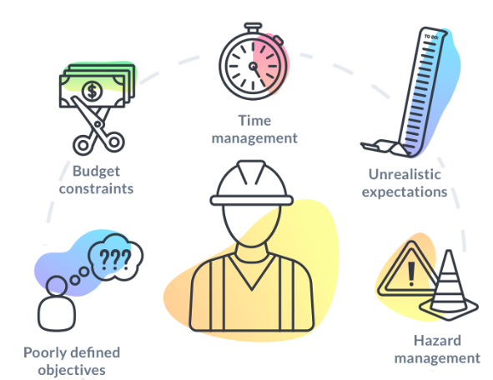
Figure 2: Key challenges in the project planning
[Source: 9]

The project managers from the UK construction industry are focusing on managing employees' training-based development planning to maintain the quality of the prefabricated housing projects. Managing training-based employment can be proven beneficial for companies to incorporate within the sustainable project development perspective in business [10]. Furthermore, managing effective communication can be proven beneficial for the companies to synchronise with the quality management perspective of the prefabricated housing projects of the UK. The community works as a path of the interaction of the companies with the stakeholders, which helps to increase the efficiency of the prefabricated housing projects work in the UK.
Analysis of the challenges in managing affordability of the prefabricated housing projects
Lack of proper goals and objectification of the project work is one of the key challenges of the prefabricated housing projects in the UK. The project managers are facing difficulties in maintaining low-cost-based projection work in order to consider affordable prefabricated housing projects [11]. Lack of accountability in the project work has become a potential issue for organisations to improve project management perspectives at a lower cost. Furthermore, the project managers have failed to meet the resource accountability of the project work, which directly impacts the stable project accountability throughout the project work [12].
Discussion of the effective system for measuring the use of prefabricated housing projects
The prefabricated housing projects can receive sustainable project work with the incorporation of the sprint analytical perspective. Application of the sprint analytical perspective can be proven beneficial for developing the affordability of the project work [4]. Resource management competency of the companies also can be developed within the organisation with the help of sustainable management planning. Furthermore, developing the availability of the project work can be helpful for the project managers of prefabricated housing projects to find a solution for project work [6]. On the other hand, the cost leadership management perspective can be proven beneficial for organisations to improve the quality of the project work [9]. Developing accessibility of the supply chain management process can be proven beneficial for developing sustainable projection work along with a stable project management perspective during the prefabricated housing projects work.
Theoretical framework
- Present underlying project accountability theory
The present underlying project accountability theory stands for delivering cost-effective project work along with developing resource dependency of the project. Incorporation of this theory can be beneficial for project managers to increase the time management capability of the organisation [8]. Furthermore, the information management perspective of the project work also can be developed within the construction companies with the application of the Present underlying project accountability theory.
Conclusion
It can be concluded that the application of sustainable projection work can be proven beneficial for companies to explore sustainable resource competencies. Lack of communication can impact the sustainable working possibility of the organisations. On the other hand, developing stability from the supply chain perspective can be proven beneficial for project work for prefabricated housing projects in the UK.

4. Methodology
This particular research adopts a deductive research approach and attempts to understand with the help of secondary qualitative information how the design industry in the UK can be improved [13]. This approach allows to development a holistic understanding of the effectiveness of prefabricated housing projects in the UK design industry. The research strategy for this particular project is utilising secondary qualitative data gathered from existing literature on the topic of the design industry, prefabricated housing and the current position of the construction industry in the UK. Using multiple sources for the secondary evaluation, a systematic literature review will be conducted which will help in understanding the different perspectives of resources on the topic and how this innovative solution of prefabricated housing can help to improve the sustainability and cost-effectiveness of the design industry of the UK. The analysis of the secondary data will be completed using the thematic analysis method due to the qualitative nature of the information [14]. The thematic and content analysis strategy helps to identify patterns in the gathered information and create a comprehensive idea about the topic under research. In this regard, the synthesis of the data that will be evaluated using the thematic method can help to understand how the future sustainability of the design industry in the UK can be achieved by promoting prefabricated housing projects.
Throughout the research, proper ethical considerations will be maintained for effective utilisation of the gathered information and refraining from data manipulation to achieve desired outcomes. However, the research project can encounter some limitations associated with the availability of data such as relevant literature on the topic along with the difficulty of comprehensively evaluating the data to come to a proper conclusion regarding the available information. Due to the brief nature of the project, the process of data validation and checking the reliability of the information can also be a difficult aspect.

5. Summary and Reflection
After the whole project planning, I have summarised that the project managers of the prefabricated housing projects in the UK are facing issues from an employee management perspective. I understood that the application of employee motivation is quite essential for the project managers to explore successful project delivery. On the other hand, I have understood that managing resource management competency can be proven beneficial for project managers to increase sustainable project delivery within time. The availability of the supply chain management perspective helps companies to improve the quality of the project work [5]. I learnt that the agile project methodology could be proven beneficial for developing the quality of the project work. Additionally, I realised that developing project design can be proven beneficial to maintain project consistency within the organisation.
I understood that it is important for project managers to be involved in sustainable project work along with sustainable working possibilities within the organisation. According to my understanding, the prefabricated housing projects in the UK are lacking in developing cost-effective marketing plans within the companies, due to the increased cost of the project work. On the other hand, project managers need to work on the budget management perspective within the organisation with the help of project management competencies. I learnt from the discussion that prefabricated housing projects in the UK might face challenges along with the cost leadership management perspective within the project work [8]. I understood that the Present underlying project accountability theory could be beneficial for the project managers to explore the impact of the resource development perspective in the project work in terms of delivering a successful project outcome. Developing alternative solutions for the project work can be proven beneficial to develop a stable business development perspective in business along with the application of employee management perspective to maintain the stability of the stakeholder engagement during the project work.

References
1. Bertram, N., Fuchs, S., Mischke, J., Palter, R., Strube, G. and Woetzel, J., 2019. Modular construction: From projects to products. McKinsey & Company: Capital Projects & Infrastructure, pp.1-34.
2. Tsz Wai, C., Wai Yi, P., Ibrahim Olanrewaju, O., Abdelmageed, S., Hussein, M., Tariq, S. and Zayed, T., 2023. A critical analysis of benefits and challenges of implementing modular integrated construction. International journal of construction management, 23(4), pp.656-668.
3. Li, X., Shen, G.Q., Wu, P. and Yue, T., 2019. Integrating building information modelling and prefabrication housing production. Automation in Construction, 100, pp.46-60.
4. Ferdous, W., Bai, Y., Ngo, T.D., Manalo, A. and Mendis, P., 2019. New advancements, challenges and opportunities of multi-storey modular buildings–A state-of-the-art review. Engineering structures, 183, pp.883-893.
5. Zhang, Z., Yuan, Z., Ni, G., Lin, H. and Lu, Y., 2020. The quality traceability system for prefabricated buildings using blockchain: An integrated framework. Frontiers of engineering management, 7(4), pp.528-546.
6. Thai, H.T., Ngo, T. and Uy, B., 2020, December. A review on modular construction for high-rise buildings. In Structures (Vol. 28, pp. 1265-1290). Elsevier.
7. Tofiluk, A., Knyziak, P. and Krentowski, J., 2019, February. Revitalization of twentieth-century prefabricated housing estates as interdisciplinary issue. In IOP Conference Series: Materials Science and Engineering (Vol. 471, No. 11, p. 112096). IOP Publishing.
8. Xu, Z., Zayed, T. and Niu, Y., 2020. Comparative analysis of modular construction practices in mainland China, Hong Kong and Singapore. Journal of Cleaner Production, 245, p.118861.
9. Navaratnam, S., Ngo, T., Gunawardena, T. and Henderson, D., 2019. Performance review of prefabricated building systems and future research in Australia. Buildings, 9(2), p.38.
10. Hou, L., Tan, Y., Luo, W., Xu, S., Mao, C. and Moon, S., 2022. Towards a more extensive application of off-site construction: a technological review. International Journal of Construction Management, 22(11), pp.2154-2165.
11. Yin, X., Liu, H., Chen, Y. and Al-Hussein, M., 2019. Building information modelling for off-site construction: Review and future directions. Automation in Construction, 101, pp.72-91.
12. He, R., Li, M., Gan, V.J. and Ma, J., 2021. BIM-enabled computerised design and digital fabrication of industrialised buildings: A case study. Journal of Cleaner Production, 278, p.123505.
13. HR, G. and Aithal, P.S., 2022. How to Choose an Appropriate Research Data Collection Method and Method Choice among Various Research Data Collection Methods and Method Choices During Ph. D. Program in India?. International Journal of Management, Technology, and Social Sciences (IJMTS), 7(2), pp.455-489.
14. Sundler, A.J., Lindberg, E., Nilsson, C. and Palmér, L., 2019. Qualitative thematic analysis based on descriptive phenomenology. Nursing open, 6(3), pp.733-739.

