

Assessment 1 – Reading Task Template
Upload your photo of your A3 in-class notes here:
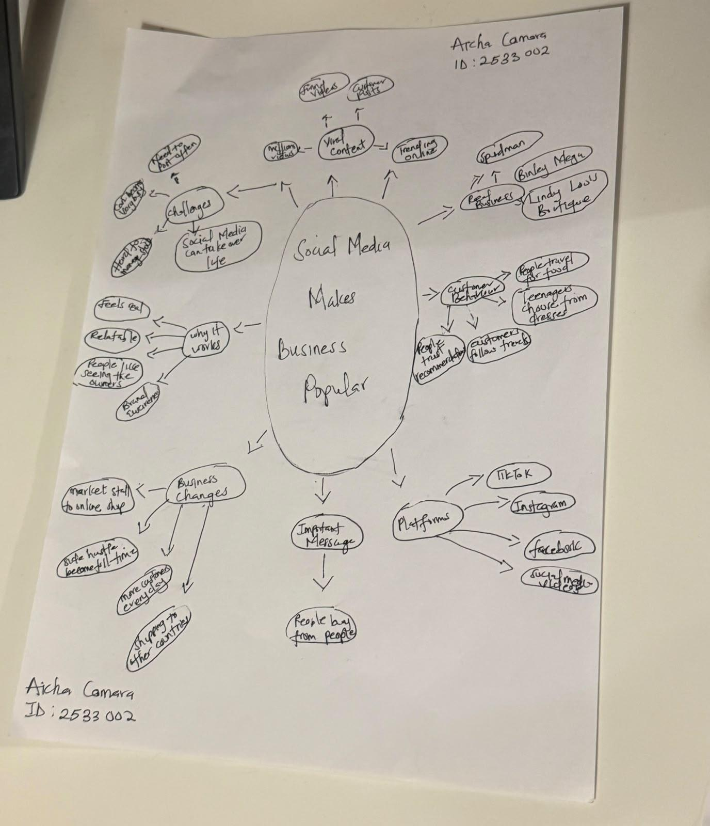

1. Answer these questions using the sentence starters below
a. What is the main idea of the text?
The main idea is that the text explains how social media platforms like TikTok, Instagram and Facebook are helping small businesses become popular, attract more customers, and grow through viral videos.
b. What are two key points?
One key point is Social media can make customers travel long distances to visit a business, like Honywood Sandwich Shop and Krystalls Boutique.

Another key point is Posting relatable and authentic content helps businesses connect with people and increase sales.

c. What part of the text did you find most important? Why?
The most important part is where the marketing expert says, “People buy from people.” This is important because it shows that customers are more likely to support a business when they feel connected to the people behind it.
d. Was anything unclear or difficult to understand?
Most of the text was clear, but some business and marketing words like “brand awareness” and “subliminal marketing” may need more explanation.
e. How did your group help you understand the text better?
My group helped me by discussing the examples in the text and explaining how social media can turn likes and views into real customers and sales.
2. One sentence reflection
Question: What did you find challenging about this task?
The hardest part was I found it challenging to pick out the most important information because the text had many different business examples.

