

Program: Master of Business Administration

Module Name and Code: International Marketing: Principles & Practices (LCMB7026)

Assessment Title: Individual Report – International Marketing
Selected Company: Adidas.

Lecturer Name: Piyumika Kithulgoda Gamage, Tushara Balendran

Student Name: Hari Mohan Singh
Student ID: 2506569
Word Count: 5132
Date of Submission: 13/08/2026

Table of contents
Section 1 3
Introduction 3
1a. Comparative Macro-environment analysis 4
PESTEL analysis 4
Hofstede’s cultural dimensions: Germany and China 6
Overall marketing implication 8
1b. Comparative STP and International Marketing Mix (7Ps) 9
Segmentation, Targeting and Positioning (STP) 9
7Ps marketing mix 10
1c. Market entry strategy analysis of China 14
1d. Ethical evaluation of marketing mix in China 17
1e. Recommendations 19
Section 2: Reflective account (Reflective cycle of Gibbs) 20
Description 20
Feelings 21
Evaluation 21
Analysis 21
Conclusion 22
Action plan 22
References 23

Section 1

Introduction
Adidas was founded by Adi Dassler in 1949 in Herzogenaurach, Germany and is the world’s second-largest sportswear company by revenue, generating €24.1 billion in net sales in fiscal year 2024 in footwear, accessories and apparel in more than 160 countries (The sustainable innovation, 2026). Germany is the home market of Adidas, wherein headquartered in Herzogenaurach. It is also listed on the German stock exchange and supplies kits to the Bundesliga and the German national football team and supplies official kits to major football leagues that include the Bundesliga and the national team of Germany (Market Data Forecast, 2026). Adidas had reported China as the “Greater China” segment, wherein the company possess third largest revenue from China after Europe and North America. Company have generated about €3.459 billion in 2024 in China, an increase of 10.3% year-on-year, and had continued to grow in 2025 (CCF Group, 2025).
This report compared the strategy of Adidas in two different markets, which include Germany and China. Germany is a mature, high-income and culturally low-context Western European economy, and China is a larger, fast-growing, and culturally distinct emerging-to-advanced economy in which Adidas has attained deep localisation. This pairing is informative as it deals with stable home market Germany with host market China, which has led the company to fundamentally restructure its product design, manufacturing, distribution, and promotional strategy. The report is structured with Section 1a comparing macro-environments of Germany and China using PESTEL and cultural contexts using Hofstede’s cultural dimensions framework. Section 1b compares Adidas’s segmentation, targeting and positioning and the 7Ps marketing mix in both markets. Section 1c analyses the market entry strategy of Adidas, wherein Section 1d evaluates the ethical problems raised through Adidas's responses towards the Xinjiang cotton controversy in China. The last section concludes with recommendations for the future international marketing strategy of Adidas.

1a. Comparative Macro-environment analysis

PESTEL analysis
Political: Germany had offered Adidas a stable, rule-based environment in the European Union, which is characterized through predictable regulations, lower expropriation risk and stronger institutional trust. Being an EU member, Germany had exposed Adidas towards supranational trade policy. Analysts had noted that US tariff actions that target European exporters might cost the German economy €20 billion, with knock-on effects for German-headquartered exporters like Adidas. The political environment of China is quite different from Germany, as the government plays a major role in regulating business and influencing the market. Foreign companies such as Adidas should carefully follow the local laws and government policies. The ill-effects of laws and regulations were seen in March 2021 when Adidas ' 2020 statement had expressed concerns regarding allegations of forced labour that involved Uyghur workers in Xinjiang. It had triggered a coordinated nationalist backlash, which included state-media criticism and had called for a boycott that was amplified by the Communist Youth League (NBC News, 2021). Political risks in China are thus less regarding macro-institutional instability and more regarding risks of becoming entangled in the geopolitical disputes between China and Western governments.
Economic: Germany is a mature, high-income economy with slower but stable GDP growth, lower volume growth potential for sportswear and demand driven mostly by replacement purchasing and premiumisation. On the other hand, China is a higher-growth economy in the sportswear category; mainly the Greater China segment of Adidas had grown currency-neutral revenues through double digits for seven consecutive quarters through 2024-2025, with full-year 2024 revenue having reached €3.459 billion and also a currency-neutral growth of 13% reported in 2025 (Adidas Annual Report, 2024). The gross margin of Greater China also increased by 2.9%, reaching 52.6% in 2025, which reflected declined discounting and a favourable product mix (Adidas Annual Report, 2025). This has made China economically indispensable towards the growth strategy of Adidas, although it is not the largest single market of the company by absolute revenue.
Social: German consumers tend to value engineering credibility, functional performance, environmental responsibility, and brand heritage, consistent with a market where sports participation is well-established, and sustainability consciousness is higher. Chinese consumers, mainly younger urban demographics, had shifted towards “Guochao” products, which celebrate Chinese designs and heritage. This is a shift that led to a larger 36% year-on-year decline in sales for Adidas in China in 2022 prior to its recovery in the renewed localisation (Daxue Consulting, 2025). Adidas had given a response by embedding the Chinese cultural themes directly in the product lines. For instance, Chinese New Year collections, city-specific activation or a pet-wear line to rebuild cultural relevance (Campaign Asia, 2026).
Technological: Both Germany and China are digitally advanced, but their retail-technology ecosystems are substantially different. The e-commerce and digital marketing infrastructure of Germany resembles the larger Western European model, which is integrated with the global digital transformation agenda of Adidas with an aim to generate sales through digitally created and sold products (Intelligent Automation Network, 2023). China possesses a highly advanced digital retail environment. Adidas makes use of platforms like Tmall, WeChat and Douyin livestreaming to enhance direct sales. These platforms are popular, as many Chinese consumers are making use of social media, livestream shopping and online communities while making the decision of purchasing (Redfern Digital, 2026).
Environmental: Consumers in both China and Germany are becoming highly concerned regarding sustainability. However, Germany and the European Union possess strict environmental regulations, needing companies to enhance supply chain transparency and give more data regarding how products are made (Adidas Annual Report, 2025). Adidas has made a commitment to make the majority of its products highly sustainable and reduce the carbon footprint of its products globally. Although such goals are applied in both countries, environmental regulations and expectations of consumers are mostly stronger in Germany than in China (World Footwear, 2021).
Legal: Germany possesses a strong legal system with strict laws on intellectual property, consumer protection and labour rights. The famous three-stripe logo of Adidas is being protected by trademark laws. However, it has faced certain legal disputes with the European Union. In China, the legal environment is, however, less predictable for foreign companies. Adidas has faced challenges like protecting its intellectual property, dealing with counterfeit products and meeting the changed trade regulations. For instance, the 2022 US ban on imports is linked with the Xinjiang enhanced scrutiny of Adidas’s supply chain and compliance practices (Business of Fashion, 2024).

Hofstede’s cultural dimensions: Germany and China
Hofstede’s six cultural dimensions give a systematic basis to understand why marketing approaches of Adidas differ significantly between home and host markets. The scores below are drawn from Hofstede Insights, which are published through country- comparison data.
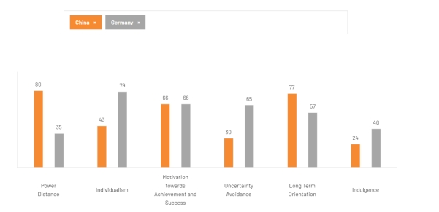
Figure 1: Hofstede’s cultural dimensions of Germany and China (The cultural factor group, 2026)
Dimension | Germany | China | Marketing Implication for Adidas
Power Distance (PI) | 35(Low) | 80(High) | In Germany, Adidas could make use of a more direct and equal communication style. In China, it needs to give respect to hierarchy, the expectation of government and local cultural values (The cultural factor group, 2026).
Individualism | 67(High) | 20(low) | German advertising could focus upon individual performance and personal achievement. In China, advertising needs to focus more upon national pride, community and belonging (Geert Hofstede, 2026).
Motivation towards achievement and success | 66 (High) | 66 (High) | Both countries valued success, competition and achievement. Sports sponsorship and messages regarding performance could thus work well in both the markets (Geert Hofstede, 2026).
Uncertainty avoidance | 65(moderately high) | 30 (low) | German customers prefer clear information, technical details and quality. Chinese consumers are more open to newer products, limited editions, livestreams and fast-changing trends (The cultural factor group, 2026).
Long-term orientation (LTO) | 83 (high) | 87 (high) | Both markets value the long-term relationship; however, in China, Adidas need to consistently invest in local culture and partnerships rather than just relying upon short-term promotions (Geert Hofstede, 2026).
Indulgence (IVR) | 40 (restrained) | 24 (Restrained) | Both markets are less focused on pleasure-based advertising. Adidas should focus on performance, identity and purpose rather than excessive or Luxury lifestyle messaging (The cultural factor group, 2026).
Table 1: Hofstede’s cultural dimensions of Germany and China (The cultural factor group, 2026)

Overall marketing implication
The main lesson is that Adidas should adapt its marketing to each of the country. In Germany, Adidas needs to use a more standard approach based on quality, technology, sporting achievement, and individual performance. In China, it requires a more localised approach which reflects collective identity, national pride, Chinese culture and changing trends of consumers. It is important as China’s higher power distances and stronger institutional influences mean adidas needs to be careful regarding the cultural and political problems. The experience of company which are followed by the 2021 Xinjiang-linked backlash shows that apologising to consumers might not be enough, and companies need to understand and engage with essential local cultural narratives. Thus, Germany could make use of more globally consistent Adidas marketing, wherein China needs greater localisation, faster adaptation and cultural sensitivity.
Altogether, PESTLE and Hofstede show that Adidas require different marketing approaches in China and Germany. In China, Adidas needs to focus more upon local culture, national pride, group identity and fast-changing trends while being careful regarding cultural and political issues. In Germany, Adidas could make use of more standardised approaches by focusing upon quality, technology, reliability and individual performance. Such differences will be utilised in section 1b to develop the STP and 7Ps marketing strategy of Adidas.

1b. Comparative STP and International Marketing Mix (7Ps)

Segmentation, Targeting and Positioning (STP)
Segmentation: Segmentation is termed as dividing customers into different groups based upon their needs, age, interests, buying behaviour and lifestyle. Adidas should use various segmentation approaches in Germany and China as consumers in these markets possess various economic and cultural characteristics. In Germany, Adidas could segment customers mainly based on sporting activities, lifestyle and personal interests. Important groups possess performance focused athletes, customers interested in sustainability and consumers who are consistent with an individualist culture. In China, segmentation is organised more by generational and cultural cohorts, mostly a fast-growing urban Gen Z “ Guochao” segment who reflect a collectivist culture wherein purchasing follows visible generational and social trends (China Daily, 2026).
Targeting: Germany possesses a mature, saturated market, which has pushed Adidas towards larger, multi-segment targeting in performance and lifestyle buyers. The targeting of China is more concentrated upon urban Gen Z and Millennial consumers, as this segment is both fast-growing economically and culturally influential in setting the collectivist trend cycles.
Positioning: Positioning refers to how Adidas wants consumers to analyse and remember the brand as compared with competitors. The positioning of Germany leans upon heritage and technical credibility. Adidas has continued to position its presence in German domestic football, wherein Bundesliga and Adidas had entered strategic cooperation to jointly strengthen the development of German professional football (Bundesliga.com, 2026). Adidas has also planned to deep dive into Chinese culture with an aim to reenergize the local market. Adidas had charted its China comeback with actor Chen Xiao, wherein the company had geared up with a revived China strategy that would double down on localisation initiatives to position the brand as “ In China, for China”. The company hoped to win China’s powerful Generation Z consumers and ride Guochao waves and understand Chinese traditions and culture (Jing Daily, 2023).

7Ps marketing mix
The 7Ps of marketing are product, price, place, promotion, people, process and physical evidence (Chartered Institute of Marketing, 2024). The differences between Adidas in Germany and China come through the cultural and business differences. China possesses a more group-focused culture, great respect for hierarchy, fast-changing consumer trends and strong government influence. Thus, Adidas should have a more local and flexible marketing strategy in China. Germany possesses a more individual-focused culture, strong EU regulations and lower power distance, so Adidas could make use of a standard strategy based upon compliance and quality heritage.
The process, people and physical evidence of the 7Ps are important as they are influenced strongly by the cultural differences.
Element | Germany | China
Product | Adidas focused on performance products like running, football and a training range. It even continues to make investments in recycled and circular materials, which are being supported by the EU’s eco-design for sustainable product regulations. (Carbon fact, 2026). Product development focuses on quality, durability and engineering that align with consumers' perception of German reliability. | Adidas gives more localised and China-exclusive collections like the Chinese New Year pet-apparel line. These products are designed with the local teams rather than simply making adaptations of global products. It gives support to Chinese cultural identity and the Guochao trend explained in the segmentation section ( SGI Europe, 2026).
Price | Adidas makes use of premium pricing as Germany is a mature and high-income market. Customers might be willing to pay more for quality and Adidas brand heritage. Adidas even uses discounts carefully to safeguard its premium brand image. | Adidas need to make use of more competitive prices as it faces strong Chinese competitors like Li-Ning and Anta. These brands gained market shares through Adidas at the time of the 2021 boycott (Fortune, 2021). Different price levels could assist Adidas in reaching both mass-market online customers and those customers who are looking for premium products.
Promotion | Adidas make usage of its sporting heritage and sponsorship of various sports events. The company's partnership with Bundesliga/DFL has strengthened its sports image. This approach fits with the individualistic and achievement-focused culture of Germany, as advertising could focus upon the performance of personal sport (Bundesliga.com, 2026). | Adidas makes use of key opinion leaders, celebrities, and also livestreaming to promote its products. Promotions give focus more upon the Chinese culture and national pride. After the company had faced a boycott in 2021, Adidas had rebuilt its promotional activities and avoided creating a negative reaction in Chinese consumers (NBC News, 2021)
People | The retail and technical staff of Adidas could build communication with customers in a very consultative way. It fits with the lower power-distance culture of Germany, in which customers mostly want direct and informative services. | Adidas requires larger frontline and livestream teams. Employees and livestream hosts need to understand the Chinese culture and consumer expectations. The company also need to be careful regarding local government expectations and public sentiments while representing the brand.
Process | Adidas gives simple and effective shopping and delivery processes across its physical and online stores. These processes are also influenced by the EU environmental and product regulations, which include the eco-design for sustainable product regulation (European Commission, 2026). | Adidas need a fast and more localised process that starts from product design to getting products in stores. Livestream shopping could also be connected directly with checkout. This will suit the fast-changing and trend-driven markets wherein consumers are more comfortable with major change and newer products.
Physical evidence | Adidas makes use of flagship stores, football-related branding and stadium pressures to strengthen its German sporting heritage and technical image. | Adidas makes use of culturally themed flagship stores, local collaboration and China-exclusive product launches. These activities assist Adidas in building brand image and understanding Chinese culture instead of positioning itself as a Western brand selling products in China (Jing Daily, 2026).
Place | Adidas makes use of an omni-channel distribution strategy which includes its own stores, e-commerce and wholesale partners. Company even possess global network for company operated and partner distribution centres (Adidas Group, 2023). | Adidas relies heavily upon advanced digital shopping platforms in China, which include Tmall, WeChat mini-programmes and Douyin livestreaming. These platforms permit customers to discover products and purchase them in a quick manner without leaving the same platforms (Gate Kaizen, 2025).
Table 2: Comparative 7Ps marketing mix, Adidas Germany vs Adidas China
Taking into consideration the STP and 7Ps analyses together, it shows the same overall patterns. The individualistic culture, lower power distance, and strong regulation support to broaden the targeting, a heritage-based position and a standard marketing mix. Moreover, the collectivist culture of China with high power distance and advance digital market supports more focus on targeting, culturally adapted positioning and a localised digital marketing mix.
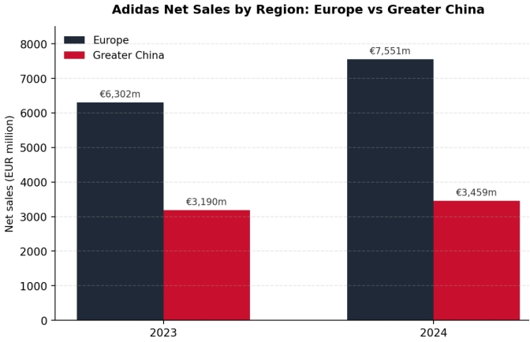
Figure 2: Adidas net sales, Europe vs Greater China, 2023-24 (Adidas Group, 2024a; Adidas Group, 2024b)
Figure 2 also show the difference between European countries and Greater China is not just cultural but also commercial. The net sales of Adidas in Greater China increased from €3,190 million in 2023 to €3,459 million in 2024, which represented an increase of 8% (Adidas Group, 2024b), whereas Europe also saw an increase in net sales from €6,302 million to €7,551 million, which represents a 20% increase in sales (Adidas Group, 2024a). Both regions are thus growing, but Adidas needs to rebuild its position in China after the 2021-22 downturn. Such a rebuilding process is dependent upon great localisation and a strong connection with Chinese consumers. Thus, the STP and 7ps strategies of Adidas in China are different from those used in Germany.

1c. Market entry strategy analysis of China
Adidas had followed a gradual entry strategy in China by increasing its level of investments and control as it had gained experience in the market. The company had first entered China in the early 1980s by means of connections with Chinese soccer and later with the basketball teams. In 1997, Adidas had built an official subsidiary in China by attaining major control of the company over its operations. The 2008 Beijing Olympics then became a main turning point that helped Adidas to rapidly expand in the growing sportswear and athleisure market (Daxue Consulting, 2025). China has been an essential market for Adidas due to its larger population, growing economy, and expanding sportswear industry. In the year 2024, Adidas generated about €3.5 billion in net sales in Greater China, that represent 10% year-on-year growth on a currency-neutral basis.
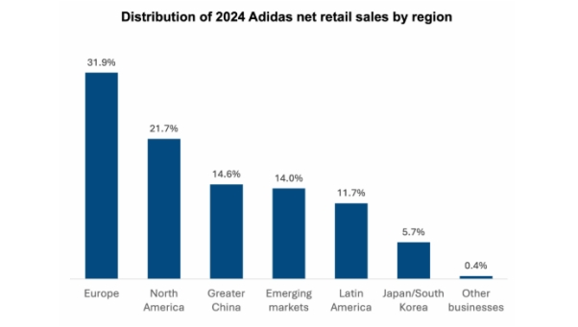
Figure 3: Adidas 2024 net retail sales by region (Daxue Consulting, 2025)
It was a major recovery after a 36% year-on-year decline in revenue in 2022. China now gives contribution to about 15% of global revenue of Adidas which had made company a third-largest market after North America and Europe (Daxue Consulting, 2025). Adidas had also expected double-digit currency-neutral growth in FY2025, which showed continued confidence in the market. The Chinese sportswear market also gave further support for this strategy. It is expected to increase by 700 billion yuan in 2027, reaching about 746.2 billion yuan, with 11.91% of CAGR in between 2022-2027. Moreover, the middle-income population of China is expected to account for more than half of the total population of the country by 2030. This has led to an increased potential customer base for lifestyle and sportswear products (China Daily, 2023).
Adidas had even changed its entry strategy from simple operation in China to “In China, For China. This strategy was introduced in 2023, which gave great decision-making power to the Chinese teams and permitted the company to respond more quickly to customer trends. It was found that about 95% of the Adidas products that are sold in China are produced locally and more than 60% are designed locally (Jiemian news, 2025). The Shanghai creative centre of Adidas, which was established 20 years ago, has supported local approaches through developing products influenced by Chinese culture, including New Chinese style and Tang-inspired collections. The significance of local decision-making is even supported through the business performance of Adidas. In the second quarter, China revenue had reached €766 million, increasing 16.4% year-on-year in 2023 (China Daily, 2023). By the end of 2024, Adidas had reported nine consecutive quarters of growth in China, wherein second quarter revenues increased by 9.3% year-on-year to €822 million (China Daily, 2024). Adidas also operates about 7500 stores across China and opened 300 stores in future cities during 2024 (China Daily, 2024).
The company has continued to make investments in local operations. In 2023, Adidas opened an automated distribution centre in Suzhou. The company had also planned to move its Greater China headquarters to a new 1500 employees campus in the West Bund of Shanghai (Jiemian News, 2025). Moreover, Adidas had also worked with Chinese athletes like Su Yiming and Pan Zhanle, the Chinese Wushu Association and national volleyball teams by supporting the “ Fitness for all” movement.
Overall, Adidas’s China strategy reveals a move towards greater local control, cultural adaptation and production rather than exporting a global strategy.
Period | Entry mode | How Adidas entered | Why this made sense
Early 1980s | Indirect / non-equity | Sponsorships done with Chinese football and basketball teams | Helped Adidas to analyse the Chinese market with low risk.
1990s | Agents, franchising & contract manufacturing | Worked with local agents, franchised retailers and local manufacturers | Local partners assisted the company to understand the market.
1997 | Wholly Owned Subsidiary (WOS) | Adidas established its own subsidiary in China (Chen, 2023) | Led to greater market knowledge and opportunities for higher investment
2008 onwards | Wholly Owned Subsidiary (WOS) | Expanded retail operations through the Beijing Olympics | Olympics increased visibility and opportunities for Adidas
2023 onwards | Wholly Owned Subsidiary (WOS) | Continued wholly owned subsidiary ownership but also introduced "In China, For China" (Daxue Consulting, 2025). | Local decision-making assisted Adidas to respond faster and analyse Chinese consumer needs, culture and changing trends.
Table 3: Entry mode table of Adidas in China

1d. Ethical evaluation of marketing mix in China
The CSR pyramid of Carroll explains that companies possess four main responsibilities, which include economic, legal, ethical and philanthropic. Sometimes, such responsibilities could lead to conflict with one another (Carroll, 2016). The marketing activities of Adidas in China show such conflicts clearly, mainly during the 2021 Xinjiang-cotton controversy. Adidas, along with other Western brands, had expressed concerns regarding the reported forced labour in the Xinjiang cotton supply chain. This positioning is consistent with Western expectations regarding responsible and ethical sourcing. However, taking this position had generated major economic issues as China was Adidas ' most important market.
Year | Greater China net sales | YoY change (Euro terms) | Share of adidas group revenue
2021 | €4,597m (Adidas Group, 2021) | +18.3% (pre-boycott peak) | 21.7% (of €21,234m group revenue)
2022 | €3,179m | ‒30.9% | N/A
2023 | €3,190m (Adidas Group, 2023) | +0.3% | N/A
2024 | €3,459m (Adidas Group, 2024b) | +8.4% | N/A
Table 4: Greater China net sales and shares of Adidas Group revenues
The financial impact of the controversy could be measured clearly, wherein within one month of the boycott, the sales of Adidas on Tmall had fallen by 78% year-on-year. As per the estimation done by Bloomberg Intelligence, Tmall accounted for more than 10% of the revenue for the Chinese sportswear brands. Similarly, rival Chinese brand Li-Nang had seen Tmall sales increase by about 800% during the same time (CGTN, 2021). The impact was even clear in the full-year results of Adidas, wherein Greater China revenue had fallen from €4,597m in 2021 (Adidas Group, 2021) to €3,179m in 2022, a decrease of €1,418m or 30.9%. (Adidas Group, 2023)This took place when China was providing about one-fifth of the revenue of Adidas Group. It was seen that instead of resolving the labour-sourcing concerns through independent checks, Adidas gave major focus upon rebuilding its positioning in China by means of cultural marketing like the Guochao collection and local design control. Even though this assisted the company in getting reconnected with Chinese consumers but did not directly solve the main controversy (Human Rights Watch, 2022). As per Carroll’s CSR pyramid, it suggests that Adidas gave major importance to its economic responsibility, but ethical issues did not get resolved fully. The global positioning of Adidas on responsible sourcing and its actions in Chinese markets was not completely connected in the public records (NBC News, 2021)

1e. Recommendations
Greater China accounted for 21.7% of Adidas ' group revenue in 2021, and controversy led to a loss of €1,418m, i.e. (30.9%) in one year. It is thus recommended that Adidas should aim for a market which helps in exceeding 20% of the group revenue over a 3-year time span. company should even expand in emerging markets like Latin America (+28%) to decline the risks while staying committed towards China. Adidas “in China, for China” strategy has led to +4.3% per annum recovery CAGR after 2022. It is thus recommended that the company should make local decision making as formal KPI, which includes its present 95% local production and 60% local design targets. Moreover, it is recommended that Adidas should reduce its digital platform dependence. Tmall accounts for more than 10% of China revenue and is linked with a 78% decline in sales in April 2021. Adidas needs to set a limit on revenue dependence on just one platform and continue using WeChat and Douyin commerce to reduce future platform-linked risks.
It is further recommended that Adidas publish an independent supply chain audit for China. This would address the concern for labour sourcing directly rather than relying heavily upon cultural marketing to build the reputation (Human Rights Watch, 2022). Lastly, it is also recommended that the company should set a measurable recovery benchmark for future uncertainty. The 2022-24 recovery of 4.3% CAGR needs to become an internal benchmark. Future regulations and competitive shocks need to trigger local decision-making in one year.

Section 2: Reflective account (Reflective cycle of Gibbs)
This section reflects how I researched and prepared Section 1 of this report. I am making use of the reflective cycle of Gibbs, which consists of six steps, namely Description, feelings, evaluation, analysis, conclusion and action plan (Gibbs,1988).
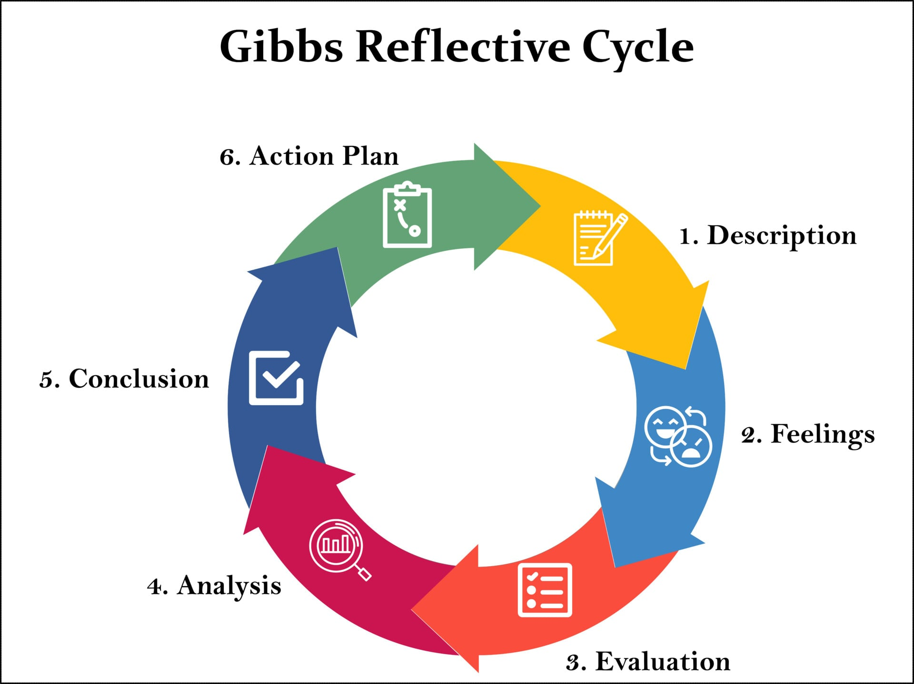
Figure 4: Reflective cycle of Gibbs(Gibbs,1988)

Description
For Section 1 of this report, I had to make a comparison of how Adidas works in China and Germany. It included looking at the STP( segmentation, targeting and positioning), PESTLE, the 7Ps marketing mix and how Adidas entered the Chinese market. To prepare this, I initially read my course notes on marketing theory. Then I searched for real information regarding Adidas, like its annual reports, news articles and academic journal articles. I built up tables and charts to show the data clearly. I wrote every part step by step, with first Germany and then China, along with the market entry part and ethics part. When I shared an early draft, my lecturer said it looked “ too basic” and required more framework, tables and numbers. So, I went back and added more data like sales figures and growth rates and even used theories like Carroll’s CSR pyramid to support my point.

Feelings
At the start, I felt confident. The topic sounded very easy to me as I already knew a little bit regarding the Adidas brand. However, when I started looking at the course material and assignment requirements, I was quite scared. I started searching for the sources needed for this work, but many of them were not easily accessible or were mostly blogs. I was told to use only good sources: articles, annual reports, journals or news articles. This made the search even harder than I expected. I even felt a little nervous when I had to work with numbers such as growth rates and net sales, as I do not enjoy maths. But I pushed myself harder and started to do research properly. I finally found certain strong sources such as Adidas’s own annual reports and open academic journals, which made me feel proud. By the end of this work, I had added tables and calculations, which made me feel more satisfied.

Evaluation
In this assignment, several things went well, wherein in managed to find good-quality sources like Adidas Group’s own reports and open-access academic journals. My usage of tables and small calculations such as growth percentage made my analysis clearer and more convincing than describing things in words. This was a major improvement between my first draft and the final ones. However, it took me a long time to find sources that were both trustworthy and fully open to read. Most of the good articles were behind paid and thus I had to reject them. Sometimes, I picked up sources too quickly but later had to double-check if it opened properly before I could make use of them.

Analysis
This assignment helped me to reflect upon what I had learned in my course. We studied Kotler’s STP model in our marketing lectures, which had assisted me in organising the segmentation. Targeting and positioning section in a proper structure rather than just describing Adidas randomly. We even learned about Hofstede’s cultural dimensions in international marketing, and this had assisted me in explaining why German and Chinese consumers had behaved differently. Without the help of this course theory, I would not have understood why culture affects the marketing choices in every country. In a similar manner, learning about entry mode in my marketing strategy classes had given me the knowledge and structure to explain how Adidas entered China. Similarly, class lectures regarding ethics had helped me to judge whether Adidas’s actions in China were ethical or not. Lastly, I also analysed that a real understanding of the project means using course theories properly and backing them up with actual evidence so that readers could see proven points.

Conclusion
Overall, I learned a lot from doing this task. I learned that stronger academic work requires both theory and real evidence together. Theory alone might look too generic, and evidence alone could feel random, but the combination of both makes the work look stronger and more authentic. I also learned that one needs to be very careful while choosing sources, as not all articles are valuable and useful. I got to know that research skills and writing skills are the two main skills needed while doing any assignment. The lack of either one might make the work vague.

Action plan
For future assignments, I have planned to do a few things differently. Firstly, I will look at my course theories and framework, starting research online so that my research gets clear directions from the start instead of searching randomly. Secondly, I will search for stronger, data-rich, and fully openable sources earlier in the process so that I do not have to make changes later. Thirdly, I will organise my work from the start, as a lack of time might affect the quality of work. This time I had to face a shortage of time as I had to make changes in my second draft due to a lack of organising skills. Lastly, I will also try to include a larger number of calculations, facts and figures, which can make the work more authentic (EBSCO, 2024). Overall, this task not only taught me about the marketing strategies of Adidas but also upgraded my researching, writing and time-management skills.

References
Adidas Group (2021) Business Performance by Segment: Greater China. Annual Report 2021. Available at: https://report.adidas-group.com/2021/en/group-management-report-financial-review/business-performance-by-segment/greater-china.html (Accessed 05 August 2026).
Adidas Group (2023) Business Performance by Segment: Greater China. Annual Report 2023. Available at: https://report.adidas-group.com/2023/en/group-management-report-financial-review/business-performance-by-segment/greater-china.html (Accessed 08 August 2026).
Adidas Group (2024a) Business Performance by Segment: Europe. Annual Report 2024. Available at: https://report.adidas-group.com/2024/en/group-management-report-financial-review/business-performance-by-segment/europe.html (Accessed 07 August 2026).
Adidas Group (2024b) Business Performance by Segment: Greater China. Annual Report 2024. Available at: https://report.adidas-group.com/2024/en/group-management-report-financial-review/business-performance-by-segment/greater-china.html (Accessed 06 August 2026).
Adidas Group (2025) Business Performance by Segment: Greater China. Annual Report 2025. Available at: https://report.adidas-group.com/2025/en/group-management-report-financial-review/business-performance-by-segment/greater-china.html (Accessed 05 August 2026).
Adidas Group (2025) Impact, Risk and Opportunity Management. Available at: https://report.adidas-group.com/2025/en/group-management-report-sustainability-statement/esrs-e5-resource-use-and-circular-economy/impact-risk-and-opportunity-management.html (Accessed 09 August 2026).
Bundesliga.com (2026) Official Future Partner: Bundesliga and adidas enter strategic cooperation. Available at: https://www.bundesliga.com/en/bundesliga/news/dfl-adidas-future-partner-strategic-cooperation-develop-german-football-37119 (Accessed 05 August 2026).
Business of Fashion (2024) Why Adidas' China Comeback Is Lagging Nike's. Available at: https://www.businessoffashion.com/briefings/china/why-adidas-china-comeback-is-lagging-nikes/ (Accessed 06 August 2026).
Campaign Asia (2026) Brand Health Check: What's behind Adidas' brand surge in China? Available at: https://www.campaignasia.com/article/brand-health-check-whats-behind-adidas-brand-surge-in-china/502988 (Accessed 09 August 2026).
Carbonfact (2026) For Fashion: Eco-design for Sustainable Products Regulation (ESPR). Available at: https://www.carbonfact.com/blog/policy/espr-textile (Accessed 05 August 2026).
Carroll, A.B. (2016) ‘Carroll's pyramid of CSR: taking another look’, International Journal of Corporate Social Responsibility, 1(3). Available at: https://link.springer.com/article/10.1186/s40991-016-0004-6 (Accessed 05 August 2026).
CCFGroup (2025) Adidas reports full-year 2024 revenue of EUR 23.68 billion. Available at: https://www.ccfgroup.com/newscenter/newsview.php?Class_ID=600000&Info_ID=2025031030088 (Accessed 05 August 2026).
CGTN (2021) ‘Adidas, Nike web sales in China plunge amid boycott’. Available at: https://news.cgtn.com/news/2021-05-08/Adidas-Nike-web-sales-in-China-plunge-amid-boycott-104yI2pP0mQ/index.html (Accessed 02 August 2026).
Chartered Institute of Marketing (CIM) (2024) The 7 Ps of marketing. Available at: https://www.cim.co.uk/content-insights/articles/the-7ps-of-marketing/ (Accessed 05 August 2026).
Chen, J. (2023) ‘An In-depth Comparative Analysis of Adidas' Marketing Strategies and Market Comparison in the Chinese Market’, Advances in Economics, Business and Management Research, 260. Atlantis Press. Available at: https://www.atlantis-press.com/article/125991551.pdf (Accessed 05 August 2026).
China Daily (2023) ‘Adidas stays in play with bullish outlook for China’. Available at: https://global.chinadaily.com.cn/a/202309/27/WS6513826aa310d2dce4bb80cd.html/ (Accessed 07 August 2026).
China Daily (2024) ‘Adidas takes part in IBLAC in Shanghai’. Available at: https://global.chinadaily.com.cn/a/202409/22/WS66ef8a71a3103711928a914a.html (Accessed 07 August 2026).
China Daily (2026) ‘Gen Z-fuelled guochao trend drives shift to meet market needs’. Available at: https://www.chinadaily.com.cn/a/202604/16/WS69e00ef5a310d6866eb43a8d.html (Accessed 05 August 2026).
Daxue Consulting (2025) Adidas in China: Winning back consumers through its “In China, For China” strategy. Available at: https://daxueconsulting.com/market-research-on-adidas-in-china/ (Accessed 05 August 2026).
EBSCO (2024) Gibbs' Reflective Cycle. Education Research Starters. Available at: https://www.ebsco.com/research-starters/education/gibbs-reflective-cycle (Accessed 07 August 2026).
European Commission (2026) New EU rules to stop the destruction of unsold clothes and shoes. Available at: https://environment.ec.europa.eu/news/new-eu-rules-stop-destruction-unsold-clothes-and-shoes-2026-02-09_en (Accessed 09 August 2026).
Fortune (2021) ‘The biggest sneaker company you've never heard of is capitalising on China's Nike and Adidas boycotts’. Available at: https://fortune.com/2021/04/03/anta-shoes-sneakers-basketball-nike-adidas-xinjiang-cotton-boycott-china (Accessed 10 August 2026).
Gate Kaizen (2025) China Livestream E-Commerce vs Traditional E-Commerce. Available at: https://gatekaizen.com/china-livestream-ecommerce-vs-traditional-ecommerce/ (Accessed 05 August 2026).
Geert Hofstede (2026) Country Comparison Bar Charts. Available at: https://geerthofstede.com/country-comparison-bar-charts/ (Accessed 05 August 2026).
Gibbs, G. (1988) Learning by Doing: A Guide to Teaching and Learning Methods. Oxford: Further Education Unit, Oxford Polytechnic. Available at: https://thoughtsmostlyaboutlearning.wordpress.com/wp-content/uploads/2015/12/learning-by-doing-graham-gibbs.pdf (Accessed 05 August 2026).
Human Rights Watch (2022) China: US Law Against Uyghur Forced Labour Takes Effect. Available at: https://www.hrw.org/news/2022/06/20/china-us-law-against-uyghur-forced-labour-takes-effect (Accessed 05 August 2026).
Intelligent Automation Network (2023) How adidas is owning the digital transformation game. Available at: https://www.intelligentautomation.network/transformation/articles/how-adidas-is-owning-the-digital-transformation-game (Accessed 05 August 2026).
Jiemian News (2025) ‘Adidas deepens China push, highlighting local design and manufacturing’. Available at: https://en.jiemian.com/article/13473628.html (Accessed 05 August 2026).
Jing Daily (2023) Adidas’ Deep Dive Into Chinese Culture Aims To Re-energise The Local Market. Available at: https://jingdaily.com/posts/adidas-2023-chinese-culture-chen-xiao (Accessed 05 August 2026).
Market Data Forecast (2026) Europe Athletic Wear Market Size & Share Report, 2034. Available at: https://www.marketdataforecast.com/market-reports/europe-athletic-wear-market (Accessed 05 August 2026).
NBC News (2021) China steps up pressure on brands to reject reports of Uyghur abuses. Available at: https://www.nbcnews.com/news/world/china-steps-pressure-brands-reject-reports-uyghur-abuses-n1262315 (Accessed 05 August 2026).
RedFern Digital (2026) Worth The Read. Available at: https://redferndigital.cn/worth-the-read/ (Accessed 05 August 2026).
SGI Europe (2026) Adidas launches new pet collection in China. Available at: https://www.sgieurope.com/products/adidas-launches-new-pet-collection-in-china/118773.article (Accessed 05 August 2026).
The Cultural Factor Group (2026) Country Comparison Tool. Available at: https://www.theculturefactor.com/country-comparison-tool?countries=china%2Cgermany (Accessed 05 August 2026).
The Sustainable Innovation (2026) Adidas Sustainability. Available at: https://thesustainableinnovation.com/adidas/ (Accessed 05 August 2026).
World Footwear (2021) adidas aims to have 9 out of 10 sustainable products by 2025. Available at: https://www.worldfootwear.com/news/adidas-aims-to-have-9-out-of-10-sustainable-products-by-2025/6343.html (Accessed 07 August 2026).

