Contents:

- Project Proposal Page. 2
- Space and Place Page. 3
- Interaction with the Environment Page. 5
- Emotional and Social Design Page. 8
- The Power of Colour Page. 10
- Conclusion Page. 14
- Bibliography Page. 16

Project Proposal:
As this is my final year studying at UWTSD, I want to ensure that my end of year degree show, social media presence and portfolio positively translates and promotes myself as a confident, strong multidisciplinary Surface Pattern practitioner. I am motivated to apply the technical processes which I have developed throughout the four years studying Surface Pattern Design, to the environment. As well as pursuing my interest in understanding humankind’s relationship with the surrounding environment, I will also explore how art can connect us to that environment; this will be the main inspiration for my work. In this proposal I will explore and set-out my own design ideas relating to space and place and consider how colour, image and texture can impact on the environment. I will also explore my own practice in relation to other artists and artistic projects that align with my own practice.
My intended outcome for Creative Venture is to create a collection of diverse lifestyle products which will be displayed in front of a related largescale interior abstract painted surface. This collection will utilise bright colours that have a strong psychological impact, and natural, rough textures taken from urban and rural environments – both these aspects define me as a design practitioner. By creating a collection of products including a one-off painting, I will demonstrate my ability to apply my designs to multiple contexts. In doing so, I aim to avoid being restricted to one particular design community and this flexible approach will broaden the opportunity to appeal to multiple future employers.

Space and Place

Being physically, emotionally and psychologically aware of the spaces that surround us and of our place within them could be described as having a sense of presence.
(Goodwin, 2014, p.36.)

I’ve always been interested and inspired by my surroundings, observing texture and unusual shapes when travelling. I am an artist that is interested in the way in which we experience and connect to the natural world around us and my body of work responds to the journeys I have taken. Yvonne Farrell (Farrell, 2014, p. 87) talks about how ‘Feeling present is becoming aware that you stand in this space at this time, that you are alive.’ She described looking at the floor as she walks and noticing the numerous ‘variety and patterns. This heightens our sense of being alive. ‘…it is important to become more aware of our surroundings, to understand the positive and negative effects of different spaces.’ Walking is an important part of my practice to inspire me and the areas that will influence my final design includes the rural Welsh landscapes of the Brecon Beacons and coastline, as well as the urban city environments of Swansea.
The first module of my MDes, The Thought Experiment enabled me to step outside my comfort zone, encouraging me to change and develop my ways of working. I usually start a project by drawing into a small A5 journal, capturing a variety of shapes, textures and patterns, which are scanned and further developed into designs and patterns.
However, for this module I drew directly onto a large, continuous roll of paper. This felt alien to me, firstly because working to this scale was unfamiliar and also because the evolution of my designs were permanently captured. This meant that audience could see the development of my ideas.
No photographs are taken during my journeys as I find that using a camera lens to observe, lessons my sense of connection to a place. Instead I make quick sketches and notes that later prompt memories and emotions, that I transfer as drawings on the paper roll. This approach requires good observational sand recollection skills that result from being engaged and emotionally connecting with my surroundings; it enables me to give a personal remembered experience of my walk in a visual form.
I use a range of colours and medias, layering shapes and forms on top of one another, reflecting what I have seen and felt. My paintings and drawings start as complete abstractions, yet some shapes become familiar due to their organic nature. Whilst they reflect my personal experience of the Welsh landscape, the familiar images may resonate with the audience creating a sense of a shared experience.
My journeys have been very important for providing inspiration and developing my ideas. In order to incorporate my experiences into my design work, I have immersed myself within my surroundings to understand the effects on my senses and emotions. This has also enabled me to connect to my surrounding environment which I strongly believe there is a lack of in the 21st century, due to the use of technology and social media (Noble, 2017). This makes me particularly interested in how design can be used to engage the audience with their surroundings and influence their emotional and social experiences.
A lecture delivered by Professor Catrin Webster in the first semester, really inspired me to research in depth about Space and Place and the connections we build to our surrounding environment. This talk made me think even more deeply about the connections we have to our surroundings and motivated me to venture into new environments for fresh inspiration.
This module pushed me outside of my comfort zone and has evolved my ways of working in practice. I will use Creative Venture to explore the effects that can be generated by working on a larger scale; I particularly want to change a space by using its environment as inspiration, to create a new space that reflects that environment in the end result.

Interaction with the Environment

Beauty comes from conscious reflection and experience. It is influenced by knowledge, learning, and culture. Objects that are unattractive on the surface can give pleasure. Discordant music, for example, can be beautiful. Ugly art can be beautiful. (Donald, 2004)

In October 2019, I visited Olafur Eliasson: In Real Life at Tate Modern (2019). This exhibition brings together a body of work consisting of a range of installations, sculptures, photography and paintings - using a wide range of materials from light and reflective metals to water and fog; these are used to change the feel and mood of a space. Eliasson’s work aims to create an experience for the audience that highlights their awareness of the environment they are in and makes them become more aware of all their senses

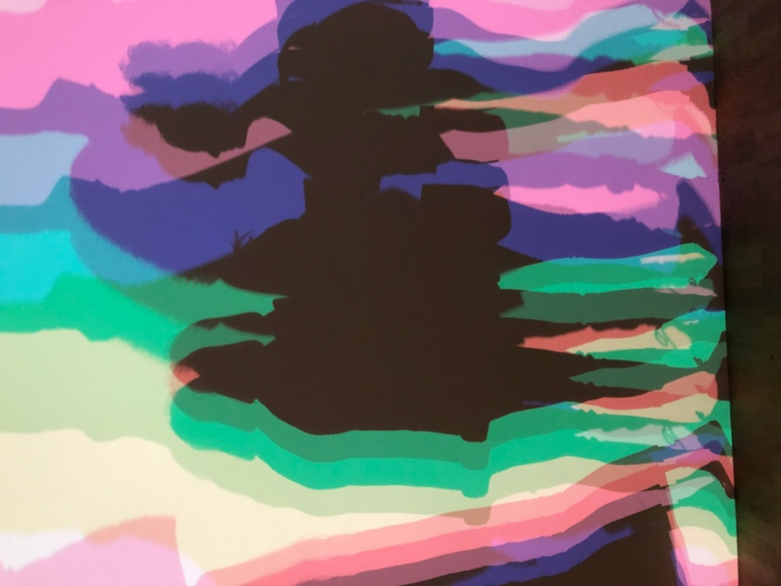
Eliasson’s interest in movement, light and space can be seen in Your uncertain shadow (colour), (2010) seen in figure one. This piece took place in a large empty room with light being projected onto a wall. On entering the room, people’s bodies interrupted the light and cast multiple shadows in varied colours that captured the flow of the body’s movements. I interpreted the term ‘uncertain’ in the title of this piece, as reference to the change in the intensity of the shadow, depending on where people stood in the room. The colour intensity of the shadows varied and was determined by the movement of the body
Figure One: Your uncertain shadow (colour), 2010

and how close a person was to the light source at the back of the room. This particular artwork was a playful visual experience for visitors to interact with light and reflections, changing the perception of how light, colour and shapes can change a space. This has made me consider how I may generate a similar level of audience engagement with my designs for my final collection.

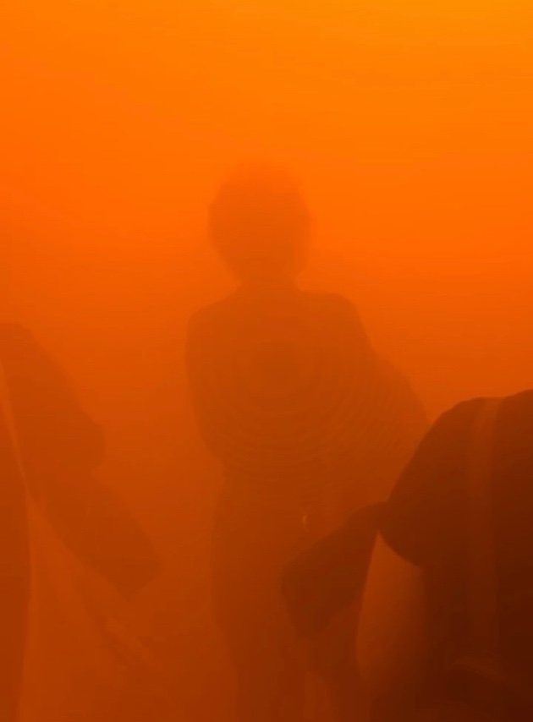
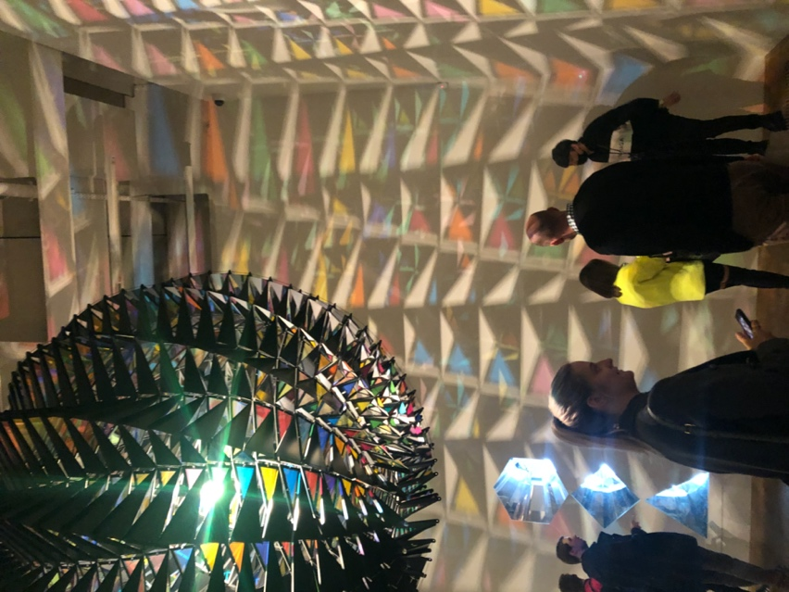
Some of my favourite artworks displayed include, In real Life (2019) (figure two) and Din blinde passager (2010) (figure three).
Figure Two: In real Life, 2019
Figure Three: Din Blinde Passager, 2010

Din blinde passager (2010) (figure three), means your blind passenger. It was a long tunnel filled with dense fog, limiting visibility and drawing a person to use their other senses which became heightened in the absence of sight. It created an experience that allows a person to engage with their surroundings, inviting close attention to be paid to subtle changes to light and sound, throughout the tunnel. Using a variety of different lights such as golden sunrise to deep twilight, Eliasson creates an entire day in a singular, intense experience. With limited vision and space, the audience are encouraged to notice the change in light that usually goes unnoticed and is quite a personal intimate experience that affects every visitor differently. In some instances, this is an unpleasant experience, that generates claustrophobia due to the inability to see at distance. However, it is ultimately a reminder of how we take our sight and environment for granted, unaware of what’s around us. Following my experience of Din blinde passager, I have concluded that I will avoid creating a design that will evoke a negative energy from the audience, as this is contrary to what I want my designs to achieve. I want the audience to engage with my work and be positively excited and uplifted from what they have experienced.

Emotional and Social Design

In the 21st century, many people feel there is an increasing lack of connection between individuals. Through the explosion of social media platforms, it can seem that we are more ‘connected’ by using our technological devices to stay in touch with friends and family, rather than real-life, direct connection. Instead, social media may be considered a distraction and a toxic substitute for real connections and may inadvertently drive us to become more antisocial. A largescale study by Kasperksy Lab revealed that people who use social media now have in the region of 23-35% less face-to-face contact than in previous years due to the ability to be in constant communication online. (Noble, 2017)

We are not only excluding ourselves from each other by communicating through devices, we are also destroying our relationship with the natural world. A virtual experience does not typically utilise all the senses and subsequently dilutes the effect of that experience. In contrast, a physical encounter enables a person to connect with their surroundings and be emotionally engaged with it. This is the effect that Eliasson’s In Real Life exhibition created.

Mark Boyle from the Guardian writes about how stopping use of his social media platforms and phone etc. allowed him to reconnect with his surroundings. He notes that constant use of our mobile devices ‘has led us to valuing the natural world less, meaning we protect and care for it less.’ (Boyle, 2016)

Access to nature has been shown to improve sleep quality, decrease blood pressure, and even lengthen lifespan. Large-scale studies conducted in the United States, Britain, and the Netherlands show that people living in greener areas have a lower incidence of anxiety and depression and display an ability to recover more quickly from stressful life events than those in less green areas. (Lee, 2018, pp.82-83)

Emotional and Social Design are processes used by designers to connect the audience to objects and the environment. This approach takes into consideration the connection between the consumers and designed objects and the emotions that arise from them. Similarly, Social Design looks at how design can bring about social change and change the views of society.

Social Design is something that I particularly wish to explore as I am interested in how negative environments can be transformed into positive ones through the use of colour, texture and image. By using bright, bold colours to positively transition a person’s experience and interaction with a space it may be possible to change their perception, awareness and desire to use and retain social public spaces.

The majority of public space in cities is taken up by roads and is dominated by traffic. By revamping social spaces and integrating colour and patterns into the environment, it introduces beauty into otherwise dull landscapes and also invites people to engage with their surroundings. ‘Our streets and squares don’t have to be dull – a new breed of designers and architects is bringing fun to public spaces’ (Kafka, 2019, p.47)

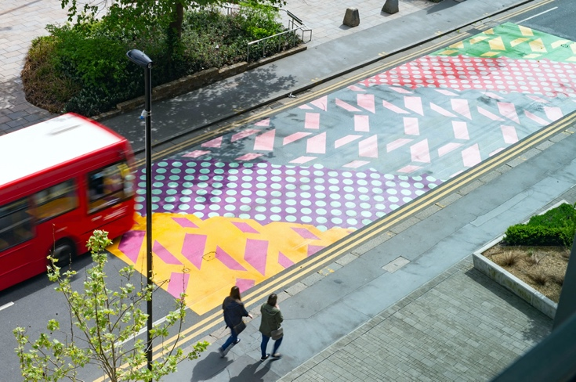
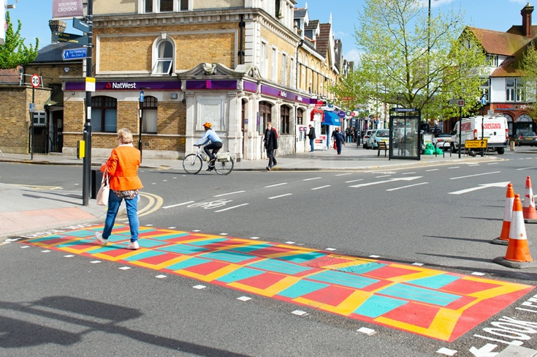
Figure Five: Look Down to Look Up, 2018

Figure Four: Look Down to Look Up, 2018

Look Down to Look Up is a project that Adam Nathaniel Furman ran in 2018 for Croydon Council, South London. He revamped public spaces across the city, for example pedestrian crossings, using abstract interpretative designs of urban skylines to change the way citizens viewed the space, as seen in figures four and five. Furman said, ‘the city around us is the biggest gallery, of life, materials and compositions, and its buildings can provide endless delight.’ (Furman, 2018).

Furman’s comments are both interesting and insightful as they offer a way to reinvent the use of public spaces and connect us back to our surroundings by using colour and pattern – a great way to uplift a grey city space. This project reinvigorates existing spaces that typically go unnoticed in everyday life. These spaces become invisible due their familiarity and bland identity that diminishes appreciation. Similarly, Kate Goodwin talks about the three factors we take for granted ‘the nature of physical spaces, our perception of them and their evocative power.’ (Goodwin, 2014, p. 36.) Look Down to Look Up takes specific features in Croydon and transforms them into fun, energetic spaces through the use of exciting patterns, colours and shapes. I believe that by using art and design the beauty of our environment can be restored, and public interaction and appreciation can be re-stablished; it is my ambition that my designs engender this change.

The Power of Colour

The combination of colour and design can be a powerful tool for engaging people, influencing their emotions and promoting interactions. A successful creation can engender feelings and opinions that people are willing to share and discuss. Additionally, colour can invite engagement with the things it has been applied to, as discussed by Ingrid Fetell Lee in Joyful: The Surprising Power of Ordinary Things to Create Extraordinary Happiness (2018),

...it was clear that the liveliest places and objects all have one thing in common: bright, vivid color. Whether it’s a row of houses painted in bold swaths of candy hues or a display of colored markers in a stationery shop, vibrant color invariably sparks a feeling of delight. (Lee, 2018, p.16)

Publicolor is an American program that helps children connect with their classroom environment by using colour and design. Publicolor believe that colour makes a strong, lasting impact on the environment. ‘The effects of color on human beings can be varied; causing excitement, lending calm, giving inspiration, raising anxiety or tension or giving peace are some of these effects’ (Etkisi, 2017). They not only work to engage children with their environments, they also look at public environments that are run down and which the council would like the public to reconnect with. For example, the grey walkway in figure six, becomes a happy, bright and warm space as shown in figure seven with the application of colour. As the Publicolor note, ‘Brightly colored corridors encourage people to move from place to place.’ (Publicolor, 2019).
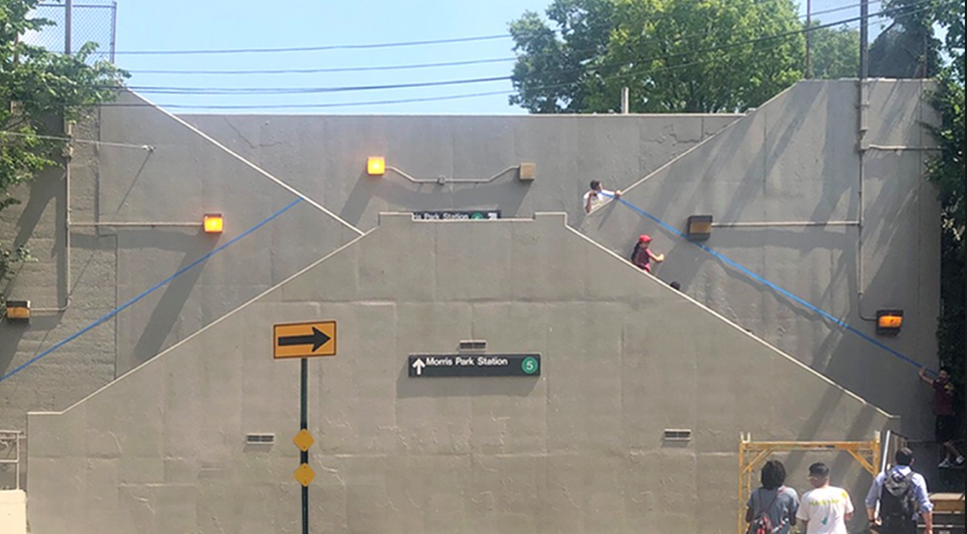

Figure Six: Before & After, Publicolor, 2019

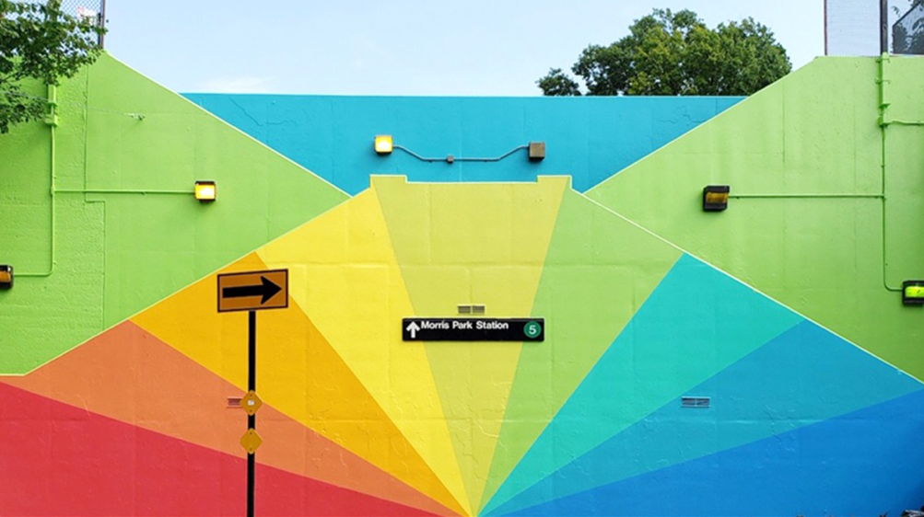

Figure Seven: Before & After, Publicolor, 2019

Camille Walala is an artist whose work expresses positivity through using bright bold colour and pattern, creating environments that stimulate the audience’s senses and inspires joy. Walala works on a both micro and macro scales to transition a space with her pop-art style art. Industry City (2018) (figure eight), is a permanent piece, covering a building in Brooklyn, New York with her iconic, playful, graphic patterns and colour scheme. Influenced by the original architecture of the building, Walala chose a palette to enhance the window frames of the building, creating a 3D illusion that is visually arresting to passes by.
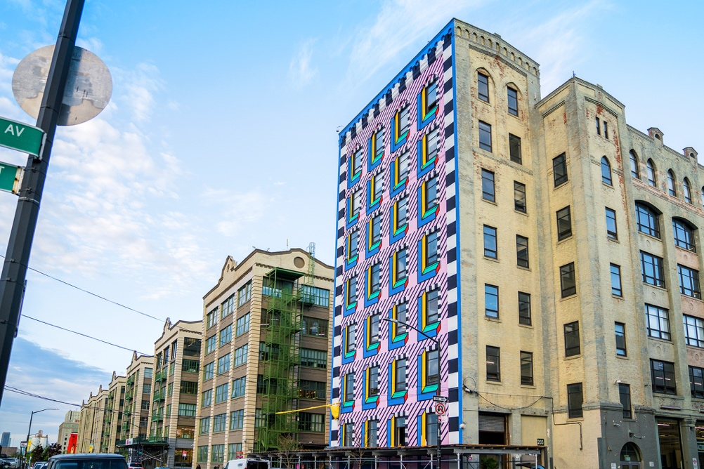

Figure Eight: Industry City, 2018

By working on a larger surface, using eye-catching colours and graphic patterns with such energy, it overrides the dull, run-down urban landscape, and in a similar way to Look Down to Look Up, reconnects the public with their surroundings. I believe this brings joy back into an area.

I have highlighted how colourful designs can be used to encourage social engagement. However, the combination of colour, texture and design has been used for more holistic purposes. I recently attended a talk delivered by Jane Willis, co-founder of Willis Newson the UKs leading arts and health consultancy; Willis Newson focuses on transforming clinical indoor spaces to become more welcoming and supportive of the healing process. Jane explained the importance of involving the public in developing the end result. For example, by running workshops with patients, Willis was able to understand what was required to make a hospital environment more positive.

Willis highlighted that patients’ key requirements included integrating a feeling of outdoors with the internal space. This involved using a colour scheme and imagery of the natural world, that patients could relate to and feel nurtured by.

Conclusion:

Within the field of Psychology there is a great deal of research regarding the impact of colour and light on mood (see for example Küller et al, 2006). While this is a very interesting area, my focus is more on how I can incorporate colour in conjunction with pattern to create a mood and connect the audience with my work. As an artist, I am working intuitively and from my personal experience rather than from research and experiments.

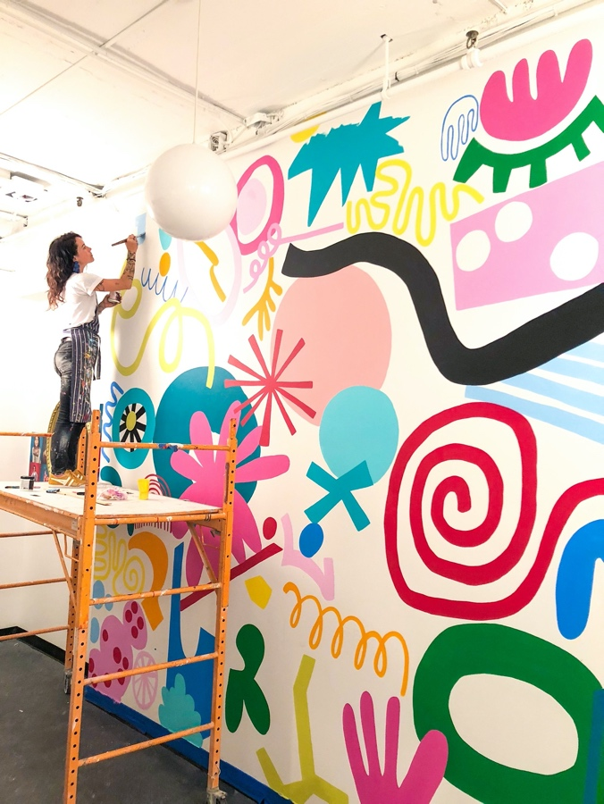
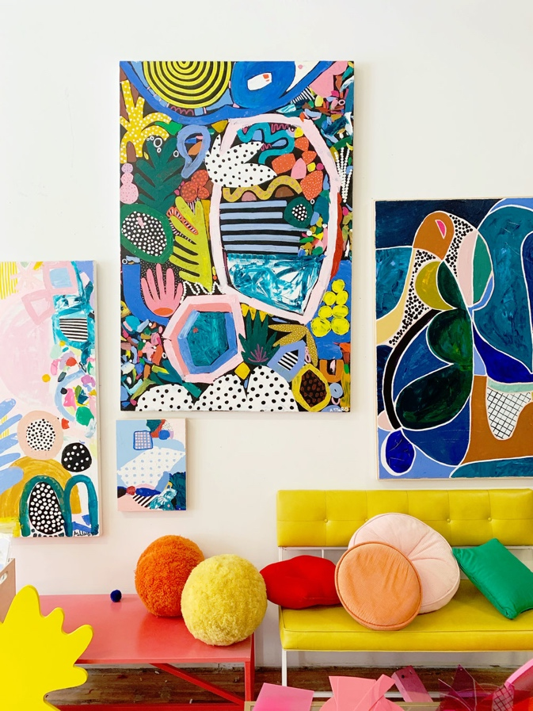
Figure Nine: Stomping Ground Mural, 2018
Figure Ten: West Elm Collaboration, 2019

Figures nine and ten are examples of work by Ashley Mary. Mary produces work that appeal to my design interests in the use of colour and pattern; this is applied across multiple surfaces from products to installations. I particularly enjoy the heavy use of textures and bold colours, creating an enhanced connection to the environment.
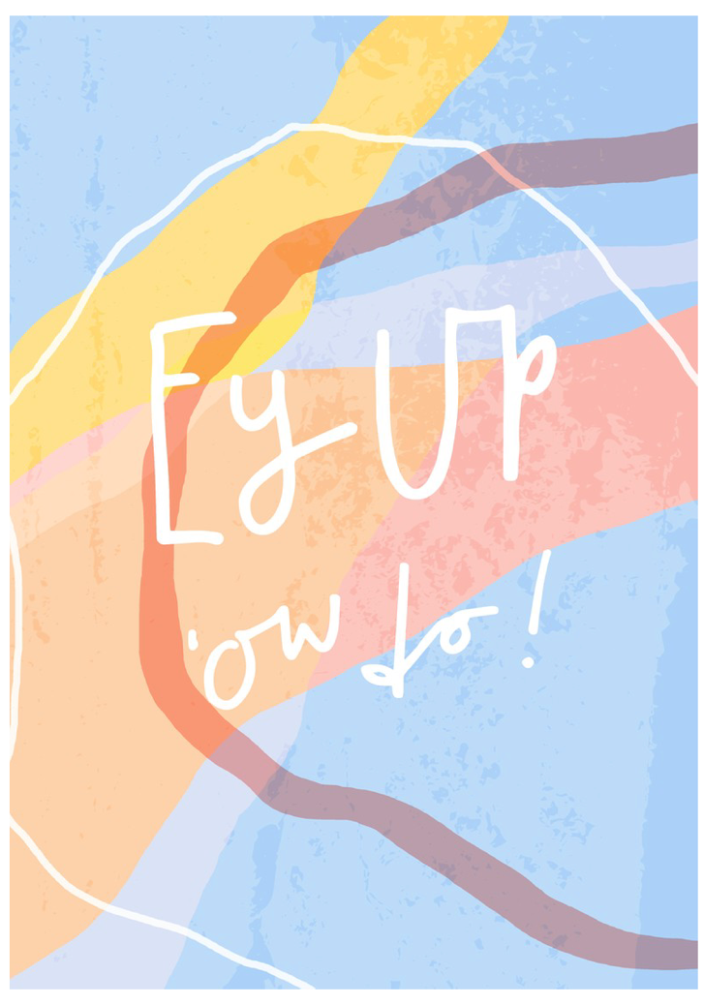
Figures eleven and twelve are examples of previous work that I produced for my end of year show 2019. These designs depict Yorkshire landscapes (figure Scarborough Bay and figure Ilkley Moor) and use Yorkshire colloquialisms that reinforce their regional identity. In a similar way to Mary, my designs incorporate abstract shapes and bold use of colour. And as mentioned before, this is something I want to develop further.
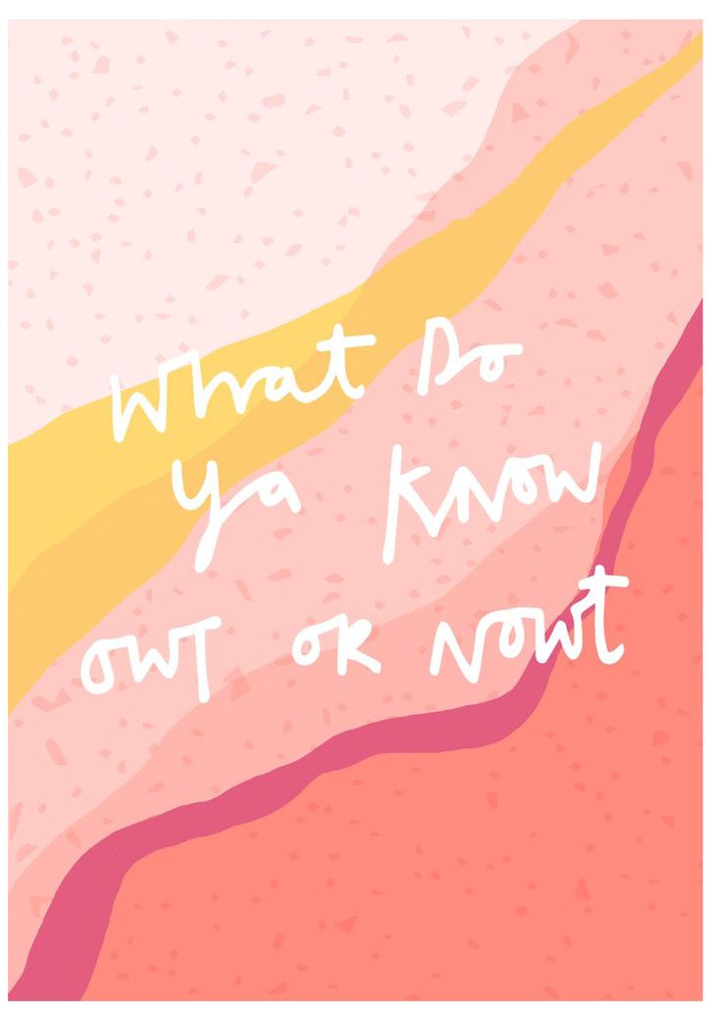
Figure Twelve: Overlooked Beauty, 2019
Figure Eleven: Overlooked Beauty, 2019

Additionally, by using colour, image and texture (three things that defines me as a designer) I want to reignite our relationship with space, helping the audience reflect on their surroundings that is currently taken for granted. By doing this, I intend the audiences emotional response to my work to be positive and joyful following a renewed appreciation of the beauty that the environment holds. This is something that Donald discusses,

It is only at the reflective level that consciousness and the highest levels of feeling, emotions, and cognition reside. It is only here that the full impact of both thought and emotions are experienced. At the lower visceral and behavioural levels, there is only affect, but without interpretation or consciousness. Interpretation, understanding, and reasoning come from the reflective level. (Donald, 2004)

I intend to develop my ideas on Space and Place by visiting Welsh rural and urban landscapes. I will obtain primary resources by documenting my personal experience and responses to the environment, working on a variety of different scaled grounds to achieve different inspirations. Creative Venture will allow me to look into types of products and their use, that will affect the consumers emotional response to their surroundings; this will include the type of materials my designs will use.

Bibliography:

- Baker, J (2019) The Art of Emotion – Norman’s 3 Levels of Emotional Design. Available: https://medium.muz.li/the-art-of-emotion-normans-3-levels-of-emotional-design-88a1fb495b1d [Accessed: 20th November 2019]
- Boyle, M (2016) ‘Technology destroys people and places. I’m rejecting it’, The Guardian. Available: https://www.theguardian.com/commentisfree/2016/dec/19/life-without-technology-rejecting-technology [Accessed: 29th November 2019]
- Donald, N (2004) Emotional Design: Why We Love (or Hate) Everyday Things,
- Eliasson, O (2019) Olafur Eliasson: In Real Life, 2019-2020. Available: https://olafureliasson.net/archive/exhibition/EXH102539/olafur-eliasson-in-real-life#slideshow [Accessed: 18th November 2019]
- Etkisi, R (2017) The Effects of Colors on Children. Available: http://renketkisi.com/en/the-effects-of-colors-on-children.html [Accessed:29th December 2019]
- Farrell, Y (2014) Sensing Spaces: Architecture Reimagined, London: Royal Academy of Arts London.
- Furman, A (2019) Look Down to Look Up. Available: http://www.adamnathanielfurman.com/projects.php?pc_id=60 [Accessed 29th November 2019]
- Goodwin, K (2014) Sensing Spaces: Architecture Reimagined, London: Royal Academy of Arts London.
- Jeon, M (2017) Emotions and Affect in Human Factors and Human-Computer Interaction. Available: https://www.sciencedirect.com/topics/computer-science/emotional-design [Accessed: 18th November 2019]
- Kafka, G (2019) ‘Social Design’ Elle Decoration UK, pp.47-50.
- Komninos, A (2018) Norman’s Three Levels of Design. Available: https://www.interaction-design.org/literature/article/norman-s-three-levels-of-design [Accessed: 18th November 2019]
- Kuller R, Ballal S, Laike T, Mikellides B, Tonello G, (2006) ‘The impact of light and colour on psychological mood: a cross-cultural study of indoor work environments’, Ergonomics. Nov 15;49(14):1496-507
- Lee, I (2018) Joyful: The Surprising Power of Ordinary Things to Create Extraordinary Happiness
- Mary, A (2019) Ashley Mary: About. Available: http://ashleymary.com [Accessed: 7th January 2020]
- Noble, J (2017) Study: Social Media Making People Anti-Social, Jealous. Available: https://www.studyfinds.org/study-finds-social-media-jealousy-facebook/ [Accessed: 6th January 2020]
- Publicolor (2019) Color Research. Available: https://www.publicolor.org/copy-of-testimonials [Accessed: 29th December 2019]
- Tate Modern (2019) Olafur Eliasson: In Real Life – Exhibition Guide. Available: https://www.tate.org.uk/whats-on/tate-modern/exhibition/olafur-eliasson/exhibition-guide [Accessed: 18th December 2019]
- Walala, C (2019) Camille Walala: Profile. Available: https://www.camillewalala.com [Accessed: 6th January 2020]
- Willisnewson (2019) About Us. Available: http://www.willisnewson.co.uk [Accessed 2nd January]

Imagery:
- Eliasson, O. (2010) Your uncertain shadow (colour), [Installation], Tate Modern, London, July 2019-January 2020.

- Eliasson, O. 2019) In real Life, [Installation], Tate Modern, London, July 2019-January 2020.

- Eliasson, O. (2010) Din Blinde Passager, [Installation], Tate Modern, London, July 2019-Jnauary 2020.

- Furman, A. (2018) Look Down to Look Up, [Collaboration] Croydon, South London.

- Mary, A. (2018) Stomping Ground, [Mural], Brooklyn, New York, Summer 2018.

- Mary, A. (2019) West Elm, [Painting Series].

- Walala, C. (2018) Industry City, [Permanent Mural] Brooklyn, New York.

