Effective communication

Academic Skills LCBB4000
Student ID:202008
Valentin Victor Zlate

Table of Contents

1.0 Introduction 3
2.0 Findings 3
2.1 Significance of effective business communication and different channels used for it 3
2.2 Role of communication in maintaining workplace environment 4
2.3 Application of Communication theory, process, or model in managing workplace harmony 6
2.4 Barriers to communication in the workplace 7
3.0 Conclusions 7
4.0 Recommendations 8

1.0 Introduction
The current report aims to explore the roles of different communication processes for maintaining workplace harmony. The discussion would be revolved around the general significance of effective business communication and the different channels used for the process. Along with this, the application of different theories, models, or frameworks of communication would also be discussed, along with highlighting the barriers companies faced while communicating with different stakeholders. In the last section, a number of strategies would be represented for improving workplace communication in the modern age.

2.0 Findings

2.1 Significance of effective business communication and different channels used for it
According to the statement of Adekunle et al. (2019), all the organisations, currently running their operations in the present era, have complete reliance on the process of communication and interaction. Chakraborty and Biswas (2021) mentioned that communication can be defined as a process of exchanging ideas, information, or messages, through speech, writing, or signalling process. Absence of communication might hamper both the internal and external processes, which ultimately leads to the workplace disharmony as well. Through considering the statement of Stiehr and Vandermause (2017), managers always need to engage with their subordinates, around 70 to 90% of the time, for showing that they are equally respected and valued, and this could create a positive work environment as well.
According to a recent Statista report, in the year 2019, around 45% of organisations follow online communication channels, like emails, HR portals or Intranet, Live Chat, Surveys, Text messages, Social network, social media, Mobile Push applications, Chat Bots, and so on (Radovic Markovic and Salamzadeh, 2018). Apart from this, various organisations also use private messaging software, video or audio conferencing software, internal podcasts, and so on. On the other hand, firms have often used various offline communication platforms for their employees, like brochures, infographics, employee manual, rack cards, and so on.
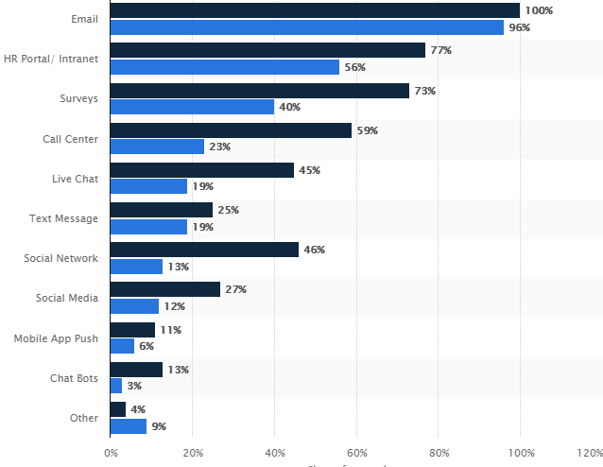
Figure 1: Usage of different communication tools within various enterprises globally in 2019
(Source: Statista, 2020)

2.2 Role of communication in maintaining a workplace environment
From the viewpoint of Vandenack (2018), communication can be considered as the backbone of every workplace, as management requires implementing the process for achieving valuable performance as well as motivational vibes. In every organisation, management requires considering their subordinates associated in each level. The purpose of involving employees in each functional or operational aspect is to explain the efficiency and performance standard required from them to meet the organisational objectives. D Hemmige (2017) mentioned that this is a significant part and parameter of business success, and to achieve this, extensive communication is required in every stage.
Hänninen and Karjaluoto (2017) mentioned that communication makes possible progress while employers try to interact, coordinate, and cooperate with their members or employees. For maintaining workplace harmony, it is necessary for every employer to first establish the communication bridge, by implementing effective and careful interaction process. The internal corporate communication process is comprised of three stages, delivering information to the employees, engaging staffs in the decision making process, obtaining feedback for every individual as well. Nabi et al. (2017) commented that as a management tool, communication and interaction could establish a good and effective interpersonal relationship, which might lead to the achievement of different common goals, improvement of various interpersonal and intrapersonal skills, and enhancement of production performance level.
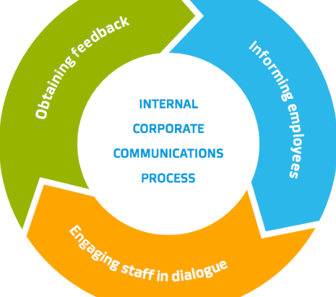
Figure 2: Internal corporate communication process
(Source: Nabi et al. 2017)
Through considering the fact stated by Genç (2017), it can be mentioned that communication can support in the promotion of motivation through informing as well as clarifying people regarding their roles and responsibilities, the ways of improving performance standards, and the value they hold in the whole operational setting. Apart from this, workplace harmony can also be maintained through the socialisation of the process, which also has an association with the advanced communication process. Mohamad et al. (2018) commented that workplace communication is also required for assisting the controlling and feedback process. Complying with the organisational policies, performing the job roles efficiently, and communicating the work-related stressors to the superiors are also parts of the management controlling process.

2.3 Application of Communication theory, process, or model in managing workplace harmony
The essentiality of communication in workplace operations can be interpreted through various theories or models (Mihai, 2017). The significance of using different theory or framework is to concrete the ground of the communication and interaction process. There are different applicable concepts or principles proposed by different theorists or activists, such as Aristotle Model of Communication, Schramm's Model of Communication, Helical Model of Communication, Shannon and Weaver Model of Communication, and so on. Among all the models, most of the workplace considers Shannon-Weaver communication process, as it describes the ground approach of two-way communication (Okoro et al. 2017). According to the model, and information could be transferred from a sender to a receiver, but there would be a possibility of disruption due to the presence of noise. Hence, organisations need to eliminate the 'noise' in an effective manner to avoid confusion, which is also essential for achieving workplace harmony.
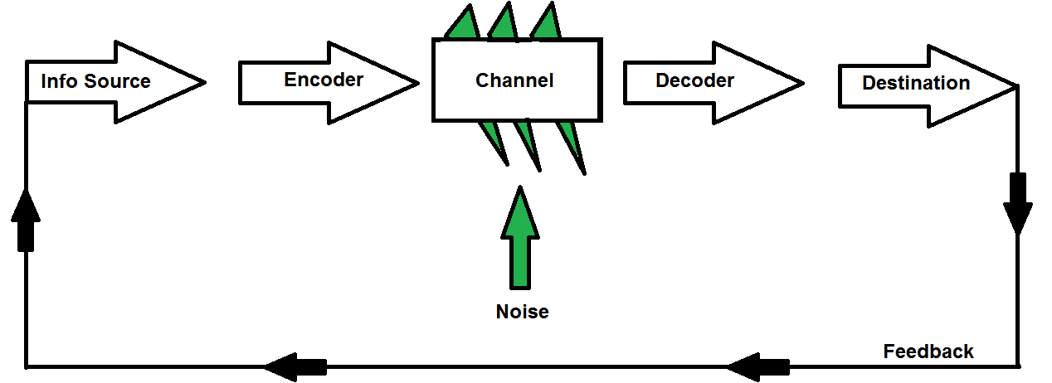
Figure 3: Shannon-Weaver Communication model
(Source: Okoro et al. 2017)
Another model, named Schramm’s Model of Communication is different from the above-described framework, as it shows a circular conception about the communication process. Unlike the Shannon-Weaver Model, this model depicts that it is not necessary to always have more than one person in a single communication process, as each individual can perform as both senders as well as the receiver, and therefore, the person itself can simultaneously interpret the message. Verghese (2017) mentioned that since feedback is a central feature, therefore, organisations can use this for interacting with their employees.
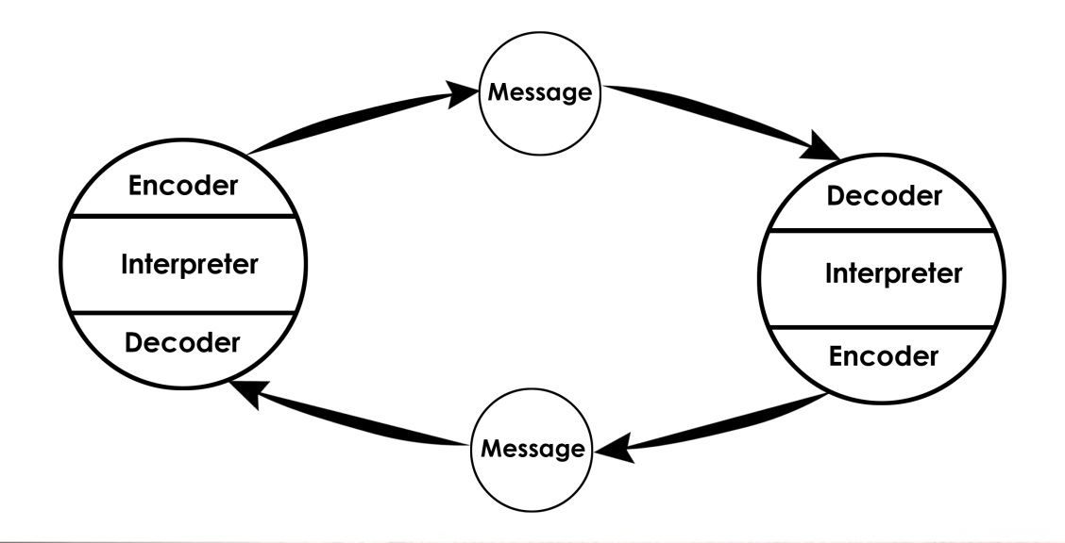
Figure 4: Schramm’s Model of Communication
(Source: Verghese, 2017)

2.4 Barriers to communication in the workplace
Although communication is a ground-level process of every workplace, there are different barriers affecting the communication process. From the broader perspectives, the barriers can be categorised as physical barriers, perceptual barriers, emotional barriers, cultural or language barriers, interpersonal barriers, and so on. For example, while employees work in a multicultural environment, they could not communicate with their colleagues or superiors due to the presence of linguistic barriers. On the other hand, as stated by Martinez and Hurtado (2018), employees having speech difficulties might also be a reason for communication error in the workplace. In some cases, the absence of proper communication style or channels from management might create confusion among the employees, due to which they could not interact in an effective way. Conflicts among the employees or between the employees and employers can also enhance the possibility of communication gap, which ultimately leads to the deterioration of workplace harmony (de Bem Machado et al. 2019).

3.0 Conclusions
From the business and management perspectives, effective communication is the linking process for both employees and employers, as this is essential for obtaining and exchanging information. The report reflects upon the essentialities of communication and its role in upholding workplace harmony as well. However, incorporating effective communication strategy is often being critical, due to the presence of internal and external barriers, and it leads to damage to the workplace environment as well. Therefore, after analysing the barriers of communication, it is necessary to find out some remedies, which can be implemented in different organisations to maintain workplace harmony.

4.0 Recommendations
In order to improve the internal communication process, it is necessary to create a receptive atmosphere for the employees. Martinez and Hurtado (2018) mentioned that employees do not want to share their perceptions if they feel that their concerns will be just brushed away. Hence, management of every organisation requires focusing on the inclusion of two-way communication method, by which they could listen to the views of workers, and vice-versa. On the other hand, for avoiding issues like multiculturalism or multi-linguistic association in multinational firms, cultural and language training could be incorporated as a strategy of improving the workplace. Establishment of proper communication style in the workplace is essential for incorporating the right tone of communication, especially while interacting with the subordinates. Apart from this, organisations might use various online and offline platforms for eliminating any kind of confusion and complexities, such as online discussion forums, one-on-one meeting platforms, and so on.

5.0 Reference List
Adekunle, A.M., Abimbola, O.S. and Ehimen, E.J., 2019. Conflicts Management Strategies: A Tool for Industrial Harmony. Izvestiya, (1), pp.19-34.
Chakraborty, D. and Biswas, W., 2021. Think love, think peace, think harmony: Rethinking on industrial tranquillity. Business Perspectives and Research, 9(1), pp.92-110.
D HEMMIGE, B.H.A.R.G.A.V.I., 2017. Inter-cultural communication for business management in the contemporary world. International Journal of Business Management Insight & Transformations [ISSN: 2581-4176 (online)], 1(2).
de Bem Machado, A., Souza, M.J. and Catapan, A.H., 2019. Systematic Review: Intersection between Communication and Knowledge. Journal of Information Systems Engineering and Management, 4(1), p.em0086.
Genç, R., 2017. The importance of communication in sustainability & sustainable strategies. Procedia Manufacturing, 8, pp.511-516.
Hänninen, N. and Karjaluoto, H., 2017. The effect of marketing communication on business relationship loyalty. Marketing Intelligence & Planning.
Martinez, L.A.M. and Hurtado, S.R.F., 2018. Internal Communication Issues in the Firms: Does It Affect Productivity. Rev. Eur. Stud., 10, p.1.
Mihai, R.L., 2017. Corporate communication management. A management approach. Valahian Journal of Economic Studies, 8(2), pp.103-110.
Mohamad, B., Nguyen, B., Melewar, T.C. and Gambetti, R., 2018. Antecedents and consequences of corporate communication management (CCM). The Bottom Line.
Nabi, N.M., Foysol, K.M. and Adnan, S.M., 2017. The role and impact of business communication on employee performances and job satisfaction: A case study on Karmasangsthan bank limited, Bangladesh. Arabian Journal of Business and Management Review, 7(301), p.2.
Okoro, E., Washington, M.C. and Thomas, O., 2017. The impact of interpersonal communication skills on organizational effectiveness and social self-efficacy: A synthesis. International Journal of Language and Linguistics, 4(3), pp.28-32.
Radovic Markovic, M. and Salamzadeh, A., 2018. The importance of communication in business management. In Radovic Markovic, M., & Salamzadeh, A.(2018). The Importance of Communication in Business Management, The 7th International Scientific Conference on Employment, Education and Entrepreneurship, Belgrade, Serbia.
statista.com. 2020. Employee communication tools utilization worldwide by organizational type 2019 | Statista. Available at: <https://www.statista.com/statistics/1085383/organizational-communication-tools-usage-worldwide-organizational-type/> [Accessed: 5 February 2021].
Stiehr, E.S. and Vandermause, R.K., 2017. Can’t we all just get along? A dual-theory approach to understanding and managing the multigenerational workplace. Journal of Organizational Psychology, 17(2), pp.103-110.
Vandenack, M.E., 2018. Facilitating Effective Communication as a Leader. Law Prac., 44, p.76.
Verghese, A.K., 2017. Internal Communication: Practices and Implications. SCMS Journal of Indian Management, 14(3).

