
Student name: Salma Begum
Student ID:2328718
Module name: Changemakers: Building Your personal Brand for Sustainable Employment
Module code: BMHP5015
Lecturer name: Christopher Mafuva

Declaration: I haven’t used AI to make this assignment. Only I have used AI to check grammar and spelling.

• Introduction .............................................................................
• Reflection on Unit 1: Brand You .............................................
• Activity Evidence for Unit 1 ....................................................
• Reflection on Unit 2: It’s a Small World .................................
• Activity Evidence for Unit 2 ....................................................
• Reflection on Unit 3: Opportunity Knocks ............................
• Activity Evidence for Unit 3 ....................................................
• Reflection on Unit 4: The Pursuit of Happiness .................
• Activity Evidence for Unit 4 ....................................................
• Conclusion ..............................................................................
• References ............................................................................

Introduction
This portfolio provides a summary of what I learnt in the four units of the Changemakers: Building Your Brand for Sustainable Employment module. It also talks about how that information could aid me in my future employment in health and social care. The module made me think about how to acquire a job in a different way. It was not just about finding a career, it was also about figuring out what I believe in, meeting other professionals, looking for chances, and remaining safe.
The online activities, forum discussions, and reflective exercises helped me understand better how safe, ethical, and person-centered care is related to personal growth. I will tell you what I learnt from "Brand You," "It is a Small World," "Opportunity Knocks," and "The Pursuit of Happiness."

Reflection on Unit 1: Brand You
Unit 1, Brand You, helped me see personal branding in a new perspective. Before this unit, I thought that personal branding was only about using social media or advertising myself. In health and social care, I heard in class and on Moodle that how you act every day is more important than how you look when it comes to developing a personal brand. This can be shown in how someone talks, how trustworthy they are, and how others see them as polite and trustworthy. I wanted to work somewhere where people feel secure, heard, and appreciated, thus this was important to me.
The Johari Window exercise really stood out to me. People said things like "be a good listener," "be patient," and "be able to understand how others feel." I had never considered of them as important pieces of my professional identity before this activity. But it made me see that I already have such skills. Conner et al. (2025) assert that communication, collaboration, and engagement are essential leadership competencies in nursing education. This helped me realize that being a leader in health and social care is not only about being a manager. You may also see it in everyday life, especially when a professional helps people trust, work together, and believe in themselves.
The strengths assessment made this thought process considerably deeper. Being fair, polite, and nice were my best traits. Kermode (2021) says that person-centered care is focused on what the person cares about and helps a more complete and cooperative approach. This made me realize that my personal brand should be more than just who I am. It should also illustrate how my principles effect how I help the people who use my services. So, my brand should be based on being courteous, respectful, and the same all the time.
Burnand et al. (2025) also showed that patients with dementia and their family carers appreciated professionals who created relationships, communicated effectively, and provided individualized care. That result made the unit seem like it would be highly helpful for practice. It taught me that being honest and open is not an option; it is part of good care. Unit 1 taught me that to have a strong professional identity in health and social care, you need to know who you are, what you believe in, and how to develop trust with others. I want to keep asking for input in the future so that the way I perceive myself and the way others see me stays the same.

Evidence from Moodle activities: Unit 1
Activity 1: My career goal
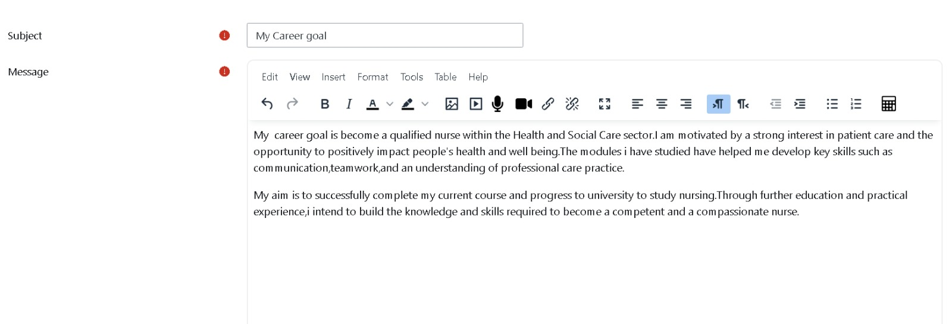
This screenshot shows my reflection on becoming a nurse and linking my future role to compassionate, person-centered care.
Activity 2: Meaning of autonomy
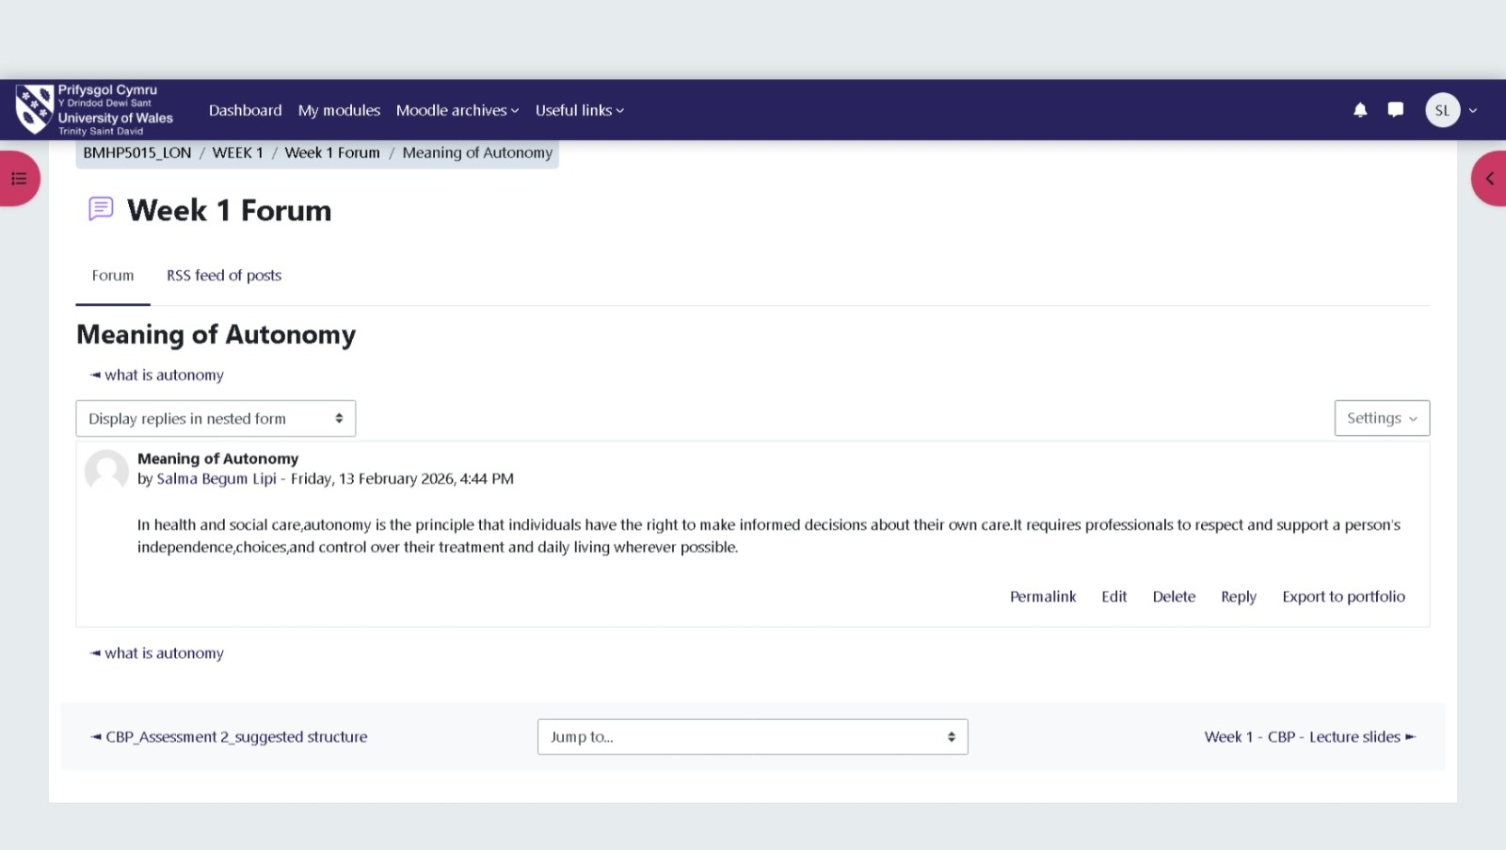
This forum post demonstrates my understanding that respecting autonomy is central to dignity, choice, and professional practice in health and social care.
Activity 3: Soft skills in health and social care
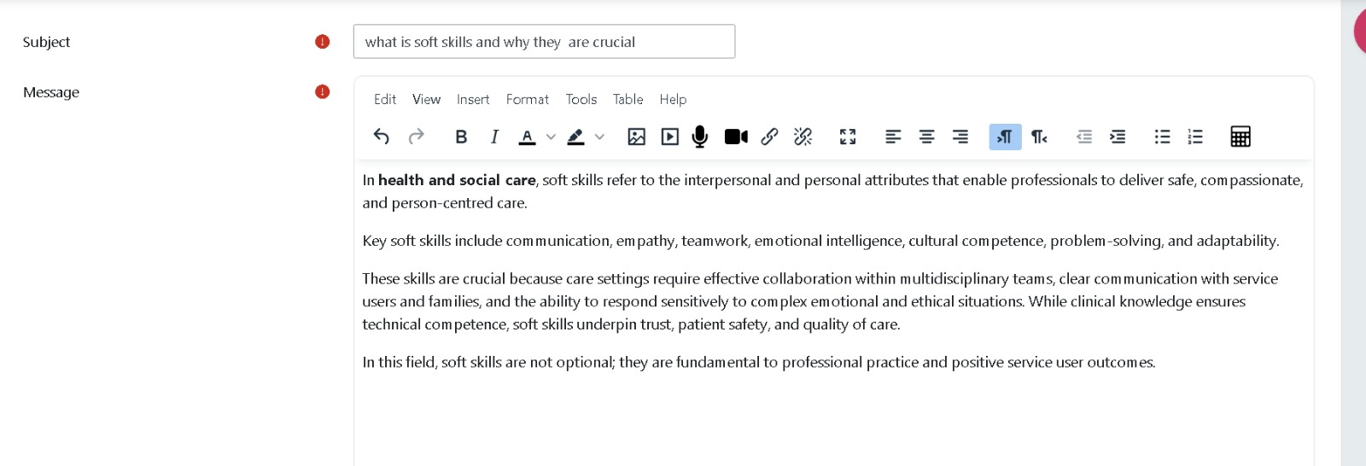
This activity highlights the importance of communication, empathy, teamwork, and cultural competence in building a trustworthy professional identity.

Reflection on Unit 2: It’s a Small World
Unit 2, "It is a Small World," made me think more about how people all around the world are connected, how much I know about other cultures, and how unfair health and social services are. I learned that care does not happen in a bubble. People's health is affected by their language, how they travel, their poverty, their identity, their housing, their education, and how easy it is for them to get what they need. Before this lecture, I thought that being culturally conscious meant being nice to people from different cultures. After finishing the duties, I learnt that being polite is important, but it is only one aspect of a greater picture.
One important thing I learned from this class is that systems are often unjust, not just one bad professional. Goddard (2023) says that integrated care systems could help with more than just ensuring sure everyone can get health care. They could also help with bigger problems in society and the economy, such jobs, housing, and education. This made me see that those who work in health and social care need to think about more than just the therapy they give people. They need to think about how their life will be in the long term.
The unit forum included a case study of a migrant patient who had trouble getting care since they did not know the language. I thought about how easy it is for people to get confused and feel left out when services are not made to satisfy everyone's needs when I prepared my response. Thana et al. (2026) demonstrate that unsafe care for individuals from marginalized groups is influenced by elements at the individual, interpersonal, community, organizational, and societal levels. This was quite helpful since it turned the issue from talking about people to talking about faults in the system. It also made me remember that good intentions are not enough to make sure everyone gets the same level of care.
Byworth et al. (2025) assert that public health must remain robust within NHS frameworks to effectively address inequities. This made me even more persuaded that frontline treatment includes prevention, advocacy, and being open to everyone. They are a part of it. Burnand et al. (2025) also stress how important it is to talk to each person in a way that is unique to them and to make sure they comprehend their treatment. That made me even more sure that being culturally modest requires paying attention, not jumping to conclusions, and changing how you interact with others so they feel like they belong. Unit 2 taught me that to be good at health and social care, you need to know about how structural inequality operates and how different cultures are.

Evidence from Moodle activities: Unit 2
Activity 1: Boundaryless careers
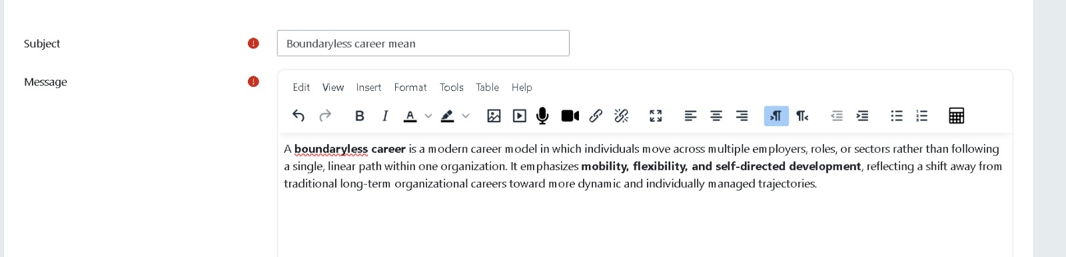
This screenshot shows my understanding of changing career patterns and the need for flexibility and self-directed development in modern health and social care work.
Activity 2: Example of the gig economy in care
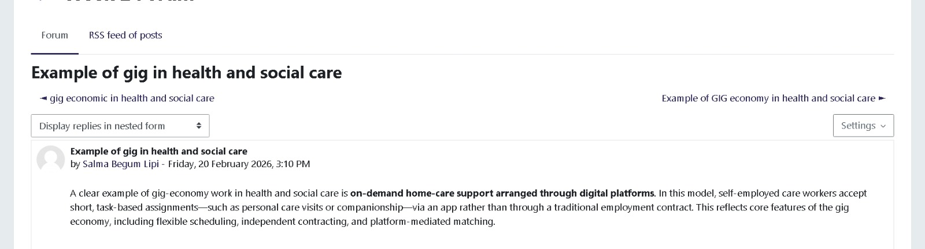
This activity reflects my awareness of how wider labor trends can affect service delivery, workforce structures, and the experience of care.
Activity 3: Changing perspective in health and social care
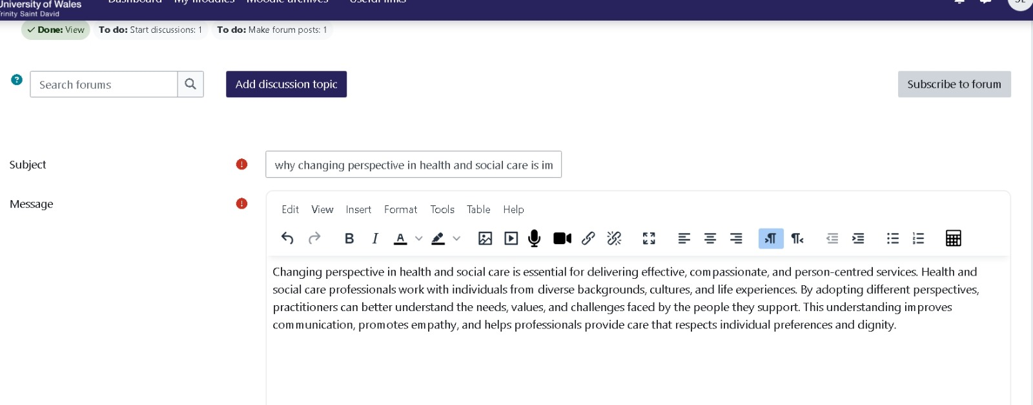
This screenshot supports my reflection on the value of seeing care from different cultural and personal perspectives rather than making assumptions.

Reflection on Unit 3: Opportunity Knocks
"Opportunity Knocks," Unit 3, urged me to look for chances. I used to think that chances were random things that happened, like job ads or applications. We used lectures and exercises to see if that idea worked. I learned that dressing appropriately, talking to new people, thinking about things, and taking initiative can all lead to new chances. This was needed since health and social care need more than simply degrees. Your confidence, ability to talk to other people, eagerness to learn, and visibility are all very crucial.
I required a map of the network. After I finished, I recognized that I knew teachers, classmates, and coworkers, but I was not exploiting these connections to their maximum potential. I had problems, especially during the practice phases. Thinking about what I had learned helped me feel more sure about reaching out and made me think of networking as a chance to learn more about my field instead of a way to sell myself. Kermode (2021) talks on how important it is for services to operate together, have a common goal, and share that goal. The piece is mostly about integrated person-centered care, but it also helped me think of a new way to look for work. It made me think about how important relationships are in health and social care and how these partnerships might lead to new opportunities.
Making a SMART action plan was another helpful thing to accomplish. I utilized it to put my basic desire to help people with dementia into particular activities, including learning more about the disease, obtaining more experience with it, and paying closer attention to job opportunities. Macdougall et al. (2024) say that the NHS needs a workforce that is trained and educated in order to continue. This made me recognize that I should not wait till I get a job to start working on my career growth. It starts before you get a job and goes on throughout your career.
Burnand et al. (2025) also add that some people with dementia and their caretakers do not know what help is available when it is hard to get to. That point stayed with me since it also has to do with employment. There are opportunities, but you will not find them unless you ask questions, talk to people, and keep looking. After Unit 3, I updated my LinkedIn profile, joined groups that were relevant to my goals, and made it clearer what kind of work I wanted to do. The unit taught me that seeing chances is a skill. It takes preparation, hard work, and being responsible for my own progress.

Evidence from Moodle activities: Unit 3
Activity 1: My thinking about networking
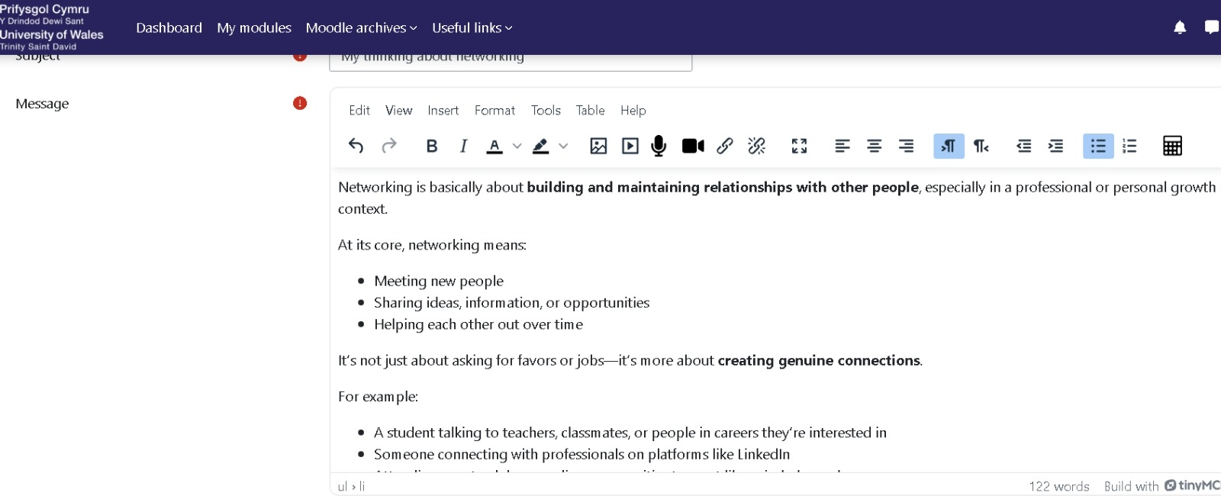
This activity shows my reflection on networking as a way of building genuine professional relationships and learning from others.
Activity 2: Opening doors to job opportunities
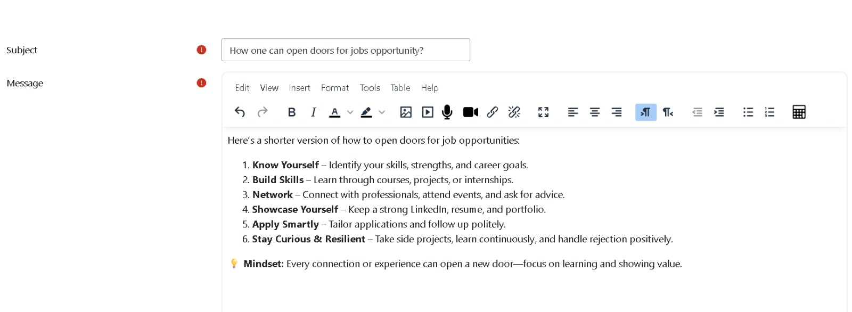
This screenshot links to my understanding that opportunities are created through self-awareness, skill development, networking, and resilience.
Activity 3: Developing a professional online presence
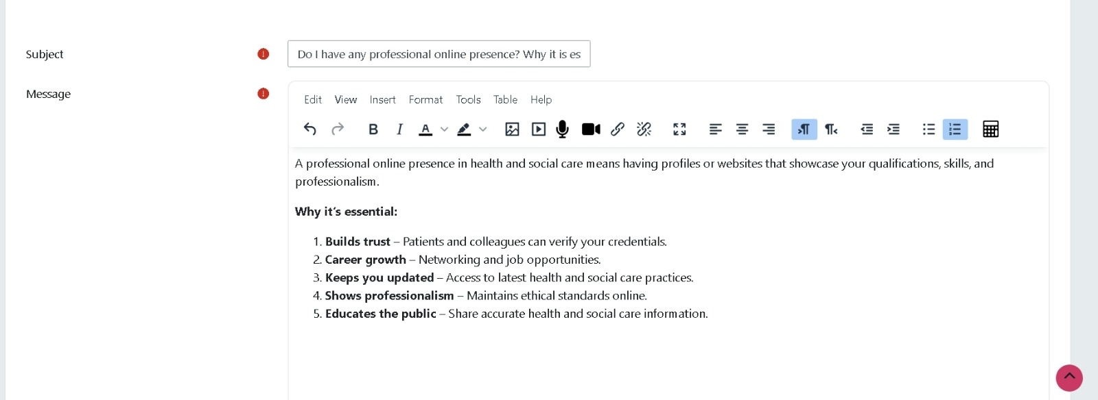
This activity demonstrates how visibility, professionalism, and online engagement can support career development and future employability.

Reflection on Unit 4: The Pursuit of Happiness
Unit 4, The Pursuit of Happiness, made me think a lot about my health, how well I can bounce back, and what type of work I want to have. People who work in health and social care often have to cope with stress, a lot of work, and situations that call for patience and kindness. That made this unit really useful for me. It made me think about what resilience really meant. I used to assume it meant dealing with things calmly. I began to view wellbeing as something that must be intentionally safeguarded to ensure the continuation of safe and compassionate treatment.
We had to think about how we deal with stress and how well we know how we feel in class. That exercise helped me recognize that I sometimes dodge hard conversations to keep things quiet. I knew this may stop honest communication, even though everything looks tranquil on the outside. Being emotionally strong is more than just keeping cool. It is also about being honest, handling stress, and asking for support when you need it.
Raajakesary et al. (2024) delineate ethical principles including justice, accountability, autonomy, respect, duty of care, and reciprocity within healthcare guidelines. I thought their presentation about reciprocity was intriguing since it suggests that if professionals are meant to care for others, systems should also support professionals. This helped me comprehend what it means to be well in a more moral perspective. Taking care of oneself is not selfish. It is part of being safe and doing the right thing.
Byworth et al. (2025) support this notion by demonstrating that continual organizational changes might adversely affect public health functions and diminish professional morale. That made me think about how the way people think and where they work may both make them stronger. Kermode (2021) also adds that person-centered care needs the correct conditions, such individuals working together, obtaining aid, and having services that operate together. It is harder to give customers the individualized and thoughtful attention they require when staff are weary or do not have adequate help.
I thought about some easy strategies to stay balanced during one of the forum activities. For example, I thought about being aware of my surroundings, following a routine, and noticing the small things that go well during the day. In Unit 4, I learned that if you want to work in health and social care for a long time, you need to be focused, set limits, think about what you do, and take care of yourself. I now realize that taking care of my health is part of my job, not something additional I have to do.

Evidence from Moodle activities: Unit 4
Activity 1: Emotional intelligence in practice
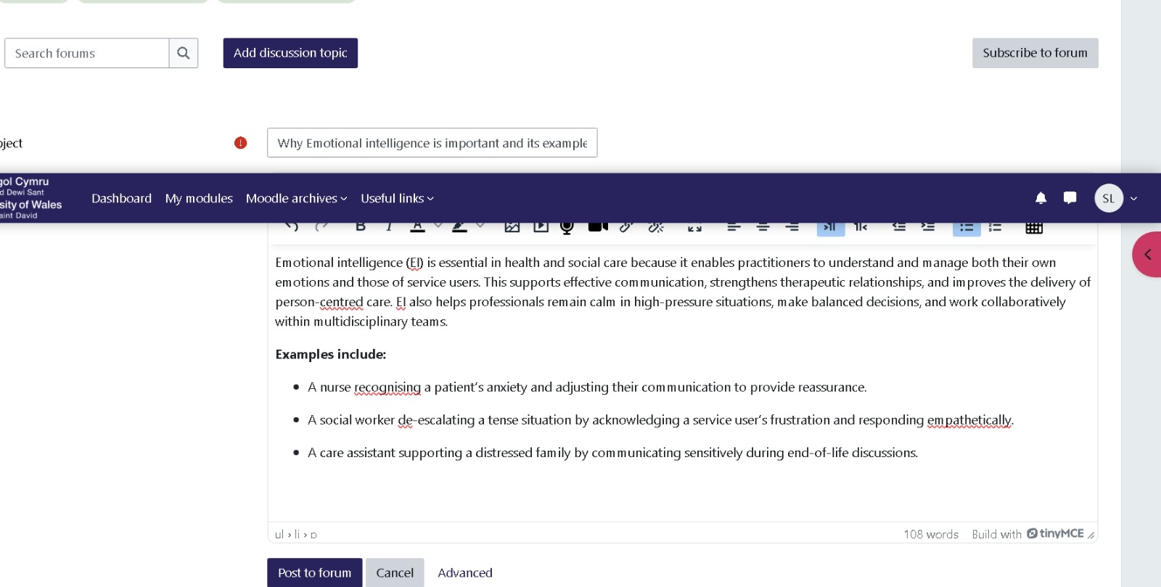
This screenshot shows my reflection on emotional intelligence as part of calm decision making, empathy, and person-centered communication.
Activity 2: Limiting beliefs
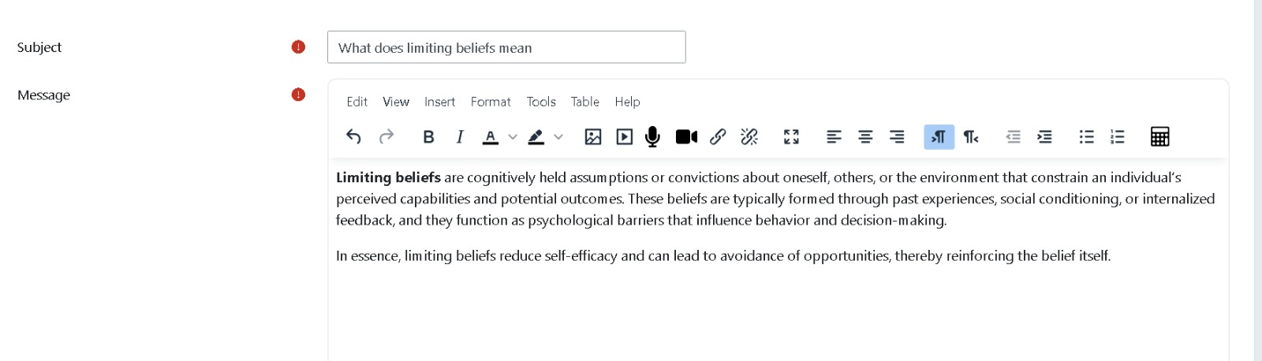
This activity supports my understanding that confidence and wellbeing can be affected by negative self-beliefs, which need to be challenged in order to grow.
Activity 3: Positive self-talk
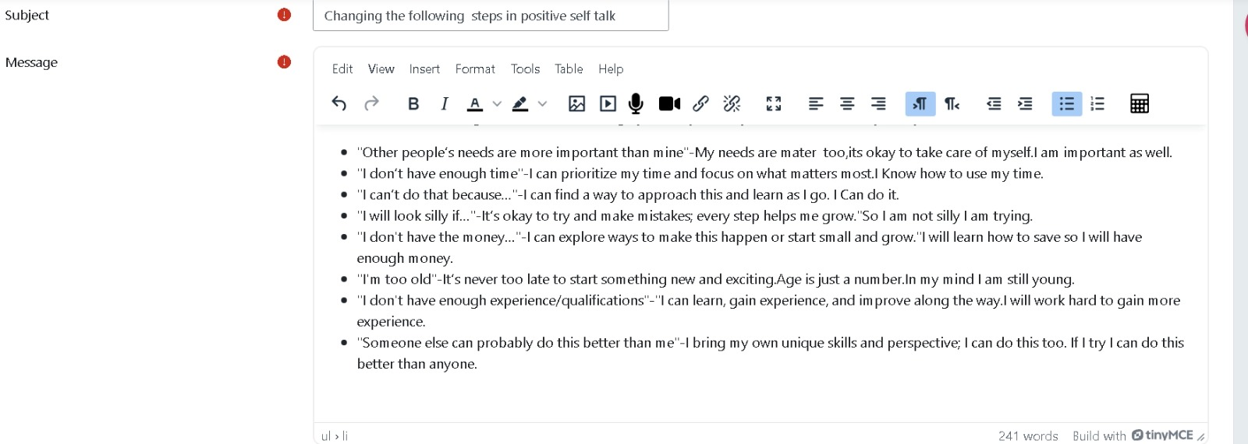
This screenshot links directly to my reflection on resilience by showing how reframing negative thoughts can support balance, confidence, and self-care.

Conclusion
This module has changed the way I think about getting a job in health and social care. Unit 1 taught me that my professional identity is based on how well I know myself, what I believe in, and how I talk to other people. Unit 2 taught me more about culture, unfairness, and the big companies that change how people get care. Unit 3 taught me that you can find and make opportunities by being ready, meeting new people, and always trying to get better. Unit 4 taught me that I need to be strong and healthy if I want to work in a caring field that is safe, moral, and long-lasting.
These units have helped me understand how my work and my personal growth are connected. I now know what kind of practitioner I want to be: one who is thoughtful, open-minded, proactive, and focused on the person. The lesson has also taught me that getting ready for work is something I do all the time. I want to keep getting more confident, asking for feedback, learning new things, and taking care of myself so that I can help people in health and social care settings.

References
Burnand, A., Woodward, A., Kantilal, K., Bhanu, C., Jani, Y., Manthorpe, J., Orlu, M., Rait, G., Sajid, M., Samsi, K., Vickerstaff, V., Ward, J., Wilcock, J. and Davies, N. (2025) ‘Understanding the perspectives of people with dementia and family carers about clinical pharmacists in primary care: a qualitative study’, PLOS One, 20(8), e0330028.
Byworth, C., Markham, C.J., Nash, S., Risso-Gill, I. and McKee, M. (2025) ‘Public health must not be an afterthought in the NHS reorganisation’, BMJ, 389, r751.
Conner, T., Allan, J., Annesley, S., Leader, C., Unsworth, J. and Tomietto, M. (2025) ‘Leadership competences in undergraduate nurse education: scale development and model testing’, Nurse Education in Practice, 87, p. 104440.
Goddard, M. (2023) ‘Integrated care systems and equity: prospects and plans’, Journal of Integrated Care, 31(5), pp. 29–42.
Kermode, L. (2021) ‘A journey towards integrated person-centred care: a case study of a mental health perspective in the voluntary sector’, Journal of Integrated Care, 29(3), pp. 334–345.
Macdougall, C.F., Allsop, S., Douglass, C., Pope, L., Park, S. and McKinley, R.K. (2024) ‘Education is essential for implementing the NHS workforce plan’, BMJ, 387, e078143.
Raajakesary, K., Galvin, L., Prendiville, K., Newport, S., MacAnulty, C. and Hussein, G. (2024) ‘The ethical principles in ethical guidance documents during the COVID-19 pandemic in the United Kingdom and the Republic of Ireland: a qualitative review’, Prehospital and Disaster Medicine, 39(5), pp. 379–389.
Thana, L., Crocker, H., Modha, S., Mulcahy, L., Hickson, F., Pope, C., Vincent, C., Hogan, H. and Peters, M. (2026) ‘Experiences of people from minoritised groups who report healthcare-related harm in the UK: a qualitative socioecological study exploring factors contributing to unsafe care’, BMJ Open Quality, 15, e003851

