ACDB 4018: Simulated and Practical Timer Circuit Design- Laboratory Report

Simon Shepherdson
Student Number: 2309878

Date: December 2024

Contents
Keywords 3
1 Introduction 3
1.1 Task Description 3
1.2 Theory and Background Information 4
2 Results 5
2.1 Proteus Software Circuit Simulation. 5
2.1.1 Determination of On/ Off time, Period and Frequency on Channel 1 (Supply Voltage) 8
2.1.2 Determination of On / Off time, Period and Frequency on Channel 2 (Capacitor, C1) 9
2.2 Results for physical circuit 10
3 Discussion 11
3.1 Interpretation 11
3.2 Relevance to OME 12
4 Conclusions 13
5 Annex A 14
5.1 References 14

Figure 1 - Astable 555 Timer Circuit to be built and tested. 3
Figure 2 - 555 Internal Circuit 4
Figure 3 - 555 Timer IC Pin Diagram 4
Figure 4 - 555 Timer circuit in Proteus. 5
Figure 5 - Forward Voltage across Resistor R3 6
Figure 6 - Addition of oscilloscope into the timer circuit. 7
Figure 7 - Simulated On / Off time 7
Figure 8 - Time base determination for On / Off time. 8
Figure 9 - Signal from capacitor, C1. 9
Figure 10 - On / Off timer circuit built on bread board. 10
Figure 11 - On / Off trace for bread board. 10
Figure 12 - On / Off and Frequency for 555 Timer 11

Table 1 - Key for 555 Pin Diagram 5
Table 2 - On / Off Time, Period and Frequency for Ch. 2 across Capacitor, C1. 9
Table 3 - On / Off, Period and Frequency 11
Table 4 - Summary of measurements. 11
Table 5 - Measured resistance of resistors used. 11

Keywords
Simulation, Practical Design, System Measurement, Circuit Design

Introduction

This report sets out the simulation and subsequent build and testing of a 555-timing circuit. The OME Level 4 Group were tasked with building and testing of an astable 555 timer circuit. This task was started by simulating an electrical circuit layout in the Proteus [1] software package.

Task Description

The task assigned to the Level 4 Ordnance, Munitions and Explosives (OME) group required individuals to build and test an astable 555 timer circuit, the circuit for the exercise is provided below in Figure 1
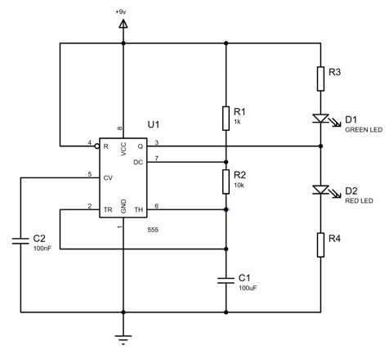
Figure 1 - Astable 555 Timer Circuit to be built and tested.
This will first be assembled and tested within the Proteus software package, including the determination of the following;
- The resistance’s of resistors R3 & R4
- The On / Off time of the LED’s
- The period of LED timings
- The Frequency of the cycle.
These values will subsequently be determined for the practical version assembled on a bread board. It is expected that the above determinations will be the same for both the simulated and physical build of the 555 timing circuit.

Theory and Background Information

The 555 timer, also known as a “Triple 5” due to the three 5k Ohm resistors, is an integrated circuit (IC) used in many forms ranging from simple timings circuits through to systems using systems on chips (SoCs). They were first introduced in 1971 [2] and have become popular in use due to the item’s low unit price, its ease of use and stability when in use.
The IC (sometimes referred to as a microchip or chip) is a small electronic device containing multiple connected electronic components, which can include resistors, transistors, and capacitors. These are etched or attached to a small semi-conducting material, typically silicon and are used in most electronics devices from computers to televisions. They can perform a myriad of functions however their primary advantage is that they are often very small and enable significant space savings within an electrical circuit compared to the same circuit constructed from interconnected discrete components.
The IC of the 555-timer used in the present study is provided in Figure 2 below;
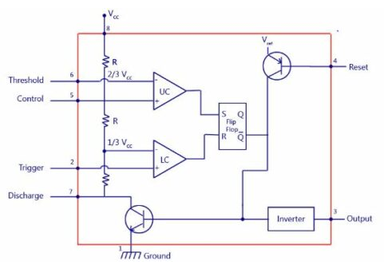
Figure 2 - 555 Internal Circuit
The 555-timer is an 8-pin microchip configured as per Figure 3;
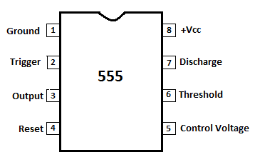
Figure 3 - 555 Timer IC Pin Diagram

From Figure 3 the explanation for the individual pins is explained below in Table 1.
Pin Number | Name | Purpose Description
1 | Ground | Ground reference Voltage, Low level (0 V)
2 | Trigger | Output at approximately 1.7 V below supply Voltage or Ground
3 | Output | Output at approximately 1.7 V below supply Voltage or Ground
4 | Reset | Timing interval may be reset by pushing this output to ground. Overrides the Trigger which in turn overrides the Threshold
5 | Control | Provides “control” access to the internal Voltage divider (by default at 2/3 supply Voltage)
6 | Threshold | The timing output interval ends as the Voltage at the threshold is greater than that at the Control (2/3 Supply Voltage if Control is open)
7 | Discharge | Open output which may discharge a capacitor between intervals, in phase with the Output
8 | Supply | Positive supply Voltage – usually between 3V and 15V depending on model.
Table 1 - Key for 555 Pin Diagram

Results

Proteus Software Circuit Simulation.

The circuit displayed in Figure 1 was re-created using the Proteus: PCB and Circuit Simulator software package and represented in Figure 4 below.
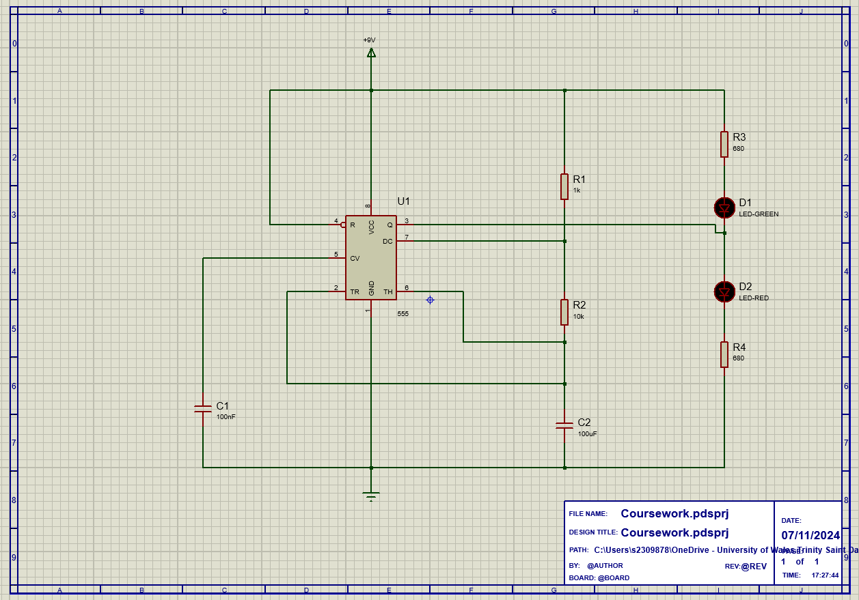
Figure 4 - 555 Timer circuit in Proteus.
Figure 1 shows the full circuit schematic to be constructed and tested, however the values of Resistors labelled R3 and R4 are currently unknown. To determine these values Ohms Law will be utilised (given in Equation 1)
$$V=I*R$$
Equation 1 - Ohm's Law
Equation 1 requires it to re-arranged to solve for resistance, giving Equation 2. By measuring the Voltage across the resistor using a suitable Voltmeter the values of the resistor can be measured.
$$R= \frac{V}{I}= \frac{V_{Supply}- V_{Forward}}{I}$$
Equation 2 – Determination of Resistors R3 & R4
Substitution of the known and measured values give Equation 3

$$R= \frac{9V-2.2V}{10mA}= 680 Ω$$
Equation 3 – Solution for R3 & R4
To ascertain whether the value obtained in Equation 3 is correct, the node in the circuit was interrogated and found to be as follows;
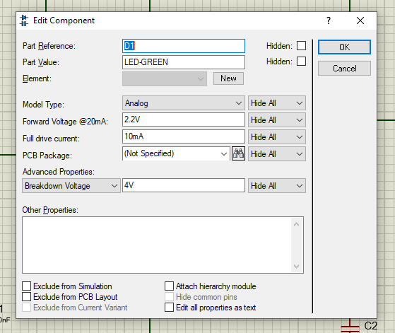
Figure 5 - Forward Voltage across Resistor R3
Once the forward Voltage over Resistor R3 was confirmed, an oscilloscope was added to the circuit within proteus to monitor the simulated supply Voltage from Pin 8 and charging of the 100µF capacitor, C1. Shown in Figure 6.
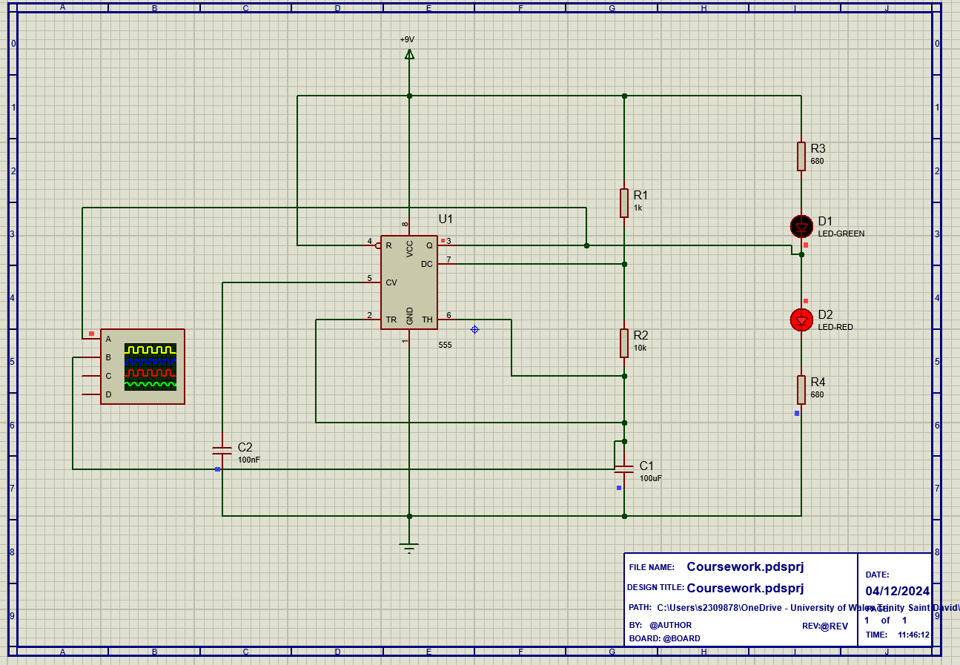
Figure 6 - Addition of oscilloscope into the timer circuit.
With the oscilloscope added to the circuit, the On / Off time can be measured within the software. The On time is determined as the duration of signal decay from the positive peak Voltage to the point where the signal switches to the Off time. The Off time is the reciprocal of the On time and is the decay from the negative peak Voltage. This is demonstrated in Figure 7.
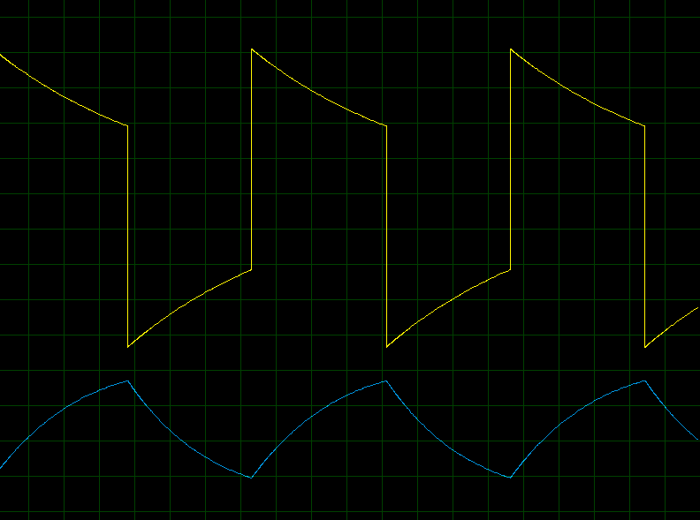
Figure 7 - Simulated On / Off time

Determination of On/ Off time, Period and Frequency on Channel 1 (Supply Voltage)

With the signal simulation undertaken, the respective On and Off times can be measured using the oscilloscope, lines are added to the time base as shown in Figure 7.
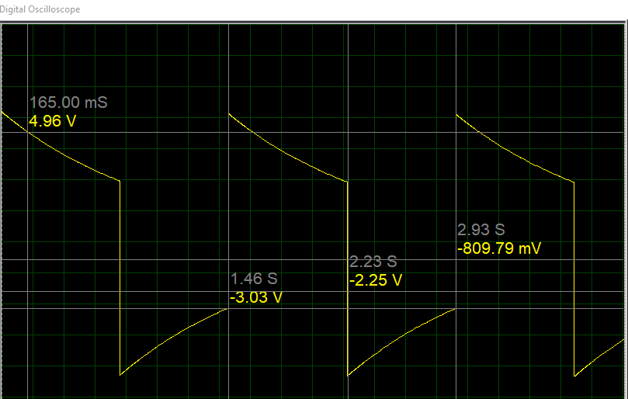
Figure 8 - Time base determination for On / Off time.
Using the values shown in Figure 8, the end of the On time can be seen as 2.23 seconds, with the beginning at 1.46 seconds. Therefore, the On time is given in Equation 4.
$$On time=2.23s-1.46s=0.77 seconds$$
Equation 4 - Determination of On time (simulated).
Similarly the Off can be determined from Figure 8, with the end of the off time as 2.93 seconds and the beginning of the off time is equal to the end of the on time shown previously as 2.23 seconds. The off time can be shown in Equation 5;
$$Off time=2.93s-2.23s=0.70 seconds$$
Equation 5 - Determination of off time (simulated).
With the determination of the On / Off cycle, the time period, which is the duration of On / Off pulse can be calculated.
$$T=On time+Off time=0.77s+0.70s=1.47 seconds$$
Equation 6 - Determination of Period
Where:
T = Period.
Lastly, the frequency can be determined. The frequency is the number of times per second the signal completes its cycle given in the unit of Hertz.
$$F= \frac{1}{T}= \frac{1}{1.44}=0.694 Hz$$
Equation 7 - Determination of Frequency (simulated).
Where:
F = Frequency in Hertz (Hz)
T = Period
From Equation 7, the simulated circuit in the Proteus software has frequency of 0.69 Hz, to 2 decimal places.

Determination of On / Off time, Period and Frequency on Channel 2 (Capacitor, C1)

The respective On / Off times, Period and Frequency were also determined across the 100µF capacitor, C1. In the same manner as Section 1.2.1.
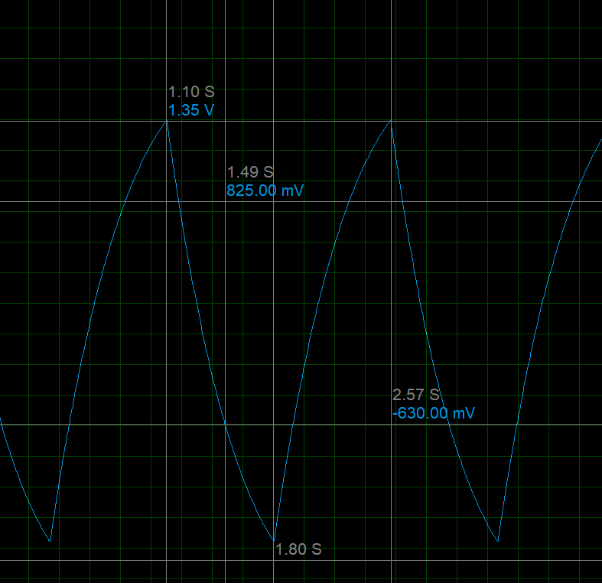
Figure 9 - Signal from capacitor, C1.
From Figure 9, the On / Off time and Period can be determined with the use of equations 4 – 7.:

On Time | Off Time | Period | Frequency
1.80 – 1.10 = 0.70s | 2.57 – 1.80 = 0.77s | 0.70 + 0.77 = 1.47s | $$\frac{1}{1.47}=0.68 Hz$$
Table 2 - On / Off Time, Period and Frequency for Ch. 2 across Capacitor, C1.

Results for physical circuit

On successful completion of the build and evaluation of the timer circuit within the Proteus software, a practical build of the circuit was made with a bread board and relevant discrete components.
The bread board was connected to a 9V power supply, the working timer circuit is displayed in Figure 10.

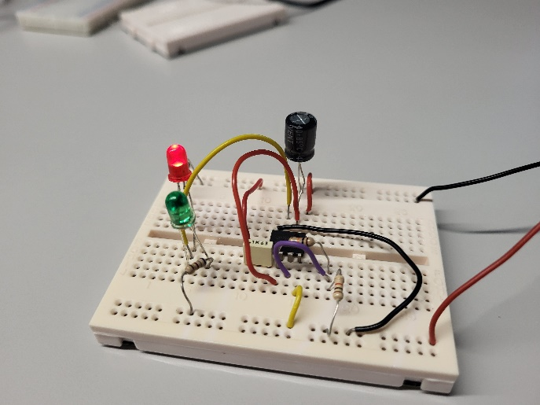 | 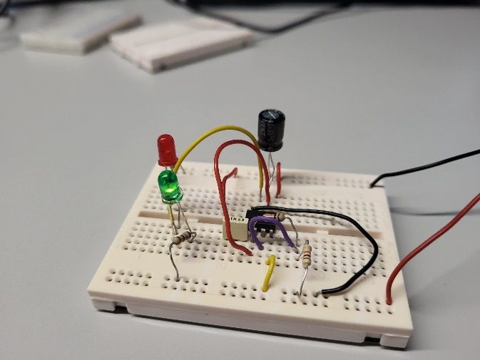
Figure 10 - On / Off timer circuit built on bread board.

As in the simulation, an oscilloscope was connected to the breadboard as shown in Figure 6. This was done to ensure that the physical measurements were the same as those performed inside the software. The resulting traces for both channels can be seen below.
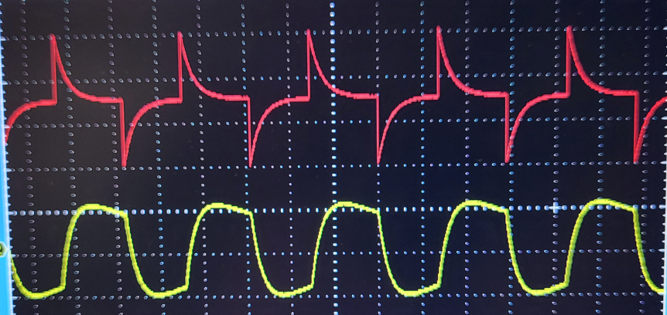
Figure 11 - On / Off trace for bread board.

From Figure 11, the On / Off times, Period and Frequency can all be calculated. By using the built-in analytical tools on the oscilloscope, the On / Off times can be seen as 0.77 seconds, with the Off time being 0.67 seconds with these being shown in Figure 12 and Table 3 respectively.
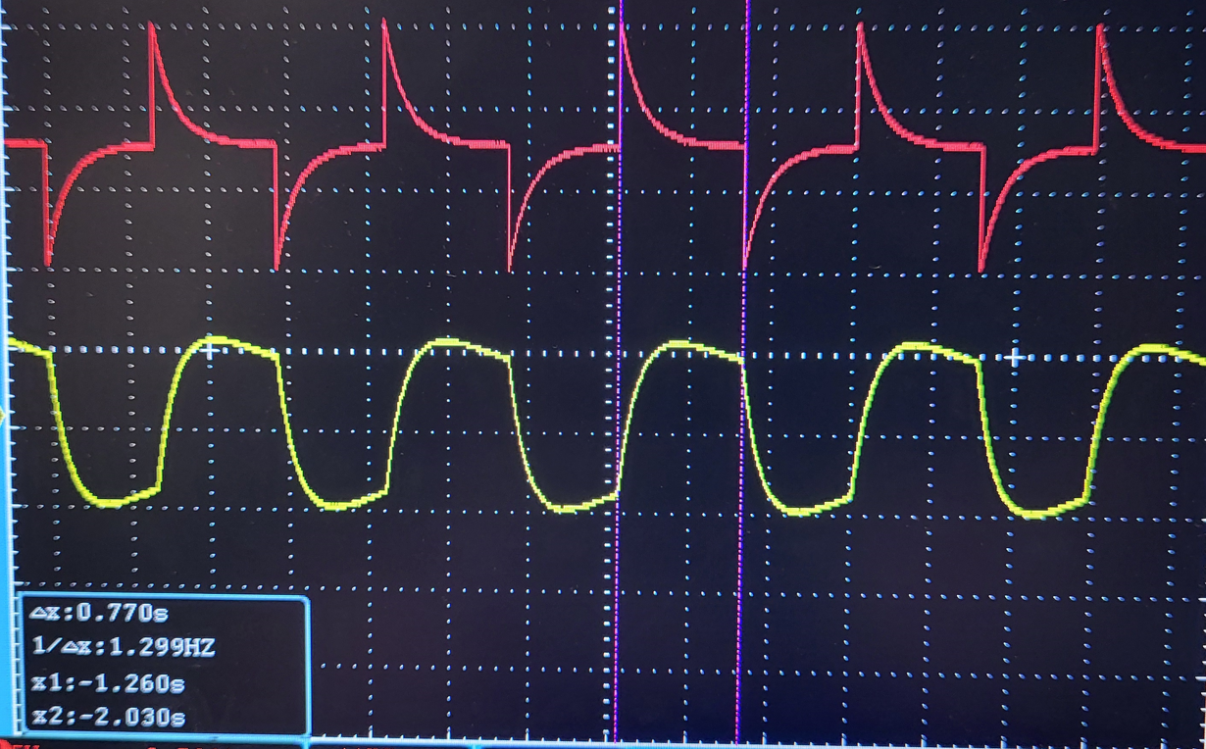 | 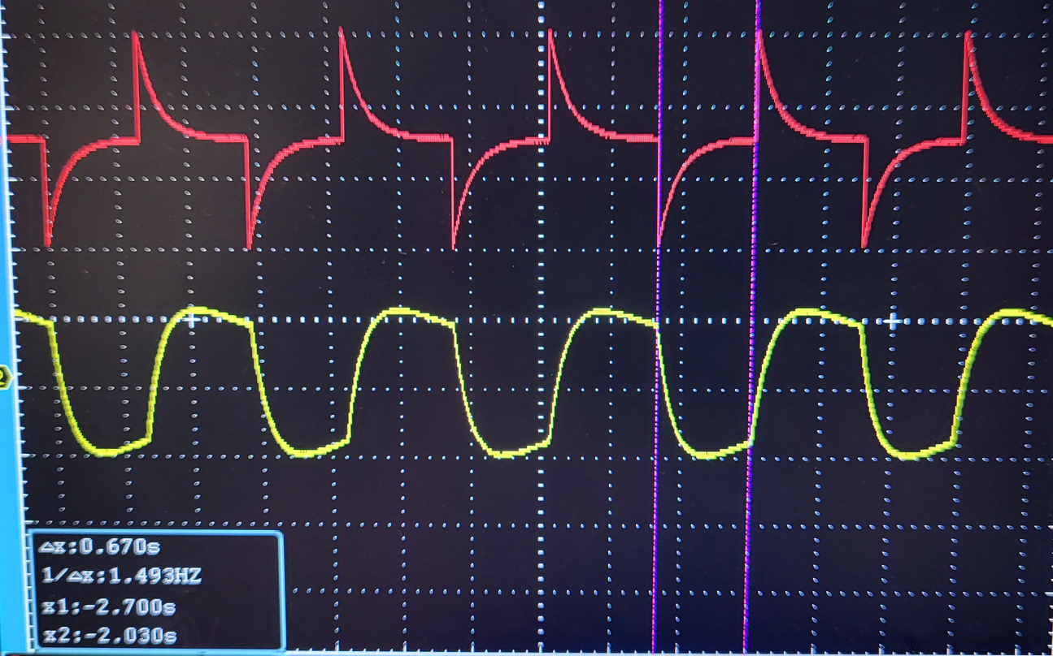
Figure 12 - On / Off and Frequency for 555 Timer
On Time | Off Time | Period | Frequency
2.030 – 1.260 = 0.77s | 2.700 – 2.030 = 0.67s | 0.77 + 0.67 = 1.44s | $\frac{1}{1.44}=$0.694 Hz
Table 3 - On / Off, Period and Frequency

Discussion

Interpretation

Timer Circuit | On Time | Off Time | Period | Frequency
Software predicted | 2.23 – 1.46 = 0.77s | 2.93 – 2.23 = 0.70s | 0.77 + 0.70 = 1.47s | $$\frac{1}{1.47}=0.68 Hz$$
Physical Build | 2.030 – 1.260 = 0.77s | 2.700 – 2.030 = 0.67s | 0.77 + 0.67 = 1.44s | $\frac{1}{1.44}=$0.69 Hz
Table 4 - Summary of measurements.
The values obtained within this report show good correlation between the values predicted from software and those from a physical timing circuit. The one discrepancy can be seen in the off time for the bread board circuit. This is most likely down to human error of the author when taking the measurement manually from the oscilloscope. There is a possibility that this discrepancy could be from the discrete components themselves, as the software is using nominal fixed values for the components. Whereas there are variances with the discrete components, the resistors used in the circuit were verified, using a multimeter and compiled in Table 5 prior to assembly.

Nominal value  (as used In Proteus) | Physical Component. | Variance (%)
680Ω | 676 Ω / 682 Ω | 0.59 / 0.3
1k Ω | 0.998k Ω | 0.2
10k Ω | 9.86k Ω | 1.4
Table 5 - Measured resistance of resistors used.

Whilst the elapsed On / Off times for signal voltage (On time = 0.77s, Off time = 0.70s) and capacitor discharge (On time = 0.70s, Off time = 0.77s) are the same, they appear to be reflections of each other. This is due to the initial delay of the signal as it passes around the circuit.

The decay characteristics of the On/Off timer seen in Figure 11 appear to be broadly exponential in appearance. With the circuit containing both resistors and capacitors, the RC time constant [3] should apply. This is defined as:
$$τ=RC= \frac{1}{2πf_{c}}$$
Equation 8 - RC Constant
Where:
τ = Time Constant
RC = Resistance (Ω) * Capacitance (F)
f_{c} = Cut-off frequency (Hz)
$$τ=RC=0.068 s$$
Equation 9 - Solved for RC
Using Equation 8 in this function will give the time constant in seconds, re-arranging for cut-off frequency will present in Hertz.
$$f_{c}= \frac{1}{2πRC}= \frac{1}{2πτ}$$
Equation 10 - Re-arranged for cut-off frequency.
$$f_{c}= \frac{1}{2π\left(680\right)*(100*{10}^{-6})}=2.34 Hz$$
Equation 11 - Solved for cut-off frequency
Results obtained for Equations 9 & 11 give the charging and discharging characteristics of the timer circuit.

Relevance to OME

Timer circuits or fuses have been used in ordnance from as early as the American Civil War [4] and have evolved from chemical timers to modern day electronic circuits [5]. The move from less reliable chemical timers to other forms (e.g. mechanical, pyrotechnic, electro-mechanical and nuclear timebase) [6] was primarily driven by the need for repeatability, safety and cost.
Nowadays there are strict design standard [7] documents that seek to ensure reliability and safety are designed into a system before they are entered into service. These safety parameters vary dependant on the end use application; however they do involve all electronic parts of the system from the fireset through to electronics in a full assembly.[8] of a system.

Conclusions

The laboratory work in building and testing a timer circuit has been a new experience for the Author and one that has given practical insights to electronic systems used in everyday personal and professional life. With a greater attention to detail, it is believed that the expectation at the outset would match that of the measured results for the On and Off times of the designed circuit. Further work to change the observable periods by altering the values of capacitance and resistance of the discrete components should be considered.
Through additional readings related to the triple 5 timer circuit it is apparent just how important electronic timers are in modern ordnance systems. Through this research the Author has subsequently discovered key technical documents governing the design, preparation and use of these items which will be of great help in future professional development within the industry.

Annex A

References

- Labcenter website, www.labcenter.com , accessed 09/12/24
- Electronics Forum website, www.electronisforu.com/technology-trends/learn-electronics/555-timer-working-specifications. Accessed 16/12/2024
- An Analog Electronics Companion: Basic Circuit Design for Engineers and Scientists, S. Hamilton – 24 April 2003
- Civil War Naval Ordnance, Volume 2, Eugene B. Canfield, Naval History Division, Navy Department, 1969
- Engineering Design Handbook, Timing systems and components. Department of the Army Headquarters United States Army Material Command. 31 December 1975
- DESIGN, TESTING, AND SAFETY CONSIDERATIONS OF AN OPTICALLY ISOLATED FIRING SET Mark W. Heyse, Keith A. Jamison Ronald E. Stearns Optical Technologies for Arming, Safing, Fuzing, and Firing II – SPIE Conference held in San Diego, CA, August 13th-17th, 2006.
- Improved Fireset Acceptance Using Established Evaluation Measurements Unclassified R. W. Davis Lawrence Livermore National Laboratory, P.O. Box 808, Livermore, CA 94551-0808 February 10, 2020
- DEF STAN 59-114 Part 1 Issue 1, Principles for the Design and Assessment of Electrical Circuits Incorporating Explosive Components, Defence Standard: First Draft Publication Date: 26 March 2010

