

LEVEL 5

SEMESTER 2

MODULE CODE: SHSS5093

MoDule Title: Biomechanics of sport and Exercise
aSSESSMENT TYPE: Experimental Research
Assessment/Component: 2

COMPONENT WEIGHTING: 50 %

WORD COUNT: 2000

MODULE TUTOR: David Gardner

SUBMISSION DETAILS: by 3.00 pm through Turnitin

Kinematic Analysis

Conduct a complete kinematic analysis of a sporting action on two athletes of different abilities, or one athlete in at least two contexts in order to full describe the movement and highlighting training advice for the athlete or coach.

Write a 2000 words article (Journal of Sport science format) describing the data and justifying training advice.

Tasks

Using video and or other relevant biomechanical assessment techniques record a sporting performance that occurs primarily in 2 dimension.

Conduct and compare an identical second analysis on the athlete within a different context (fatigue, higher resistance, different equipment) or compare to a high performing athlete.

Describe the observed sporting action potentially in terms of;

Phases,

Joint angles,

Linear displacement, velocity and accelerations.

Angular displacement, velocity and accelerations.

Joint and muscle forces (if appropriate)

Additional biomechanical assessments as appropriate

Based on the information observed, collected and deduced justify training and performance recommendations.

Complete a 2000 work journal (in the format of the Journal of Sport Sciences) based report describing

Assessment Criteria

Further details relating to the specific requirements of levels grading and format for the article will be provided during lectures and tutorials.

School of Sport, Health & Outdoor Education

Assessment Feedback Sheet

Student No./Name: 1809246 Hannah Warlow

Module Code: SHSS5093
Module: Biomechanics of sport and Exercise

Personal Evaluation – to support your academic progress please complete the section below BEFORE submitting your work.
What do you consider to be the best aspects of this work? |  |  | It was good to see the technique of the rower changing, so that this could be improved.
Which aspects do you consider could have been improved in this piece of work? |  |  | Analysis of the movement for over a longer period.
What have you found most satisfying whilst undertaking this submission? |  |  | Learning about the different phases of movement and being able to correct technique to improve the rower’s performance.
ASSESSMENT CRITERIA | Learning  Outcomes |  | GRADE
ASSESSMENT CRITERIA |  |  | Poor  < 20% | Weak  20-29% | Unsatisfactory  30-39% |  | Satisfactory  40 – 49% | Good  50 – 59% | Very Good  60 – 69% | Excellent  70 – 84% |  | Exceptional  85– 100% | %
Abstract | 1,2 |  |  |  |  |  |  |  |  |  |  |  | 5
Introduction | 1,2 |  |  |  |  |  |  |  |  |  |  |  | 15
Method | 1,2 |  |  |  |  |  |  |  |  |  |  |  | 10
Results | 1,2 |  |  |  |  |  |  |  |  |  |  |  | 25
Discussion | 1,2 |  |  |  |  |  |  |  |  |  |  |  | 25
Conclusion | 1,2 |  |  |  |  |  |  |  |  |  |  |  | 5
References | 1,2 |  |  |  |  |  |  |  |  |  |  |  | 5
Article format | 1,2 |  |  |  |  |  |  |  |  |  |  |  | 10
It is expected that students will present work that is proof read, correctly referenced and adheres to the Assessment Checklist. Therefore a range of 0 – 10 marks will be deducted for non-completion of any of the points on the checklist below.
TUTOR COMMENTS:
Submission date:  via Turnitin |  | Return date:  (at least within 4 weeks) |  |  |  | Tutor: |  |  |  |  | Mark:

Assignment Checklist

- Please complete the Personal Evaluation section of the Assessment Feedback sheet, add your name and details, and paste the whole of this assignment document into the front of your assignment

- Submission is a single word file, clearly labelled with your name and module code
- Font style - Times New Roman, size -12 for text and 14 for headings
- Ink colour – black only
- Line spacing – 1.5 line spacing and 2cm- 2.5cm page margins
- Quotations more than three lines to be indented 1 line spacing
- One line space between paragraphs, paragraphs must be left aligned
- Pagination (your assignment should have page numbers)
- All tables and figures are internally referenced and have a title
- Word count checked and written at end of text (before references and any appendix)
- Assignment is within 10% of the word limit (excluding references and any appendices)
- All references in the text are included in the reference list
- Correct referencing following the Harvard style, as described in the Palgrave study skills book ‘Cite them Right’.
- Correct spelling using UK English
- Correct use of punctuation
- Grammar and syntax correct- double check anything that has a green line under it
- I have read my assignment out loud to myself and it makes sense and is easy to read
- Somebody else has read my work and it makes sense to him or her!
- I have checked and I have not plagiarised
Failure to follow these guidelines will cost you marks!

HannahWarlow 1809246
SHSS5093 Biomechanics of Sport and Exercise.

Two Different Speeds analysed on a Concept2 Rowing machine, carried out by a semi-professional rowing Athlete

Abstract

During this report a comparison and investigation was carried out on the technique and body positioning of a female rower, using the concept2/ergometer gym-based rowing machine. The movement was captured on video using an apple iPad with the app called HUDL. The female was asked to continuously row for 2 minutes at a time, for 2 different speeds. The first speed of 150 watts and the second speed for 300 watts. The faster speed was shown during analysis that there was less control during the recovery stage and the body seemed to concertina, with the lower legs folding together completely. This was seen happening only during the faster speed. The finish phase, during both speeds, showed that the rower possibly flexes too much at the hip, leaning back excessively.
Technique on the ergometer or in the water is a very important part in the performance. A good technique will help to prevent injury and achieve the greatest amount of power to move a good distance with each stroke (Richerbush, 2019). The aim of a stroke is, in the most effective and efficient way, to move the boat as far forward as possible and to maintain speed, producing maximum speed with minimum effort (British Rowing 2020).

Introduction

The concept2/ergometers found in the gym is one piece of equipment that requires a moderate technical competency in the correct use. This will ensure maximum benefits from training with it and preventive injury from use (British Rowing, 2019). Competitive rowers will use the ergometer rowing machines, more so during the winter months when the weather may not be suitable to go out on the water. There has been a concern regarding discrepancy between biomechanical properties of techniques used on the water and the techniques used on the ergometer (Sarabon, 2019). Lots of ergometer training has seen a high volume of injuries, with the lower back being the most common injury (Wilson, 2014). This is seen to be possibly because of the higher lumber flexion range of motion seen on an ergometer in comparison to that on the water (Wilson 2013).

A good rowing stroke is defined by a long drive phase and then a smooth and controlled recovery phase (British Rowing, 2019).

The Drive Phase

1. Starting with the push off from/with the legs.
2. When legs have extended halfway, hip angle will start to open.
3. As the legs extend fully, the back becomes vertical and the arms will begin to pull the handle towards the body.
4. Handles should finish halfway up the body with the elbows following the same line with the handle. Wrists should also stay in line with the forearms.

The Recovery Phase (Requires most concentration)

1. When at the finish position the legs and back are expected to be straight.
2. When arms are straight also the recovery is initiated.
3. Hips should start to pivot before any bend in the legs start.
4. To finish the recovery stage legs flex up until the shins are vertical.

The back should stay in a neutral position throughout both stages. To transport power from the legs the hips will pivot and this will allow the power to be transported evenly through to the spine to help prevent back injury (British Rowing, 2019). When a biomechanical analysis was carried out in a lab and on the water, it showed a neutral spine and the position of the pelvis is important in the role of reducing injuries (Wilson, 2014). The body needs to rock forward over the sit bone allowing flexion through the hips at the time between transitioning from the drive phase to recovery, concentrating on keeping the back in a neutral position throughout the whole movement. When the participants were seen to be fatigued good hip movement was lost and the load was then put in the lower back, leading to possible back injury (Wilson, 2014). At the university of Dublin, Dr Wilson conducted a study on back strain comparing the ergometer rowing machine and sculling in the water. The sagittal plane is the plane of motion during the use of the ergometer. It was found that more stress was put on the lumbar spine flexion as fatigue increased, with the use of the ergometer than when rowing on the water in a sculling boat. This highlighted the need for technique to be correct more so on the ergometer indoor rowing machine (Wilson, 2013).

Method

The participant was marked using multi coloured small round stickers, these were placed on joints of her body that were later used to get measurements of angles for the analysis. An ergometer/concept2 rowing machine was used, this was set on a medium level of a resistance (number 5). The participant was then asked to sit on the machine and the feet plates were set for her size shoe and the straps on the foot plates, tightened around the feet.

The joint positions of the coloured stickers:

1. On the Shoulder
2. On the Elbow
3. At the Wrist
4. At the Hip
5. On the Knee
6. At the Ankle of performance

Next the participant was requested to continuously row for 2 minutes at the speed of 150 watts, during the 2 minutes this was filmed at 90-degree to the line of performance using the HUDL app on the apple iPad, this app later slowed the footage right down in order to analyse the movement in smaller fractions. The same process was carried out for the higher speed of 300 watts, again later this was properly reviewed. The app split the video clips up into small timed intervals of a second, 0.1 of a second. Next, a piece of acetate was placed over the screen and a pen specifically for a sheet of acetate was used to mark and join up the small coloured stickers that had been placed on the participants joints. This was carried out for both speeds recorded. Then a protractor was used to get the angular displacement/join angles using the images of the rower’s knee and hip left on the clear acetate sheet, the changes in joint angle, divided by change in time. A sheet of plain white paper was placed under the clear acetate to make it clear to see. Using these joint angles to work out what the rotation’s angular velocity is. The final stage of this method was to use the measurements to plot line graphs to analyse the collected data more clearly.

Results

The results of this test showed that in the faster the speed of rowing at 300 watts there was a loss of proper rowing technique. It showed that the hips and buttock moved closer to the ankle at the higher speed during the recovery stage. As body parts compressed, a jerk or bounce was caused, having a negative effect on overall performance. Instead of just powering the boat forward it could bounce it back in the wrong direction. Overall, there was not a lot of difference found between the angles of both the speeds plotted on the graphs.

Discussion

The technique is an important part of rowing, this is for both with a machine or on the water (Richerbush, 2019).
The rowing movement should be one fluid stroke, it is not like the separate phases broken down and used to explain, in order to analyse, learn or teach the technique (Hart, 2006). On a rowing machine, any physical weakness or injury cannot be hidden, that is also the same for the mental state of the individual. When using a rowing machine in order to harness an athlete’s full potential and get faster times by improving their performance, the proper technique is essential. A large range of movement is used recruiting the use of major muscles and joints. This should be a powerful sequence in a non-impacted way (Hart, 2006).
It the year 1829 the first Oxford rowing race took place, it is noted that boat velocity has been improved by 2-3 % per decade since. This is partly because the general population has got taller and stronger. Less than 10% of this accounts for improvements because, with the increase of the body mass, an increase in boat drag has been seen. As for velocity, a big improvement has been seen, of 25-30% decreasing boat drag on average over the last 150 years. There has also been better efficiency seen with oar blades and by improving the technique (Seiler, 2006). In this report, the participant showed that, during the recovery stage, the forward flexion at the lower body around the hips compressed together. The weight was then shifted from back to front in a jerky or bouncy way, this would need improving as is would stop a smooth move forward and would decrease the possible propulsion or distance of the boat going forward with every stroke. This is a short study and only done for 2-minute intervals. The study could be repeated and broken up into 3 different stages. Stage one would be as it is in this report and filmed for 2-minute intervals. Second stage could use longer, 5-minute intervals, but firstly (before filming) start with a 5-minute warm up. Then thirdly during fatigue after the first two stages. This report is limited as it analysed the rower’s technique from a ‘cold start’ and for two minutes only, as such it is difficult to generalise from it. With a 5-minute warm up the brain and body might engage better and the technique could improve.

Conclusion

Looking at and comparing the different speeds on the graphs, it does not look like there is much difference in them. The hip and knee angles are similar, and the technique, overall, is the same. This is limited data, but shows that at these speeds for that amount of time, there is room to improve on the participant’s technique. By improving technique there could be a faster time achieved. This would best improve the start of a race when a spring start is needed, this means fast paced strokes are used for a short distance at the beginning of a race to try to gain distance between boats. Minimising the bounce or jerk in the boat will enable the participant a good head starts in races. By further testing it can be determined if the technique settles down after the initial sprint, meaning that just the sprint speed technique needs addressing or if it is an improper technique throughout that needs work to get the best race results.

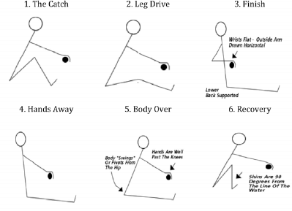

Phases of a rowing Stroke

Mazzone. Kinesiology of a rowing stroke, Wyoming county community hospital. New York. N
SCA Journal, volume10. (1988)

(Wordcount 1832)

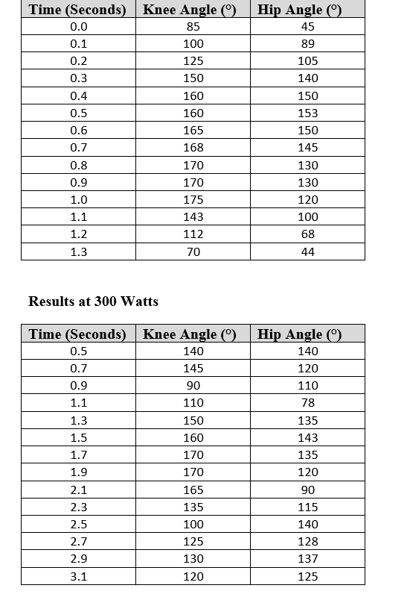

The Hip angle at Two Different speeds
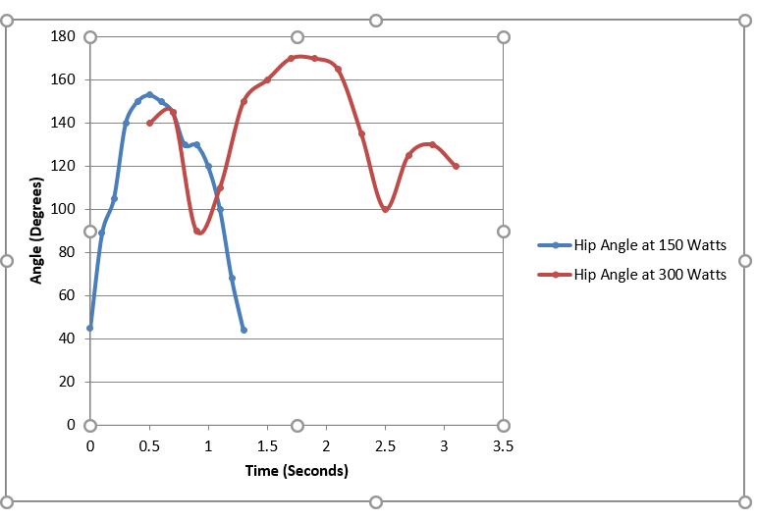

The knee Angles at Two Different Speeds
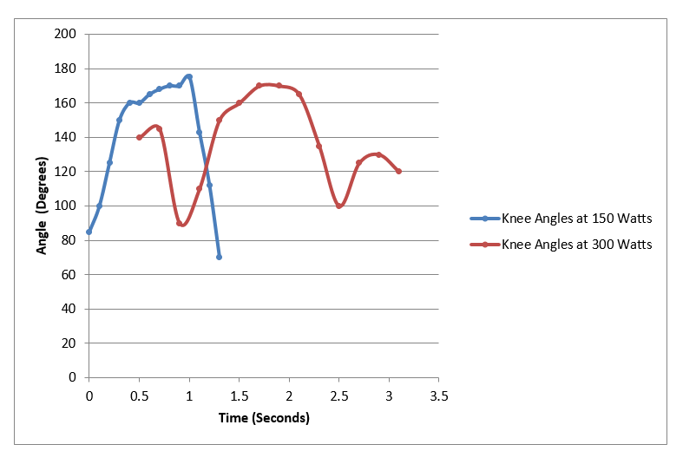

Reference list

An ergometer-based study on the role of upper limbs in the female rowing stroke- scientific figure’ on ResearchGate. Available from:
Available at: https:// www.reserchgate.net/figure/the-different-phases-of-the-rowing-stroke-fig1-229825873 (Accessed May 16 2019)

British Rowing (2019) Indoor Rowing Technique. Available at: https://britishrowing.org (Accessed: 15 January 2020).

Hart, A. (2006) ‘Rowing Technique’, Crossfit Journal, 50. Available at: https://libarycrossfit.com>free>pdf (Accessed: 15 January 2020).

Richerbusch, E. (2019) ‘Rowing: Does proper technic matter in terms of power production and does it help to prevent injury’, Athletic Lab. Available at: https://www.athleticlab.com (Accessed: 15 January 2020).

Seiler. S. (2006) Sport science- Agder University College, facility of health and sport, Krislansand 4604 Norway. Reviewer; Alanhahn, Australian institute of sport, Belconnen. ACT 2616. Australia. (2006) Available at: https://sportsci.org/2006/ssrowing.htm (Accessed: 15 January 2020).

Mazzone. (1988) ‘Kinesiology of a rowing stroke’, Wyoming county community hospital. New York. NSCA Journal, 10. Available at: https:// www.nccrew.com (Accessed: 15 January 2020).

Wilson, F., Gissane, C., Gormly, J., and Simms, C. (2013) Sport Biomech. Trinity Centre for Health Sciences. St James Hospital, Dublin. June. Available at: https:// www.ncbi.nih.gov (Accessed: 15 January 2020).

Wilson F. (no date) Back Pain in Rowing. Trinity College of Dublin. The University of Dublin -. Available at: https://www.worldrowing.com (Accessed: 15 January 2020).

British Rowing (2020). 6 Lower Mall Hammersmith, London, W6 9DJ. Available at: www.britishrowing.org (Accessed: 15 January 2020).

N. Sarabon., Z. Kozinc and G. Markovic (2019) ‘Effects of Rowing Ergo meter Compliance on Biomechanical and Physiological Indicators during Simulated 2,000-metre Race’, Journal of Sports Science & Medicine. Available at: www.ncbi.nih.gov (Accessed: 15 January 2020)

Wilson. F., Gissane C., McGregor, A. (2014) ‘Ergometer training volume and previous injury predict back pain in rowing; strategies for injury prevention and rehabilitation:Table 1.’ British Journal of Sports Medicine 48, 1534-1537. Available at: www.pubmed (Accessed: 15 January 2020

Wilson. F., Gissane. C., Gormley J., and Simms, C. (2013). ‘Saggital plane motion of lumbar spine during ergometer and single scull rowing’. Sports Biomechanics 12, 132-142. Available at: www.pubmed (Accessed: 15 January 2020)

