

Methods and Search Strategy Academic Poster

Student name: Asteria Joseph Nyamhanga Wilson
Student ID: 2311121
Lecture Name Chloe Harries
Module name: Independent Project
Module code: BMHP6020

Element 2 Poster
An investigation into the role of applying AI-supported mental health triage systems to enhance Improving Access to Psychological Therapies (IAPT) for the patients suffering from Dementia in the UK healthcare industry: A case study of NHS hospitals
01 Introduction and Research Aim  Brief Overview: Saunders’ Research Onion acted as the guide for methodological considerations, providing a sound structure at all stages. Key words and Boolean operators were selected in order to strike the balance between precision and comprehensiveness of the search. Databases selected included Google Scholar, PubMed, and NHS England databases owing to the relevance of their content for UK context. Credibility of sources was assessed using the CRAAP criterion.  Research Aim: The research study aims to examine the influence of AI-supported mental health triage systems on IAPT (Improving Access to Psychological Therapies) for increased Dementia care in the UK healthcare industry from the organisational context of NHS hospitals | 02 Search Strategy  Definition of search strategy in secondary research: Search strategy in secondary research is a systematic process or method of finding the existing literature that is relevant by predetermined keywords, databases and filtering terms to ensure the information is accurate and relevant (Chigbu et al., 2023).  Use of this strategy: The Boolean operators were used in Google Scholar, PubMed and NHS Evidence to identify specialised academic literature with key keywords (AI mental health triage, IAPT NHS, and therapy to dementia UK).
03 Searching for Information  Process of Searching: Peer-reviewed journals, NHS publications, UK healthcare policy documents were used to conduct information search to make sure that the information is contextual and relevant to organisations.  Break down of the steps considered  a. The search terms were evaluated based on the conversion of them to research goals, helping in choosing keywords and Boolean operators.  b. The identified references were recorded on a Source Tracking Table (Appendix 1) by documenting the author, topic, and relevance of the resource.  c. Every resource was analysed using the CRAAP test for Currency, Relevance, Authority, Accuracy, and Purpose.  d. All screened resources were put together on a Results Summary table (Appendix 2). | 04 Picture / Graph / Visual Aid / Statistics  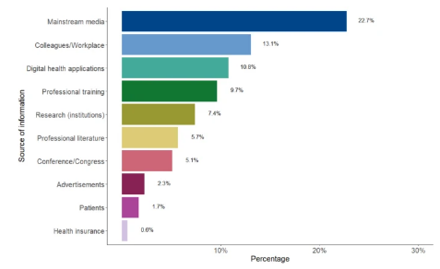  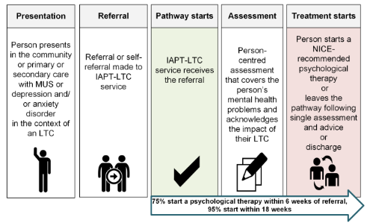  Source: NHS England, 2026  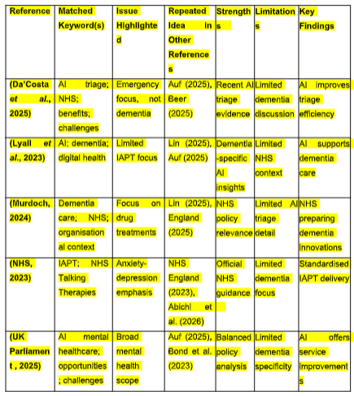
05 Research Validation and Analysis
Definition of validation: The CRAAP test was conducted on all the sources that had been identified during this evaluation. This process involved evaluating the sources based on currency, relevance, authority, accuracy, and purpose. The sources that satisfied these criteria were retained while the rest were disposed of (Shaheen et al., 2023).
Credibility and Reliability of importance: Healthy academic integrity ensures credible and reliable information, valid conclusions, minimises bias, increases the transparency of the research, boosts trust in the readers, and enhances the overall quality of the dissertation in a remarkable way (Zhaksylyk et al., 2023).
Benefits and limitations: Credible sources make arguments stronger, accurate, add more confidence and scholarly rigour and require relying on them which limits the range of views, blocks future studies, and is more time-consuming (Lim, 2024).
Explanation of Drawing themes: Codes formed groups based on four themes including policy integration, care relationships, operational restrictions, and institutional readiness, described in the Result Summary table referring to the appendix section in the assignment. The application of the Braun and Clarke model to analyse the theme generation from the Boolean Coding was applied for gaining feasibility in the research process.
06 Inclusion Criteria  The research will involve 10 sources, peer-reviewed scholarly research papers, NHS reports, and documents of healthcare policies in the UK that have been published within the past 5 years. The literature on AI-assisted triage tools, mental health intervention related to dementia, IAPT frameworks and NHS organisational background were given priority. | 07 Exclusion Criteria  The research will also disqualify 10 sources, the excluded materials will be outdated publications older than 5 years, non-essential theoretically, non-UK healthcare research, lack of empirical evidence articles, sources that are not in full text. The research that had no relation to mental health triage or dementia care pathways were also eliminated to ensure conceptual consistency with the research objectives.
08 Ethical Considerations
In secondary research, some of the ethical challenges include an accountable treatment of pre-existing data and upholding academic honesty and openness. Other ethical behaviours included proper references, objective analysis of findings, and avoidance of plagiarism and attentive representation of the information on the dementia patient (David et al., 2024).

References
Chigbu, U.E., Atiku, S.O. and Du Plessis, C.C. (2023) ‘The Science of Literature Reviews: Searching, Identifying, Selecting, and Synthesising’, Publications, 11(1), p. 2. Available at: https://doi.org/10.3390/publications11010002.
David, M.C.B., Giovane, M.D., Wilson, D., Truman, T., Huntley, J.D., Suleman, M., Keene, A.R., Parker, M., Sharp, D.J. and Malhotra, P.A. (2024) ‘Considerations for legal, ethical, and effective practice in dementia research’, Brain communications, 6(4). Available at: https://doi.org/10.1093/braincomms/fcae211.
Lim, W.M. (2024) ‘What Is Qualitative research? an Overview and Guidelines’, Australasian Marketing Journal (AMJ), 33(2), pp. 199–229. Available at: https://doi.org/10.1177/14413582241264619.
Shaheen, N., Shaheen, A., Ramadan, A., Hefnawy, M.T., Ramadan, A., Ibrahim, I., Hassanein, M., Ashour, M.E. and Flouty, O. (2023) ‘Appraising Systematic reviews: a Comprehensive Guide to Ensuring Validity and Reliability’, Frontiers in Research Metrics and Analytics, 8(8). Available at: https://doi.org/10.3389/frma.2023.1268045.
Zhaksylyk, A., Zimba, O., Yessirkepov, M. and Koçyiğit, B.F. (2023) ‘Research Integrity: Where We Are and Where We Are Heading’, Journal of Korean Medical Science, 38(47). Available at: https://doi.org/10.3346/jkms.2023.38.e405.

