BSc (Hons) Health and Social Care

Psychological Classifications and Provisions

BMHP6029

Component 1: Individual Presentation (Academic Poster)

Student Name: Rafia Farooq

Student Number: 2325948

Lecturer Name: Neale Haddon

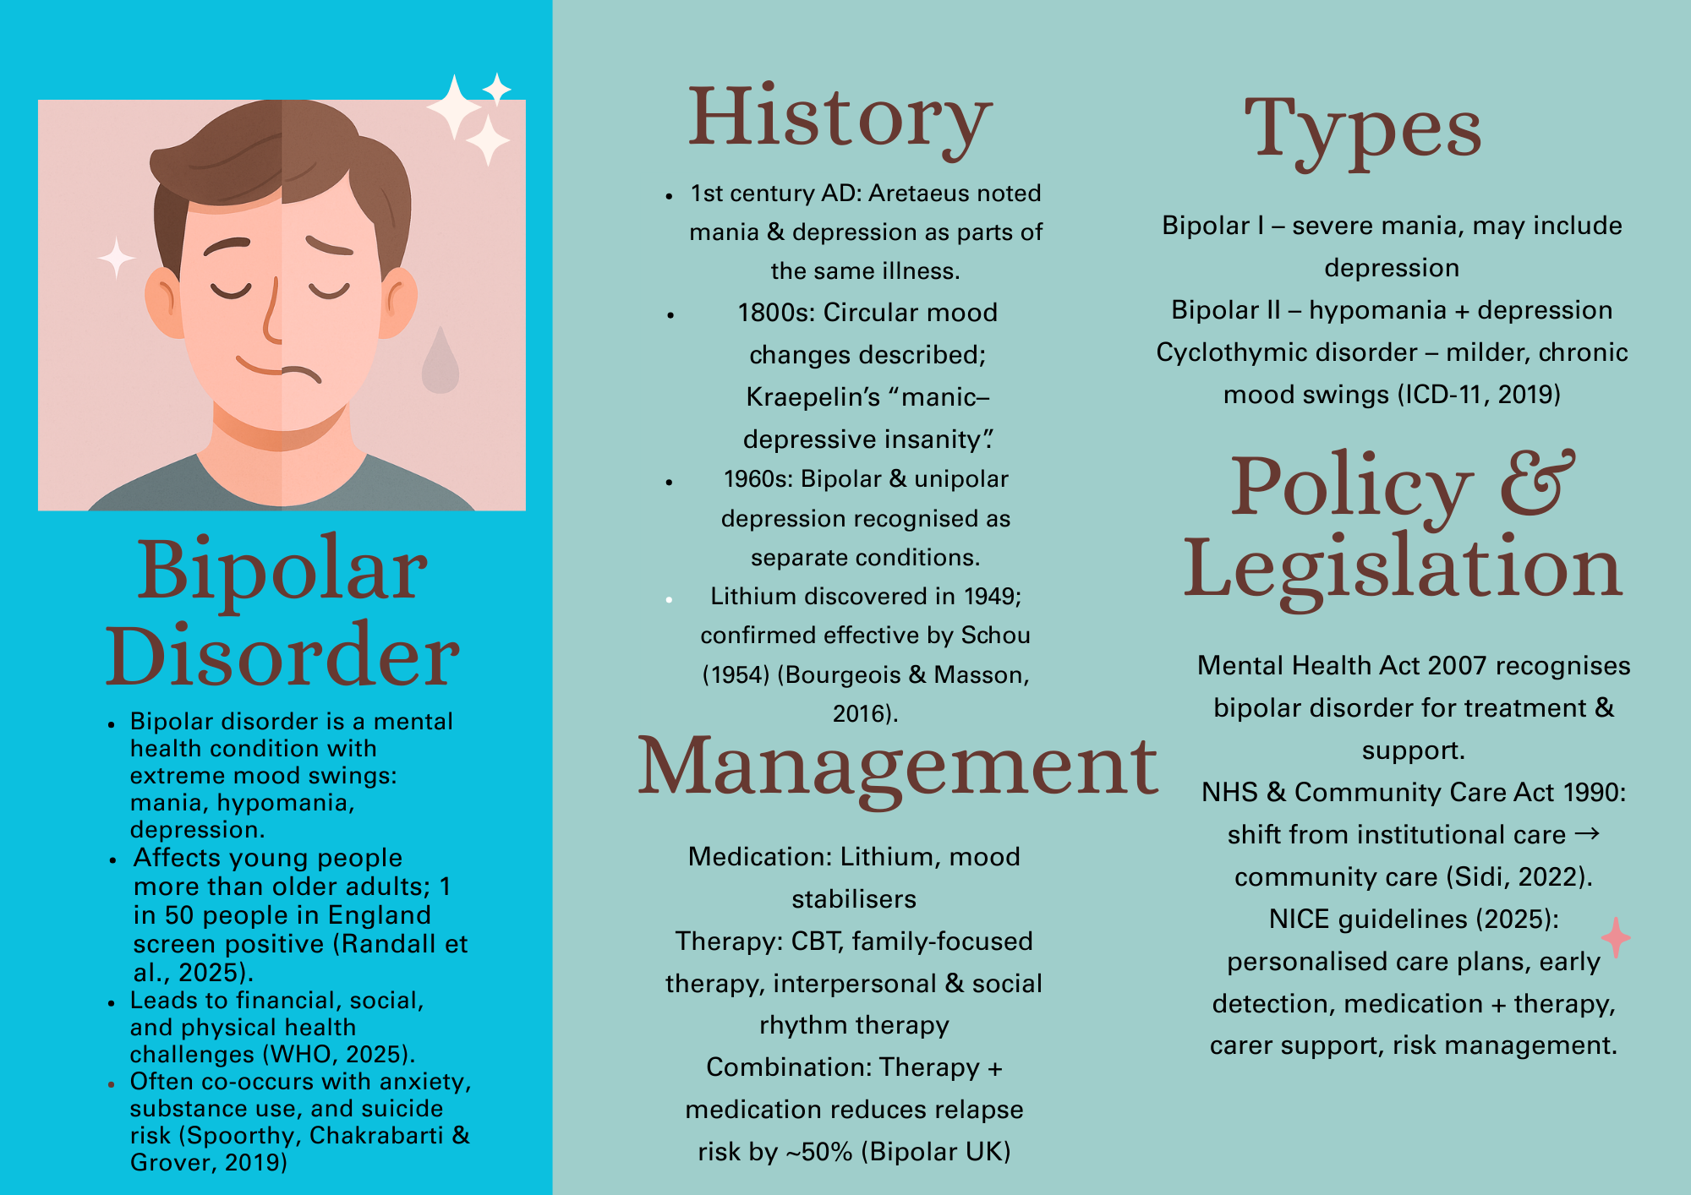
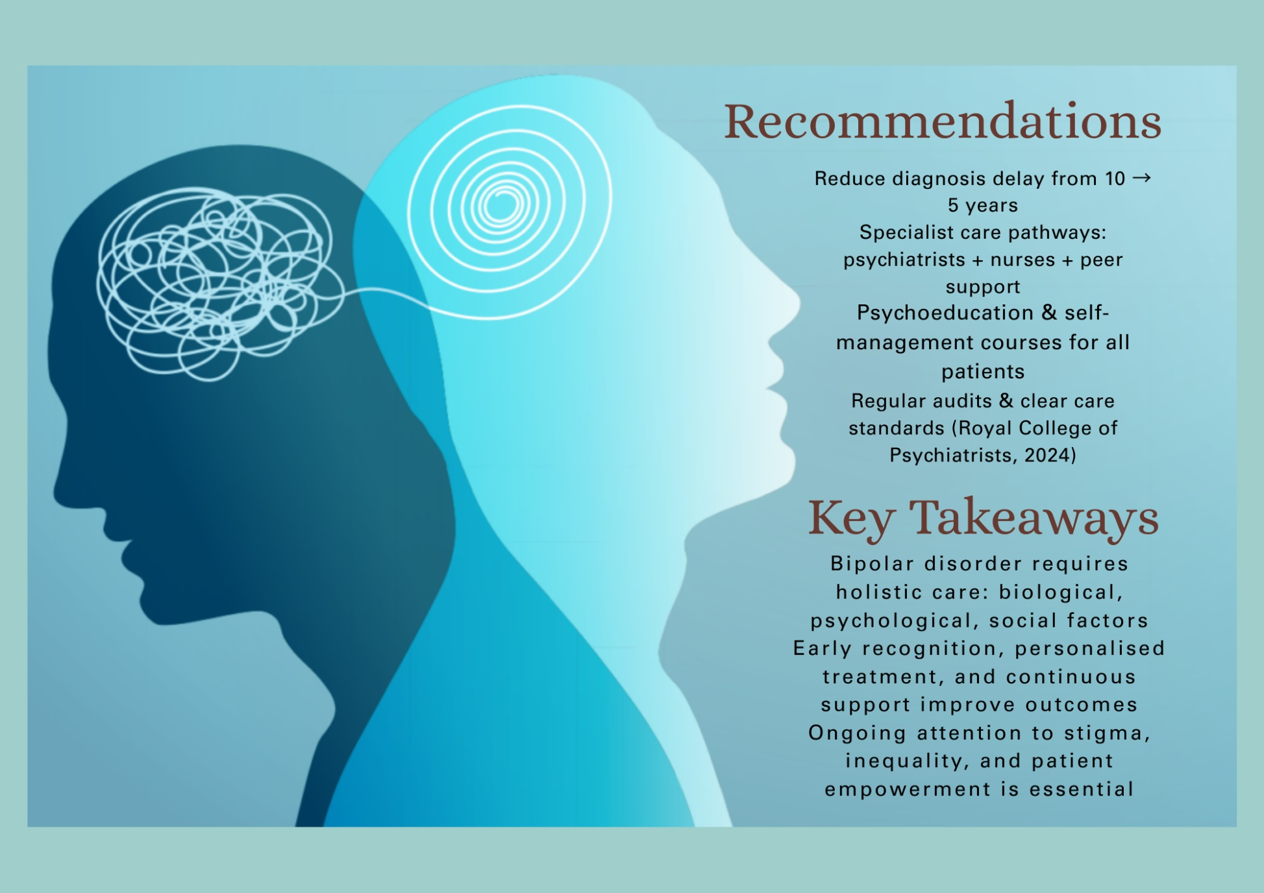
Reference.
Angst, J. and Marneros, A. (2001) ‘Bipolarity from ancient to modern times:: conception, birth and rebirth’, Journal of affective disorders, 67(1-3), pp.3-19. Available at: https://doi.org/10.1016/S0165-0327(01)00429-3
Bipolar UK (no date) Therapy for bipolar Available at: Therapy | Bipolar UK (Accessed: 24 January 2026).
Bourgeois, M.L. and Masson, M. (2016) The history of lithium in medicine and psychiatry. In: Malhi, G. S., Masson, M. and Bellivier, F. (eds.) The science and practice of lithium therapy. Springer, Cham, pp. 181–188. Available at: https://doi.org/10.1007/978-3-319-45923-3_10
Mental Health Foundation (2026) Bipolar disorder: statistics. Available at: Bipolar disorder: statistics | Mental Health Foundation (Accessed: 20 January 2026).
National Health Service (2024) Bipolar disorder. Available at: Bipolar disorder - NHS (Accessed: 20 January 2026).
National Institute for Health and Care Excellence (NICE) (2025) Bipolar disorder: assessment and management (CG185) – recommendations. Available at: Recommendations | Bipolar disorder: assessment and management | Guidance | NICE (Accessed: 23 January 2026).
Randall, E., Clery, E., Morris, S., McManus, S., and Marwaha, S. (2025). Bipolar disorder. In Morris, S., Hill, S., Brugha, T., McManus, S. (Eds.). Adult Psychiatric Morbidity Survey: Survey of Mental Health and Wellbeing, England, 2023/4. NHS England Digital. Chapter 11: Bipolar disorder - NHS England Digital Accessed: 23 January 2026).
Royal College of Psychiatrists (2024) Improving care and diagnosis for those with bipolar disorder: Bipolar Day 2024 consensus statement. Available at: Improving care and diagnosis for those with bipolar disorder (Accessed: 23 January 2026).
Sidi, L. (2022) ‘After the madhouses: the emotional politics of psychiatry and community care in the UK tabloid press 1980–1995’, Medical Humanities, 48(4), pp.451-460. Available at: https://doi.org/10.1136/medhum-2020-012117
Spoorthy, M. S., Chakrabarti, S., and Grover, S. (2019) Comorbidity of bipolar and anxiety disorders: an overview of trends in research. World Journal of Psychiatry, 9(1), pp. 7–29. Available at: doi: 10.5498/wjp.v9.i1.7
UK Government (1990) NHS and Community Care Act 1990. Available at: National Health Service and Community Care Act 1990 (Accessed 24 January 2026).
UK Government (2007) Mental Health Act 2007: Explanatory Notes. Available at: Mental Health Act 2007 - Explanatory Notes (Accessed 24 January 2026).
World Health Organization (2024) Bipolar or related disorders. International Classification of Diseases for Mortality and Morbidity Statistics (ICD-11 MMS). Available at: ICD-11 for Mortality and Morbidity Statistics (Accessed: 20 January 2026).
World Health Organization (2025) Bipolar disorder fact sheet. Available at: Bipolar disorder (Accessed: 23 January 2026).

