

BMIH5007
Financial Management for the Hotel Industry

Business Report – Comparison of Shangri-La Hotels and Premier Inn Hotels

Student Name: Marin Marius Enache
Student ID: 2241513
Lecturer: Tristan Hawkins

Words count: 2081

Table of Contents
Introduction 3
Total Revenue and Financial Comparison 4
Market Position 5
Growth Potential 7
CSR (Corporate Social Responsibility): Financial Responsibility 8
Recommendations 9
Conclusion 10
References 11
Appendix 13

Introduction
This business report evaluates critically the financial management strategies of Shangri-La Hotels and Premier Inn Hotels. They are analysed based on the total sales revenue differential, market segment, growth prospects, and CSR spending. Through these primary areas of analysis, the report seeks to provide a financial feasibility analysis and identify strategic direction for both the hotel groups in the UK and in the international market.

Total Revenue and Financial Comparison
The total revenue of Shangri-La Hotels and Premier Inn Hotels can be better understood in light of their global and especially their UK markets and the financial models and operational blends they both adhere to. Shangri–La Hotels is a luxury international hotel and has the tendency to attract high-end travellers and business clients since its price tariffs are relatively higher hence it has relatively higher revenues (Blagoev, Nikolskaya and Popov, 2019). On the other hand, another mid-scale chain hotel group coming from the United Kingdom, the Premier Inn, has decided to pick cheaper price levels as its unique selling proposition. The above-stated differences in target markets and positioning strategies affect their revenues in a clear way.
Shangri-La has achieved revenue approximated of £1,712,800,000 in FY 2023 and £1,168,000,000 in FY 2022 Shangri-La obtains its total revenues from the hotel accommodation facilities, food sold, and all the other related services that direct its products to the high-end market segment including spas and meetings (Drury, 2021). The firm operates across Asia, Europe and the Americas region and in essence; it can harness diverse revenue streams.
On the other hand, Premier Inn revealed £2.48 billion in revenues for the financial year ended February 2024. This revenue is primarily derived from the UK market and Premier Inn is operating in a strong position in the UK’s budget hotel industry (Seal, 2019). Most of the revenue-generating business for Premier Inn is room sales revenue, which is generally way below that of Shangri-La, because of the fact that the two are in different strata. Other streams of income are through food and beverage services resulting from managing own brand eating joints although it is not as massive as that of room sales for Premier Inn.
Fig 1: Comparison of Revenue (Self-made, 2024)
The company has been receiving- Both in terms of local and international markets, the company has been enjoying good revenue growth due to various factors among which is the aggressive expansion strategy across the UK especially towards city centres and near transport facilities. However, Shangri-La has a greater reliance on its revenues from international travellers, thus exposing it directly to geopolitical risks, fiscal conditions globally and pandemics (Ellis, Stipanuk and Association, 2014).
Based on the cost driver analysis we see that the cost structure is much higher for Shangri-La than that of Premier Inn because of the difference in brand image. Increased customer satisfaction, number of rooms and facilities, and locations, in turn, escalate the labour cost, maintenance expense, and utility costs of Shangri-La. Hilton chain company has a low operating cost per room that helps the company generate a high operating profit margin in the budget segment as illustrated by Premier Inn (Marques and Marques, 2023). These distances show how Shangri-La has a high-margin service model while Premier Inn has a volume and cost control model.

Market Position
Market positioning is also different due to the reasons that Shangri-La Hotels and Premier Inn are in different segments of the hospitality industry. Shangri-La companies in the market segmentation as a luxury hotel chain thus rival other luxury hotel brands like Ritz Carlton, Four Seasons, and Mandarin Oriental. They include businesspeople on travel, wealthy tourists and organisations involved in holding luxurious events, among others. In the UK, Shangri-La has one luxury hotel at The Shard, London: the hotel targets to attract wealthy travellers wishing to undertake business in the region.
Shangri-La currently has hotel locations in the Asia-Pacific region, the Middle East, North America and Europe which means that it can tap markets in the emerging markets with growing middle and upper-income earners. It enjoys a luxury brand image, which enables it to sustain and even grow its market share in the luxury section (Setia, Ronald and Amelia, 2021). However, this segment is very competitive in regard to Shangri-La and its growth in the UK market is somewhat constrained mainly because the luxury hotel sector is not as large as in more populous areas of the world such as Asia.
Although Hilton is an international hotel industry company with facilities in more than 100 countries, Premier Inn is one of the largest UK-based economy hotel companies with more than 800 hotels in England. The company occupies the strategic position of an economical, dependable, and easily accessible hotel, meeting the demands of budget tourists, families with children, and businessmen (Bower, 2017). Main fast rivals of Premier Inn target similar levels and segments and include Travelodge and Ibis companies. However, far and away, the threat assessed for Premier Inn is relatively low due to its enormous size, brand identity, and location in ideal places the dominant market in the United Kingdom.
As is seen from the details above, the current market share of the Premier Inn in the UK market of the budget hotel is huge, and this is because of the low-cost competitive advantage strategy, coupled with the company’s ability to ensure that there is the standard quality of lodging in all their outlet (Scheele, 2014). The market expansion into the German sector is strategically pertinent as the company aims to recreate its profitable business model in a new market. Their focus on people travelling within their country especially after the effects of the pandemic has made them establish a market in the ‘staycation’ in the United Kingdom.
On this criterion, Premier Inn is a lot less diversified than Shangri-La, most of their outlets are based in the US with a few starting to come up in Germany. This means that Premier Inn is more vulnerable to specific economic risks of the United Kingdom market but at the same time, the company can focus on the online UK market which is already familiar with its brand.

Growth Potential
The market positioning, geographical coverage and strategic directions are the four pillars through which Shangri-La Hotels and Premier Inn can grow. This means that there is a greater opportunity for Shangri-La with its global operations to grow in various extensions in the developing economies especially in Asia and the Middle East because of inflationary demand for luxury hotels due to an increase in the standard of living and tourism (Larrinaga and Strangio, 2023). The firm is seeking to enter more new markets for growth in combination with innovation spending on technology and environmental issues also ensures that the firm is well positioned for future growth (Kasavana, 2016). Nevertheless, the company’s heavy dependence on international tourist traffic is one of the main sources of unpredictability making Shangri-La potentially more sensitive to fluctuations in the global economy and standards in the sphere of tourism.
This is particularly so because the UK market will be comparatively less expensive for the expansion of Shangri-La, which is in the luxury hotels industry segment which is relatively and competitively smaller than that of China (Camilleri, 2017). Still, the company can remain focused on its brand dominance in London and consider scenarios for adapting the offer to the needs of international HVs, especially those from the Middle East and Asia.
The factors causing the growth of this company are the expansion plans in the UK and the operation of the company in Germany. The UK market is also still relatively uncrushed and although opportunities for development in London may be limited, possibilities in other parts of the country, specific popular tourist cities for example, are still significant. Rigorous growth plans of acquiring new properties by Premier Inn along with operation dynamism and customer centricity increase the prospects for further growth (Hua, Mejia and Wei, 2018).
The markets of Germany are a prime target for expansion for Premier Inn as it targets to do in Germany what it has been doing in the United Kingdom. The firm will have to expand its operations across the German market and achieve growth. Thirdly, there is a clear growth potential for Premier Inn still in effect due to continued preference for travel within domestic space witnessed across the UK and other European countries in the foreseeable future.

CSR (Corporate Social Responsibility): Financial Responsibility
Currently, the level of CSR investment of Shangri-La and Premier Inn is comparable, but it differs because of the difference in the market positioning and operation-focused geographic location.
Shangri-La has a sincere concern about the corporation’s responsibilities to the environment and society, which the corporation strives to minimise its negative effects on the environment as well as support society. They have set a framework known as “Sustainability, Social and Governance” (SSG) which includes cuts on carbon emissions, cuts on wastes, and encouraging energy saving measures on all their properties (Kakar, Popovski and Robinson, 2021). Other social responsibilities of Shangri-La include supporting educational, health and disaster relief activities in the respective adopting Shangri-La regions. These actions not only increase brand value but are also in response to increasing global concerns about sustainability and responsible tourism, especially in the luxury segment (Walker, 2021).
In the financial aspect, Shangri-La invests a great amount in CSR activities because it is important to have sustainability for the future and for the enhancement of the brand image. Luxury buyers are travelling to Ghana more often expecting CSR options in their travel and holidaying; thus, it is a competitive strategy for the company (Pedersen, 2015).
Like TP, there is also quite a good CSR policy maintained by Premier Inn which is a wholly-owned subsidiary of the Whitbread Group Limited and the major CSR activities of this firm include environmental, societal and employee relations. This means that the firm has outlined in its Force for Good sustainability plan the amounts of carbon emissions it aims to eliminate, how much food waste it will avoid and ways in which it will support local people (Rasche, Morsing and Moon, 2017). A similar pledge has also been made that all electricity used in Premier Inn will come from renewable sources, less water shall be used, and energy performance on premises shall be enhanced.
What we notice about Premier Inn’s CSR initiatives is that they are in sync with its positioning as a low-cost hotel company that maintains social responsibility. CSR spending by the company includes the capital being put into energy-efficient tools, green buildings, and supporting the communities. These initiatives are therefore mutually beneficial for the company as they help achieve business sustainability and sell the company to environmentally conscious clientele (Igbc, 2023).

Recommendations
As for Shangri-La, as a leading player in the industry, it is suggested that the company must step up its operations in the areas of growth/profitable markets, especially within the Asia and Middle East regions where demand for luxury hotels is most likely to rise in the near future. Further, it should seek synergistic relationships with technology vendors to improve on its sustainability goals and serve its clients with unique, sustainable experiences (Hazas and Nathan, 2017). It will not only optimise its operating coinciding to enhance brand appeal in the more saturated luxury market.
Based on the case of Premier Inn one suggestion that can be made is for Premier Inn to intensify its coverage of Germany and the consideration of the expansion of the other countries in Europe (Resources, 2018). The company should also continue to embrace sustainability, this is because it boosts the mission of targeting tourists who are conscious of the environment and is essential in this firm’s competitive strategy in the low-cost provider segment (Murniati and Bawono, 2020). Moreover, the strengthening of the company’s coverage of the domestic market in the UK, especially in provincial and recreational zones, will also contribute to the development in the long run.

Conclusion
Due to global locations and prestige, the company generates plenty of revenue from the luxury segment though operating costs are always high. The hotel has a competitive position in the United Kingdom, a diversified revenue stream profile, and a low-cost strategic positioning. Both companies are involved with CSR but they follow different approaches towards it. Some proposals are the opening of more hotels and branches of Premier Inn on the global level, as well as the increasing the company’s Springs Protect programmes of Shangri-La in following the sustainable development goals.

References
Blagoev, V., Nikolskaya, E.Y. and Popov, L.A. (2019) THE HOSPITALITY INDUSTRY: Understanding Hotel Business. Varna University of Management.
Bower, J. (2017) 'Whitbread: routines and resource building on the path from brewer to retailer,' Management & Organizational History, 13(1), pp. 1–23. https://doi.org/10.1080/17449359.2017.1408471.
Camilleri, M.A. (2017) 'The Tourism Industry: An Overview,' in Tourism, hospitality & Event Management, pp. 3–27. https://doi.org/10.1007/978-3-319-49849-2_1.
Drury C (2021) (11th Ed) Management and Cost Accounting, London, Prentice Hall
Ellis, R.C., Stipanuk, D.M. and Association, A.H.& L. (2014) Security and Loss Prevention Management (AHLEI). Pearson Higher Ed.
Hazas, M. and Nathan, L. (2017) Digital Technology and Sustainability: Engaging the Paradox. Routledge.
Hua, N., Mejia, C. and Wei, W. (2018) A new age of acquisitions in hospitality & tourism: The Bidding War to Acquire Starwood.
Igbc (2023) Introduction to green buildings & built environment. BS Publications / BSP Books.
Kakar, N., Popovski, V. and Robinson, N.A. (2021) Fulfilling the sustainable development goals: On a Quest for a Sustainable World. Routledge.
Kasavana, M.L. (2016) Managing technology in the hospitality industry.
Larrinaga, C. and Strangio, D. (2023) The development of the hotel and tourism industry in the twentieth century: Comparative Perspectives from Western Europe, 1900–1970. Springer Nature.
Marques, J. and Marques, R.P. (2023) Digital transformation of the hotel industry: Theories, Practices, and Global Challenges. Springer Nature.
Murniati and Bawono, S. (2020) Marketing strategy for hotel business: The Secret Of Improving Hotel Marketing Performance in the Tourism Industry. BookRix.
Pedersen, E.R.G. (2015) Corporate social responsibility. SAGE.
Rasche, A., Morsing, M. and Moon, J. (2017) Corporate social responsibility. Cambridge University Press.
Resources, M.A.I. (2018) Global Business Expansion: Concepts, methodologies, tools, and applications: Concepts, Methodologies, Tools, and Applications. IGI Global.
Scheele, D. (2014) The trade-off between cost leadership and differentiation. GRIN Verlag.
Seal W (2019) (6th Ed) Management Accounting, London, McGraw Hill
Setia, L.C., Ronald, R. and Amelia, A. (2021) 'Analysis of the Effect of Service Quality Dimensions on Customer Loyalty through Perceived Value, Image, Consumption Emotion and Customer Satisfaction on Shangri-La Hotel Customers in Surabaya,' JURNAL NUSANTARA APLIKASI MANAJEMEN BISNIS, 6(2), pp. 307–320. https://doi.org/10.29407/nusamba.v6i2.15977.
Tieng, S. (2018) Hotel design, planning and development.
Walker J (2021) Introduction to Hospitality, Harlow, Pearson

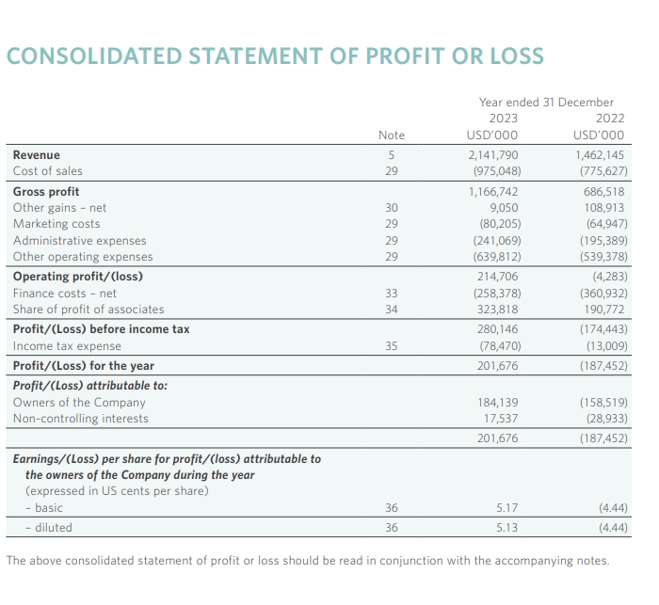
Appendix
Fig 1: Income Statement for Shangri La Hotel (Drury, 2021)

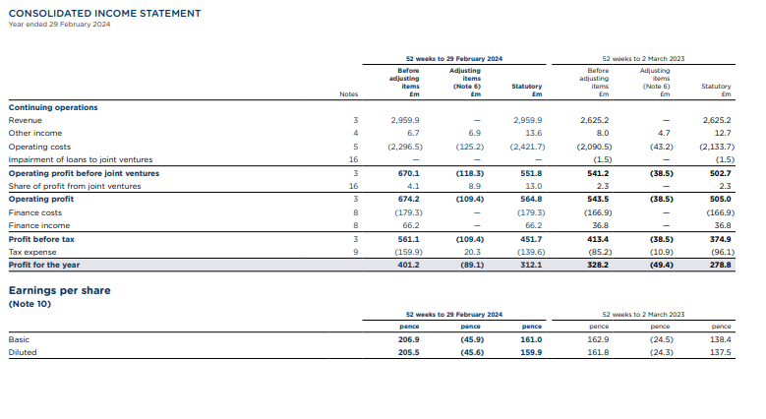
Fig 2: Income Statement for Premier Inn (Tieng, 2018).

Table 1: Comparison of Revenues (in GBP million)
Year | Shangri-La Hotels (GBP million) | Premier Inn Hotels (GBP million)
2021 | 1,150 | 1,300
2022 | 1,463 | 1,450
2023 | 1,750 | 1,600

