Managing Enterprise in 21st Century
BMSW4006
Shaila Sultana Sonia Kazi (2013422) Maimuna Sani (2010130)
Mireia Male Una Detna (2008766) Martina Rossi (2007919)
Yogesh Saulick (2011272)

BOM APETITE
PORTUGUESE CUISINE TAKE AWAY
MARTINA ROSSI (2007919)

Introduction
- Bom Appetite is a general partnership B2C.
- The vision includes Synergy with local farmers.

EXECUTIVE SUMMARY
- Bom Apetite has a unique selling point.
- Different kind of marketing strategy and all the possible technologies will be involved.
- The company has different targets.

Mission, Vision and Aims
- MISSION : inspiring the other human’s spirit, one person, one dish, and one neighbourhood at the time.
- VISION: Build a company that will be able to build a community.
- AIMS: the sales, market share and financial affordability likewise independence.

Student Name: Maimuna Sani
Student I.D: 2010130

Home Made Food
(
Bom
Apetite
)
Product, Services &
Technology
Descriptions

Bom Apetite Products
❖Our product and services will be offering the best qualities of Portuguese food in North London.
❖Healthy & Safety
❖Store product of cooking appropriately to keep it safe.
❖Natural homemade drinks with vitamins, sweet, tasty and abundance health benefits.

Bom Apetite Services
- Food safety management will be fulfilling with food hygiene and food standards.
- Safeguard our clients Healthy & Safety.
- Food values management actions (Hazard Analysis and Critical Control Point).
- Guidelines, planning, structure and labelling of cooking.

Bom Apetite Technology

The use of Internet.
Data Protection.
Social media
Uber/ Just eat.

Shaila Sultana Sonia Kazi (2013422)

Market Analysis and trend
Market Analysis is important to determine the attractiveness of market, to have insights of evolving opportunities and threats ( David,2012).

‘Bom Apetit’ Market Analysis through a secondary research
- North London population 913 K
- Average salary 40 to 50 K / per month
- Average age 36.2
- Working age 16-64, total weighted 69% of population
- Population growth rate 2.2 % (Plumplot, 2019)
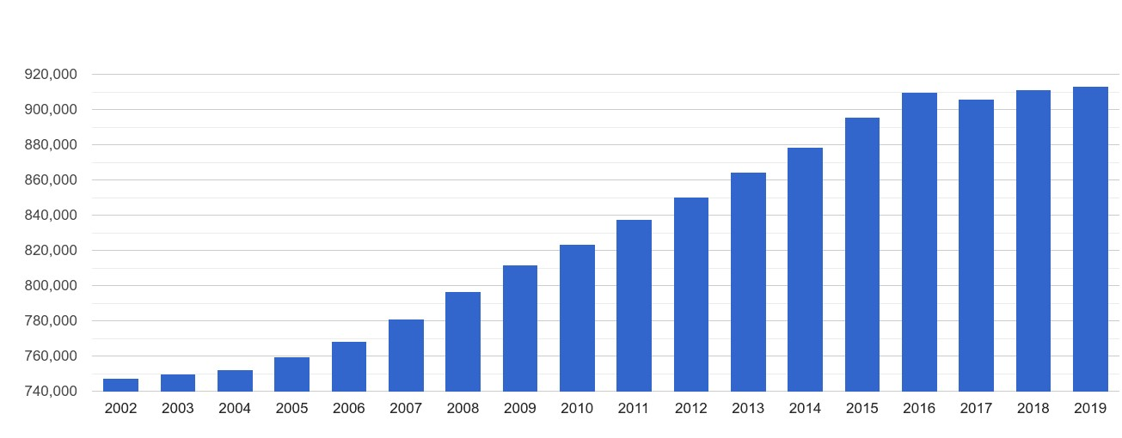
North London population growth
Market Segmentation and Target Market
Modern marketing strategy appeals to selective group rather than only for basic buying motives (Smith, 1956).
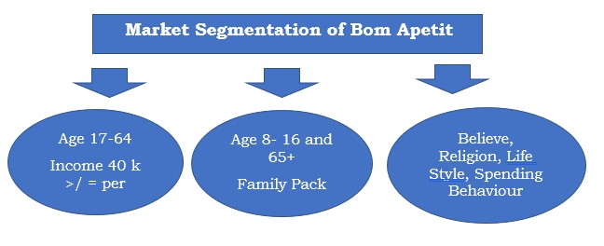

Marketing Strategy
It is a directional concept for future behaviour (Henry, 1987)
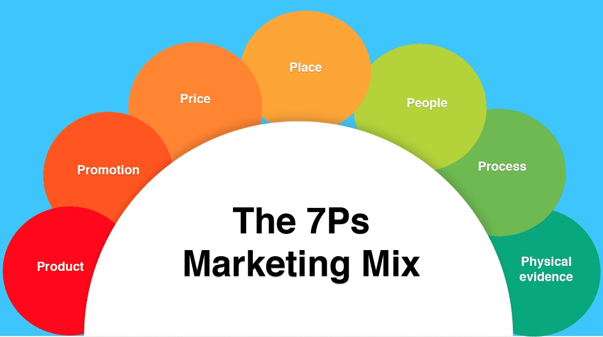
- B2B Marketing Strategy
- B2C Marketing Strategy
- 7Ps of Marketing Strategy
- Promotional Strategy
- Positioning Strategy

Business Environment
It refers to factors and forces that affect a business to decision making (Yard,2020)
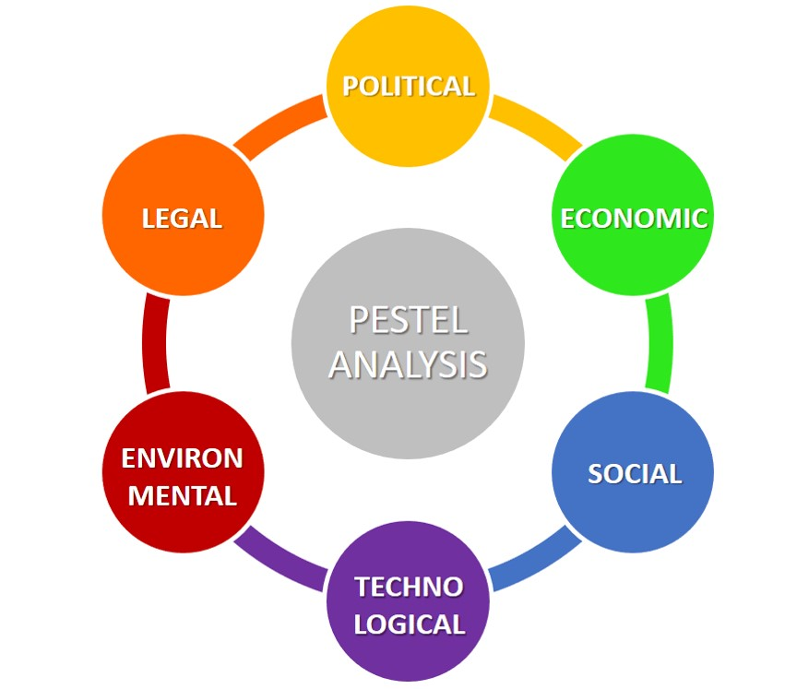
- Internal Environment
- Micro Environment
- Porter’s 5 Forces Analysis
- Macro Environment
- PESTLE Analysis

SWOT Analysis
It is a technique to asses a business through its Strengths, Weaknesses, Opportunities and Threats (Mindtools, 2016).
Strengths of Bom
Apetite
•
USP
•
Ethic
•
Competitive Price
•
Bargaining power
Weaknesses
of Bom Apetite
•
Finance
•
Physical Evidence
Opportunities
of Bom Apetite
•
Technology Advantages
•
Political Approach
Threats
of Bom Apetite
•
New Entry Barrier
•
Economic Instability
•
Pandemic Situation
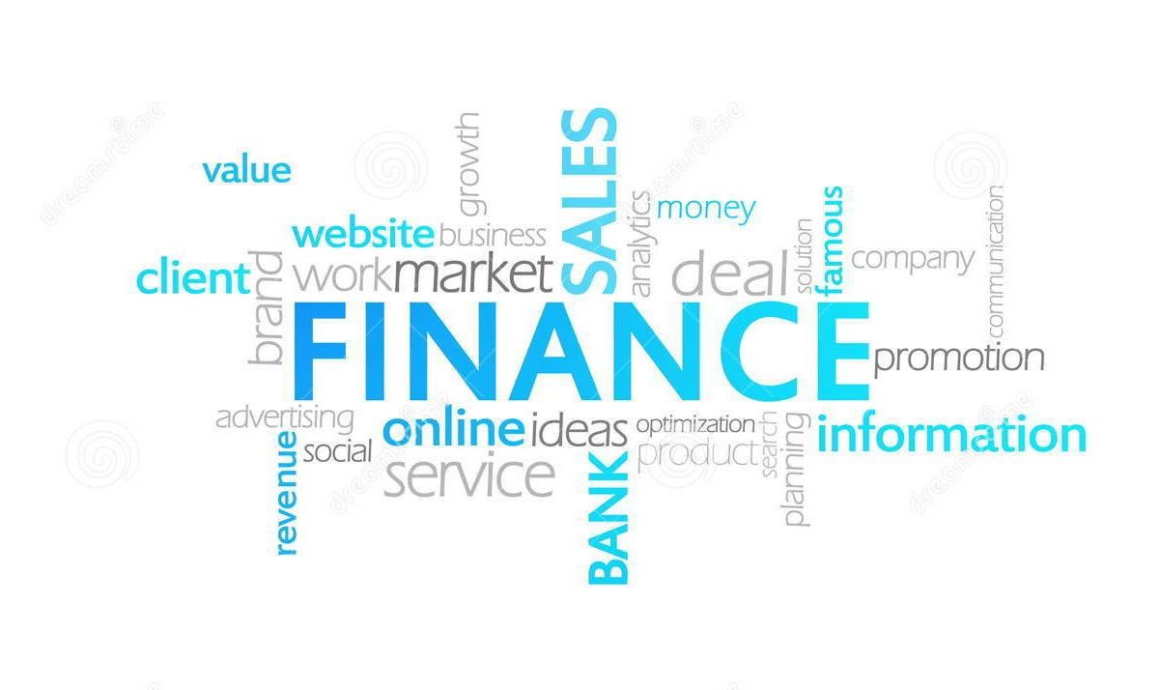
Yogesh Saulick – (2011272)
Importance of Finance
Survival of company
Facts
90% of New
Businesses Bankrupt
- Region and national changes
- To Measure Progress
- Be prepare of any situation
(Chen, 2019)
Strategy to Obtain Loan or Investment
- Investment - £100,000  - Share in business  - % Profit per year | - Bank Loan - £100,000  - Interest  - Monthly repayment

Est Sales Year 1 - 50k
Variable – 30% of sales
Fixed cost – £20k per year
Profit – 15k
Examples of Cost
Variable Cost | Fixed Cost
Ingredients – supplies | Rent
Packaging Material | Loan
Cost of goods | Bills
Marketing | Insurance and legalities
Taxes in labour | Salaries and Wages
Break-even point analysis
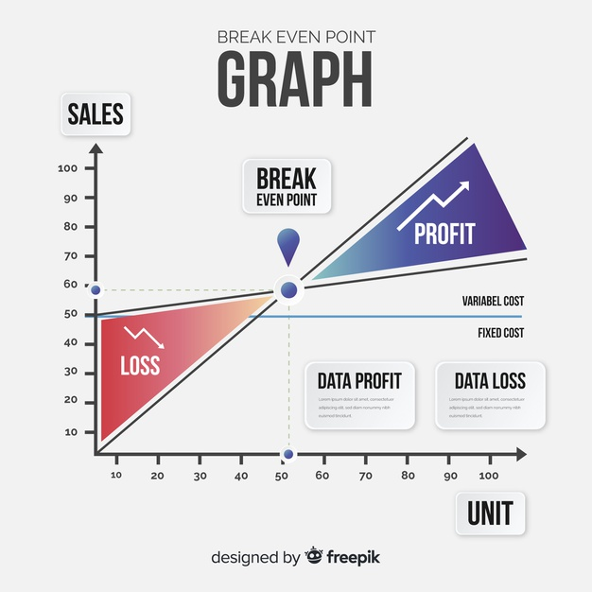 (Chen, 2019)
How to calculate Contribution
- Revenue - £4000 per Month
Break Even Point
£2700
Variable + Fixed Cost
£1200 + £1500
- Variable cost - £1200(30%)
- Contribution - £2800
- Fixed cost - £1500
- Profit - £1300
Reporting
- Balance sheet – Assets and liability
- Cash Flow sheet – Detailing
- Sales Forecast – Targets

Reporting all incoming, outgoing, Decrease and Increase
(Chen, 2019)
REFERENCES
- Adler, T. (2020), “Checklist for going self-employed-a small simple guide”, Small Business.co.uk, [Online], Available from:
https://smallbusiness.co.uk/checklist-for-going-self-employed-a-small-business-guide-745586/ _{, (Accessed: 20}
March 2021).
- Cady, S., Wheeler, J., DeWolf & Brodke (2011), ‘Mission, Vision, and Values: What do they say?, Organization Development Journal, 29(1), pp.63-78, Research Gate [Online], Available from:
https://www.researchgate.net/publication/259265396_Mission_vision_and_values_What_do_they_say , (Accessed: 23 March 2021).
- Jung, L. A. (2007)’ Writing SMART objectives and Strategies That Fit the Routine’, TEACHING Exceptional Children, 39(4), pp.54-58, Sage Journals [Online], Available from: https://journals.sagepub.com/doi/10.1177/004005990703900406#articleCitationDownloadContainer ,
(Accessed: 23 March 2021).
- Law, T. J. (2019), ‘15 seriously inspiring mission and vision statement examples’, OBERLO [Online], Available from
https://www.oberlo.com/blog/inspiring-mission-vision-statement-examples , (Accessed: 21 March 2021).
- Sanders R. (1987)“The pareto Principle: its use and abuse", Journal of Services Marketing, 1(2), pp. 37-40, MCB UP Ltd [Online], Available from: https://doi.org/10.1108/eb024706 , (Accessed: 19 November 2020).

REFERENCES
- © 2021 Chartered Trading Standards Institute
- Business guidance | Food Standards Agency
- YouTube and Facebook Bright Side 19 June 2020 ·
- Brian Lee
- Chief of Product Management at Lifehack ( Last Updated on December 18, 2020)
- Can Technology have Biases Like Humans? (lifehack.org)
- Gourmet Food Store Business Plan - Products and Services (bplans.com)

REFERENCES
- Chen. H. (2019), Introduction to the special issue
‘Business Finance and Enterprise Management’ Asia Pacific Management Review, 24 (1), Available at http://doi.org/10.1016/j.apmrv.2019.02.002
- David, A. A. ( 2017) NetMBA.com [Online]. Available at: http://www.netmba.com/marketing/market/analysis/ (Accessed: 23 April 2021).
- Henry M. (1987) Crafting Strategy. USA: Harvard Business Review, pp.66-74
- Mindtools (2016) Mindtools.com [Online]. Available at:
https://www.mindtools.com/pages/article/newTMC_05.htm (Accessed: 18 April 2021).
- Plumplot (2019) plumplot.co.uk [Online]. Available at: https://www.plumplot.co.uk/North-London- / (Accessed: 23 March 2021).
- Smith, W. R. (1956) Product Differentiation and Market Segmentation as Alternative Marketing Strategies. Journal of Marketing, 21(1), pp. 3-8.
- Yard, F. (2020) Element of the Business Environment [Online]. Available at:
https://financialyard.com/elements-of-the-business-environment/(Accessed: 25 March 2021).

University of Wales Saint Trinity David
(London Campus)
MAE Component 1 BMSW4006
Online group assignment
Business Plan

Shaila Sultana Sonia Kazi (2013422) Martina Rossi (2007919)
Mireia Male Una Detna (2008766) Maimuna Sani (2010130)
Yogesh Saulick (2011272)
Contents
Martina Rossi (2007919) 4
EXECUTIVE SUMMARY 4
DESCRIPTION 5
BUSINESS STRUCTURE 7
MISSION 8
VISION 9
AIMS 9
Maimuna Sani (2010130) 11
Shaila Sultana Sonia Kazi (2013422) 16
MARKET ANALYSIS AND TREND 16
Market Segmentation: 16
BUSINESS ENVIRONMENT 22
Yogesh Saulick (2011272) 27
Financials 27
Summary 27
Common Facts 27
Description 27
Bom Appetite Strategy to Obtain Loan or Investment 27
Option 1: Bank Loan 27
Option 2: Investor 28
Yearly Milestone of Bom Appetite 28
Long Term Projected Revenue 28
What is Fixed Cost? 28
How to Calculate Contribution? 29
What is Variable Cost? 29
What is Break -Even Point? 29
Bom Appetite projected profits 30
Such as KPI’s – Key Performance Indicator; 31
Reporting 31
Cash Management 31
Stock Management 31
Health and safety 31
Food Legislation 31
What is a Business Asset? 32
6 Important Features of Assets 32
References 34

Martina Rossi (2007919)

EXECUTIVE SUMMARY
‘Bom Apetite’ is a small firm-definition business, an organization created by five private Entrepreneurs, Yogesh Saulick, Shaila Sultana Sonia Kazi, Maimuna Sani, Mireia Male Una Detna, and Martina Rossi in 49 Belsize Park, London NW3 4EE.

We would love to start a general partnership B2C, so Business to Customers, initially with a unique selling point, a special selection of Portuguese homemade food that will be delivered to your door.

The common thread of the project is based on the opportunity to order in North London healthy affordable food. Our strengths must be family-friendly recipes, food delivered on time, environment-friendly packaging, and very competitive price.

We are all people with a long experience in Hospitality, between Front of House managers and chefs. We will be able to deal with the daily challenges because we have already been trained to work under stress and especially in how to manage a restaurant.

We will try to stay focused on different kinds of targets, our selection of food goes from dinner/lunch to breakfast and snacks. We are part of a lovely community and our neighbourhood will be very happy to start to order with us. We will start providing a service in Belsize but, in a short time frame, we will work for all London market.

We already have more than one marketing strategy that could guarantee the company survival and get the first short-term aim, set up the company. Therefore, we know that technology will be vital for this project. We want to use different selling platforms like JustEat, Deliveroo and Uber Eats to spreading around our food, and, by the way, our team of riders will be provided by electrical bicycles.

To reach this topic we are planning to invest ten thousand pounds coming from our savings and ask for a loan to a bank. We will be able to afford all the expenses and have some financial backup for eventually practical and economic issues. We want to invest in everything that could be environmentally friendly. We got a mission likewise a vision: providing good food and on-time service behind the vision is to bring together people with food which respect the planet. Using a different kind of marketing strategy and involving all the possible technologies will be some of our major assets.

Due to this pandemic likewise, people started to cook at home. With plenty of free time and missing to go out for dinner, they will evaluate the opportunity to order various sorts of cuisine and, generally, is always more than a welcome option. Healthy, affordable, and tasty food; on time and ready for there is the way we want to make it real. We are planning to see a Return of Investment at the end of the second year.

DESCRIPTION
We are a small firm-definition business organization of private Entrepreneurs that would like to start a general partnership B2C, so business to customers, involving Portuguese homemade food. The idea behind a new Company was born from the opportunity to have a straightforward economical plan that will help us to survive during the Covid 19 crisis that killed most of the current businesses decimating the UK market with unemployment doubling to 7.5 percent by Christmas (Adler, 2020).

The new brand ‘Bom Apetite’, will represent an investment opportunity based on competitive prices in a family-friendly environment with a unique selling proposition of our Portuguese food to be delivered in sustainable and recyclable packaging.

The vision includes Synergy with local farmers trying to use zero miles products likewise only local veggies, poultry, and dairy products. We would have a Return of Investment not only delivering food but additionally hosting exclusive private dinner and party as an unusual catering company.

We felt the obligation to begin independent and, in the meantime, create something that could bring joy and happiness after all the terrible things that recently happened to all of us. The aim is to create somewhat that could combine our passion for healthy flavoured food and unique Portuguese background.

We are five neighbours based in Belsize Park, North London, bound by a long-term friendship. The idea comes out a morning when we were busy trying to find and order a healthy brunch for us and the kids that were far away. We were looking for a reasonable price and we noticed that, apart from the classical chip and not the best quality fast foods, to get a healthful meal without going to a gourmet zone was almost impossible. We realized that in North London there is no chance to get a nutritious brunch without using fast food or to be obliged to spend a huge amount of money.

Belsize Park is a very residential middle-class and upper-class area close to Primrose Hill Park hence lots of people love to order and try different cuisine from all corners of the world. Most of them love to have pick-nick. Instead of cook food at home, they order directly through the different platforms their meal, avoiding carrying food around. By the way, almost all of them, are looking for food that kids could eat in the park, without renounce to a healthy lifestyle. Here we are with our Portuguese healthy food which is easy to make and reasonable to everybody.

Portuguese food, likewise, all the Mediterranean cuisine, is very nutritious and not too much expensive to produce because most of the recipes were born based on leftovers and very chip ingredients full of vitamins. This prerequisite will give us the chance to start quickly maximizing its value to get the best-selling prices.

Shortly, cooking at home creating a different tasty reasonably priced menu for families, couples and students will be our secret equally a lovely list of local wines and beers will contribute to retaining our customers. We want to build a straightforward relationship with the customers to build a community with a large connection between people who wants to enjoy a different kind of condiments from other countries.

The short-term goals will be:
- Establishing our company.
- Start with deliveries.
- Slow introduction of the possibility to order with us like a properly catering company that will take care of the food for your special event.

The medium-term goals will be:
  - Open our shop.
  - Set Up an online Portuguese kitchen school.
  - The publication of a recipes book.
  - In five years get a loan and open our restaurant that perhaps will be the first of new franchising of Portuguese restaurants.

BUSINESS STRUCTURE
Each of us will invest in our project the same amount of money, £10.000 for a total of £50.000. We will share the profit in equal parts, so we will not ask for more than one planning permission nor building regulation approval at the Council.

Everybody will work actively following different shifts organized with the purpose to keep the business open 7/7 days. No bank holidays closing, with five shifts for a week for each worker, hence two days off for a maximum of 40 hours per week. In this way, the kitchen will be able to manage the two rush moments of the day at lunch and dinner time.

Lunchtime if not a busy shift will be pretty much dedicated to tidy up the food and packaging delivery, organising the already scheduled placed orders, and setting in place the food line preparation for the dinner and the day after.

A rota characterized by different shifts from opening to closing will be organised and everybody will be trained to learn how to accomplish all the tasks that the job requires. Just in case someone will not be able to attend the shift, all the others could be able to carry on the things to do. The synergy with local farmers as suppliers will be vital for the project. It will be Portuguese food made using English biological food commodities and sustainable packaging.

The main target is to create an affordable menu, with no maximum of orders so everybody could order as much they want. Our offering must be easy to find on a platform like Just EAT, Deliveroo, and Uber Eats. Some flyers will be spread around the whole neighbourhood presenting a discount for those that will place an order directly on our website or with a direct call rather than order through online platforms.

Two of us will be in the kitchen all the time carry on preparing the food while one of us will take care of the orders and the customer's service meantime. Someone else will be busy with the local delivery in the neighbourhood. We will not buy a car or hire any driver because we will use the ones already owned. If the business grows, we will evaluate if hire some drivers.

MISSION
A small firm-definition business organization of private Entrepreneurs that would like to start a general partnership B2C, providing Portuguese homemade food of the highest quality following our centuries-old traditions recipes passed through generations of our family and made only using premium grade locally sourced ingredients.

An investment opportunity where the focus will be characterized by competitive prices in a family-friendly environment with a unique selling proposition also providing superior customer service. Our Portuguese cuisine will be delivered in sustainable and recycled packaging protecting the environment and ensuring equal access to resources while we will encourage innovation and creativity.

VISION
The vision behind our organization is to create a company that will be able to bring people together giving birth to a community thanks to our delicious and satisfying food. We have chosen Portuguese cuisine because of the provenience of two of the entrepreneurs. It is very healthy and not too expensive to produce thanks also to the locally sourced products get from local farmers and markets.

There is also a lack of possibility to choose a different kind of food in our area so we will be a ‘summer breeze’ for the neighbourhood. However, the secret of our business is not only the reasonable price and locally sourced products but also the friendly- environment packaging helpful for our ecosystem and very important for the future of our kids. Children and a healthy diet are a couple of targets very important for us.

Because we use only premium grade locally sourced ingredients for Portuguese centuries-old traditions recipes passed through generations, we got a unique selling point made every day fresh with lots of love and passions hence every customer who will taste our food, she/he will do it with a smile because of the good customer service that we want to.If during the time, we will be able to keep a high standard, we will set in place a shop, a recipes book, and in five years a restaurant franchising.

AIMS
Every business needs an Aims, that is the overall target or goal of the business, whereas business objectives are the steps a business needs to take to meet its overall aims. We got our aims too that provide us with a purpose for what the business does each day.

Following the SMART acronym (Jung, 2007), we got more than one financial aim like business survival, so keeping the business operating for a certain amount of time or the profit that usually the business aims to make within the first two years. We might consider also as aims the sales, market share, and financial affordability.

The sale refers to an amount of a product or service sold by our business, the market share means the percentage of the market that a business occupies. Our business must be able to afford to pay off all its costs and have enough cash left to survive, hence an entrepreneur achieving a level of income that will allow us to keep our business operating.

As a new enterprise, we got some non-financial aims that are strictly connected with some of the values that we established as a company like, for instance, Social objectives consequently doing things in an ethical or environmentally friendly manner or meeting social needs. Personal satisfaction relates to our joy as entrepreneurs to have created a successful business, so basically have crossed, and won a challenge to set up a business getting out of the comfort zone. A Skill like decision making is very important. At this stage, in fact, between the different non-financial aims we also got control, of the business and decide about how it is run. However, the most important aim is Independence, which relates to a group like us of entrepreneurs working for themselves and running their own key business decisions.

Maimuna Sani (2010130)
BOM APETITE

Creating a small business plan is one of the most vital responsibilities once launching up a fresh company. It will help us decide goal, organize all our initiatives, project the opportunity of our enterprise, and to make sure that our plan for business is practical and effective. The business plan is an important instrument in bring together financial support to get started. It is also an energetic document that would be evaluated consistently to examine and evaluate the execution of our company.
Starting this small business has been very exciting for myself and my partners as we are going to be our own boss and spend more time together as good friends and neighbour we are, spending our energy on something we are very passionate about which is a Portuguese cuisine in North London. Before starting there are a plenty of things, we need to consider getting star in term of product, services, and technology. To star with it, we need to come up with a successful idea and to create a business plan, consider how the business will be sustainable, to keep all our balance in order marketing, research and bits and pieces.
To make this business happen, our idea needs to be a strong idea. The idea that we came up with it is not something that we just picked out of the blue, it took us sometimes to sit down and research what fields of opportunity there are for us. What issues as co-workers and friends we are facing in our everyday life style and what potential solution could we create for us and in case there is a solution, how can we make our product or service better.
Now that our idea is settle, it is time for us to sit down and write all about it, make sure everything is in order. It is very essential and ideal to know which fields each one of us needs to spend more time to work on. To start our business plan, we need to start in Executive Summary, a description of the current problem and solution, an overview of the product and service we are offering, our business to our costumer, a breakdown of the team a short analysis of the current competitors in the area, the roles, and the financial plan.
Business plan is a living document, it is not an easy plan to make but it is something that will give us a better idea of where we are, and it is an excellent way to start a business and to become more effective and efficient. Advertising it is the way or form to get close to the costumers and it is a way of business to be successful. Social media become a platform much easier to get a larger audience, it offers a small business like ours the option to pay a bit more in term of advertisement on their sites.
Social media is very beneficial in many ways, it is the most popular and perfect place to show off our product, services and what the company is all about. To continue and updating our business plan and financial to be on track grow helps a lot, it helps us to see at what to Human Resources form flow. HR is the division of business where recruiting, training job application and administering employee benefit program.
Our Products and Services will offer a good quality of food from Portugal breakfast, lunch, and dinner. Our food will involve elements that characterize the best well-known and desired foods from Portugal, the items will include soups, salads, different type of meat, fish, chicken, potatoes, carrots, sauces, oils, spices, different flavours of seasonings, rice, pasta, peppers, onions, garlic, cheese, sausages, different types of soft and homemade drink, cocktails and different types of homemade salty and sweet desserts such as puddings, cakes moose, codfish pasty, meat samosa, chicken samosa etc…
Breakfast
Tea/ Coffee/ Latte/ Hot Chocolate
Fresh bread/ Sweet bread/ Cheese Bread & Garlic Bread
Cakes/ Chocolate/Fruit Cake
Sandwich/ Ham & Cheese/ Bacon & Egg/ Tuna
Frying Egg/ Boiled Egg & Omelette
Codfish Pasty/ Meat Samosa/ Chicken Samosa & Cream Pasty
Lunch
Soups/ Bean Soup, Green Broth & Chicken Soup
Fried Beef, Salad, Rice & Chips
Grilled Pork Chops, Salad & Chips
Grilled Lamb Chops, Salad & Rice
Codfish with Cream
Feijoada
Snacks/ Appetizers
Grilled Chorizo
Gizzards with Bread
Olives
Squid with Onions & Garlic
Dinner
Grilled Tilapia with Salad & Rice
Grilled Golden with Rice & Salad
Grilled Chicken with Rice, Salad & Chips
Baked Codfish with Chickpeas & Potatoes

Drinks/ Natural & Healthy Homemade Fruit Drinks
Banana & Oatmeal Smoothie
Watermelon, Cucumber, Honey & Mint Leaves
Tomatoes & Carrots
Strawberries Milkshake
Fizzy Drinks
Coca Cola
Fanta
7up
Sprite
How we will manage our business and food safety, food safety management is fulfilling with food hygiene and food standards. We need to guarantee that we have food welfare supervision processes in place. One of the things we must consider are the suppliers we use, how you trace the food we buy, food we sell companies and how to transport the food.
First, based on the food values management actions which are Hazard Analysis and Critical Control Point that we need to put that in place (HACCP) is an arrangement that will helps the business possible, our food hazards present actions to make sure individuals hazards are uninvolved or compact to a suitable level. These processes will help us create and sell food that is safe to eat offering us keeping current files to our methods, documents, regularly reviewing our processes to ensure they reveal what we deliver or how we work.
The law now a days sets out what is needed to be demonstrated on cooking advertising and branding, Labelling is controlled to defend customers who would have the accurate knowledge to make positive and advised cooking choices founded on nutrition, allergic reaction, individual test or expense.
The law agrees guidelines that include the planning, structure and labelling of cooking provided for human use. The value must connect the belief of the user, it should be as defined and not offered in a way that misrepresents the customer and nothing may well be increased or eliminated that would make it to damaging to wellbeing. Also, the regulations involving food safety can be split into two strong areas which are the planning of a product e.g., hygiene and the completed product such as identifying and planning.
It is very essential to store product of cooking appropriately to keep it safe, to protect the food from toxic chemical, injurious bacteria and items falling into the food. We will need to storeroom different types of food product by storing in a freezer, a fridge, shelves or cupboards and containers such as beans, flour, rice, pasta ingredients and so on.
About chilling food properly, it prevents dangerous bacteria from spreading. Some foods are necessary to be maintained chilled to keep them safe, for example, food with use by date, desserts, cooking dishes, other ready to eat food, such as prepared salads. It is very essential not to leave these kinds of food remain standing around at the room temperature. What we need to follow, which is very important is to follow the instructions, stock food that needs to be chilled in the fridge straight away, make sure we keep chilled food out of the fridge for the shortest time possible throughout preparation and frequently check the fridge and exhibition units are cold enough. Cold food can be served or displayed out of the fridge for about four hours but in case it has been left out more than four hours, the food should be thrown away.
Defrosting food perfectly should be defrosting in the fridge, placing food in the fridge will keep it at a safe temperature while it is defrosting. If we cannot defrost it in the fridge, we could place it in a container and then place it under cold running water. If there are a big joint of raw meat or chicken, it should not be defrosted under the cold running water unless they are in a wrapped container. Microwave also it is one of the ways to defrost food on the defrost setting and food should be carefully defrosted before cooking if the producer's instructed or laboured it.
About our drinks, we will try our variety of natural and healthy homemade fruit drinks. They will be made from only fresh fruit, water, milk, sugar, or honey, For the experience we have, there are drinks we can make in under five minutes for example banana and oatmeal smoothie for breakfast.
Natural drinks are well-known for serving resolve any possible problem, from mass gain to a skin condition. It is all the time great to begin the morning on an optimistic message, so what the better way to do that than a delicious extremely nutritious Banana and Oatmeal Smoothie for breakfast, banana is the best fruits out there thanks to their sweet tasty and abundance health benefits. Stabilize blood sugar level, promote heart health, helps the digestive system work better and provide you with all the energy you need for the day.
Oatmeal is also known for is own properties including impressive amount of phosphorus, magnesium, zing, and vitamin B1 and B5 also to make this brink taste even better, you can mix it with low fat milk or orange juice and just blended. As we know orange is a great source of vitamin C plus it boots your immune system and detoxifies the body.
Other option, watermelon and cucumber, health benefits are headaches and migraines. To make this drink it is only needed watermelon, honey and mint leaves you good to go. Watermelon as we know as H20 is it a lot of water as well as potassium and magnesium. All its good stuff hydrates your system and boots its natural processes. Cucumber is H20, 96% of water as well which also helps system function properly and it is also contain vitamin B. Honey adds its own health benefit thanks to its ante inflammatory properties.
Tomatoes and Carrots for hair growth, shinny, healthy. Tomatoes contain endless supply of vitamins including vitamins A, B, C and E, Carrots also helps hair growth too, it also contains vitamins B, C and E along with magnesium and phosphorus that boots blood circulation in your scalp.
Technology now a days is essential instrument that is directing the playing field for these entrepreneurs. Now, we have technology relevant in the easiest human events as clever products with intelligent processes operating them as they make mistake free decisions and offer intelligent and analytical results.
The growing use of Internet, smartphones and other App, technologies have required several businesses to move online and to provide a wider audience. Utilization of the correct technology can speed up company methods by creating various business duties more adaptable such as creating communication effortless, ensuring your company data, increasing consumer protection and much more.
Highest persons are not informed of the objective of Cloud which is influencing the path we use technology daily. Cloud computing permits a unified database method that can be accessed across smartphone, tablets, laptops, or any other Internet device. Regardless of its approval, numerous businesses have even declined to accept Cloud computing in any kind. It can support businesses to develop our manufactured goods and customer services and our internal telecommunications. All Through Cloud computing technology, the whole workers be able to link with one another beside with the data functionality or any other information we require.
It is difficult to calculate how each one of the technologies will affect our company or our labour force, but it is very important to be informed of every change in the trade to react to us before our competitor. Embracing a brand-new plan to influence a developing technology for our company may well be just the bonus we require to get a step up on our battle with others competition.

Shaila Sultana Sonia Kazi (2013422)

MARKET ANALYSIS AND TREND
Market Analysis is an important component of a business plan and a large part of market research (Elisabeth, 2018). In order to carry out a Market analysis we need reliable qualitative and quantitative data and information which can be collected by primary research or secondary research. Market analysis will help the entrepreneurs of Small Business like ‘Bom Apetite’ to have a holistic picture of market, furthermore, our Unique Selling Point (USP) and Corporate Social Responsibility (CSR).
Market Segmentation: One of the key components of successful marketing is Market Segmentation, and it is fundamental to satisfy customers’ and consumers’ by combining their demand and organization’s ability to supply them (McDonald, Christopher, and Bass, 2003).



Modern marketing strategy appeals to selective group rather than only for basic buying motives (Smith, 1956). The purpose of market segmentation is to identify different groups within target market, and it gives the chance to pinpoint exactly what goods or services deliver (Thomas, 2020). In a simple word Segmentation is a kind of sorting into distinct groups and fall into four categories (Roberts,2020).

Demographic Segmentation: The group can be identified by gender, ethnicity, age, income, education level, profession, and religion.
Psychographic Segmentation: Customers’ personalities, hobbies, goals, values, lifestyles, beliefs are counted here.
Geographic segmentation: This can be defined by country, region, city, or postal code.
Behavioural Segmentation: In this section customers are gathered according to their spending/purchasing habits, browsing, interaction with brand, review.

Based on the market segmentation a Secondary Research has been done through online to collect qualitative and quantitative data for our Business Plan to segment our target market and proceed with exact products and services to the exact group.
‘Bom Apetite’ is a small, homemade food business, located in North London which will cover as below: N2, N3, N4, N5, N15, N16, N17, N 18 in addition, the postal code which has border with above postcode.
Based on Census in 2019, North London population statistics 913 K, average age 36.2, population density 7.9 per square km, resident per household 2.46 and population grew by 2.2 % since 2002 (Plumplot, 2019).

North London population growth

Total population per year outlines headcount differences.
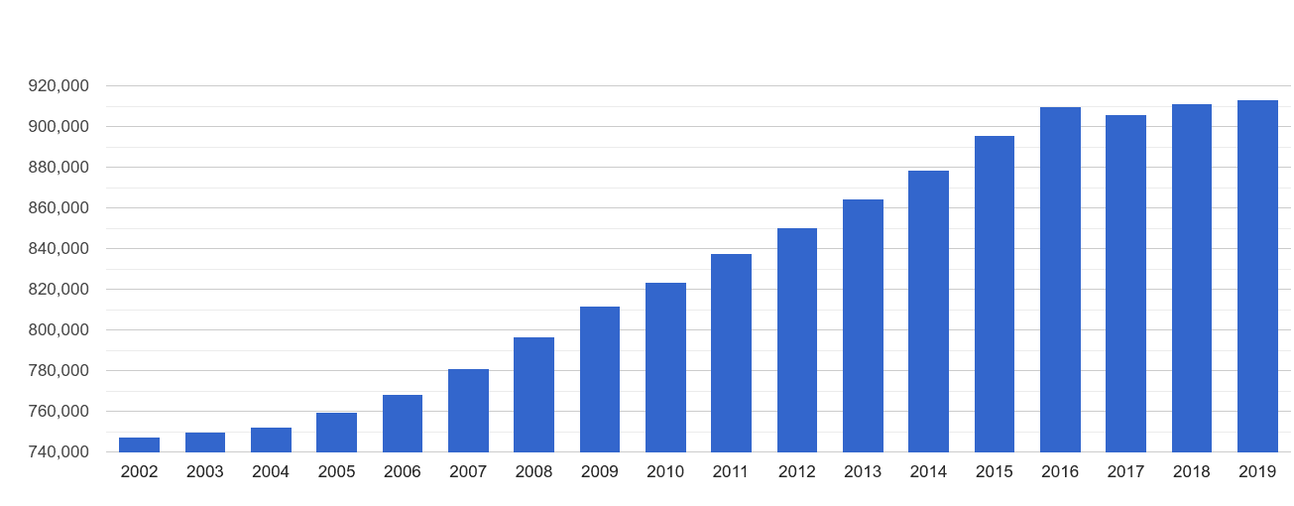

North London working age population share

Working age population share compared to working age population share in England & Wales, 2019.
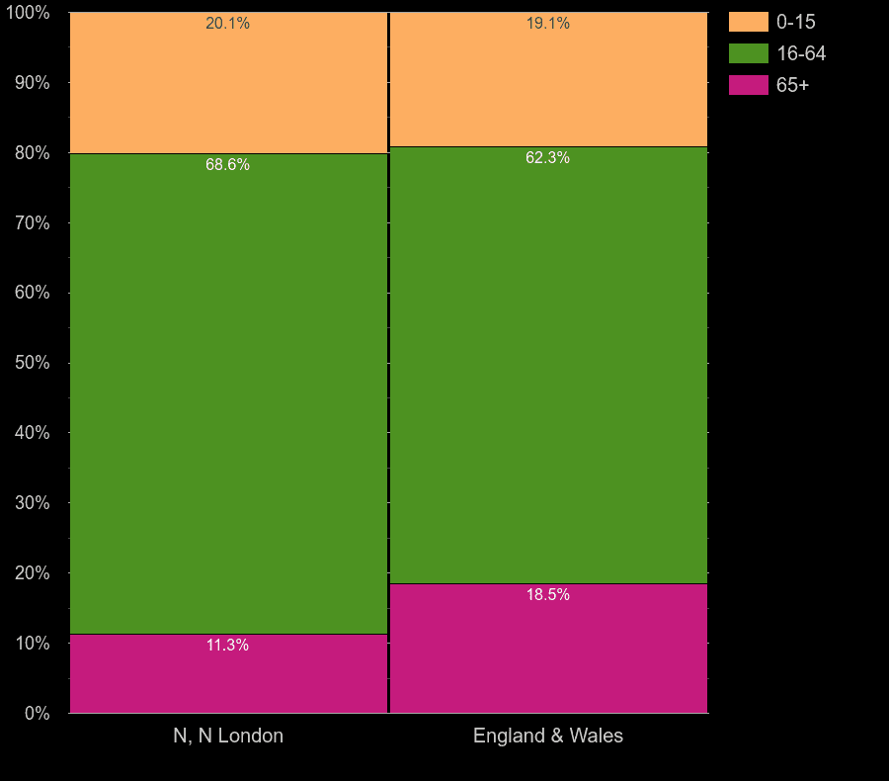

North London average Salary Comparison (Plumplot,2020)
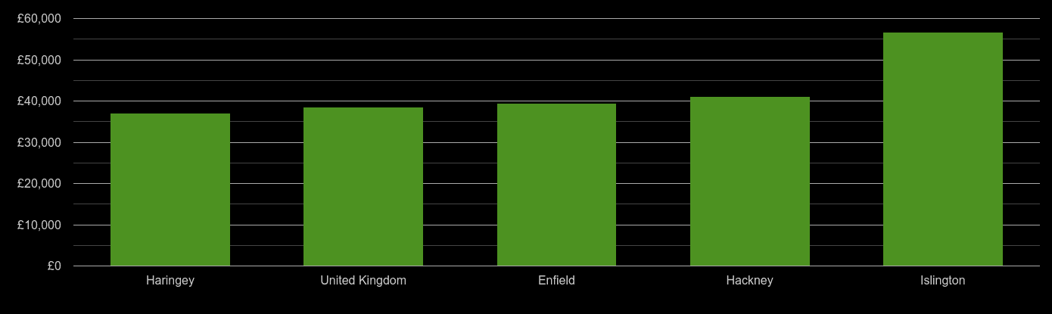

Target Market Segment Strategy: Target Market Strategy means divide a market into segments according to demography, behaviour, geography, and psychographic segmentation and then concentrate on one or a few segments. This strategy is the most important part of a new business plan (Susan,2020).

According to the Segmentation and based on Secondary Research conducted, ‘Bom Apetite’ has been segmented into 3 groups, targeting all group but giving priority on the first group: Age 17-64, Income 40 K >/= per month as the number of people is high in this group and they are more active and aware of healthy and sustainable food.

Market Segmentation of Bom Apetit

Age 17-64
Income 40 k >/ = per month
Age 8- 16 and 65+
Family Pack
Believe, Religion, Life Style, Spending Behaviour

B2B, B2C and 7 Ps Marketing Strategy:

B2B known as Business-to-Business marketing focuses on purchasing driven by logic. B2B strategy play the main role for being able to reach a target segment market. (Guest, 2020).
B2C known as Business-to-Consumer marketing focuses on purchasing driven by emotion. B2B target the customers like managers, owner of small business or head of department not only for selling but also build a long – term relationship.

‘Bom Apetite’ will apply B2B and B2C Digital Marketing Strategy to reach general customer as well as corporate business client through marketing, advertising, and branding to build a long-term business and also focused on purchase driven by emotion.

7 Ps Model: This is an extended form of 4 Ps model (McCarthy,1960). 7Ps strategy has been adopted to make ‘Bom Apetite’ marketing strategy and has been followed the following factors which has helped to make decision and develop strength and weaknesses.

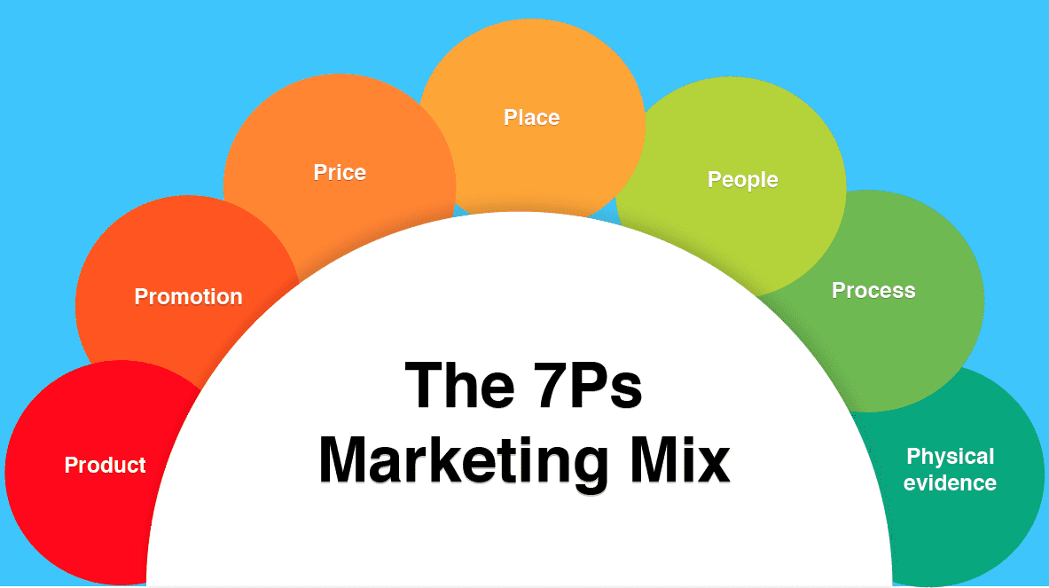

1P: Product that satisfies customers’ demand as well as the aspects need to consider here are product design, packaging, branding, guarantees, warranties, and service (Nathan, n.d)
2P: Price strategy, discounts, payment terms and method has been considered for a successful business plan.
3P: As a Place, Bom Apetite refers Online where target customer happy to shop.
4P: Advertising, marketing, and sales promotion.
5P: People refers interaction between employee and customers.
6P: Process is the mechanism of Tracking product, customization, standardization.
7P: Physical Evidence refers the environment where customer receive the service.

Market Trends: A market trend is anything that alters the market for future tendency of customers wants. In order to keep business ahead of the competition, it is vital to utilize market trend analysis. Market trend analysis looks at how a company started in the market, how it is growing , and what is the long term goal. (Allison, 2019)
A secondary research is conducted to have an insights of food industry and its trends. Research has shown that consumers are more concern about the source of their food and services, while the interest in light and healthy food continues to increase.
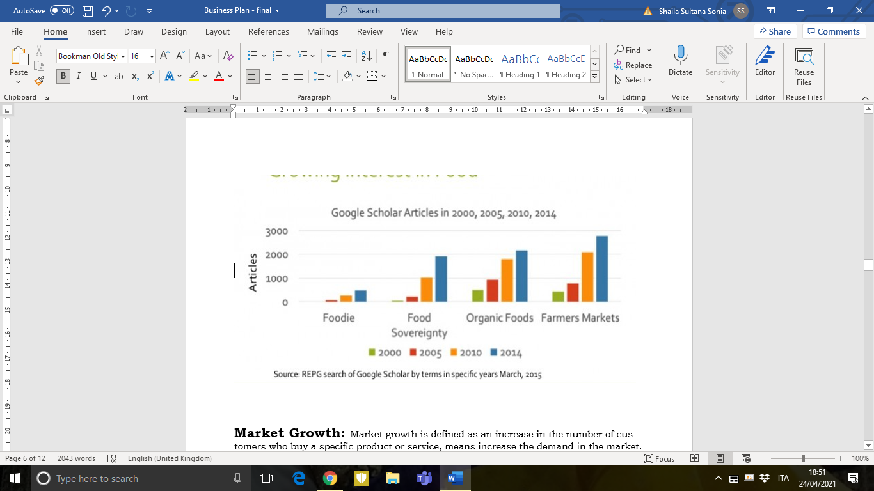

Market Growth: Market growth is defined as an increase in the number of customers who buy a specific product or service, means increase the demand in the market. (Hitesh,2020). Market growth is proportional to market demand.
Several factors like demand and supply of the product, nature of growth, competitors, inflation, pricing, performance of product or service, affect Market growth positively or adversely. As a new business ‘Bom Apetite’ need to be aware of these factors to increase their Market Growth.

BUSINESS ENVIRONMENT
Business Environment consists of various factors that influence directly and indirectly how a business operates. The components of Business Environment can be the customers, competitors, economic, the laws, competitors, politics, and social (Yard,2020).

Internal Environment : The Internal Environment consists of the factors which remain in the boundaries of the organization and in the decision-making process can be taken directly into consideration (Duncan, 1972). The factors are as follow:

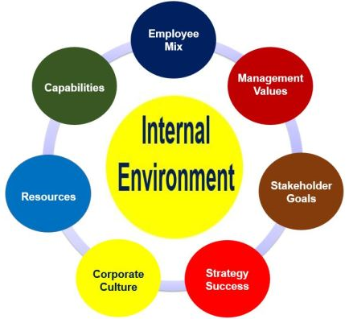

Bom Appetite has full control of all of his internal factors such as Organizational Structure: management, and shareholders who influences the decision-making capacity of a company, employee, value system, plan, policies, finance, culture, mission and objectives.

Micro Environment: It refers to all factors of an organization’s immediate environment which directly influences the performance and profit margin of the company (Umar, 2017). To analyse the Microenvironment ‘Porter’s 5 Forces’ are used for the business plan of ‘Bom Apetite’,

Porter’s 5 Forces Analysis
Porter’s Five Forces is a framework which offers to analyse the level of competition within a certain market. It is vital for a new business plan to analyse the level of competition and shape them to maximize profitability for a long-term successful business (Lars, 2016).
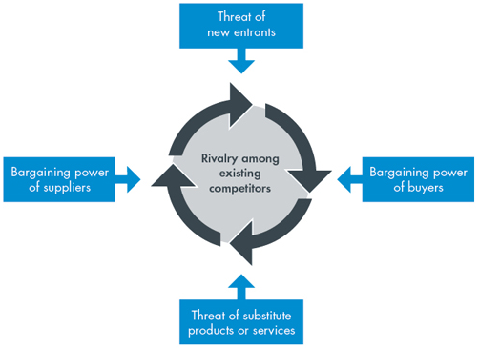

1. Threat of new entrants: Required capital for this type of homemade food business is not too high, government policy and brand loyalty are flexible. Therefore, for ‘Bom Apetite’ can be considered this threat from medium to high,

2.Bargaining power of suppliers: The bargaining power of suppliers for this business can be consider low, because of available supply chain exist in this sector and the switch cost is low.

3.Bargaining power of buyers: Customer are more powerful when they have more alternative and easier to switch. Considering ‘Bom Apetite’, the bargaining power of buyers would be low as number of customers is high, reasonable price, lack of substitute.

4.Threat of substitute products or services: This threat is low for ‘Bom Apetite’ Business, because of the types of Portuguese food which are nearly unique of its flavour and test.

5.Existing industry rivalry: Rivalry among existing industry is low for Buonapetit.Because there are few competitors with less diversity of Portuguese food. Furthermore, the barrier to exit and switching cost is low.

Poter’s 5 Forces for ‘Bom Apetite’ Food Industry
1 | 2 | 3 | 4 | 5
Medium to high | Low | Low | Low | Low
‘Bom Apetite’ (as shown in the table) has control on Poter’s 5 Forces, and there are some spaces to manipulate them in favour of its profit maximization.

Macro Environment: Macro Environment refers the external forces that cannot be controlled by an organisation, instead organisations need to adopt the effects of macro environment in a way that benefits to succeed (Sridhar, 2016).

PESTLE Analysis

The PESTLE analysis is used to identify the factors affect externally an organisation. PESTEL is stand for Political, Economic, Social, Technological, Environmental and Legal factors. Using this PESTLE Framework, has been analysed the macro environment of ‘Bom Apetite’ and adopted them in favour of the business development.

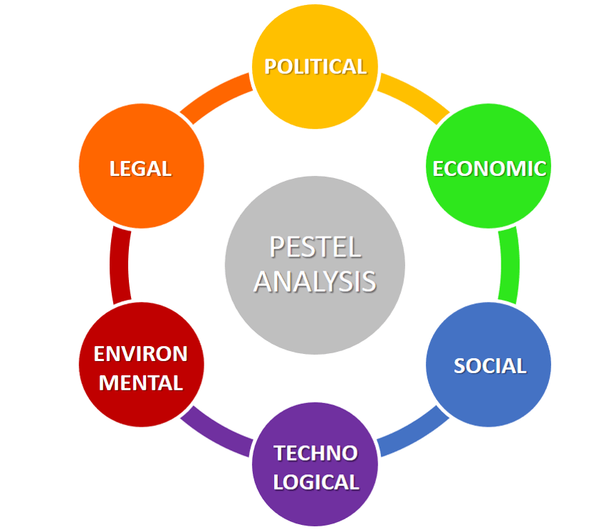

- Political factors: These factors are in favour of Bom Appetite because of the flexibility of Government policy towards food industry, tax, and labour law.

- Economic factors: Pricing strategy are adopted considering the factors like inflation, recessions, economic growth, and unemployment rates: those affects the purchasing power of consumers.

- Social factors: During the market segmentation of Bom Appetite, Social Factors like demographics, culture, and lifestyle. age, lifestyle attitudes and cultural barriers has been considered.

- Technology: Bom Appetite prioritizes the use of technology and its innovation.

- Legal factors: Bom Appetite has the proper knowledge about consumer law, health, and safety law to perform ethically.

- Environmental factors: This business plan is aware of its Corporate Social Responsibility (CSR) and sustainability considering the environment and climate change.

SWOT Analysis: It is an effective tool to analysis Business Environment. This platform gives opportunity to assess Strengths, Weaknesses of internal environment, Opportunities, and Threats of external environment. To get the insights of business environment of ‘Bom Apetite’, SWOT Analysis tool has been used to maximise the strengths of the business, while minimize the effect of weaknesses, furthermore, optimize the opportunities and being preventive against threats.

Strengths  - Unique Selling Point  - Value system  - Ethic of work  - Effective teamwork  - Low administrative cost  - Competitive price  - Knowledge and experience  - Low bargaining power of suppliers and buyers  - Threat of substitute is low. | Weakness  - Finance  - Human resource  - Technical Capability  - Legal Factors  - Physical evidence
Opportunities  - Political factors  - Trend and fashion  - Technology development | Threats  - Instable economy  - Threat of new entry  - Global influence  - Environmental effect

The results of the SWOT are shown that the strength of the business is effective teamwork, USP, price strategy, value that allow to offer excellent service. The weakness of the company is HR, technical capability, legal factors; therefore, need to focus on training to increase relative skills. New government policy, present trends are opportunities to succeed. Company has no control on macro environmental threats, therefore need to adjust the efficiency and proficiency of the policy to tackle the threat.

Yogesh Saulick (2011272)

Financials
Bom Appetite Financial Plan

Summary
Bom Appetite will be the next rapid growing business, in North London as a Portuguese food restaurant. Food will be prepared as Home Made and will be delivered to customers. Orders will be taken via online, phone calls and at the restaurant front desk.

Common Facts
90% of new business fail to survive due to poor financial planning by facing competitors or repaying their loans or facing bank debts. Also, small business finds it very difficult to exit liquidity in effective manner.

Description
On this Report I will be writing and planning a successful financial plan for Bom Appetite Restaurant. I will also provide all figures of projected revenues and costs on this report. Majority of the information my report is from my researches.

Bom Appetite Strategy to Obtain Loan or Investment
To establish the Bom Appetite Restaurant, me and my team will need £100,000 of capital to start up the business. Why £100, 000?
Investment Cost
Categories | Amount | Duration
Loan or investment | + £100,000 | 10 Years Loan
Rent | - £20,000 | Per Year
Renovation | - £20,000 | One time investment
Equipment (Assets) | - £10,000 | One time investment
Total Remaining | £50,000

On the table above are the fixed cost of Bom Appetite. The remaining 50% of balance will be used as an emergency or as maintenance of inventories. Bom Appetite have across two deals of how we will get the £100,000 for the next 10 years.

Option 1: Bank Loan
The Bank is willing to provide us with a business Loan with APR of 3.5% of the total amount. Which mean the longer we take we will pay more interest or vice versa.

Option 2: Investor
To find an Investor who is interested to invest in our company for a percentage on our profits and will also own a share in the company, plus perks such as free meal.

Yearly Milestone of Bom Appetite
Year 1 – Heavy Investment and Start Up of Operation
Year 2 – Scaling upwards and keep striving more through marketing
Year 3 – Rapid growth and expansion
Year 4 – Stabilisation and fine tuning
Year 5 – Fully Mature with exceeding operation

Long Term Projected Revenue
Year 1 | Year 2 | Year 3 | Year 4 | Year 5
£100,000 | £110,000 | £132,000 | £158,000 | 160k -180k
Target | +10% | +20% | +20% | + 5% to 15%

Setting up sales target will give the restaurant a direction to strive for more. However, revenue is not net profit, contribution will need to be calculated.

What is Fixed Cost?
Fixed costs are the constant expenses, which normally get deducted monthly. These are mandatory payments are nearly the same amount every month. For example;
- Rent, Loan, Mortgage
- Bill’s such as Electricity, gas, water council tax etc
- Salaries with labour tax
- Business tax and insurance
- Other
Bom Appetite Fix Cost is £40,000
 | Year 1 | Year 2 | Year 3 | Year 4 | Year 5
Total Sales | £100,000 | £110,000 | £132,000 | £158,000 | 160k -180k
Fix Cost | -£40,000 | -£40,000 | -£40,000 | -£40,000 | -£40,000

How to Calculate Contribution?
Revenue Subtract Fixed cost equals contribution
Sales – Cost = Contribution
 | Year 1 | Year 2 | Year 3 | Year 4 | Year 5
Total Sales | £100,000 | £110,000 | £132,000 | £158,000 | 160k -180k
Fix Cost | -£40,000 | -£40,000 | -£40,000 | -£40,000 | -£40,000
Contribution | £60,000 | £70,000 | £92,000 | £118,000 | £120k – £140k

What is Variable Cost?
Variable cost depends on the amount of items produced. For example, the more meals that the restaurant produce, the same amount of ingredient and material will be needed and their utilities are known as the variable cost.
After carefully calculated I found out the 30% of sales will be the variable cost.
 | Year 1 | Year 2 | Year 3 | Year 4 | Year 5
Total Sales | £100,000 | £110,000 | £132,000 | £158,000 | 160k -180k
Fix Cost | -£40,000 | -£40,000 | -£40,000 | -£40,000 | -£40,000
Contribution | £60,000 | £70,000 | £92,000 | £118,000 | £120k – £140k
Variable cost | -£30,000 | -£33,000 | -£39,600 | -£47,400 | -£48k – £54k

What is Break -Even Point?
Break-even point is the amount between profit or lost. Every successful business owner, CEO’s or the financial directors should be aware and be able to estimate, if the business will be meeting their sales target or go in to losses. By reviewing the break-even point analysis report the restaurant owner will be able to make necessary amendment.
There 2 ways to find out the break-even point for Bom Appetite.
- Fix cost + Variable Cost
- Total sales vs item produced
Bom Appetite option 1 Break-Even point
 | Year 1 | Year 2 | Year 3 | Year 4 | Year 5
Fix Cost | -£40,000 | -£40,000 | -£40,000 | -£40,000 | -£40,000
Variable cost | -£30,000 | -£33,000 | -£39,600 | -£47,400 | -£48k – £54k
Break-Even Point | £70,000 | £73,000 | £79,600 | £87,400 | £88k - £94

Break-Even point is when business revenue neither making profit or losses, but anything less than the amount will be losses or more will be profits.

Bom Appetite projected profits
 | Year 1 | Year 2 | Year 3 | Year 4 | Year 5
Total Sales | £100,000 | £110,000 | £132,000 | £158,000 | 160k -180k
Fix Cost | -£40,000 | -£40,000 | -£40,000 | -£40,000 | -£40,000
Contribution | £60,000 | £70,000 | £92,000 | £118,000 | £120k – £140k
Variable cost | -£30,000 | -£33,000 | -£39,600 | -£47,400 | -£48k – £54k
Profit Margin | £30,000 | £37,000 | £52,400 | £70,600 | £72k - £86k

This is an estimation of our projected financials, if the restaurant meeting their targets. However, with the Bom Appetite long term vision is to expand more across UK, by opening more branches. Also, we want to create our own brand to be known as reputed company with our USP.
All above yearly projected figures and information is an overview of Bom Appetite successful long-term goals and plans. However, there are controls and much more other details that will have to take place and put in consideration.

Such as KPI’s – Key Performance Indicator;
- Reporting
- Employment Profiles
- Health and Safety
- Food Legislation

Reporting
Reporting is also known as administration such as filing, reconciliation paperwork, balance sheet and many more. It’s very important to keep records of all paperwork and filed in the right order, so when its needed, it’ll be quick finding relevant information.

Cash Management
Cash management is vital for every businesses, so therefore proper filing and controls are really necessary in these departments. Every entries and outgoings must be accurate to manage cash flow correctly.

Stock Management
Mostly in every business, there are losses that comes across, that will need a thorough investigation to find out where the discrepancy comes from. Such when receiving raw materials from a supplier, sometimes missing items are not identified, where these paper trails will help the business where there is a problem occurring.
Employment Workers
According to corporate financial planning, strategies state that, it is not advisable to hire a large number of full time or permanent workers to benefits and flexibility issues that a company have to face for survival.
Part timers or freelancers are the best the hire, so the company will have much better flexibility and will save more funds from labour taxes and other benefits.

Health and safety
Following all health and safety rules and regulation is very important for the welfare of the business and security for employees. Failure to follow them rules may lead to catastrophic consequences of fines to be paid. Health and safety have many rules but most common are;
- Fire safety
- Manual handling
- Using equipment

Food Legislation
Restaurant who produces meals and food, must follow all hygiene rules and keep food at the right temperature. Failure to do so may lead for business close down or severe imprisonment. Also, all ingredients used to produce meals must be transparent for customer or else it may lead of risk of allergies for customers.
General Knowledge
The reason health and safety rules and regulation fall into KPI’s is because, that’s shows the guarantee of produce good food with in good hygiene and will attract more customers to the business. Also, it secures of risk of close down which may lead in fines and imprisonment, then the company won’t be making profits but mainly repaying debts.

What is a Business Asset?
An asset is a resource or property having a financial or economic value possessed by an individual or entity, which is capable of producing some future economic benefits or in accounting context is an asset is a resource that can generate cash flows.
What are Assets Required?
- Increase in value
- Source of funds

6 Important Features of Assets
- Price or economic Value
An asset usually has a price or value in the market, such price is either to be paid or be payable.
- Revenue Generation
An asset must have the capacity or potential to generate revenue in a business.
- Maintenance Cost
An asset usually has a maintenance or repair cost.
- Depreciation with Time
An asset usually undergoes in depreciated over a period of time.
- Estimated useful life span
An asset usually has a shelf life to be use.
- Scrap Value
If an asset is overused then there is a value for scrape.

General Knowledge
In the beginning as a company, we have invested £10k on equipment, which mean the equipment will still hold value when in its life span or even after. If company struggles in payment sometimes selling, trading or converting our asset into cash can be a way out of debts.

References
Martina Rossi Refence Lists
Adler, T. (2020), “Checklist for going self-employed- a small simple guide”, Small Business.co.uk, [Online], Available from: https://smallbusiness.co.uk/checklist-for-going-self-employed-a-small-business-guide-745586/, (Accessed: 20 March 2021).
Cady, S., Wheeler, J., DeWolf & Brodke (2011), ‘Mission, Vision, and Values: What do they say?, Organization Development Journal, 29(1), pp.63-78, Research Gate [Online], Available from: https://www.researchgate.net/publication/259265396_Mission_vision_and_values_What_do_they_say, (Accessed: 23 March 2021).
Jung, L. A. (2007)’ Writing SMART objectives and Strategies That Fit the Routine’, Teaching Exceptional Children, 39(4), pp.54-58, Sage Journals [Online], Available from: https://journals.sagepub.com/doi/10.1177/004005990703900406#articleCitationDownloadContainer, (Accessed: 23 March 2021).
Law, T. J. (2019), ‘15 seriously inspiring mission and vision statement examples’, OBERLO [Online], Available from https://www.oberlo.com/blog/inspiring-mission-vision-statement-examples, (Accessed: 21 March 2021).

Shaila Reference Lists
Doyle, P., Philip, S. (2006) Marketing management and strategy. England: Pearson Prentice Hall, pp.461
Duncan, R. B. (1972) Characteristics of Organizational Environments and Perceived Environmental Uncertainty. JSTOR.ORG, 17(3), pp. 313-327.
Guest, A. (2020) Worldstream.com [Online]. Available at: https://www.wordstream.com/blog/ws/2019/05/20/b2b-vs-b2c (Accessed 25 March 2021).
Hall, M. (2020) Porter's 5 Forces vs. PESTLE Analysis. [Online].
Available at: https://www.investopedia.com/ask/answers/041015/whats-difference-between-porters-5-forces-and-pestle-analysis.asp (Accessed 22 March 2021).
Hitesh, B. (2020) Marketing91.com [Online]. Available at: https://www.marketing91.com/market-growth/ (Accessed 23 March 2021).
Lars, D., B. (2016) Business-to-you [Online]. Available at: https://www.business-to-you.com/porters-five-forces/ (Accessed 27 March 2021).
McCarthy, E. (1964) Basic Marketing. A Managerial Approach. Homewood, Il: Irwin.
McDonald M., Christopher M., Bass M. (2003) Market Segmentation. In: Marketing. London: Palgrave, pp. 41-65.
Nathan, N. (n.d) ProfessionalAcademy. [Online]. Available at: https://www.professionalacademy.com/blogs-and-advice/marketing-theories---the-marketing-mix---from-4-p-s-to-7-p-s (Accessed 24 March 2021).
Plumplot (2019) plumplot.co.uk: North London Population Statistic [Online]. Available at: https://www.plumplot.co.uk/North-London- / (Accessed 23 March 2021).
Roberts, G. (2020) Orientation Marketing. [Online]. Available at: https://www.orientation.agency/insights/pharmaceutical-market-segmentation (Accessed 25 March 2021).
Roberts, G. (2020) Orientation Marketing. [Online]. Available at:
Available at: https://www.orientation.agency/insights/pharmaceutical-market-segmentation
(Accessed 25 March 2021).
Sridhar, R. (2016) International Review of Public Administration. Taylor & Francis Online, 21(3), pp. 216-232
Smith, W. R. (1956) Product Differentiation and Market Segmentation as Alternative Marketing Strategies. Journal of Marketing, 21(1), pp. 3-8.
Susan, W. (2020) thebalancesmb.com [Online]. Available at: https://www.thebalancesmb.com/target-marketing-2948355 (Accessed 25 March 2021).
Thomas, S. (2020) Yieldify.com. [Online]. Available at: https://www.yieldify.com/blog/types-of-market-segmentation/ (Accessed 24 March 2021).
Umar, F. (2017) Businessjargons [Online]. Available at: https://businessjargons.com/micro-environment.html (Accessed 26 March 2021).
Yard, F. (2020) Element of the Business Environment [Online]. Available at: https://financialyard.com/elements-of-the-business-environment/(Accessed 25 March 2021).

Maimuna Sani Reference Lists
Gourmet Food Store Business Plan - Products and Services (bplans.com)
© 2021 Chartered Trading Standards Institute
Business guidance | Food Standards Agency
YouTube and Facebook Bright Side 19 June 2020 ·
Brian Lee
Chief of Product Management at Lifehack ( Last Updated on December 18, 2020)
Can Technology have Biases Like Humans? (lifehack.org)

