DS 1 Template

Giorgi Kurtsikidze
- Please add 4–6 screenshots or photos of your digital life.
- You can use your phone or laptop.
- For each screenshot, write one or two sentences explaining what it shows.

Screenshot 1 From phone
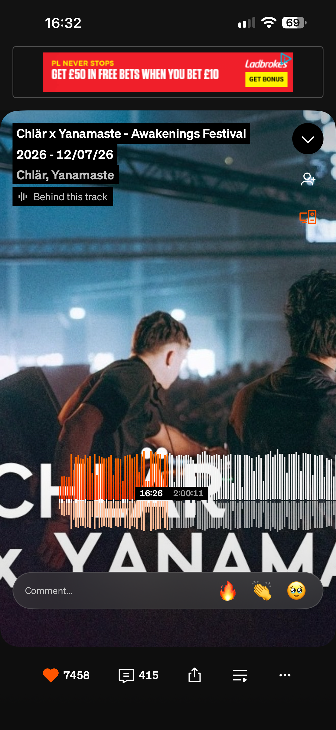
This is soundcloud app, probably I’m using this most, listening and following my favorit DJ and Produsers almost every day. Best way for me relax.

Screenshot 2 from PC
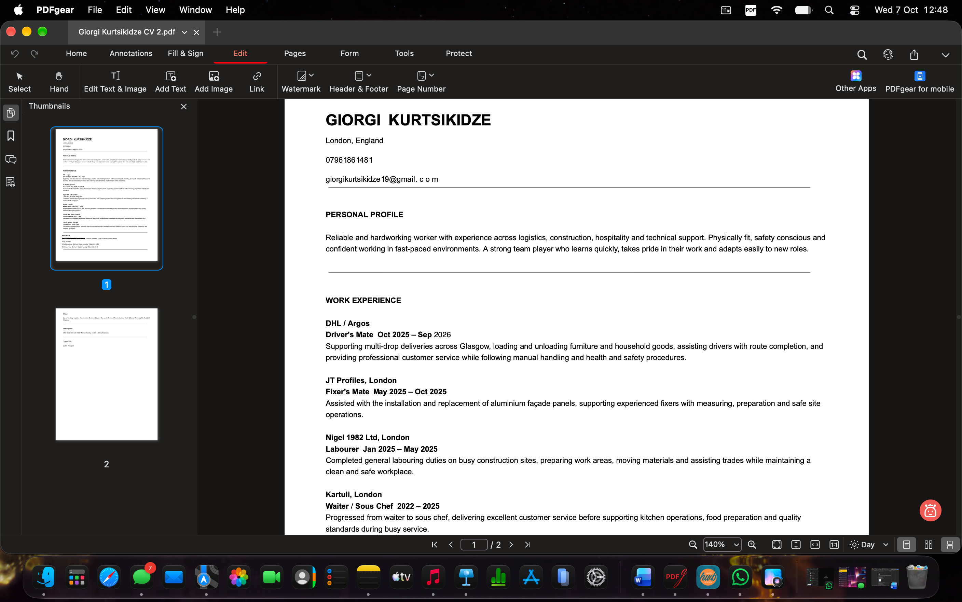
[trying to tidy personal CV and make it ready in PDF file to find job]

Screenshot 3 from phone
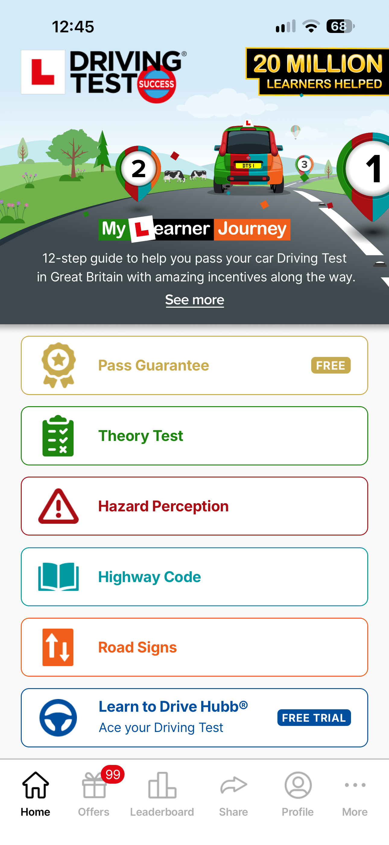
[using application for learn drive licence theory]

Screenshot 4 from PC
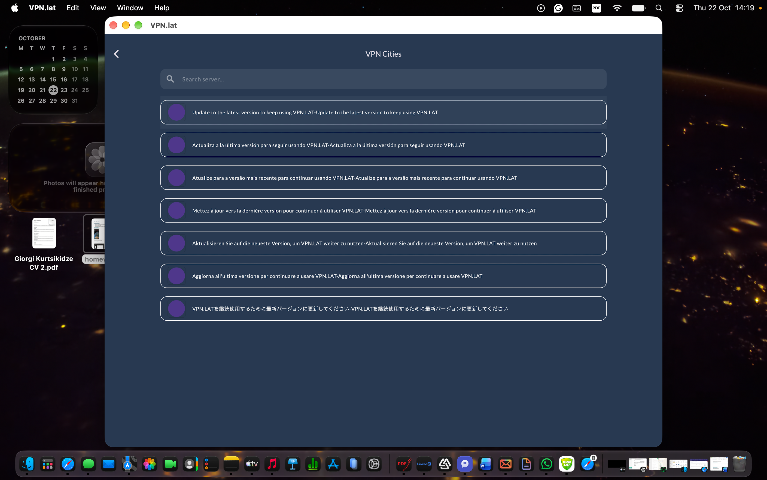
[using VPN to get access website(liveball.com), to watch F1 in Live]

Screenshot 5 from phone
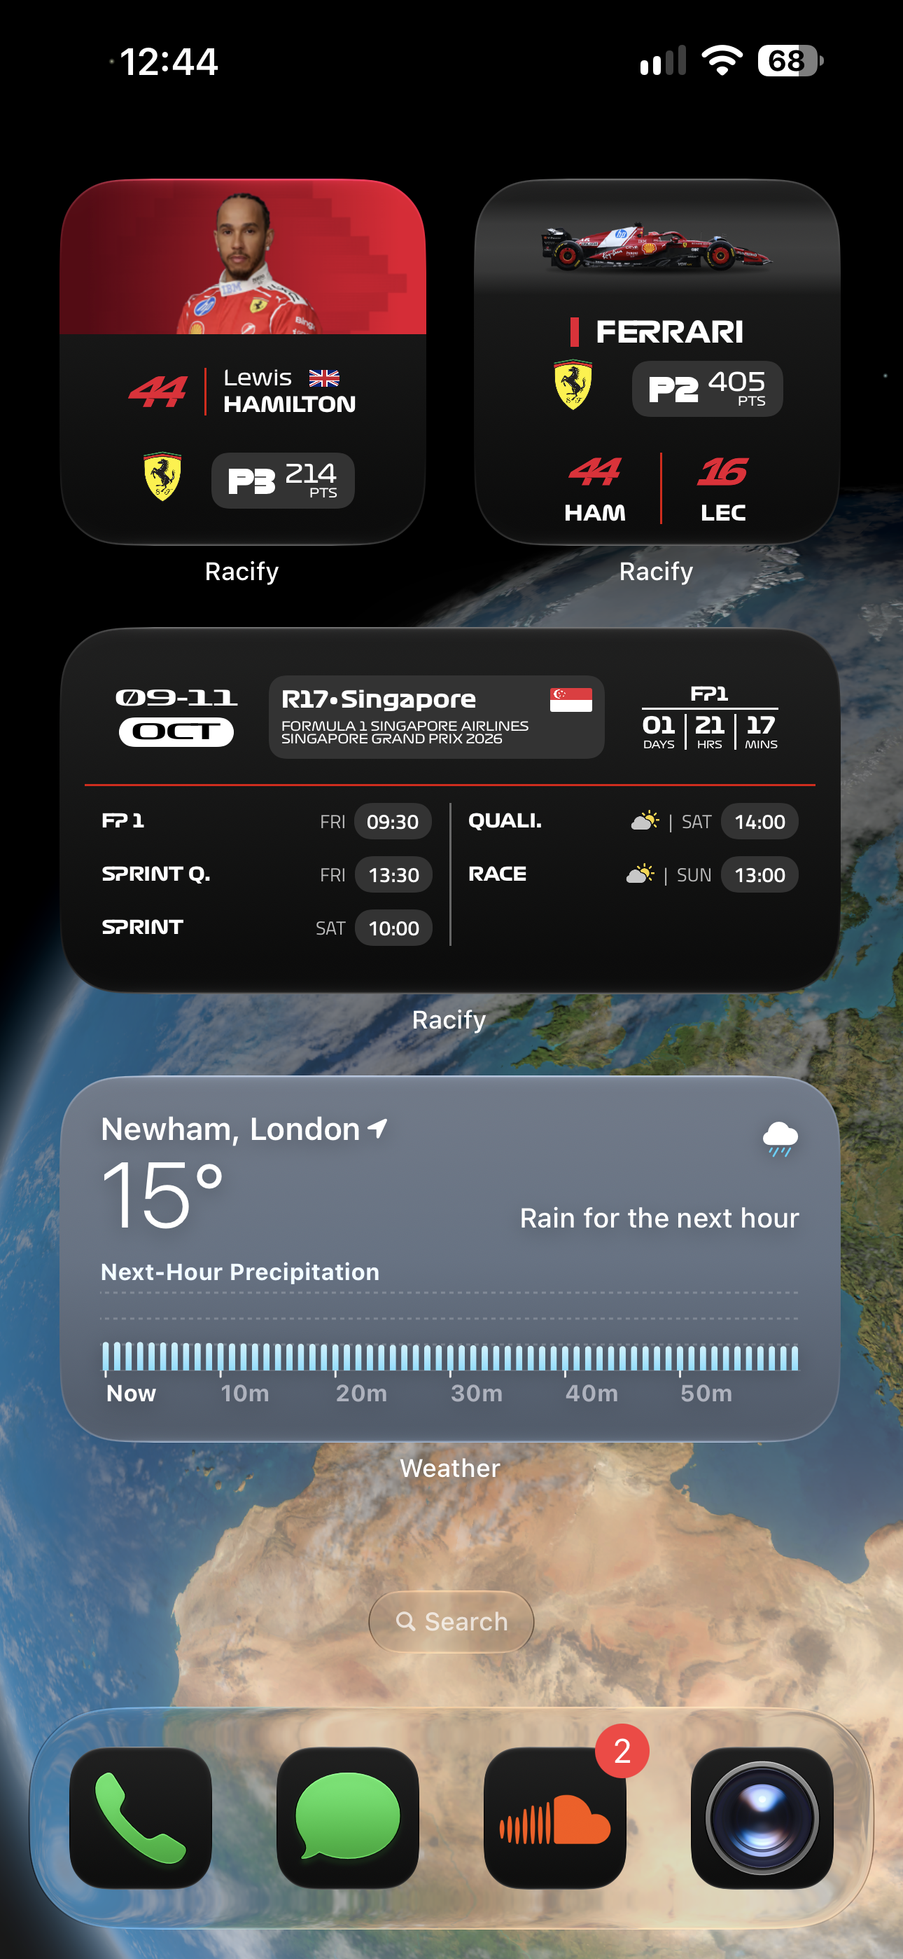
[this is application for F1, monitoring stats, timing, points and dates.
also weather before I go out have to check, it helps me to wear properly]

Screenshot 6 from phone
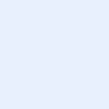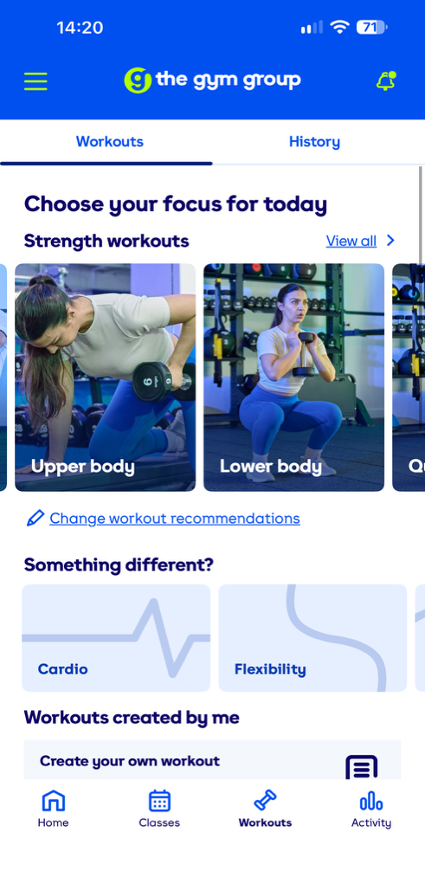
[before I go to the gym checking which part off body workout I have to focus for.
it helps me to don’t forget or miss different workouts ]

My Short Reflection
- Write 5–8 simple sentences about your digital life.
- You can use the sentence starters below if helpful.
About My Digital Life
I try to use my time in a useful way by learning new things and using the information in my everyday life. For example, I look for information about healthy food, exercise, computer technology and personal development.I use many different apps and websites to find information and check if it is correct. Digital technology helps me learn new things, improve myself and find useful information for different situations in my life.
This is one of the reasons why I chose this course. Together with my previous background and experience, I believe it is very important for me to develop my knowledge and learn different skills.
These skills will help me in the future with communication, using office software, finding and checking information, and continuing my personal development. I believe this course will help me become more confident and improve both my professional and everyday life.

Sentence starters
- I use digital tools to …
- I feel confident when I …
- I want to improve …
- I often use these tools: …
- I sometimes feel nervous about …
- I hope this module will help me …
- Digital skills are important for me because …
You can write more if you want.

Submission Checklist
Before you submit, please check:
​​​ ☒ I added 4–6 screenshots
☒ I wrote short sentences for each screenshot
☒ I wrote my short reflection
☒ My work is my own
☒ My file opens correctly
​​☒ My file opens correctly

