My Takings from the Improvising and Devising Module and Assessment, including Process and Reflection
This module has taught me how to work collaboratively to make a piece of theatre, which we performed improvised, while also learning to compromise, mediate, and build on others’ ideas along the way. I have done quite a comprehensive amount of devising in the past and found it a jarring process. It has been interesting to see the difference this year and learn what makes devising smoother and more enjoyable. I loved the beginning of Improvising and Devising as it included a lot of research following the release of our stimulus, The Golden Age of Piracy (1650-1730). (See Appendix 1) I have come to learn over the past few months that I love researching and presenting and what is often considered preparation. This has altered how I present my work in my own private notes, and coupled with the creation element of this module, has led me to start thinking about my future career options. My spirits took a bit of a blow when we reached the point of turning our initial ideas into a solid story line as everyone had different ways of working or thoughts on what direction the piece should go in, which led to a disturbed group dynamic. Fortunately, we had a conversation about communication led by our lecturer that helped to uncover a better distribution of group ‘roles’ and any discountenance people might be dealing with. Building on this, once I understood the different stages of devising - Forming, Storming, Norming and Performing – I was able to relax more into the process and trust we would work out any issues, whether work-focused or social. This is similar to the concept Preparation, Generation, Exploration, Distillation and Presentation which I explored in Jessica Swale’s Drama Games for Devising. I also found part of another text, “When it comes to creative inspiration, job titles and hierarchy are meaningless”, particularly helpful in working towards approaching subtle or subconscious social hierarchies with confidence but it also reminded myself that just because I am often the appointed mediator, doesn’t mean I can’t take on new roles. (See Appendix 2) (Ed Catmull, 2014)
I didn’t have much improvising experience before starting this module. Games such as ‘Some Toast’ and ‘Freeze’ helped introduce me to the notion and I began some research into other games that might help in the devising process. (Jessica Swale, 2012) I found developing my character is what propelled my improv skills forward as I was able to latch on to a comedy aspect. I played the role of quartermaster of a pirate crew whom I named Mercy O’Malley following some research into Irish pirate Grace O’Malley. (Joshua J Mark, 2021) (See Appendix 3) As a highly ranked member of the crew we first thought our O’Malley may be authoritative and direct similar to the way of ‘Capitano’ in Commedia dell’Arte. (Laura and Kenneth Richards, 1990)(John Rudlin, 1994) However, this serious personality was hindering my contribution to scenes and lowering overall energy as a result. As myself, I often wanted to throw out some silly quips in reaction when devising scenes and I realised that because I was so focused on keeping my character accurate that I was blocking my ability to improvise by second guessing all the time. I decided to push past my doubts, saying what came to mind first, and overtime I developed this cowardly character that had somehow climbed the ranks through devotion to her captain. The positive support of my class, strengthened after our storming phase, really helped me here to not feel foolish when acting so ‘largely’. I used several different methods to cement my character work including looking more at Commedia Dell’arte stock characters (John Rudlin, 1994), taking the Myers-Briggs test as my character (See Appendix 4) and participating in class imagery activities such as ‘walking aboard a ship’ and ‘aging myself up and down as a pirate’. I also read up more, following the class task to base our character’s basis off of someone we know slightly. The introduction to Drama Games for Devising (Jessica Swale, 2012)) includes passages into Mike Leigh’s same process. I decided to draw on a few different people as Leigh often suggests - for example, one person inspired O’Malley’s walk, another her worried facial expressions.
Commedia dell’Arte was a huge contributor for me in Improvising and Devising. I was already suitably familiar with the movement but new learning of structures and the like was incredibly interesting for me. I found the way Commedia includes brief scene explanations dotted with Lazze (See Appendix 5) similar to the devising process of Frantic Assembly, whom I have developed an extended knowledge of in some past modules. This way of laying things out like a pegboard helped how I saw the storyline structured and reassured my memory. Before going into this module, I really thought I preferred scripted work as I’m a serial fan of guidelines but I’ve actually found improvising freeing and simpler foundations confidence-building in the way I visualise the theoretical.
Returning to my comment on energy, I decided to read into what can help sustain the ‘energy’ of a piece as raising it was a consistent note we were receiving. The sentence ”Try to get your status just a little bit above or below your partner’s” (Keith Johnstone, 2018) really stood out to me. While it is often used to improve believability of a piece and promote consistency, I decided to run with the belief that if I raise my status, others in the group would likely adjust their own status in accordance. I experimented with larger gestures, projecting voice and reacting to everything as animatedly as possible. I had positive results from this, finding my classmates supporting me in active reactions in scenes and hopefully finding the increased energy a springboard for their own in-character actions.
The story we created was an enjoyable one for me to work through. I was pleased with the way we’d created the scenes as individual blocks so their order was easily moveable. This resulted in a nice variation in pace and depth and similarly I enjoyed the different configurations of characters. Following our end performance, I felt confident in my work, which was pleasantly new for me as I often have small doubts or regrets. This year for me has mostly been about consistently building my confidence and stepping away from societal standards with what may or may not be embarrassing. I loved that I felt secure enough in myself to be so dramatic with my character and offer up ideas in devising and act intuitively. My next challenge for myself is to be more vocal in the creative process, and I’m delightedly surprised that I’m hoping I have another devising opportunity to do this. Getting to learn more about the technical side as well helped me to think about theatre as a whole – how can I work alongside sound, where should I stand to best complement the lighting? For me my next steps are to take my newfound confidences in aspects like projection and improvisation and continue to build on them by independently exploring this module’s process further.
Bibliography
Catmull, E. (2014) Creativity, Inc.: overcoming the unseen forces that stand in the way of true inspiration. London: Bantam Press.
Digital Theatre+. (2023) How To: Commedia dell'arte – Workbook. Available at: https://edu-digitaltheatreplus-com.uwtsd.idm.oclc.org/content/guides/how-to-commedia-dellarte-workbook. (Accessed: 26th March 2026 onwards).
Johnstone, K. (2018) Impro: improvisation and the theatre. London: Bloomsbury Academic.
Mark, J. (2021) Grace O’Malley. Available at: Grace O'Malley - World History Encyclopedia (Accessed: 28th April 2026).
Swale, J. (2012) Drama games for devising. London: Nick Hern Books.
Richards, L and K. (1990) The commedia dell’arte. Oxford: Basil Blackwell Ltd.
Rudlin, J. (1994) Commedia dell’arte: an actor’s handbook. London: Routledge.
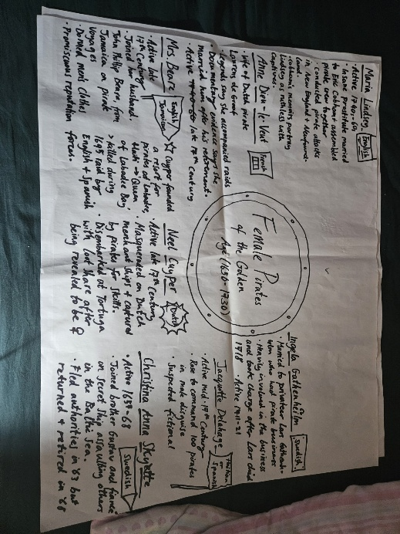
Appendix
Appendix 1
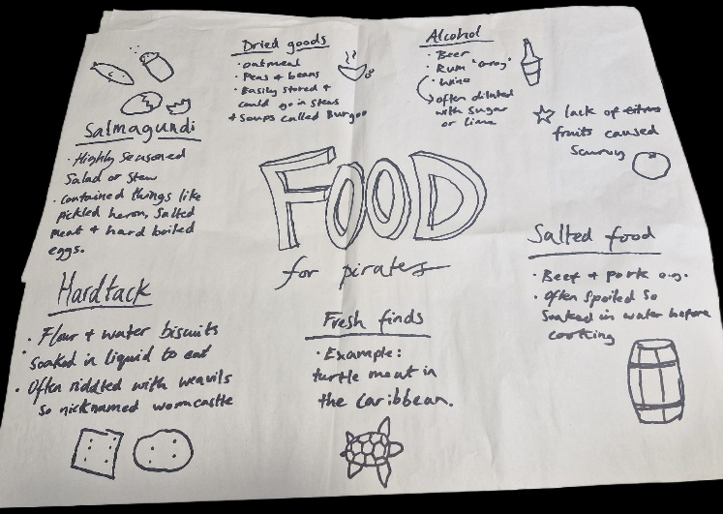

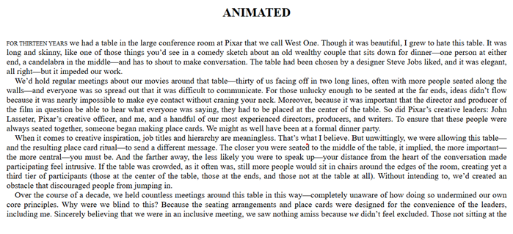
Appendix 2

Appendix 3
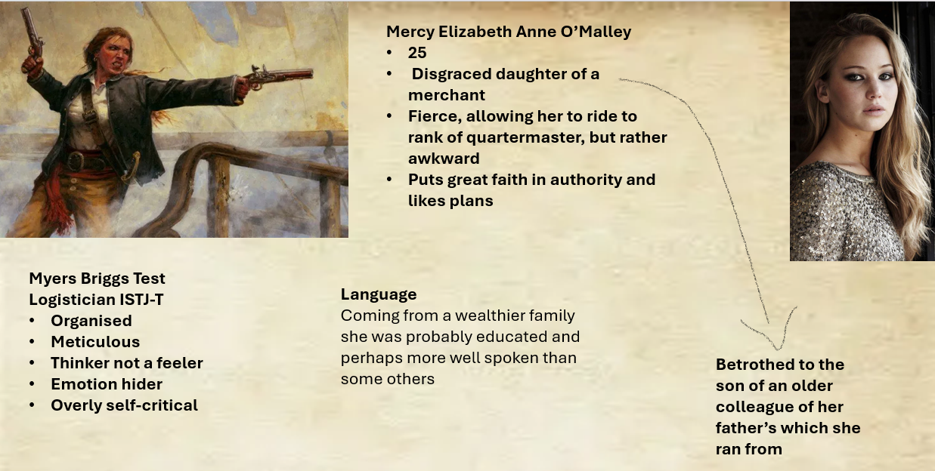

Appendix 4
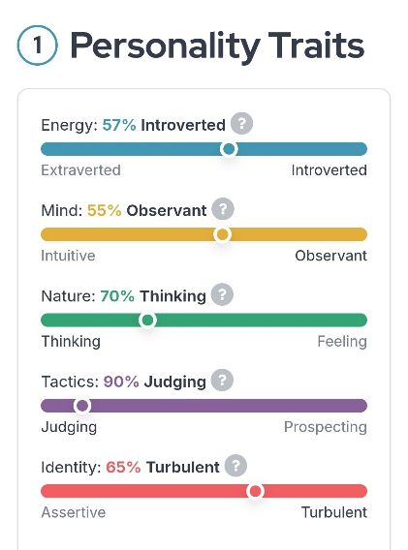

Appendix 5
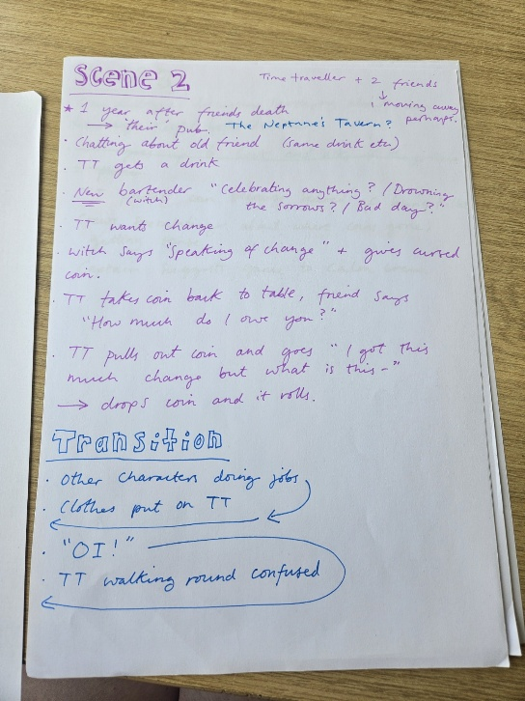

Appendix 6 – set and props stimuli


