Cloud computing: An overview and Recommendation based on specified case study

Marco Vinicio Martinez Garces
1814732

INDEX.
- Introduction
- Cloud computing definition
- Cloud computing concepts
- Cloud computing characteristics
- Cloud computing benefits and disadvantages
- Cloud service models
- Clou deployment models
- London Bikes deployment model recommendation
- Cloud migration
- Cloud security problems and against measures
- References

Introduction.
In this report, cloud computing will be explained. At cloud definition, characteristics and benefits and disadvantages will be explained. Then services models and deployment models will be explained followed by the recommendation of the deployed model for the company. Finishing the report explaining security problems and how to avoid them.

Cloud computing definition.
In the first instance, cloud computing needs to be defined, many definitions can be founded around the internet as nowadays this definition still in discussion. Some of the definition gave it by the specialists are:
- According to the National Institute of Standards and Technology (NIST) (2011), “Cloud computing is a model for enabling ubiquitous, convenient, on-demand network access to a shared pool of configurable computing resources (e.g., networks, servers, storage, applications, and services) that can be rapidly provisioned and released with minimal management effort or service provider interaction.
- According to Erl et al. (2013), “Cloud computing is a specialized form of distributed computing that introduces utilization models for remotely provisioning scalable and measure resources”
- According to Forrester Research (2010), “Cloud computing is a standardized IT capability (services, software, or infrastructure) delivered via Internet technologies in a pay-per-use, self-service way”
Cloud computing concepts.
To improve the understanding of cloud computing some concepts need to be explained.
- Cloud:
Cloud is an environment designed to proportionate user scalable and quantified IT resources accessible remotely via the internet. These clouds can be public or private, where the public is a cloud owned by a third-party company and shared by different users and a private cloud is a cloud owned by the same company that is going to use it.

- IT resources:
IT resources are assets that can be used by users as software, storage devices, applications, hardware, server, etc. These assets can be physical or virtual.

- On-premise:
On-premise in cloud computing means to use IT resources available inside of a company that is not a cloud-based company. This means that the company is a normal company that does not offer cloud services.

- Cloud provider and Cloud consumers.
Cloud providers provide IT resources in the cloud and cloud consumers use the IT resources.

- Scaling.
The scale is the ability of the IT resources to increase or decrease usage based on the demand of these. Two types of scaling exist:
- Horizontal.
Horizontal scaling is focused on adding more resources of the same type as the resources at the start. These resources normally are virtual. This scaling benefits installation time, cost of IT resources, and not limited by hardware capacity.
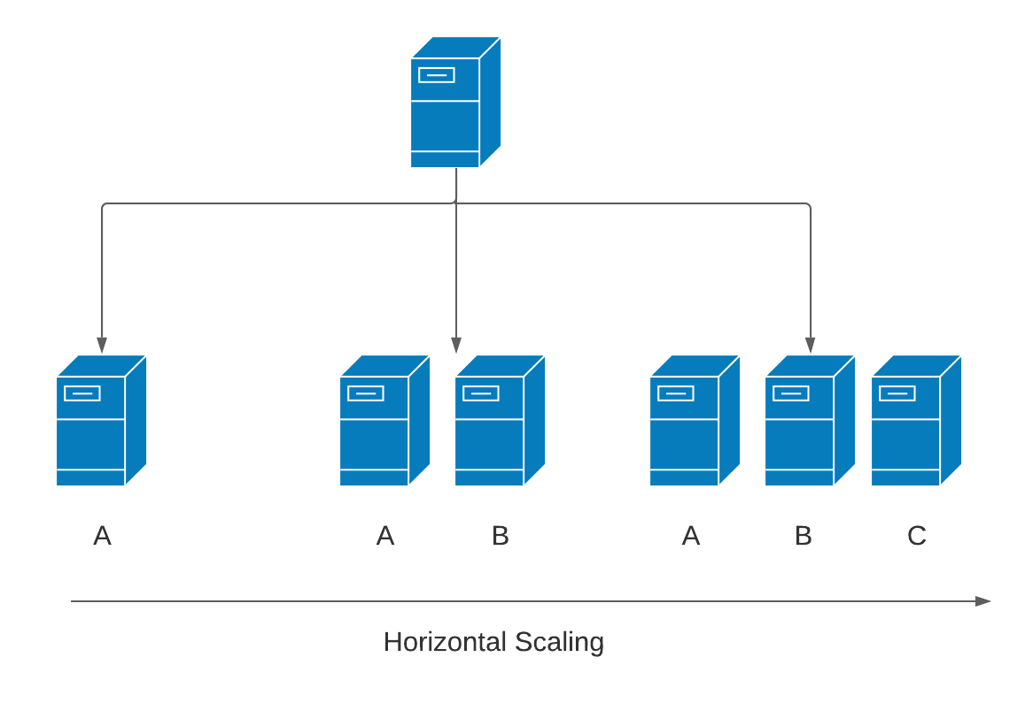
- Vertical
Vertical scaling s focused on replacing the previous IT resource with a higher (scaling-up) or lower (scaling down) capacity depending on the user requirements. This option is more expensive, takes more time to install, and is limited by the hardware capacity.
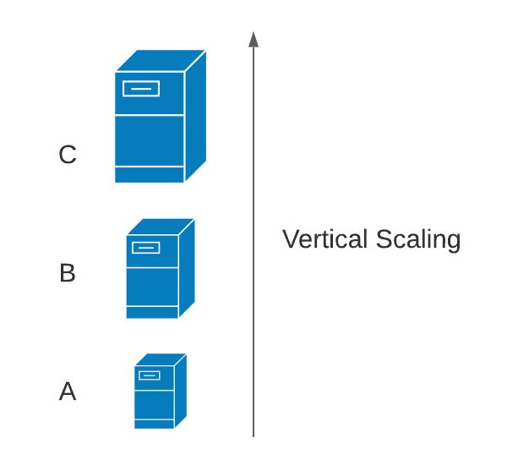

- Cloud Service
Cloud services are IT resources that can be accessed via a cloud.

Cloud computing characteristics.
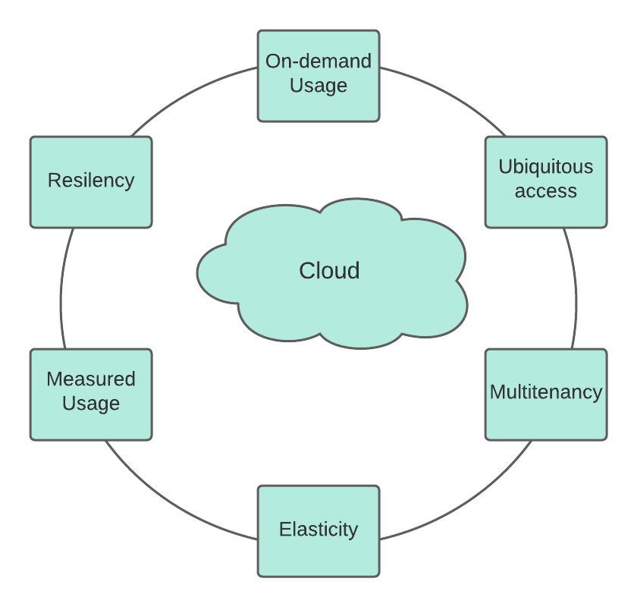
A particular set of features are required for an IT environment to allow Remote provisioning of IT services that are scalable and calculated in an efficient process. Such features must be important to exist.

For the majority, the following six basic characteristics are typical to Environments in the Cloud:
- On-demand usage.
This characteristic gives the possibility of configuring the self-provisioned IT resources and once the configuration is done these resources can manage the usage of resources automatically with no further intervention from humans.

- Ubiquitous access
With this characteristic cloud service can be accessed from anywhere, any time, and any device using an internet connection. For the different devices, support is needed as transport protocols, interfaces, and security.

- Multitenancy
Cloud providers give to the users a pool of IT resources that can be used by multiple users, but each user is isolated from the other user, which derivates in a multitenancy model. To help this model the use of virtualization technologies is required, which permits that these resources can be dynamically distributed and delegated to in compliance with cloud service customer requirements, reassigned. In the next figure, single-tenant and multi-tenant will be showed

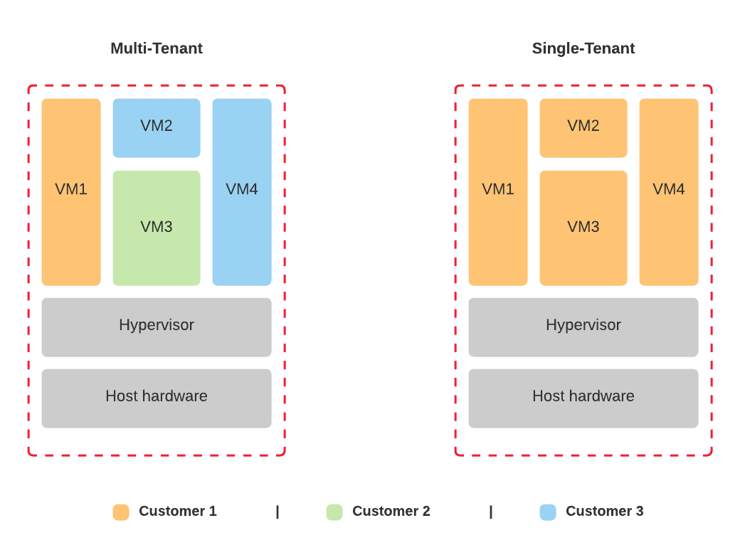

- Elasticity
Elasticity is the capacity of the cloud to scale IT resources as these are needed depending on the runtime conditions or responding to previous configurations done by the cloud consumer or provider.

- Measured usage
This is the ability of the cloud that control and calculate the usage of the IT resources that were used by the cloud consumer. So, with this, the cloud provider can charge consumers the exact amount for the services used. Further than using measured usage for billing purposes is used as well for monitoring the resources and create a report of the usage for cloud providers and consumers

- Resiliency.
This characteristic of the cloud is focused on giving a full working system or IT resources by distributing redundant implementations through tangible locations. So, in case that an error happens, that affects any resources these can be pre-configured the process is conducted to a redundant resource so the process will not be stopped. On the cloud, these redundant resources can be located on the same cloud or through different clouds.
Cloud computing disadvantages and benefits.
In this part of the report, some of the benefits and risks of using the cloud will be explained.

- Benefits:

- Reduce investment and costs.
As different types of cloud environments exist and with different prices. This allows the companies to save some costs in IT resources like hardware and software so they can invest the money in the main objective of the company. On another side cloud computing gives options for start companies to purchase at the start what they need and on a future scale as it is needed.
- Increased Scalability.
Scalability gives to the companies a range of IT resources that can be instantly allocated to cloud consumers via direct configuration or on-demand. This helps companies to support peaks and unpredictable usage assigning automatically or manually.

- Increased Availability and Reliability
Availability on cloud computing is referred to the capacity to assure accessibility of the IT recourses for longer periods. On another hand, reliability refers to the capacity to avoid or recover IT resources from errors that can influence the consumer experience.

- Disadvantages:

- Increased Security Vulnerabilities.
Access to the data of the company will be shared with the cloud company and overlapping trust limits of the company inside the cloud with the limits of other companies using the same cloud which decrease the security of company data.

- Reduce Operational governance control.
The level of government control assigned to the cloud consumer is lower than over on-premise. The main risks are coming from how the cloud providers operate the cloud and about the external connections used to connect users with the cloud.

- Limited Portability Between Cloud providers.
This risk is focused on how to complicate is move custom-built solution dependencies from a cloud provider to another provider which sometimes makes it easier to create from zero the solution in the other provider.

- Multi-Regional compliance and legal issues.
Data centers are located in convenient geographical locations, these locations are not proportionated to the cloud consumers. Which can present serious legal problems referring to regulations of the government about privacy and storage policies.

Cloud Services Models.
Cloud providers depending on the specification that the consumers need, three services models are available on cloud computing:
- Software-as-a-Service (SaaS).
In this model software and data linked with it are hosted in a cloud that can be accessed via the internet. The software does not need any installation. SaaS is an on-demand model which means that the charge will depend on the user usage or can be a pay-monthly.
SaaS has some characteristics that make it different from traditional software. Six characteristics are essential for SaaS.
- One too many.
This describes how SaaS is provided, a single software can be shared by different cloud consumers.

- Web access.
SaaS can be accessed by any device with an internet connection using a browser to connect with the cloud.

- Centralized management.
Software is managed by the central location and this one is in charge to update the software ensuring that each user has access to the newest version without unnecessaries side-updates.

- Multidevice support.
Software is accessible by any device as a laptop, smartphones, tables, etc.

- Scalability.
SaaS takes benefit from IaaS and PaaS for its development and implementation. This ensures scalability better than traditional software and makes that the resources of the cloud work properly even when facing diverse loads.

- Availability.
SaaS implements backup and restoration systems at the back end to ensure that the services are available for use at any time even if an error happens.
SaaS can provide the next services:
- Social Networks.
As one of the advantages of SaaS is the sustainability to support high peaks of traffic, nowadays social networks are adopting SaaS as their deploy model. So, they can support the constant growth of social media users.

- Document management.
With the growth of new technologies, the use of digital documents is increasing, and SaaS provides services or resources for the customer to create, modify, and follow the process of the digital documents.

- Business services.
SaaS provides customers in the business environment different tools for doing bills, control sales, create enterprise resource planning, and customer relationship management. This is a good choice for start-up companies that are starting and helps human resources with their tasks

- Email services.
Nowadays E-mail is one of the most used applications to send email between business workers, familiars, friends, etc. The future of this technology is uncertain and is growing more every day with more customers. So, to support this; growing e-mail companies give their services as part of the SaaS model, which helps to support future growth.
Benefits and Cons of SaaS
  - Benefits
    - Low-cost investment.
    - Easy access.
    - Pay for the resources used.
    - Scaling and Recovery.
  - Cons
    - Security.
    - Lose control over company data.
    - Connectivity network ( speed and signal).
    - Privacy.
Some real-world applications that use SaaS are Dropbox, Amazon web Services, Lumen5, Box, etc.
- Platform-as-a-Service (PaaS).
PaaS is a pre-defined environment that usually consists of IT services that have already been implemented and configured. PaaS is mostly used by developers that want to deploy their application into the platform provided by renting virtual servers inside of a cloud provider. Other of the usages of this service is to run the application that has been already created, test the newest ones, build, and maintain the infrastructure related to the development and launching of the apps.

PaaS has some specific characteristic that differentiates it from traditional development platforms:
- All in one.
PaaS provides integrated development environments that offer tools for developing, testing, deploying, and maintaining applications.

- Web access.
Development platforms are accessible via the internet.

- Offline access.
Users will not always be connected to the internet, but this cannot stop their work so PaaS is accessible even offline which lets the users work without the dependence of having a connection.

- Built-in scalability.
Scalability is an important characteristic of nowadays technologies. So PaaS provide this scalability for the applications that have been deployed using this service model.

- Collaborative platform.
PaaS proportionate maintenance for collaborative work in developing applications using this service.

- Diverse client tools.
To do the development easier for the users PaaS proportionate a range of tools that users can use. These tools are command-line interface (CLI), web user interface and CLI, Representational API, IDE, billing handling, and subscription management.
PaaS can provide different services to developers which ones are:
- Programming languages.
PaaS can supply a range of programming languages. So developers can use them to develop.

- Application framework.
PaaS providers have different frameworks that can provide to costumers that can help to make simple the creation of applications.

- Database.
As some applications need to be linked with a database, PaaS provides databases with their platforms.

Benefits and cons of using PaaS
  - Benefits:
    - Easy use
    - Less maintenance cost
    - Scalability on application creation
  - Cons:
    - Reduced flexibility.
    - Security.
    - Provider block.
Some real-world services of PaaS are programming languages like Java, phyton, and PHP, frameworks as WordPress or Joomla, and databases as Clear DB or Mongo DB.
- Infrastructure-as-a-Service (IaaS)
IaaS is a service model that provides virtualized IT resources like hosts, servers, and storage between others. These virtual resources are located inside different physical resources in data centers.

Some of the characteristics of IaaS are:
- Remotely access.
IaaS makes available access to infrastructure resources via the internet
- Central Management
Physical resources are divided into different locations but a single one is in charge of their management.
- Scalability.
As the other service models, IaaS also provide good scalability to support the ups and downs on the usage of the resources
- Divided infrastructure
IaaS use a one-to-many model which means that one physical infrastructure can be shared for multiple users.
- Virtual Machines preconfigured.
As an important part of the IaaS model, the service provider offers virtual machines previously configurated down the user criteria.
- Measured Services.
IaaS use pays for use, which gives the option to rent services and not buy these. So, depending on how much resources or services are used the billing will be per the use.
Benefit and Cons of IaaS model:
  - Benefits
    - Pay-as-you-use.
    - Reduce the total cost of ownership.
    - Elastic scalability.
  - Cons
    - Security.
    - Connectivity dependence.
    - Difficulties in migration between providers.

Resume of the control and functionalities available for cloud consumers
Service Model | Cloud consumer control over the service | Functionalities available for the cloud consumer
SaaS | Usage and usage-related configuration | Access to front-end user-interface
PaaS | Limited administrative | Moderate level of administrative control over IT resource relevant to cloud consumer’s usage of the platform
IaaS | Full administrative | Full access to virtualized infrastructure-related IT resources and, possibly to underlying physical IT resources

Cloud consumers and clour providers activities in each service model:
Service Model | Cloud consumers activities | Cloud provider activities
SaaS | Uses and configures cloud services | Implements manage and maintain cloud services  Monitors usage by cloud consumers
PaaS | Develop, test, deploy and manage cloud services and cloud-based solutions | Pre-configures platform and provisions underlying infrastructure, middleware, and other needed IT resources, as necessary  Monitors usage by cloud consumers
IaaS | Set up and configure infrastructure, and install, manage, and monitors needed software | Provisions and manages the physical processing, storage, networking, and hosting required  Monitors usage by cloud consumers

Cloud deployment models.
- Private
A private cloud is a cloud created and owned by only a single organization. This cloud can be located, managed, and operated by the same company or a third party company. Services of the cloud will be used by employees of the same company.

The private cloud characteristics are:
- Security.
As the private cloud is mostly deployed and managed by the same company. Give permissions for access to the data to a third company are not required. This increases the security of this one as it will be only accessed by the company, reducing the possibility of data leaking.
- Control.
As this cloud is private, means that the company will be in charge of the management of the cloud. Having full control over it.
- Service level agreement reduced.
Because the cloud is managed by a single company the SLA’s are not existing. By the way, if any SLA exists, this is weak and is an internal agreement between the company and employees of this one.
This deployment model is suggested for companies or organizations that found themselves in the next cases.
  - Requires a different cloud for the company employees.
  - Have enough fund to face the cost of management and maintenance of a private cloud
  - Consider security as an important factor.
  - Small organizations with a reduced number of employees.
For another hand is necessary to mention the two types of private cloud based on the location and management of this one.
  - On-premise.
On-premise private cloud is a cloud that is managed by the same organization where is located. So, the cloud is directly connected to the company network.

  - Outsourced.
Outsourced private cloud is a cloud that is located and managed by a third party company.
Benefits
  - Easier to maintain
  - Higher security
  - Centralized control
Disadvantages.
  - Expensive in comparison to other models
  - Complexity increased for the company

- Public

A public cloud is a cloud environment located and managed by a third-party company. Public clouds normally ae delivered via the previous service models (SaaS, PaaS, IaaS), and the cost of the service goes concerning the usage of the customer.

Characteristics of the public cloud are:

- High Scalability.
As the public cloud is located in a third party company more resources are available which improves the scalability.

- Affordable.
As the public cloud is offered to costumers as pay-as-you-go. So, customers will be charged based on the usage of the resources. Which proportionate affordable prices.

- Less secure.
The public cloud is less secure because the third party company has full control over the cloud and the data of the company.

- High availability.
As this cloud can be accessed from anywhere around the world via the internet

- Rigorous SLA.
SLA are followed strictly to avoid any data leaked.
Benefits
  - Not need to invest in infrastructure
  - No limit to growing
  - High scalability
Disadvantages.
  - Less Secure than other clouds
  - Lose control over data

- Community

The Community Cloud may be owned, maintained, and run by one or more community groups, a third party, or a combination thereof, and may reside on or off-premises.
The characteristics of this cloud are:
- Collaborative.
As the cloud is shared by multiple users from a community the maintenance and distribution depend on them.
- Secure partially.
Because the cloud is shared exists a risk where the data from a user of the cloud can be leaked to another user or users.
- Reduced cost
This cloud cost is reduced concerning another cloud because the cloud cost is divided between all the users of the cloud.
Benefits:
  - Collaborative work
  - Share responsibilities
  - Security improvement respect public
Disadvantages:
  - Dependence on collaborative work
  - Lost part of the autonomy of a company

- Hybrid
A hybrid cloud is a combination of one or more clouds like a public cloud with a private cloud.
Hybrid cloud characteristics:
- Scalability.
As hybrid cloud can be formed for different cloud, which means that it will have good scalability.
- Security.
Security depends on the deployment model chosen. For example, private has a strong one but the public is weak which means that security could be compromised
- SLA
Hybrid cloud needs to have SLA to secure to costumers that their data will be secured under SLA.
Benefits:
  - Better Scalability
  - Security better than Public cloud
Disadvantages
  - Complex management
  - Tough SLA
London Bikes deployment model recommendation.
In this part of the report, the deployment model recommendation for London Bikes Ltd will be discussed.
Based on the information and requirement proportionated by the company. In conclusion, the recommended deployment model should be a public cloud. This recommendation is based in that the requirements needed as web page support, database support, billing tools among others.
As this model support, these characteristics and the cost of it is reduced in comparison to the other models. For another hand using public cloud services models as SaaS, PaaS and IaaS can be deployed.
With the knowledge of the data that need to be kept safe the security proportionate by public cloud should be enough. As well this model proportionates good scalability to the company as the resources can be adjusted to the growth of the company.
Concerning the protection against possible errors in the system that can stop the function, with the reliability of the public cloud this problem will be fixed.

Cloud Migration
Once the deployment model is selected is necessary to explain the cloud migration process and how this can be implemented in the company.
Cloud migration is the process of moving the data and resources from the company system to the cloud. This process is divided into five phases:
- Evaluation
In this phase, an evaluation of the application and requirements of the company.
- Migration strategy
Once the evaluation is done a migration strategy is deployed
- Prototyping
After the previous one, a prototype is deployed to test if the resources or applications that are going to be moved to the cloud are compatible with this.
- Provisioning
Once the prototyping is successful the resources are moved to the cloud and deployed inside of this.
- Testing.
In this phase, some tests are realized to ensure that all is working successfully.
The most commons strategies used are:
- Re-host.
This strategy does not require any changes in the resources and the process is moving from one host to another

- Re-platform.
The main body of the architecture will not change but will need some updates to achieve all the benefits of the new platform.

- Re-architect.
This consists of re-build all the architecture using cloud-native features to make it easier for the adaption to the cloud characteristics.

- Re-purchase.
Move to SaaS from perpetual licenses.

- Retire.
Once the application or the resources are no longer needed these can be removed from the cloud.

- Retain.
Consist of keeping apps that are important to the enterprise but that need substantial refactoring before they can be migrated.
Cloud security problems and against measures
As part of moving to the cloud, some security threats need to be discussed. Once the data is in the cloud could be exposed to different attacks as the next ones:
- Traffic Eavesdropping
Traffic eavesdropping happens as data is transferred or transferred to inside a cloud, a malicious service agent is passively intercepted for unlawful intentions of collecting knowledge. The goal of this attack is intended to explicitly violate the secrecy of the documents and, probably, the privacy of the link between the user of the cloud and supplier of the server. Owing to the passive nature of the attack will go undetected for extended periods.

- Malicious Intermediary.
The malicious intermediary threat occurs when messages are intercepted by a malicious service agent and changed, thus potentially jeopardizing the secrecy of the communication and/or completeness. Until injecting harmful data into the post, it can also insert harmful data
transferring it to its destination.

- Denial of service.
Denial of service attack is focused on overload the IT resources until the functionality of this one is affected even taking down the service.

- Overlapping trust boundaries.
Consumers of malicious cloud services can target with the purpose of compromising the cloud, shared IT resources consumers, or other IT properties that share the same confidence cap.
The effect is that any or more of the other cloud providers are the attack could affect customers and/or the attacker could be harmed. Using virtual IT tools against those who happen to have shared the same Border of Confidence.
Cloud providers take the security of their customers seriously for this reason some against measures are implemented. Some of these are:
- Encryption.
A digital coding scheme committed to protecting data secrecy and integrity is the encryption mechanism. It is used in a secure and unreadable format to encrypt plaintext data.

- Hashing.
The hashing function is used where data security requires a one-way, non-reversible one. It is locked after hashing has been added to a message, and no key is given for unlocking the message. To check that the generated message digest is similar to the one preceding the message, the receiver applies the same hash function to the message.

- Digital signature.
The digital signature system is a way of providing data validity and legitimacy through verification and non-repudiation. A digital signature provides proof that the received message is the same as that provided by the legal sender. The digital signature scheme aims to mitigate malicious intermediaries.

References
Top-Selling Author, T. E., 2013. Cloud Computing concepts, technology & Architecture. s.l.: Prentice-Hall.
Mell, P., and Grance, T. (2011). The NIST definition of cloud computing (draft). NIST Special Publication
Chandrasekaran, K. (2015). Essentials of Cloud Computing. New York. CRC Press: Taylor & Francis Group

