
Design Criteria – Water Supply and Waste Drainage
Mark Jones

Assignment 1
School: Built Environment
Subject: Built environmental services
Hand In date: 24th of January
Lecturer: Allan Nantel
2019

Page index
Contents

Question 1
1.1 Introduction 3
1.2 London’s original sewer 3
1.2.1 Sir Joseph Bazalgette 3
1.2.2 Problems due to the capacity of Bazelgettes sewer system 3
1.3 London’s new ‘super’ sewer 4
1.3.1 Peoples views on the new system 5

1.4 Question 2
1.4.1 Indirect system 7
1.4.2 Direct system 7
1.5 References 7

1.1 Introduction

London’s new ‘super’ sewer system is currently under construction. The old system is not enough, with London’s population size gradually increasing, more and more pollution is spilling into the themes. The aim of the sewers new construction is to support London’s growing population and stop all further contamination to the river. This report will discuss the 150-year-old sewer system, why the parliament decided a new sewer system was needed. How the sewer was constructed and the potential health problems it prevented. The report will cover all the problems the sewer has encountered and its existing problems, the reasons for the problems will be described. The new ’super’ system will be described, and the advantages and disadvantages will be discussed. The report will provide Local people, environmentalists and engineers’ views on the existing and new sewer. Part two of the assignment is to describe what cold and hot water systems are, how they are use in a building. All types of buildings will be considered, and the ages of the buildings will be compared against each other.

1.2 London’s original sewer

OpenLearn, (2018) notes, London’s original sewer system came into action following the Great Stink of London, as there was no actual sewer system in place, it was basically an open sewer. Houses usually had cesspools, once full were collected and used as fertilizer for local farms. Liquid waste usually ended up into the river themes. Over time the themes got more and more polluted as waste would flow straight into the river from houses and businesses. In the month June 1858 the weather was extremely hot for London, which caused the river to smell extremely bad. People at the House of Parliament realised a new sewer system was needed, to prevent the waste ‘smelling’ around central London.

1.2.1 Sir Joseph Bazalgette

Sir Joseph Bazalgette “Was the main engineer on the metropolitan board of works for London” Broughttolife, (2017). Openlearn describes that after the great stink, London’s county council laid down the first bye law to install a sanitary system. Which allowed Bazalgette to be hired as the main engineer of the new sewer system to be constructed in London, this was mainly because of his background in ground drainage. Many proposals for the new sewer system were received, Bazalgette carefully considered each one. Bazalgettes engineering was very good for the time it was designed, he decided to make the sewer large enough to prevent it filling up although made overflows for backup as he knew London’s size would grow in the future. The sewer constructed was semi-circle shaped, which allows the waste to flow down by gravity, at certain points it would be pumped to a higher level by machinery. The sewer is in great working order, Portland cement was used as it is water resistant and good quality bricks, meaning the sewer was built to last. Broughttolife explains that a design which channelled the waste through small street sewers to find larger main sewers which would take it all the way through central London, to multiple pumping stations at the end of its cycle it would find a pump house located in Breakton, where the waste would be stored deep underground and pump up and out to sea on the outgoing tide. Tideway improvements, (2010) states the sewer was also designed to capture surface water, although If London receives any heavy rainfall the sewer would fill right up discharging its content directly into the river Themes from its 57 overflows without any treatment over 50 times a year.

1.2.2 Problems due to the capacity of Bazelgettes sewer system

Bazelgette P, (2017) explains the sewer system was built 150 years ago, with a population of around 2.5 million, Bazalgette though ahead and realised the population of London was bound to grow and decided to design the system for a population of 4.5 million. As the population is past 8 million now, the people of London are now experiencing major problems. Firstly, with London’s sewer system being a combined system it often overflows spilling untreated waste directly into the Themes. With tonnes of raw sewerage infecting the river, local people who use the river regular are experiencing health problems. The river before Bazalgettes construction caused the people of London health problems, as drinking water was supplied straight from the river Themes itself, causing cholera. Themes water, (2017) explains fishermen are being affected by the sewer problems, with the fish population decreasing due to the fact they are being diseased by the sewer waste in the river, oxygen levels are getting low which is slowly killing them off. The people who are eating these fish may be getting ill. Another example is rowers and other people who use the river on boats are getting sick from the waste in the Themes, as the waste used to get disposed on the outgoing tide people further out of London used to experience problems as the waste would washup on their shores. Another issue is blockage in the sewer, fat and oil are being poured down drains causing ‘fatbergs’ which is fat, oil and other material waste sticking together in big clumps blocking the sewers.

1.3 London’s new ‘super’ sewer

London’s new ‘super’ sewer is currently under construction and the aim is to get it completed by 2024, according to CH2M, (2015) there are three different elements to the sewer. Firstly, the major upgrades to the existing sewerage works and pumping stations, secondly, the ‘Lee’ tunnel (already completed) and thirdly the 25k (16 mile) long Themes tideway tunnel. The Themes tideway tunnel stretches from Acton all the way up to Abbey mills where it meets the ‘Lee’ tunnel’ as shown in figure 3. The tunnel will need to be deep enough to miss the river and all the existing services underground, a boring machine will be used to dig the tunnel. The tunnel will be constructed so it is completely water tight containing three different water proof layers, rounded concrete segments will form the inside of the tunnel to create a circular 7.2-meter wide design. The construction is designed to last London for a further 120 years. The tunnel “connects to 34 of the most polluting CSOs” Varghese, (2018), CH2M states this will reduce the number of overflows caused by heavy rainfall from 50 a year to 4, making the river Themes over 95% cleaner.
A major benefit with the ‘super’ sewer being constructed so close to the river Themes is materials can be transported by boat meaning no traffic will occur on the roads. Varghese, (2018) explains that 90% of transport for materials and earth will be by barge/boat.
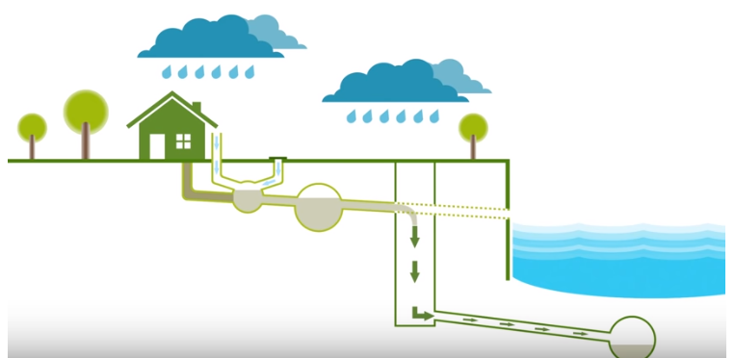
Figure 1 shows the combined sewer system for one house getting over full and discharging into the new ‘super’ system rather than the river Themes. (CH2M, 2015)

Water technology, (2018) explains the ‘Lee’ tunnel collects any discharge from the overflow at Abbey mills and other points along its journey up to Beckton, where it receives treatment before being released back into the river, as shown in figure 2.

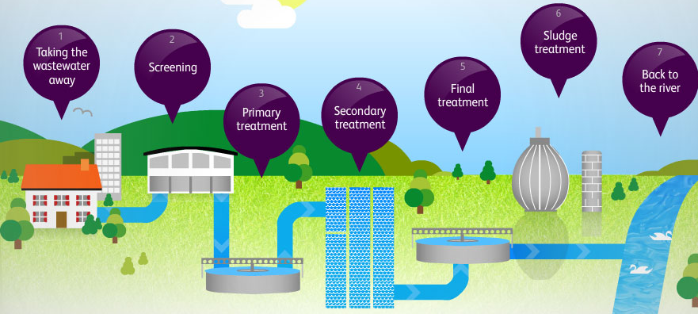
Figure 2 explains the treatment the waste receives when it gets to Beckton (themes water.co.uk, 2018)

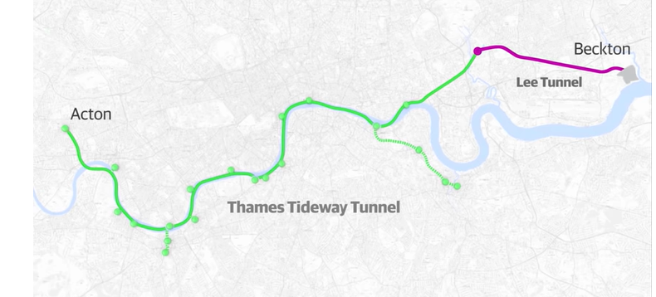
Figure 3 shows the route of the Thames tideway tunnel and the ‘Lee’ tunnel (CH2M, 2015).

1.3.1 Peoples views on the new system.

Different people have different views when it comes to the ‘Super’ sewer, almost everyone wants changes to be made as the river is too polluted. Although not everyone wants huge construction projects to take place near their homes. Citymetric (2015) states “The aforementioned 24-hour drilling by giant machines at Battersea, Fulham and Chambers Wharf would, as Hammersmith & Fulham Council has noted, subject residents to 24/7 noise, dust and air pollution. There are eight primary schools within a mile of the Fulham drilling site, and residents living within ten yards.” This statement is arguing that noise and air pollution will disrupt local people’s everyday life until the construction comes to an end. Machinery and equipment working all day will produce major noise pollution although if needed in certain area, machinery can be only operated at certain times for example ‘no noise pollution between 9.00pm to 8.00 am’.
Varghese (2018) states “some of the cost of the £4.2 billion project will also be passed onto the public: many Thames Water customers have already seen an increase of £13, on average, to their annual water bill as a result (this figure, by Tideway’s own estimates, could rise to £25 before inflation by the end of the project).” As this has an effect to every house hold in London, more people may disagree and want it to be funded elsewhere.
Tideway (2018) explains that they have got in touch with a local charity to collecting plastic from the river Themes and recycling it into a plastic timber which will be used to build a small ‘punt’, the vessel will be used to collect more floating plastic from the Themes. This will allow the public to participate, where they will see the issue first hand and realise that the new sewer system is benefiting the river majorly. (Tideway) states that schemes are being developed to get younger people more involved with the river Themes, hosting events and starting clubs such as “London youth rowing” these activities are getting people more involved with the river.

Associated press (2014) Gives the opinions of:
Professor Roberts, environmentalist, explains that the construction of London’s sewer could be more sustainable. Explaining that there are lots of sites around that could accommodate small decentralised treatment, site could generate power.
Philip stride, Project leader, states sustainable approaches to the construction will take too long and may not have the capacity that is needed for future use.
As the construction isn’t very environmentally friendly it may receive fines from the ‘European union’ if nothing is put in place for the sustainable aspect of it.

Total word count: 1645

1.4 Question 2

“By 1944, 70% of rural households and nearly 100% of urban households in England and Wales had piped water supplies” Gov.Wales (2017). The types of systems commonly used in Wales for older domestic houses are ‘direct’ systems, newbuilds are usually fitted with the ‘indirect’ system. According to myboilerservice.com (N.D) Combination boilers are becoming a lot more common in Wales, 70 % of people would choose this system over others. Combined boilers provide the buildings hot water and heating system together without using two separate water tanks. They are usually added into new builds but can be fitted in an older building.
Wales has the oldest housing stock in Britain, with a large amount of different types of buildings. Gov.Wales (2017)
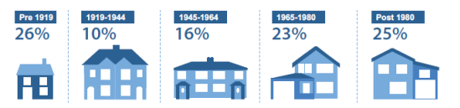
Figure 4 Gov.Wales (2017)

1.4.1 Indirect
Depending on the age and type of building, different water supply systems to a building are used. The most common in newer domestic buildings is the indirect system, which “sends fresh water into your property through to the household stopcock valve (main on/off tap). Once the water has reached this area, you can get drinking water from the kitchen sink, but the rest of the water is moved to a storage cistern which supplies the water for the rest of the house. Chard, (2018)

1.4.2 Direct
Direct systems are more common in old buildings, the direct system “sends mains pressured drinking standard water to every cold tap in the house, including the bath, bathroom basin and kitchen sink. Depending on the hot water system, the cold feed will either enter the hot water cylinder or the combination boiler.” Chard, (2018)

Indirect in Commercial buildings
The most common type of system used for commercial buildings is indirect water supply, when “Cold water enters the building from a rising main and is stored in an intermediate cold-water tank. The cold water is fed from the tank by gravity to the points of use without recirculation.” Hse.gov.uk, (2019)

1.5 References

Associated press, (2014). Inside London's Massive Sewer Tunnel Project. [online] Available at: https://www.youtube.com/watch?v=snV67BuXp-k [Accessed 20 Jan. 2019].

Bazalgette, P (2017). London sewers. [online] available at: https://www.youtube.com/watch?v=_drmmd_-ueg [accessed 12 jan. 2019].

Broughttolife (2017). Joseph Bazalgette (1819-91). [online] available at http://broughttolife.sciencemuseum.org.uk/broughttolife/people/josephbazalgette [accessed 18 jan. 2019].

Ch2m, (2015). Thames tideway tunnel - transforming the ecology of London’s river. [online] available at: https://www.youtube.com/watch?v=lyvpywpov18 [accessed 18 jan. 2019].

Chard, A, (2018). a browser update is required | victoriaplum.com. [online] victoriaplum.com. available at: https://victoriaplum.com/blog/posts/understanding-home-water-systems [accessed 18 jan. 2019].

Citymetric, (2015). what's a super sewer, and why does London need one? | citymetric. [online] available at: https://www.citymetric.com/horizons/whats-super-sewer-and-why-does-london-need-one-635 [accessed 18 jan. 2019].

Gov.wales, (2017). [online] Available at: https://gov.wales/docs/statistics/2018/181206-welsh-housing-conditions-survey-headline-report-2017-18-en.pdf [Accessed 20 Jan. 2019].

Hse.gov.uk, (2019). Appendix 2 - types of hot and cold water systems. [online] Available at: http://www.hse.gov.uk/foi/internalops/sims/pub_serv/07-12-07/appendix2.htm [Accessed 17 Jan. 2019].

Myboilerservice.com, (N.D)Pros and Cons of Combi Boilers | Combi Boiler Guide. [online] Available at: https://www.myboilerservice.com/the-pros-and-cons-of-combi-boilers [Accessed 16 Jan. 2019].

Openlearn (2018). London got its victorian sewers. [online] available at: https://www.open.edu/openlearn/science-maths technology/engineering-technology/how-london-got-its-victorian-sewers [accessed 17 jan. 2019].

Thameswater, (2017). why is the Thames tideway tunnel needed?. [online] available at: https://corporate.thameswater.co.uk/about-us/thames-tideway-tunnel/why-is-it-needed [accessed 18 jan. 2019].

Thameswater.co.uk, (2018). Thames water. [online] available at: https://cycles.thameswater.co.uk/accessible/the-sewage-treatment-process [accessed 14 jan. 2019].

Tideway improvements (2010). London tideway improvements - creating a cleaner, healthier river Thames - Thames water. [online] available at: https://www.youtube.com/watch?v=wft1tsycnu4 [accessed 16 jan. 2019].

Tideway, (2018). London's super sewer - august 2018 update. [online] available at: https://www.youtube.com/watch?v=hyzwemm5pnm [accessed 14 jan. 2019].

Varghese, (2018). London's super sewer won't solve the city's epic poop problem. [online] wired.co.uk. available at: https://www.wired.co.uk/article/sewage-environment-climate-change-london [accessed 13 jan. 2019].

Watertechnology, (2018). Thames water's lee tunnel project, London, uk - water technology. [online] available at: https://www.water-technology.net/projects/lee-tunnel/ [accessed 14 jan. 2019].

