  Component One: Student Journal (learning log)  Contribution to Overall Module Assessment: 25% | Student No: | 2225011
 | Module Title: | Hotel Administration and Front Office
 | Module Code: | BMIH4004
 | Lecturer: | Neil Dyer
A wide range of skills, such as effective communication, customer service, organisational prowess, and problem-solving, are necessary for front desk jobs in hotels. By employing Gibbs' Reflective Model, I will examine my experiences, abilities, and theoretical concepts while reflecting on my experience during my placement at Hunton Park.
In my position at the Hunton Park Hotel front desk, effective communication has been essential. Speaking with guests and answering their questions at check-ins brought to light the value of verbal and nonverbal cues. When I was able to communicate with guests in an effective manner, I felt a sense of achievement most of the time. However, there were times when handling visitor problems was difficult. This made it clear that further progress was required. As I evaluate my communication abilities, I see that clarity and empathy are two of my strong points. I did, however, see room for development, especially in dealing with difficult circumstances. Theoretical frameworks, like Smith's guest communication model provide valuable insights for improving these abilities (Alazaizeh et al. 2019). It is emphasised by theoretical ideas that guest interactions are dynamic. I evaluated the significance of adjusting communication methods based on visitor cues and the influence of non-verbal cues using Griffin's ideas on communication. Even while they work well, my communication abilities may use some improvement. My understanding has grown as a result of theoretical ideas that have brought to light subtleties that enhance positive guest experiences. In order to get better, I will actively look for chances to use theoretical communication models in practical settings. Apart from that, taking part in appropriate training courses will improve my capacity to manage difficult situations.
The front desk of a hotel is centred on customer service. I have had expertise attending to a variety of visitor requirements, including dealing with unique requests and room choices. A sense of fulfilment was brought about by positive visitor interactions. Notwithstanding, difficulties surfaced in harmonising personal choices with practical limitations, necessitating a more profound comprehension of theoretical frameworks. As I think back on my interactions with customer service, I see the necessity for a sophisticated strategy. A theoretical model that offers a foundation for surpassing guest expectations is the "Moments of Truth" notion (Groth et al. 2019). It's critical to comprehend the entire guest experience. Theoretical insights from Kotler's customer satisfaction defines the feeling of satisfaction or dissatisfaction of individuals as a mere result of comparison between an object's perceived performance to that with their expectations (Razak and Nayan, 2020). It emphasises the significance of consistency in service quality and serves as a continuity guide for my methodology. My capacity to continuously provide guests with exceptional experiences has been enhanced by my ability to connect my talents with theoretical frameworks, even though they have proven to be beneficial. In order to advance, I will study customer satisfaction models and look for ways to make everyday operations and theoretical concepts coincide. Actionable insights can be obtained by routinely going over visitor input.
Managing reservations, check-ins, and other front desk duties requires organisational prowess (Vallen and Vallen, 2014). My experiences include communicating with multiple departments inside Hunton Park and multitasking during peak hours. Although the fast-paced setting frequently created pressure, successful coordination gave one a sense of achievement. It was essential to maintain efficiency while juggling multiple duties. When I think about organisational abilities, I see how important strategic prioritisation is. The significance of systematic approaches is emphasised by Robbins and Coulter theoretical ideas on organisational behaviour. Using organisational behaviour principles when check-in is at its busiest improves productivity and reduces wait times for guests (Patricia and Asoba, 2021). Although my organisational abilities are strong, a more methodical and flexible approach is guaranteed by a strategic alignment with theoretical frameworks. I will relentlessly seek out time management feedback and prioritise activities using organisational behaviour concepts in order to improve my organisational abilities.
In order to handle visitor complaints and operational difficulties, problem-solving is essential (Tewan, 2009). My experiences include managing operational issues that emerge at this hotel, answering guest complaints, and handling anomalies in room allocation. Overcoming obstacles with success gives one a sense of achievement. But in other cases, making decisions quickly was essential, which made the necessity of an organised approach to problem-solving clear. Thinking back on problem-solving techniques, I see how important a methodical approach is. Theoretical frameworks that highlight reflective problem-solving as an ongoing learning process include those put forth by Dewey. Using a methodical strategy guarantees prompt resolutions, preventing escalation, and upholding a satisfying visitor experience (Latasha, 2020). Although my problem-solving abilities are strong, a better organised and productive resolution process is guaranteed when they are in line with theoretical frameworks. I will actively pursue opportunities to use theoretical models in practical settings, evaluate results for improvement, and actively engage in continuous learning to strengthen my problem-solving abilities.
Marriott International is a prime example of effective communication and customer service in the industry. Industry leaders incorporate theoretical concepts into practice, as seen by their dedication to providing personalised guest experiences through the Bonvoy reward programme (Marriott, 2023).
In summary, a dynamic skill set is required in the hotel front office. By using Gibbs' model to reflect on my experiences, I can identify my strengths and places for progress. My ability to efficiently manage obstacles is enhanced when theoretical principles are aligned with practical experiences.
Thus, the effective integration of these competencies is demonstrated by industry examples, especially those from Marriott International, highlighting the continued significance of theoretical frameworks in the changing field of hotel front office management.
References:
Alazaizeh, M.M., Jamaliah, M.M., Mgonja, J.T. and Ababneh, A., (2019). Tour guide performance and sustainable visitor behavior at cultural heritage sites. Journal of Sustainable Tourism, 27(11), pp.1708-1724.
Groth, M., Wu, Y., Nguyen, H. and Johnson, A., (2019). The moment of truth: A review, synthesis, and research agenda for the customer service experience. Annual Review of Organizational Psychology and Organizational Behavior, 6, pp.89-113.
Latasha, H., (2020). John Dewey: A look at his contributions to curriculum. Academicus International Scientific Journal, 11(21), pp.142-150.
Marriott, (2023). Best Hotel rewards program. Available at: https://www.marriott.com/en-gb/loyalty.mi (Accessed on: 11 November, 2023).
Patricia, N.M. and Asoba, S.N., (2021). Theories of job satisfaction in the higher education context. Academy of Entrepreneurship Journal, 27(2), pp.1-16.
Razak, M.A.A. and Nayan, S.M., (2020). The price of customer satisfaction. Journal of Undergraduate Social Science and Technology, 2(2).
Tewan, J. (2009). Hotel Front Office: Operations and Management, Oxford Higher Education Press.
Vallen, G.K. and Vallen, Jerome J. (2014). Check-in check-out : managing hotel operations Ninth edition.; Pearson new international.

Component Two
Contribution to Overall Module Assessment: 25%
Trip Advisor Review Response
Dear Guest,
We appreciate your time in sharing your wonderful Hunton Park Hotel experience! We are happy to learn that you had a great time during your stay. Your kind words about our front office assistant, Paula has been a huge inspiration for her to work harder. Your comments on our exquisite breakfast and clean and lovely rooms are truly appreciated.
We at Hunton Park work hard to make your stay here remarkable, therefore it pleases us to know that we were able to do so. We take great pride in providing outstanding service, and your feedback inspires us to keep going relentlessly.
I shared your lovely and kind words with our team. We hope to have you back for another enjoyable visit. Please do not hesitate to contact us if you have any special requests for your next visit. Your visit has truly created a positive impact on our growth. Thank you yet again for choosing your precious time with us at Hunton Park Hotel.
Warm regards,
Name
Position
Hunton Park Hotel

Screen shot of referenced Trip Advisor review used:
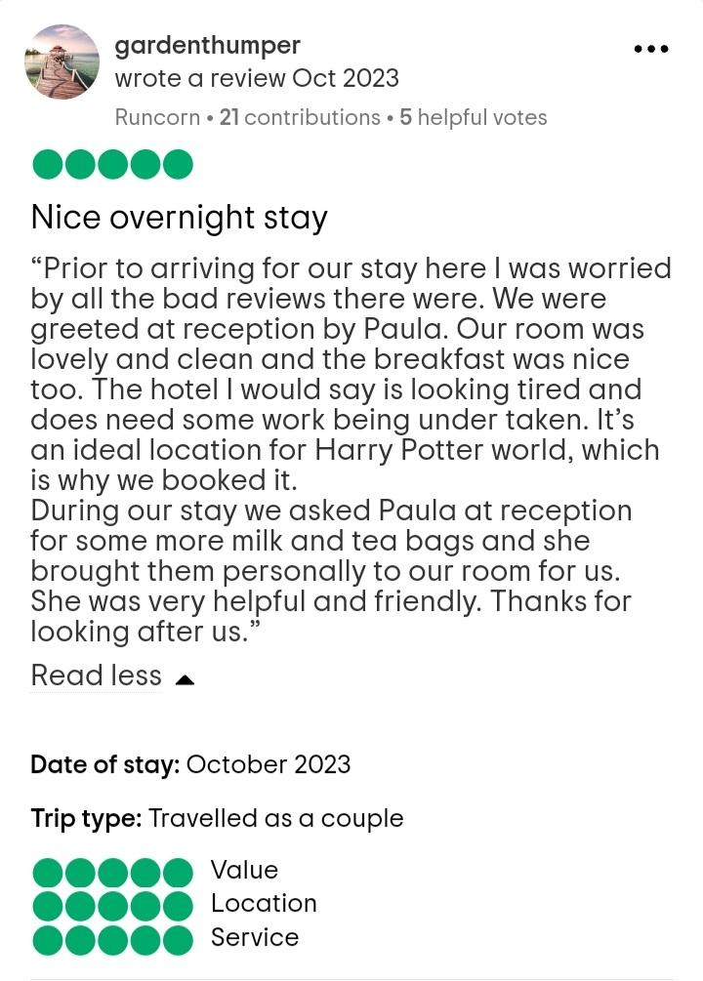
Figure 1: Trip Advisor Review of Hunton Park Hotel
(Source: Trip Advisor, 2023)
Letter of complaint response
Hunton Park Hotel
Essex Lane, Hunton Bridge, Watford WD4 8PN
Name
Position
September 11th, 2023
Mr. Ronald Federick
17 Trinity Court, Swansea SA1 2AR
Subject: Resolution of Your Previous Stay Issues

Dear Mr. Federick,
I hope this correspondence finds you well. First of all, I extend my heartfelt regret for the dissatisfaction you felt while staying at the Hunton Park Hotel on August 26. We value your input very much and promise to give your concerns our full attention.
Breakfast Quality:
I apologise if the quality of your breakfast did not live up to your standards. I apologise sincerely for any inconvenience this has given you. To make sure that every dish is served at the right temperature and has flavour, we are constantly evaluating our morning menu and have noted your review of the same. It is known that food holds an integral position in the realm of hotel operations (Alrawadieh et al. 2021). Thus, your insights prompt us to enhance our culinary offerings so that we serve the best array of food that matches your elevated expectation.
Noise Disturbance:
I empathise with the disturbance by a crying baby in a neighbouring room. As a peaceful environment holds an influential impact, it is the responsibility of all niche hotel properties to ensure a peaceful and tranquil environment for the guests (Wang et al. 2020). We recognise how important a tranquil setting is for our visitors, and we are taking further steps to stop these disruptions in the future. Our staff is examining our room allotment processes in order to reduce disturbances and promise a relaxing atmosphere for all.
Room Cleanliness:
Sincerely, I apologise for the unkempt conditions you experienced in Room 205. Hygiene is yet again an indispensable factor which not just enhances guest comfort but helps infuse an enjoyable and safe atmosphere for guests by preventing the spread of any illness (Spence, 2022). I, on behalf of our entire housekeeping team, ask for your apology. You can be confident that we are taking prompt action because we place a high focus on hygiene. In order to avoid such mistakes, we are reviewing our housekeeping procedures and bolstering training.
Just like every other establishment focuses on customer satisfaction to enhance their services, it should be the imperatives for all the hospitality entities (Khatter, 2023). An offer to a complimentary two-night stay at the Hunton Park Hotel is extended as a sign of our dedication to your satisfaction. We promise an enriched experience for you during this visit, which includes a priority room assignment, diligent cleaning up, and a complimentary dinner. Our goal is to restore your confidence in our services.
Please get in touch with me personally so that we can work out the specifics of your complimentary stay and take care of any special requests you might have.
We sincerely apologise once more for any problems you may have had. Your suggestions provide us with a chance to do better, and we sincerely value your help in improving the Hunton Park Hotel for our visitors.
We appreciate your understanding and welcome the chance to earn back your trust in our hotel.
Yours sincerely,
Full Name
Your Position
Hunton Park Hotel.

References:
Alrawadieh, Z., Altinay, L., Cetin, G. and Şimşek, D., (2021). The interface between hospitality and tourism entrepreneurship, integration and well-being: A study of refugee entrepreneurs. International Journal of Hospitality Management, 97, p.103013.
Khatter, A., (2023). Challenges and Solutions for Environmental Sustainability in the Hospitality Sector. Sustainability, 15(15), p.11491.
Spence, C., (2022). Sensehacking the guest’s multisensory hotel experience. Frontiers in Psychology, 13, p.1014818.
Trip Advisor, (2023). Hunton Park Hotel. Available at: https://www.tripadvisor.in/Hotel_Review-g3470755-d1152874-Reviews-Hunton_Park_Hotel-Hunton_Bridge_Kings_Langley_Hertfordshire_England.html (Accessed on: 11 November, 2023).
Wang, W., Ying, S., Mejia, C., Wang, Y., Qi, X. and Chan, J.H., (2020). Independent travelers’ niche hotel booking motivations: the emergence of a hybrid cultural society. International Journal of Hospitality Management, 89, p.102573.

Assignment Title: Portfolio-4 elements
Component No: 3 of 3
Introduction
Pre-arrival, Arrival, Duration of Stay and Departure are the four key phases of the hotel guest cycle (Hammer, 2016). A flawless and unforgettable visitor experience depends on each step being managed with painstaking attention to detail. In order to highlight the crucial components that lead to hospitality excellence, this essay will examine the nuances of each step, citing examples from the hospitality industry.
Element 1 – Pre-Arrival
The first part of the hotel guest cycle is the pre-arrival stage, during which visitors start interacting with the facility prior to their actual arrival. It includes interacting with guests, making reservations online, and anticipating their needs (Bardi, 2011). Efficient pre-arrival management encompasses optimising reservation procedures, delivering tailored communications to establish anticipations, and utilising technology to create tailored experiences (Wood, 2013). Making a good first impression and setting the groundwork for a smooth and delightful visitor experience depend heavily on this phase. By exhibiting timeliness, attentiveness, and a dedication to visitor satisfaction, it establishes the tone for the entire guest experience (Solomon, 2018). Hotels in the UK are the epitome of pre-arrival management perfection. For example, Premier Inn uses an easy-to-use online booking system that lets visitors personalise their stay by choosing their preferred accommodation and extra amenities (Giousmpasoglou and Hua, 2020). This expedites the check-in procedure and increases visitor satisfaction. However, Marriott's Bonvoy reward programme is a prime example of this component. Marriott customises pre-arrival messaging, providing visitors with individualised recommendations and guaranteeing a warm welcome by utilising data analytics. Pre-arrival management that works so requires a combination of technology, customisation, and communication.
Element 2 – Arrival
In the hotel guest cycle, arrival is a critical point where customers go from expectation to the real experience. It describes the moment when visitors actually set foot on hotel grounds (Corgel et al. 2011). According to a 2021 J.D. Power survey, a guest's likelihood of coming back and recommending the hotel is substantially correlated with their satisfaction with the check-in and check-out procedures (Rana and Singh, 2022). Personalised care, a friendly environment, and effective check-in procedures are essential components of handling this phase (Tesone, 2010). Self-service kiosks are used by the UK's Premier Inn, which is well-known for its efficient operations. This reduces wait times and improves the arriving experience (Vallen and Vallen, 2014). A feeling of exclusivity and warmth is fostered upon arrival by personalised greetings and attention to detail, as demonstrated by The Ritz-Carlton, a hotel renowned for its luxurious service. Technological advancements are critical to the implementation of efficient check-in procedures. Self-service kiosks at Premier Inn and mobile check-in choices at Marriott are two examples of how technology improves efficiency and shortens wait times for guests. The personalised approach of The Ritz-Carlton highlights the importance of human touch and makes guests feel truly welcomed (Vilana Olmos and Martín Miralles, 2019). To sum up, overseeing the arrival phase necessitates striking a careful balance between technical effectiveness and individualised attention (Fanthorne, 2004). Examples from the hospitality industry, such as Premier Inn and The Ritz-Carlton, show how easy check-ins and kind, individualised greetings provide a great first impression and create the foundation for an enjoyable stay.

Element 3 – Duration of stay
The whole time a guest stays on the property is included in the "Duration of Stay" stage of the hotel guest cycle. It entails exceeding expectations, keeping guests comfortable, and delivering consistent service (Williams et al. 2020). Positive ratings, guest happiness, and loyalty all depend on this phase (Fallon and Rutherford, 2011). For instance, the Watford Hunton Park Hotel carefully handles the length of stay phase to guarantee a thorough and enjoyable stay for visitors. The hotel prioritises the comfort of its guests and provides a variety of services, such as a spa for unwinding, a variety of eating options, and well-appointed rooms with contemporary comforts. By strategically utilising its proximity to popular tourist destinations such as Warner Bros (Hunton Park Hotel, 2023). Studio Tour London, the hotel offers its visitors ample opportunity for discovery while they are visiting. Longer stays are encouraged as a result, which enhances visitor satisfaction overall. A memorable and pleasurable stay is made certain by Hunton Park Hotel's dedication to personalised services, constant quality, and meticulous attention to detail. In order to foster visitor loyalty and positive word-of-mouth referrals, this commitment to excellence during the duration of stay is crucial (Tewan, 2009).
Element 4 – Departure
The check-out procedure and the end of a guest's stay are included in the departure stage of the hotel guest cycle. It is a crucial stage in making a good first impression that will last. It is crucial to have quick check-out processes, polite staff, and a feedback section for visitors (Johnston et al. 2012). This phase has a major impact on the possibility of repeat business and positive referrals in addition to overall guest satisfaction. A smooth exit builds the seamless reputation of the hotels, encourages client loyalty and boosts good online ratings (ASET, 2013). Hotels may strategically cement a positive visitor experience during the departure stage of the guest cycle, in addition to its being a practical issue.
The well-known Hilton Hotels are one such celebrated illustration of the departure stage. Using the mobile app, guests can check out easily owing to the Hilton Honours programme (Hilton, 2023). This creative method eliminates the need for conventional front desk contacts by enabling guests to effortlessly pay their bills, check out and receive digital receipts. Hilton uses technology to increase productivity when guests are leaving, giving them a contemporary and easy-to-use experience. In addition to being in line with the industry's trend towards contactless services, this facilitates a hassle-free departure process, which increases overall visitor satisfaction and loyalty.
Conclusion
In essence, the hotel visitor cycle is a proactive journey that consists of four essential phases: pre-arrival, arrival, duration of stay and departure. The groundwork is laid by efficient pre-arrival communication and tailored expectation. The Ritz-Carlton and Premier Inn are two excellent examples of the smooth check-in experience that is required during the arrival stage. Hotels like Hunton Park put the comfort of its guests first, resulting in wonderful stays. Lastly, a seamless exit creates a favourable impression that lasts, as demonstrated by Hilton's mobile app check-out. Getting the hang of each step guarantees a comprehensive and fulfilling visitor experience, which promotes industry reputation and loyalty.

References:

ASET, (2013). ASET Good Practice Guide for Work based and Placement Learning, ASET, Sheffield.
Bardi, J. (2011). Hotel Front Office Management, Wiley, London
Corgel, JB, Sturman, MC and Verma, R. (2011). The Cornell School of Hotel Administration on Hospitality: Cutting Edge Thinking and Practice, John Wiley & Sons, Incorporated, Hoboken.
Fallon, M. and Rutherford, D. (2011). Hotel Management and Operations, Wiley, London.
Fanthorne, C (2004). Work Placements – Survival Guide for Students Macmillan, Basingstoke.
Giousmpasoglou, C. and Hua, T.T., (2020). The use of self-service technologies in budget hotels: the case of Bournemouth. European Journal of Tourism, Hospitality and Recreation, 10(3), pp.251-261.
Hammer, J. (2016). Revenue superstar! The simple rules of hotel revenue management. Great Britain: Amazon.
Hilton, (2023). Earn rewards, enjoy exclusive discounts, explore destinations, book hotels and more with the Hilton Honors app – and it's free! Available at: https://www.hilton.com/en/p/hilton-honors-mobile-app/ (Accessed on: 11 November, 2023).
Hunton Park Hotel, (2023). Local attractions. Available at: https://www.huntonparkhotel.co.uk/local-attractions/ (Accessed on: 11 November, 2023).
Johnston, R Clark, G. and Shulver, M. (2012). Service Operations Management, Pearson, London.
Rana, V. and Singh, S., (2022) DESIGNING THE HOTEL SAFETY AND SECURITY SERVICES FOR REPEAT PATRONAGE INTENTION.
Solomon, M. (2018). The Heart of Hospitality. New York: SelectBooks, Inc.
Tesone, D. (2010). Principles of management for the hospitality industry. London: Routledge.
Tewan, J. (2009). Hotel Front Office: Operations and Management, Oxford Higher Education Press.
Vallen, G.K. and Vallen, Jerome J. (2014). Check-in check-out : managing hotel operations Ninth edition.; Pearson new international.,
Vilana Olmos, A. and Martín Miralles, A., (2019). Should the Employee Promise of Ritz Carlton Gold Standards be updated?.
Williams, K, Woolliams, M and Spiro, J. (2020). Reflective writing, Macmillan International, Oxford.
Wood, R. (2013). Key Concepts in Hospitality Management, Sage, London

