Name: George Lumsdaine
Student number: 1809700
Programme: Quantity Surveying
Module: Fundamentals of Construction Technology
Lecturer: Tom Duxbury

Fundamentals in Construction
ACBA4001
Swansea Foreshore Ice-cream Parlour

Desk Top Study

Background

City and County of Swansea and Marriott Hotels (Client) are proposing to redevelop the subject site for commercial purposes. G Lumsdaine has been instructed to undertake a preliminary desk top study of this site and to identify and evaluate potential hazards which could impact on the proposed development.
The proposed development consists of a restaurant (plus café bar, ice-cream parlour, kitchen and food stores) at ground level and a residential apartment in addition to welfare facilities at first and second floor levels.
Access to the site is available through an existing road and car parking will be available at both the Marriott Hotel and the Civic Centre.
The scope of works for the investigation consists of a desk top study of historical Ordnance Survey maps, memoirs and data and a field reconnaissance visit.
The site description is largely based on field reconnaissance and site inspection visits made to the site in January 2019 generally during fine, dry and windy weather. General views of the site are included as a series of photographs as part of the report.

Site Location and Description

The site is located on the southern side of Oystermouth Road, on the western approach to Mumbles. The National Grid Reference of the centre of the site is SS654923 and the postcode of the nearby hotel (adjacent to the site) is SA1 3SS. A Site Location Plan is presented as Figure 1.
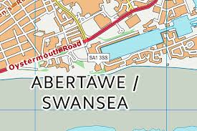
Figure 1
The site lies between Swansea Foreshore (to the south) and Dunvant Place (to the north) and is on the edge of the Swansea Marina development. It compromises an approximately rectangular- shaped parcel of land.
It is presently partly developed partly as a car park for nearby facilities and also has green areas containing trees and shrubs.
The general topography of the area is relatively flat and leads to Swansea beach at its southern side.
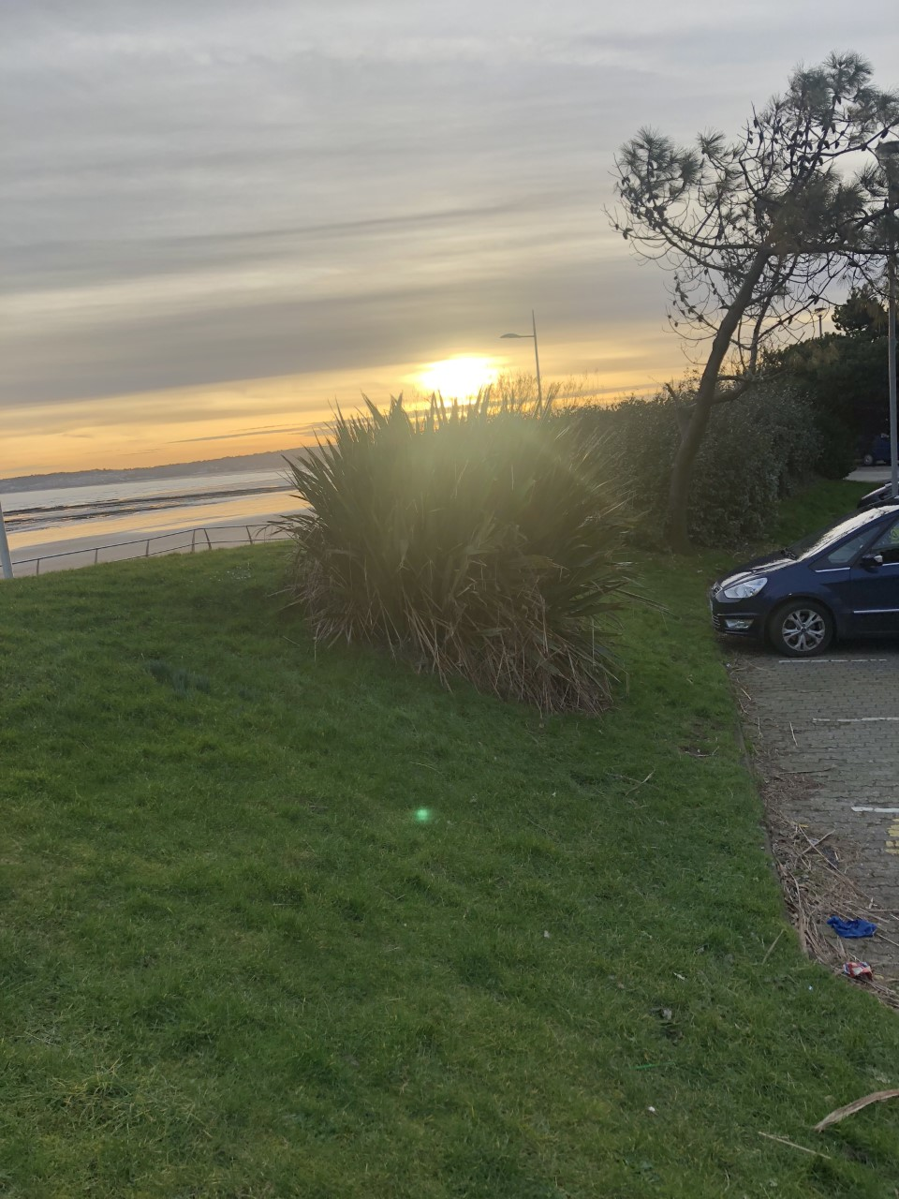
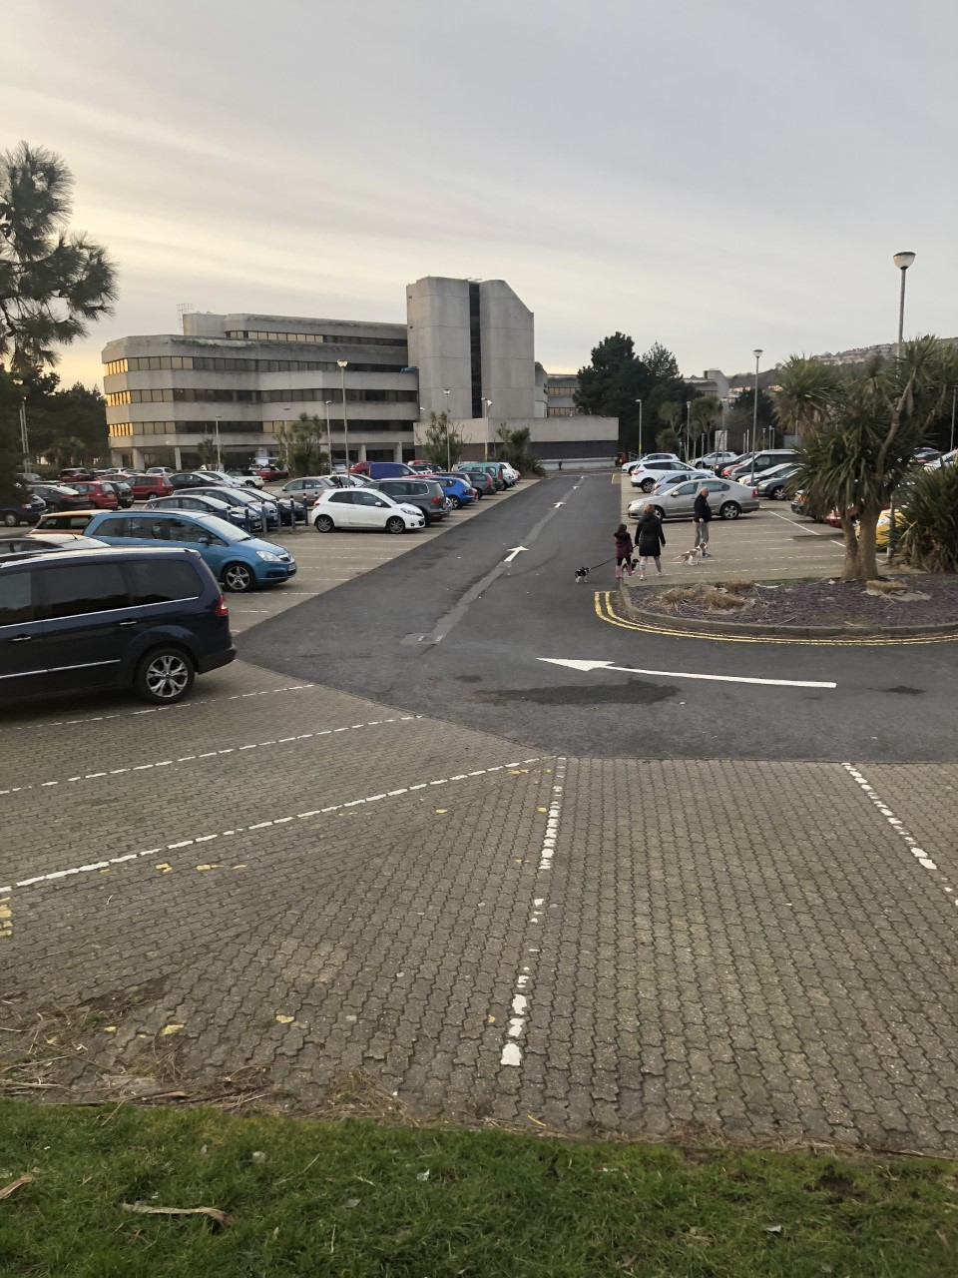
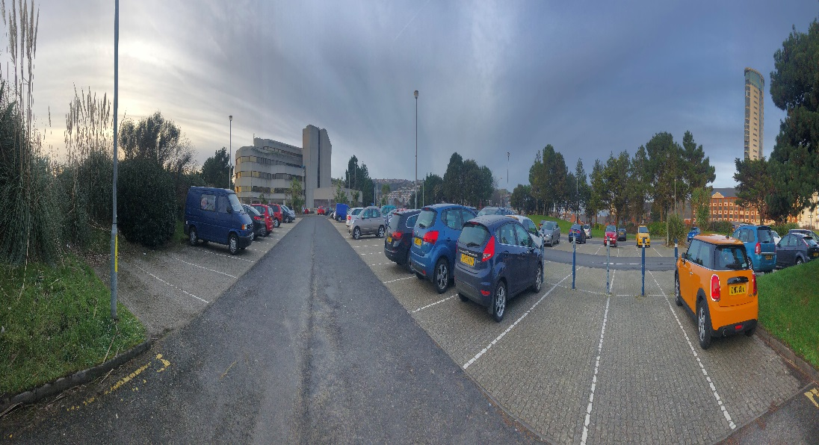

Site History
The site history has been assessed from a review of available historical Ordnance Survey Maps and publications illustrating the previous use of the area. Extracts from the historical maps are presented within this section.
The area around the site would have been developed as part of Swansea Docks and consisted of buildings and infrastructure used to support the business of the Docks. Railway lines used to transport items such as coal were evident until the 1960’s and these would have later formed part of the Swansea to Mumbles train line. Industrial buildings such as timber yards were present although both these and the railway line would have been dismantled by the beginning of the 1970’s.
There is the potential for the site to contain contaminants as it was formerly occupied by timber yards, railway land, and unspecified ground workings and closely sited to the dock. Historical tanks are known to have been located close to the site and unspecified ground workings are also a distinct possibility.
Given the site history there is the potential for slag to present within Made Ground as this material was commonly used as railway track ballast.
Swansea was previously an area of a great deal of mining activity, however further checks with the Coal Authority would be necessary to establish if the area that is likely to be affected by past underground mining.
Swansea Docks were subject to repeated bombings during World War Two (Zetica, 2017) suggests that the area is a “High” risk region with regards to the risk from buried unexploded ordnance.
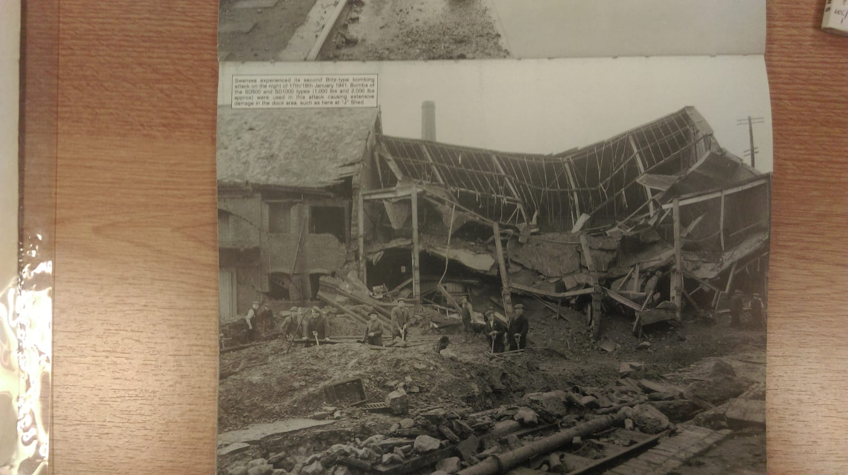The effects of the bombing.

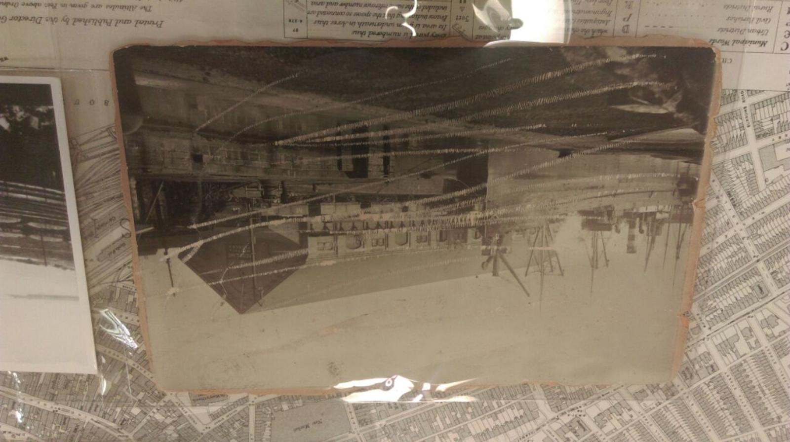An image showing the Swansea Docks and what the site has looked like many years ago.

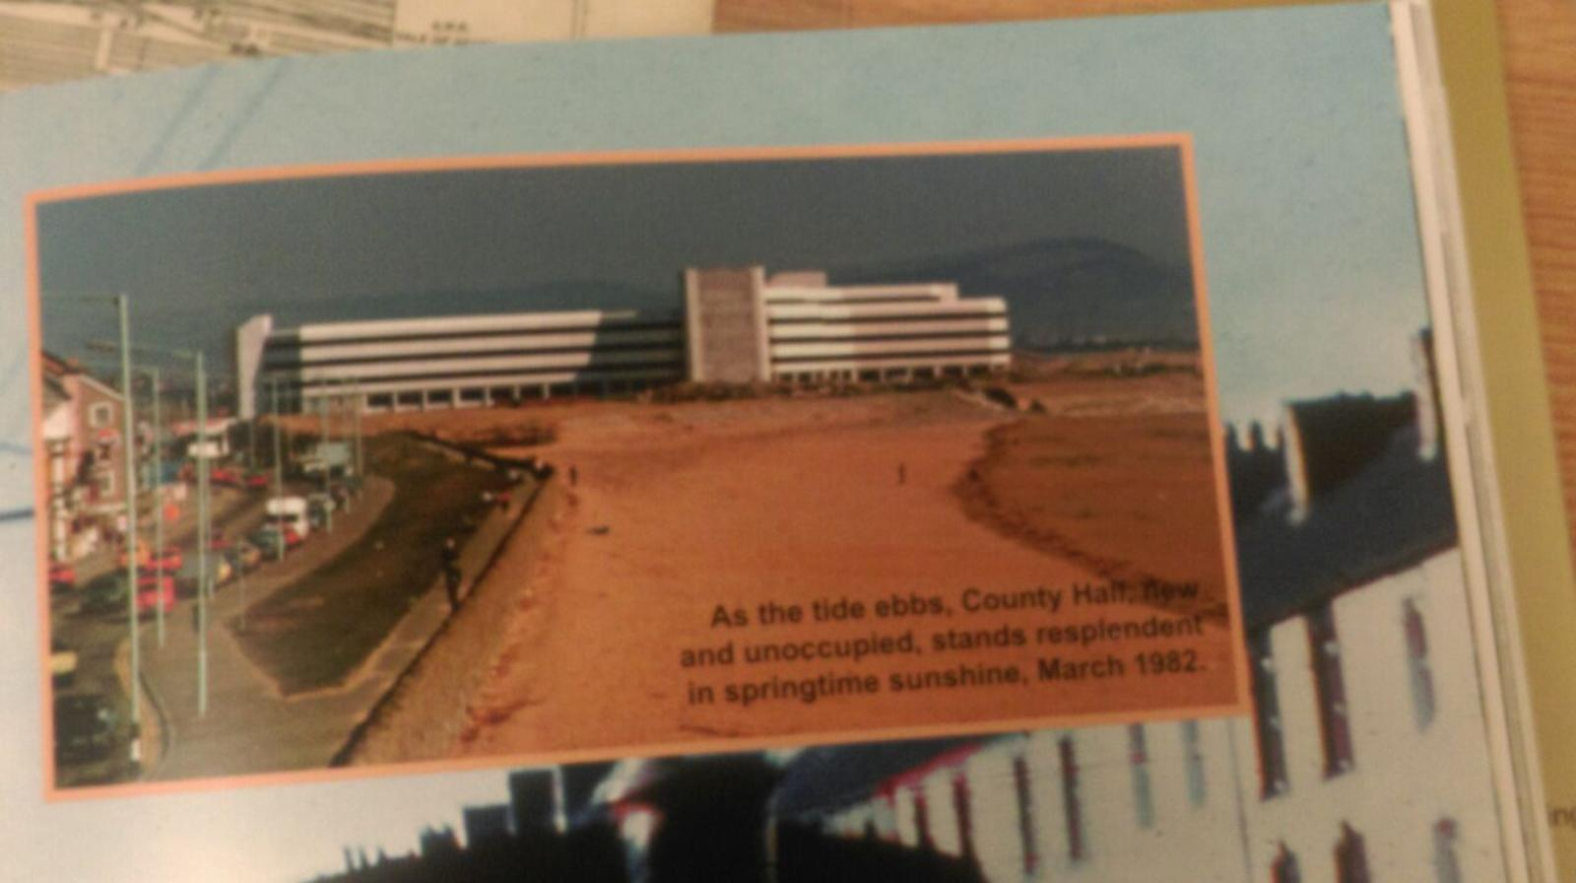
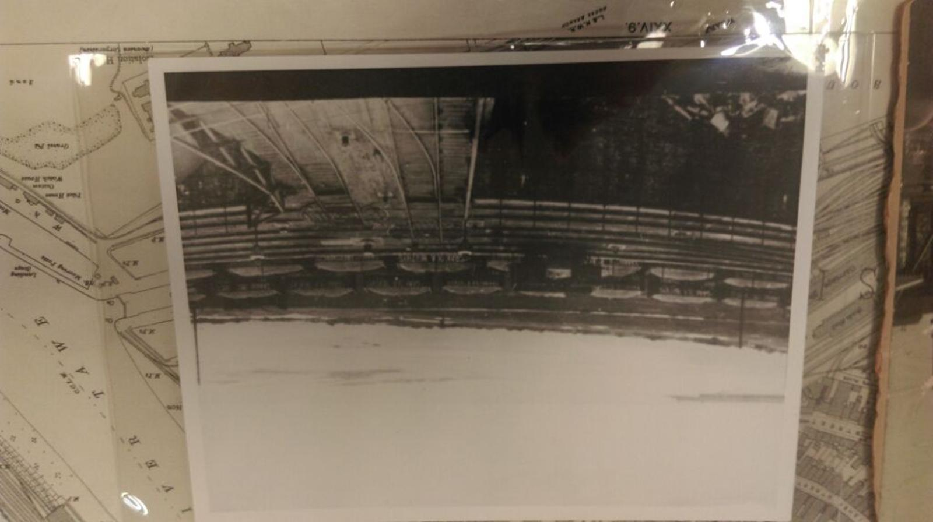This Is image shows the railway that the site had previously.

Recommendations for further Site Investigation
Topographical Survey
This survey will present an accurate representation of the area of the site and show all natural and manmade features and levels.
Geo-Environmental and Geotechnical site investigations
Ground contamination
It is understood that the site has had industrial land uses on and in the vicinity of the site and it is proposed that an investigation of the geological conditions including soil and groundwater testing and gas monitoring is carried out.
Subject to the findings of the preliminary ground investigation works, additional investigation works may be required prior to development of the site to further investigate contaminative and or geotechnical issues highlighted by the works.

Exploratory holes should be carried out in accordance with BS5930:2015 and BS10175:2013 in order to investigate geo environmental and geo technical hazards raised in the desk top study. Any investigative work will compromise:
- Liaison with the Local Authority Land Officer to agree scope of works
- Window sample boreholes for insitu geotechnical testing and contamination sampling and characterisation of any potential made ground and superficial materials encountered.
- Trial pits carried out using a JCB 3CX or equivalent excavator
- Hand dug trial holes within the stockpiles of material for contamination testing and characterisation
- Sample groundwater ( to check for any sulphates) and measure ground gas concentrations and ground water levels
- Geotechnical testing of soil samples in accredited laboratories.

The site history has indicated that it has previously been developed as railway land, timber yards and that it has been filled with Made Ground.
Due to the previous use of the site and its surrounding area, there is the possibility that the following contaminants could be present on the site;
- Heavy metals and semi-metals( Arsenic, copper lead, nickel,)
- Cyanide, sulphate, sulphide
- Petroleum hydrocarbons
- Asbestos
A ground investigation that is compliant with Eurocode 7, will help to establish the presence of any of these contaminants and as there is no evidence of any Japanese Knotweed in the location, should be able to proceed without issue.
.

Coal Authority Mining Report
This report is necessary due to Swansea being an area of extensive coal mining in the past. The report will examine whether:
- Any surface hazard or surface mining is identified within the vicinity of the site
- Any past shallow coal mining is indicated in the vicinity of the site
- Any mine entries are within the site boundary
- The site is an area where the Coal Authority has plans to grant a licence to remove coal

Ecology Report
The CIEEM recommends “that the Ecological Impact Assessment ( EcIA) process is used to present an assessment of the likely significant ecological effects of any development project which could affect biodiversity irrespective of the scale of the project ( CIEEM 2018).
Flood Risk Report
This report assess whether a Flood Risk Assessment is necessary for the site and would be appropriate for a location so close to sea level.
Invasive plants
There was no evidence of Japanese Knotweed present at the time of investigation, however it is recommended that validation is sought from the local authority that any previous knotweed impacted soils has been removed.

Existing Foundations and services
The site has been previously developed and may contain timber piles as a result of past buildings. These features could form obstructions to piling and their presence considered in any design. There is also a possibility that sewers and water mains pipes exist beneath ground level.

Foundation Design and construction
The site is being considered for potential development for commercial and residential purposes and recommendations in this report advise the construction of traditional load-bearing masonry for this development.
Given the presence of Made Ground which is highly variable and has poor bearing properties and advice provided in the Building Regulations, (Section E of Approved Document A) conventional shallow foundations such as strip are not considered appropriate for the development.

Raft Foundations
Raft Foundations may be suitable as a foundation for the development, however substantial ground improvements may be necessary as a result of investigations identifying unsuitable soils.
Raft foundations tend to be used when the soil is susceptible to movement or is unstable. Rafts are more commonly used in the building of commercial buildings as opposed to domestic houses. When using a raft foundation, you are spreading the weight of the building over the whole ground floor area of that particular building and this is done by removing soil until you are at the right depth and then compacting the foundation bed by ramming and then reinforcement is placed over the foundation bed before concrete is finally poured on top of the reinforcement.

Pile Foundations
It is likely that the soil investigation will identify that existing soils do not have the capacity to restrict settlements to within tolerable limits and that piled foundations would be necessary for this development.
Based on the site, it is likely that the most appropriate system is likely to be a driven, displacement pile system, which may prove the most efficient. The use of driven piles should only be considered if vibrations and environmental constraints can be maintained within acceptable limits, with regard to the proximity of existing buildings and services.
Similarly, to raft foundations, piles are used when the soil is unstable or potentially has movement, but they are considered a more cost effective approach, mainly due to the long lasting effect they have. There are different classifications of piles, all with the same job which is distributing the weight of the building evenly. The piles are driven into the ground carefully using a pile driver. The piles are held perfectly vertical as the driver “hammers” each structure firmly into the ground also acting as a crane.
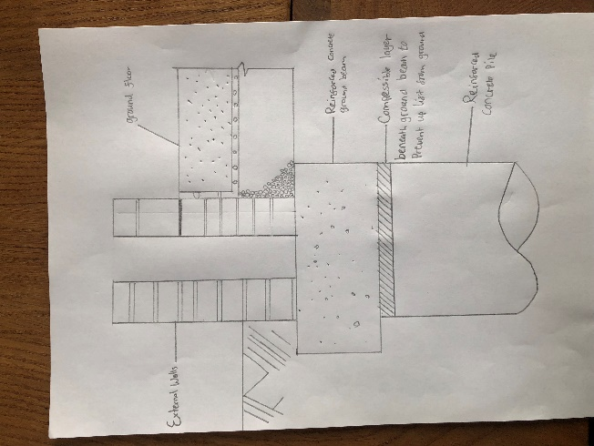 Pile Foundation

Floor slab
Due to the possible presence of Made Ground/soft compressible soils at the site, it is recommended that a suspended floor slab is utilised with suitably dimensioned, vented sub-floor voids and gas resistant membrane if required.
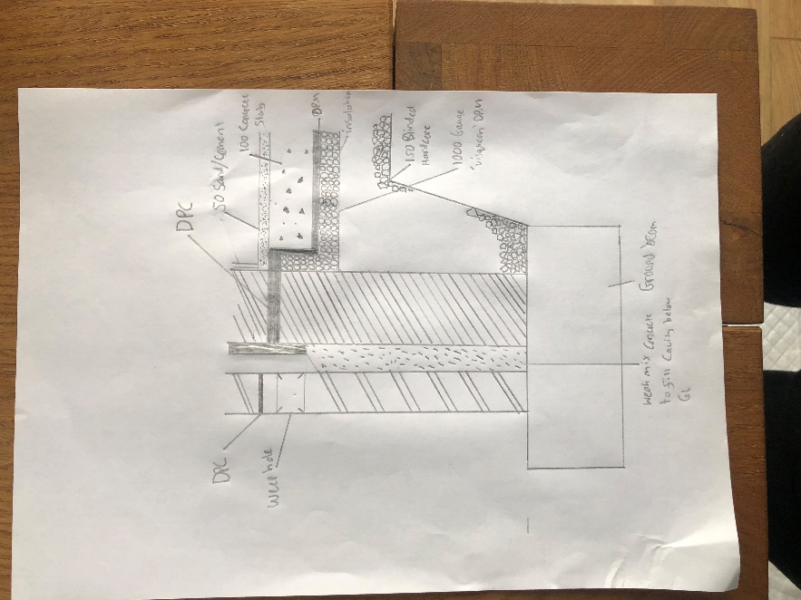Ground floor
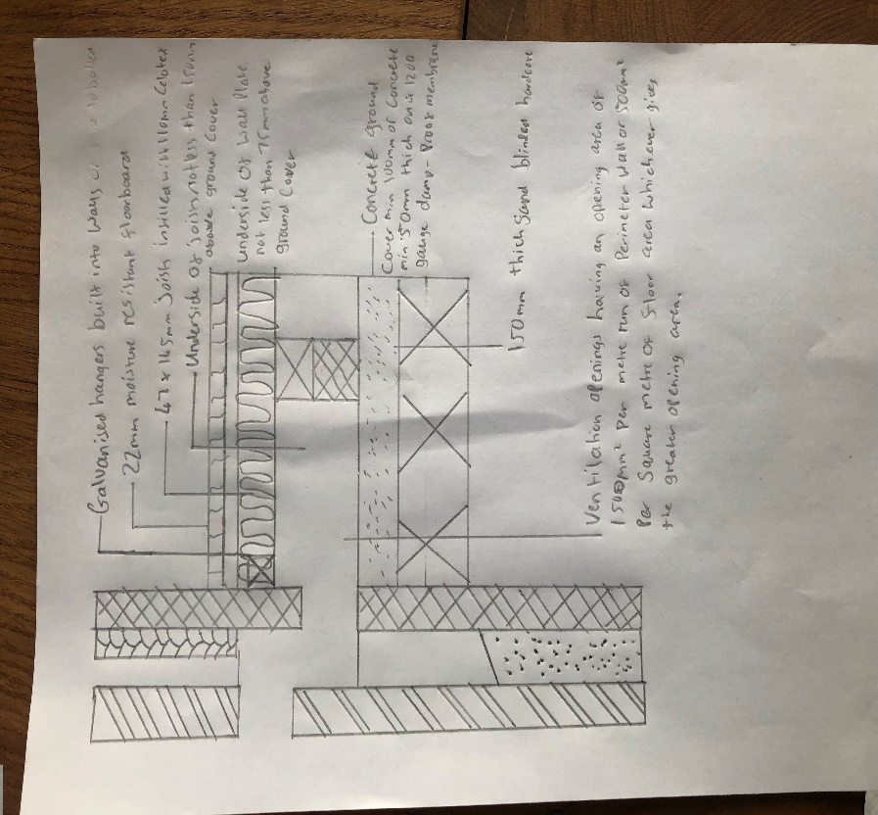Suspended Ground Floor

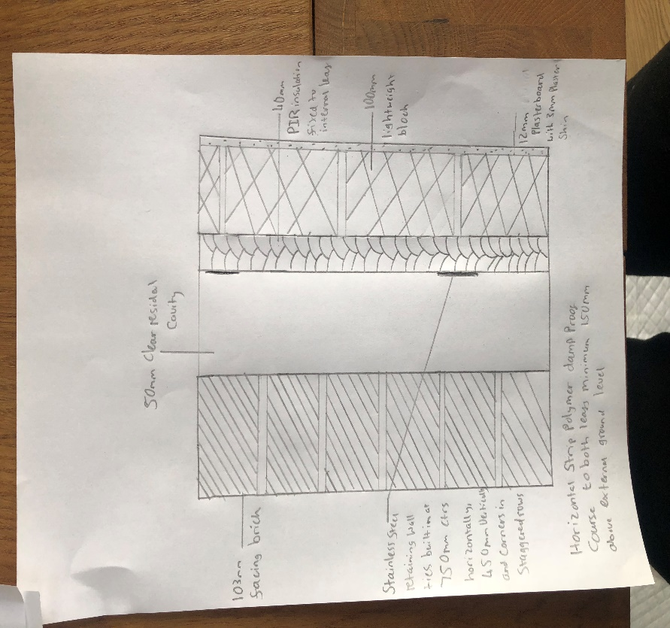External Wall
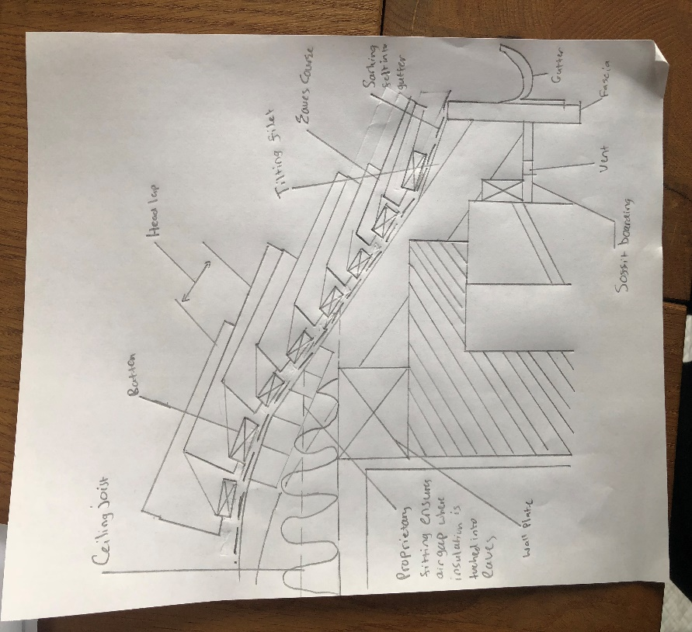 Roof.

Construction Site Set up
The Health and Safety Executive provide comprehensive guidelines on organising a safe and healthy construction site and identifies legislation which is most relevant to site set up which include;
Health and Safety at Work Act 1974
The Act places a duty on all employers and the self-employed to take reasonably practicable steps to ensure the health and safety of people who are not in their employment, such as members of the public.
Construction (Design and Management) Regulations 2007 (CDM)
15 Clients must also provide project specific health and dafty information at the pre-construction stage. The pre-construction information should include, among other things, arrangements for planning and managing the construction work, including health and safety goals for the project and arrangements for the security of the site and site hoarding requirements.
Management of Health and Safety at Work Regulations 1999
This act provides detail of what is required of employers under the health and safety acts. The act demands employers must assess exactly who could be affected by particular risks and employers who have more than 5 employees must record all significant findings of any risk assessments and they are also fully expected to communicate and cooperate with any other employers who share the workplace.
Control of substance hazardous to health regulations 1999
There many different substances that employers may use that could be hazardous and therefore they must abide by the regulations. Employers must take precautions for these hazards not just for their employees but anyone who could be affected by the substances.
The Site and the safety precautions required
The employer must undertake the role of the size of the perimeter of the site and then ensure what risks there are within the perimeter and also what risks could occur outside of the perimeter of the site because of the work that’s being done. When conducting the risk assessment, the employer should consider many different factors.
- The nature of the construction work
- What machinery is required
- How heavily populated is the area
- Who will be visiting the site during the project?
- Whether the site may attract children
- Site Characteristics
- Is disabled access required
- Who and when will there be deliveries?

The employer needs to consider the most appropriate way of setting out the site. For example, the location of the offices should ideally be close to the entrance to prevent people from unnecessarily walking across the site and it also provides supervision of those arriving. Additionally, anyone who arrives on site should report their presence on site whenever they are on it. The site entrances should be clearly marked and there should be access for vehicles and pedestrians and no one who is unfamiliar with site should walk around it unsupervised. The employer must also assess where the most appropriate places to have the accesses are. The employer should try and eliminate any need to be reversing onto the street or the site and should therefore implement one-way systems and also plan deliveries so they can safely access the site and ensure that deliveries do not clash with heavy pedestrian traffic.

REFERENCES

BRITISH GEOLOGICAL SURVEY (BGS). 2019. Website accessed January 2019.
BRITISH STANDARDS INSTITUTION (BSI). 2002. Geotechnical Investigation and Testing: Identification and Classification of Soil, Part 1. Identification and Description. BS EN ISO 14688-1. HMSO, London.

BRITISH STANDARDS INSTITUTION (BSI). 2004. Geotechnical Investigation and Testing: Identification and Classification of Soil, Part 2. Principles for Classification. BS EN ISO 14688-2. HMSO, London.

BRITISH STANDARDS INSTITUTION (BSI). 2015. Code of Practice for Ground Investigation.
BS5930:2015. HMSO, London.
Chartered Institute of Ecology and Environmental Management – www.cieem.net/guide to ecological surveys and their purpose, 2019
DEPARTMENT FOR ENVIRONMENT, FOOD AND RURAL AFFAIRS (DEFRA) AND THE ENVIRONMENT AGENCY. 2004. The Model Procedures for the Management of Land Contamination. R&D Publication CLR11.

Evening Post, Swansea at War, A Pictorial Account 1939-45.

Welsh Government. The Building Regulations 2010, Approved Document A.

Alban JR. The Three Nights Blitz,

The Coal Authority-Gov.UK, 2019

TOMLINSON, MJ. 2001. Foundation Design and Construction (7th edition). Prentice Hall.
ZETICA LTD. 2019. Regional Unexploded Bomb Risk Maps – Glamorgan.
West Glamorgan Archive Service. Historical Ordnance Maps, January 2019
Riley and Howard Construction Technology 1 House Construction
https://dartandco.co.uk
www.diydoctor.org.uk
Chudley and Greeno Building Construction Handbook
www.buildingregs4plans.co.uk

