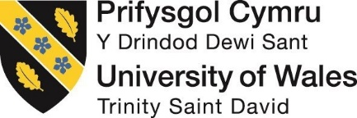
MODULE CODE:M5X01924

Lecturer: Dr Adubite
Student number: 1813330
Student name: Shahzia Ahmed
MANAGEMENT AND ORGANISATIONAL BEHAVIOUR: VIRGIN GROUP CONGLOMERATE ORGANISATIONAL PERFORMANCE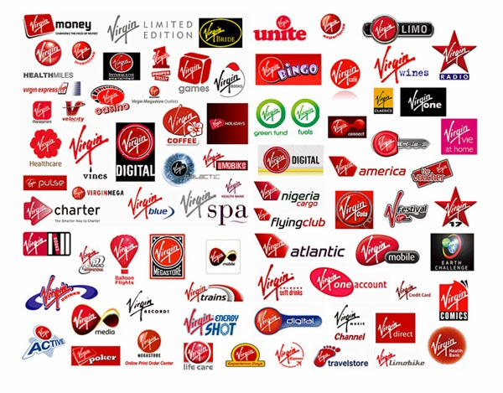

Introduction
Every business organisation, irrespective of the sector it is functional in, requires dealing with certain amount of competition. While the major focus of any business organisation is to increase its profit margin by expanding its sales, in order to do the same numerous activities are carried out. These activities are channelized based on the organisational culture and structure (Hurst et al., 2019). All these aspects are stated to be effective in providing better identity to any company as an individual entity. For driving the company towards its goals, roles of leaders are undeniable as well. Therefore, it is apparent that in order to shape functions and effectiveness of any company roles of organisational structure, culture, and leadership are evident.
The Virgin Group of Companies is globally renowned conglomerate. Founded by Richard Branson, the group in discussion successfully obtained strong positions in diverse business industry facets. The portfolio of this conglomerate is impressive since it continues to grow by providing different sets of services in travel and tourism, banking, telecommunications, and numbers of other sectors. This specific essay discusses the impact of organisational structure and culture on functionality of Virgin Group (Muthee, 2019). In addition to this, the role of efficient leadership has been tried to be evaluated as well.
Discussion:
When it comes to global business operations, it may be stated that the Virgin Group is one of the most successful empires in the world. There are multiple industries where the company has successfully established strong feet. Apart from ruling British market, the company has expanded in different regions. Currently, services of Virgin Conglomerate are available in 35 countries. There are more than 60 Virgin companies employing more than 71,000 employees (Virgin, 2020). It has one of the most extensive company profiles. It is continuously listed as one of the most significant and powerful global brands. The majority of the success of this group is seen to be credited to co-founder and CEO of Virgin Group Sir Richard Branson. It is widely stated that his belief and philosophy were integrated in the corporate culture of the organisation which led to its immense success in almost any sector it is operational (Virgin. 2020). This can be considered as one of the major reasons for the company to be able to hold strong foot in different sectors with highly competitive business environment. The Virgin Group main competitors are the BT group, Sky, Vodafone, Delta airlines as well as Sprit airlines amongst many others, Sir Richard Branson’s approach to his competitors is
"If you want to be successful in business, you need to welcome your competition with open arms - just don’t let them walk all over you. Strike the right balance between respecting your rivals and focusing on how you can beat them, and you’ll have a winning formula," explained Richard Branson in a recent entrepreneur.com blog. 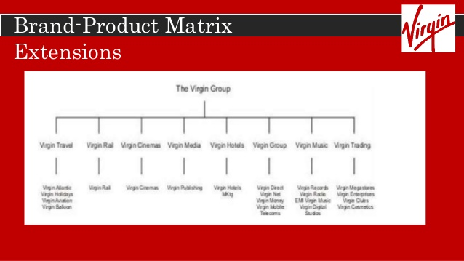

One of the most notable facts about Virgin Groups is that each of the 60 odd companies of the group functions completely separately as individual entity where CEO Branson holds prime position as a shareholder and chairman. These companies generally own assets and employ individual (Rosa et al., 2019). These companies are controlled by holding companies. Thus, it may be seen that the organisational structure is complex, and it may be termed as Keiretsu structure embedding relationships. Moreover, it may also be termed as organic structure since the company is discussion is capable of adapting quickly in changing business environment building alliances as well as forging relationships. The social spotlight on the Individualism versus Collectivism measurement drove Triandis (1995) to parting it into flat and vertical independence. This split ignores the way that the Hofstede measurement of huge versus little Power Distance previously secured the even/vertical angle sufficiently. From my perspective the even/vertical differentiation as a component of culture is debateable. It might be helpful at the individual level. The embedded structure of the business can also be reflected in Hofstede’s model, how defining the layers and establishing integral core values, steering the business and induvial to success within the many areas Virgin family has developed. 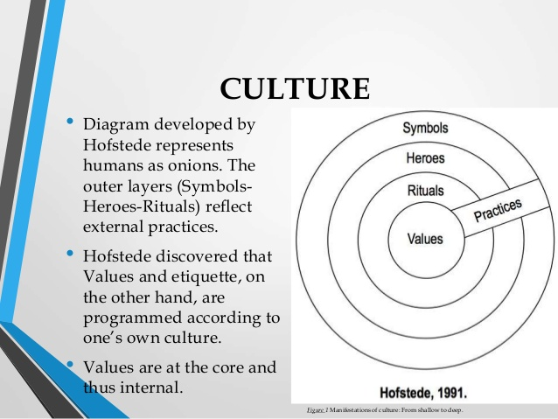The company in discussion has one of the most unique management structures. It is seen that it doesn’t adhere to conventional management models. However, it takes into account that varied concepts are brought together in order to form its distinctive and unique style which set the company apart from the rest. In regards with the functions of Virgin Group, 'mindless conformity' doesn't hamper the pace expected to drive development, the concept of scientific management proposed by theorist F.W Taylor may be suitable. In this particular concept, there are six key aspects are identified including observation, experiment, standardisation, selection and training, payment by results, and cooperation. It may be stated that even though the working environment is largely stated to be relaxed in Virgin Group, certain aspects of scientific management are deeply rooted (Branson, 2017). For instance, the selection and training process, where it is tried to be maintained that most skilful employees are hired for different job roles and they are provided with substantial training facilities to realise their potential in best interest of the company. In addition to this, payment by results management. 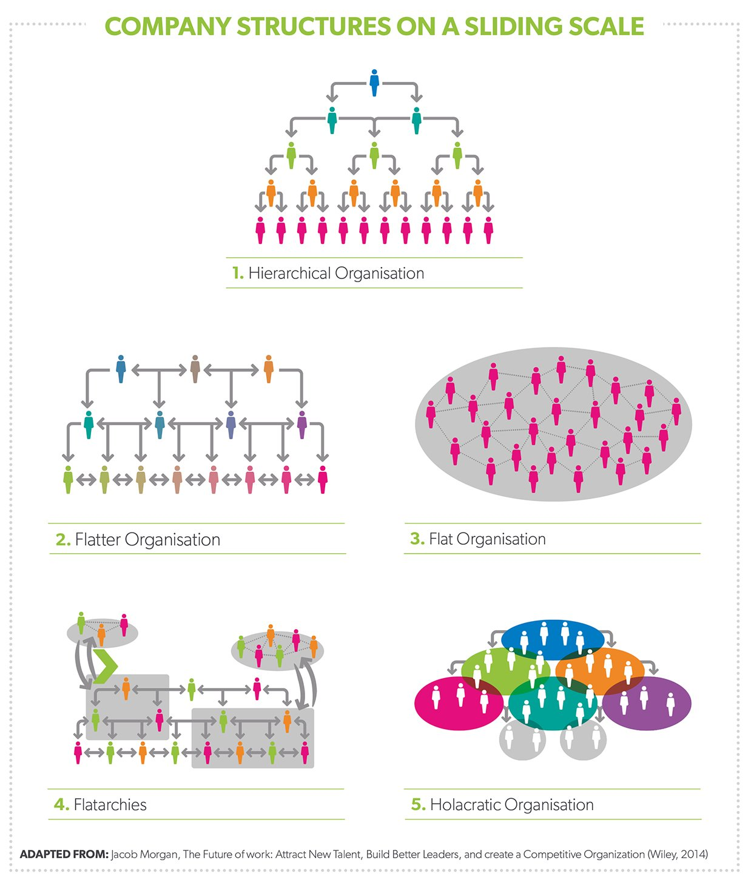
When it comes to hierarchical structure, it is also seen that the division of labour is different from that of traditional styles. The employees in different departments of different companies are treated like members of family rather than part of hierarchy. The employees are empowered and are provided with opportunity to run their affairs on their own terms. Shared values and ideas, as well as interests and goals are what ensure that the organisation is able to attain a stronger position in the market (Bruijl and Gerard, 2018). Most of the employees are responsible for making unsupervised decisions rather than following the suits of commands which are needed to be achieved. Thus, the employees have more confidence and ensure that the overall functions which are undertaken by the company are done in a successful manner. Interaction among different level of employers is largely promoted. Richard Branson himself interacts often with employees to discuss ideas. It is seen that effective communication is being given importance by him as a leader. Thus, interaction among different level is easier and effective. Therefore, it may be stated that the hierarchical structure of the company is flat.
It may also be stated that the flat structure largely contributes to the ability of the company venturing in new sectors since the span of control among individuals with possibly higher knowledge is expansive. The efficient and quick decision making mostly works in organisational interest. Higher involvement and authority are provided to the employees in regards with scepticism of Branson towards orthodox leadership style. Thus, it is seen that there is constant effort to minimise bureaucratic approaches and he strives to provide better control to employees and ensure that their involvement towards the organisation is increased. Hence, it may be stated that his adoption of unorthodox business management approaches is significant in cohesive business operations contributing to its overall success. In regards with the same, Richard Branson may be regarded as one of the most successful visionaries in recent times.
The Virgin Groups culture may also be stated to be largely influenced by the personal philosophies of Sir Branson and leaning toward Keiretsu model of a group member company and affiliated or subsidiary companies being attached equating to growth and knowledge. He considers employees and the customers equally important. Even though the company largely functions on what could be termed as a non-formal structure, it still emphasises on the necessity of extending best services to the employees in different positions. However, it is needed to be recognised that even in informal environment high level of employee commitment is needed. The theory of hierarchy of needs can be applied in this context (Muegge and Reid, 2018). It suggests that the human needs are divided into different segments and once the lower stages of needs are met, individuals move towards higher level. In respect to the same, it is seen that the first three stages are achieved by the company; it also strives providing employees opportunity to develop better self-esteem. Hence, recognition of performances and brilliant ideas are done, which ensures long term commitments from the part of the employees. Benefits like impromptu parties, getaways which are sponsored by company, and so on as well. Thus, healthy relations are maintained between the employees and employers. This is an indicator of an inclusive culture which is followed by the company. 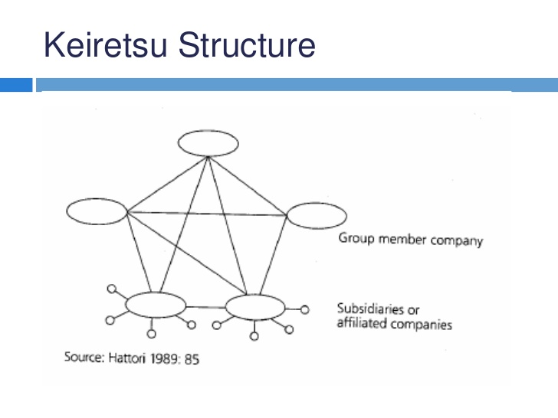The company describes itself not in conventional corporate way, but rather as a ‘family’. Thus, it may be inferred that although informal, it may be stated that the values and belief systems are strong in this company. It believes in providing wider scope to the employees and set a healthy and inclusive work environment where knowledge and ideas are exchanged in a productive manner. One of the major reasons for the company’s effective coordination may be the healthy working environment and strongly integrated culture. It may be stated that working as a community and depending on the efficiency of employees is undeniably the major driving force of the company. The primary belief and value are to provide equal opportunity to be able to compete and thrive in different roles (Ruck, 2017). Thus, having a motivated and positive mind set is necessary aspect for Virgin’s organisational culture. Thus, it may be stated that the dominant culture of the company also contributes as an effective marketing tool. The overall reputation of the brand is increased due to these strongly instilled cultures. It is seen that even though the different companies function independently, there is also a centralised website which are effective in creating closer ties between these entities. Thus, the approaches, beliefs and cultures are shared and similar even in separate sectors. The culture of Virgin also firmly establishes the fact that providing best experience to the customer is priority. Thus, the services are tried to be arranged by the company accordingly as well. Thus, value for money services are tried to be extended. It contributes to better brand recognition.
It may be stated that the bold and risk-taking attitude of Richard Branson is primarily responsible for the organisational function. His strong belief in participative and democratic approaches is required to be attributed to the innovative environment. In addition to this, his firm aversion to orthodox and traditional method paved way for the company to explore multiple dimensions seamlessly (McCurdy, 2019).
Therefore, it is evident that strong leadership is what shaped the culture and structure of the company. It enhanced the overall scope for the company to obtain better results in most effective manner. As businesses operate in this customer driven demanding environment, the need for advancement in new technologies and consumer business value is rapidly changing, there is a constant need competing quality improvement, new investment and new trends. The next level (Grant, 2015) is the creation of the Virgin Group, often related to Keiertsu method in Japan, The Three “Sacred Treasures” These three treasures were Lifetime Employment, Seniority Wages, and Enterprise Unionism, were brand franchises share a common sense of identity and management, shares financial relations between the member companies Although Sir Richard Branson restricts formal limited affiliations with companies, his influence on the company’s board of directors and the use of the Virgin brand is crucial. (Grant, 2015).

Conclusion:
Based on the above-mentioned discussion, it may be stated that the corporate culture of Virgin Group is substantially different from other competitors. The outcomes show that despite an altogether different methodology, the enormous assortment of individual leadership and horizontal partnerships, despite everything mirrored the structure of the first Hofstede model, along with Keiretsu models being incorporated this has lead to a healthy mix of styles not attributing any specific frame work allowing a new and horizontal and holistic approach, allowing for a new and organic method to provable. This is one of the major reasons for overall success of the company. The company is functional in different sectors and its business is spread over different countries. However, one of the major reasons for the success of the organisation is the visionary approach of Richard Branson. The practices undertaken by the company are largely unorthodox. Nevertheless, it has grown to be significantly suitable for the company. Thus, it is evident that effective communication, democratic leadership and a free and innovative work culture is what driving the company towards its success. A satisfied set of employees can share their knowledge and beliefs and implement innovation in their functioning in most suitable manner. Thus, the aims and objectives of the conglomerate are achieved successfully with credible inputs of the company. The independent entities also share a central hub which makes the company more connected, Validating the different dimensions of business to be mainly quantitative in revenues. Equally important is the qualitative interpretation of what associated businesses and the dimensions of the Virgin group being embedded into their structure and culture influencing their own leadership styles, to increasing revenues and create a sustainable business is based firmly on a visionary leader, excelling and striving to constantly evolve, this is largely due to the trust he places in his extended Virgin family and knowing they are capable of making and executing the right choices.

Reference List:
Branson, R., 2017. Finding My Virginity: The New Autobiography. Penguin.
Bruijl, D. and Gerard, H.T., 2018. Sir Richard Branson: A Global Leader with a Difference. Th., Sir Richard Branson: A Global Leader with a Difference (January 31, 2018).
Hurst, N.W., Bellamy, L.J., Geyer, T.A.W. and Astley, J.A., 2019. Organisational, management and human factors in quantified risk assessment: a theoretical and empirical basis for modification of risk estimates. In Revival: Safety and Reliability in the 90s (1990) (pp. 70-79). Chapman and Hall/CRC.
McCurdy, H.E., 2019. Virgin Galactic: Promoters and Prizes. In Financing the New Space Industry (pp. 73-83). Palgrave Pivot, Cham.
Muegge, S.M. and Reid, E., 2018, August. Richard Branson and virgin galactic: A case study of entrepreneur as emancipation. In 2018 Portland International Conference on Management of Engineering and Technology (PICMET) (pp. 1-10). IEEE.
Muthee, D., 2019. Keiretsu business structure in Virgin group: A literature review of advantages and disadvantages of Keiretsu.
Rosa, P., Rautiainen, M., Pihkala, T., Parada, M.J. and Cruz, A.D., 2019. Introduction: Presenting the Case for Studying the Emergence and Development of Family Business Groups. In The Family Business Group Phenomenon (pp. 1-13). Palgrave Macmillan, Cham.
Ruck, K., 2017. Organisational Culture. In Exploring Internal Communication (pp. 37-46). Routledge.
Virgin.2020. AboutUs.[online]Availableat: <https://www.virgin.com/virgingroup/content/about-us> [Accessed 17 March 2020]. www.virgin.com/entrepreneur/richard-branson-how-deal-competitors[Accessed 24March2020]
http://www.virgin.com/richard-branson/people-are-your-biggest-assets [Accessed22nd March 2020]
www.virgin.com/virgin-unite/business-innovation/tearing-up-the-organisational-chart[Acsessed 23 March 2020]
wixsite.com/virgin-management/organisational-structure-[Accessed 21st March 2020]

