

LOCATION: Swansea | LLEOLIAD: abertawe
LEVEL 4 | LEFEL 4
EXAMINATION PERIOD | CYFNOD ARHOLIADAU
July 2019 | Gorffennaf 2019

MODULE CODE: ACDB4002
Electrical & Electronic Principles
TIME: 2 HOURS
answer all questions

Equipment or materials required – calculator, graph paper
Adnoddau neu ddefnyddiau sydd eu hangen – cyfrifiannell, papur graff

Formula sheet and graph paper are after questions

Detach graph paper and place in your Answer book write your student number and question number on any graph paper used

ANSWER ALL QUESTIONS

- For the circuit shown in Fig Q1, calculate:
  - The total resistance.
[2 Marks]
  - The total circuit current
[1 Mark]
  - The current flowing through resistor R5
[4 Marks]
  - The total power dissipated by the circuit
[1 Mark]
  - The power dissipated by resistor R2
[4 Marks]

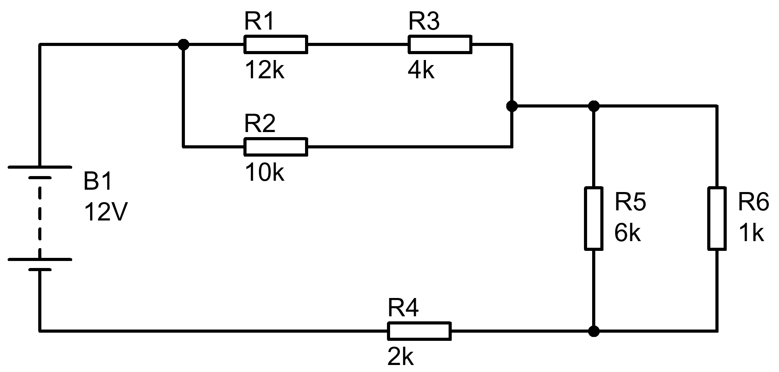
Fig Q1
- Total resistance
$$R_{T}=\left(\frac{1}{\frac{1}{\left(12k+4k\right)}+\frac{1}{10k}}\right)+\left(\frac{1}{\frac{1}{6k}+\frac{1}{1k}}\right)+2k$$

$$R_{T}=6153.846+857.143+2k=9010.989 Ω$$
- Circuit current
$$I=\frac{V}{R}=\frac{12}{9010.989}=1.332 mA$$
- Current through R5
Two methods:
$$I_{R5}=\frac{1k}{6k+1k}×1.332 mA$$  $$I_{R5}=190.286 μA$$ | $$V_{Top R5}=12×\left(\frac{857.143+2k}{9010.989}\right)=3.805 V$$  $$V_{Bot R5}=12×\left(\frac{2k}{9010.989}\right)=2.663 V$$  $$V_{R5}=3.805-2.663=1.142 V$$  $$I_{R5}=\frac{1.142}{6000}=190.333 μA$$

- Total Power
$$P=I×V=1.332×{10}^{-3}×12=15.984 mW$$
- Power in R2
$$V_{R2}=12-\left(12×\frac{857.143+2k}{9010.989}\right)=8.195 V$$

$$P_{R2}=\frac{V^{2}}{R}=\frac{{8.195}^{2}}{10000}=6.716 mW$$

i) Convert the following rectangular form to polar form, using any method.
a) 8 – j3
[1 Mark]
$$8-j3=8.544∠-20.56°$$
b) 10 + j5
[1 Mark]
$$10+j5=11.18∠26.565°$$

ii) Convert the following polar form into rectangular form, using any method.
- 7.2 / 56.3
[1 Mark]
$$7.2∠56.3°=4+j6$$
- 10.3 / -60.95
[1 Mark]
$$10.3∠-60.95°=5-j9$$

iii) A 20 Ω resistor, a –j8 Ω capacitor and a +j14 Ω inductor are connected in series. Calculate:-
- The total impedance in complex form.
[1 Mark]
$$Z=20+j14-j8=20+j6 Ω$$
- The magnitude of the total impedance.
[1 Mark]
$$\left|Z\right|=\sqrt{{20}^{2}+6^{2}}=20.881 Ω$$

- A series RLC circuit consisting of a 200 Ω resistor, a 200 mH inductor and a 5 µF capacitor is supplied from a 20 V 100 Hz source. Calculate the voltage dropped by the resistor.
[7 Marks]
$$X_{L}=2πfL$$

$$X_{L}=2π×100×200×{10}^{-3}=125.66 Ω$$

$$X_{C}=\frac{1}{2πfC}$$
$$X_{C}=\frac{1}{2π×100×5×{10}^{-6}}=318.31 Ω$$

$$\left|Z\right|=\sqrt{R^{2}+{\left(X_{L}-X_{C}\right)}^{2}}$$

$$\left|Z\right|=\sqrt{{200}^{2}+{\left(125.66-318.31\right)}^{2}}=277.694 Ω$$

$$I=\frac{V}{Z}=\frac{20}{277.694}=72.02 mA$$

$$V_{R}=R×I=200×72.02×{10}^{-3}=14.4 V$$

- A 12 V battery has an internal resistance of 12 Ω,
  - Calculate the power dissipated by various load resistances and complete the table below.

Load resistance (Ω) | Load power (W)
4 | 2.25
8 | 2.88
12 | 3
16 | 2.938
20 | 2.813
[10 Marks]

  - Plot a graph of the load power against load resistance
[6 Marks]
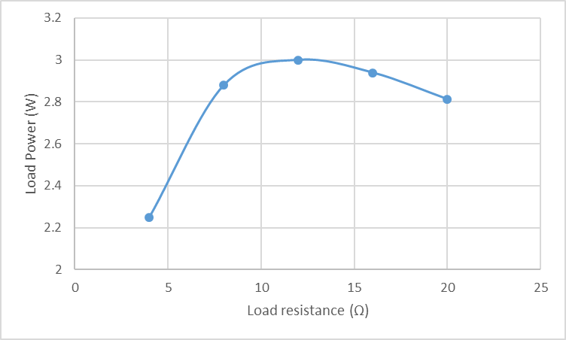
Marks awarded for: Labels, Units, Scale, Correct Axis, Trend

- For the symmetrical sinusoid shown immediately below:
- Determine its period ( T )
[1 Mark]
- Determine its peak-peak voltage.
[1 Mark]
- Determine the r.m.s. value of the waveform.
[2 marks]
- Sketch the diagram immediately below and indicate on it any two points between which the PERIOD (T) could be measured
[1 Mark]

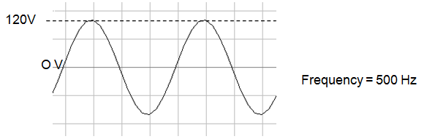
Fig Q5
- $Period=\frac{1}{Frequency}=\frac{1}{500 Hz}=2 ms$

- $V_{pk-pk}=V_{pk}×2=120×2=240 V$

- $V_{RMS}=\frac{V_{pk}}{\sqrt{2}}=\frac{120}{\sqrt{2}}=84.853 V$

- Any two points on the waveform exactly one complete cycle apart.

- Determine Vs for the following circuits and draw phasor diagrams showing each of the voltages.

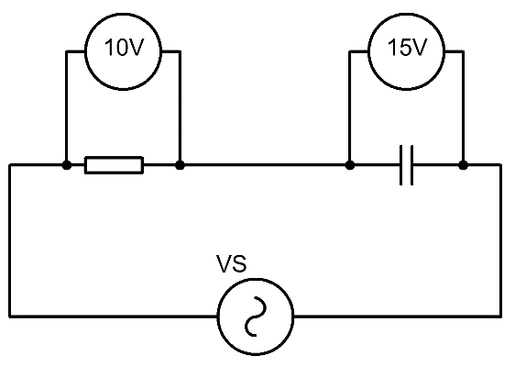
Fig. Q6a
[2 Marks]
$$VS=\sqrt{{10}^{2}+{15}^{2}}=18.028V$$

VR
VS
VC
I

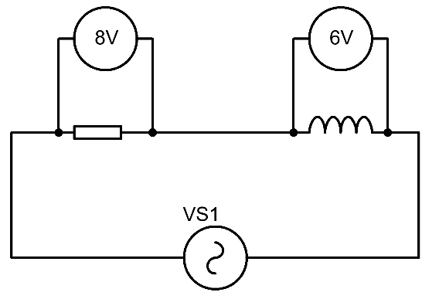
Fig. Q6b
[2 Marks]

$$VS=\sqrt{8^{2}+6^{2}}=10V$$
VR
VS
VL
I

Diwedd/End

$$V=IR$$  $$I=\frac{V}{R}$$  $$R=\frac{V}{I}$$ | $$P=VI$$  $$V=\frac{P}{I}$$  $$I=\frac{P}{V}$$ | $$P=\frac{V^{2}}{R}$$  $$P=I^{2}R$$ | $$R_{T}=R_{1}+R_{2}+…+R_{n}$$  $$\frac{1}{R_{T}}=\frac{1}{R_{1}}+\frac{1}{R_{2}}+…+\frac{1}{R_{n}}$$ | $$V_{Out}=V_{in}\frac{R_{B}}{R_{A}+R_{B}}$$
$$X_{C}=\frac{1}{2πfC}$$  $$X_{C}=-j\frac{1}{ωC}$$ | $$X_{L}=2πfL$$  $$X_{L}=jωL$$ |  | $$\frac{1}{C_{T}}=\frac{1}{C_{1}}+\frac{1}{C_{2}}+…+\frac{1}{C_{n}}$$  $$C_{T}=C_{1}+C_{2}+…+C_{n}$$ | $$f_{res}=\frac{1}{2π\sqrt{LC}}$$
$$X_{T}=X_{L}-X_{C}$$  $$Z=R+j\left(X_{L}-X_{C}\right)$$  $$\left|Z\right|=\sqrt{R^{2}+{\left(X_{L}-X_{C}\right)}^{2}}$$ | $$φ=\tan^{-1}{\frac{X_{T}}{R}}$$  $$pf=\cos{φ}$$ |  | $$L_{T}=L_{1}+L_{2}+…+L_{n}$$  $$\frac{1}{L_{T}}=\frac{1}{L_{1}}+\frac{1}{L_{2}}+…+\frac{1}{L_{n}}$$ | $$ω=2πf$$
$$τ=RC$$  $$V_{C}=V_{s}\left(1-e^{{-t}/τ}\right)$$  $$I_{C}=\frac{V}{R}\left(e^{{-t}/{RC}}\right)$$  $$V_{C}=V_{0}\left(e^{{-t}/τ}\right)$$  $$I_{C}=-\frac{V}{R}\left(e^{{-t}/{RC}}\right)$$ | $$τ=\frac{L}{R}$$  $$V_{L}=V\left(e^{{-Rt}/L}\right)$$  $$V_{L}=-V\left(e^{{-Rt}/L}\right)$$  $$I_{L}=\frac{V}{R}\left(1-e^{{-Rt}/L}\right)$$  $$I_{L}=\frac{V}{R}\left(e^{{-Rt}/L}\right)$$ |  | $$f=\frac{1}{2πRC}$$  $$A_{V}=20\log{\frac{V_{out}}{V_{in}}}$$  $$A_{P}=10\log{\frac{P_{out}}{P_{in}}}$$ | $$Q=\frac{X_{L}}{R}$$  $$Q=\frac{X_{C}}{R}$$  $$Q=\frac{f_{R}}{f_{U}-f_{L}}$$  $$Q=\frac{1}{R}\sqrt{\frac{L}{C}}$$
$$V_{B} \text{=}\frac{\text{RB2}}{\text{(}\text{RB}\text{1 + }\text{RB}\text{2)}}\text{×} V_{CC}$$  $$V_{E}=V_{B}-0.7$$  $$I_{C}=I_{E}$$  $$V_{C}=V_{CC}-\left(I_{C}×R_{C}\right)$$  $$Av=\frac{v_{c}}{v_{b}}$$  $$V_{E}=10\%V_{CC}$$  $$R_{IN}=\frac{1}{\frac{1}{R_{1}}+\frac{1}{R_{2}}+\frac{1}{\left(h_{FE}×R_{E}\right)}}$$  $$R_{OUT}=R_{C}$$  $$A_{V}≈-\frac{R_{C}}{R_{E}}$$ |  |  | $$V_{out}=-\frac{R2}{R1}×V_{in}$$  $$V_{out}=\left[1+\frac{R2}{R1}\right]×V_{in}$$  $$V_{out}=\frac{R2}{R1}×\left[V_{2}-V_{1}\right]$$  $$V_{out}=-\frac{R2}{R1}×\left[V_{1}+V_{2}\right]$$  $$V_{out}=-\left[\frac{R}{R1}×V_{1}+\frac{R}{R2}×V_{2}+…+\frac{R}{Rn}×V_{n}\right]$$

Graph paper for Q4.b

Student Number ………………………………………



