Stephen Jones
Student No: 2440121

Relational Database
ACCA4023 – Component 1

Contents
Scenario Analysis 1
Introduction 1
Entities and Attributes 1
Relationships 2
Entity Relationship Diagram (ERD) 3
Normalization 4
First Normal Form (1NF) 4
Second Normal Form (2NF) 4
Third Normal Form (3NF) 4
Sample Data Population 5
Query Development 7
Testing and Validation 13
Design Decisions and Future Work 13
References 14

Scenario Analysis

Introduction
The purpose of this assignment is to design a relational database for a pharmacy chain, called MediLink, to keep track of stock, prescriptions and customer information.
A relational database has multiple tables that relate to each other with the use of key information [1]. For example, a shipping company would have a list of customer addresses, as well as a list of delivery addresses, and the delivery addresses would correspond to the customer ones. This link is known as a relationship. The company could then use these relationships to query certain information, such as which customers had deliveries in the past week, with ease.

Entities and Attributes
The first step in planning the database is to establish the entities and their attributes. The entities are what you want the data to represent, and the attributes are the types of data that you need to build the information [2].
In this case, the pharmacy wants to store information about stock, customers and prescriptions, therefore the entities for this database will be:
Medicines – This will include the entities MedID, which will be the unique number to identify each item. MedName, which will be the name of each medicine. Supplier, which will list the company that supplies the medicine to the pharmacy. Price, which will list the sale price of each medicine. Stock, which lists how much of each item the pharmacy has, and OverCounter, which will inform the user if the medicine can be sold without prescription or not.
Customers – This will include the entities CustID, the unique identifier for each customer. FirstName and LastName, so the database has the first and last name of the customer. Address, this lists the customers home address, and Phone, which will be the customers’ phone number.
Prescriptions – This will include the entities PrescriptionID, the unique identifier for each prescription, CustID, this will be the same as the customer ID number in the customers entity, MedID, this will be the same Medicine ID number as the Medicines entity. Quantity, this is the amount of medicine the customer needs to be prescribed, and NextDate, which will be the date that the next prescription is due to be dispensed.
Sales – This will include the entities SaleID, the unique identifier for each sale. MedID, once again, this will be the same as the same attribute within the medicine’s entity. Quantity, this is the amount of each item sold, and SaleDate, which gives the date of each sale.

Relationships
Relationships are the links between each table that keep the information together. They help ensure that the data is consistent between tables through the use of keys [3].
The image below shows the relationships between the tables in my database.
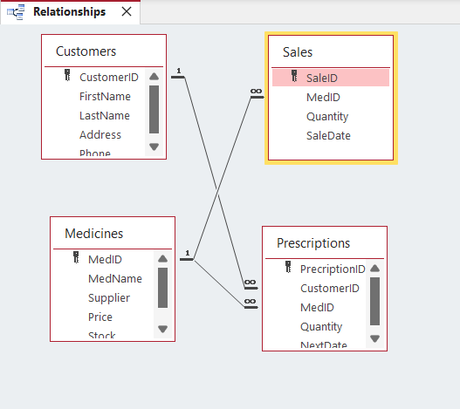
Figure 1: Relationships

Entity Relationship Diagram (ERD)
The Entity Relationship Diagram works as a plan for the database. It displays the entities and attributes, as well as the relationships between them [4].
My ERD shows my four entities, Medicines, Customers, Sales and Prescriptions, and the accompanying attributes. The following relationships are displayed.
- Some medicines are available for sale
- Some medicines can be sold to customers
- All customers can be given prescriptions
- Some medicines can be given on prescription

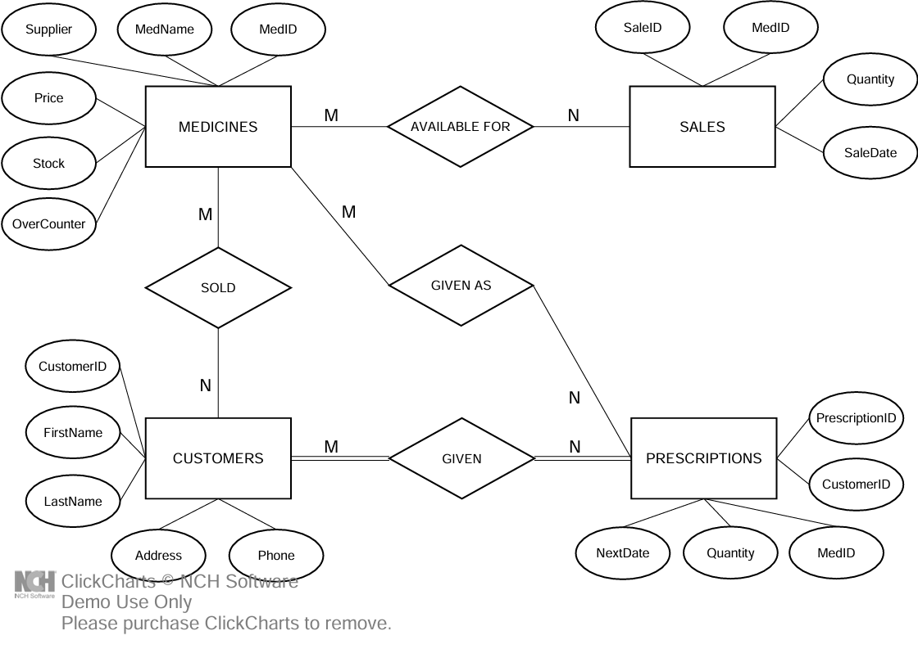
Figure 2: Entity Relationship Diagram

Normalization
Normalization is the process of structuring your tables to eliminate things such as repeated or redundant data. This done by transforming data into something knows as normal forms [5].

First Normal Form (1NF)
First Normal Form involves removing any multivalued attribute, meaning that each cell can only contain one piece of information. For example, if a customer has several prescriptions, they must be listed separately. I’ve done this by splitting customer and prescription information into separate tables, using the customer ID number as a relationship between both tables.

Second Normal Form (2NF)
Second Normal form involves making sure that the attributes of each table all rely entirely on the primary key. For example, if any information in a table depended on the primary key as well as one of the non-primary attributes, this would violate 2NF.

Third Normal Form (3NF)
Third Normal Form involves assuring that two non-primary attributes don’t depend on each other. Using the medicines table as an example, If the supplier, price or stock changed, it wouldn’t affect anything else in the table and the primary key would always remain the same. This means it’s compliant with 3NF

Sample Data Population

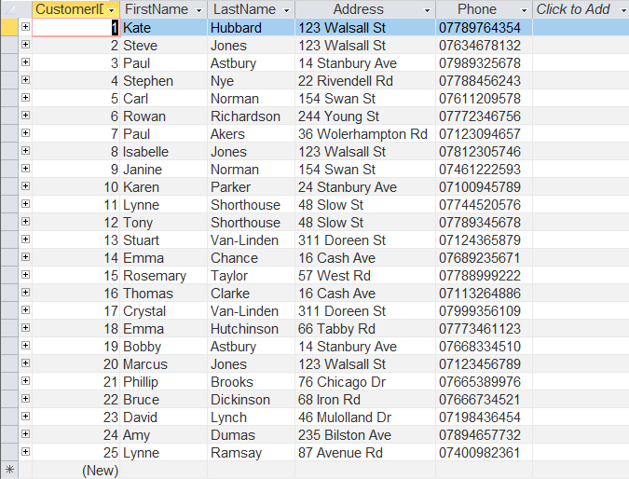
Figure 3: Customers Table
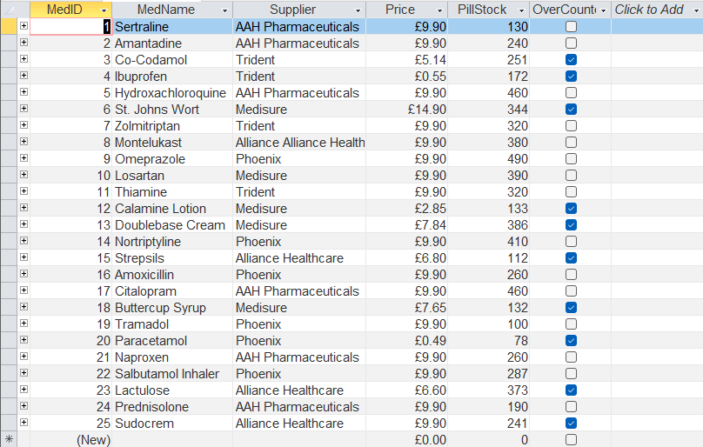
Figure 4: Medicines Table

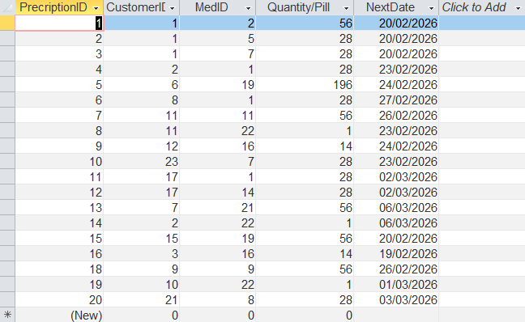
Figure 5: Prescriptions Table

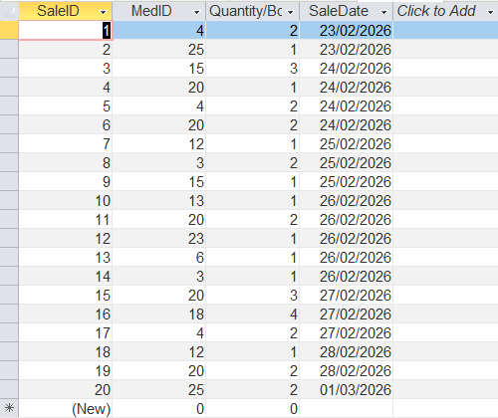
Figure 6: Sales Table

Query Development
Since a database can contain huge amounts of information, the user is able to run queries. These queries can be designed in a way where a set amount of data will be displayed based on the information the user needs to see, eliminating the need to search the entire database, which could take too long and make it possible to miss something. [6]
I have designed four simple queries in my database to show how this works, they are as follows.
The first query is requesting the names of the medications each customer in prescribed. I designed the query to show the first and last name of the customer, as well as the names of the medicines they’re prescribed to.

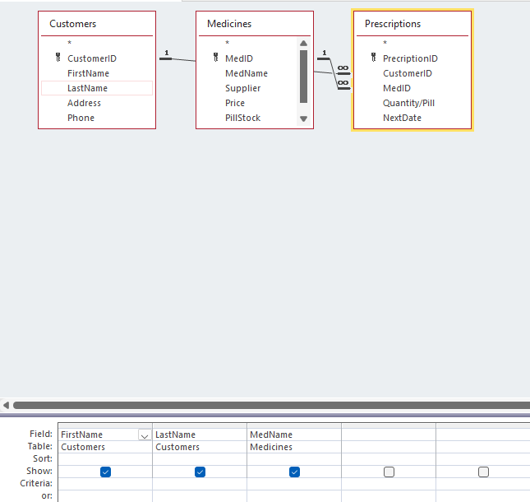
Figure 7: Prescribed Meds query design view
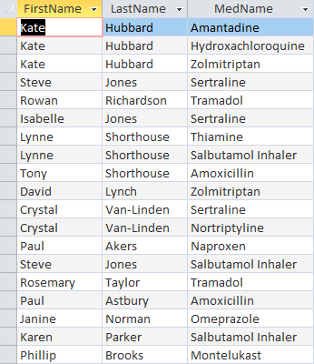
Figure 8: Prescribed Meds query result

The second query allows the user to input a date and find out if any prescriptions are due that date. This would help plan ahead so orders are ready on the due date.

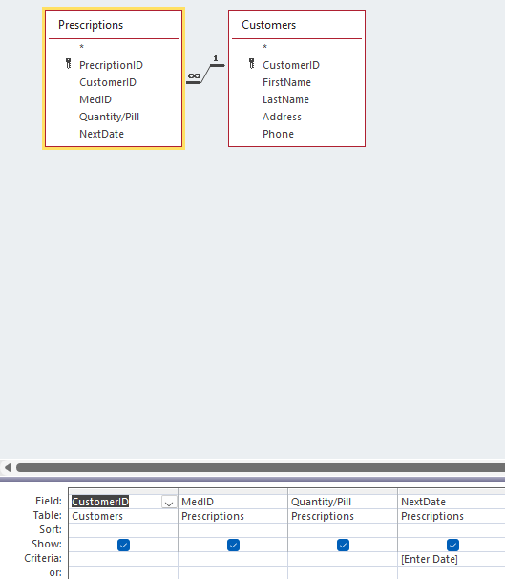
Figure 9: Prescription Due Date design view

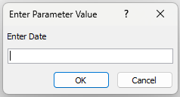
Figure 10: Date entry field presented when query is run

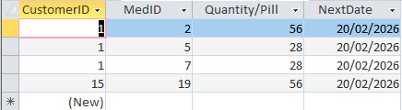
Figure 11: Query result for a chosen date
The third query is simpler. It shows the user which of the medicines can be sold over the counter without having to check the tick boxes on the full list.

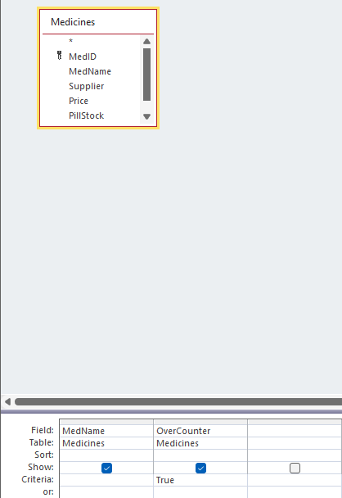
Figure 12: Over the counter query design view

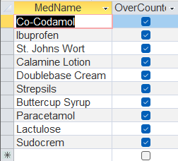
Figure 13: Over the counter query result

The fourth query prompts the user to input a medicine supplier name to bring up a sales list showing the sales from that specific supplier.
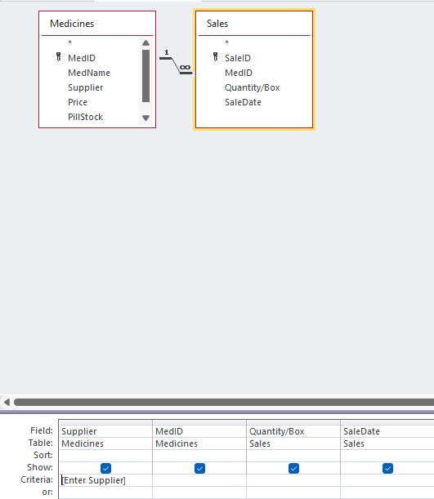
Figure 14: Supplier sales query design view

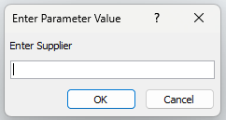
Figure 15: Supplier entry field presented when query is run
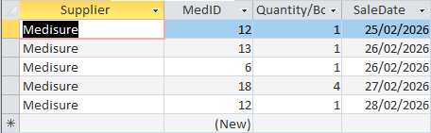
Figure 16: Query result for a chosen supplier

Testing and Validation
I checked all my tables to assure there was no repeated information unless it was necessary, e.g., more than one customer at an address or more than one customer with a certain surname. All data is in its own place following the rules of normalization.
I’ve tested my queries with different inputs where available and cross referenced with tables to assure that the data was correct.
I also tested sorting data in columns and made sure the change was consistent across the entire table, for example, I sorted customers surnames alphabetically and checked all the other fields changed with it, as they did.

Design Decisions and Future Work
I feel this is a good jumping off point for a database, however, as the data population grows, the queries I’ve designed that present lists will become much longer so another method will need to be developed to prevent users having to read through loads of information.
I think the way I’ve provided stock and sales quantities needs revision because the stock is presented in individual pills, though inhalers and creams are by item. I feel this is confusing. Also, the sales presented, by box or item, making things further confusing. This also makes any future development of a system that updates stock when sales are made impossible to implement properly.
Other than these things, I’m happy with the layout presented here. I particularly think having instruction on whether the medicine can be sold over the counter was a good idea.

References
[1] P. L. Soto, “Relational Databases for Behavior Science,” Perspectives on Behavior Science, Dec. 2025, doi: https://doi.org/10.1007/s40614-025-00486-w.
[2] S. P. Panda, “Relational, NoSQL, and Artificial Intelligence-Integrated Database Architectures: Foundations, Cloud Platforms, and Regulatory-Compliant Systems,” Jun. 2025, doi: https://doi.org/10.70593/978-93-7185-129-9.
[3] O. J. Mbanugo, S. Sneha, and A. Taylor, “Buttressing the power of entity relationships model in database structure and information visualization: Insights from the technology association of Georgia’s digital health ecosystem,” World Journal of Advanced Research and Reviews, vol. 25, no. 02, pp. 1294–1313, Feb. 2025, doi: https://doi.org/10.30574/wjarr.2025.25.2.0521.
[4] I.-Y. Song, M. Evans, and U. Park, “A Comparative Analysis of Entity-Relationship Diagrams 1,” Journal of Computer and Software Engineering, vol. 3, no. 4, pp. 427–459, 1995, Available: https://www.cin.ufpe.br/~in1008/aulas/A%20Comparative%20Analysis%20of%20Entity-Relationship%20Diagrams.pdf
[5] M. Hardini, V. Agarwal, D. Apriani, I. A. Widjaya, E. Setiawaty, and N. Nurasiah, “Application of Database Normalization in Increasing Data Storage Efficiency,” International Transactions on Artificial Intelligence (ITALIC), vol. 3, no. 2, pp. 201–211, May 2025, doi: https://doi.org/10.33050/italic.v3i2.799.
[6] V. B. Ramu, “Optimizing Database Performance: Strategies for Efficient Query Execution and Resource Utilization,” International Journal of Computer Trends and Technology, vol. 71, no. 7, pp. 15–21, Jul. 2023, doi: https://doi.org/10.14445/22312803/ijctt-v71i7p103.

