Research report.
A link in the chain from the past leading towards future generations.
Genetics its origins, influences, and future implications.

This essay examines the question of whether there can be a connection between Charles Darwins theory of evolution, the Eugenics movement and Adolf Hitler.
Leading us to the future use of genetic treatment and its moral implications.
I must firstly ask could one man be responsible for the death of six million Jews, plus millions more including Russian prisoners, Gypsies, and countless other ethnic minorities. Those suffering from mental health and physical disabilities plus the Slavic people.
This would be impossible to have achieved without the support of numerous groups within politics, plus he would have needed to gain the support of the German nation.
Such popular support would mean being able to circulate and disseminate information of which the people wanted to believe. Propaganda alone is a highly effective tool when keeping onboard the population of your nation when your mission is to get continued support, from a targeted audience. However, an underlying attitude and a way of thinking had to be in place so that it could be nurtured and used. Ideas it could be said, brought to the table, talked about, becoming common talk within the workplace and in the bars.
Focus on information you would have been privy to as a child, through schooling or discussions between adults and newspapers celebrating your nations achievements within its colonies.
To find a connection we need to go back to when Europe was colonising the world.

The UK and France along with Belgium and Portugal, Italy and even Spain had colonised parts of Africa, and Germany was making its move into Southwest Africa, today’s Namibia, with the first German settlers arriving in1883 (D Gretton, 2019, P545).
Atrocities by European Colonists were being conducted, throughout Africa, before and after this time, however, we are looking to see how the attitudes towards indigenous people may have led to the way future leaders within Germany acted in the 1930’s. Dr Heinrich Goering, father of Hermon Goering, who would later oversee vast swathes of Nazi eastern Europe, was appointed by Bismack, to negotiate treaties with local tribes. Gretton suggests that Goering was influenced by his father’s stories passed down from father to son of the heroic adventures he had experienced in Africa (D Gretton, 2019, p552).
Charles Darwin in 1856 publishes The Origin of Species (C Darwin 1859). And later in 1871 goes on to publish The Descent of Man (C Darwin 1871). These books were to revolutionise the way we think about the evolution of mankind. However, the way in which the philosophy behind Darwin’s hypothesis, was to become open to interpretation isn’t so straightforward.
Academics were discussing the ideas which led to a differing of opinions on the subject, in turn this would open ideas that could be taken up by academic’s philosophers and governments around the world with differing opinions.
Writer Sven Lindqvist says in his book, exterminate all the brutes, when he quotes Darwin who wrote in the descent of man (Darwin, 1871) that ‘today between the primates and civilized man are intermediate forms such as gorillas and savages but both these forms are dying out’. (Lindqvist S, 2018 p107).
This explanation by Darwin would go a long way to helping the justification of the dominance of the strong over the weaker in society, hence justifying the extermination of indigenous people under colonial rule around the world.
Using the theory that evolution is inevitable and those lesser spices would naturally giveaway to the stronger more powerful specimen.
On reading an article by M Liscum and M. l. Garcia. I have included parts of this article to help give an example on attitudes on Eugenics.
United States of America, the sterilization of both male and female when legally and humanly employed persons who are radical defectives though heredity (feeble-minded, habitual criminals, blind and deaf-mutes) should be rendered sterile…”-G.H. Parker. (1915).
“But all would agree on some eugenic principles: That it is better to be healthy and vigorous than sickly and week well-fitted for their part in life rather than the reverse. In fact, good specimens of their kind whatever that kind may be, no one can doubt that the science of eugenics must become a great and beneficent force in the evolution of man.”
Marriages and healthful rearing of their children. Natural selection rest upon excessive production and wholesale destruction; Eugenics on bringing no more individuals into the world than can be properly cared for and only of good stock” (Galton,) 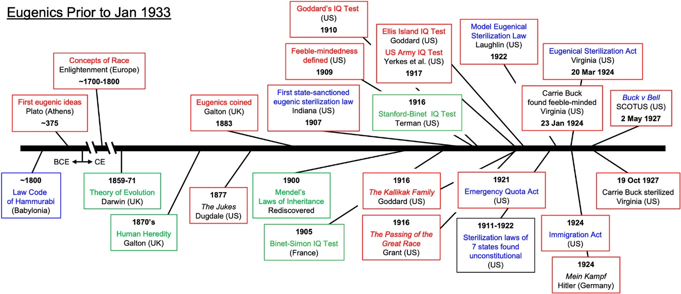1908) (F. Darwin.1914)

(Galton, 1908) (F. Darwin.1914). Liscum. M.& Garcia. M.L. (2022).

You can begin to see from early colonial times a continued theme about the theory of evolution leading to the eugenics movement and when Adulf Hitler was fighting in the first world war.
An article written by Richard Weikart quotes ‘Cornua – along with a host of leading scientist, physicians and social thinkers who embraced Darwinian social explanation and Eugenics in the nineteenth centuries and early twentieth centuries, thus argued that the key to progress was the annihilation of the lower races, who stood in the way of advanced cultures and civilization. social Darwinist thinkers went further arguing racial extermination even conducted by bloody means. Weikart R. (2003p p273 – 294).
Eugen Fisher who had studied medicine and had a degree in anatomy and anthropology at the university of Freiburg, had become mesmerised by the growing pseudo-science of eugenics.
Eugen Fisher would go on to carryout measurement and the cataloguing of photographs on local mixed-race people in southwest Africa, where he later in 1913 publish his book. Die Rehoboth Bastards und das Bastardierungsproblem problem beim Menchen.
(‘The Rehoboth Bastards and the Bastarardisation Problem in Man’).
This had become a point for discussion in Germany before the first world war.
About race hygiene and the need to save ‘our wonderful German nation.’
1921 would see Books co-written by Eugen Fischer Erwin Baur and Fritz Baur,
called Human Heredity and racial hygiene, ideas which were to become central to Nazism in the next generation.
This book was to find itself into translation into English too. (D Gretton, 2019 p592).
The argument to how we keep our nation’s blood pure was certainly circulating before 1930’s Germany begins to put theory into practise.
We can see that when imprisoned Adolf Hitler in 1924, was digesting Ratzel’s theory of Lebensraum, and he was also given a copy of Human Heredity and Racial hygiene.

Many of the ideas from this work were to reappear the following year, though in Adolf Hitlers words now, in Mein Kampf (D Gretton, 2019 p 593).
It is fair to say that supporters of Adolf Hitler would argue that Mein Kampf was the result of the mind of a great Leder.
It could be also argued that before Darwin’s theories where released. Indigenous people had been treated in some cases in a horrific way, during the mass land grab of European colonialism.
With all that been said we need to consider the philosophies of the times before Charles Darwin had published his theories. The argument on how we would treat indigenous people would not have been influenced by his work, leaving us to have to look further into the common practices of the time and how European governments treated inhabitants of the new worlds, and Africa as an example. Europeans had been trading with African kings, like King Tegbesu who made £250,000 a year from selling Africans in about 1750: far more than any English duke’s annual income. And King Alvare of Congo, who provided slaves to the Portuguese,c1687. (H,Thomas,2006 p192- 193).
This appears to seem that an agreement between businessmen from both continents however shocking it may be for us today existed. After the end of the slave trade, we change our approached to native people. And with increased colonisation we took on an approach that all indigenous people where now a lesser species. No longer potential goods or property so demanding a different set of rules in how we relinquish our guilt in the way we treated them. This does seem to become more apparent especially after Charles Darwins Books are published in (1856 – 1871) . And The growth of the eugenics movement.
(S, Lindqvist. 2021p107).

Today within science and the medical profession, we can see a growing need to discover ways in which we can eradicate Genetic defects in humans, which is still an important topic of discussion, on the moral ethics of where we place ourselves on the use of Generic modification today and in the future.
In the UK today we see the demand for assisted dying being debated in parlement this in itself has potential moral problems to be considered.
It could be said that we run the risk of playing God. However in a more secular world we need to look for our moral compass in a way that does not offend people, and also look to where that has come from and do we simply look towards the likes of Charles Darwins theory’s or take on a wider view encompassing all the different beliefs and cultures that make our world such a fascinating place to live in.

Part 2. Reflection.
I had to plan how to keep the information I was discovering in order to be able to use it in a constructive way. I then chose to connect the information I was gathering, so I tried to keep to a mind map and a pyramid system that I have been taught through our Lectures. I have read books on the subject as well as using the University Library and also read articles from Googol When choosing my subject matter, I took on a huge undertaking as this could have led me to a myriad of avenues that could be followed, although I was up for the challenge, as the subject matter is for me very interesting, however that doesn’t mean I didn’t have my doubts on my choice of subject.
Making sure to reference my work, and to make sure to do so as I was in the process of writing not to have to return to my work and have to search for the information in which I have used. I decided to use the Harvard way of referencing and to make sure that I would keep to only one method .
When beginning to wright my essay I wanted to make sure to include an introduction and a main body and to end with a conclusion even though I could have gone into it much deeper when relating to eugenics and the eugenics movement.
Looking for suitable information to learn from and think about using it for my Essay. When trying to get across the information that I wanted to wright about I felt the need to also look at how the philosophy throw-out time had an effect on how we would see and use ideas on evolution and Eugenics. The way we would approach people from different continents, and how governance and trade was affected by the way we would see and treat other people, especially in country’s that had been colonised.
As well as how Germany along with others have used discrimination against People and using the topic of genetics as a weapon.
I have tried to use a critical way of thinking, so as not to just put my opinion across, to stick to the facts that could be referenced, researched, and checked for validation. I have proofread through my essay and hope it stands up to a standard that makes it worthy of a read. And is following an academic way of putting together a piece of work for my Assignment. This assignment has helped me to look at ways of putting together an essay, having to look for information store it and reference it. I know I have a long way to go till I become more proficient at writing and the use of grammar, however the more confident I get through practise and familiarisation on using my laptop, the better I hope to get. I look forward to studying in the future, to learn more and grow my knowledge and skills.

Bibliography
Darwin, C. (1859). The Origin of Species. London: John Murry.
Darwin, C. (1871). The Decent of Man. London: John Murry.
Gretton, D. (2019). I You We Them. London: Penguin.
Lindqvist, S. (2018). EXTERMINATE ALL THE BRUTES. London: Granta Books.
Progress \ through Racal Extermination.
Social Darwinism, Eugenics and pacifism in Germany, 1860- 1918 Author (s) Richard Weikart. Source: German studies: May 2003 vol. 26 no 2 (May 2003). pp.273-294 Published by the John Hopkins University press on behalf of the German studies Association Stable YRL https://ww.jstor,org / stable / 1433326.
Liscum, M., & Garcia, M.L. (2022) You can’t keep a bad idea down: Dark history, death, and potential rebirth of eugenics. The Anatomical Record, 305(4), 937, https;//doi.org /10.1002/ar.24846.
Thomas, H, ( 2006 )The Slave Trade. London: By Phoenix.

