Certificate of Higher Education Business Skills for the Workplace
Digital Skills
LCLM4002
Digital Skills - Portfolio of tasks

Student Name Maria Vasileva Petkova
Student ID 2417933
Table of Contents
Introduction 3
Task 2 of 3 – Information Poster 3
Task 3 of 3 – Report 6
Conclusion of the Portfolio: 9
References: 11

Introduction
Higher education business skills blended with digital capabilities are essential for individuals and students in the modern world (Castro, 2019). These skills include several digital platforms and tools, such as social media and digital media, which also contribute to building a business customer base. Alongside the accessibility and usage of digital tools, they also require fundamental safety measures. Therefore, this portfolio highlights basic digital safety through an informative poster. Next to it, the report included in this portfolio shows how social and digital media can be used to reach a wider customer base.

Task 2 of 3 – Information Poster
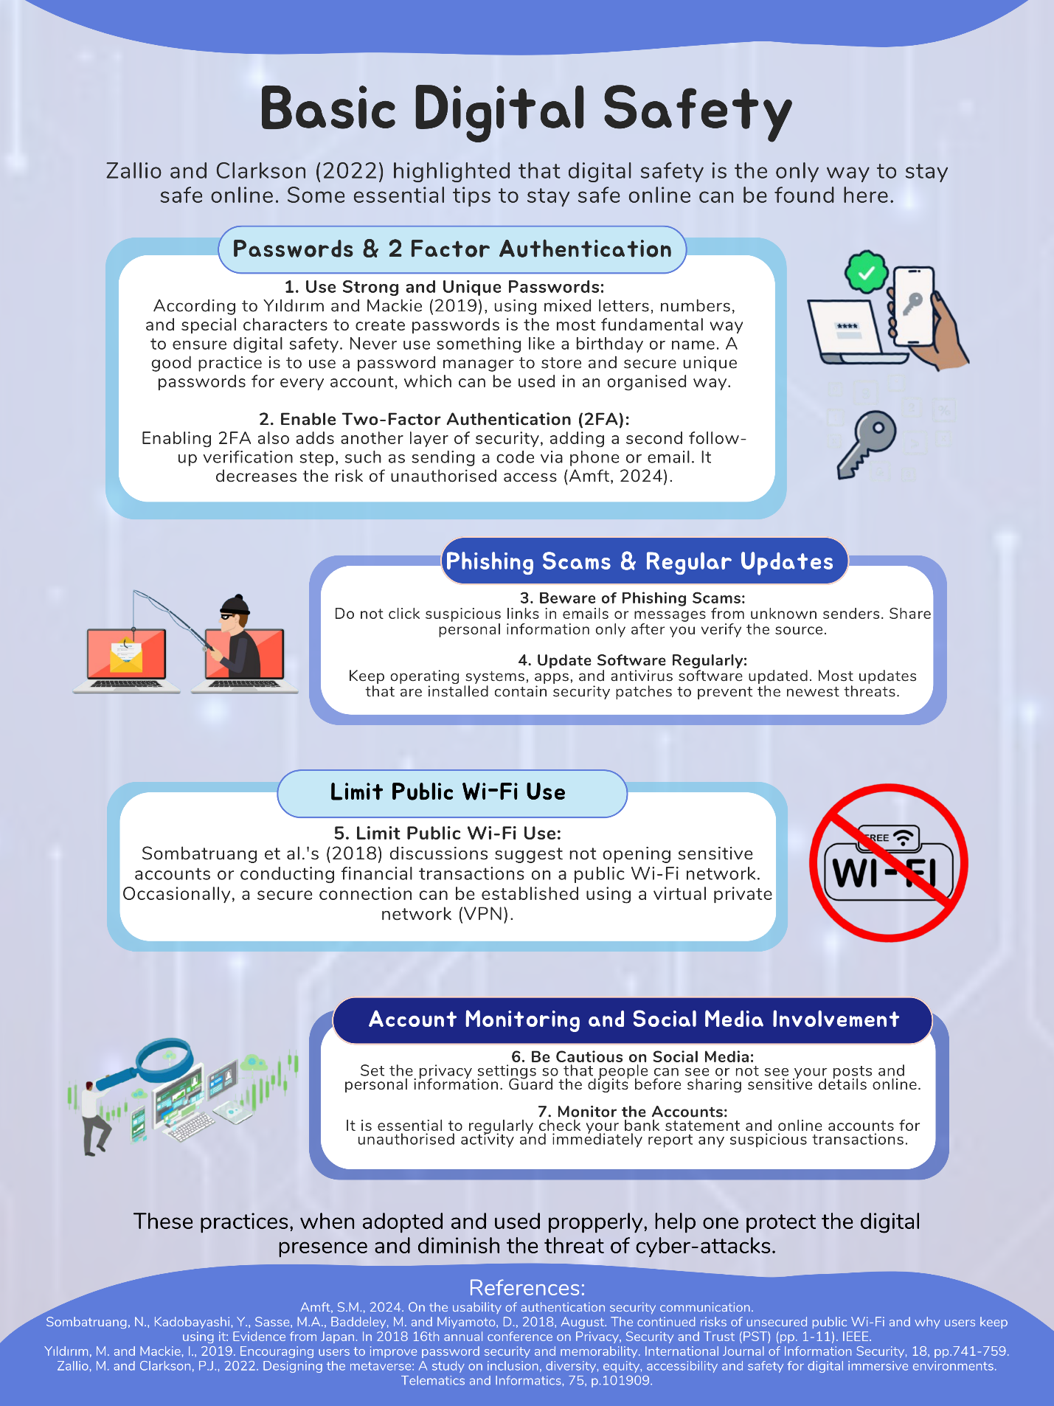

Basic Digital Safety
Zallio and Clarkson (2022) highlighted that digital safety is the only way to stay safe online. Some essential tips to stay safe online can be found here.

1. Use Strong and Unique Passwords:
According to Yıldırım and Mackie (2019), using mixed letters, numbers, and special characters to create passwords is the most fundamental way to ensure digital safety. Never use something like a birthday or name. A good practice is to use a password manager to store and secure unique passwords for every account, which can be used in an organised way.

2. Enable Two-Factor Authentication (2FA):
Enabling 2FA also adds another layer of security, adding a second follow-up verification step, such as sending a code via phone or email. It decreases the risk of unauthorised access (Amft, 2024).

3. Beware of Phishing Scams:
Do not click suspicious links in emails or messages from unknown senders. Share personal information only after you verify the source.

4. Update Software Regularly:
Keep operating systems, apps, and antivirus software updated. Most updates that are installed contain security patches to prevent the newest threats.

5. Limit Public Wi-Fi Use:
Sombatruang et al.'s (2018) discussions suggest not opening sensitive accounts or conducting financial transactions on a public Wi-Fi network. Occasionally, a secure connection can be established using a virtual private network (VPN).

6. Be Cautious on Social Media:
Set the privacy settings so that people can see or not see your posts and personal information. Guard the digits before sharing sensitive details online.

7. Monitor the Accounts:
It is essential to regularly check your bank statement and online accounts for unauthorised activity and immediately report any suspicious transactions.

These practices, when adopted, help one protect the digital presence and diminish the threat of cyber-attacks.

Task 3 of 3 – Report
How Social and Digital Media Can Be Used to Reach a Wider Customer Base

Introduction
Social and digital media are platforms and technologies on the Web that facilitate user communications, content sharing and interactions (Sutherland and Jarrahi, 2018). On social media, Facebook, Instagram, and Twitter concentrate on social media as a body to curate communities based on interpersonal connections and real-time event status. Digital media does much more than that and extends to websites, email marketing, digital advertising and so on, from which companies can connect with diverse audiences at diverse touch points, dynamically and at scale. This is due to business growth; the market visibility for the business by reaching out to a broader customer base will help in sales potential and business brand recognition. According to Son and Niehm (2018), these media help companies navigate geographical barriers and convey their messages to the chosen consumer segments. This report explains how businesses can use social and digital media to have more reach and a customer base, emphasising the advantages and disadvantages that businesses experience while using these tools.

Role of Social and Digital Media in Business Growth
Today's social and digital media platforms help businesses communicate better with their customers, promote business, and increase brand awareness. Instagram and LinkedIn are some of the social media that can be used efficiently to target posts, stories, and live interaction directly directly. On the same principle, Lucy Alexander (2024) emphasised that conventional marketing communication tools (such as mail and websites) can also deliver content to suit a pre-decided audience. Over time, the user choices of individualised promotion material and hierarchical material forms like polls, videos, and campaigns are slowly shifting towards them. Efficiency is targeted advertising, which means that the adverts we put across the internet will be seen by potential clients who are more relevant then. Secondly, Barbosa et al.’s (2024) discussion also shows that content marketing is meant to provide quality content to satisfy customers and analytics tools are intended to learn and understand the consumer so you can make intelligent decisions.

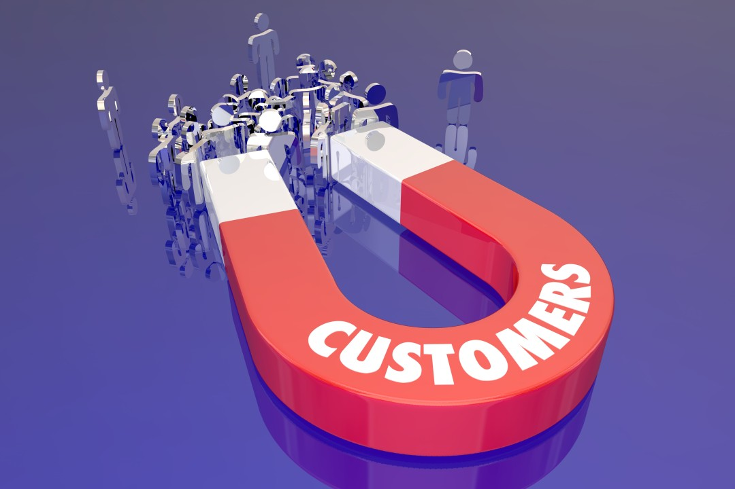
Figure 1. Wider Customer Base
Source: (Licdn.com, 2024)

Reaching a Wider Customer Base Through Digital Media
Through digital media, marketing makes business operations more effective because it gives universal access across online platforms and thus makes it easier to establish and strengthen a customer base. However, Quesenberry (2020) stressed that unlike classic advertising techniques, which are often locally bound, digital media allows for direct interaction with multiple different consumers simultaneously online and simultaneously. Image SEO has a significant role in promoting the site, making it easy for businesses to appear at the top of the search results when customers seek such products. In the case of email marketing, firms are still able to speak directly to consumers and get messages from them, but they attempt to engage or form bonds with the consumers so that they will use them later. Paid media like Google AdWords helps find the type of consumer base businesses want through keywords and behaviour patterns. However, how Google Ads and YouTube can help drive user connections and programmatic advertising grants concrete ad placements. Analytics can even be applied to companies so that they understand how users use their products and services and apply marketing to them similarly. With digital media, the customer niche expands, and advertising messages become more important and impactful.

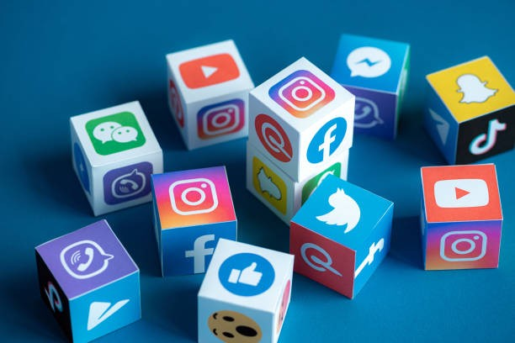
Figure 2. Social Media Tools
Source: (Licdn.com, 2024)

Advantages of Social Media Tools
Businesses are paying massive agreement that social media tools play a better role in marketing solutions because they are cheaper than average for companies wanting to reach a large and diversified audience (Evans et al., 2021). About different ways of promotion, some spending must be made. However, that is different from Facebook and Instagram for promotions; their use is cheap, allowing all business brands to incorporate it within the advertising of their enterprise. Moreover, through these platforms, customers can be spoken directly to, which is helpful so they can nurture a relationship with a business and help the business become loyal to them. Furthermore, the Social media on which consumer-generated content is available is better as consumer returns, complaints, likes, and use history can be viewed on info graphs like analytics dashboards (Gour et al., 2022). Effective strategies have been some first-rate examples. Once Coca-Cola did Share a Coke through personalised, their clients' connection and union opportunities improved. Therefore, social media tools offer the most effective communication and market development.

Disadvantages of Social Media Tools
The challenges in using quality social media tools must be addressed. There are downsides, such as negative feedback or plain harmful content that can spread like wildfire, damaging a brand (Al Shehab, 2022). In addition, the business also faces data theft, account hacking, and other security threats that affect customers' trust. Equally, this presents a problem of consistency in reach since algorithms can often change, which leads to content needing to be visible. A business is highly dependent on social media; once it goes out of trend, it tends to take time for the business to change. The use of social media is considered ethically sensitive given that it violates user's privacy and regularly propagates information that is fake, dishonest and false (Guo et al., 2020). Imagine there are creases about many brands that churn out intrusive sponsored ads tracking users' data. Though social media is a great marketing tool, a lot has to be considered when using social media to avoid the ill effects that are so common today.

Conclusion of the Report
In conclusion, Businesses need social and digital media tools to analyse and extend their coverage and audience reach in the contemporary world. These platforms are affordable and can improve customer relations and generate insights, but they also have issues such as ethics and dependence. Therefore, proper usage of these tools should follow various marketing approaches, maintain high standards of ethical practices, and centre client satisfaction. In this way, organisations can manage social and digital media opportunities to ensure ongoing profitable growth and market leadership.

Conclusion of the Portfolio:
Conclusively, this portfolio highlighted a blend of higher education business skills and digital capabilities. Firstly, an informative poster points out how digital safety is essential and provides tips for protecting one's online presence. The report furthermore explored how social and digital media are helping in reaching customers to widen their customer reach, its advantages, disadvantages, and ethical issues. Together, these parts allow one to see how to move through the digital world in an effective and responsible way.

References:
Al Shehab, N.A., 2022. the dark side of social media: spreading misleading information during covid-19 crisis. Advances in Data Science and Intelligent Data Communication Technologies for COVID-19: Innovative Solutions Against COVID-19, pp.277-306.
Amft, S.M., 2024. On the usability of authentication security communication.
Barbosa, B., Saura, J.R., Zekan, S.B. and Ribeiro-Soriano, D., 2024. RETRACTED ARTICLE: Defining content marketing and its influence on online user behavior: a data-driven prescriptive analytics method. Annals of Operations Research, 337(Suppl 1), pp.17-17.
Castro, R., 2019. Blended learning in higher education: Trends and capabilities. Education and Information Technologies, 24(4), pp.2523-2546.
Evans, D., Bratton, S. and McKee, J., 2021. Social media marketing. AG Printing & Publishing.
Gour, A., Aggarwal, S. and Kumar, S., 2022. Lending ears to unheard voices: An empirical analysis of user‐generated content on social media. Production and Operations Management, 31(6), pp.2457-2476.
Guo, Z., Cho, J.H., Chen, R., Sengupta, S., Hong, M. and Mitra, T., 2020. Online social deception and its countermeasures: A survey. Ieee Access, 9, pp.1770-1806.
Licdn.com. (2024). Available at: https://media.licdn.com/dms/image/v2/D4D12AQEa0PIOMs_2Yw/article-inline_image-shrink_1000_1488/article-inline_image-shrink_1000_1488/0/1705139854622?e=1735776000&v=beta&t=bulDJptkEz2MMAjrDRdUvqVqbwmYyeHh4lsX8bLUXnM
Licdn.com. (2024). Available at: https://media.licdn.com/dms/image/v2/C5612AQEKrNQtkXCOug/article-cover_image-shrink_720_1280/article-cover_image-shrink_720_1280/0/1643290403604?e=2147483647&v=beta&t=jMOVX_zDkqFMT17eyvtl4tcY2tcE9MzUkW4IBLhDq1U
Lucy Alexander. (2024). What is Digital Marketing: Everything You Need to Know. Hubspot.com. [online] doi: https://doi.org/109517657415/1730819309594.
Quesenberry, K.A., 2020. Social media strategy: Marketing, advertising, and public relations in the consumer revolution. Rowman & Littlefield.
Sombatruang, N., Kadobayashi, Y., Sasse, M.A., Baddeley, M. and Miyamoto, D., 2018, August. The continued risks of unsecured public Wi-Fi and why users keep using it: Evidence from Japan. In 2018 16th annual conference on Privacy, Security and Trust (PST) (pp. 1-11). IEEE.
Son, J. and Niehm, L.S., 2021. Using social media to navigate changing rural markets: The case of small community retail and service businesses. Journal of Small Business & Entrepreneurship, 33(6), pp.619-637.
Sutherland, W. and Jarrahi, M.H., 2018. The sharing economy and digital platforms: A review and research agenda. International Journal of Information Management, 43, pp.328-341.
Yıldırım, M. and Mackie, I., 2019. Encouraging users to improve password security and memorability. International Journal of Information Security, 18, pp.741-759.
Zallio, M. and Clarkson, P.J., 2022. Designing the metaverse: A study on inclusion, diversity, equity, accessibility and safety for digital immersive environments. Telematics and Informatics, 75, p.101909.

