

Academic Discipline of Tourism and Hospitality Management
BA(Hons) International Hotel Management Module Code: BMIH6005
Module Name: Organisational Consultancy
Assignment Title: Consultancy Report
Student Name: Diana Valerica Paul
Student ID: 2221008
Lecturer Name: Jaliya de Silva
Date :04/03/2025

Table of Contents
Executive Summary 3
Introduction 6
Analysis 8
Recommendations and Change Management 21
Action Plan 29
Conclusion 33
References 36

Acknowledgement Statement
“I confirm that I have not used any Al tools in the research and creation of this assignment. I confirm that I have not presented any Al generated materials as my own work. I confirm I have copies of my drafts, notes, and other resources I used, which I may be asked to provide in evidence”

Executive Summary

The problem or issue at stake
The following report has briefly shed light on hospitality problems in-depth to identify weaknesses and suggest appropriate solutions to bring necessary improvements. Capella Bangkok, which is a renowned luxury hotel under the branches of Capella Hotels and Resorts, has faced problems which are related to housekeeping and pest control. In spite of maintaining a strong reputation and premium guest experiences, many customer feedback have shown inconsistency in services that mainly surround hygiene concerns. Those issues posed a big threat to guest satisfaction and brand image. Similarly, the hotels which operate in the luxury sector demand for the best services and hygiene standards to sustain client trust and loyalty. Any kind of declination in these grounds directly yield negative reviews, less bookings and financial losses. The guests who have faced poor service and unclean environments expressed dissatisfaction, which is harmful to encourage repeat visits and getting new clients.

Findings
There are many operational inefficiencies which were present in services deliveries, surrounding hygiene maintenance and pest control measures at Capella Bangkok. Visitors who leave their honest feedback from online platforms like TripAdvisor and Google Reviews highlighted a decline in service consistencies. Those consistencies were based on delayed housekeeping, unclean rooms and occasional pest sightings. Audits on housekeeping uncovered inconsistent cleaning protocols that did not always meet hospitality standards. Also, the hotel’s pest control management was reactive instead of being preventive which gave rise to occasional infestations that impacted guest experiences. Considering from a marketing perspective, the DESTEP model focused on external aspects like economic fluctuations and technological advancements which influenced guest expectations. On the other hand, the
SOAR framework revealed strong brand positioning, but there are other opportunities that lie in service and hygiene enhancements. The TOWS matrix demonstrated a requirement for improved reputation management and proactive service solutions for addressing weaknesses and problems. Therefore, the outcome has confirmed that Capella Bangkok should undertake a structured approach by changing old practices to bring new service standards to get a hold of its premium positioning.

Analysis of these findings
The research findings have uncovered different domains of service inconsistencies which connect cleanliness lapses with pest control difficulties for comprehensive intervention. Insufficient staff training and lack of structured performance monitoring have brought differences in service qualities. Housekeeping problems delayed various operations on cleanliness concerns that affected guest expectations. Since there had been an absence of a proactive pest control solution, it allowed minor infestations that escalated into guest complaints. After carefully analysing market conditions, it showed that luxury travellers always prioritise hygiene and personalised services so that their needs can be met. They expect flawless housekeeping from premium hotels followed by timely room service and clean environment which makes minor inconvenience very impactful. Industry expectations and benchmarks state that hotels which have maintained consistent hygiene service standards have acquired more guest retention and revenue growth.

Recommendations
Considering the insights that has been gained from the study, various recommendations for the brand can be made which can help to gain long-term success. Primarily, training workshops were found to be a prominent field as the success of a hospitality business depends on it. Emphasising on high etiquette as well as hygiene standards is central since the hotel has to serve not only local but also global visitors. Performance tracking dashboards have been suggested to monitor service efficiencies while introducing a reward system for those individuals who succeeds in service qualities. UV sterilisation, electrostatic disinfection and many other modes of cleaning processes are important to keep sanitation in luxury hotel industries. Moreover, using automated feedback systems are recommended to track hygiene ratings and resolve concerns promptly by partnering with certified cleaning agencies for deepcleaning services. These solutions would not be effective if external parties are not involved in such operations. They demand for collaboration with professional pest control services to conduct routine inspections and preventive treatments. As a result, bringing such pest management solutions can minimise risk to keep guests comfortable during their stay.

Conclusion
The study has uncovered all irregularities that are present in current service deliveries in Capella Bangkok in terms of hygiene as it posed huge risks to guest satisfaction and business image. After properly implementing the recommended strategies, Capella Bangkok can steadily increase guest loyalty and improve brand reputation. Strengthening operational processes using data-driven insights and continuous staff development would greatly secure its position as a leading luxury hotel in Bangkok. From here, it can be understood that maintaining the highest standards and ensuring a smooth guest experience are important to resolve any concerns. Together, it would reinforce Capella Bangkok’s dedication towards hospitality excellence that can directly ensure long-term success and competitive advantage.

Introduction

Research Background
Cleanliness and friendly hospitality are one of the biggest factors which decides the success rate of hotel companies. When a high amount of proper hotel services is maintained, it helps to attract visitors from not only local regions but also international locations (mylomehotels, 2024). A similar brand which is renowned for its premium hospitality and guest experiences is Capella Bangkok. The following research will explore some concerns placed by customers on the hotel on room services based on industry standards and best practices followed in luxury hospitality management. This way, some new areas for improvement can be found after an examination of service efficiency and hygiene protocols.

Company Background
Capella Bangkok is a famous luxury hotel which functions under the operations of Capella Hotels and Resorts. It is a widely recognised hospitality chain which is known for the personalised services and high-end accommodations (capellahotels, 2025). The hotel is located along the Chao Phraya River where it mixes contemporary elegance with Thai cultural heritage to offer exclusive suites and villas that have scenic river views. Further, the company is celebrated for its special guest experiences, fine dining and wellness facilities. Being part of the Capella brand, it has sustained a commitment to memorable service and hospitality excellence. Even then, keeping high service standards intact remains a critical factor to ensure guest satisfaction and preserve the luxury reputation (lhw, 2025).

Problem Statement
Despite maintaining a good reputation of luxury excellence, the firm has faced problems regarding service quality, cleanliness and pest control. Some of the feedback coming from guests showcased concerns on inconsistent service, hygiene problems and pest sightings that can negatively impact brand reputation and visitor satisfaction (tripadvisor, 2023). Keeping excellent standards in a competitive hotel sector is very important to attract clientele who have disposable income and gain positive reviews (tripadvisor, 2025). Any kind of lapse in such areas brings negative publicity, financial losses and a decline of guest loyalty.

Theoretical Framework
Considering the practical considerations on the operations of Capella Bangkok, the main theories will focus on the issues related to service quality, cleanliness and pest control. The DESTEP analysis will examine external aspects which have been influencing hotel operations whereas the SOAR framework will demonstrate strengths and new opportunities for improvement (marcommodels, 2024). Similarly, the TOWS matrix will offer strategic insights that can find threats and weaknesses along with opportunities and strengths. The McKinsey 7S model will then analyse internal alignment done in operations and then Six Sigma principles will be done for bringing more efficiency and cleanliness. Through the frameworks, the study will be able to make comprehensive solutions to bring high guest satisfaction.

Analysis

DESTEP Analysis
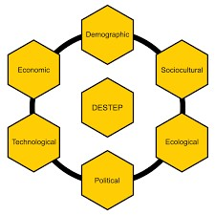
Figure: DESTEP Analysis
Source: (Altman, 2023)
Demographic | Economic | Sociocultural
Demographic factors  influence hotel businesses including different age  groups, higher income levels, cultural backgrounds and travel purposes that are used to segment the market to meet consumer preferences and needs. Bangkok influences a diverse combination of travellers, such as higher- | Economic upswings and downturns widely affect client spending and travel patterns, which in turn hotel revenue and occupancy rates. Apart from that, international economic policies including trade agreements and tariffs impact the cost of goods and services effective for hotel operations (Stebliuk et al., | Within the tourism industry,  there is a growing  prominence on wellness, health and sustainability among travellers. These factors like community  attitudes, cultural norms and social media trends impact tourism by influencing destination choices,  interactions with locals and

efficiency individuals looking for luxury  experiences (Altman, 2023).  From the perspective of Capella Bangkok, the brand must focus on sorting hotel guests into categories depending on their booking patterns, tourism habits, reasons for travelling and willingness to spend.  Offering tailored offerings and development programs become essential for the  brand to embrace  housekeeping services and managing pest control  services (Berman, 2023). | 2022). Hence, Capelle Bangkok needs to be aware of financial instability, economic changes and  understand guest preferences and market dynamics to mitigate housekeeping and service issues (Denizci  Guillet and Chu, 2021). | favourable activities while travelling (Andrade et al.,  2021). Therefore, Capelle Bangkok must prioritise cleanliness and a strong dedication to hygiene as well as ecological responsibility  for fulfilling client  satisfaction (Clarke, 2020).
Technological | Ecological | Political and Legal
Technological advancements have become an essential aspect in transforming guest experience, reducing travel  costs and increasing | The hospitality industry contributes to climate change via its direct and indirect carbon emissions. Most hotels follow essential | Political and legal  environments including data privacy, economic volatility and taxation that affect hotel business operations. Political

efficiency (Mejia et al., 2021). Through the help of modernised technologies and tools like AI, AR and VR systems to examine guest profiles and behaviour and promote the best services to  them (Zambello, 2020). Capelle Bangkok also needs to concentrate on current technologies like IoT  services, robot assistants and servers to personalise guest needs. | sustainable practices like lowering waste, application of renewable energy sources  and waste generation  programs to improve their hotel operations (Sibian and  Ispas, 2021). Hence, Capelle Bangkok must focus on utilising eco-friendly  practices and green process innovation initiatives like building strong relationships  with communities and promoting environmental awareness to reduce their ecological impact (Bugdol et al., 2023). | stability in Bangkok massively impacts its tourism services where companies feel less  comfortable to invest and operate in this market (bbc, 2021). Alternatively, restrictions on migrant labour, government policies towards tourism protocols, fluctuations in currency exchange and economic crises have a significant impact on hindering Capelle  Hotels & Resorts’ operations. Through  advocating for applicable labour regulations and investing in modernised infrastructure becomes essential for stabilising housekeeping services and ensuring quality hygiene standards (bbc, 2020).

SOAR Analysis
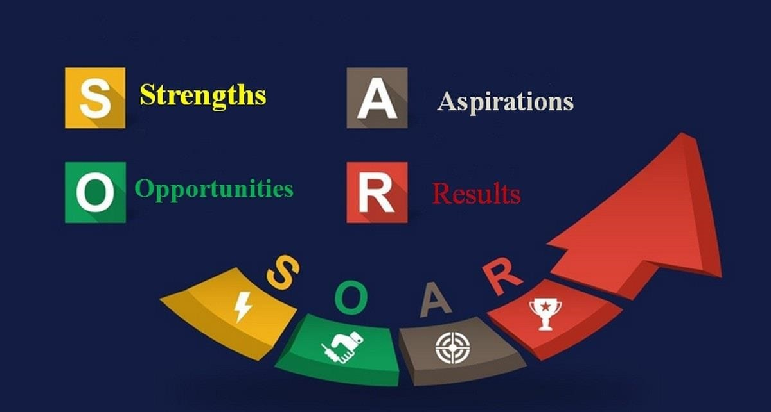
Figure: SOAR Analysis
Source: (Mowery, 2025)
Strengths | Opportunities | Aspirations | Results
One of the  renowned hotel  businesses, Capelle  Bangkok is  responsible for  providing personalised service, world-class  amenities and a  prestigious atmosphere | Apart from its luxury offerings, Capella Bangkok targets to expand its market presence and embrace guest satisfaction. It  offers a range of  opportunities including riverfront experiences, special packages and family- | Capella Bangkok’s primary aspiration is to become a citywide hotspot, a top-tier luxury hotel and a neighbourhood hub. Its culture and  experience curation, spa-specific facilities and fine dining help the firm to gain a | Organising the  process of strategic advancements,  Capella Bangkok is recognised as the best-quality hotel worldwide.  According to various tourist-review  platforms like  Booking.com and
(indagare, 2025). Spacious rooms with modern  comforts, private plunge pools and  sophisticated facilities ensure a seamless  experience for  guests. As it is a part of Capelle  Hotels & Resorts, it  is famous for  attractive luxury properties throughout Europe and Asia Regions. | friendly activities. Additionally, the implementation of  sustainable practices,  enlarging service excellence and  technological  advancements are used to unlock new  levels of profitability,  efficiency and  traveller preferences  (Robertson et al.,  2023). | competitive  advantage in the  competitive market. It also aims to utilise AI gatekeeper services, biometric check-ins  and hyper-  personalised weblogs to restructure service excellence effectively. | TripAdvisor, the  brand has been voted as the No.1 hotel in Bangkok through promoting travel  facilities and leisure  services (Mowery, 2025). Making  strategic collaborations with  local hotel  organisations, the company aims to  source eco-friendly activities through energy-efficiency  procedures for limiting carbon footprint services  efficiently.

TOWS Analysis
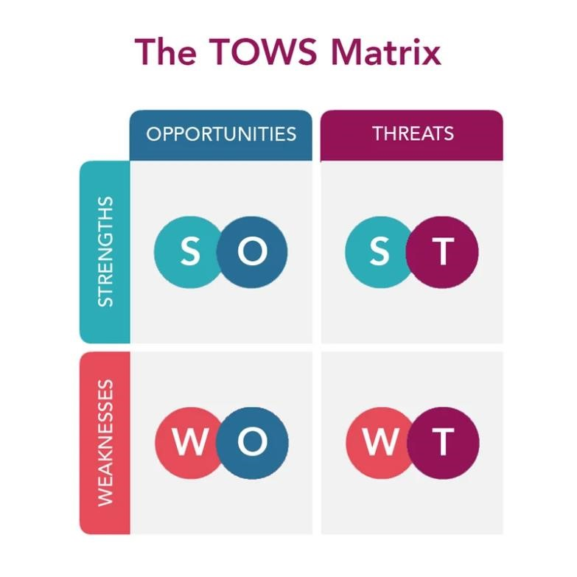
Figure: TOWS Analysis
Source: (Brannon, 2024)
Strengths/Opportunities | Strengths/Threats
Sustainable Luxury: After entering the market, the primary focus of Capelle Bangkok is to incorporate eco-friendly practices including renewable energy sources and home-grown products while offering top-quality services. Alternatively, the brand prioritises richness and comfort without compromising environmental or social sustainability (Brannon, 2024). | Brand differentiation: Capelle Bangkok targets to integrate tradition, individuality and a twist of the unexpected to develop a perfect stay for each guest. Its locations  are structured by well-renowned architects and restaurants primarily promote authentic flavours imaginatively modified (Pereira-Moliner et al., 2021).  The brand’s innovative attributes

Cultural programming: Within the hospitality industry, cultural competence is important where hotels hinge on supportive leadership, shared values and a key concentration on employee well-being. While staff understand and respect guests’ cultural norms and expectations through active listening  techniques, brands have the option to deliver more personalised and appropriate services (Varga et al., 2021). Capelle Bangkok also follows this practice by establishing aristocratic cultural captivation packages only to leverage its  riverside settings as well as regional partnerships for transforming travel  indulgences. |  | including luxurious facilities and supreme status help to ensure its position within the competitive market.  Dynamic reputation management: Effective hotel reputation management assists hoteliers to stand out and provides consumers the confidence in ensuring the right choices for their trips. However, the impact of intense competition becomes challenging for hotel brands to deliver best-quality services for their guests in an  efficient manner. Hence, Capelle Bangkok must focus on adopting key performance indicators (KPIs) to measure guests' positive and negative reviews as well as capture valuable feedback for ensuring sustained operational efficiency (Whittington, 2020). Depending on that, the brand has to interact with responsible guests and undertake proactive measures based on their essential feedback only to optimise its production process for  upscaling service delivery.
Weaknesses/Opportunities |  | Weaknesses/Threats

Modernised cleaning protocols:  Technological advancements are one of the essential aspects of hotel brands for the purpose of transforming service quality. It requires cutting-edge technologies like automated systems, checklists and frequent cleaning schedules for ensuring higher housekeeping standards. Capelle Bangkok needs to organise modernised technologies and tools for automating cleaning shifts, develop training programs and incorporate digitalised maintenance systems to strengthen its brand image and improve guest satisfaction  (Subramaniam et al., 2011).  Vigorous employee training: Hotel staff  training is an essential approach for hospitality firms to understand guest needs, adopt open communication and resolve issues efficiently. Maintaining a healthy and safe workplace environment becomes a challenging task for companies to handle negative reviews and complaints about sub-standard cleanliness. Looking forward to that, Capelle Bangkok must initiate active employee training programs by | Hygiene maintenance: One of the  biggest challenges most hotel businesses witness about maintaining hygiene standards due to poor housekeeping systems, inconsistent service, lack of amenities and unfriendly staff. The same situation faced by Capella Bangkok where most of the guests delivered bad reviews regarding uncomfortable services, limited target market segment and vulnerable to economic downturns (Marques et al., 2022). Hence, to maintain its higher standards, the brand must focus heavily on hiring qualified staff and developing a safe working environment for fulfilling guest preferences.  Staffing issues: Within the competitive travel market, hotel firms witnessed staffing issues that often manifest from  higher employee turnover which  massively impacts service quality and traveller satisfaction (Kwok, 2022). Capelle Bangkok also faced relatable issues about staff friendliness and room
offering them with first-hand experience and a detailed understanding of responsibilities and hotel operations (He et al., 2021). Applying specific protocols becomes an essential factor for the brand to easily design these programs regarding cleaning practices for embracing housekeeping activities and ensuring service excellence. | cleanliness which is an essential factor for upscaling guest satisfaction.

Porter’s Five Forces
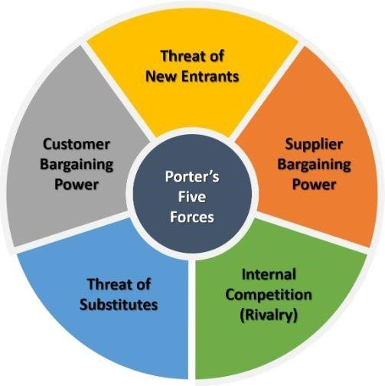
Figure: Porter’s Five Forces
Source: (Thomas, 2020)
Five Forces | Impact | Analysis
Threats of  new entrants | Moderate | The hotel industry poses a variety levels of obstacles for a new entry and opening in new areas that are saturated makes it more

difficult for them to gain an advantage. Capelle Bangkok also faced significant issues like a lack of regional coordination, insufficient communication services and limited infrastructure that made it difficult for them to compete for market share
(Thomas, 2020).
Bargaining power suppliers | of | Low | This force does not potentially too much threat to the hotel industry compared to the bargaining power of buyers, still, it inflicts real-time pressure. Capelle Bangkok eager to make strategic partnerships with potential suppliers to reduce staffing issues, and optimise the production process to ensure higherquality housekeeping standards.
Bargaining power buyers | of | Moderate | As consumers gain greater bargaining power, hotels are inclined to lower their prices. Hotels like Capelle Bangkok target specific tour groups and travel agencies by offering the best quality services for their guest at affordable prices. They always focus on delivering expectational and luxurious accommodations through which have the option to meet  traveller experiences. As a result, this also helps the brand to maintain higher expectations in cleanliness or reduce declination in their services (Blackmore, 2024).
Threat substitute | of | High | The rise of alternate accommodations including homestays and vacation rentals majorly impacts the demand for hotel rooms.  Innovative disruptions have proved to be a challenging task for
 |  |  | hoteliers in terms of adopting modernised technologies to ensure operational efficiency. Capelle Bangkok primarily focused on organising substitute products like alternative lodging choices including luxurious service apartments and boutique hotels that possessed a threat. Focusing on that, the firm primarily focused on implementing new communication channels and platforms to meet in virtual spaces. Through this initiative, the firm has the option to eliminate the requirements of travel and booking rooms which reflects in ensuring unique stays and sustaining guest expectations.
Industry rivalry |  | High | The hospitality sector in Bangkok is highly competitive where each business has prime approaches to meet guest preferences and gain an added advantage. Within this market, maintaining cleanliness and service quality is an essential factor and unable to meet these specifications uprising competitive power. Hence, Capelle Bangkok must be aware of the intense competition factors including price wars, marketing strategies and promotional offers to attract a broader audience (Santa et al.,  2025).

Total Quality Management (TQM)
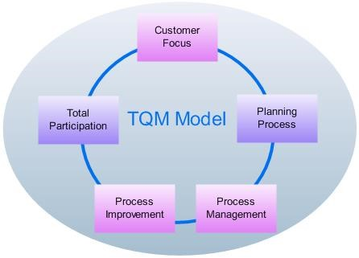
Figure: Total quality management model
Source: (Palmer, 2021)

Customer Focus
Total quality management aims to tackle business elements from sourcing to production, to sales to after-sales service provisions. Through analysing and measuring performance, this framework enables businesses to monitor and improve client satisfaction levels and locate improvement areas. According to various client reviews, Capelle Bangkok has witnessed housekeeping and pest control difficulties that may degrade its business operations (Palmer, 2021). Focusing on that, the brand targets to implement guest feedback mechanisms, quality circles and standardised cleaning procedures to ensure higher standards and meet guest expectations.

Process Improvement
Based on marketing situations, hotels primarily looking for deploying guest-facing technologies and tools for improving client service and reducing fraudulent activities. The development process of Capelle Bangkok is clear about initiating a one-pass cleaning process, smart order procedures and promoting on-job training to their staff only to personalise guest experience (work.chron, 2025).

Process Management
Apart from organising training and development programmes as well as cleaning protocols, hotel businesses also emphasise the requirement of performance-based evaluations. Capelle Bangkok willing to connect with top-level managers to implement a structured quality plan including inventory control, efficient communication channels and key performance indicators based on market circumstances. Utilisation of these methods helps the brand to invest in quality cleaning products and equipment, applying sustainable initiatives to fulfil service quality and meet guest expectations (Silvestri et al., 2024).

Recommendations and Change Management

Recommendation

Staff training and performance evaluation
Capella Bangkok is recommended to start using a structured training program that will mainly put focus on hospitality excellence, communication skills and problem-solving. In this situation, staff will get proper training on how to follow all hotel service standard protocols. When this training is done, a performance monitoring system can be placed to collect feedback from customers and make real-time service evaluations (Mangco and Andales, 2023). Introducing a guest satisfaction dashboard can also help to keep a track on service quality and find any areas which need instant attention. Bringing a reward system for best services will motivate employees to do their best work that can directly foster continuous improvement culture in guest interactions (Glaveli et al., 2023).

Strengthening hygiene and cleanliness protocols
Maintaining best cleanliness needs strict housekeeping personnel who are always ready to be available whenever they are called. The hotel is suggested to adopt advanced sanitation techniques like UV sterilisation and electrostatic disinfection that can improve hygiene (Marques et al., 2022). Similarly, a cleanliness audit system consisting of regular inspection should be kept to make sure it follows global hospitality hygiene standards (Neog, 2021). Based on those, a guest feedback protocol on the level of cleanliness is important that will offer realtime insights for improvement through digital surveys.

Implementing modern pest control measures
Capella Bangkok can begin to collaborate with professional pest control services for regular checking and preventive treatments to resolve pest-related issues. Integrating a pest management system will assist to identify possible risk areas and apply targeted solutions which will not disrupt guest experiences at all (Rodríguez and Samaniego-Puertas, 2023).
Modernising waste management practices may be done through proper disposal and regular sanitation of waste storage areas to reduce pest attraction (Simon, 2023). As a result, regularly checking those areas and reviewing pest control solutions to adopt sustainable pest management solutions will bring a balance between safe cleanliness standards and pest prevention.

Change Management Practices
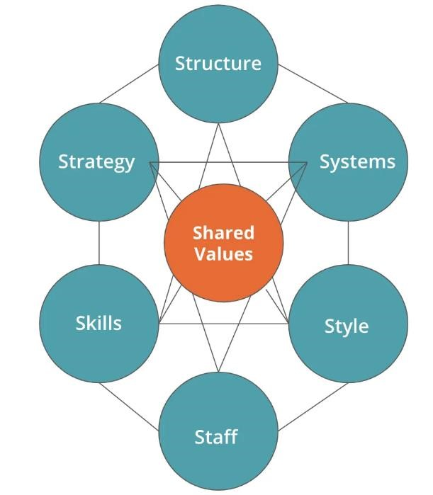

Figure:

McKinsey 7s Model

Source: (quantive, 2024)

Strategy
Clear and actionable strategies must be implemented to resolve service qualities and hygiene problems in Capella Bangkok. The solution should keep the main focus on improving guest experiences since it can directly enhance operational success and maintain regulatory compliance (Bonfanti et al., 2021). This is why a guest-centric service plan has to be made that will include structured staff training and performance tracking. A cleanliness and sanitation protocol for the hotel will enable advanced disinfection methods and cleanliness audits.
Further, comprehensive pest control strategies should be brought to sustain proactive prevention and quick response mechanisms (Kotter, 2012).

Structure
The hotel needs to redefine older methods and make new ones by defining clear roles, communication channels and accountability mechanisms. A service quality task force is important in this situation, consisting of department heads and frontline workers. They will oversee the execution and evaluation of the proposed solutions. Housekeeping, pest control and front-office teams can be managed by dedicated superiors who will ensure the new protocols are followed carefully. Bringing cross-departmental collaboration is vital so that all teams work together to maintain cleanliness and service excellence (Suwanda et al., 2022).

Systems
Capella Bangkok has to upgrade the operational systems to implement the new changes and support quality control measures. Introducing a real-time service tracking system will allow managers to keep a track of guest interactions, service fulfilment metrics and housekeeping schedules. Those tracking should also be done on digital cleanliness audits that are performed through AI tools to follow all hygiene standards (Luhende, 2022). During this time, a pest management database is vital to record inspections, treatments and follow-up actions. Immediate knowledge into service and cleanliness perception may be gained using automated guest feedback collection to enable rapid collective measures. Such technological developments will streamline procedures and improve accountability in operational
effectiveness.

Shared values
The success rate of change initiatives hugely depends on the core values of Capella Bangkok that represents luxury, excellence and guest satisfaction. This is why the management should bring teamwork and accountability culture while following a mindset of guest-first service. In this time, employees can proactively offer new suggestions which can help to keep high standards. Other recognition programs like ‘Employee of the Month’ awards will boost motivation and encourage employees to stay committed to excellence (Cwibi et al., 2023). Performing town hall meetings will allow to discuss progress rate, address difficulties and instill a responsible philosophy to uphold hotel values.

Skills
The support change can only be implemented successfully when the hotel starts to invest in skill development for all levels of staff. Firstly, service training workshops can bring focus on the improvement of communication, problem-solving and hospitality etiquette. Secondly, modern hygiene training programs should be given to housekeeping employees to bring the highest proficiency in sanitation best practices (Mastilović et al., 2024). Thirdly, pest control awareness sessions must be conducted to give knowledge to employees on early detection, proper reporting and preventive measures. Additionally, cross-training practices will leverage flexibility throughout the workforce that can enable workers to manage different responsibilities and adapt smoothly to new regulations.

Style
Leadership approaches followed at the organisation plays a critical role to drive and sustain effective change. Senior management are required to lead by example and display their commitment to service and cleanliness protocols. That is the main reason why participative leadership style is suitable here to encourage open interaction and feedback from workers (Mata et al., 2023). Aside from leaders, managers have to perform one-on-one meetings with different team members to resolve concerns and motivate them. A leader who recognises individual efforts will bring an excellence culture where everyone can feel valued for their individual contributions.

Staff
Finally, employees are deemed to be the key drivers for proper change implementation.
Therefore, their engagement levels and adaptability must be managed in a proactive manner. Change readiness evaluation is important here to know about employee concerns and later prepare them for new changes (Whittington and Molloy, 2005). Getting feedback through regular communications will ensure that all staff members feel heard and valued throughout the change procedure. The best way to make it work is by introducing a change champion program in which selected employees can act as advocates or role models to deploy new services. However, their mental well-being should also be kept into consideration since being prolonged exposure to huge responsibilities can lead to stress and burnout (Back et al., 2021).

Measuring the impact

Guest satisfaction and feedback analysis
The success of new service qualities and pest control improvements at Capella Bangkok can only be measured when there is sufficient guest feedback and satisfaction surveys kept into action. Digital feedback collection with the help of post-stay emails, mobile applications and in-room tablets will offer real-time knowledge. Other feedback platforms like TripAdvisor and Google Reviews are significant to monitor sentiment changes over time (Ma and Kirilenko, 2021). Similarly, a Net Promoter Score (NPS) system will examine guest loyalty and their willingness to suggest the hotel to others (Baquero, 2022). Also, mystery guest audits can be done periodically to examine and analyse service consistency and find any areas which need improvements. As positive responses increase from guest feedback, it will mark the successful implementation of new protocols.

Operational performance and compliance audits
Consistency in operational audits will show if the hotel has followed new cleanliness and hygiene protocols. A housekeeping efficiency tracking system will display cleaning schedules by monitoring response times to make sure it complies with sanitation standards. After every month, pest control assessments can interpret the effectiveness of preventive measures to understand if there has been a reduction of reported cases. KPIs hold a big factor to bring continuous improvement through room turnaround time and housekeeping quality scores
(Jugović and Maričić, 2024).

Financial and brand performance evaluation
The complete effect of these changes on revenue, occupancy rates and guest retention can be easily reviewed through financial reports and performance analytics. High booking trends, repeat customer visits and direct reservations will highlight improvements in gaining customer trust (Mann, et al., 2024). Keeping that aside, public perception throughout hospitality platforms will give insights on brand reputation over time. When there is a reduction in compensation claims on service failures and cleanliness complaints, it will demonstrate tangible improvements. Lastly, long-term growth in positive media coverage followed by corporate partnerships would confirm that the implemented solutions were successful.

Potential Benefit

Higher guest satisfaction and loyalty
After carefully implementing proper cleanliness, housekeeping and pest control strategies, it holds potential to superior guest experience that can bring high satisfaction levels. Both old and new guests will start appreciating consistent and professional services which give high attention to hygienic environments, resulting in positive reviews and repeat visits (Singgalen, 2024). When guest loyalty starts to increase, it will convert to more direct bookings and less dependence on third-party programs. Improved service standards will further boost word-ofmouth recommendations so that more high-end visitors can come to seek luxury experiences. Such customer trust will strengthen brand reputation and bring a competitive advantage in the hotel sector (solenis, 2023).

Operational efficiency and cost savings
Redefining housekeeping procedures, optimising pest control management and introducing new staff training has the possibility of bringing higher operational efficiency. Modern cleaning protocols which are guided by advanced monitoring systems will greatly reduce delays in service and enhance staff productivity (Tymoshchenko, 2025). Moreover, preventive pest control measures can lower the chances of infestations in storage areas and reduce guest complaints and compensation claims. Other streamlined procedures will decrease inefficiencies to sustain smooth day-to-day operations. Over time, the improvements can not only decrease maintenance costs but also make the best out of resources to prevent wastage.

Strengthened brand image and market position
Showing strong commitment to advanced service and cleanliness standards will bring Capella Bangkok’s position as a premium luxury hotel. Positive reviews and high guest ratings will amplify its ranking on online travel platforms that may attract a bigger market. Such a strong reputation will open new pathways to better partnerships and corporate bookings. Along with that, building and maintaining a positive brand image that is exclusively on hygiene will differentiate the brand from competitors to introduce premium pricing solutions (problemsolvedpest, 2024). Overall, Capella Bangkok can only acquire long-term growth and sustainability when it gives full priority on guest experience externally and internally.

Associated Costs
Category |  | Implementation Details | Estimated  Costs
Staff training performance evaluations | and | Development of performance metrics, Pilot Testing and identification of skill gaps | 4,000-8,000
Strengthening  cleanliness and  hygiene protocols |  | Personal hygiene practices, waste management procedures and implementation of sanitisation practices | 7,000-  12,000
Implementing modern pest control measures |  | Integrated pest management, targeted control methods, prioritisation of eco-friendly approaches and smart traps with advanced monitoring  capabilities | 9,000-  15,000

Action Plan
Numbe  r | Problem | Solution | Desired  Outcome | Time  Scale | Completio n Date | Planne d  Budget  (£)
1 | Inadequate housekeepin g | Application of housekeeping  audits, development of a cleaning  checklist, offering on-job training and  automated shift management  helps to  maintain guest experience and quality standards  (Clarke, 2020). | Maintaining good housekeepin g helps to  increase operational efficiency, reduce cleanliness complaints, positive brand perception and enhance  staff morale. | 4 months | July 2025 | 12,000

2 | Pest Control | The development  of a  comprehensive  pest  management  plan evolves as an essential strategy for  ensuring a safe and pleasant  guest experience  (Rodricks,  2024). It  requires regular  cleaning and maintenance programs, routine inspections,  and staff  training that | Reduced  health hazards regulatory violations, maintained food integrity and ensured  quality standards. | 6  Month  s | September  2025 | 15,000

Capelle
Bangkok must address to upscale its
brand image.
3 | Maintenance problems | Requirement of clear service standards, offering regular training, hiring the right staff  and using  appropriate technology to embrace and  personalise guest experience. Implementatio n of proactive maintenance programs, and  hotel | Fosters a culture of teamwork, emphasising sustainability  , and  responding quickly to  guest feedback is essential for rectifying operational issues before they escalate  into real  problems.
maintenance software and develop standard operating procedures to ensure guest
safety.

Conclusion
This report has discussed the marketing problem faced by Capelle Bangkok related to their housekeeping and pest control service challenges. Within the hospitality industry, the effect of COVID-19 produced a range of unprecedented difficulties like economic downturns and shifting marketing trends. According to various sources, managing hygiene and cleanliness standards becomes a challenging task for them. Relevant facts and figures have been outlined with identifying the inconsistency of hotel services operations that downgrade their revenue margin. Here, Capella Bangkok has been chosen as an essential international hotel that operates under the branch of Capella Hotels & Resorts. The firm comes up with the purpose of offering top-quality services at affordable prices only to gain an added advantage in the competitive market. Relevant online reviewing platforms such as TripAdvisor and Booking.com have been taken into consideration by understanding about guest dissatisfaction circumstances. Most of the tourists still complained about the inconsistency in its performance and effective practices for fulfilling their needs. They have explored about brand investment in low-quality furniture, poor cleaning standards, inadequate inventory management, maintenance concerns and staffing shortages. Looking forward to that, essential recommendations have been briefly explained as problem-solving methods to build plan of actions for resolving and ensuring higher-quality hotel service standards for guests. A detailed analysis of key theories and frameworks have been dictated by identifying brand internal and external factors that contribute towards the problems they experienced. The application of DESTEP analysis helps to address political stability, technological advancements, economic downturns and legalised protocols that affect business operations. A SOAR analysis has been conducted by evaluating the mission and aspirations of Capelle Bangkok only to achieve an added advantage over the biggest competitors. Through this method, it has been observed that the brand targets to inspire travellers about river-facing accommodations for delivering a fine dining experience. This has been achieved through its curated unique experiences and cultural discoveries to offer unforgettable moments as well as establish a life of authenticity. Based upon the findings from the SOAR analysis, the identification of brand threats and weaknesses have been inspected related to cleanliness and housekeeping standards through the application of TOWS analysis. Most of the facts have pointed out the challenges of Capella Bangkok regarding traveller dissatisfaction and health and safety concerns as well as poor cleaning practices. Here, common challenges have also been evaluated about budgetary limitations, poor online reviews, lack of in-room technologies or outdated websites that possess negative feedback from the brand’s point-of-view. Porter’s five forces have been described by analysing the competitive nature of the hospitality market and the position of Capella Bangkok to gain an added edge over competitors. Regarding the market circumstances, the brand is eager to make strategic partnerships with potential suppliers to optimise its production process only to sustain its profitability margin. Additionally, key recommendations have been dictated by assessing the importance of staff training programs, adaptation of performance evaluation mechanisms, strengthening cleanliness protocols and pest control measures to improve consumer service. Some of the authors have examined the implementation of a guest satisfaction dashboard for tracking service quality features and inspiring employees to apply the best facilities to fulfil tourists' needs. The development of electrostatic disinfection and UV sterilisation has been considered as quality inspection techniques for maintaining hospitality hygiene standards. Capturing valuable findings from digital surveys have been evaluated regarding guest feedback protocols on the level of cleanliness. The practicality of modern pest control procedures has been discussed through the identification of preventive treatments and regular checking activities to hinder the possibilities that disrupt guest experiences. Hence, the demonstration of waste management initiatives has been addressed through proper disposal and sanitisation practices for maintaining a stable balance between pest prevention and safe cleanliness standards. Furthermore, McKinsey’s 7S model has been evaluated by understanding the guestcentric approaches of Capelle Bangkok to sustain proactive prevention and organise responsive mechanisms for overcoming cleanliness issues. Real-time service tracking systems have been introduced with the aim of tracking guest interactions and housekeeping schedules. Based on that, the measurement of strategic impact has been figured out regarding the adoption of modernised technologies, KPIs and other reviewing platforms to fulfil hotel service consistencies. Its potential benefits and associated costs have also been included by which the brand stands out successfully over its competitors in the hospitality market.

References
Altman, D., (2023). How Are Hospitality Businesses Meeting Rising Demand With Smaller
Teams?. [Online] Available at:
https://www.forbes.com/councils/forbesbusinesscouncil/2023/04/13/how-are-hospitalitybusinesses-meeting-rising-demand-with-smaller-teams/ [Accessed 22 February 2025]. Andrade, M.S., Miller, D. and Westover, J.H., (2021). Job satisfaction factors for housekeepers in the hotel industry: a global comparative analysis. International Hospitality Review, 35(1), pp.90-108.
Back, R.M., Park, J.Y., de Souza Meira, J.V. and Hight, S.K., (2021). Employee work status, mental health, substance use, and career turnover intentions: An examination of restaurant employees during COVID-19. International Journal of Hospitality Management, 93, p.102764.
Baquero, A., (2022). Net promoter score (NPS) and customer satisfaction: relationship and efficient management. Sustainability, 14(4), p.2011. bbc, (2020). Hospitality firms threaten legal action over lockdown. [Online] Available at:
https://www.bbc.com/news/business-54463132 [Accessed 23 February 2025]. bbc, (2021). Hospitality staff set to keep all their tips under rule change. [Online] Available at:
https://www.bbc.com/news/business-58669632 [Accessed 23 February 2025].
Berman, D., (2023). Navigating The Ever-Evolving Landscape Of Hospitality Investment.
[Online] Available at:
https://www.forbes.com/councils/forbesbusinesscouncil/2023/12/22/navigating-the-everevolving-landscape-of-hospitality-investment/ [Accessed 22 Februrary 2025].
Blackmore, L., (2024). Porter's Five Forces: Complete Guide, Examples & Template. [Online] Available at: https://www.cascade.app/blog/porters-5-forces [Accessed 25 February 2025].
Bonfanti, A., Vigolo, V. and Yfantidou, G., (2021). The impact of the Covid-19 pandemic on customer experience design: The hotel managers’ perspective. International Journal of Hospitality Management, 94, p.102871.
Brannon, I., (2024). A Larger Hotel Chain Is Good For The Industry And The Economy. [Online] Available at: https://www.forbes.com/sites/ikebrannon/2024/01/31/a-larger-hotelchain-is-good-for-the-industry-and-the-economy/ [Accessed 24 February 2025].
Bugdol, M., Szromek, A.R. and Puciato, D., (2023). Proposal for the implementation of proenvironmental behaviours in the form of open eco-innovations–A perspective of consumers of hotel services. Journal of Open Innovation: Technology, Market, and Complexity, 9(2), p.100059.
capellahotels, (2025). CAPELLA BANGKOK. [Online]Available at:
https://capellahotels.com/en/capella-bangkok [Accessed 20 February 2025].
Clarke, G., (2020). How To Achieve Cleanliness And Infection Prevention Standards In
Hospitality. [Online] Available at:
https://www.forbes.com/councils/forbesbusinesscouncil/2020/10/26/how-to-achievecleanliness-and-infection-prevention-standards-in-hospitality/ [Accessed 22 February 2025]. Cwibi, M., Silo, M. and Nyathela-Sunday, T., (2023), June. What do hotel managers think of employee rewards? An exploration of five-star hotels in Cape Town. In ICTR 2023 6th International Conference on Tourism Research. Academic Conferences and publishing
limited.
Denizci Guillet, B. and Chu, A.M.C., (2021). Managing hotel revenue amid the COVID-19 crisis. International journal of contemporary hospitality management, 33(2), pp.604-627.
Glaveli, N., Manolitzas, P., Palamas, S., Grigoroudis, E. and Zopounidis, C., (2023). Developing effective strategic decision-making in the areas of hotel quality management and customer satisfaction from online ratings. Current Issues in Tourism, 26(6), pp.1003-1021.
He, J., Mao, Y., Morrison, A.M. and Coca-Stefaniak, J.A., (2021). On being warm and friendly: the effect of socially responsible human resource management on employee fears of the threats of COVID-19. International Journal of Contemporary Hospitality Management, 33(1), pp.346-366.
indagare, (2025) . Capella Bangkok. [Online] Available at:
https://indagare.com/lodging/capella-bangkok [Accessed 23 February 2025].
Jugović, T. and Maričić, M., (2024). How did Hotels Measure Performance during Covid-19? Insights from Central and Eastern Europe. Business Systems Research: International journal of the Society for Advancing Innovation and Research in Economy, 15(1), pp.201-252.
Kotter, J (2012). Leading change. Harvard Business Review Press.
Kwok, L., (2022). Labor shortage: a critical reflection and a call for industry-academia collaboration. International Journal of Contemporary Hospitality Management, 34(11), pp.3929-3943.
lhw, (2025). Capella Bangkok. [Online]Available at: https://www.lhw.com/hotel/CapellaBangkok-Thailand [Accessed 20 February 2025].
Luhende, M., (2022). Defining the Concept and Creating the Training Materials for Commercial Cleaning and Hygiene for the Fine Dining Segment.
Ma, S. and Kirilenko, A., (2021). How reliable is social media data? Validation of TripAdvisor tourism visitations using independent data sources. In Information and Communication
Technologies in Tourism 2021: Proceedings of the ENTER 2021 eTourism Conference, January 19–22, 2021 (pp. 286-293). Springer International Publishing.
Mangco, C.A. and Andales, N., (2023). Assessing Hygenic Practices, Sanitation Procedures of Housekeeping Department Perceived by Hotels-Motels Housekeeping Heads.
Interdisciplinary Social Studies, 2(8), pp.2186-2193.
Mann, R., Scully, E., Straus, M. & Holub, J. T., (2024). How the world’s best hotels deliver
exceptional customer experience. [Online]Available at:
https://www.mckinsey.com/industries/travel/our-insights/how-the-worlds-best-hotels-deliverexceptional-customer-experience [Accessed 26 February 2025].
marcommodels, (2024). DESTEP Analysis: Understanding the External Environment of Your Business. [Online]Available at: https://marcommodels.com/destep-analysis-understandingthe-external-environment-of-your-business/ [Accessed 20 February 2025].
Marques, I.A., Borges, I., Pereira, A.M. and Magalhães, J., (2022). Hotel technology innovations as drivers of safety and hygiene in hotel customers. In Advances in Tourism, Technology and Systems: Selected Papers from ICOTTS 2021, Volume 2 (pp. 571-583). Singapore: Springer Nature Singapore.
Marques, I.A., Borges, I., Pereira, A.M. and Magalhães, J., (2022). Hotel technology innovations as drivers of safety and hygiene in hotel customers. In Advances in Tourism,
Technology and Systems: Selected Papers from ICOTTS 2021, Volume 2 (pp. 571-583).
Singapore: Springer Nature Singapore.
Mastilović, J.S., Vukotić, J.R. and Ćerović, S.R., (2024). Challenges and importance of food safety management in hospitality industry. Food and Feed Research, 51(1), pp.19-30. Mata, P.N., Mata, M.N. and Martins, J., (2023). Does participative leadership promote employee innovative work behavior in IT organizations. International Journal of Innovation and Technology Management, 20(05), p.2350027.
Mejia, C., Ciarlante, K. and Chheda, K., (2021). A wearable technology solution and research agenda for housekeeper safety and health. International Journal of Contemporary Hospitality
Management, 33(10), pp.3223-3255.
Mowery, L., (2025). Capella Bangkok Tops Hotel Industry ‘Best Of’ Lists. Here’s The Real Story. [Online] Available at: https://www.forbes.com/sites/lmowery/2025/01/14/capellabangkok-worlds-best-hotel-heres-the-real-story/ [Accessed 24 February 2025]. mylomehotels, (2024). The Importance of Hygiene and Cleanliness in Hotels. [Online]Available at: https://mylomehotels.com/en/the-importance-of-hygiene-and-
cleanliness-inhotels/#:~:text=Cleanliness%20and%20hygiene%20are%20among,schedule%20to%20meet %20this%20expectation. [Accessed 20 February 2025].
Neog, R., (2021). New Hotel Cleaning Procedures After COVID-19-A Study of New Housekeeping Practices in Hotels. Atithya: A Journal of Hospitality, 7(2), pp.1-7.
Palmer, M., (2021). The Technologies And Best Practices For Making Quality Your Corporate
Hallmark. [Online] Available at:
https://www.forbes.com/councils/forbestechcouncil/2021/08/16/the-technologies-and-bestpractices-for-making-quality-your-corporate-hallmark/ [Accessed 26 February 2025].
Pereira-Moliner, J., López-Gamero, M.D., Molina-Azorín, J.F., Tarí, J.J. and Pertusa-Ortega, E.M., (2021). Sustainability, competitive advantages and performance in the hotel industry: A synergistic relationship.
problemsolvedpest, (2024). Pest Control for Hotels: Essential Practices to Ensure a Clean and Safe Environment. [Online]Available at: https://problemsolvedpest.com/pest-control-forhotels/ [Accessed 26 February 2025].
quantive, (2024). The McKinsey 7S Model in 2025: Strategic Framework for Synergy.
[Online]Available at: https://quantive.com/resources/articles/mckinsey-7s-model [Accessed
26 February 2025].
Robertson, L., McFadyen, C., McHardy, F., Fox, C., Watts, R., Congreve, E., Davidson, J., Hirvonen, A., Vaupel-Schwittay, H., Shields, S. and Catalano, A., (2023). Workers' Experiences of Low-Paid Work: A Snapshot of the Hospitality Industry.
Rodricks, C., (2024). How can hoteliers effectively get rid of pests. [Online] Available at:
https://www.hotelowner.co.uk/176341-how-can-hoteliers-effectively-get-rid-of-pests/
[Accessed 26 February 2025].
Rodríguez, D. and Samaniego-Puertas, V.B., (2023). Hygienic management in hotel facilities, food safety, and service quality. Journal of Advances in Education, Sciences and Humanities, 1(2), pp.26-33.
Santa, R., Rodríguez Victoria, O.E. and Tegethoff, T., (2025). The role of quality in the hotel sector: the interplay between strategy, innovation and outsourcing to achieve performance. The TQM Journal, 37(1), pp.199-221.
Sibian, A.R. and Ispas, A., (2021). An approach to applying the ability-motivation-opportunity theory to identify the driving factors of green employee behavior in the hotel
industry. Sustainability, 13(9), p.4659.
Silvestri, C., Silvestri, L., Piccarozzi, M. and Ruggieri, A., (2024). TQM and sustainability: a study of the methods and CSFs of TQM for achieving sustainability. Total Quality Management & Business Excellence, 35(1-2), pp.226-272.
Simon, O.W., (2023). Hospitality Restaurant Operations: Safety and Hygiene Practices. In Food Safety-New Insights. IntechOpen.
Singgalen, Y.A., (2024). Hotel Customer Satisfaction: A Comprehensive Analysis of
Perceived Cleanliness, Location, Service, and Value. Journal of Business and Economics
Research (JBE), 5(3), pp.352-369.
solenis, (2023). Guest Satisfaction: Perceptions of Cleanliness. [Online]Available at:
https://www.solenis.com/en/resources/blog/guest-satisfaction-perceptions-of-cleanliness/
[Accessed 26 February 2025].
Stebliuk, N., Volosova, N., Nebaba, N., Yudina, O., Korneyev, M. and Zhuravka, F., (2022). Economic trends forecasting in the development of hotel business enterprises.
Subramaniam, Collier, P., Phang, M., & Burke, G. (2011). The effects of perceived business uncertainty, external consultants and risk management on organisational outcomes. Journal of Accounting & Organizational Change, 7(2), 132–157.
Suwanda; Nugroho, Bernardus Yuliarto, (2022). Literature reviews: McKinsey 7S model to support organizational performance. Technium Soc. Sci. J., 38, p.1.
Thomas, D., (2020). Hospitality worst-hit as unemployment rises again. [Online] Available at:
https://www.bbc.com/news/business-55313752 [Accessed 25 February 2025].
tripadvisor, (2023). Hygiene problems. [Online]Available at:
https://www.tripadvisor.com/ShowUserReviews-g293916-d20235329-r892218371-
Capella_Bangkok-Bangkok.html [Accessed 20 February 2025].
tripadvisor, (2025). Capella Bkk Overrated and undeserving of its reputation. [Online]Available at: https://www.tripadvisor.in/ShowUserReviews-g293916-d20235329r993828113-Capella_Bangkok-Bangkok.html [Accessed 20 February 2025].
Tymoshchenko, D., (2025). How Hotel Housekeeping Software Drives Operational Excellence & Guest Satisfaction. [Online]Available at: https://acropolium.com/blog/how-hotelhousekeeping-software-drives-operational-excellence-guest-satisfaction/ [Accessed 26 February 2025].
Varga, S., Mistry, T.G., Ali, F. and Cobanoglu, C., (2021). Employee perceptions of wellness programs in the hospitality industry. International Journal of Contemporary Hospitality
Management, 33(10), pp.3331-3354.
Whittington, R. and Molloy E. (2005) HR’s role in organisation: shaping change. Research report. London: Chartered Institute of Personnel and Development.
Whittington, R. et al (2020) Exploring Strategy. Harlow: Pearson Education Limited.
work.chron, (2025). Effective Quality Management in the Hotel Industry. [Online] Available at: https://work.chron.com/effective-quality-management-hotel-industry-27514.html [Accessed 26 February 2025].
Zambello, L., (2020). Four Travel And Hospitality Trends Emerging From The Pandemic.
[Online] Available at:
https://www.forbes.com/councils/forbesbusinesscouncil/2020/09/22/four-travel-andhospitality-trends-emerging-from-the-pandemic/ [Accessed 22 February 2025].

