Feasibility Plan for an International Meeting
Future of Dining Symposium

Event Theme: Technology and Innovation within the Hospitality Sector

Student Name: Simina Maria Suciu
Student ID: 2131600
Module: 6007
Lecturer: Kathryn Flynn
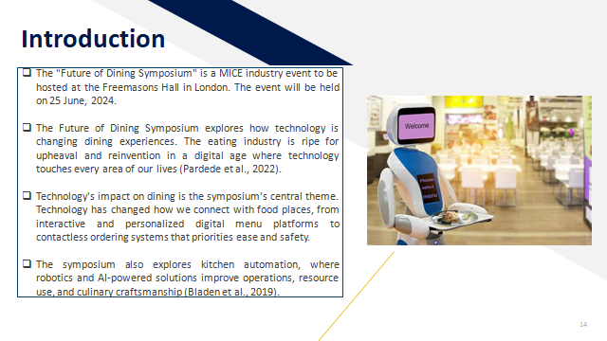
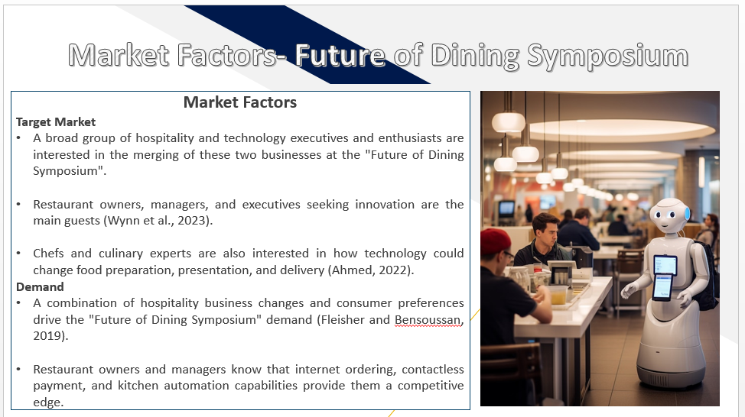
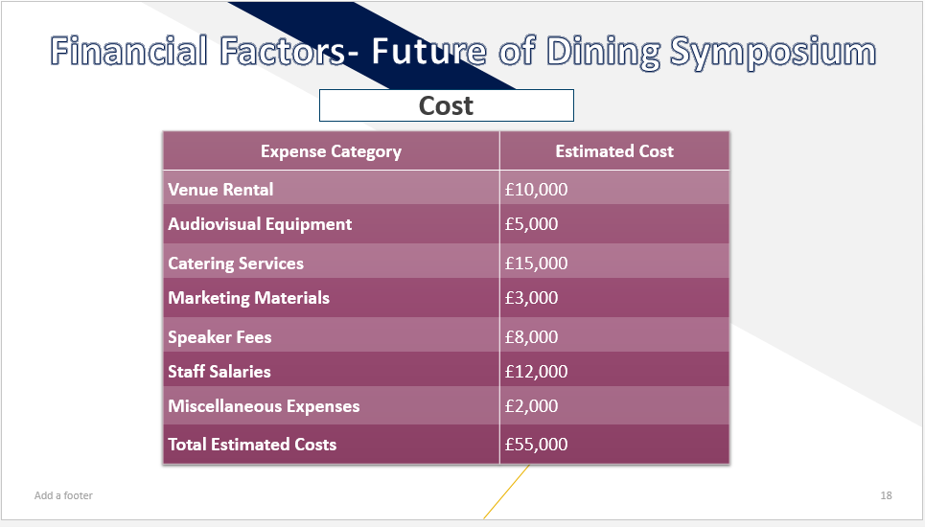
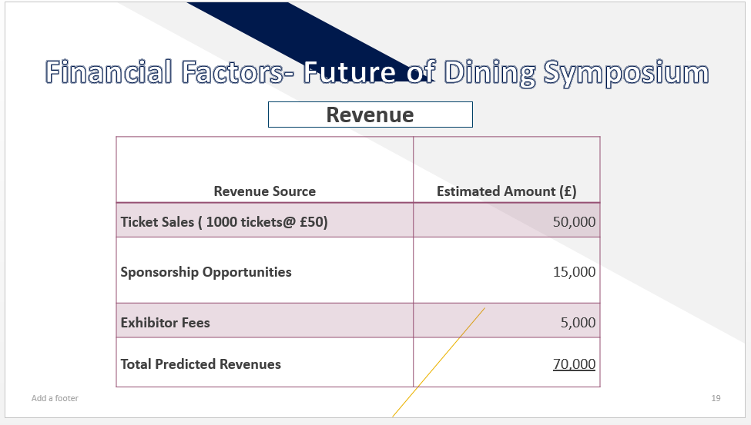
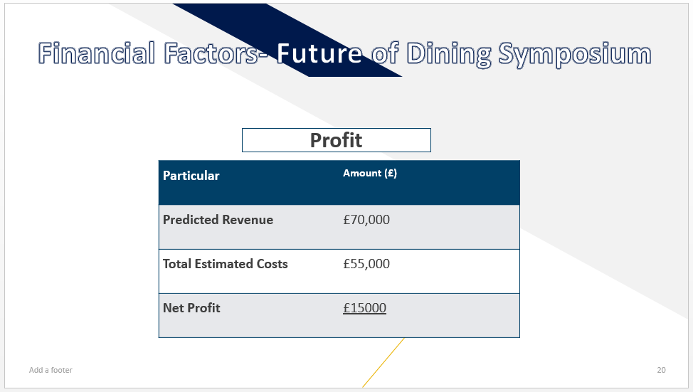
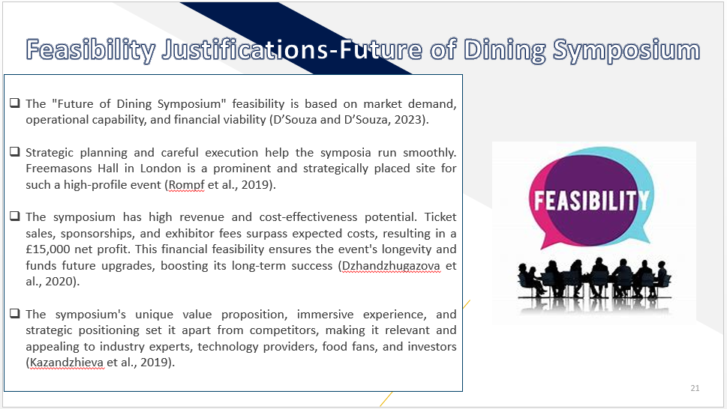
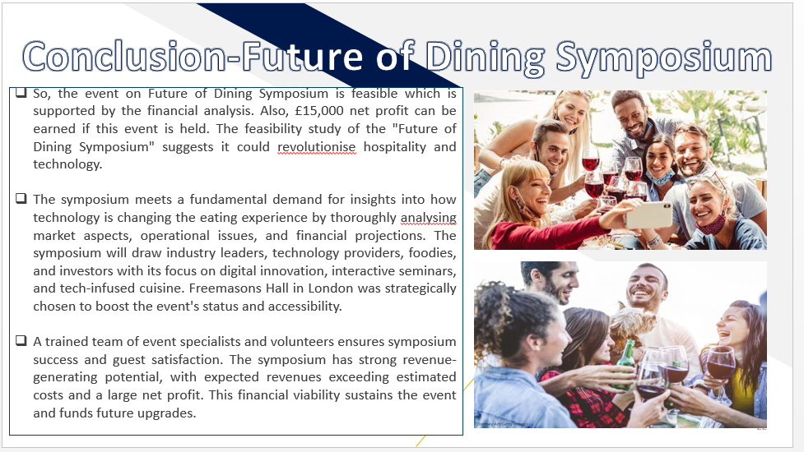
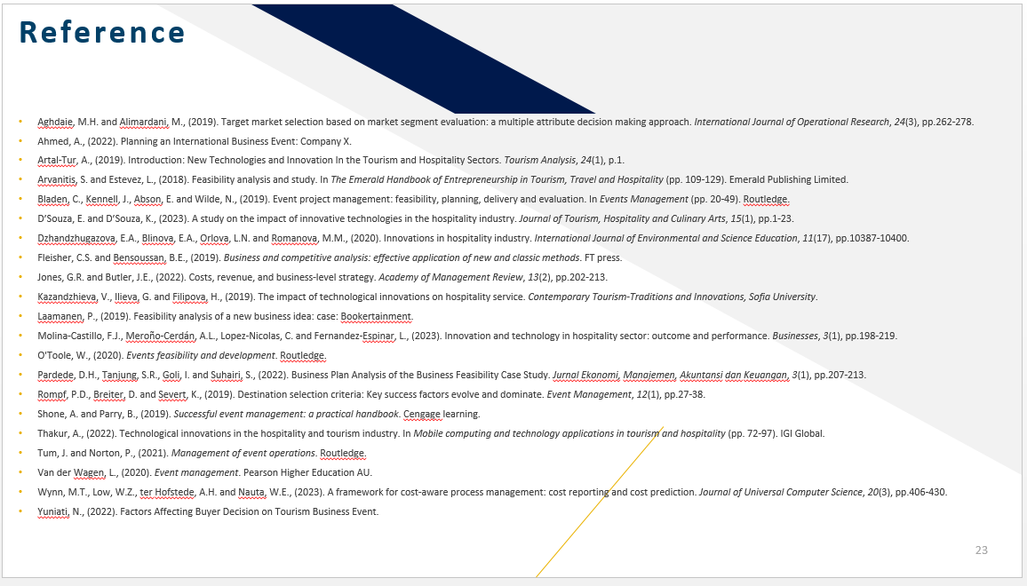

References
Aghdaie, M.H. and Alimardani, M., (2019). Target market selection based on market segment evaluation: a multiple attribute decision making approach. International Journal of Operational Research, 24(3), pp.262-278.
Ahmed, A., (2022). Planning an International Business Event: Company X.
Artal-Tur, A., (2019). Introduction: New Technologies and Innovation In the Tourism and Hospitality Sectors. Tourism Analysis, 24(1), p.1.
Arvanitis, S. and Estevez, L., (2018). Feasibility analysis and study. In The Emerald Handbook of Entrepreneurship in Tourism, Travel and Hospitality (pp. 109-129). Emerald Publishing Limited.
Bladen, C., Kennell, J., Abson, E. and Wilde, N., (2019). Event project management: feasibility, planning, delivery and evaluation. In Events Management (pp. 20-49). Routledge.
D’Souza, E. and D’Souza, K., (2023). A study on the impact of innovative technologies in the hospitality industry. Journal of Tourism, Hospitality and Culinary Arts, 15(1), pp.1-23.
Dzhandzhugazova, E.A., Blinova, E.A., Orlova, L.N. and Romanova, M.M., (2020). Innovations in hospitality industry. International Journal of Environmental and Science Education, 11(17), pp.10387-10400.
Fleisher, C.S. and Bensoussan, B.E., (2019). Business and competitive analysis: effective application of new and classic methods. FT press.
Jones, G.R. and Butler, J.E., (2022). Costs, revenue, and business-level strategy. Academy of Management Review, 13(2), pp.202-213.
Kazandzhieva, V., Ilieva, G. and Filipova, H., (2019). The impact of technological innovations on hospitality service. Contemporary Tourism-Traditions and Innovations, Sofia University.
Laamanen, P., (2019). Feasibility analysis of a new business idea: case: Bookertainment.
Molina-Castillo, F.J., Meroño-Cerdán, A.L., Lopez-Nicolas, C. and Fernandez-Espinar, L., (2023). Innovation and technology in hospitality sector: outcome and performance. Businesses, 3(1), pp.198-219.
O'Toole, W., (2020). Events feasibility and development. Routledge.
Pardede, D.H., Tanjung, S.R., Goli, I. and Suhairi, S., (2022). Business Plan Analysis of the Business Feasibility Case Study. JurnalEkonomi, Manajemen, AkuntansidanKeuangan, 3(1), pp.207-213.
Rompf, P.D., Breiter, D. and Severt, K., (2019). Destination selection criteria: Key success factors evolve and dominate. Event Management, 12(1), pp.27-38.
Shone, A. and Parry, B., (2019). Successful event management: a practical handbook. Cengage learning.
Thakur, A., (2022). Technological innovations in the hospitality and tourism industry. In Mobile computing and technology applications in tourism and hospitality (pp. 72-97). IGI Global.
Tum, J. and Norton, P., (2021). Management of event operations. Routledge.
Van der Wagen, L., (2020). Event management. Pearson Higher Education AU.
Wynn, M.T., Low, W.Z., terHofstede, A.H. and Nauta, W.E., (2023). A framework for cost-aware process management: cost reporting and cost prediction. Journal of Universal Computer Science, 20(3), pp.406-430.
Yuniati, N., (2022). Factors Affecting Buyer Decision on Tourism Business Event.

