Programme: BA Business Management

Module: Data Handling and Business Intelligence

Module code: LCBB5000
Student name:FLORINA DOBRE
Student id: 2112018
Lecturer: Eric Osei

Introduction:
In this report, we will evaluate a supermarket sales dataset to provide useful insights that can assist the company in making informed business decisions. The analysis will concentrate on identifying the most lucrative product line, evaluating the performance of each branch (A, B, and C), and analyzing sales performance by gender. Furthermore, we will examine customer ratings by utilizing descriptive statistics and discuss the benefits and drawbacks of using different analytical tools, such as SPSS, Excel, or Tableau. Lastly, we will elaborate on the significance and implications of the Data Mining Cycle, utilizing appropriate examples.

HOW I HAVE DONE (STEP BY STEP)

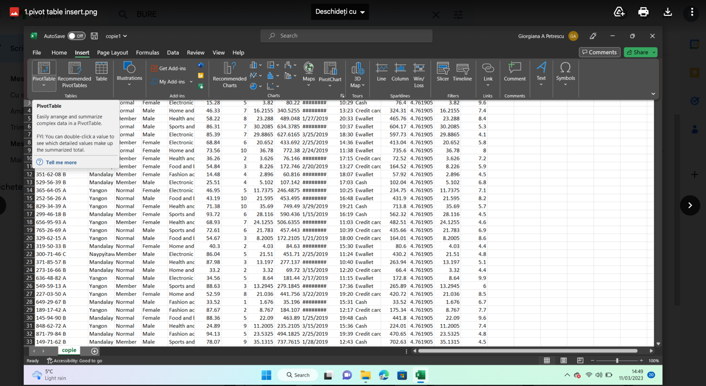

1.1. Inserting a pivot table: Open the "Insert" tab and click on the "PivotTable" button to create a new pivot table based on your data.

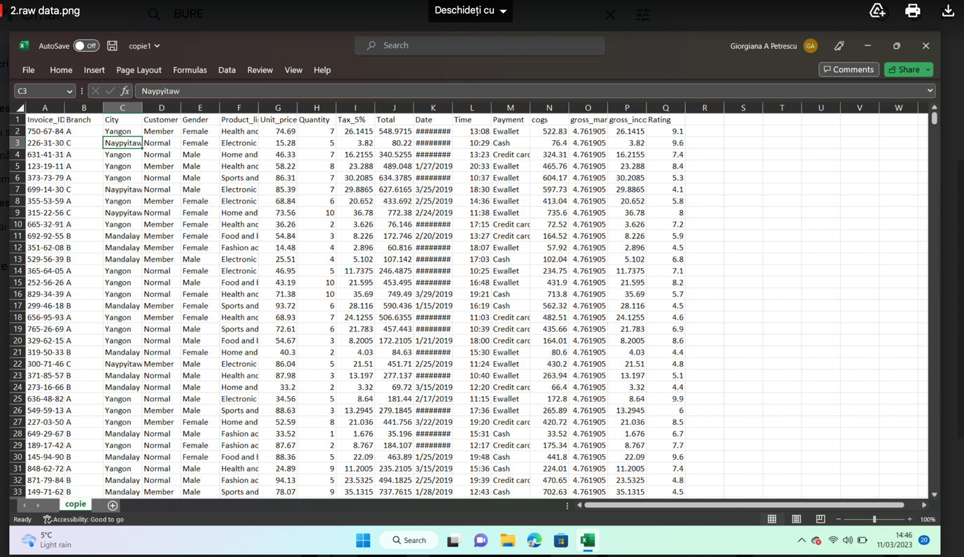

- Raw data: Display your raw data in SPSS for further analysis.

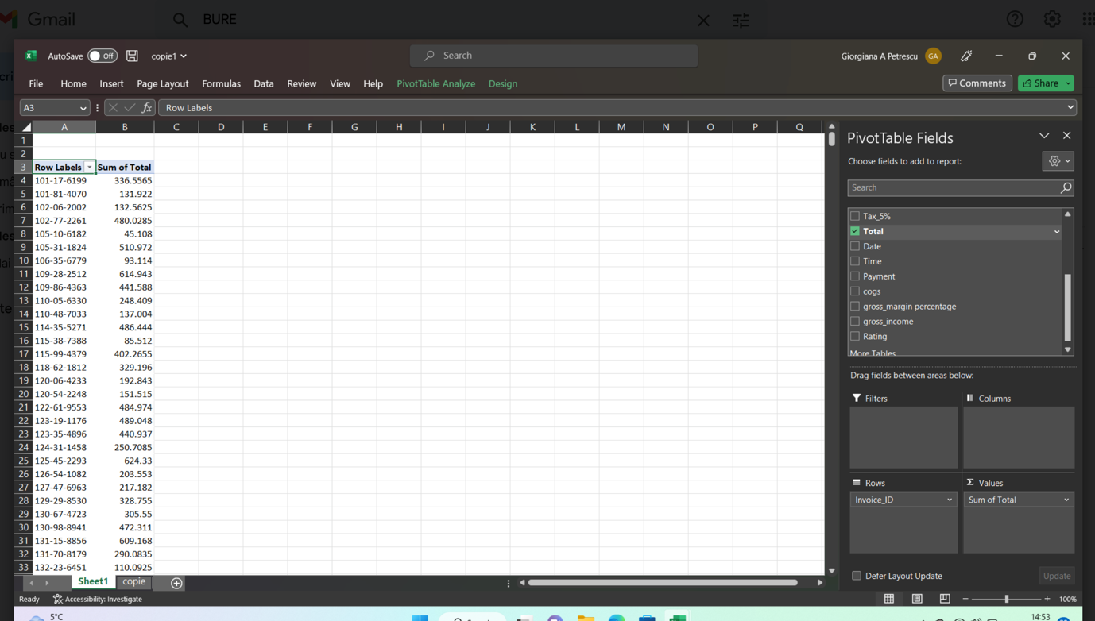

- Adding the "Invoice ID" and "Total" variables.

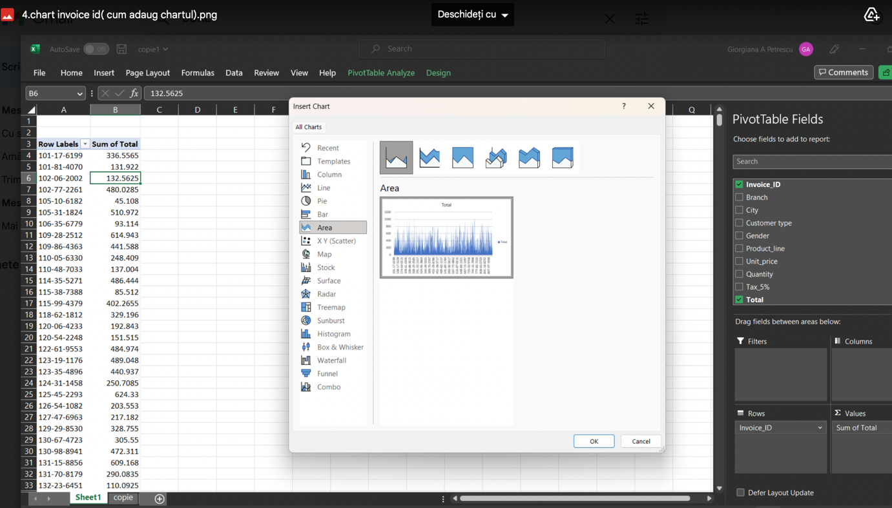

- Inserting a chart for Invoice ID: Create a chart based on the Invoice ID variable in the pivot table.

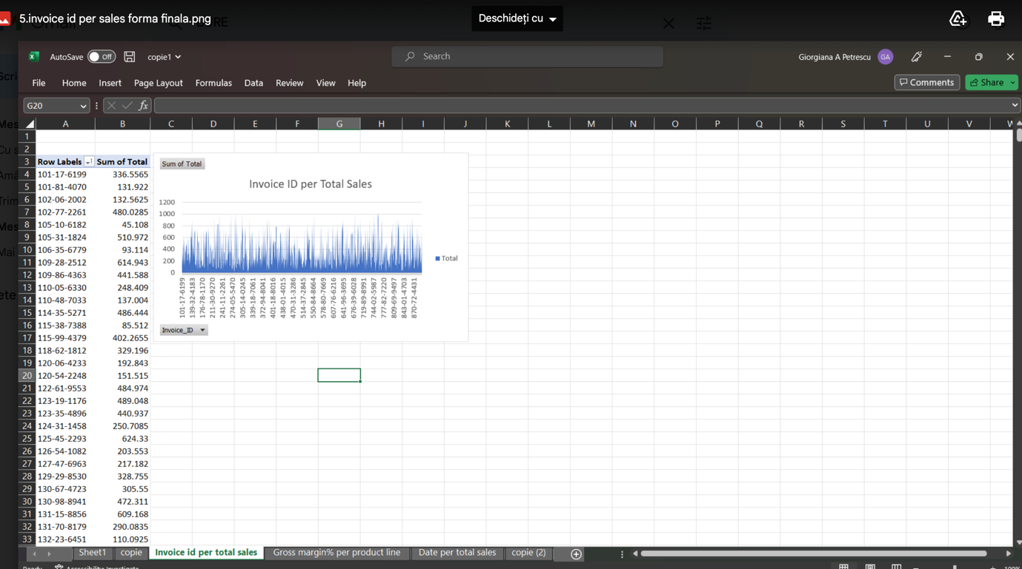

- Final form of Invoice ID per Sales: Display the final chart of Invoice ID per Sales.

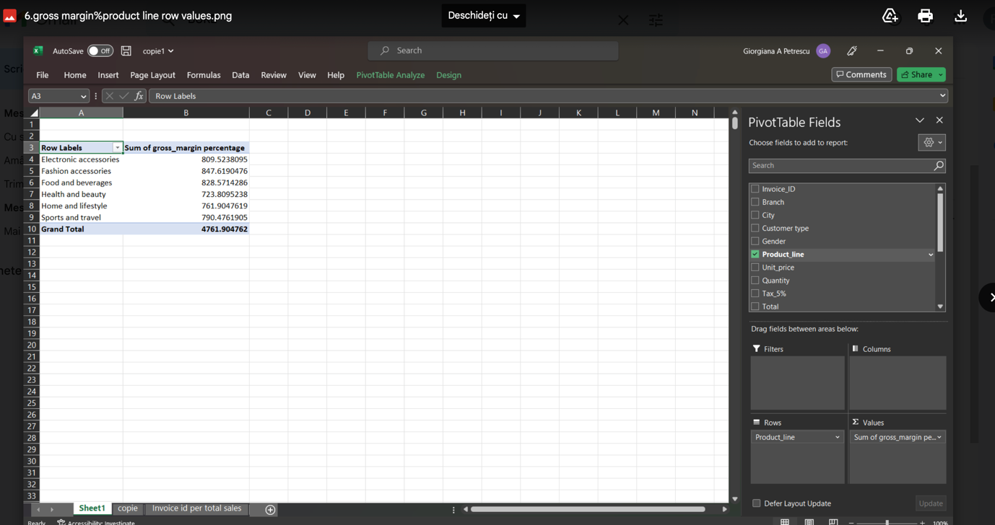
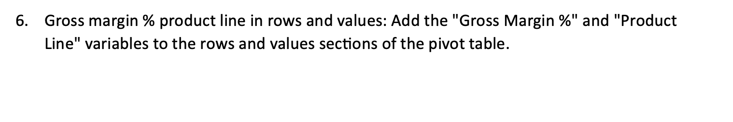
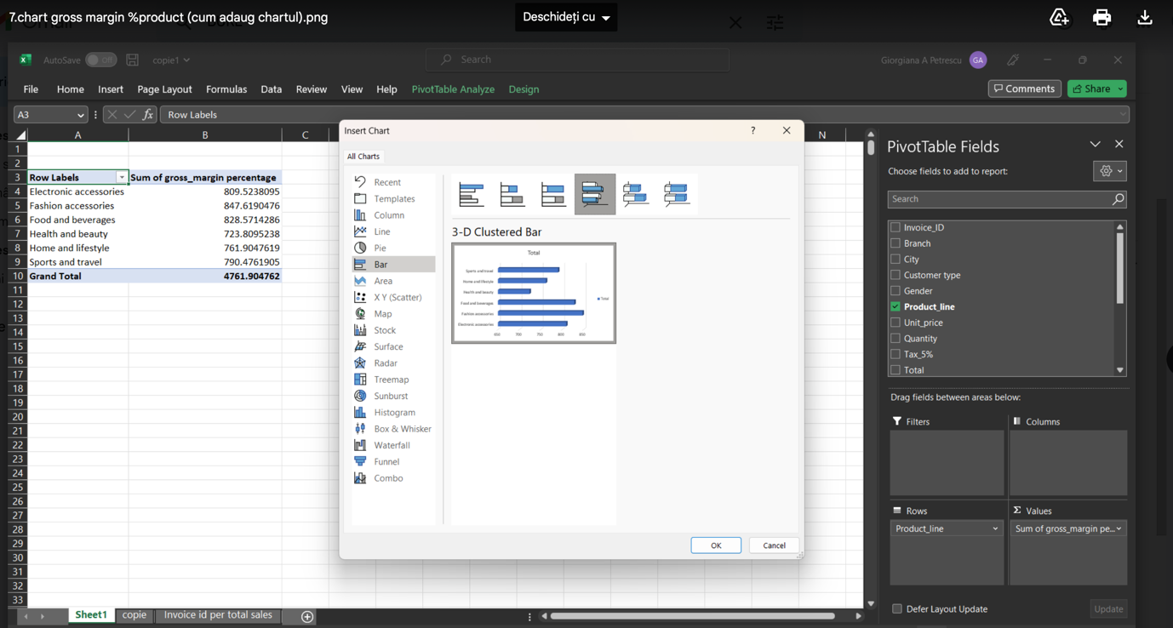

7.Inserting a chart for Gross Margin % product: Create a chart based on the Gross Margin % Product variable in the pivot table.

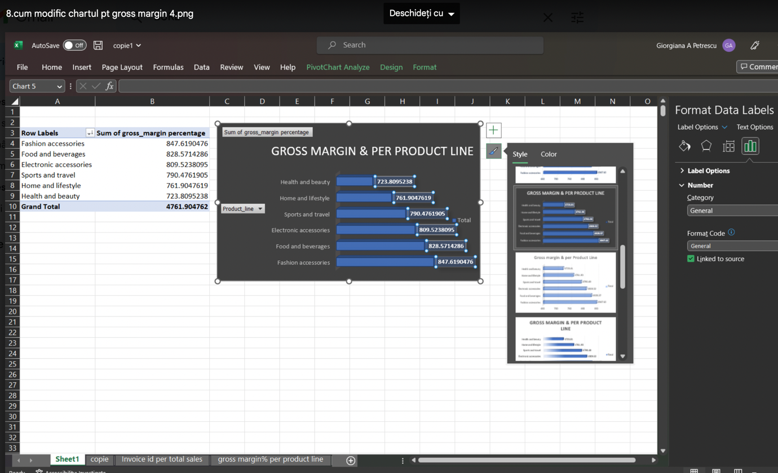

8.Modifying the chart for Gross Margin %: Edit the chart to customize the appearance and display of the Gross Margin % data.

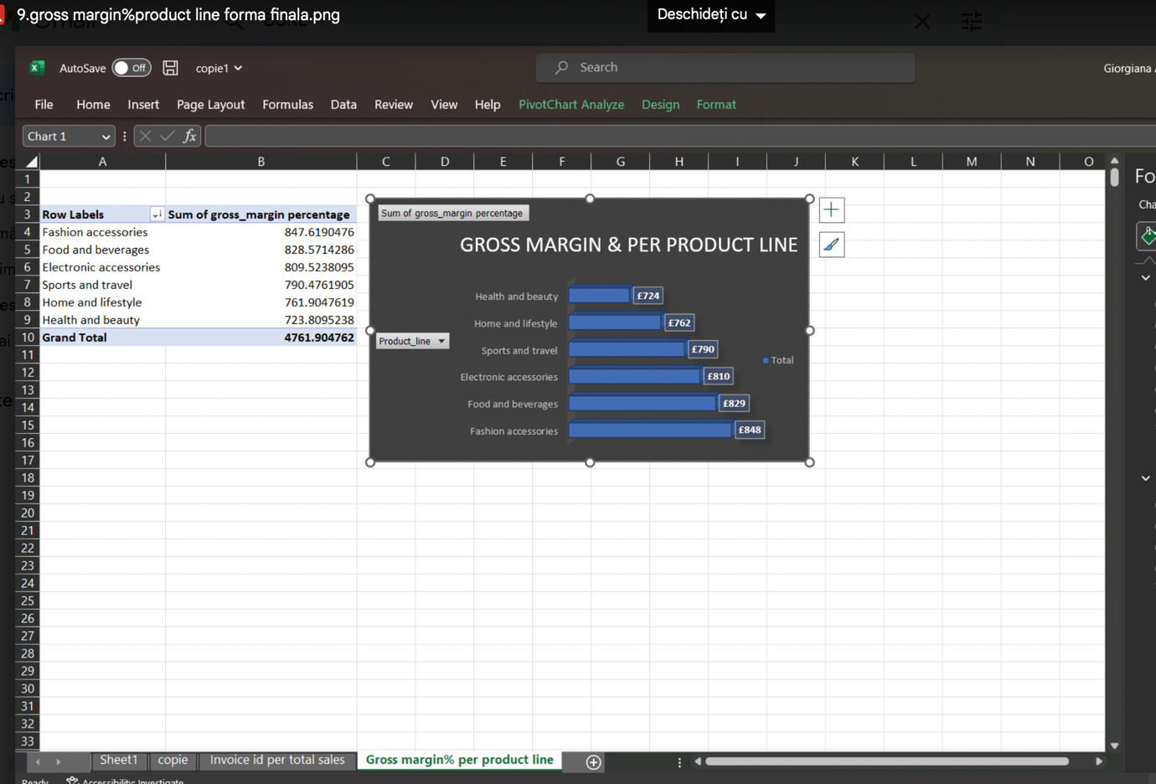

9.Final form of Gross Margin % product line: Display the final chart of Gross Margin % product line.

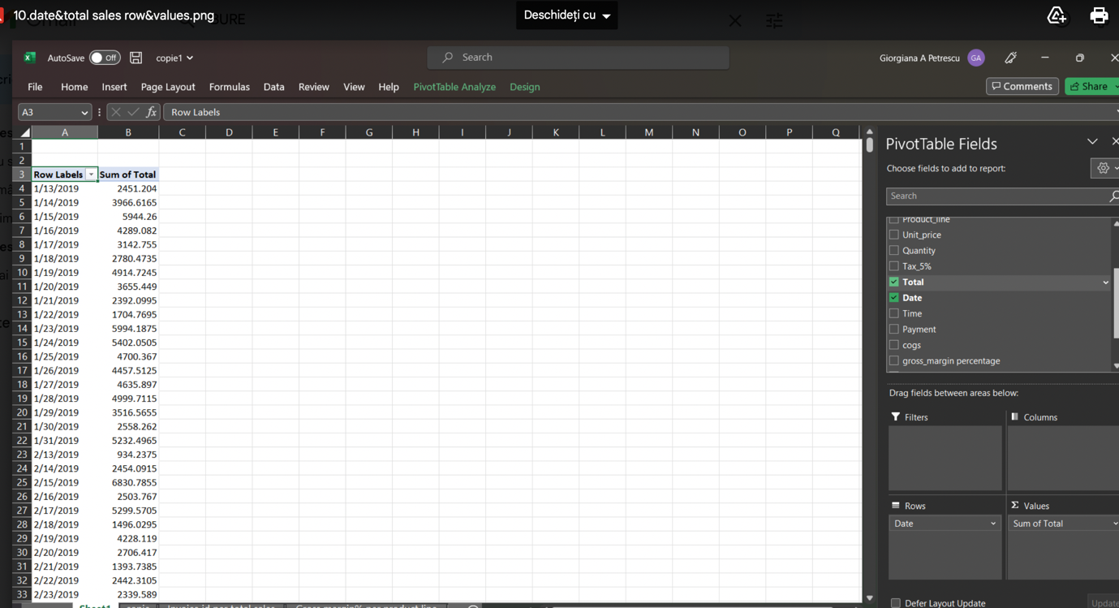

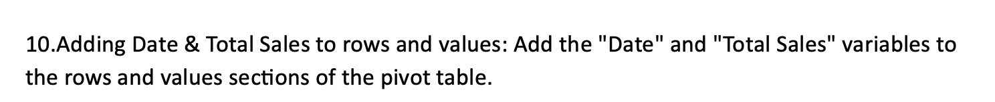

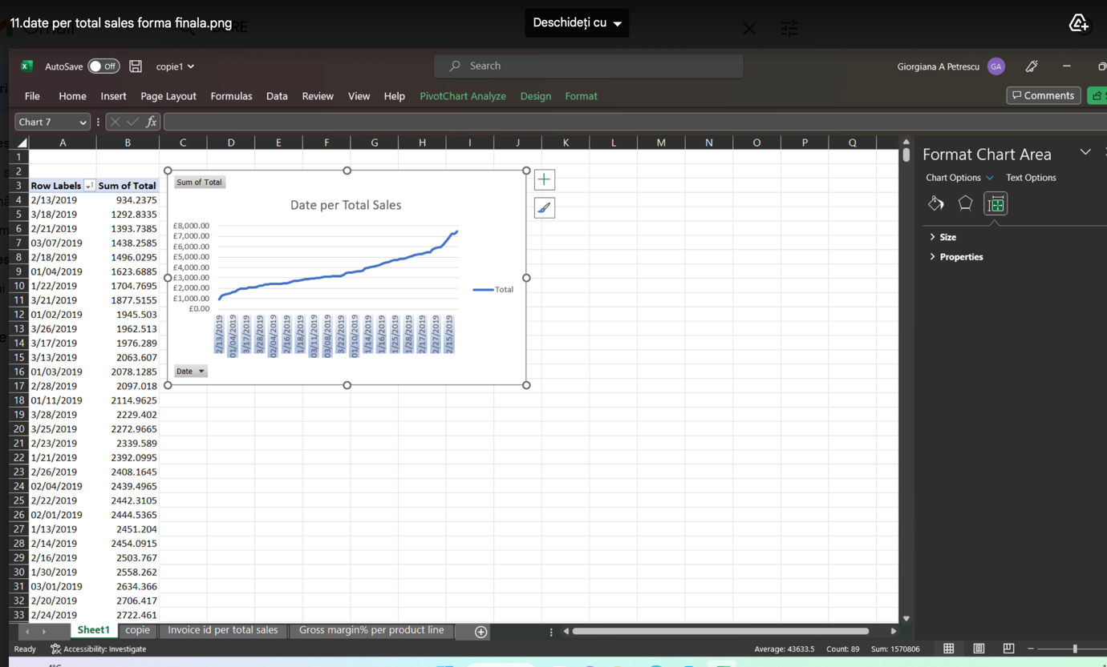

11.Final form of Date per Total Sales: Display the final chart of Date per Total Sales.

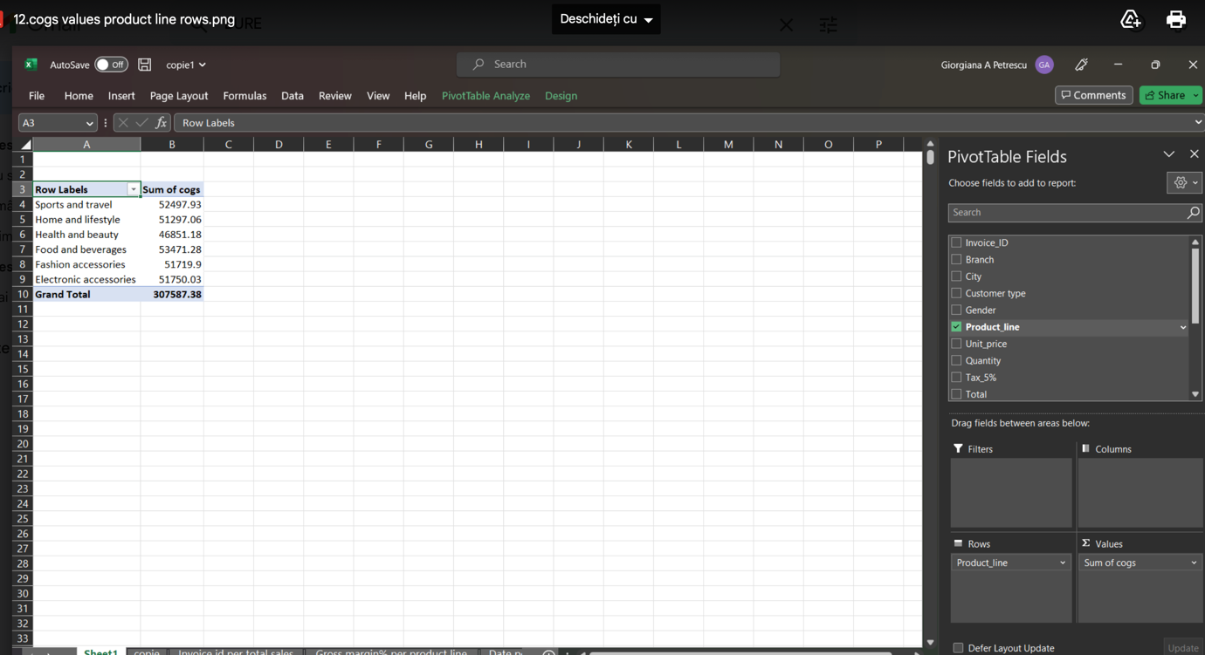

12.COGS values and Product Line in rows: Add the "COGS" values and "Product Line" variables to the rows section of the pivot table.
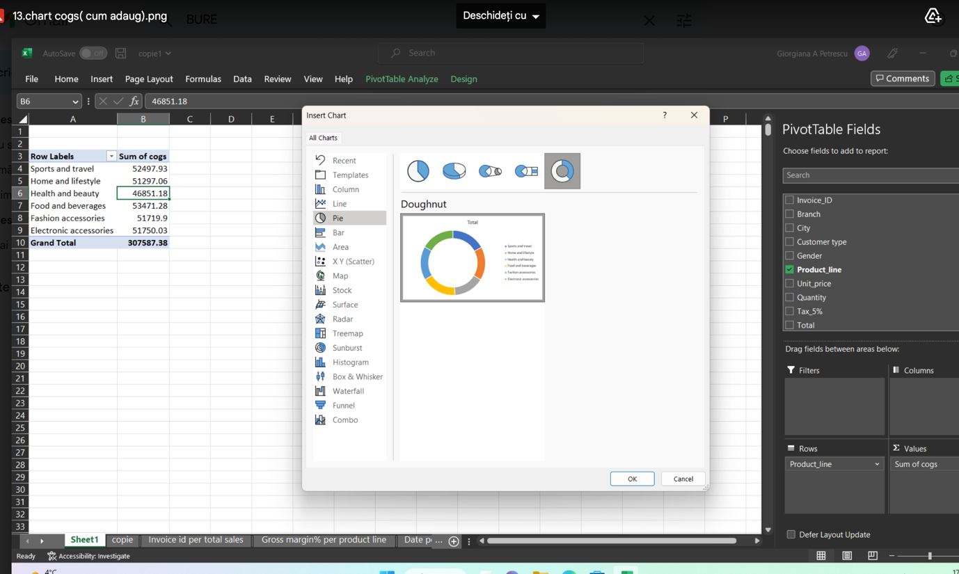

13.Inserting a chart for COGS: Create a chart based on the COGS variable in the pivot table.

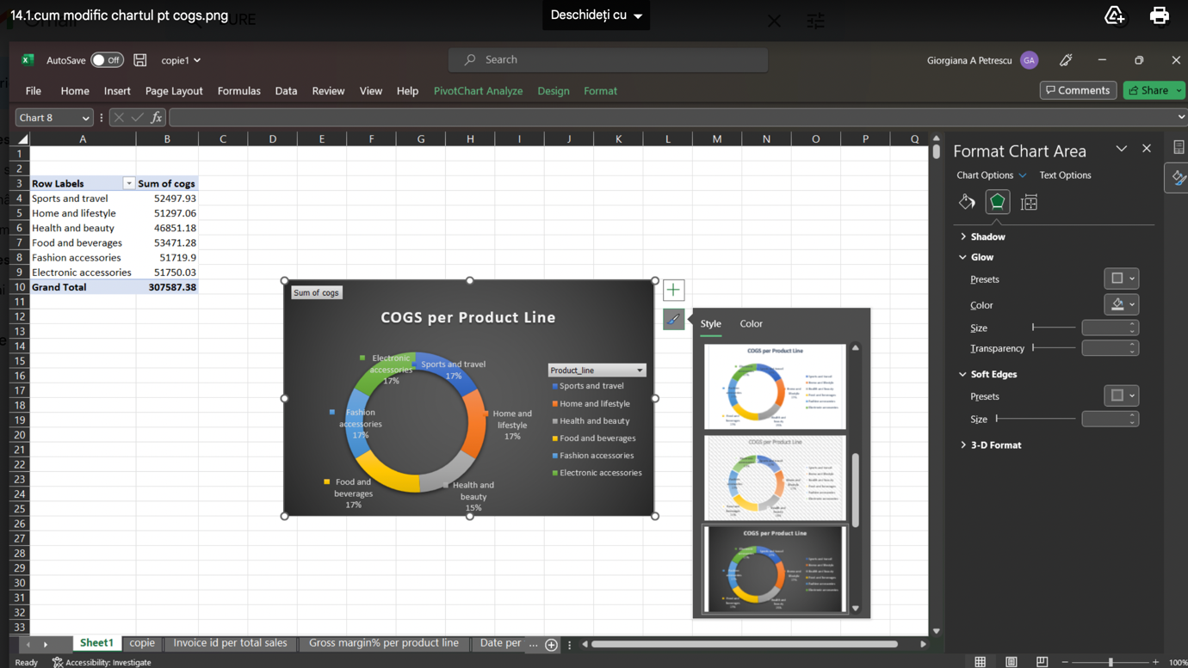

14.Modifying the chart for COGS: Edit the chart to customize the appearance and display of the COGS data.

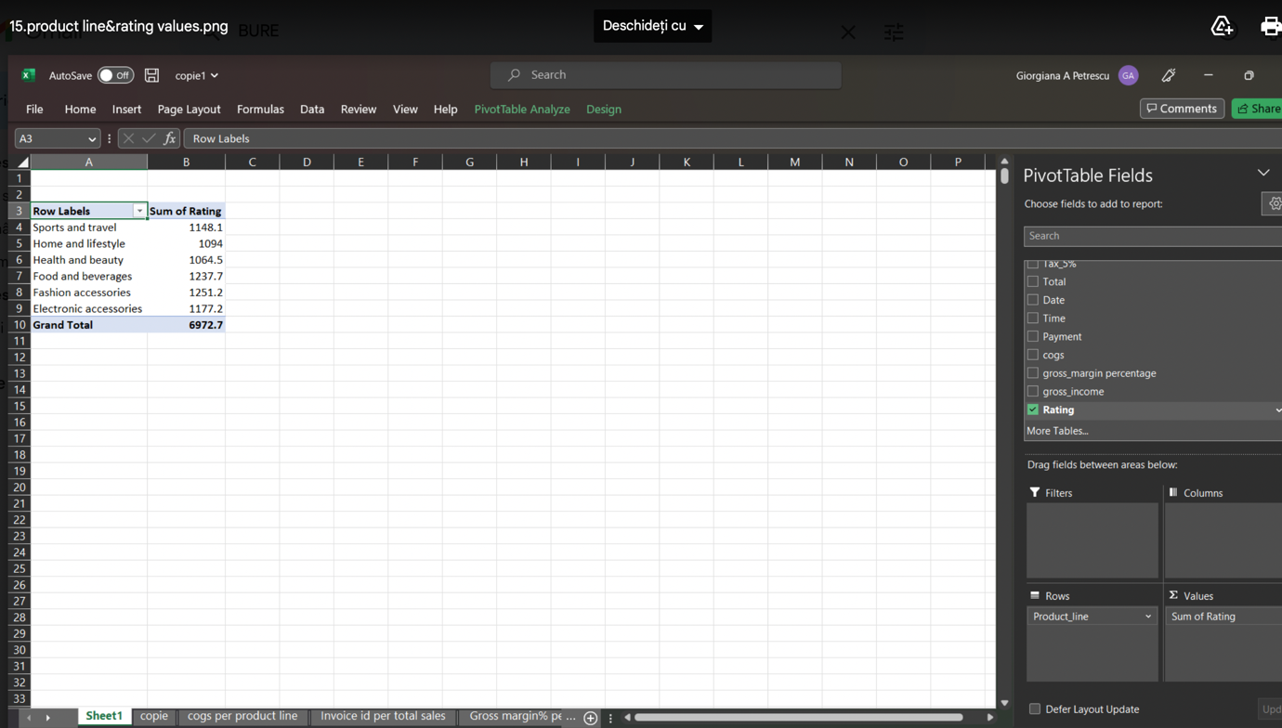

15.Adding Product Line & Rating values: Add the "Product Line" and "Rating" variables to the values section of the pivot table.

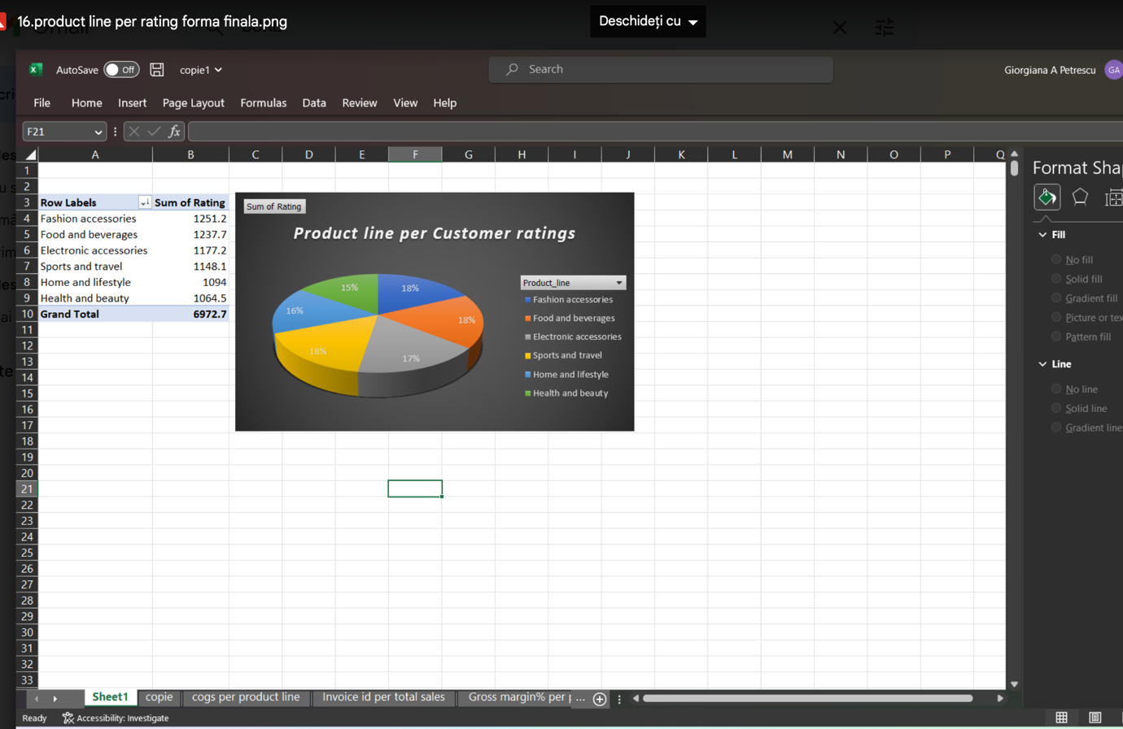

16.Final form of Product Line per Rating: Display the final chart of Product Line per Rating.
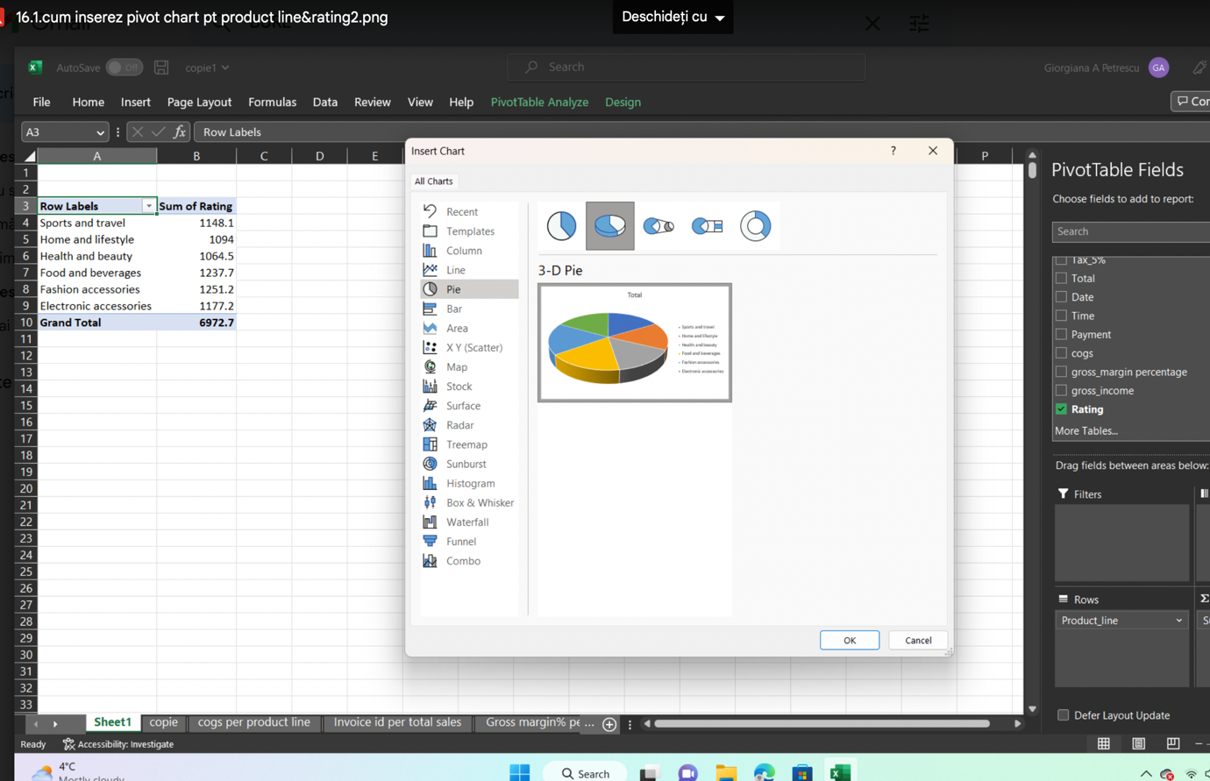

16.1. Inserting a pivot chart for Product Line & Rating: Create a pivot chart based on the Product Line & Rating variables in the pivot table.

- 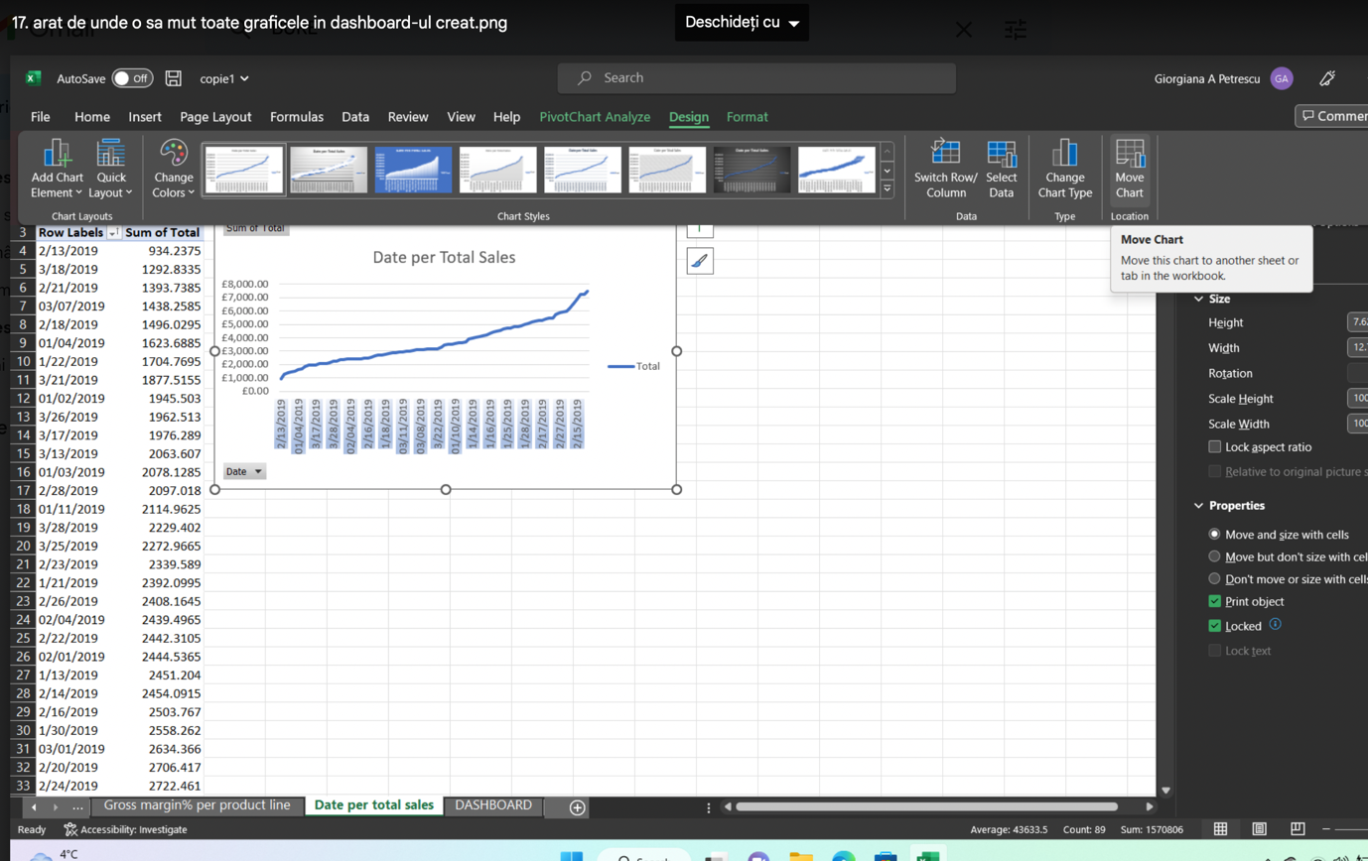 Preparing to move all charts to the dashboard: Get ready to copy and paste all charts into a single sheet or document to create a dashboard.

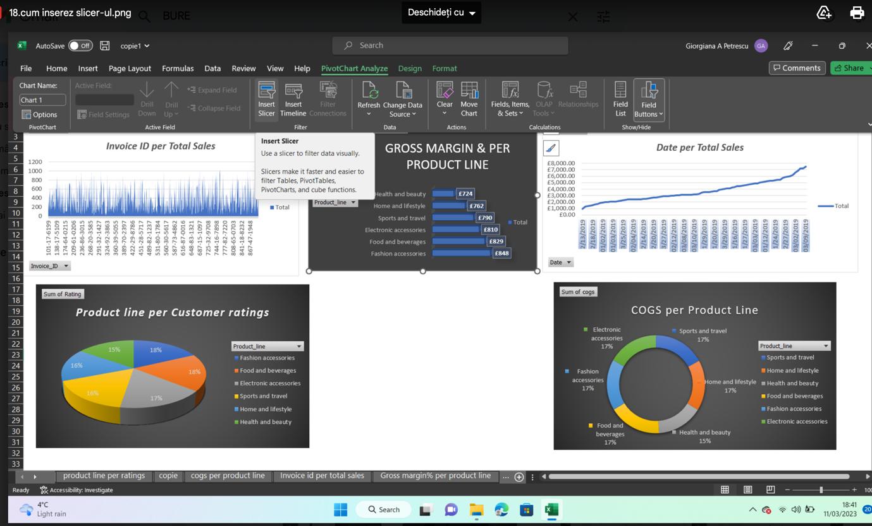
18.Inserting a slicer: Go to the "Insert" tab and select "Slicer" to add an interactive filter to your dashboard.
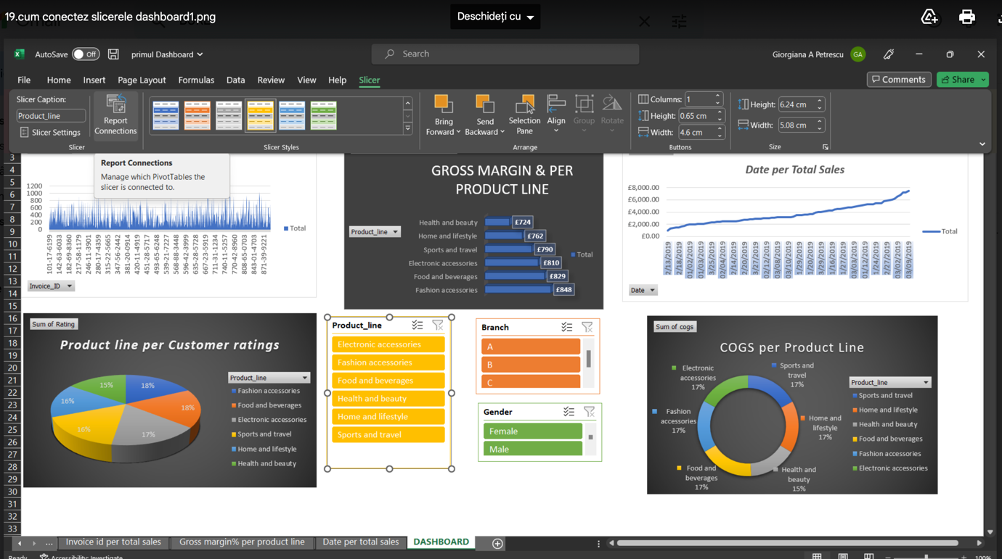

19NConnecting slicers to the dashboard: Link the slicers to the appropriate visualizations on your dashboard to enable users to filter the displayed data.
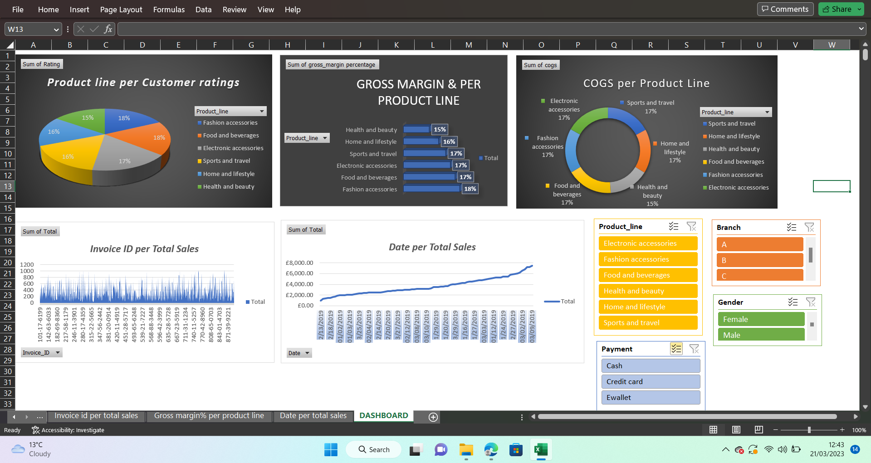
20,Final look of Dashboard 1: Display the completed dashboard with all visualizations and slicers.

Part one:



The gross margin, which is the profit earned by a company after deducting the cost of goods sold from its revenue, is crucial in determining the profitability of a product line. To identify the most profitable product line, it is necessary to analyze the gross margin, which can be calculated by subtracting the cost of goods sold from the revenue. Utilizing a pivot table or dashboard, we can filter the data by product line and calculate the total revenue, COGS, and gross margin for each product line. Furthermore, considering customer rating as a supplementary metric can assist in assessing the product line's popularity among customers. After gathering the relevant data, we can rank the product lines based on their gross margin and customer rating to identify the most profitable and popular product line. A higher gross margin and customer rating indicate a more profitable and popular product line. (Chakrabarti, 2003)We need to check the Dashboard for the following metrics: COGS, Gross Margin%, and Customer Rating, in order to determine the most profitable product line.
We can rate the product lines for each branch using the filter connections in the Branch window, and then determine which product line is the most successful across all branches.
The same ranking can be extract from pivot table or from Dashboard:
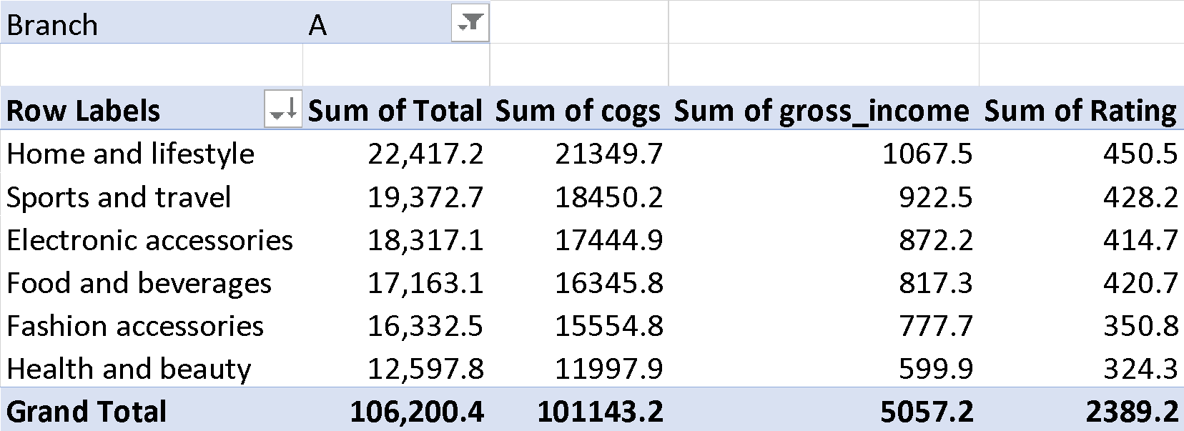

Branch | B
Row Labels | Sum of Total | Sum of cogs | Sum of gross_income | Sum of Rating
Sports and travel | 19,988.2 | 19036.4 | 951.8 | 403.6
Health and beauty | 19,980.7 | 19029.2 | 951.5 | 376.3
Home and lifestyle | 17,549.2 | 16713.5 | 835.7 | 325.8
Electronic accessories | 17,051.4 | 16239.5 | 812.0 | 391.4
Fashion accessories | 16,413.3 | 15631.7 | 781.6 | 416.8
Food and beverages | 15,214.9 | 14490.4 | 724.5 | 349.7
Grand Total | 106,197.7 | 101140.6 | 5057.0 | 2263.6

Branch | C
Row Labels | Sum of Total | Sum of cogs | Sum of gross_income | Sum of Rating
Food and beverages | 23,766.9 | 22635.1 | 1131.8 | 467.3
Fashion accessories | 21,560.1 | 20533.4 | 1026.7 | 483.6
Electronic accessories | 18,969.0 | 18065.7 | 903.3 | 371.1
Health and beauty | 16,615.3 | 15824.1 | 791.2 | 363.9
Sports and travel | 15,761.9 | 15011.4 | 750.6 | 316.3
Home and lifestyle | 13,895.6 | 13233.9 | 661.7 | 317.7
Grand Total | 110,568.7 | 105303.5 | 5265.2 | 2319.9

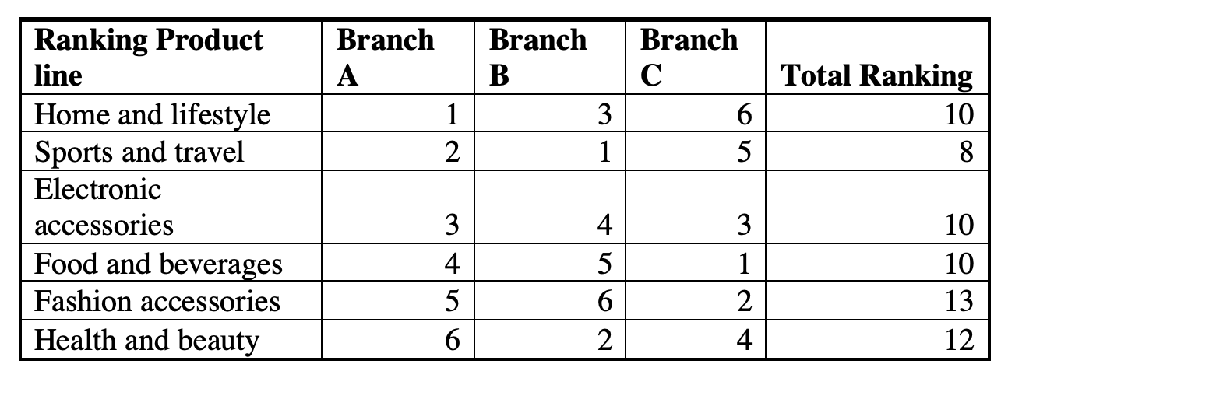

The smallest value from column Total Ranking from the above table will indicate the most profitable product line for all branches, in our case is Sport and Travel.

ii) The following is an analysis of the performance of branches A, B, and C based on the given data:
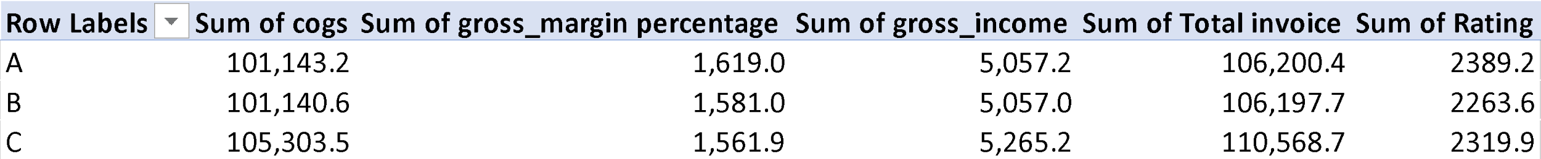

The analysis of the "Sum of gross_income" section indicates that branch C has the highest gross income, followed by branch B and then branch A. This implies that branch C has the highest revenue among the three branches. However, it is essential to consider other financial metrics such as gross margin, COGS, and customer ratings to gain a comprehensive understanding of a branch's financial performance and customer satisfaction.

The "Sum of gross_margin percentage" column reveals that branch A has the highest gross margin percentage, followed by branch B and branch C. This suggests that branch A is performing well in terms of revenue generation.
The "Sum of cogs" column highlights that branch C has a higher COGS than branches A and B, indicating potential production inefficiencies or higher production costs. Branch C needs to analyze its COGS to identify ways to reduce expenses and improve profitability.

In contrast, the "Sum of Rating" section reveals that branch A has the highest customer reviews, indicating a high level of customer satisfaction. Branch B, however, has the lowest customer satisfaction and may need to improve its customer service or product quality to meet customer expectations.

Each branch has its unique strengths and weaknesses. While branch C has the highest gross income, it has the lowest gross margin. Branch A performs well in terms of gross margin percentage and customer satisfaction, despite having the lowest gross income. Meanwhile, branch B needs to enhance its customer service to improve customer satisfaction.

To improve the overall performance of the company, management needs to analyze these areas and implement necessary changes. By identifying and addressing areas of weakness, management can improve profitability, customer satisfaction, and overall company performance.
In conclusion, analyzing multiple financial metrics such as gross margin, COGS, and customer ratings is crucial in evaluating a branch's financial performance and customer satisfaction. These insights can assist management in identifying areas of improvement and implementing necessary changes to enhance overall performance. (Han, Pei and Kamber, 2011; Hastie et al., 2009)

iii) We can see the company's sales success by gender across various product categories based on the provided data:
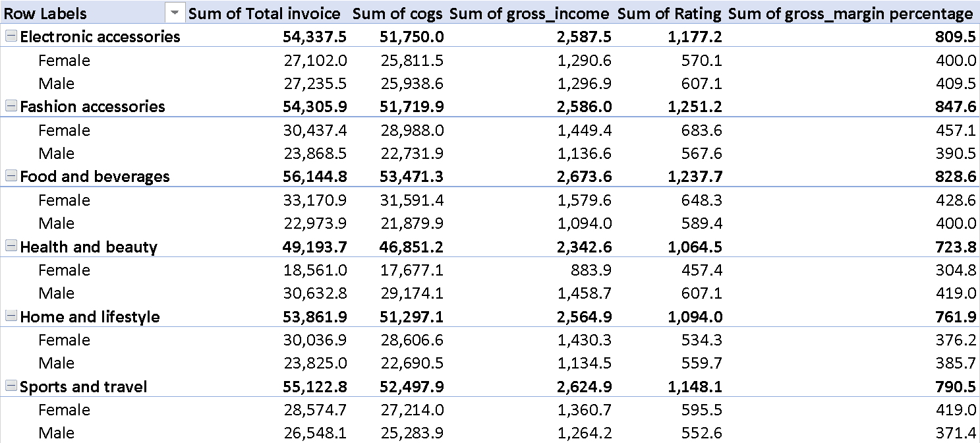
The analysis of sales data indicates that there is not much difference in sales between men and women across all product categories, with only slight variations in some areas. However, when examining gross revenue and gross margin percentage, some interesting insights can be derived. Female customers generate slightly less gross revenue than male customers, but they have a higher gross margin percentage in all areas except for food and beverages. This implies that sales to female customers have a higher profit margin for the business than sales to male customers. Furthermore, the gross margin percentage varies depending on the gender for each product category, with male customers having higher gross margin percentages in the food and beverage category and female customers having higher gross margin percentages in electronic accessories and health and beauty products.

Customer ratings do not differ much between male and female customers across all product categories. This suggests that the businesses are performing well in terms of customer satisfaction across all genders and product groups.

To increase the gross margin percentage for both male and female consumers across all product categories, it would be beneficial for the businesses to further analyze this data. While the sales revenue between men and women is comparable, the data shows that male customers generate slightly more revenue than female customers. By identifying successful strategies for appealing to female customers, the company can implement them in other product categories to enhance profitability. (Berry and Linoff, 2004; Berson and Smith, 1997; Aggarwal, 2015)
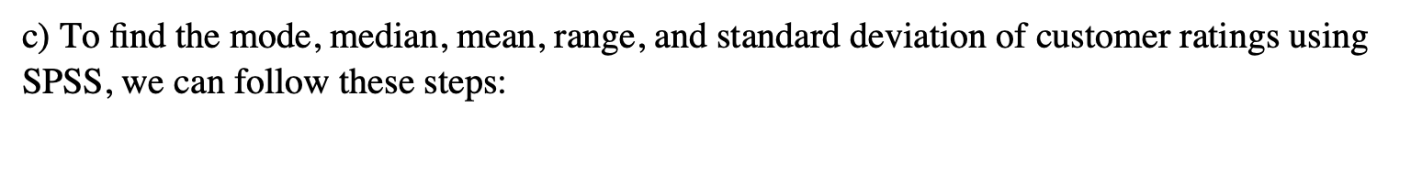



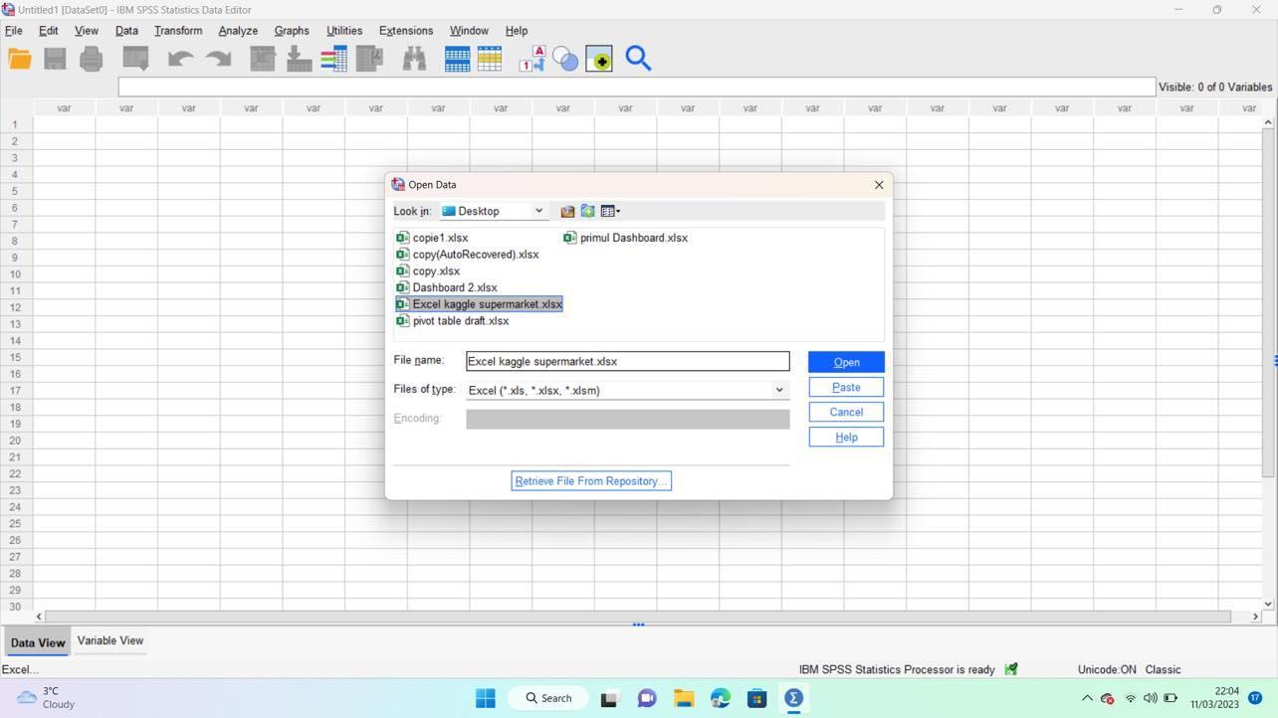

3. Select "Analyze" from the top menu, then "Descriptive Statistics", and then "Frequencies".
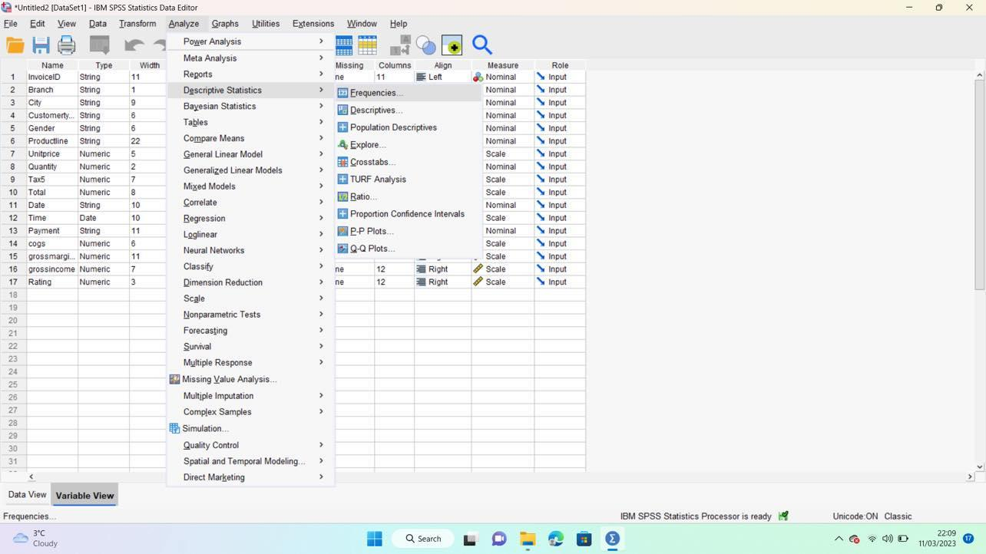

4. Move the "Rating" variable to the "Variable(s)" box on the right-hand side.
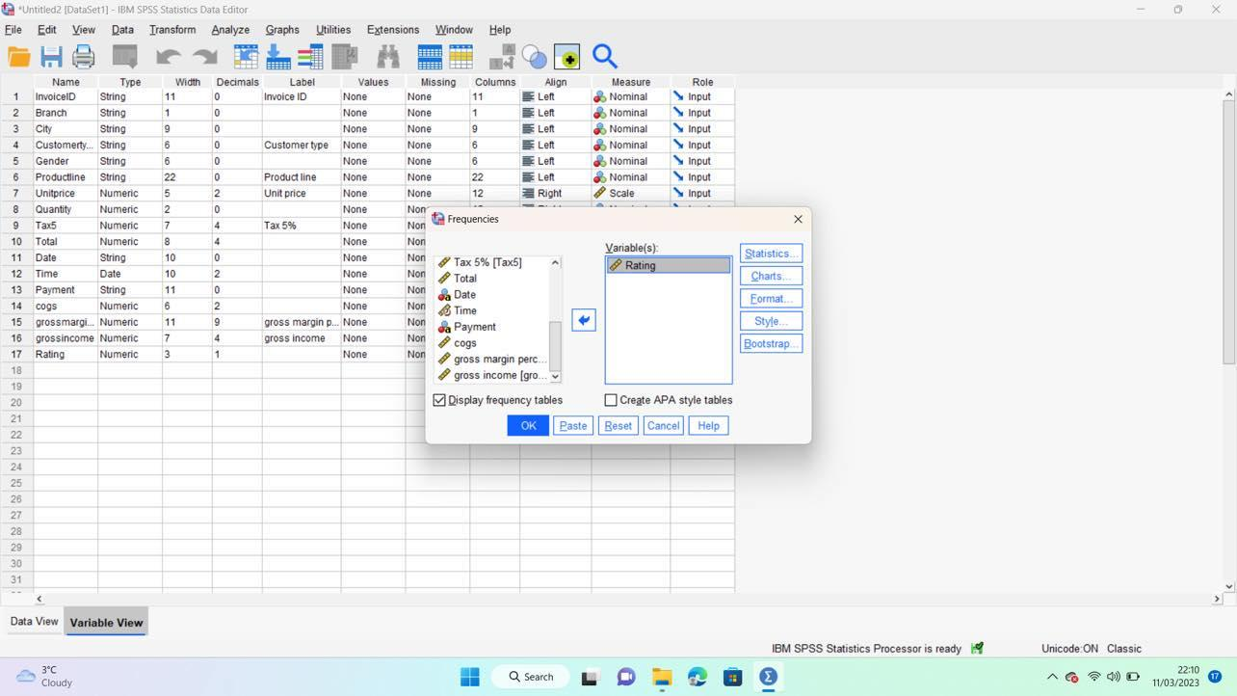
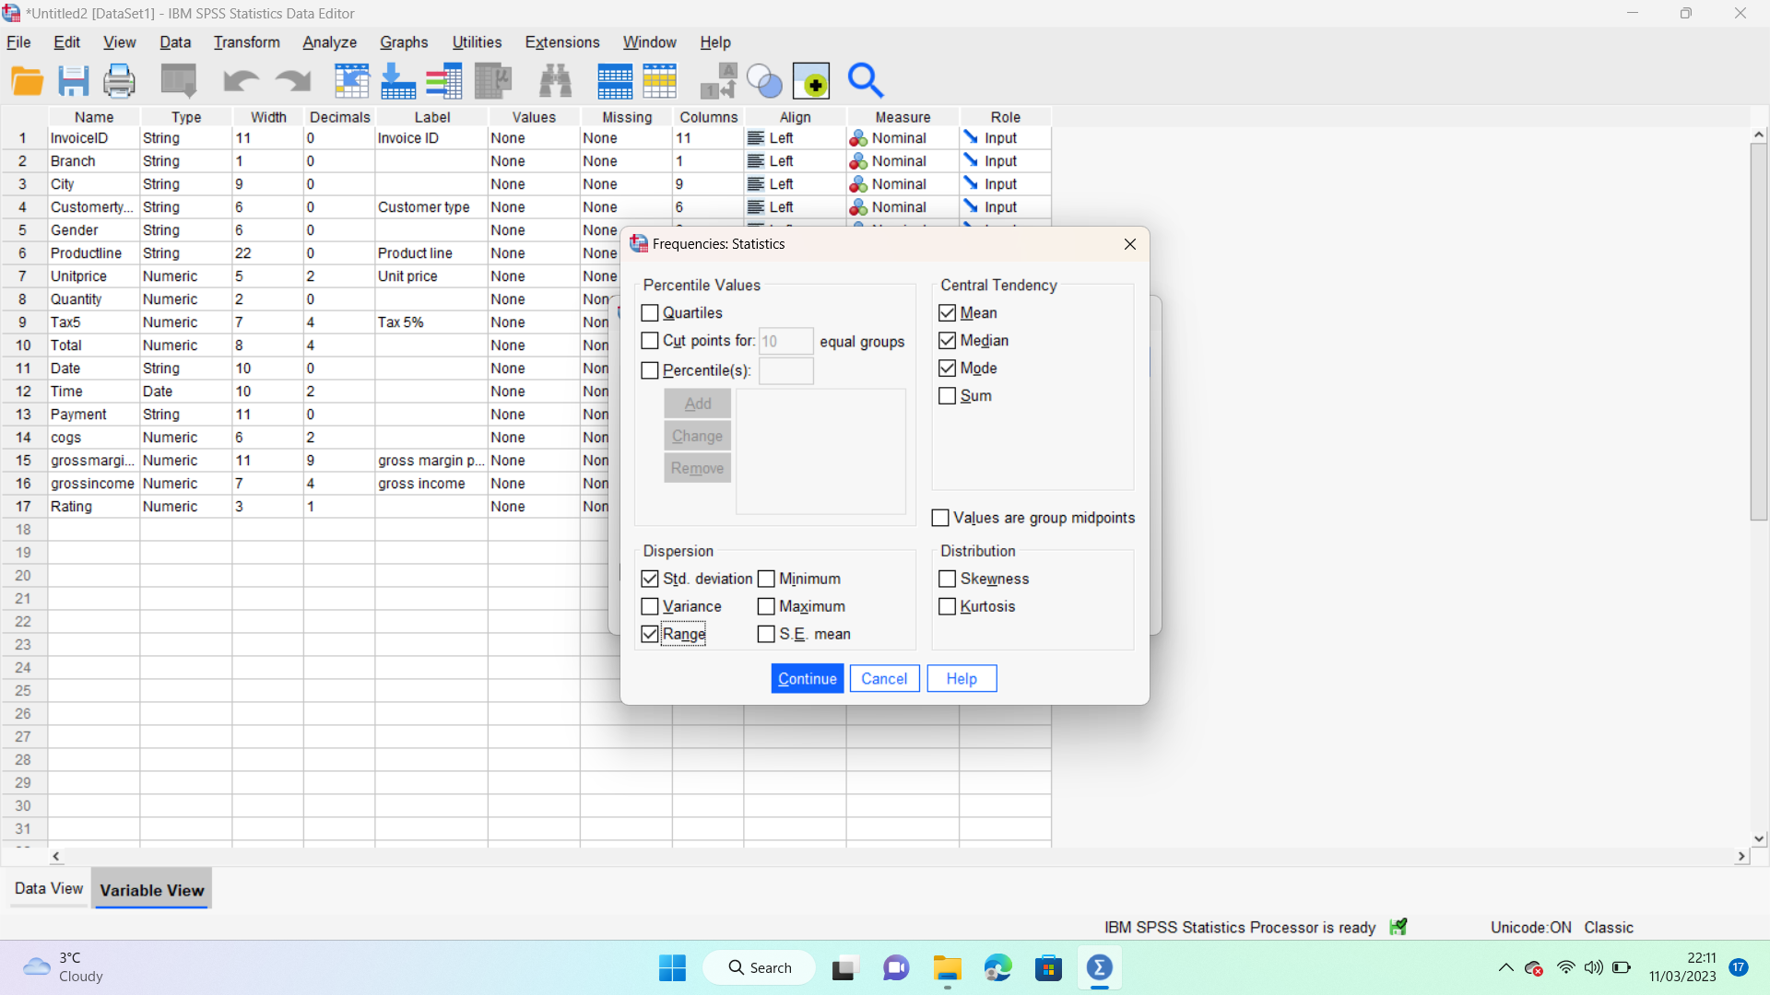
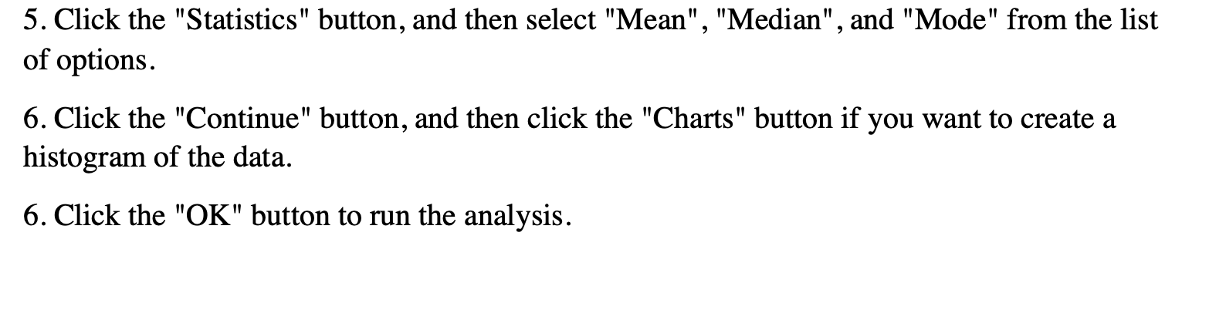

Customer Rating | All Branch | Branch A | Branch B | Branch C | Female | Male
Mode | 6.00 | 4.20 | 5.10 | 9.50 | 9.50 | 6.00
Median | 7.00 | 7.10 | 6.70 | 7.10 | 7.10 | 6.90
Mean | 6.97 | 7.03 | 6.82 | 7.07 | 6.96 | 6.98
Range | 6.00 | 6.00 | 6.00 | 6.00 | 6.00 | 6.00
Standard Deviation | 1.72 | 1.73 | 1.71 | 1.70 | 1.11 | 1.17

Based on the information provided, several conclusions can be drawn. The average customer rating across all locations and gender categories is 6.00, which is the most frequently occurring rating. The norm for customer ratings is 7, with half of the ratings above and half below this value. The mean of customer reviews is 6.97, indicating a slight leftward skew in the distribution of ratings. The customer rating range is 6.00, with the highest rating being six points higher than the lowest rating. The standard deviation of customer ratings varies marginally between gender categories and branches, with Branch A having the highest variability and the female group having the lowest variability.

In summary, the data suggests that the distribution of customer ratings is slightly left-skewed and the most common rating is 6. There is limited variability in the customer ratings across branches and gender categories.
Conclusion:
In conclusion, the analysis of the supermarket sales dataset has provided valuable insights into the company's performance, product lines, and customer demographics. The utilization of data visualization tools, such as Excel, and the application of descriptive statistics in SPSS have enabled us to identify the most profitable product line, compare the performance of the three branches, and assess the sales performance by gender. These insights can guide the company in making strategic decisions to improve overall performance and customer satisfaction.

Part 2 – 20 marks :


- SPSS (Statistical Package for the Social Sciences)
Advantages:
- Advanced statistical analysis: SPSS is specifically designed for conducting complex statistical analysis, making it ideal for academic research, social science studies, and market research(Hand et.al 2001)
- User-friendly interface: SPSS has a graphical user interface that is easy to navigate, which makes it suitable for beginners and experts alike.
- Comprehensive data management: SPSS allows users to import data from multiple sources, clean it, and perform extensive data transformation.
Disadvantages:
- Cost: SPSS is a proprietary software and can be quite expensive, especially for individual users or small organizations.
- Limited visualization capabilities: Although SPSS can generate basic charts and graphs, its visualization capabilities are limited compared to Tableau.
Practical example: A researcher could use SPSS to analyze the relationship between variables in a large social science dataset, such as examining the factors that influence voter turnout in a particular election.
- Microsoft Excel
Advantages:
- Wide adoption: Excel is widely used across various industries, making it a popular choice for basic data analysis and management tasks.
- Easy to use: Excel has a user-friendly interface, making it accessible for users with little experience in data analysis.
- Cost-effective: Excel is often included in Microsoft Office suites, making it a cost-effective option for many organizations.
Disadvantages:
- Limited statistical capabilities: Excel is not designed for advanced statistical analysis, which limits its usefulness in complex research projects.
- Scalability: Excel can struggle with large datasets, which can lead to slow performance and limited analytical capabilities.
Practical example: A small business owner could use Excel to track their monthly expenses and revenues, and create a simple visual representation of their financial performance over time(Chen et.al 2012)
- Tableau
Advantages:
- Powerful data visualization: Tableau is specifically designed for creating interactive and visually appealing data visualizations, which can be easily shared and understood by a wide audience. (Hand, Mannila and Smyth,2001)
Disadvantages
- Cost: Tableau can be expensive, particularly for smaller organizations or individual users.
- Limited statistical capabilities: Although Tableau offers some statistical features, it is not designed for complex statistical analysis like SPSS.Practical example: A marketing analyst could use Tableau to create an interactive dashboard that displays key performance indicators (KPIs) for an online advertising campaign, making it easy to identify trends and areas for improvement(Berry and Linoff,2004)
- In conclusion, the choice between SPSS, Excel, or Tableau will largely depend on the specific needs of the users, such as the complexity of the analysis, budget constraints, and the importance of data visualization.


b) The Data Mining Cycle refers to a series of iterative steps that guide the process of extracting valuable insights, patterns, and relationships from large datasets. It is crucial in the data mining process as it ensures a systematic and efficient approach to discovering meaningful information that can be used for decision-making and predictive modeling. The Data Mining Cycle typically consists of the following six steps:
- Business understanding: In this stage, the main objective is to understand the problem or goal from a business perspective. This involves identifying the key stakeholders, defining the project's scope, and setting clear objectives(Berson and Smith,1997)
Example: A retail company wants to improve its targeted marketing efforts and increase customer retention. They aim to identify specific customer segments and their preferences to develop tailored marketing campaigns.
- Data understanding: This stage involves collecting, exploring, and understanding the available data. It includes assessing data quality, identifying potential issues, and understanding the relationships between variables.
Example: The retail company collects data on customer demographics, purchase history, online browsing behavior, and customer feedback. They analyze the data to understand trends and correlations that may be relevant to their marketing goals(Fayyad et.al 1996)
- Data preparation: In this stage, the data is cleaned, transformed, and pre-processed to make it suitable for data mining algorithms. This may involve handling missing values, removing outliers, normalizing data, and selecting relevant features.
Example: The retail company cleans the data by filling in missing values, removing duplicate entries, and encoding categorical variables. They also create new variables, such as average spending per transaction and frequency of store visits.
- Data modeling: This step involves selecting and applying appropriate data mining techniques and algorithms to discover patterns and relationships within the data. The choice of algorithms depends on the specific objectives and the nature of the data.
Example: The retail company applies clustering algorithms, such as k-means, to segment customers based on their spending habits, demographics, and preferences. They also use association rule mining to identify common product combinations that customers purchase.
- Model evaluation and validation: In this stage, the performance of the data mining models is assessed to ensure they meet the business objectives. This may involve measuring model accuracy, precision, recall, or other relevant metrics, and fine-tuning the model as needed(Hastie, Tishbirani and Friedman,2009)
Example: The retail company evaluates the customer segmentation model by analyzing the characteristics of each cluster and ensuring they align with their marketing goals. They may also use cross-validation or holdout samples to assess the model's performance on unseen data.
- Deployment and monitoring: The final step is to deploy the data mining models and insights into business processes, such as marketing campaigns, and monitor their performance over time. This may involve adjusting the models as new data is collected or business objectives change.
Example: The retail company launches targeted marketing campaigns based on the customer segments identified in the data mining process. They monitor the campaigns' performance, track customer retention rates, and make adjustments as needed to improve their effectiveness.
The Data Mining Cycle is crucial for ensuring a structured and efficient approach to discovering valuable insights from data. By following these steps, organizations make better the company in terms of its business process, operations. Therefore, these it is offering to the company a crucial aspect when considering the competition. Companies that are using this it is widely known that they receive a great competitive advantage. (Chaudhuri and Dayal,1997)

References:
- Aggarwal, C.C. 2015, Data mining: the textbook, Springer, Cham, Switzerland.
- Berson, A. and Smith, S.J. 1997, Data warehousing, data mining, and OLAP, McGraw-Hill, New York.
- Berry, M.J.A. and Linoff, G.S. 2004, Data mining techniques: for marketing, sales, and customer relationship management, 2nd edn, Wiley, Indianapolis, IN.
- Chakrabarti, S. 2003, Mining the web: discovering knowledge from hypertext data, Morgan Kaufmann Publishers, San Francisco, CA.
- Chaudhuri, S. and Dayal, U. 1997, An overview of data warehousing and OLAP technology, ACM SIGMOD Record, vol. 26, no. 1, pp. 65-74.
- Chen, H., Chiang, R.H.L. and Storey, V.C. 2012, Business intelligence and analytics: from big data to big impact, MIS Quarterly, vol. 36, no. 4, pp. 1165-1188.
- Fayyad, U., Piatetsky-Shapiro, G. and Smyth, P. 1996, From data mining to knowledge discovery in databases, AI Magazine, vol. 17, no. 3, pp. 37-54.
- Han, J., Kamber, M. and Pei, J. 2011, Data mining: concepts and techniques, 3rd edn, Morgan Kaufmann Publishers, Waltham, MA.
- Hand, D.J., Mannila, H. and Smyth, P. 2001, Principles of data mining, MIT Press, Cambridge, MA.
- Hastie, T., Tibshirani, R. and Friedman, J. 2009, The elements of statistical learning: data mining, inference, and prediction, 2nd edn, Springer, New York.

