Enhancing Community Development and Safety:
Insights into Bridgend County Borough 'Safer Streets'
Initiative and Growth Strategies

Ashley Patricia Jones
Module lead: Corey Edwards
Student Number: 2109676

Context Page

- – Introduction………………………………………………………………...Page 3
  - – Background………………………………………………………...Page 4

- – Imagery and Cultural impact………………………………………...……Page 4 and 5
  - – Approaches to development……………......…………………..….Page 5 and 6

3.0 – Behavioural Change and Challenges………………………………………Page 7

4.0 – Analysis and Recommendations…………………………………………..Page 7 and 8

5.0 – Conclusion………………………………………………………………...Page 8

References.……………………………………………………………… Page 9 and 10

Appendices………………………………………………………………Page 11 and 12

1.0 Introduction
Community" should be inter-
preted broadly as all who will be af-
fected by the research results, in-
cluding lay residents of a local area,
practitioners, service agencies, and
policymakers
Community" should be inter-
preted broadly as all who will be af-
fected by the research results, in-
cluding lay residents of a local area,
practitioners, service agencies, and
policymakers
Community" should be inter-
preted broadly as all who will be af-
fected by the research results, in-
cluding lay residents of a local area,
practitioners, service agencies, and
policymakers.
Communities have always been complexed; this is due to its multifaceted nature. Theorists have also suggested that the term ‘Community’ is constantly evolving (Krause and Montenegro, 2017). These evolving factors are driven by cultural, history, age, religion, gender, socioeconomic, ethnicity and occupational diversity (Ocaña-Riola and Sánchez-Cantalojo, 2005). One operational definition may be that community exists in three broad categories as discussed by Wilmot (1989). One is defined in terms of locality or territory; another as a community of interest or interest group, such as the Black community or Jewish community; and thirdly, a community composed of people sharing a common condition or problem.
This report aims to firstly investigate the ‘locality’ community, Bridgend County Borough. In light of this, the report will narrow its lens on a specific community that serves a ‘common problem’ within Bridgend. This common problem is Anti-Social Behaviour (ASB) which is a rural issue in all communities (Andrews and Moon, 2005). In addition, this report will delve into the importance of understanding its growth and development, along with its recent implementation of the 'Safer Streets' initiatives in Bridgend County Borough. The UK Government has invested 125 million into Safer Streets Fund across England and Wales. The intended investment has support to fund 413 projects across England and Wales. South Wales region received a substantial allocation of £980K (GOV, 2023). These initiatives encompass a range of measures proven to tackle neighbourhood crime, notably addressing anti-social behaviour. The allocated funds will support the establishment of Neighbourhood Watch programmes, empowering community-led initiatives to combat crime and promptly report suspicious activities (Butcher, 2019). Furthermore, these include reshaping the public attitudes and behaviours concerning ASB through educational campaigns and targeted programmes promoting behavioural change.

1.1 Background

Nestled in South Wales, Bridgend is home to 145, 200 people (UK National Statistics, 2022).
Mining was once important part of the county borough, but it had ceased by the end of the 20th century. The town of Bridgend has industrial, commercial estates, shopping centres and new industries such as engineering, factories have been introduced. Bridgend County Borough was officially established under the Local Government (Wales) Act 1994. Bridgend is the second most dangerous small town in Mid Glamorgan, and the third most dangerous overall among the county's, 68 towns, villages, and cities (National Crime Statistics, 2022). In 2022, the overall crime rate in Bridgend was 120 offences per 1,000 people. Considering this, a partial proportion of these 120 offences is due to anti-social behaviour. The Crime and Disorder Act of 1998 defines anti-social behaviour as activities or conduct that cause or are likely to cause harassment, alarm, or distress for those who do not live in the same household (Crawford, 2009). This broad category includes a variety of activities ranging from disruptive or inconsiderate behaviour commonly displayed by peers and youth, such as being noisy, impolite, indifferent to the concerns of others vandalism, graffiti, and environmental degradation (Crawford, Lewis and Traynor, 2013).

Recognising these issues, through collaboration and community initiatives Bridgend County Borough have attempted to create a safer and more cohesive community for Bridgend residents (Hardcastle, Bellis and Hopkins, 2021). This is through the implementation of these practical strategic solutions and empowering active involvement, which seeks to address current challenges.

2.0 Imagery and Cultural Impact:

There have been shifting patterns of anti-social behaviour within Bridgend between 2016 and 2022. There has been a fluctuation in anti-social behaviour within Bridgend. Over the six-year period, a noticeable decline was observed (Please see Appendix 2.1). However, between 2018 and 2020, there was a concerning rise with 20 additional reported cases of anti-social behaviour. This increase was rationalised as the impact of the Covid-19 pandemic, which potentially indicates significant cultural impacts within the community (Hardcastle, Bellis and Hopkins, 2021). These external stressors included pandemic-induced restrictions, altering social norms and interaction. This period might have triggered heightened anxieties, isolation, and frustration within the community, potentially impacting how individuals interacted and coped, leading to a temporary spike in reported cases (Kraut, Li and Zhu, 2022)

Nevertheless, a remarkable turnaround emerged within Bridgend from 2020 to 2022, witnessing a rapid decline of 50%, notably with only 28 reported cases. Specifically, in 2021, there were 48 recorded cases, followed by a significant drop to 28 cases in 2022. Controversially, Jones, (2022) suggests that while the police reported incidents have decreased, it does not necessarily indicate a complete cessation of anti-social behaviour. Instead, hints there is ongoing occurrences within the community, henceforth self-reported experiences of ASB have increased over a 10-year period from 2012 to 2022 (Please see Appendix 2.2). Henceforth, research from Jones (2022) suggests a potential discrepancy between the actual prevalence of such behaviours and their reporting due to various factors influencing community reporting habits or perceptions. On the other hand, this decline of police reported instances could imply a cultural resilience or adaptability within Bridgend, where the community, perhaps through increased solidarity or awareness, actively worked towards mitigating anti-social behaviours (Hardcastle, Bellis and Hopkins, 2021).

2.1 Approaches to Development:

A collaborative effort between the Police and Crime Commissioner for South Wales and Bridgend County Borough Council has kickstarted a set of initiatives to enhance safety in streets, town centres, and residential areas throughout Bridgend County Borough. The local Community Safety Partnership (CSP) secured nearly £750,000 in funding from the Home Office as part of the 'Safer Streets Fund,' a £75 million programme supporting initiatives to curb neighbourhood crime (Gov, 2022). The partnership, involving key stakeholders like Bridgend County Borough Council, South Wales Police, the Police and Crime Commissioner, and others, crafted a bid focusing on addressing neighbourhood crime and anti-social behaviour, and expanding successful ongoing efforts.

The strategies, policies, and initiatives adopted by the Bridgend County Borough, in collaboration with key stakeholders and the 'Safer Streets' initiative, aim to play a fundamental role in stimulating growth and development within BCBC. One notable effort involves a substantial investment of £595,000 directed towards upgrading the CCTV systems across the county borough, focusing particularly on Bridgend. A collaborative, multi-agency approach is adopted by the community safety partnership to respond to reports of anti-social behaviour, with partner agencies such as schools, the police, the health service, and housing associations promptly reporting such incidents to BCBC (Hardcastle, Bellis and Hopkins, 2021). In response to Welsh Government research that highlighted the lack of suitable and appropriate health and welfare services, education and training, recreational opportunities in the area (Jones, 2022). BCBC launched the mobile Youth Centre. The BCBC’s Youth Support and Community Safety Partnership departments collaborate on a joint effort to work hand in hand with the South Wales Police, with this mobile centre to tour to designated 'hot spot' areas identified for anti-social behaviour, extending support to communities with limited or no access to youth services (Hardcastle, Bellis and Hopkins, 2021). Its primary objective is to create a secure and welcoming environment for young individuals to engage with professionally trained youth workers and PCSO’s (Owens, 2023). The mobile Youth Centre is a brightly coloured mobile unit with a digital screen, comfortable seating, heating, and refreshments, and is strategically designed to provide youth support services across the county borough. The Mobile Youth centre is an early project in Bridgend and opened its doors on November 20th, 2023. In light of this, research proposes this initiative was launch in Claymore, south-western Sydney in 2015 (Orlando and Moustakim, 2016). Orlando and Moustakim (2016) research proposed that the attendance records captured in the signing-in sheets and quarterly reports, consistently show high levels of participation by children and young people from diverse cultural and linguistic backgrounds.
In addition, further proactive measures taken by the Youth Support Team at Bridgend County Borough Council with the relaunch of the local Youth Centres also known as ‘Youth Clubs’. The Youth Clubs are managed collaboratively with the local authority's youth workers, this initiative is catered to individuals aged 11 to 24 years old. This initiative strives to provide a secure, inviting environment with engaging activities, supported by trained youth workers, thereby steering young individuals away from street congregations and deterring anti-social behaviour (Eriksen and Seland, 2021). The overarching goal is to offer a safe alternative to street gatherings and hope to reduce anti-social behaviour through supplying a fun engaging alternative (Eriksen and Seland, 2021).

3.0 Behavioural Change and Challenges:

Addressing key concepts related to behavioural change within the community poses significant complexities (Rousell and Cutter-Mackenzie-Knowles, 2020). Literature suggests there is an urgent call in the literature for innovative approaches to early intervention, particularly in communities grappling with persistent disadvantage (Bigras et al, 2021). The driving force behind behavioural change through both initiatives lies in the collective expertise of the youth workers. Without these key workers a youth club is just a building, and a mobile youth centre is just an elegant vehicle. Serving as positive role models, these staff members attempt to bring diverse skills and knowledge to the forefront (Hadley and McGrath, 2021). Leveraging technology for educative outcomes to engagement through outdoor sports activities, the staff's varied skills contribute to a holistic approach (Hadley and McGrath, 2021). The staff attempt to promote changes in behaviour through positive and empowering interactions with the youth. There is a collective focus on youth empowerment, active participation, and involvement in decision-making. On the other hand, Borden, Schlomer and Wiggs (2011) suggests the troublesome reality, that there is a mismatch with youth workers in relations to their training, education, and experience. Such of which creates scepticism of the delivery of such practices.

4.0 Analysis and Recommendations:

There is evidence of these early initiatives to have long-Term Monitoring, such of which will help establish and assess the sustained impact of initiatives. Such monitorisation needs to include a mixed method approach of both quantative and qualitive research (Taherdoost, 2022). This includes regularly evaluating the effectiveness of Youth Centres and mobile units in reducing anti-social behaviour. Furthermore, embedded within the monitorisation needs to be quarterly assessments on staff, along with a continuous professional training is relevant to the initiatives (Dachner, et al, 2021). In light of this, it could be further supported through an anonymous questionnaire which is completed by the youth works to assess if the origins of the initial training and education is sufficient or needs to be modified (Livne and Goussinsky, 2018). This can enhance their effectiveness and credibility in driving behavioural change.

There needs to be particular focus are cultural need and sensitivity within Bridgend (Jones, 2022). Research proposes that Bridgend youth clubs was once closed. It was deemed to be “no longer viable” (Morris, 2015). Henceforth there needs to be real focus around what the community want and is this efficient? Furthermore, suggest that there is a strategic 5-year plan surrounding the youth centre. However, this strategic plan is not just for the BCBC to create but in collaboration with 11-24 years old. This collaborative plan will hopefully build the bridge to the needs of the community (Keough and Blahna, 2006).

5.0 Conclusion:

This exploration into Bridgend County Borough unravels its community dynamics, growth, and multifaceted nature. It highlights the economic, social, cultural, history, and environmental conditions that underpin growth and development. (Ocaña-Riola and Sánchez-Cantalojo, 2005). This report focused on Bridgend County Borough, specifically addressing the issue of Anti-Social Behaviour (ASB) and the implementation of the 'Safer Streets' initiatives (Hughes, 2009).
The analysis highlighted the complexities of ASB within Bridgend, noting fluctuations over the years and potential cultural impacts, notably accentuated during the Covid-19 pandemic (Halford, Dixon, and Farrell, 2022). While reported incidents showed a decline, discrepancies emerged between official records and self-reported experiences, indicating potential community resilience or increased reporting habits. Collaborative efforts between local authorities, law enforcement, and community partners resulted in initiatives like the mobile Youth Centre and relaunched Youth Clubs (Borden, Schlomer, and Wiggs, 2011). These interventions aimed at providing safe spaces, fostering engagement, and steering youth away from street congregations, thereby addressing ASB proactively. However, challenges remain, particularly in achieving behavioural change and ensuring the sustained impact of these initiatives (Crawford, Lewis, and Traynor, 2013). Recommendations include the need for continuous monitoring through mixed-method approaches, regular staff assessments, and cultural sensitivity considerations, emphasising community input and involvement in strategic planning. In conclusion, the journey towards reducing ASB in Bridgend demands ongoing commitment, evaluation, and community-driven strategies to create a safer and more cohesive environment for all residents (Murphy, 2023).

References
Bigras, N., Lemay, L., Lehrer, J., Charron, A., Duval, S., Robert-Mazaye, C. and Laurin, E.I., 2021. Early childhood educators’ perceptions of their emotional state, relationships with parents, challenges, and opportunities during the early stage of the pandemic. Early Childhood Education Journal, 49, pp.775-787.
Borden, L.M., Schlomer, G.L. and Wiggs, C.B., (2011). The evolving role of youth workers. Journal of Youth Development, 6(3), pp.124-136.
Butcher, S.B., (2019). Organised voluntary action in crime control and community safety: A study of citizen patrol initiatives in Northern England (Doctoral dissertation, University of Leeds).
Crawford, A., (2009). Criminalizing sociability through anti-social behaviour legislation: Dispersal powers, young people, and the police. Youth justice, 9(1), pp.5-26.
Crawford, A., Lewis, S. and Traynor, P., (2013). Anti-social behaviour interventions with young people. Bristol: Policy Press.
Dachner, A.M., Ellingson, J.E., Noe, R.A., and Saxton, B.M., 2021. The future of employee development. Human Resource Management Review, 31(2), p.100732.
Eriksen, I.M. and Seland, I., 2021. Conceptualizing well-being in youth: The potential of youth clubs. Young, 29(2), pp.175-190.
Hadley, R. and McGrath, M., (2021). When social services are local: The Normanton experience. Routledge.
Halford, E., Dixon, A. and Farrell, G., 2022. Anti-social behaviour in the coronavirus pandemic. Crime science, 11(1), pp.1-14.
Hardcastle, K., Bellis, M.A. and Hopkins, J.C., (2021). The Early Action Together Programme.
Henderson, R., (2023). The government’s antisocial behaviour action plan risks exacerbating the homelessness crisis. bmj, 381.
Hughes, G., Case, S., Edwards, A., Haines, K., Liddle, M., Smith, A. and Wright, S., (2009). Evaluation of the effectiveness of the Safer Communities Fund 2006-2009.
Jones, R., (2022). The Welsh Criminal Justice System. University of Wales Press.
Keough, H.L. and Blahna, D.J., 2006. Achieving integrative, collaborative ecosystem management. Conservation biology, 20(5), pp.1373-1382.
Kraut, R.E., Li, H. and Zhu, H., (2022). Mental health during the COVID-19 pandemic: Impacts of disease, social isolation, and financial stressors. PloS one, 17(11), p.e0277562.
Livne, Y. and Goussinsky, R., 2018. Workplace bullying and burnout among healthcare employees: The moderating effect of control‐related resources. Nursing & health sciences, 20(1), pp.89-98.
Morris, F. and Lee, A., 2015. Managing Cuts: Lawful Decision-Making, PSED and Consultation. Elder LJ, p.182.
MURPHY, F., 2023. A Scoping Audit of the Use of Sport and Physical Activity as a Crime Prevention Tool Across Police Forces and Police and Crime Commissioners in Wales.
Orlando, J. and Moustakim, M., (2016). Evaluation of the Mobile Youth Van Claymore Project NSW. Penrith: Western Sydney University.
Owens, R., (2023). Gather round: stories that expand the possibilities of Contextual Safeguarding practice. In Contextual Safeguarding (pp. 175-187). Policy Press.
Rousell, D. and Cutter-Mackenzie-Knowles, A., (2020). A systematic review of climate change education: Giving children and young people a ‘voice’and a ‘hand’in redressing climate change. Children's Geographies, 18(2), pp.191-208.
Taherdoost, H., (2022). What are different research approaches? Comprehensive Review of Qualitative, quantitative, and mixed method research, their applications, types, and limitations. Journal of Management Science & Engineering Research, 5(1), pp.53-63.

Appendix

2.1 Anti- Social behaviour in Bridgend

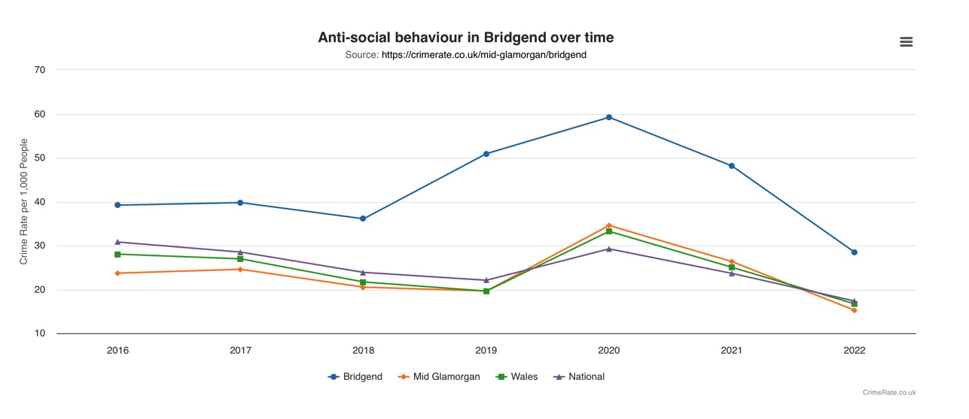

2.2 Anti- Social behaviour police recorded ASB Incidents vs Self-reported experience

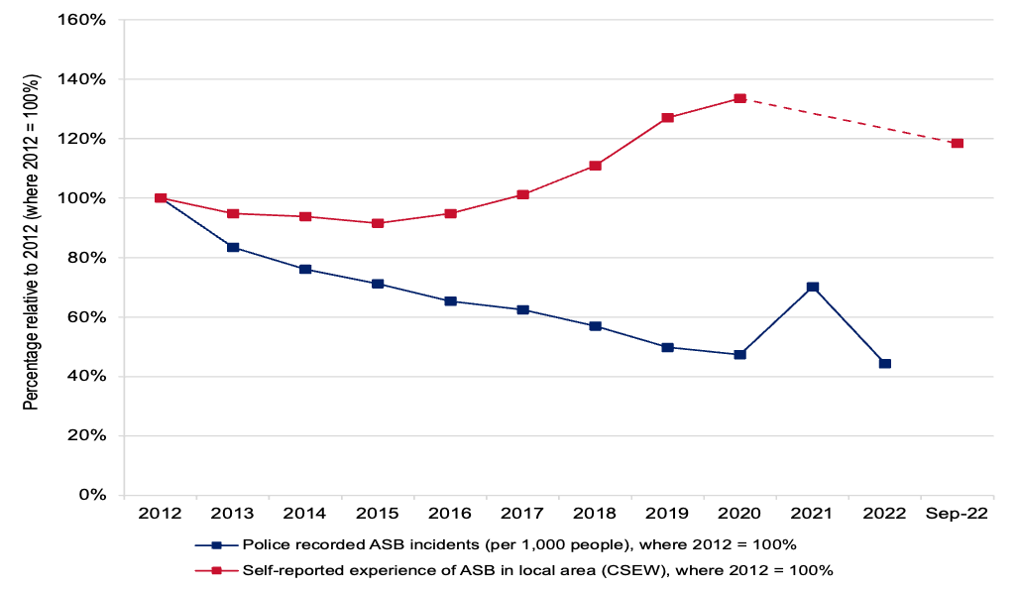

Bridgend County Borough – Mobile centre



