Student name: Nikole Atkinson
Student ID: 1910236
Programme: HND/BSc Health and Social Care /Care Management
Module: Children, Young People and Families
Module code: BMHP5004_BIRM
Lecturer: Dr Crisford Chogugudza
Assignment Title: Essay

Content page

PAGE NO
Introduction 3
Poverty 3-4
Statistics 4-5
Strategies 5-7
Reference 8
Appendix 9

Introduction
In this written assignment, I will describe what child poverty is, distinguishing different areas of poverty, utilising historical and current facts from the United Kingdom's children’s poverty statistics, this should reveal the truth about the extent of overall poverty in the United Kingdom, as well as the strategies and policies in place to assist prevent and reduce child poverty including government and private organisations.

Child poverty
What is the definition of child poverty? This is thought to occur when a kid lives in a family where the income is less than 60% of the UK average., he or she is considered poor, this means parents are unable to afford basic necessities, or afford school clothes or shoes, families living in poverty may use food banks or charities and organisations to help them to live day by day or get clothes and shoes to provide for themselves and their families according to Wickham et al., (2016) “This perspective of poverty as a relative (rather than absolute) measure of a person's wealth given environment acknowledges that standards of living fluctuate throughout time. The most often used metric of relative poverty in the European Union is the proportion of persons with household earnings less than a specific percentage of the population's current median”.
Poverty is a complicated concept that means different things to different individuals, trying to identify what poverty is in more detail, distinguish are six categories of poverty, situational, generational, absolute, relative, urban, and rural poverty,
- Situational poverty is generally the outcome of greater fear or loss, and it lasts for a few minutes. meaning temporary loss of earnings, in which they will be able to recover from this quite quickly.
- Absolute poverty is defined as a condition in which a person is unable to satisfy fundamental requirements such as food and water, this may cause families to rely on foodbanks and charities for help, families my find that they become more reliant on this service.
- Relative poverty is judged in relation to the economic position As a result, someone may be poor in the relative sense even though they are not wealthy in the absolute sense, in the sense that they can meet their fundamental necessities.
- Generational Poverty Cleveland, (n.d.) states “The phrase "generational poverty refers to families who have been poor for at least two generations”. It can have an impact on a person's physical, social, emotional, and mental well-being.
- Urban poverty & Rural poverty Rural poverty refers to poverty in rural areas and the factors that contribute to it, such as the rural population, rural economy, and political institutions. Rural poverty is usually linked to high migration, which in this context refers to the gap between urban and rural areas.
There are a lot of factors when living in poverty that can have an major effect on every aspect of their lives, this also puts children in vulnerable positions.
- Relationships poverty can cause relationship breakdowns, and this will have a massive impact on the child in many of ways
- Abuse/ discrimination, parents may not be able to cope and take it out on children leaving them vulnerable, or children may be bullied at school or discriminated based on how they look or were they come from.
- Unemployment/ low paid jobs being trapped in the system may find it hard to find job or even afford to go to interview, which leave a long-term effect on the children.
- Low levels of skills and Education, children may be unable to attend school all the time and will not be able to get the right level of education.
According to, what is poverty? (2021)
Evidence currently shows that living in relative poverty and being exposed to relative economic disparity, particularly throughout infancy, can have a negative impact on health and well-being throughout life.

Statistics
Poverty has been an ongoing issue for many and many of years there are many data analysis that will help provide us with statistics to see if child poverty has improved in recent time or has it become worse, according to Main and Bradshaw, (2015) from data that they have collected the total poverty statistics for children and adults, “adult rates are displayed in aggregate, as well as when comparing adults in homes without children versus adults in families with children. According to income poverty and the PSE poverty measure, the child poverty rate is greater than standard poverty rate and significantly higher than poverty rates among adults in non-working families that do not have additional children.”. See appendix 1 For further information, this graph shows that kid poverty is the most common sort of poverty, regardless of how you look at it, and that the correct remedy is needed to solve it.
Joyce, (2015) Appendix 4 has presented child rates of relative economic “poverty since 1961. To put things in perspective, it also includes the same statistics for retirees and working-age adults without children. Data is provided for the United Kingdom only, rather than the European Union as a whole, for consistency's sake”. Children's relative poverty stayed stable throughout the 1960s and 1970s. Children's relative poverty remained stable, but on a smaller scale than it had been previously, It then rose dramatically in the 1980s, growing from 13 percent in 1979 to 29 percent by 1992. In the early 1990s, after a period of stability or modest decline.
Looking at the data collected from Appendix 3 Not only are more children living in poverty, but families with children are indeed suffering from poverty at a higher rate than they were ten years ago. Since around 2012, when the first surge of cuts to welfare payments such as the benefit cap and reductions in housing assistance start to take an impact, the poverty line has risen dramatically.
Moving down the line to 2013-2014 that child poverty has increased considering, during this time period which will be discussed more in polices and procedures, it has been suggested that they have been guidelines updated ACT’S to put in place to help improve the area of Child poverty Wickham et al., (2016) According to the most recent data,” 3.7 million children in the UK lived in poverty in 2013–2014, accounting for three out of every ten children, furthermore Child poverty is on the rise in the United Kingdom. For the first period in over two decades, child poverty increased in absolute terms in 2011–2012 higher levels of child poverty are linked to poorer health outcomes for children”
Strategies and Policies in place to prevent child poverty
In the 1930s, its rules and processes were mostly based on the Poor Law Amendment Act, which was designed to assist individuals who were poor in ensuring that they had the essential living standards that single adults and their families need, poor law amendment ACT 1843 ensured that the underprivileged in workhouses were housed, clothed, and fed, In the workhouse, children were provided some schooling In repayment for this care, all workhouse paupers would have to work for several hours each day, implying that this was their policy at the time to deal with poverty in general.
Recent history of UK child poverty, ( n.d.) It demonstrates that “child poverty rates fell steadily from 1998/9 to 2004/5, and that the 2004/5 objective of halving child poverty was nearly missed. The drop was attributed to a number of governmental measures, including attempts to boost work for lone parents, as well as new benefits aimed explicitly at children, such as the child tax credit”. This just shows that there have been policies and procedures that has made a positive impact during this time, boosting income and the other benefits for families showed that it helped child poverty reduce so implementing these regulations gave families the ability to be more stable.
Main and Bradshaw, (2015) “Tony Blair, the then-Labour Prime Minister, pledged in 1999 to end child poverty by 2020. Following that, in 2010, With bipartisan backing, the Child Poverty Act was passed, under this Act”. This was put in place to reduce child poverty and to help improve the quality life of children The purpose of the Act is to define success in the battle against child poverty and to create a framework for doing so for national and local progress monitoring In summary, the Act mandates that the Secretary of State submit a report to Parliament on whether or not the 2010 goal was met. The statistics in Appendix 2 reveal that child poverty has decreased, in this period of time, indicating that the employment of a strategy that included enacting new laws, regulations, and procedures over this period of time was beneficial.
As said by Bradshaw, (2016) “Key statistics show that in 2013/14, 17 percent of children in the United Kingdom were living in poverty, and that two-thirds of children in poverty live in households where someone work, they also show that the United Kingdom has the second highest ratio of child poverty caused by low intensity in the European Union, and that child poverty costs the United Kingdom £1 billion. In 2013, the government spent £29 billion” again during this time period it shows that child poverty was on the rise again which now included families that also worked was starting to struggle with the basic needs.
Kennedy, (2014) states that “Following a consultation, the government issued its second Child Poverty Strategy on June 26, 2014, which covers the years 2014-2017.. The approach lays out steps to address the "root causes" of child poverty, such as assisting families in finding jobs and increasing their wages, enhancing living standards, and improving impoverished children's educational performance”. This approach was supposed to be put in place to address the highlighted issues within child poverty by attempting to utilise strategic plans from the core causes, digging deeper into the tactics enforced by the government to avoid child poverty. “The government's second Child Poverty Strategy, which spans the years 2014 to 2017”, includes (Kennedy, 2014).
• monetary aid to youngsters and parents
• Education, welfare services, and physical and mental health Parents are given information, counselling, and assistance, as well as the development of parental abilities, are all important factors to consider.
The government planned targets for 20202 was:
Relative poverty – to lower the percentage of children living in poverty to very little than 10%. in households with incomes below 60 percent of the median, before housing expenditures.
Combined low income and environmental deprivation – to decrease the number of children living in material deprivation and limited income to less than 5%. below 70 percent of the median, before housing expenses
“Persistent” poverty. – to reduce the proportion of children who live in relative poverty for long periods of time, with a specific target set for December 2014; and “absolute” poverty – to reduce the proportion of children who live on less than 5% actual earning.
Accommodation, the social and environmental interventions, and the development of public inclusion are all issues that need to be addressed when trying to improve the quality of life of children and reduce how much families struggle, There could be many contributing factors to this, such as rising living costs, low-paying income, and a lack of jobs., The government are not the only ones that try to improve child poverty.
There are also private organisations such as the children’s society that is a charitable organisation to help children in poverty their vision is ‘The Children's Society, (2021) “they are committed to ensuring that this generation of youngsters has a better childhood in the coming decade. As a result, they will work to create a happier, safer society for young people to grow up in, one in which they may look forward to a brighter future.” And their goal is to “reverse the harmful fall in children's well-being by 2030, paving the way for long-term progress”. They address poverty This type of charity works to alleviate child poverty. It also benefits children by providing them with a ray of hope and self-esteem, as well as assisting families by providing them with food and school clothing, their aims and goals already is a strategy to tackle poverty.
UNICEF is another charity that tackles child poverty worldwide, According to UNICEF, (2017) “NICEF UK is a registered charity that raises funding for UNICEF's emergency and growth activities around the world, as well as campaigning for children's long-term transition. Working to reform government policies and practises that are harmful to children's rights in the UK and around the world is one example.”
According to their 2017 report, they were able to raise 100.2 million for each child. UNICEF's baby friendly campaign has helped 690,000 new-born babies in the UK and elsewhere. In the United Kingdom, 5 million youngsters attend schools that prioritise human rights.
Reference
Bradshaw, J., (2016). The well-being of children in the UK. 4th ed. [ebook] Great Britan: Policy Press, pp.34-67. Available at: <https://www.google.co.uk/books/edition/The_Well_Being_of_Children_in_the_UK_4th/UeXDCwAAQBAJ?hl=en&gbpv=1&dq=child+poverty+uk+statistics+&pg=PA31&printsec=frontcover>
Bradshaw, J. and Keung, a., (2018). UK child poverty gaps still increasing. [ebook] social policy research, p.3. Available at: <https://www.york.ac.uk/media/spsw/documents/news-and-events/UK%20child%20poverty%20gaps%20still%20increasing.pdf> [Accessed 3 August 2021].
Childrenssociety.org.uk. (2021). About Us | The Children's Society. [online] Available at: <https://www.childrenssociety.org.uk/about-us> [Accessed 29 July 2021].
Cleveland, L., (n.d.) CHAPTER FOUR: CHARACTERISTICS OF GENERATIONAL POVERTY. [online] Medicine.yale.edu. Available at: <https://medicine.yale.edu/childstudy/zigler/21c/projects/arkansas/payne_ch4_210417_284_25747_v1.pdf> [Accessed 31 July 2021].
CPAG. ( n.d.) Recent history of UK child poverty. [online] Available at: <https://cpag.org.uk/recent-history-uk-child-poverty> [Accessed 1 August 2021].
Joyce, R., 2015. Child poverty in Britain: recent trends and future prospects. [online] Available at: <https://www.econstor.eu/bitstream/10419/119567/1/818702311.pdf> [Accessed 3 August 2021].
JRF. (2021). What is poverty?. [online] Available at: <https://www.jrf.org.uk/our-work/what-is-poverty> [Accessed 30 July 2021].
Kennedy, S., (2014). Child Poverty Act 2010: a short guide. [ebook] house of commons, pp.1-10. Available at: <https://researchbriefings.files.parliament.uk/documents/SN05585/SN05585.pdf> [Accessed 1 August 2021].
Main, G. and Bradshaw, J., (2015). Child poverty in the UK: Measures, prevalence and intra-household sharing. Critical Social Policy, [online] 36(1), p.43. Available at: <https://journals.sagepub.com/doi/pdf/10.1177/0261018315602627> [Accessed 28 July 2021].
Rose, M., (1872). The Relief of Poverty, 1834-1914. 2nd ed. Macmillan education ltd, p.10.
Wickham, S., Bar, B., Anwar, E., Taylor-Robinson, D. and Law, C., 2016. Poverty and child health in the UK: using evidence for actio. 8th ed. [ebook] Liverpool: Bmj, pp.759-766. Available at: <https://adc.bmj.com/content/archdischild/101/8/759.full.pdf> [Accessed 31 July 2021].
2017. Unicef. [ebook] UNCIEF, p.3. Available at: <https://www.unicef.org.uk/publications/unicef-uk-annual-report-2017/> [Accessed 3 August 2021].

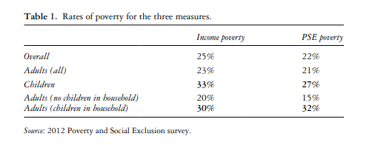
Appendix

Appendix 1
Main and Bradshaw, (2015)

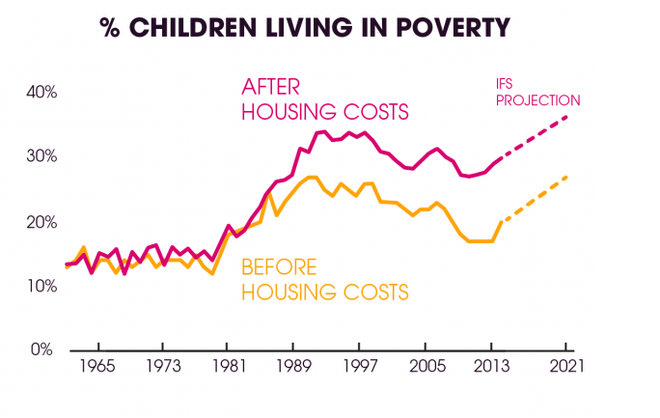

Appendix 2
CPAG. (n.d.)
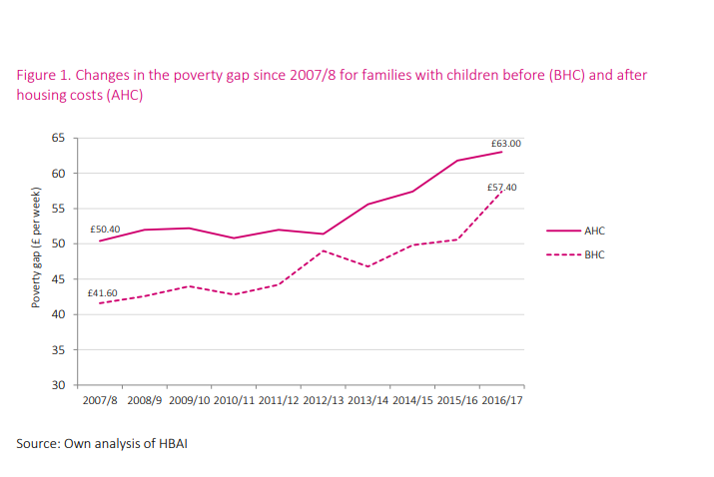

Appendix 3
Bradshaw and Keung ,(2018)

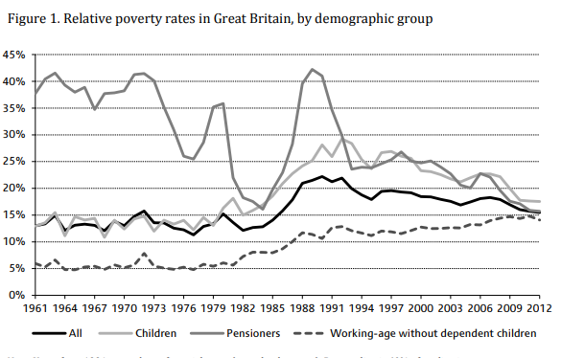
`
Appendix 4

