08/08/2026
Ddddddddddddddddddddddd
Janete Monica Dos Santos Machado

Student N: 2539377
DS3 Assessment Digital Portfolio & Reflection

Business Digital Portfolio & Reflection
Digital Skills (LCLM4002_LON)

CONTENTS

01 | Personal Profile

02 | Introduction

03 | Digital portfolio

04 | Reflection

06 | Conclusion

07 | Screenshots

09

About Me
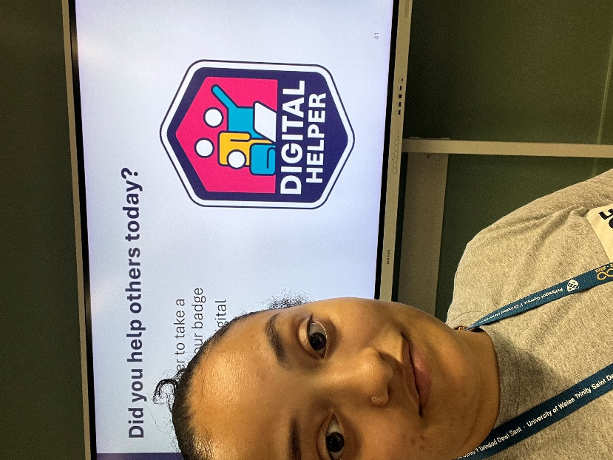

My name is Janete Monica Dos Santos Machado; I’m a student and a worker. At my work I’m a supervision and chef cook, I’m working in a care home Jews.
I choose business skills for my studies because I have my own business on my country Portugal and I’ll like to continuo and learn more skills.

- Key interests (Business skills)

- Strengths (professional at work)

- Values (learn fast)

Introduction
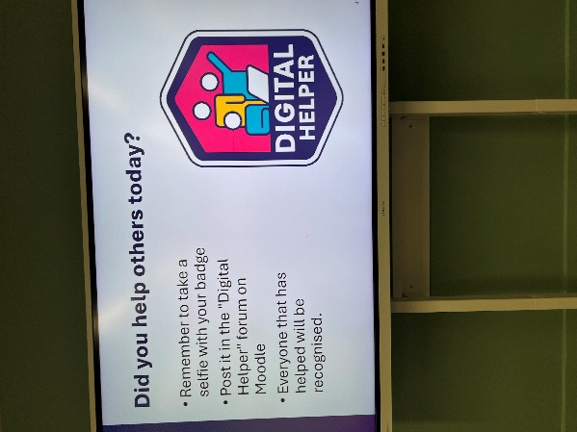
Over the past nine weeks, I have developed many digital and professional skills that will help me in both my university studies and my future career. At the beginning of the module, I was not very confident using some digital tools, but through weekly activities, practical tasks, and class discussions, I became more confident and independent.

Digital portfolio
In Week 1, I learned about digital foundations, how to use Moodle effectively, and the importance of safe online practices. This helped me understand how to access learning materials and protect my personal information online.
During Week 2, I learned how to plan my assessments and was introduced to LinkedIn. I realised that LinkedIn is more than a social media platform because it helps people build a professional profile and connect with employers.

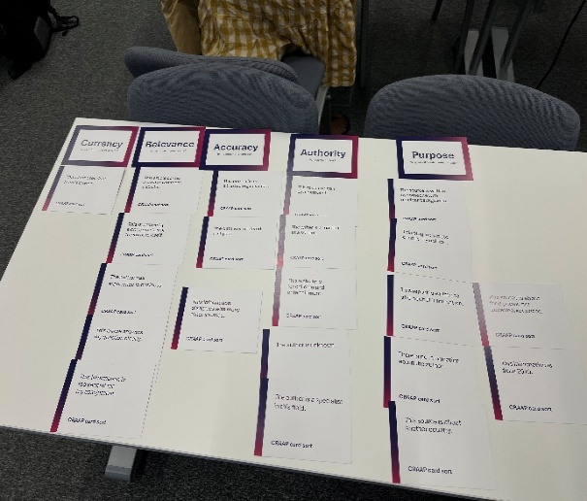
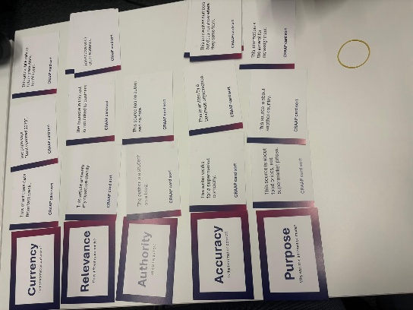

In Week 5, I learned about digital referencing, academic integrity, and copyright. I understood why it is important to reference sources correctly and avoid plagiarism by giving credit to the original authors.
During Week 6, we explored editing, paraphrasing, and the responsible use of artificial intelligence. I learned that AI can support learning, but it should never replace my own thinking or understanding. It is important to use it ethically and responsibly.

In Week 3, I learned how to find and evaluate reliable business information. This showed me the importance of using trustworthy sources instead of accepting everything I find online.
Week 4 focused on digital tools for business writing. We used Microsoft Word to create professional documents and learned how to organise information clearly. This improved my confidence in writing reports.

In Week 7, we focused on professional digital communication, including writing emails and improving our LinkedIn profiles. This helped me understand the importance of communicating professionally and presenting myself positively online.
In Week 8, I learned how to create effective digital presentations. I discovered that a good presentation should be clear, simple, visually attractive, and engaging for the audience rather than containing too much text.
Finally, in Week 9, I learned how to use digital tools for report writing and how to use feedback to improve my work. I realised that feedback is valuable because it helps me identify my strengths and improve my weaknesses.

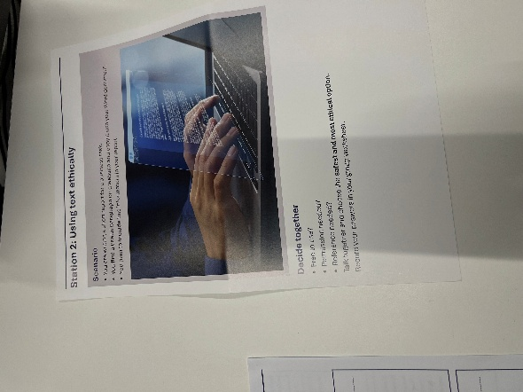
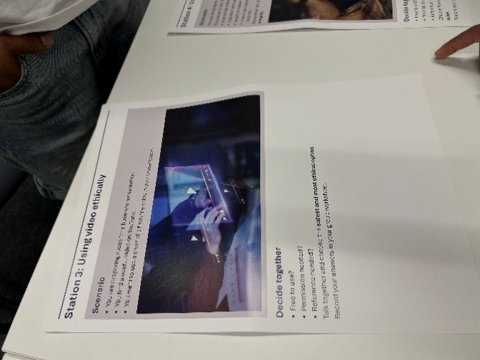
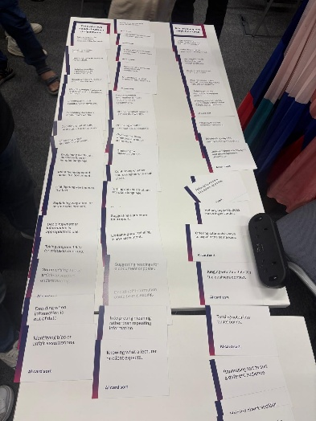

Reflection

One of the most valuable parts of this module was completing my Business Digital Task, where I analysed the Valley Coffee Co. weekly sales at Greenleaf Grocers using Microsoft Excel. I created tables and charts to present the data and used Microsoft Word to explain my process and findings. This task improved my confidence in analysing data and presenting information professionally.
I also completed my My Digital Life activity, where I reflected on the digital tools I use every day, including Moodle, Vivox, RotaCloud, Microsoft Excel, and WhatsApp. This helped me recognise how technology supports my studies, work, communication, and organisation.

Conclusion

Throughout the module, we also completed different classroom activities using Microsoft Word, Microsoft Excel, and interactive challenge cards. These practical activities made learning more enjoyable and helped me apply what I learned each week instead of only reading about it.
Overall, this module has improved my digital confidence, communication skills, academic writing, and ability to use technology effectively. I now feel better prepared for future university assignments and for the digital skills that employers expect in the workplace.

Screenshots



