
Skills for the Workplace
Module Assignment Submission
Student Name: | Sandra Khonde
Student Number: | 1706732
Module No: | BMSK4005
Module Title: | Professional Career Development

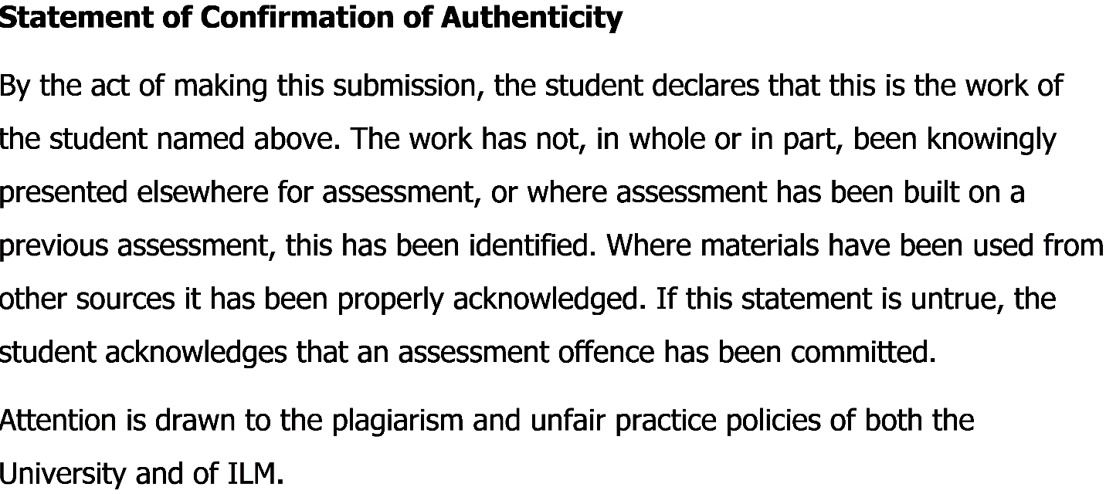

Table of Contents
Introduction: 3
Lifeline exercise: 4
Self-evaluation review: 5
Johari Window: 8
Research and learning: 9
VAK Learning Styles Self-Assessment Questionnaire 10
SWOT analysis: 16
Review of my understanding and expectations of the world of employment: 18
A review of own potential in suitable job roles: 19
The effectiveness of my personal contributions when working with others in your workplace: 20
Suitability: 21
Short term, medium term and long term goals: 22
Personal development plan (PDP): 23
Assessing the effectiveness of the PDP for your suitable roles: 25
Conclusion: 26
Reference: 27
Appendix 27

Introduction:
In this report, going to discuss about the use of lifeline exercise which actually helped me a lot to identify my highs and lows of my life. It helped me a lot to show up in the sector of my education, work and in some also other activities. Here in this report mainly going to talk about the portfolio of evidence where it will help to understand that skills and knowledge contributes a lot in the workplace. Furthermore, readiness for employment, then understand personal strength and also developing a personal action plan can assist one to develop his career. It can be added that self-review assessment has helped me a lot to make my performance appraisal in various way to make it more effective. SWOT analysis has also been done by me so that I can identify crucial strength, weakness, threat and opportunities as well. Moreover, I have established a review of my potential job and its roles. When I started using models of human relationship and Johari Window model, assist me to improve understanding level with other people has increased than before. Some of the various learning style such as visual, aural, linguistic, kinaesthetic helped me a lot to develop learning styles in real life because an individual need all those three types of modalities if they want to develop their personal learning style.

Lifeline exercise:
Lifeline exercise defines the highs and lows of my life from where I have actually gone through in my life. In below I have attached a screenshot of my ups and downs in my life by giving a lifeline exercise sample:
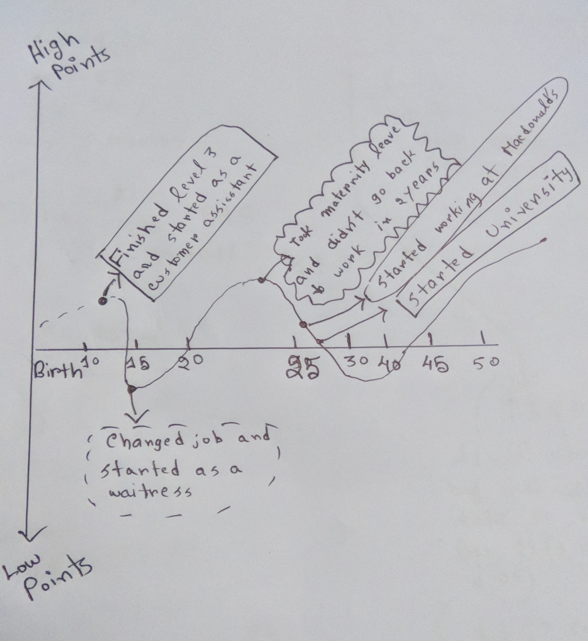

Self-evaluation review:
In the beginning, it is very significant for me to identify in which sector I can find myself more enjoyable to work with enthusiastic. And for this need to identify my strength on that sectors so that I can make myself better on those sectors. If I start improving my skills and knowledge on those sectors that can help me to achieve my goals. Drivers and influencers like family, education, friends, and ethnicity help me a lot to prepare myself what I actually want and what I want to be.
Personal value actually plays an important role to achieve happiness. Personal value is important because it helps to satisfy own needs, help me to establish in my life, help me to shape my behavior and also values help to guide me. Understanding the value that you have passion in some field or some creativity, and it can lead me to happier by doing a job which help me to be more innovative and nurtured my passion. (Anon, 2018).
Personal principles helps one to achieve success in life. It is kind of a general law or truth and from this other peoples are derived and this is the principle of modern physics.
- My personal values:
- Honesty: I believe that honesty is the greatest treasured value in all human life. It open myself freely and expose myself to other people.
- Creativity: Creativity is kind of about ideas. I always like to do something in life in such a creative way because I believe that my mind can be very creative if my mind is full of contradictions.
- Enthusiasm: Enthusiasm is actually the interest what I actually love to do is the secret where I actually enjoy my life. It is a powerful feeling which is a strong emotion that is intractable.
- Leadership: I believe that I can give the proper lead to the people and group in a logical way. I always assist others to see my goals and objectives as a leader so that they can follow my goals to achieve those. And it helps me to become a successful leader.
Some of the other values are loyalty, compassion, motivation, positivity, optimism and so on. These are the drivers and influencers from I get influence in my life. My friends, my family always support me and stand by my side with respect and this influence sectors are developing my values every day. My religion also influence some value like honesty. (Beblavý and Martellucci, n.d.).
My family and my close friends are the most important driver in my life. They always help me to improve my values while I spend good times with them. From educational sector I also get assist to develop my values. After family, friends, education, culture is the important sector of influence because it always inspire me from my childhood to form good values.
Self-motivation quiz: 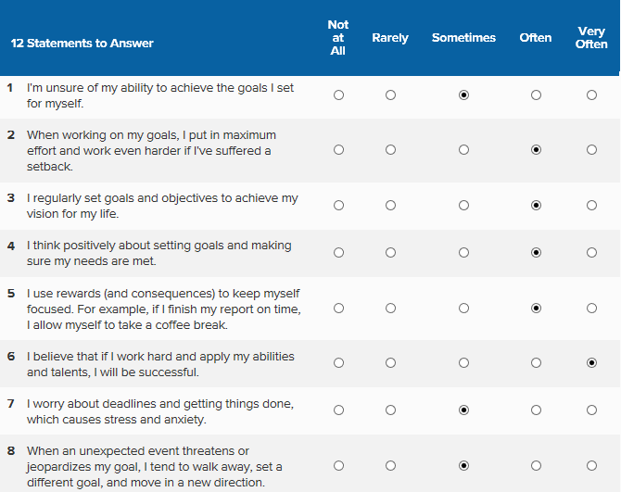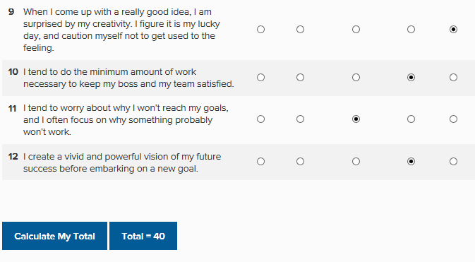

Skills audit:
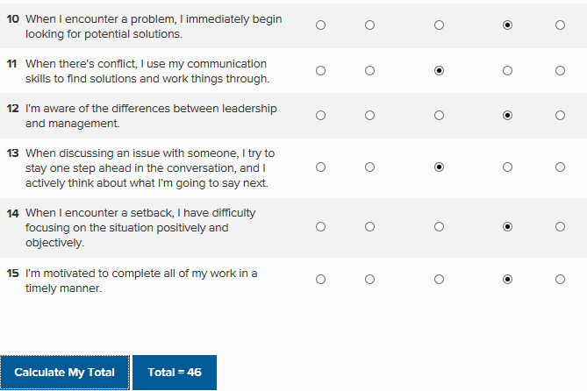
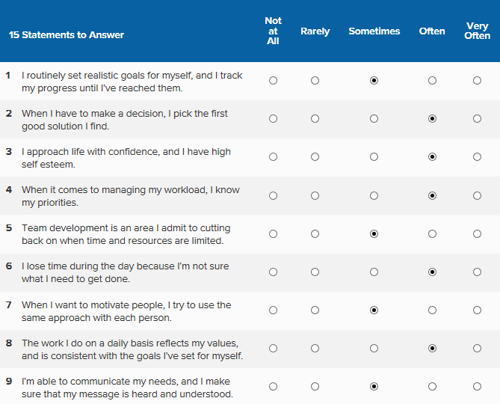

Johari Window:
According to (Self Awareness, 2018). Johari window was actually invented by two person, whose names were Joseph Luft and Harrington Ingham. In the 1950s this model was built so that they can mapping the awareness of personality.
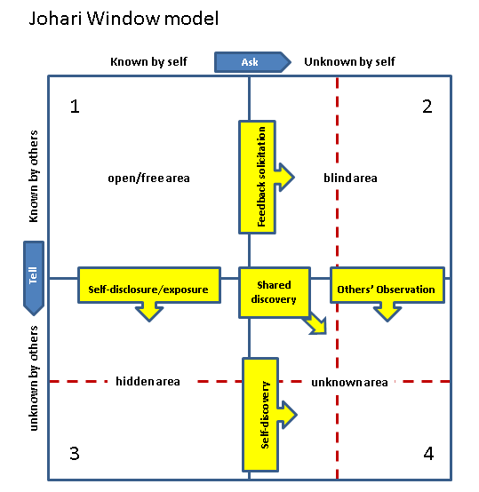

This model is beneficial for self-awareness, personal development, improving communication, group dynamics, and team development and so on. There are mainly two factors at work in the Johari window. The first factor mainly indicates that what I actually know about myself and on the other hand the other factor indicates that other people know about me. This model has four quadrants area. The first quadrant is known as open or free area. This area helps me to identify my strength sectors or weakness sectors because this area is what I know about myself. Second quadrant is blind area. This area is about my behaviors and also motivations. This behaviors and motivations will not know by me but other people will know it. Here the feedback can help me to improve myself as well because it helps me to aware of my positive or negative traits. The third quadrant is hidden area. Some aspects about myself that I don’t want other to know about those aspect of myself. And the last and final quadrant is unknown area where not only i know the information about my behaviors but also other people don’t know about this.

Research and learning:
According to (Cottrell, 2015). Learning is the procedure of gaining knowledge or acquisition skills, values through study or experience. A person’s behavior can be changed or perception can be changed by understanding the new information through this process. This learning process is kind of transformative process.
Like intellectual ability learning styles are important. For students learning styles are directly related to their school. There is a difference between individual learning and group learning and for this the outcome of the result is not same as well.
There are different types of learning style- Honey and Mumford, Kolb’s, VARK, Dantec and so on. Among these four learning styles, two learning styles has been discussed in the below:
- Honey and Mumford learning style: In this learning style there are four distinct learning styles- Activist, Theorist, Pragmatist and Reflector.

Activist: Here people actually learn something by doing. Open minded learning approach and there is no bias while experiencing something new. Activities are brainstorming, problem solving, puzzles, and competition and so on.

Theorist: Here the learners are eager to understand the theory behind various actions. Those learners need different types of models or concepts so that they can engage themselves in the learning process. Stories, models, statistics are some of the activities in this segments.

Pragmatist: In this sector people actually learn how to put their learning into the real life. Time to think, case study, problem solving and discussion are the activities of this part.

Reflector: These kind of people actually learn from observing or thinking what is happening around them. They mainly prefer to watch from different sidelines. Paired discussions, self-analysis questionnaires, personality questionnaires, time out, feedback, coaching are some of the activities. (Cottrell, 2018).

- VARK learning model: In the VARK learning model there are actually four types of learners and they are visual learner, auditory learner, reading or writing learner and kinesthetic learner. Fleming model is also known as VARK learning styles. Here learners are mainly identified themselves whether they have any preferences for visual learning like pictures or movies, auditory learning like music, discussion, reading or writing like taking notes, making lists, kinesthetic learning like movement, experiments. VARK learning model is actually used for categorizing the learning style properly. VARK teaching strategies are kind of create some questionnaires to help students to acquire various knowledge. (Maund, n.d.).

I am applying the VARK learning style to discuss my own learning style and it has given below:

VAK Learning Styles Self-Assessment Questionnaire

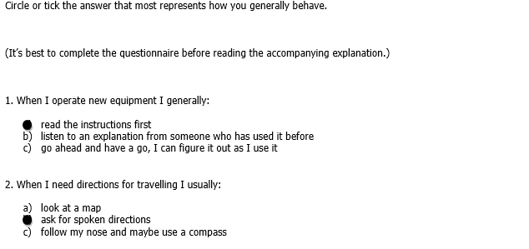
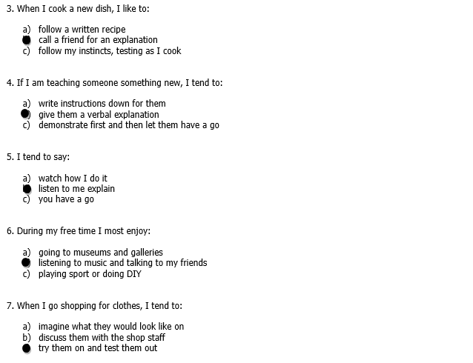
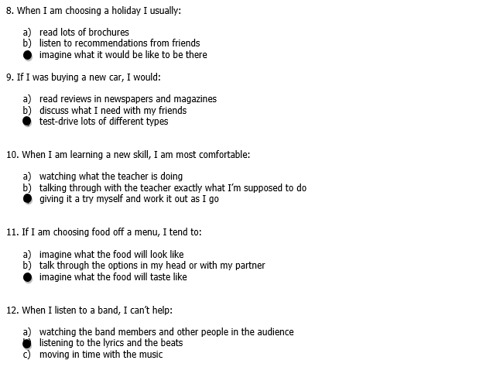
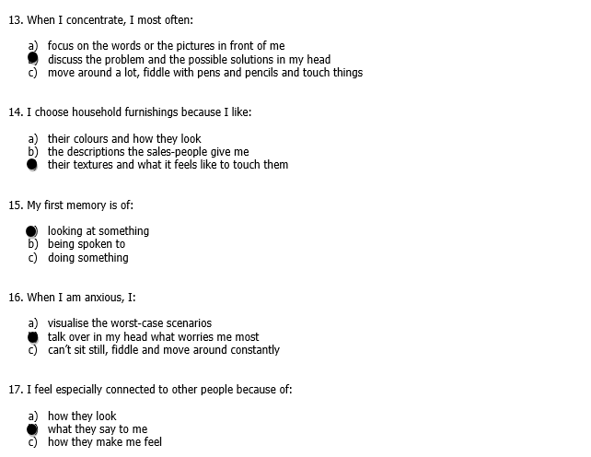
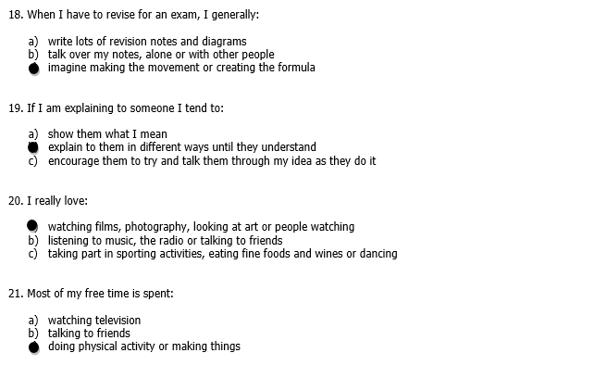

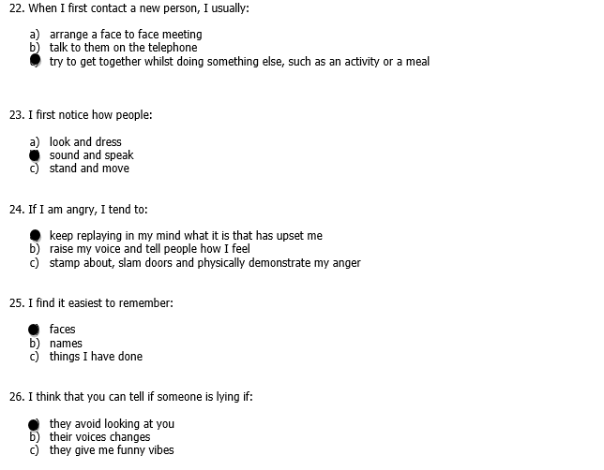
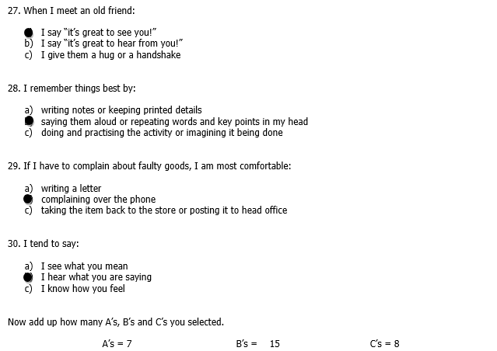
I have chosen mostly B’s, so I have an auditory learning style where I like to learn through listening. (McMillan, 2007).
Reflection on learning style worksheet
 | Visual | Auditory | Kinesthetic | Reflections
Guidance | Follow how a leaders lead | Listen leaders speech |  | I believe that if I follow and observe leaders speech and leading style it can also improve my skills
Morals |  | Listen to different moral topics |  | I believe that moral can be gained from the society and family
Time management | Observe people who actually maintain proper time |  | Need to maintain the time by making proper schedule, right deadlines and always use stopwatch | I believe that proper time management will make me punctual in the future
Communication |  | Observe how people communicate and listen what they say
Influence |  | Listen motivational speech |  | I believe that if I listen motivational or influential speech it will help me to understand staffs needs and psychology.

SWOT analysis:
According to (Morgan, 2017). SWOT analysis helps me to identify my strength, weakness, opportunities and threats and this actually help me to overcome various barriers so that I can improve myself in different sectors. For example when I will be able to know my weakness I can overcome those weakness and can develop myself by doing alternatives. Furthermore, knowing opportunities will help me to take advantage of the sectors. And threats will alert me what can harm my skills in the future or which obstacle can hinder my goals or objectives. By this I can improve skills and also my learning skills. And how I can improve my learning, it has analyzed by given my personal SWOT analysis in below:

Review of my understanding and expectations of the world of employment:
- What the employers are following to recruit:
Skills: In an organization, the employers always seek for those employees whether he or she has that capability to do the role in a specific position. Employee must have those skills so that they can achieve organizational mission and goals.

Inner strength: Employers always look for inner strength because it determines employee’s ability to persevere various adversity. During the job interview employer always test employees how he or she can be calm or cool if any situation going gets rough.

Innovative: Now a days, most of the employer find that almost every recruiter comes from highly educated background. But they want some innovative employers who can be so creative in that specific job role. Because they believe that employee can easily deal with a tough challenge.
These are some of the skills actually employers are following to recruit. (Pritchard, 2008).

- What the recruiters are doing:
Recruiters are required to do study organization plan and objectives so that they can meet organization needs. And according to organization needs they try to hire the best employees. For hiring the best employees they do recruiting process in a very efficient way. Some recruiters always try to maintain every organizational policies so that the organization goals can be achieved in time. Furthermore they also help employees to improve their skills and encourage potential employees to develop their personal knowledge and traits.

- The purpose of the job description:
The purpose of job description is that hiring the right employees so that right position can be filled. Job descriptions are crucial part while achieving organizations goal. Some organization maintain structured job description and other follow automated systems. Well documented job description is kind of an evolving tool and it reflects various current needs. Job description helps the applicants in such a way that they are enable to know for which position and for which role organizations are hiring employees. After seeing the job description potential employees apply for that job. And by this organization recruiters find potential employees to fill up that position.

- The purpose of person specification:
Job specifications are mainly mixed up with job descriptions. When the job is described that what kind of employees the organization need in which position are known as job specification. There are two elements in the person job specification, first one is essential elements and the other one is desirable elements. In the job specification persons qualifications, skills. Knowledge, experience are contained. Recruiters use job specification so that employees can get the idea about the job position and their requirement. A proper job specification has no discrimination and also it allows the diversity whilst they need the potential employees of the job.
- The way employers make a selection:
Employer always go through a formal structured recruitment process while selecting the potential employees. Also the employer can arrange a written exam for those applicants and then take interview based on their written exam. Throughout this process employer judge all those employees for the next round selection process.

A review of own potential in suitable job roles:
Now I am going to discuss about the development possibilities and suitable career that are open and attractive to me. Three suitable roles has described in below (Prospects.ac.uk, 2018). :
- Manager at MacDonald’s: Now I am working at MacDonald’s in the manager position and I love the manager role for many reasons. Because it actually teach me how to manage people, how to handle all the managerial staffs, how to make right decision, how to make proper time management and so on. Also I have to look over everything and make research in every month about restaurants environment. For example, need to take customer feedback so that I can improve the customer service better than before.
- HR manager: I find myself that HR manager role is another open and attractive to me. I developed myself and skills to become the HR manager in any restaurant. How to handle a team, how to manage all human resources, how to make effective communication with various people, all of these things can be achieved when I will be doing this job. There are several requirements needed to become an HR manager, such as need to have a knowledge of recruitment process, resource allocation knowledge, incentive policies and so on.
- Manager in any restaurant: If I want to become a successful manager in any well-known restaurant, I have to gain various skills and need to develop personality. For example, important to know how to deal with consumers, how to overcome various barriers, how to manage all managerial operations, need to have a knowledge about restaurants food menu and so on.

The effectiveness of my personal contributions when working with others in your workplace:
Teamwork means where individual people collaborate together so that they can achieve a specific goal and complete the task efficiently and effectively. Group of people work together to attain the objectives.
Examples of how I work with the service users, colleagues and other at workplace has given below:
- Skills and abilities: I use the leadership skills at my workplace in MacDonald’s so that I can manage all managerial operations and try to give the best lead to all staffs to attain goals and objectives. Also help to develop and train crew members and ensure better workplace for all staffs.
- Knowledge: Now I am studying at university and besides this working at MacDonald’s. Furthermore I have completed level 3 and finish several HND courses so that I can gain more knowledge and develop my personal skills. Also I worked as customer assistant in a store.
- Communication skills: Every day I have to communicate with various consumers, staffs, clients and need to handle deal with different clients. That’s why I have to maintain an effective communication to ensure that all the function runs smoothly.
- Responsibilities: I am responsible to all of my staffs at MacDonald’s because I need to ensure safe working place, also I am responsible to maintain all managerial operations and functions in the organization.
- Adherence to the policies and procedures: I always obey all organizational policies and rules and look over all employees whether they are also maintaining all policies or not. For example, I obey employee protection act, safety act, incentives act, refund policy and so on.
The impact of my contribution at MacDonald’s is in the every sectors. Because I always try to maintain all managerial functions and also ensure to manage resource properly in right sectors. When any customer complains about our service, I always try to handle those customers and try to give them the best service in return.
There are few areas of my contributions where I need to improve those sectors. I need to improve my time management so that all the staffs can get free time after a long period of work. Furthermore, I need to increase better incentive facility for the staffs because it will help them to work harder by creating a motivational environment. (Schnirman, n.d.).

Suitability:
The major ethical dilemma I have faced in my workplace at MacDonald’s is that I have to check all of my staff’s personal things such as their mail, phone record, or social apps all the time. I have to do it so that they cannot do any kind of illegal task. But I always maintain not to go to their privacy field but I just ensure to check their outdoor activities and especially when they are in their workplace sector.
Change in personal values: Good personal value always makes good image to everyone. Personal value never change frequently, actually they persist stable for a long period of time. Personal value can be changed, sometimes personal values are also modified. For example, a person who has freedom but not has fun in his life. So that person can add fun or happiness in his life beside his freedom opportunity so that the person can maintain balance in his life. Sometimes change in personal value can change everything.
Most recent regulation and legislation and its impact on my work: Government always set up regulations and legislations to maintain the organizational activities properly. And it has a great impact on the organizational process. For example, the equality act of 2010 means to protect every disabled employees. This act actually inhibit from making discrimination among the employees. Then there are also other act such as health and safety act, laws regarding age discrimination, gender discrimination, and employment right act and so on. According to employment act an employee cannot be terminated without any proper reason. This act also helps the employees to protect their all rights.
The reason staffs leave their jobs:
- When staffs do not get their proper rights and no drivers while they are working.
- When staffs do not get proper incentives facility.
- When staffs find themselves that their owner of the organization never create effective communication with them, boss never try to hear their problems in the workplace.
- Interpersonal conflict also causes staff leaver their jobs also.
- When staffs do not get any friendly working environment or any kind of discrimination symbol force staffs to leave their job. (Self Awareness, 2018).

Short term, medium term and long term goals:
GOAL 1: Shift Running Manager
Required to achieve goal 1:
For becoming a shift manager I have to manage all managerial operations in every shift. I have to show the manager practical example like utilizing every crew supervisor’s talents so that their ability can increase so that production goals can be met. Furthermore I have to complete level 2 food and safety course. I also have to show the manager that I can take the responsibility of guarantee a safe, lucrative and smooth running shift in the workplace.
GOAL 2: Store Manager
Required to achieve goal 2:
For becoming a store manager, I need to show the passion that I can help to achieve company’s future goals. I also need to ensure that I will run the store in an active way. After that need to gain first assistant person. As a shift manager I need to ensure customer satisfaction, control service quality, train employee, stocking supplies, resetting tables. Then doing all these activities, I can gain the position of first assistant. And after that I will be able to achieve store manager position.
GOAL 3: Area Manager
Required to achieve goal 3:
The company always oversee the performance of a store manager. If the company see that a store manager is performing really well, they select them for the area manager post. If I want to become an area manager I should have knowledge how to set sales target & maximize profit, need to provide supportive environment, drive team performance, and develop staffs.

Personal development plan (PDP):
Personal career development means when an manager invest in career development in personal sector, such as identifying threats or personal weakness and overcome those weakness to gain the strength. On the other hand professional career development means it is a 2 hour credit course and helps to start the career planning and development. Career exploration, planning are some of the process of PCD (professional career development).
Personal development plan means where a person create an action plan according to various factors such as awareness, reflection, planning, or values and so on. And all these happen within different context like education, self-improvement, and career.
Professional development plan is important because it helps to create a form of the ambition in a written summary and helps to achieve targeted objectives. Also it sharpen the focus. By developing professional development plan career success can be gained after a period of time.

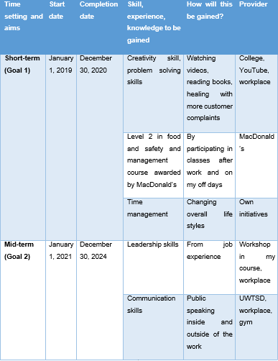

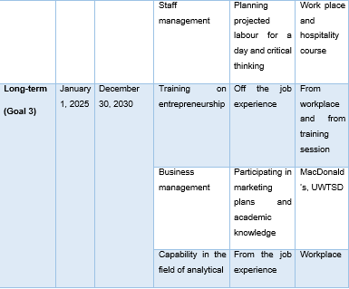

Assessing the effectiveness of the action plan:
A proper action plan has been created by me which shows that I can develop my career in an efficient way in five years. And those activities can be applied in my later personal life for personal development. Hope so this action plan will help me to gain my future goals and other career dreams.

Declaration:
This career plan is prepared by Sandra Khonde. This career plan is all about career argument. Here it indicates the pathway of present and future relationship between employment and professional sector.

Review Dates:
Agreed course action plan review date is 19/06/2019
This career plan review date is 19/06/2019

Assessing the effectiveness of the PDP for your suitable roles:
Importance of monitoring personal and professional progress:
Personal development plan helps to get a framework which helps to identify various sectors of strength and weakness. And later it helps to optimize the existing skills and capabilities. Monitoring personal and professional is helpful to identify whether the plan is going in the right track or not. Also identifies the problems which later assists to overcome those crucial problems to make proper decisions.
Characteristics of an effective personal development plan:
- Set a specific objectives
- Set short term, medium and long term goal
- Monitor personal development plan to attain goals and vision effectively and efficiently
- Need to develop personal skills
- Need to know what actually helps to attain the goal
- Need to draw a framework which will help to grab the success where the success has not reached yet

What I have achieved through my personal development plan:
Through my personal development plan I am able to identify my weakness, also where I need to develop my personal skills. Feedback process also help me to improve my skills and learn other roles in various sectors. For future I have gained a specific track where I will be able to achieve different opportunities to improve my career and development plan besides.
Benefits of having a plan that includes SWOT, skills audit, PDP, and reflection:
Having all of these, there is great benefit behind this and that one is it helps me to set a specific goal and objectives. Furthermore it need to be stated that I also able to overcome my barriers after knowing the threats and weaknesses.
The dis-benefits that can occur when I do not have a plan:
I will not be able to know in which sector I need to improve myself, also what skills I need to develop. Furthermore, which opportunities need to be grabbed and which threats are harmful for my career and future plan will not be known. Also, it can be stated that proper decision cannot be made to gain goals and objectives in personal and professional sectors.
What I need to improve and what I will do differently in future when doing my plan:
I need to complete many higher level courses to increase knowledge, gain and develop personal and professional skills, and need to identify my weakness to gain strength sectors. It will help me to attain my future goals as well.

Conclusion:
Finally it can be conclude that in the report personal or professional development plan importance has been described and an analysis has been made. Furthermore from SWOT analysis weakness and threats assists me to overcome from those barriers to attain future goals. Also it can be stated that goal oriented encouragement improve my skills and abilities than before.

Reference:
Anon, (2018). [online] Available at: https://nationalcareersservice.direct.gov.uk/advice/getajob/ interviews/Pages/default.asp [Accessed 16 Aug. 2018].
Beblavý, M. and Martellucci, E. (n.d.). Extending working lives.
Cottrell, S. (2015). Skills for Success. Basingstoke: Palgrave Macmillan.
Maund, A. (n.d.). Certificate in higher education.
Cottrell, S. (2015). Skills for Success. Basingstoke: Palgrave Macmillan.
McMillan, K. (2007). The Smarter Student. Pearson Education UK.
Morgan, P. (2017). Business student's guide to study and employability. Los Angeles: SAGE.
Pritchard, A. (2008). Studying and learning at university. London: Sage.
Prospects.ac.uk. (2018). Prospects.ac.uk. [online] Available at: https://www.prospects.ac.uk [Accessed 16 Aug. 2018].
Schnirman, R. (n.d.). The effect of audiocassette presentation on the performance of students with and without learning disabilities on a group standardized math test.
Self Awareness. (2018). Self Awareness. [online] Available at: http://www.selfawareness.org.uk/news/understanding-the-johari-window-model [Accessed 16 Aug. 2018].

