

Human Resource Management

Student Name: Komalpreet Kaur
Student Number: 2223343
Lecturer Name: Mushfiqur Rahman

Executive Summary
In recent times, the UK labour market show a small downfall in economic inactivity and an increase in the employment rate. It has been found that the skills shortage has been a major concern for organizations, as they face challenges to fill the vacancies with the right talent. The global pandemic has been found to bring changes in HR strategies in the UK. The major change is noticed in job design, as HR managers are required to design hybrid work or complete remote work. The emergence of online digital platforms in recruiting, selecting and training and development has been identified in the post-pandemic times in the UK. In the post-Brexit environment, the HRM of the UK headquartered organizations adopts several policy changes regarding recruitment of overseas candidates, wage structure and training and development. Cross-border recruitment has become challenging for organizations in the UK after Brexit.

Table of Contents
Introduction 3
Main discussion 3
a) The current state of the UK labour market 3
The UK labour market statistics 3
Industry structure 5
Characteristics of labours in the UK 5
Earnings and hours 6
b) The emerging changes in HR strategies in the post-Covid-19 and post-Brexit external environment 7
The emerging changes in HR strategies in the post-Covid-19 7
The emerging changes in HR strategies in the post-Brexit external environment 9
Conclusion and recommendations 10
Reference List 12

Introduction
The present situation of the UK labour market is stable, with a low unemployment rate and an increasing rate of vacancies across different industries (Mayhew and Anand, 2020). However, the economic challenges in the UK have encouraged organizations to slow down the recruitment process. Labour and skill shortage have been a major concern for organizations (Brunello and Wruuck, 2021). In the post-pandemic times, human resource policies and strategies have changed to a great extent in the UK. On the other hand, Brexit has also brought some major changes in the existing HRM functions and policies (Cumming, Wood and Zahra, 2020). The purpose of this report is to conduct a detailed analysis of the current scenario of the UK labour market and the impact of Brexit and Covid-19 on HR strategies. In discussing the current scenario of the UK labour market, the characteristics of the labour market, industry structure and earnings and hours have been analysed. The author has also analysed the emerging changes in HRM activities, such as recruitment, job design, training and development post-Covid-19 and Brexit. For this assessment, the researcher has used secondary data collected from authentic online sources, such as government portals, media releases and other informative websites.

Main discussion

a) The current state of the UK labour market

The UK labour market statistics
In spite of the weak UK economy, the labour market data of the country shows a different picture of growth (McIntyre, 2023). However, there are several challenges affecting the UK labour market. In the last quarter of 2022, the UK labour market has seen some improvement, as published by the data of the Office for National Statistics (ONS). The unemployment rate in the country reduced to 3.7% in the last three months of 2022. The total number of unemployed people increased by five thousand to 1.25 million (Office for National Statistics, 2023).
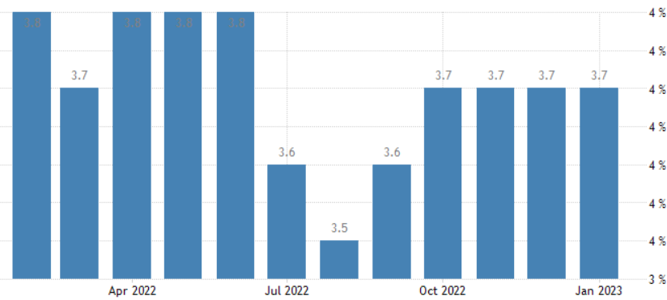
Figure 1: The unemployment rate in the UK
(Source: Trading Economics, 2023)
As shown in Figure 2, the employment rate in the UK rose from 75.60% in November to 75.7% in December 2022 (Trading Economics, 2023). To assess the extent to which the global pandemic has created a long-term impact on the labour market, ONS has started watching closely the rate of economic activity. The rising number of industrial disputes is certainly linked with the falling real wages. Currently, the UK economy is confronting challenges that may have an impact on the labour market. Due to such economic downfall, the country has been facing, recruitment across different industries has been held back by the organizations. Organizational management decides to hold back recruitment, as the economic pressure can affect business operations significantly. In the period of September to November 2022, the total number of vacancies was reduced by 65,000 to 1,187,000 (Office for National Statistics, 2023).
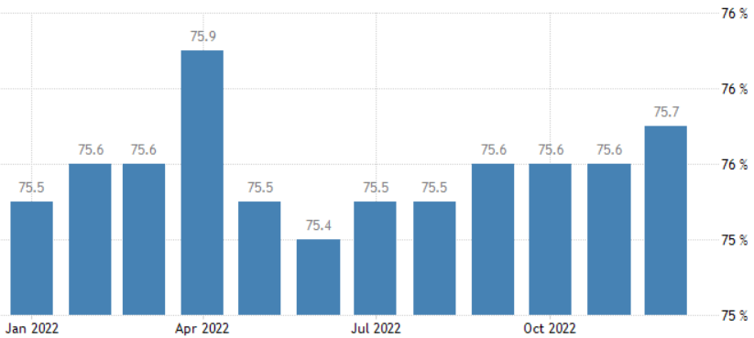
Figure 2: The employment rate in the UK
(Source: Trading Economics, 2023)

Industry structure
According to estimates, the human health and social work activities industrial sector in the United Kingdom has the most job vacancies as of February 2023 with 205,000 (Statista, 2023). Mining and quarrying had the fewest number of vacant positions, with only two thousand predicted openings. The supermarket industry is one of the major employers in the country followed by the healthcare sector (IBISWorld, 2023). Other major employing industries in the UK include construction, education, construction and tours and travel.

Characteristics of labours in the UK
The private sector employs the great majority of people in the UK. There are 27 million individuals employed in the private sector in the UK. On the other side, there are around 5.8 million individuals employed in the public sector (Statista, 2023). With almost five million workers, the wholesale and retail business is the industry sector in the UK private sector that employs the most people. With approximately 2 million employees, the National Health Service (NHS) is both the largest employer in the UK overall as well as the biggest employer in the public sector of the country. The majority of individuals in the UK still work full-time instead of part-time, despite the fact that work schedules have grown much more adaptable in the past few years. With 5 million employees as of January 2020, the rise in the number of self-employed is another important change in the UK labour sector (Statista, 2023). As shown in Figure 3, since 2020, the number of full-time self-employed has increased, while the part-time workforce has shrunk significantly. The percentage of individuals who work from home increased to 17.4% in 2020 because of the global pandemic (Statista, 2023). The number of work-from-home employees is expected to rise higher in the years to come as companies and organisations adjust to the advantages of an increasingly remote workforce.
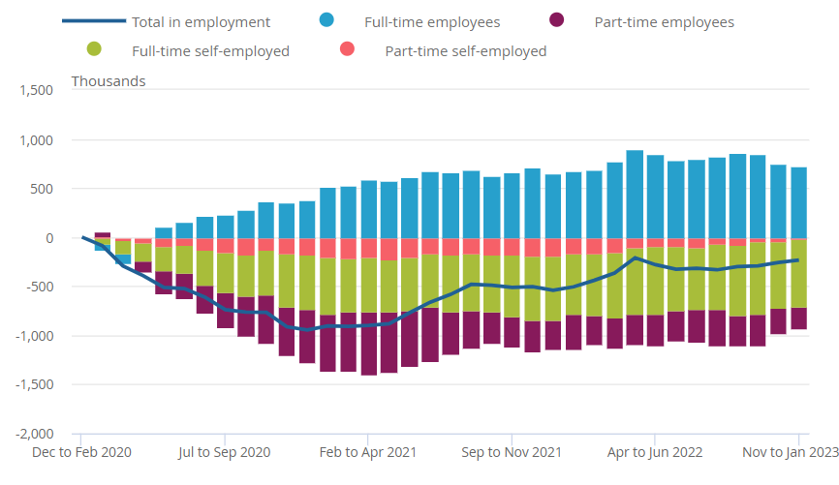
Figure 3: The labour force survey by ONS
(Source: ONS.GOV.UK, 2023)

Earnings and hours
When it comes to discussing the pay growth for employees, the total average pay, including bonuses was unchanged from August to October 2022, at 6.1%. However, for the regular pay, it was the most impressive growth rate outside of the Coronavirus pandemic. The average yearly wage for full-time employees in the UK was 33,000 British pounds, with males receiving 35,260 pounds and women earning 29,684 pounds (Statista, 2023). Despite the fact that the gender wage gap has been shrinking in recent times, it becomes extremely important to ensure that men and women continue to have access to equal financial opportunities. There is a pay gap existing between the regions of the UK. For instance, the people of London earn more than those in North East England. The pay gap in different ethnicities is also found in the UK labour market. The total number of jobs in the country in 2020 was reduced to a great extent due to the government-imposed restrictions on businesses to contain Covid-19.
According to the UK government's current forecasts, unemployment will continue to be on the lower side, at approximately 4 to 4.4% until 2027 (ONS.GOV.UK 2023). Although the unemployment rate in the UK rose to 8.5% in late 2011, after the financial crisis of 2008, the labour market has generally been in perfect shape. The UK's labour market improved despite a slowdown in economic growth beginning in 2015 and the impact of Brexit on the country's economy. Even though the COVID-19 pandemic's entrance in 2020 overturned these favourable tendencies, the damage seems to have only been temporary.

b) The emerging changes in HR strategies in the post-Covid-19 and post-Brexit external environment

The emerging changes in HR strategies in the post-Covid-19
The global pandemic has brought several changes in the way Human Resource Management carries out its operations in the organization (Azizi et al., 2021). It has become important that employees provide adequate support to the management, and in return, the management support employees during any uncertain times, when there is a risk of losing employment. One of the major changes that Covid-19 has brought in HR functions is the emergence of remote work patterns. However, before the global pandemic, the UK saw a slow rate of growth in the work from home jobs (Gigauri, 2020). Several IT companies operating at the global scale have adopted a work-from-home job pattern, as it is found more productive than that of traditional job patterns.
With the increasing trend of remote working practices across different sectors in the UK, it has become essential for HR managers to pay substantial attention to design as well as implement effective remote work policies. In the post-Covid-19 era, many organizations in the UK have focused on hybrid working practices, which is based on the idea of working partly in offices and partly in remote setting (Bennett, 2021). The human resource management of organizations in the UK follows the policies developed by the Chartered Institute of Personnel and Development (CIPD). In an effort to assist HR to make better strategies related to the changing work pattern, CIPD has developed a new set of principles for hybrid working. The HRM provides managers with knowledge of flexible working (Butterick and Charlwood, 2021). Moreover, the HR strategies include training sessions for employees to gain knowledge of managing digital well-being effectively. Moreover, the HRM also focuses on hiring employees, who can work in a hybrid work model. Therefore, the HR strategies regarding the changing work pattern in the post-Covid-19 times in the UK have changed to a great extent.
The skills gap has been an emerging challenge in the post-pandemic times in the UK (rzytuła, Strzelec and Krysińska-Kościańska, 2020). The tech industry in the UK makes around 5.5% contribution to the national economy and the particular contribution is expected to rise in the future. According to the Digital Economy Monitor, 57% of UK IT companies find difficulties in recruiting employees because of skill shortages (Flavell, 2022). To deal with the issue, the HRM has focused on identifying skills gaps and the required training programs to fill such gaps. By using emerging technology, HR management offers training to employees to enhance their IT skills (Caligiuri et al., 2020). The recruitment process has become very critical for HR managers, as they need to recruit the right candidate with the right digital skills. Therefore, after the global pandemic, the HRM strategies regarding the recruitment processes have been reviewed to ensure that the right digital professionals are recruited. In the UK labour market, the HRM of the Accommodation and Food Services and Construction sector faces significant challenges due to the high shortage of workers. Construction, Accommodation and food services account for 20.7% and 35.5% of worker shortages as of November 2022 (UK Parliament, 2023). Considering the recent economic downfall, organizations operating in these sectors have stopped their recruitment process. The HRM has adopted temporary staffing solutions to address the short-term skills gap (Stuart et al., 2021). Moreover, organizational managers have focused on investing in training and development for candidates with skills shortages. Staff retention has become an imperative strategy for the HRM to deal with the skill shortage issue in the UK. With flexible work arrangements, the HRM attracts and retains skilled talent in the organization for a long period.
In the new normal times following the global pandemic, recruiting challenges have become a critical concern for the HR recruiters of organizations operating in the UK (Hamouche, 2021). One major change in the HRM strategies post Covid-19 is the use of virtual recruitment practices. Most employees in the UK favour a hybrid working model, and to stick by that model, the HRM has adopted a virtual job interview process (The Guardian, 2023). However, it has become beneficial for the HRM to carry out the recruitment process virtually, as it assists them to tap into a large talent pool. Training and development programs are essential parts of employees’ skill development. In the post-pandemic era, online training programs have emerged as a key tool to enhance employees’ skills and competencies. The global pandemic has pushed HRM to make these changes to its existing activities to attract and retain talent successfully.

The emerging changes in HR strategies in the post-Brexit external environment
The UK left European Union (EU) on 31st January 2020. After the UK left the EU, the laws surrounding employment changed, as the EU employment laws are no longer applicable to the organizations operating in the UK (Johnstone and Dobbins, 2021). The overseas recruitment process into the UK and EU has changed after Brexit. The HRM of the organizations based in the UK need to follow the post-Brexit immigration system. The HR professionals must secure official approval of the qualifications of the EU candidates trying to grab a job in the UK organization (Ridgway, 2019). Similarly. the people of the UK working in any EU country need to get permission from the UK government to continue being a part of the EU organization. However, the HRM of the UK and EU countries deals with different paperwork. The role of HRM has become critical as it needs to review all information in detail to recruit EU nationals.
Besides changes in the recruitment policies, wage differences are another change that HRM considers (Leonida et al., 2022). As mentioned earlier, the global pandemic has begun a trend of remote working models. Currently, the HR managers of UK-based organizations must review the remuneration package for employees working remotely from any of the EU countries. The UK-based organizations’ HR needs to offer pay to EU nationals as per the local market data. Therefore, for HRM, the wage distribution process has become critical, as they need to follow new policies. The HRM must pay attention to how Brexit is affecting employee mental health in addition to the new laws and regulations it is causing businesses to be conscious of. The HRM must comprehend and effectively handle the stress that Brexit is causing for individuals who are affected (Martynowska, Korulczyk and Mamcarz, 2020). EU individuals, who work in UK organizations face mental stress, which needs to be eliminated by the HRM through clear and transparent communication. The HR managers need to help employees understand new employment policies that are put in place after Britain exists in the EU. Maintaining the mental health of UK individuals working in EU countries and EU nationals working in the UK is an imperative part of the HR functions, as it is linked to the performance and productivity of the employees.
Before Brexit, the UK organizations largely employ EU nationals to deal with the skills gap and labour shortage. After Brexit happened, cross-border recruitment has become a challenge for UK businesses. However, the changes in HR strategies surrounding remote work setting has assisted organizations in the UK to overcome the skill shortage issue to a great extent. Currently, the UK headquartered organizations pay substantial attention to hiring a remote workforce (Moradlou et al., 2022). Businesses may reconsider their organisational boundaries and the idea of the conventional employee in the post-Brexit world. Many talented employees no longer opt to work for businesses under long-term contracts because they value flexibility, productive work, and a work-life balance. On the contrary, the "gig economy" does not just include low-wage workers who are compelled to move from one brief assignment to the next (Horak et al., 2019). Highly competent and skilled workers actively select this sort of profession in substantial numbers. To counter this tendency, HRM would be well to pinpoint the skills they require to stand out from the competition. To select people based on a specific aptitude rather than taking macroeconomic factors into account or adhering to long-term succession plans, HRM must make modifications to its hiring practices. These movements have the potential to alter the UK labour market's characteristics and create a new type of employment environment.

Conclusion and recommendations
To conclude, the skills shortage has been a major issue in the UK labour market. Organizations face difficulties in recruiting the right talent for their business because of skills shortage issues. At present, the labour market in the UK is stable, with an increasing rate of employment. Although the vacancies across industries have increased, the labour shortage issue and the recent economic crisis in Britain have created a barrier for organizations to increase recruitment. Remote working has emerged as a major change in HR’s job design approach after the global pandemic and Brexit. After Brexit, the HR strategies related to the recruitment process and remuneration system have changed significantly, as the EU employment laws are no longer applicable for the UK headquartered organizations.
The international human resource management needs to focus on identifying employees’ needs, in terms of changing work design. The continuation of remote work practices could contribute to the higher performance and productivity of employees. The HR managers of UK-based organizations must follow the new set of principles for hybrid and remote work practices, as developed by CIPD. The skill gap has been found as a major factor that can affect the performance of UK organizations in the post-Brexit environment. The HRM needs to design employees’ skill assessment programs and provide them with training session as required. To successfully recruit the EU candidates in the UK, the HR managers need to secure the official approval of the qualifications of the candidates, who want to work in the UK. The HR also needs to review the remuneration package with respect to the local market to offer appropriate wage to remote employees.

Reference List
Azizi, M.R., Atlasi, R., Ziapour, A., Abbas, J. and Naemi, R., 2021. Innovative human resource management strategies during the COVID-19 pandemic: A systematic narrative review approach. Heliyon, 7(6), p.e07233. https://www.sciencedirect.com/science/article/pii/S2405844021013360
Bennett, A.M., 2021. The impact of the COVID-19 crisis on the future of human resource management. Journal of Human Resource Management, 9(3), pp.58-63. http://article.johrm.net/pdf/10.11648.j.jhrm.20210903.11.pdf
Brunello, G. and Wruuck, P., 2021. Skill shortages and skill mismatch: A review of the literature. Journal of Economic Surveys, 35(4), pp.1145-1167. https://www.researchgate.net/profile/Giorgio-Brunello/publication/351126192_Skill_shortages_and_skill_mismatch_A_review_of_the_literature/links/617d04cf0be8ec17a94b9e5f/Skill-shortages-and-skill-mismatch-A-review-of-the-literature.pdf
Butterick, M. and Charlwood, A., 2021. HRM and the COVID‐19 pandemic: How can we stop making a bad situation worse?. Human Resource Management Journal, 31(4), pp.847-856. https://onlinelibrary.wiley.com/doi/pdf/10.1111/1748-8583.12344
Caligiuri, P., De Cieri, H., Minbaeva, D., Verbeke, A. and Zimmermann, A., 2020. International HRM insights for navigating the COVID-19 pandemic: Implications for future research and practice. Journal of international business studies, 51, pp.697-713. https://link.springer.com/article/10.1057/s41267-020-00335-9
Cumming, D.J., Wood, G. and Zahra, S.A., 2020. Human resource management practices in the context of rising right‐wing populism. Human Resource Management Journal, 30(4), pp.525-536. https://drive.google.com/file/d/1hF9MnDClYZCm2Dgx0lreRdcEc-1SnuO3/view
Flavell, S. 2022. The UK badly needs to fix its digital skills gap, Tech Monitor. Available at: https://techmonitor.ai/policy/digital-economy/uk-needs-fix-digital-skills-gap (Accessed: 3 April 2023).
Gigauri, I., 2020. Effects of Covid-19 on Human Resource Management from the Perspective of Digitalization and Work-life-balance. International Journal of Innovative Technologies in Economy, (4 (31)). https://rsglobal.pl/index.php/ijite/article/download/1438/1485
Hamouche, S., 2021. Human resource management and the COVID-19 crisis: Implications, challenges, opportunities, and future organizational directions. Journal of Management & Organization, pp.1-16. https://www.cambridge.org/core/services/aop-cambridge-core/content/view/6857481FD64558659EE4C17C6DAE9AB9/S1833367221000158a.pdf/human_resource_management_and_the_covid19_crisis_implications_challenges_opportunities_and_future_organizational_directions.pdf
Horak, S., Farndale, E., Brannen, M.Y. and Collings, D.G., 2019. International human resource management in an era of political nationalism. Thunderbird international business review, 61(3), pp.471-480. https://doras.dcu.ie/22855/1/Horak_et_al_thunderbird.pdf
IBISWorld 2023. The 10 Biggest Industries by Employment in the UK. Available at: https://www.ibisworld.com/united-kingdom/industry-trends/biggest-industries-by-employment/ (Accessed: 3 April 2023).
Johnstone, S. and Dobbins, T., 2021. Employment relations in the United Kingdom. International and comparative employment relations: Global crises and institutional responses, pp.29-55. https://books.google.com/books?hl=en&lr=&id=1tAiEAAAQBAJ&oi=fnd&pg=PA29&dq=Brexit,+UK+employment+laws,+HRM+strategies&ots=38ovQWnhVq&sig=664BERArOYw_ZyqE0BxdEonNZ-o
Leonida, L., Giangreco, A., Scicchitano, S. and Biagetti, M., 2022. Britain and BrExit: Is the UK more attractive to supervisors? An analysis of the wage premium to supervision across the EU. British Journal of Industrial Relations. https://onlinelibrary.wiley.com/doi/pdf/10.1111/bjir.12675
Martynowska, K., Korulczyk, T. and Mamcarz, P.J., 2020. Perceived stress and well-being of Polish migrants in the UK after Brexit vote. Plos one, 15(7), p.e0236168. https://journals.plos.org/plosone/article?id=10.1371/journal.pone.0236168
Mayhew, K. and Anand, P., 2020. COVID-19 and the UK labour market. Oxford Review of Economic Policy, 36(Supplement_1), pp.S215-S224. https://www.academia.edu/download/69240572/graa017.pdf
McIntyre, S. 2023. What’s happening in the UK labour market? - Economics Observatory (2023). Available at: https://www.economicsobservatory.com/whats-happening-in-the-uk-labour-market#:~:text=The%20UK%20employment%20rate%20rose,the%20rate%20of%20economic%20inactivity. (Accessed: 3 April 2023).
Moradlou, H., Fratocchi, L., Skipworth, H. and Ghadge, A., 2022. Post-Brexit back-shoring strategies: what UK manufacturing companies could learn from the past?. Production Planning & Control, 33(14), pp.1319-1336. https://dspace.lib.cranfield.ac.uk/bitstream/handle/1826/16276/Post-Brexit_back-shoring_strategies-2021.pdf?sequence=6&isAllowed=y
Office for National Statistics 2023. Labour market overview, UK. Available at: https://www.ons.gov.uk/employmentandlabourmarket/peopleinwork/employmentandemployeetypes/bulletins/uklabourmarket/december2022 (Accessed: 3 April 2023).
ONS.GOV.UK 2023. Employment in the UK - Office for National Statistics (2023). Available at: https://www.ons.gov.uk/employmentandlabourmarket/peopleinwork/employmentandemployeetypes/bulletins/employmentintheuk/latest (Accessed: 3 April 2023).
Przytuła, S., Strzelec, G. and Krysińska-Kościańska, K., 2020. Re-vision of future trends in human resource management (HRM) after COVID-19. Journal of Intercultural Management, 12(4), pp.70-90. https://sciendo.com/pdf/10.2478/joim-2020-0052
Ridgway, M., 2019. Brexit: human resourcing implications. Employee Relations: The International Journal. http://irep.ntu.ac.uk/id/eprint/36824/1/14067_Ridgeway.PDF
Statista 2023. Topic: Labor market in the UK. Available at: https://www.statista.com/topics/7284/employment-in-the-uk/#topicOverview (Accessed: 3 April 2023).
Statista 2023. UK job vacancies by industry 2023. Available at: https://www.statista.com/statistics/530177/job-vacancies-uk-by-industry/ (Accessed: 3 April 2023).
Stuart, M., Spencer, D.A., McLachlan, C.J. and Forde, C., 2021. COVID‐19 and the uncertain future of HRM: Furlough, job retention and reform. Human Resource Management Journal, 31(4), pp.904-917. https://onlinelibrary.wiley.com/doi/pdfdirect/10.1111/1748-8583.12395
The Guardian 2023. Recruitment challenges 2023 hire smart. Available at: https://recruiters.theguardian.com/advice/recruitment-challenges-2023 (Accessed: 4 April 2023).
Trading Economics 2023. United Kingdom Employment Rate - March 2023 Data - 1971-2022 Historical (2023). Available at: https://tradingeconomics.com/united-kingdom/employment-rate (Accessed: 3 April 2023).
Trading Economics 2023. United Kingdom Unemployment Rate - March 2023 Data - 1971-2022 Historical (2023). Available at: https://tradingeconomics.com/united-kingdom/unemployment-rate (Accessed: 3 April 2023).
UK Parliament 2023. Skills and labour shortages. Available at: https://commonslibrary.parliament.uk/research-briefings/cdp-2023-0001/

