Student Learning Log

Laurentiu Gelu Iftimoae
2206170
Module: Managing Guest Service Operations
Module code: BMIH6003
Lecturer: Jessica Newport

I confirm that I have not used any AI tools in the research and creation of this assignment. I confirm that I have not presented any AI generated materials as my own work. I confirm I have copies of my drafts, notes, and other resources I used, which I may be asked to provide in evidence.

Weekly Progress Tracker
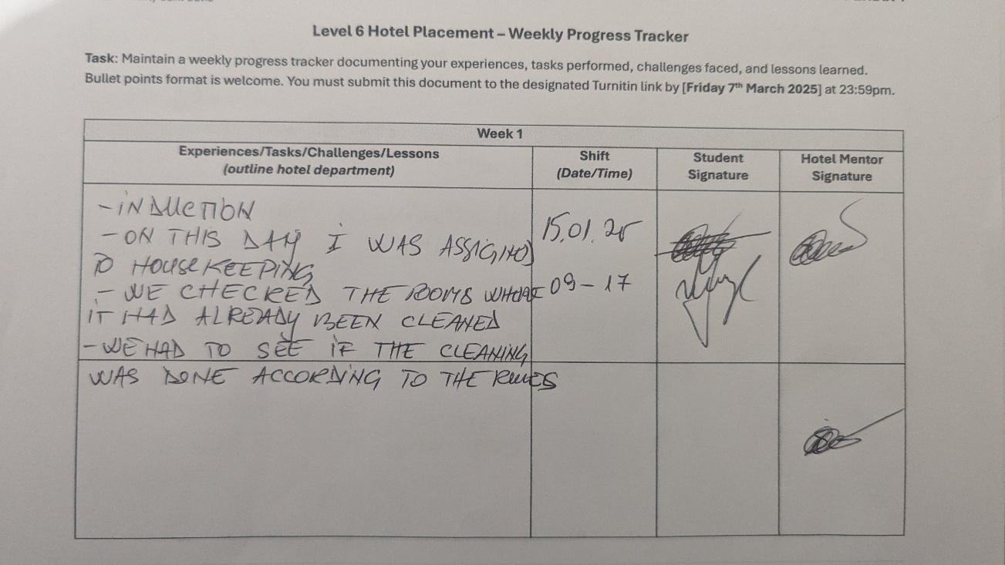
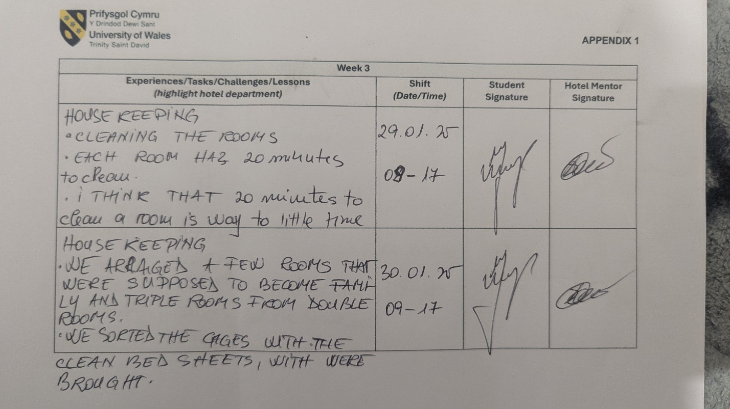
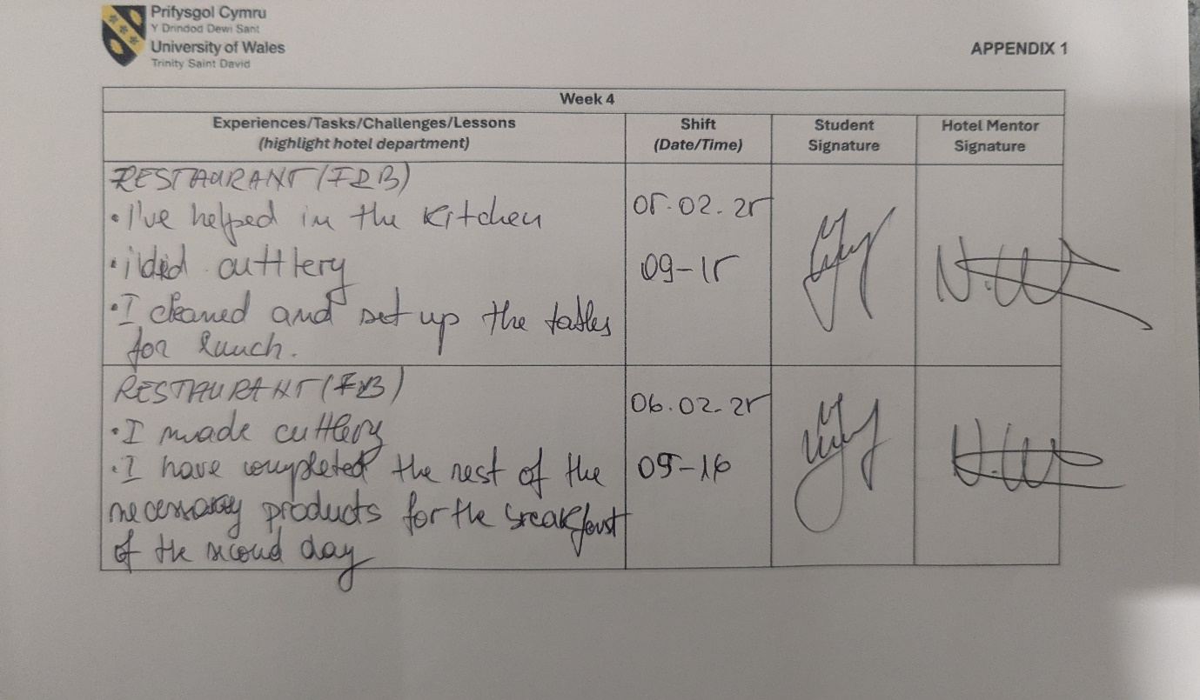
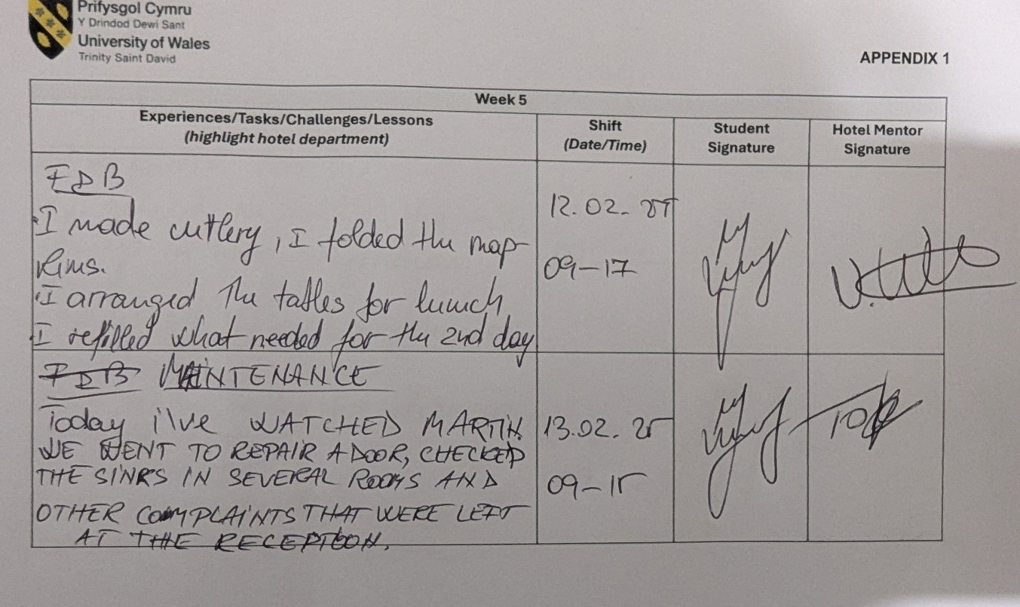

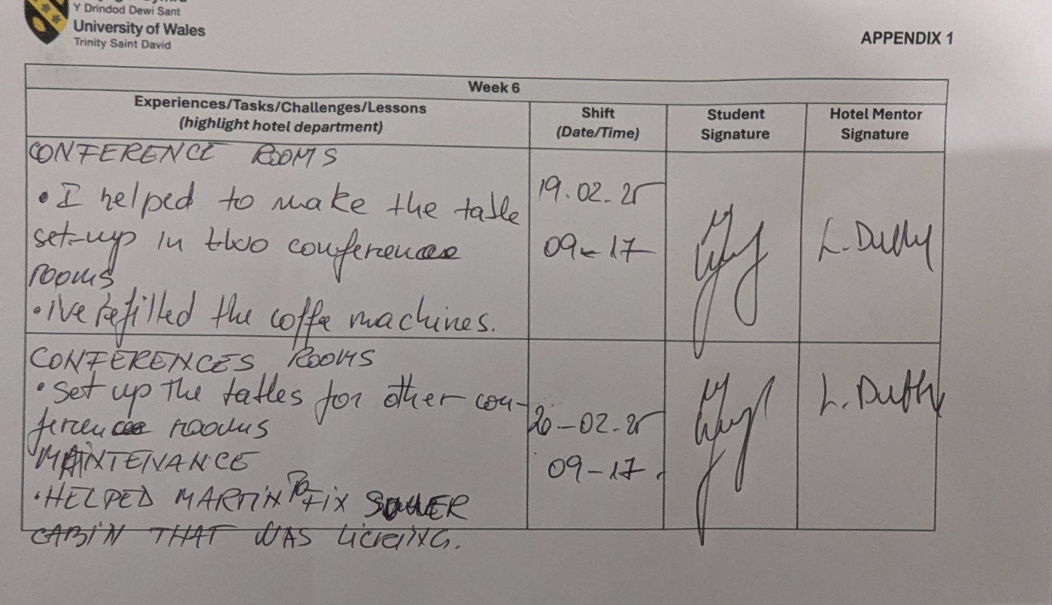

During my hotel placement, I had the chance to shadow a supervisory role in the M&E (Meetings & Events) department. This was a great opportunity to see the nuances of the different aspects of running an event from guest interactions to operational issues. The Meetings & Events department is a pillar of the hotel's guest service operations, coordinating corporate meetings, weddings and other private events while ensuring seamless service is delivered (Park and Jones, 2021).
The primary aims of this placement were:
- To learn what the role of an event supervisor entails, and their function in the guest service journey.
- To foster communication, teamwork and problem-solving skills within the context of an event.
- Learn about most of the event planning, execution, and post-event analysis.
- To examine guest expectations to understand how the department provides exceptional service.
I will be evaluating both personal and vocational growth, workplace skills, issues within the organizations and an action plan for a future career within the hospitality industry by interpreting my experiences within this department.

Reflection on Experience and Personal Development
The time I spent shadowing the Meetings & Events Supervisor provided insight into how events are managed from start to finish. I assist with pre-event briefings, setup coordination, guest interactions and post-event evaluations. One of the things I learned was how critical it is to be detail-oriented and make sure every aspect of the event matches up with the guest's experience. I faced one big issue which was a sudden shift in the setup of a corporate seminar. Just 30 minutes before the event, the client asked for a different seating arrangement and I needed to think on my feet and coordinate with the banqueting team to make it happen (Saryatmo and Sukhotu, 2021).
Personal and Vocational Development.
My background here was a combination from my last experience in hospitality and systematic academic learning giving me an approach to problem-solving in this role. Some of the key areas of development were:
- Communication and Teamwork: Successful events relied heavily on coordinating with the kitchen staff, housekeeping and the front-of-house teams. I focused on honing my ability to communicate quickly and professionally under pressure (Kalogiannidis, Kalfas and Chatzitheodoridis, 2022).
- Task Breakdown and Organization: The task shadowing with the supervisor provided a much more in-depth understanding of the importance of tasking, assigning work and adhering to schedules to ensure seamless workflow (Mun, Park and Woo, 2022).
- Guest Services and Conflict Resolution: Patience and active listening skills were necessary as I handled guests inquiries, special requests and last minute changes. I discovered that meeting the needs of a guest improves guest satisfaction (Tyron, Kaminska and Korotka, 2024)

Critical Analysis of Work-Based Skills and Technical Knowledge
Work-based skills action normal distribution of events and the limit value of guest service. The Meetings & Events department is also a unique area of the hotel where committee meetings are anchored around logistical coordination, guest relations and problem-solving capabilities. Supervisors and event coordinators need to foresee what guests might need, manage unexpected challenges, and make sure the quality of each event is top-notch for the hotel (Islam, 2022). Time management was one of the most vital skills I noticed because events run on strict schedules and any delay could decrease guest satisfaction. Being relied on for the effective delegation of tasks and prioritization also comes in handy for juggling multiple events at one time. Moreover, communication is vital in this role as supervisors must liaise with multiple teams, from kitchen crews to front desk staff and tech support teams to make sure everything is running well (Marshall et al., 2021).
Technical Knowledge
In addition to soft skills, technical skills are key to operational efficiency. Event managers should be familiar with all aspects of event setup as well as audiovisual (AV) equipment and make sure safety regulations are followed. I learned about event layouts like theater style, banquet style and U-shaped styles to name a few throughout my placement which are all tailored towards the specific needs of each event (Vasilakakis and Sdrali, 2023). Furthermore, I witnessed how event managers utilized function sheets and event management software to monitor logistics, seating arrangements and client preferences to facilitate a smooth transition from planning to execution. AV equipment is another important area of technical knowledge. Events tend to involve microphones, projectors, speakers and lighting setups to engage audiences and add visual interest to talks and entertainment. I shadowed the hotel's AV technician as he explained common technical issues that arise during events, like microphone feedback and connectivity issues with presentation equipment. A specific incident was germane to a project that went down seconds before a corporate seminar (Wang and Uysal, 2024).
Work-Based Skills and Standards for Guest Services
Work-based skills and technical knowledge directly correlate with guest satisfaction and standards of service. This expectation is especially true for many significant occasions like weddings and corporate functions. A hallmark of exceptional service is anticipating and proactively meeting guest needs. For instance, I discovered the significance of pre-event checklists and guest briefings, making sure all client requests were fulfilled before the start of the event. I also found the way event supervisors onboard junior staff on guest service protocols interesting and meaningful as it helps to create calibre for consistent service (Gudeta, 2022).

Reflection on Organizational Issues
Meetings & Events Department challenges
Some of the organizational challenges I experienced during my time in the Meetings & Events department affected guest service as well as operational efficiency. The biggest problem was the last-minute change to bookings for events which caused logistical issues and put people under pressure. For instance, a corporate client suddenly changed the setup for their conference in our space on the day of the event, asking for more tables, seating, and audiovisual changes, all on the spot. Another continuing problem was communication between departments. Coordination with different departments like catering, housekeeping, and the front office is necessary for the event to run seamlessly (Sudiyono, Utomo and Severesia, 2022).
Effect on Guest Service and Departmental Effectiveness
Inefficiencies within the organization impact the quality of service s rendered to guests based on aspects such as guideline adherence and lack of clarity on the roles of individuals. If staff do not know what is expected of them, it can cause delays, confusion and inconsistency in the delivery of service. For instance, I once saw(not here) a wedding reception where the event planning team and housekeeping had a lapse in communication and the venue was not set up on time, causing guests to be displeased. A structured planning process and detailed pre-event briefing to align all departments and mitigate the risk of last-minute snags were thus clearly needed (Tyron, Kaminska and Korotka, 2024).
Proposed Solutions and Theoretical Approaches
The key to solving these organizational problems is having a communication system that is more structured and I think improved coordination strategies are needed. Adopt event management software that has built-in scheduling, preference and interdepartmental communication capabilities is one example of what can be done. This would facilitate information sharing and reduce errors along with ensuring that all teams are aware of event requirements. TQM philosophy can also be used to gain service efficiency (Murillo Oviedo et al., 2021). A high-functioning Meetings & Events department needs values that are shared with TQM which include continuous improvement, teamwork, and ensuring customer satisfaction. This educational approach may create an environment where individuals feel empowered and responsible (Wang and Uysal, 2024).

Conclusion and Action Plan
Looking back on these organizational challenges, I have learned a lot about what it means to manage events in a hotel. Events like small changes that are being made at the last minute, poor communication between the hospitality departments, and scarcity of the workforce can have a huge impact on guest service which requires solid and promising solutions with well-defined and formally structured planning. Efficiency can be achieved and guest experience elevated through improved communication between departments, event management technology and principles of quality management. Learning these lessons has reinforced how crucial adaptability, teamwork, and problem-solving are in a dynamic hospitality environment, and how I will approach event management and guest service operations in the future.

References
Gudeta, D., (2022). Professional development through reflective practice: The case of Addis Ababa secondary school EFL in-service teachers. Cogent Education, 9(1), p.2030076.
Islam, A., (2022). Project Report on" Marketing Activities of Square Food and Beverage Ltd.".
Kalogiannidis, S., Kalfas, D. and Chatzitheodoridis, F., (2022). The impact of collaborative communication on the physical distribution service quality of soft drinks: A case study of beverage manufacturing companies in Greece. Beverages, 8(3), p.47.
Marshall, T., Keville, S., Cain, A. and Adler, J.R., (2021). On being open-minded, wholehearted, and responsible: a review and synthesis exploring factors enabling practitioner development in reflective practice. Reflective Practice, 22(6), pp.860-876.
Mun, S.G., Park, E.O. and Woo, L., (2022). Strategic target customers of food and beverage offerings in full-service hotels: Outside-hotel customers. International Journal of Hospitality Management, 102, p.103159.
Murillo Oviedo, A.B., Pimenta, M.L., Piato, É.L. and Hilletofth, P., (2021). Development of market-oriented strategies through cross-functional integration in the context of the food and beverage industry. Business Process Management Journal, 27(3), pp.901-921.
Park, M. and Jones, T., (2021). Going virtual: The impact of COVID-19 on internships in tourism, events, and hospitality education. Journal of Hospitality & Tourism Education, 33(3), pp.176-193.
Saryatmo, M.A. and Sukhotu, V., (2021). The influence of the digital supply chain on operational performance: a study of the food and beverage industry in Indonesia. Sustainability, 13(9), p.5109.
Sudiyono, K.A., Utomo, P. and Severesia, C., (2022). Effect of customer experience and customer value towards customer loyalty and satisfaction on B2B food and beverage sector. Journal of Business and Management Review, 3(9), pp.627-640.
Tyron, O., Kaminska, S. and Korotka, N., (2024). Assessment of Reflection Abilities of Maritime Students: Maritime Education and Training. Journal of maritime research, 21(3), pp.127-135.
Vasilakakis, K. and Sdrali, D., (2023). Supplier selection criteria in the Greek hotel food and beverage divisions. Journal of Hospitality and Tourism Insights, 6(2), pp.447-463.
Wang, Y.C. and Uysal, M., (2024). Artificial intelligence-assisted mindfulness in tourism, hospitality, and events. International Journal of Contemporary Hospitality Management, 36(4), pp.1262-1278.

