Title:

Self Reflective Portfolio

Student Name: Mohammed Moshahid Ali Number: 1813825
Course Module: Professional and Career development
Module Code: BMSW4005
Programme: Certificate in Higher Education Skills for the Workplace
Lecturer: Buddhi Pathak - Date 06/11/19 to 30/01/2020

TABLE OF CONTENT
PART A
1. DISCRUSIVE REPORT INTRODUCTION PAGE
2. ABSTRACT PAGE
3. SELF AWARENESS PAGE
4. EXPLORING EMPLOYMENT PAGE
5. THE SELECTION PROCESS PAGE
6. CAREER ASPIRATION TEST
7. CONCLUSION PAGE
PART B
1. REFLECTIVE REPORT INTRODUCTION PAGE
2. IMPORTANCE OF JOB ADVERT PAGE
3. STEPS FOR INTERVIEW
4. MOCK INTERVIEW PERFORMANCE PAGE
5. INFLUENCE ON MY CAREER DEVELOPMENT PAGE
6. CONCLUSION PAGE
Part A & Part B
REERENCE PAGE
APENDIX PAGE

PART A
1. DISCRUSIVE REPORT INTRODUCTION
In this report I shall express my personal views and facts about myself, conducted from self-awareness test tool that has been learnt in class, and the report will focus on the relevant insights and information gained from the test, combining with my future aspiration and progression.
The report will have explained in depth about my personality type and the key expectations as per my personality, with informative key facts and information about my character from my self-awareness tool. The discursive report will encompass my strengths and ability as an individual and the vision I see myself and expect to have achieved and progressed in the future.
This report will explain subject to subject in brief detail as to my personality type, achievement’s and aspirations and where I see myself based on the self-awareness test. The reports information will be based on my knowledge and factual information sourced from the website search engine google through various sites, article and blogs.

2. ABSTRACT
This report will emphasize my personality type and character as an individual and my career aspirations, with reference from personality test conducted in class, and how I wish to progress in the future with my career and prospects.
3. SELF AWARENESS TEST
Personality test Result Consul
From the personality test carried out in class, I believe the result reflects truly about me, and I was really amazed how accurate this personality type was. I came out to be a Consul, a hardworking and motivated person which I am, the test tool feedback was really digging deep into my character and personality type. I can say the information I found to be close to accurate to what I am as a person and have taken into account the key facts and believing information to reflect myself and understand my personality type. (ESFJ stand for Extraverted Sensing Feeling Perceiving)
As the test results categorized me as consul, it says I’m a social and thriving person that likes to stay up to date with my friend’s and be in the know-how of the latest in what my friends and family are up to. People with the consul type will base their moral compass on established traditions and laws, upholding authority and rule, rather than drawing their morality from philosophic or mysticism, I find that information to be true and it really shines on my character, as I am very upholding to values and trust as I never break my promises. I also found that Consuls love to be of service, enjoying any role that allows them to participate in a meaningful way, that is the cherry on the cake for me, because I am truly compassionate and helpful, I love to aide and support others regardless, it’s just this natural drive in me to go out and help others, I love to be of service and share my ideas and thoughts with others.
3.1 And consuls make loyal and devoted partners and parents. Consul personalities respect hierarchy, and do their best to position themselves with some authority at home or at work, which allows consuls to keep things clear and stable and organized for everyone. I love being ready and up to date with organized actions and I’m not very authoritarian I can sometimes rely on other feedback and assurance before I conduct any final task, because I’m more of a get it right guy than get it wrong, in other words id rather be safe than sorry.
3.2 Consuls spend a lot of their energy establishing social order and prefer plans and organized events to open-ended activities or spontaneous get-togethers. People with this personality type put a lot of effort into the activities they’ve arranged, and it’s easy for consuls’ feelings to be hurt if their ideas are rejected, or if people just aren’t interested.
My personality consul can always be spotted at a party- they’re the ones finding time to chat and laugh with everyone. Consuls truly enjoy hearing about their friend’s relationships and activities, remembering little details and always standing ready to talk things out with warmth and sensitivity. If things aren’t going right or there’s tension in the room, consuls pick up on it and try to restore harmony and stability.
As cited in a blog by (A. Kennerly 2016) Anyone with the ESFJ personality type loves people and social interaction. They have a great interest in others. This can often make them adept at offering support to others. My character is exactly based on the above, and I am more of an intellectual debating person than argumentative, I’d rather clear things straight than hurt someone else’s feelings. I can at occasions be straight forward to the point not in a rude way but in a logical way that brings clear understating to all. Below graph data from test result showing how outgoing I am.
Graph by Mohammed M Ali
4. EXPLORING EMPLOYMENT
Based on my ESFJ-Consul Test Report, I have always looked and focused on jobs that meet my desired skills and expectations, I have always worked in environment that fits me perfectly into supervising and team leading roles, such as team management. With a variety of skills and experience I possess I have always explored employment that combines me as an individual to work either on my own or lead a group.
Having worked for big utility companies to becoming a life insurance agent, and working in sales to business marketing, I have explored many job roles and my personality type really reflects this well.
I found a blog called hubspot.com where I came across a written blog by (C. Chi 2018) Choosing your career path is arguably the most important decision of your life. But how do you know what a job you actually like if you’ve never had any experience working it? That’s why I have explored many roles in different organization and found managing is the best fit for me.
I believe exploring a few jobs to find the right employment is key and very important to achieving the goals one wishes to pursue, until you haven’t experienced different work environments you will never no what’s right for you, thus increasing in knowledge and mental experience to be able to bring to the table the exact capacity of skills you possess.
5. THE SELECTION PROCESS
Different organizations and companies have many ways in selecting candidates that suit them, we can analyze that these days they consider more academic progression than experience, because companies believe knowledge is king, and if you don’t have it with experience to back it up it’s not useful to them. I can say this from present experience as I am the head managing director of an online company. So, for many people applying for jobs their work experience as well as their academic achievements will land them an interview and possibly a job.
In businesses and companies job selection process includes, job advert and job vacancies post, looking at the candidate criteria and what they expecting. Without prejudice, organizations select candidates via either job applications or cv sometimes both, it is important that one has an up to date cv and cover letter to hand in with the application. Recruiting possible candidates require assessment within the company head of managers and directors, so that they can emphasize the role that needs fulfilling, with detailed information on their job advert or job post. Job adverts from the company or agencies recruiting will include the job role and criteria they are looking for most will specify the salary or hourly rate, the hours the job is for and whether it’s a part time or full time job, or temporary fulfillment, other detailed information may be included such as about the company or the job, and benefits that may be included, like holidays or pensions.
5.1 It is always Important to look broadly and closely before applying for jobs that may lead you to a successful enrollment and thus the job being more than expected, as I found information related to this in an online blog by (P. Landau 2015) in the Guardian says, you should check that the job description adequately reflects the role you are applying for, and does not look to impose added responsibilities that you can’t or don’t want to do.
As explained in a website called (Smartrecruiters) The hiring process begins by identifying a need within the organization. This need could vary from filling a vacated position to better managing a team’s workload, or even expanding the reach of organizational tasks. It’s always key to be sure what your applying to before any downfalls.
In most cases applicants are more aware about the company they are applying for and many carry out research in regards to this, I have found in an online blog by (N. Schreiber 2020) mentioning that more than 75% of job seekers carry out research about a company’s reputation and employment benefits before applying. So, companies need to take the time to assess what will engage and build trust within potential talent communities. This increases the chance for recruiters to gain more applicants and interest’s and makes the selection process swifter and easier.
6. CAREER ASPRIRATION
My career aspiration is to achieve the best I can in what I’m doing, and follow my desired role that I am comfortable with, as a managing director of my company I would like to grow my online business and establish a successful brand, something that I already possess as an entrepreneur, that always loves challenges and love to run and own a company. So, for me it’s a wish come true that I am able to be my own boss and I look forward to growing my company, rather than me preparing for job interviews I now look forward to interviewing other candidates.
Going into jobs and apply for them, especially when successful for an interview, one must do their best to answer all the questions they ask and be true and confident with yourself. In an online article cited by (A. Doyle 2019) I found that an interviewer will almost always ask this question. You want to come to your interview ready to answer in a way that will make you seem prepared to stay with the company for a reasonable amount of time. You want to capture the mind of the interviewer and the interviewer to understand that the job you're interviewing for will help you develop a certain skill set that will benefit the company and others.
Career prosperity is important and deciding about your future outlook is key, looking at things like do you wish to pursue a career that you have knowledge and experience about? Or something that you love? It is always important to understand the broad aspects of career aspirations, as said in an online article in careeraddict.com written by (M. Karrera 2019) that career goals can be defined in terms of a short to medium-long term timeframe. When setting them it's always wise to consider how your short-term goals will help you to achieve your long-term ones.

7. CONCLUSION
In short, this report above explains the key points about my personality and character, and the way I look at other opportunities, brining vital knowledgeable facts and explanations about self-awareness, employment, and career aspirations. I believe self-awareness is important because if your aware about your desired hobbits and future expectations, you can easily decide what you wish to do with your career and the direction you wish to follow. Concluding with the advice that one should always look to change their mind set that appears relevant with their job and title, especially if you’re the chosen and successful candidate within an big company they will look up to you and expect your outcomes to be correct even if you directed them incorrectly. Self-expression is important and how you come about to others, I found reading in an online article called quora.com said by a PHD certified medical psychology (J.P Gagnon 2018) that there are three major zones as self-awareness we can have, Exteroceptive Awareness, which is senses, sight and hearing Interoceptive Awareness which is the ability to think, and Proprioceptive Awareness which is feelings and pleasure. Awareness is important if wish others to take you seriously.

PART B
1. REFLECTIVE REPORT INTRODUCTION
In this report I will look to explain the key facts about myself and my understanding of job adverts and how the importance of job interview is critical as well as the feedback in regards to the interview.
The report will look at job adverts and how they are a vital piece of recruitment tool for employers, and the steps to take for a job interview, looking broadly at my career prospects and how it has had an influence on me. The reports information will be based on my knowledge and factual information sourced from the website search engine google through various sites, article and blogs.
We will look at diversity and work environment flexibility, job descriptions and applicant specifications, and pitching yourself to an employer.
Firstly, I start with an elevator pitch introduction about myself,
Hi I’m Mohammed Ali, I’m a Managing Director of an Online Furniture Company, I love thinking out the box things that inspire me and love new challenges and innovations, I’m a hard worker, very motivated and a passionate individual. I’m kind, friendly and generous, I love outdoor activities, spending time with my friends and family and sightseeing, playing snooker and motor cars.

2. IMPORTANCE OF JOB ADVERT
Job adverts are important and crucial for the employer, they must be clearly informed and specify the criteria they desire, when an applicant is looking at the job advert, they must read it carefully before considering applying, you must question yourself with things like does this meet my goals? Is the job right for me? Looking at things like location and travel and convenience. All these attributes will help establish if the time consuming in the application is worth it.
Companies and businesses will advertise jobs these days via online job sites and with their recruitment agency, some organizations have a recruitment department and will post job vacancies on their own websites and job links for a faster and popular demand.
Many Job adverts will have:
-Job role title
-Date posted and Date ending
-Pay structure and salary
-Time length either temporary or full-time
-Location of the job
-Application process
-Job description and roles involved
-What they are looking for
-And about the company
A job adverts in this day and age will never incite discrimination or show lack of consideration, rather they welcome all interested applicants to apply, and the selection process is up to the company as to whom fits the job well.

2.1 As a business when looking for new candidates and assessing for recruitments, it’s a vital piece of investment for the company, it cost money to publish and source the right candidates as well as time consuming for the team involved, this is why its important use the PMI Strategy and decision making tool. Looking at things like What’s good? What’s bad? What’s interesting? Involving brainstorming, decision making, evaluating and identifying strengths and weaknesses.
One important evaluation tool to use is the Key Performance Indicator (KPI) It can help evaluate and assess all attributes, within a business and of its complex managing strategy.
It can help provide objective evidence, measure what is intended to be measured such as decision making, offer a comparison and performance changes, help with business tracking efficiency, quality and effectiveness.
Below is the diagram of the KPI Strategy
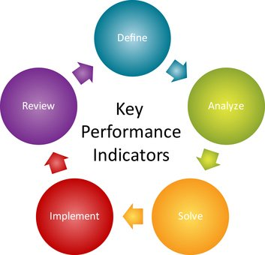KPI Image link: https://www.salesforlife.com/blog/kpi-keep-your-president-interested/
I have found from sourcing the web in an online article by quora.com cited by (D. Tran 2018) mentioning that an organization may have many measures for assessing; some for specific divisions and departments, others for your operations. It’s a good idea to set targets for all measures associated with your organization

3. STEPS FOR INTERVIEW
The job interview is the break or make moment for yourself, taking careful precautions and valued steps will help make the interview process easier.
How recruitment and hiring is processed and handled is different with all businesses, the screening and system they have in place and evaluating potential new candidates.
As a company the steps taken are very professional and friendly approach, to make the candidate feel welcome and relaxed, the company will have arranged an interviewer, may be more than one interviewer, and a room and private environment to conduct the interview. Asking crucial questions and assessing the applicant so that they meet the company’s terms and policy. Such as background checks and work references.
As a Candidate the steps I would take for an interview are all down to self-preparation, Different jobs and different companies have many ways to approach you before a meeting or interview, some may screen you on paper to see if you meet their requirements, some may call you and taken a phone interview, while others may arrange and welcome you to what we call a 1st interview assessment, if any of them go successful, they will be a follow up reminder or announcement to let you know the outcome, at this point businesses will carry out background checks and credit checks, once successful you may then be called for a 2nd interview or asked to conduct an induction work placement leading to the job offer or declined offer.
I found useful information in an online blog by (A. Doyle 2019) said that It's not always quick and easy to get hired. The job interview process can be lengthy. Being interviewed once and getting a job offer is typically a thing of the past. These days many companies have an involved interview process starting with screening interviews, which often take place on the phone, followed by in-person interviews, second interviews, and even third interviews.
3.1 Employment legislations is important to both applicants and employers, it is always good to know your rights and what law legislates what policy. Below is the Employment Legislations:
- Recruitment – Equality Act 2010 – Non discrimination
- Contract – Employment Rights Act 1996
- Data Protection – 2018 Act of UK Parliament
- Pay & Holiday – 1938 The Holiday Pay Act
- Working Time (WTR) 1998 Average 48 hours
- Health & Safety (HSWA) Safety at work Act 1974
- Discrimination – Equality Act 2010 EU legislation
- Discipline & Grievance – Regulation 2008
- Dismissals & Redundancies – Employment rights Act 1996
3.2 Preparing for an interview means taking the time to thoughtfully consider your goals and qualifications related to the position and employer. As said in an online web page article link by indeed.com (How to prepare for an interview 2019) That preparing for an interview might seem intimidating, but there are several steps you can take to prepare yourself for a successful interview. You can create an interviewing prep checklist with the following items:
- Carefully examine the job description
- Consider why you are interviewing and your qualifications
- Perform research on the company and role
- Consider your answers to common interview questions
- Practice your speaking voice and body language
- Prepare several thoughtful questions for the interviewer(s)
- Conduct mock interviews
- Print copies of your resume
- Prepare your travel arrangements
- Sell yourself
- Get ready to follow up after the interview
From preparing for an interview to what to wear all must be considered as well as your performance to deliver on the day with confidence. An Editorial Manager (D. Mason 2019) for an online blog called Prospects.ac.uk has written a well explained steps to take for an interview, your performance in an interview depends, to a significant extent, on how well you prepare. Don't leave this until the last minute. In the days leading up to the interview, focus your research on the employer, the job role, and question they may ask.
What you'll be expected to wear depends on factors such as the size of the company, the industry in an interview many choose to dress smartly but if your unsure how the company or organization expects you to dress its always good to ask before the interview.
4. MOCK INTERVIEW PERFORMANCE
In my mock interview at the UWTSD conducted by Noreen and Yohan, they have assessed me as a candidate and possible employee for the job I applied for (Furniture Sales Consultant).
I prepared my self for the interview arriving early and dressing smartly and appropriately, and I was courteous and met them both with a hand shake, which I knocked the door before entering the interview room, showing clear and profession approach from my experience from job interviews in the past.
The feedback from both the interviewers was as expected and outstanding as I am very confident with these particular situations.
Doreen had scored me 76% out of 100% with an overall score of Very Good. Noting that I had well designed cv and documents and to ensure I possessed good research on the company and job role I applied for.
Yohan had scored me 75% out of 100% with an overall score of Very Good. Noting that had good use of approach, and that I should have taken my blazer off to look more professional which I think I already did. And to ensure that I highlight key achievements on my cv.
From the mock interview I have learnt that I must know and research the company I applied to, so that I have a better understanding about them and the job role. And found that having key knowledge about my past achievements and awards is important to express to the interviewer so that they get a better understanding about my skills and experience.
I found in an online job search website called Cv-Libray.co.uk article written by (A. Hendrie 2017) saying that one of the first things a company will ask you is how much you know about them and their ethos. Answering this gives an indication of your work ethic and understanding, and initiative and the best part is they won’t expect you to reel off their latest business plan or an overview of the company structure.
12. INFLUENCE ON MY CAREER
Everything has had an influence on my life and especially on my career, the studying of the course skills for the work place at UWTSD Birmingham Campus, has made my expectations and life goals more important to me, I have had the opportunity to learn and seek knowledge that I may have lacked in, this course and the whole experience has improved my career aspirations, as I always had the entrepreneurial drive in me I always wanted to pursue a career in management and inventor, which lead me to set up my own ecommerce business.
I Found useful information from a website article written by (S. Gentle 2019) in onrec.com showing useful statistics about career choice and influences. Research from leading UK hospitality jobs board Caterer.com has revealed parents are the leading influence on their career choices.
- Parents top the list of career decision influencers for 18-24-year olds
- Careers in Engineering (49%), Law (43%) and Finance (43%) top the list for parents of 18-24-year olds preferred career choices
- Young people are three times more likely than parents to find a career in hospitality attractive (42%), going against their parents’ discouragement of the career (14%)
I am grateful for my achievements and the experience I have in management and business operating, I know where I see myself in the next 5 to 10 years but as cited by (E. Marsh 2017) about personality trails influences, that not everyone knows what they want to do with their life. Many people find that they just fall into their career. However, whether deliberate or not, do people tend to move into careers that reflect their interests or even their personality traits? This question of information is something I believe it’s important to look at what you actually want.
13. CONCLUSION
The report in Part B specifies the relative key points I mentioned and emphasizes on the reflective report, it is always important to know what to expect in an interview and job advert, also knowing your rights is very crucial, I conclude with the information that having a clear plan and career goal is very helpful and important if you wish to pursue the job you desire. I have established what certain organizations require from an applicant and what steps should you take for an interview and preparing for it. It is always best to have experience and knowledge within the sector and role you are applying for. My recommendation would be that to evaluate your personal character, financial obligations and get support that is necessary. As cited in an online blog by (D.R. Mckay 2019) what is career development. The Career development is the process that forms a person's work identity. It is a significant part of human development and spans over the individual's entire lifetime from life skills and experience, beginning when the individual first becomes aware of how people make a living, such as looking at how other people have chosen their career and job role, it is from growing within the environment and building your career experience.

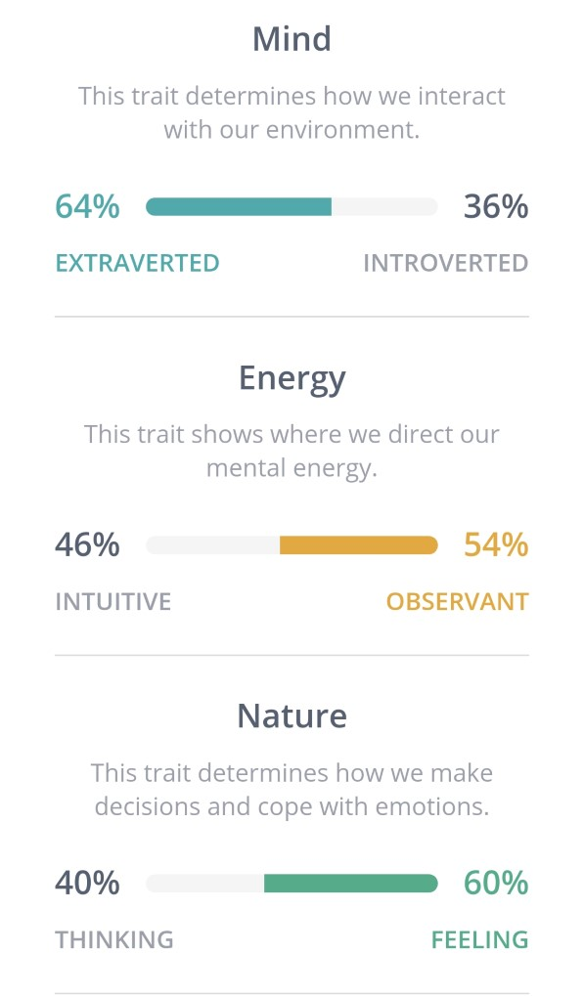PART A & PART B Reference

14. REFERENCE
PART A
Clifford Chi 11/May/2018 http://blog.hubspot.com/marketing/public-relations-jobs PAGE 5
Alison Doyle 25/Nov/2019 https://thebalancecareers.com/what-are-your-career-aspirations PAGE 7
Jean-Pierre Gagnon 6/Mar/2018 https://quora.com/whats-self-awareness PAGE 8
Alisha Kennerly 20/Jan/2016 https://thecareerproject.org/blog/esfj PAGE 4
Mariliza Karrera 20/Feb/2019 https://careeradfict.com/examples-achievable-carrer-goals PAGE 7
Phillip Landow 15/Jan/2015 https://theguardian.com/careers-new-job (six things to know before signing that contract PAGE 6
Noah Schreiber 09/Jan/2020 How to win in talent acquisition in 2020 https://smartrecruiters.com PAGE 6
Hiring Process Steps https://smartrecruiters.com/resorces/glossary/hiring-process-steps PAGE 6
PART B
Alison Doyle 09/Jan/2019 https://thebalancecareers.com/steps-in-he-jon-interview-process PAGE 12
Stuart Gentle 20/Aug/2019 https://onrec.com/news/statistics PAGE 15
Alistair Hendrie 30/Mar/2017 https://cv-library.co.uk/career-advice (5 steps for interview success) PAGE 15
Dan Mason (Editorial Manager) May 2019 https://prospects.ac.uk (How to prepare for an interview) PAGE 14
Emily Marsh 17/Oct/2017 https://t-three.com/soak/ (how do our personality traits influence our career choices) PAGE 16
Dawn Roseberg Mckay 09/May/2019 https://thebalancecareer.com/what-is-career-dvelopment PAGE 16
David Tran 27/Sep/2018 https://quora.com/what-is-a-kpi PAGE 11
Website https://indeed.com/career-advice (how to prepare for an interview) PAGE 13

15. APENDIXESFJ CONSUL Self-awareness Test Tool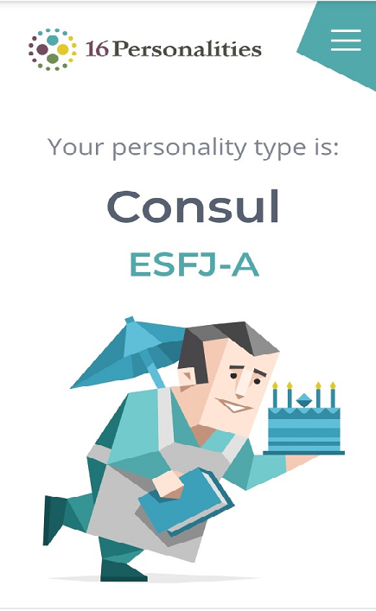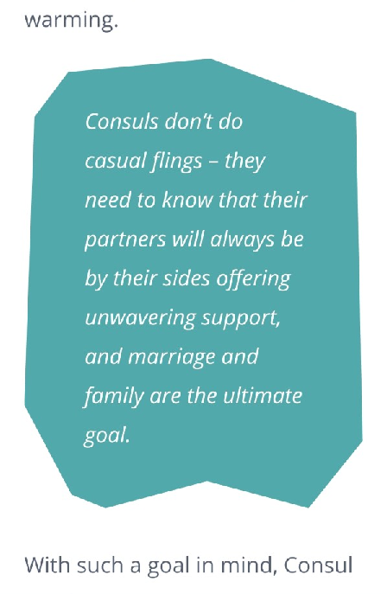
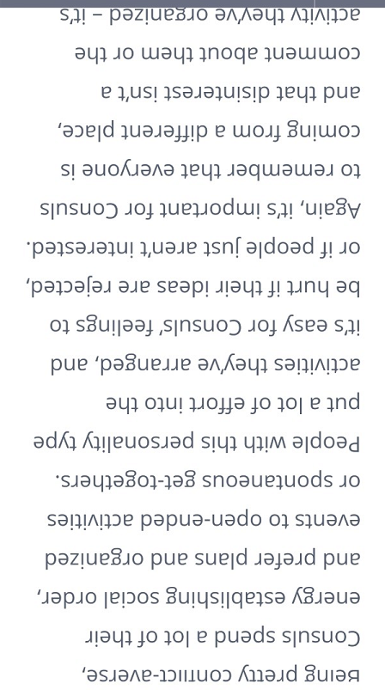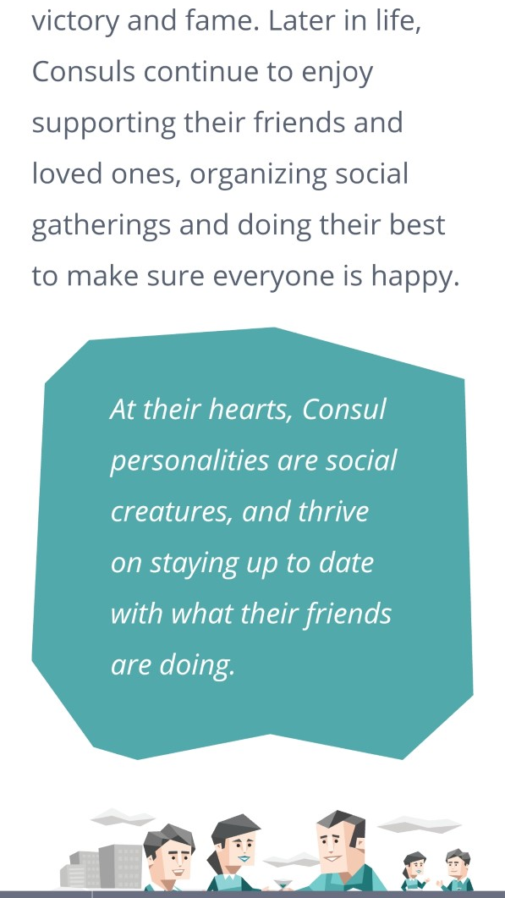
Career Aspiration Test.

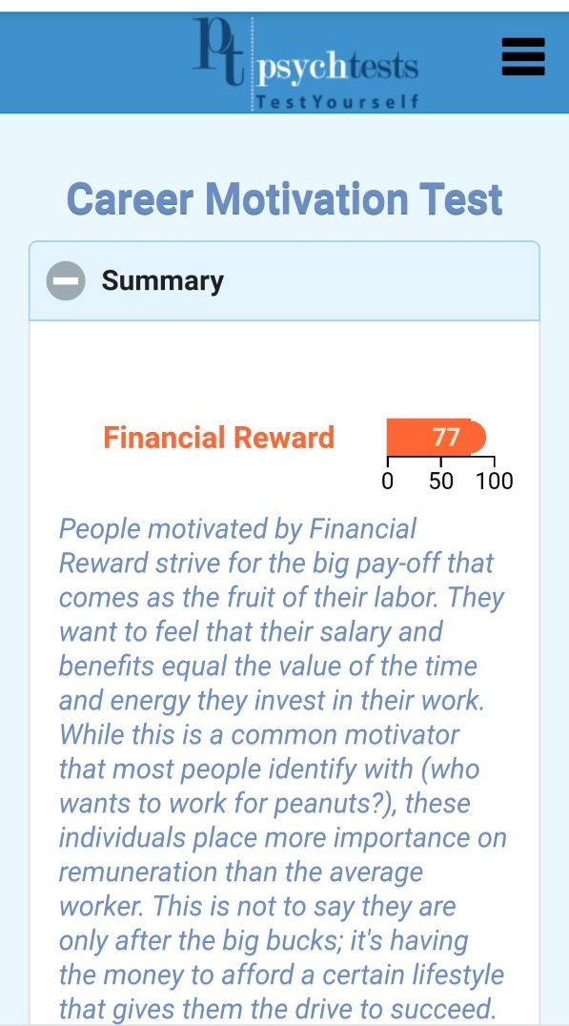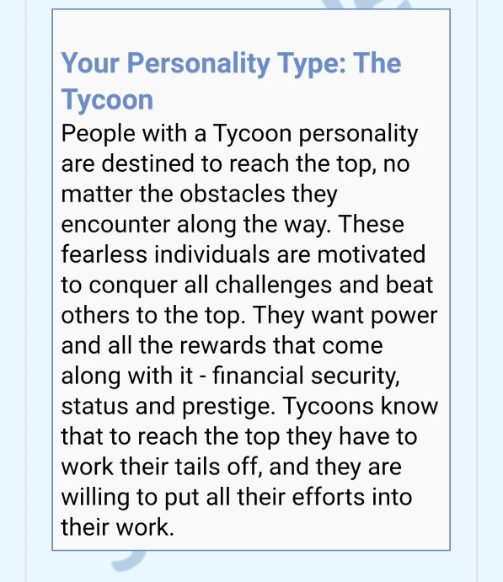

 |  | curriculum vitae
CV Mohammed Moshahid Ali
 | 07770529291 |  |  |  |  | ABOUT ME
 | Ali786a321@outlook.com
 | Walsall West Midlands |  |  |  |  | Managing Director for an online based furniture company, very passionate and hardworking individual, love new challenges and innovations, and things that inspire me. I Love outdoor activities, sightseeing, playing snooker and spending time with my family and friends.
 | Mohammed M Ali
Skills  SALES  10/10  CUSTOMER SERVICE  10/10  MANAGEMENT  10/10  DECSION MAKING  10 / 10  COMMUNICATION  10/10  Education  JOSEPH LECKIE CTC SCHOOL  GSCE  2001-2006  WALSALL COLLEGE  MOTOR MECHANIC  2007-2009  NORDIC TRANING  HAZADOUS WASTE REMOVAL  2010-2010 |  |  |  | Experience  Managing Director  D&C Limited Furniture Walsall 2019 - Present  I am the head of directors within the company, and have significant control and hold majority of the shares in the company, my day to day role involves carrying out order inspections and making sure suppliers and customers are happy.  - Staff management  - Finance and bookkeeping  - Internal affairs resolution  Insurance consultant  Owl finance plc Coventry 2014-2016  My Job role was to sell insurance to customers who are looking for a better future and protection for the income and family  - Sales consultant  - Customer advisor  - Regional sales agent  Warehouse operative  DPD Logistics Oldbury 2016-2017  I was working for a very busy delivery company, a company with a very high recognition in this industry and the job was a hands-on work, loading and unloading customer parcels.  - Load/unload parcels to vehicles  - Manage work area / health and safety precautions

COVER LETTER
Mohammed Moshahid Ali DATE 11/DEC/2019
TEL 07770529291 EMAIL ali786ali321@outlook.com
My names Mohammed Ali, I’m 29 and from Walsall West Midlands, I’m a managing Director for an online Furniture Company.
I am writing to you for my interest in the job position for Furniture sales consultant, i found the job online via reed.co.uk, and i would like to apply for this job because i think i have the skills and experience to match. I’m a hard worker and a very motivated and passionate individual, I’m kind, friendly and generous, i love thinking out the box, things that inspire me and i love new innovations and challenges.
I come from a sales experience background, and have a very broad range of skills, i was the executive director of my previous business as a courier company which i sold. I have worked for Owl finance as an insurance consultant, with customer service and sales experience in field sales and cold calling, i have a wide range of sales experience having worked as a sales agent and sales representative. My skills and ability don’t end there, i have the passion and drive to succeed and work towards my targeted goals, i have smart appearance and excellent working skills, problem solving, management skills and communication skills.
I’m looking for a fulltime permanent job, I’m available to work weekends and can attend interviews any time, i can start work immediately, i hold full UK driving license and have access to own car. If you need more information please don’t hesitate to get in touch. Yours faithfully M.M ALI

