APPENDIX GA36a

LEVEL 4 ASSESSMENT SPECIFICATION

Student name: |  | Student ID number:
Programme: | Construction Portfolio
Module: | Fundamentals of Construction Technology
Module code: | ACBA4022 | Contribution to Overall Module Assessment (%): | 50%
Lecturer: | Rhodri Thomas | Internal Verifier: | Allan Nantel
Assignment Title: | Case study | Word count (or equivalent): | 2,000 words (or equivalent) +/- 10%
Submission deadline: | 08/1/26 | Return date of provisional marks & written feedback: | 12/2/26
Submission method: | All written assessments, where practical and possible, must be submitted via Turnitin unless otherwise instructed by the Lecturer. (Please DO NOT put this assessment specification into Turnitin or it will match many similarities with other students’ submissions.)  Alternative submission method (if applicable):  Late submission of the assessment will result in a late penalty mark:  Work which is submitted up to 1 week late will be capped at 40% for the first attempt and will be awarded a mark of 0% for re-assessment. Late submission penalties may be lifted only if there is an approved extenuating circumstances claim.  Work submitted more than 1 week late will be considered as a non-submission and will not be marked. The work may be considered as a submission for reassessment if offered by an Examining Board or if there is an approved extenuating circumstances claim.
Academic honesty / referencing: | Academic honesty is required. In the main body of your submission you must give credit to authors on whose research and ideas your work is based. Append to your submission a reference list that indicates the books, articles, etc. that you have used, cited or quoted in order to complete this assessment.

Module Learning Outcomes
(from module syllabus)
- Interpret and produce annotated sketches that illustrate a broad range of common constructional forms, demonstrating understanding of their potential defect and repair needs.

TASK DESCRIPTION

Use of Generative AI in Assessment
(Lecturer to indicate Yes or Not against each element)

RESEARCH | For this assessment, you can use Generative AI to support you in research and data analysis. | Yes ☒  No
STRUCTURE | For this assessment, you can use Generative AI to support you in structuring your submission, including creating a draft argument structure, identifying parts and headings, etc. | Yes ☒  No ☐
PROOFREADING | For this assessment, you can use Generative AI to check your own text/creation for grammatical and syntactical mistakes, including getting suggestions to rephrase your work. | Yes ☐  No ☒
WRITING | For this assessment, you can use Generative AI to create text for submission. | Yes ☐  No ☒
CREATIVE | For this assessment, you can use Generative AI to create creative materials, such as images. | Yes ☐  No ☒
PROGRAMING | For this assessment, you can use Generative AI to create and check code. | Yes ☐  No ☒
NONE | For this assessment, you are not allowed to use any type of Generative AI support. This includes research support, structure support, writing/proofreading support and creative support. | Yes  No X

TASK DESCRIPTION

Case Study

In St Fagans National Museum of History there is a row of houses called “Rhyd-y-car Terrace”. This small terrace was built by Richard Crawshay around 1795 to provide housing for the workers in his iron-ore mine. Each dwelling contains a living room with bedroom above, accessed by a steep circular staircase next to the fireplace. A second bedroom and small pantry are located at the back.

The six houses are intended to display different periods of their history, namely 1805, 1855, 1895, 1925, 1955 and 1985. In this way the changes in the buildings, their contents and their gardens can be shown. Below is a link to the webpage:
https://museum.wales/collections/historic-buildings/29/Rhyd-y-car-Terrace/

St Fagan’s assessment
Table of contents

- Windows and doors……………………………………………..…3
- Roof coverings………………………………………….…….…4,5
- Eaves details and rainwater goods…………………………...........5
- Floor coverings………………………………………...………..5,6
- Internal Joinery…………………………………………………....6
- References …...……………………………………………………6

Windows and doors

Initially we see that in the first house at ST Fagans that the windows were small panes of glass held within wood frames and lead cames, these were channels that fit onto the glass and frames to hold them in place. The doors were made with wood panels with small metal hinges. These probably didn’t provide much insulation or a great amount of security to the home as the door was thin and had no strong locking mechanism that can be seen.
We see the advancement of windows over time where they transition to bigger panes of glass, still installed on wooden frames but now with rails allowing the windows to open and close. This small advancement allowed for more airflow through the house, when needed, which may have helped to prevent health issues related to the fireplace and smoke inhalation.
Eventually the windows advance again and on the last house from 1985 we see 2 panes of glass with narrow frames to move towards big windows with a hinge at the top, that opens horizontally, and a main window made of 1 pane. These window frames also changed to lightweight steel or alloy.
The advancements of windows over the terrace shows us the increases of technology enabling both functionality from older houses with the aesthetics of modern designs. (Wtbf.co.uk, 2019)
With the doors, we can see a difference with decoration and slightly thicker newer doors. The main difference between doors being the inclusion of glass panes in the doors as decorative pieces and the newest of the door being constructed to support a sturdier frame and door making them a lot stronger over the oldest of the doors which were just timber panels with 2 supports to hold it together. The differences in the construction of these doors may have been to help and improve insulation but also helps with security of the home, as well as this we see key locks introduced compared to simple latches and twist locks which added another level of safety to the home. (Gov.wales, 2023) (Museum Wales, 2025)

Wall coverings

The wall coverings of these houses develop substantially over time, we can see that a massive jump in the technology as well as an understanding on how important the coverings are take place, the first houses we can see are made of rock and rubble with larger pieces on the outside with a rubble infill and then finally mortar was used to seal the house walls. This sealant / mortar provided a “breathable” structure which allowed damp to escape out through the walls. To help mitigate the walls permeability they were made thicker meaning they had more room to absorb water before it began leaking into the house, the sealant / mortar was mainly limestone and sand that been crushed in a permeable mortar and spread over the house, while this was the main covering was used, other options such as wattle and daub coverings for timber framed structures existed. This technique consisted of woven wooden strips on the inside of the walls which were then daubed with materials such as clay and hay to provide insulation.

Houses were developed like this till 1850 when gypsum and bricks became more readily available, the gypsum was used to replace the lime which resulted in smoother finishes and allowed for more decorative design and quick installation on housing while also adding a level of fire resistance.
The use of bricks also meant an increase in the level of insulation, both heat and sound, as well as this we can see an increase in the overall durability of the house due to the load dispersion of bricks as well as less upkeep and maintenance.
We can also see the further development of wall coverings and plaster after 1930 when Portland cement became available for use, this then replaced the gypsum / lime render. This type of covering was easier again to apply making it quick and when set it hardened leading to less damage, the downside to this was that the cement was less “breathable”, this meant that moisture trapped in older buildings walls eventually led to decay and cracking over time.

This then further evolved again when more aggregates were added into the mix, such as gravel and stone chips between 1950 to 1970, this made it more weather resistant and still cheap to install which then again changed from 1970 to 1985 when the introduction of polymer gave more adhesion and flexibility as well as a greater resistance to cracking, this also eliminated the need for painting as dyes could be added to the render before being applied.

Over all the iterations we can see a variety of changes and upgrades being made, each of these changes over the years helped to insulate homes better and add more protection from the weather and protect form age deterioration. The development also enabled more artistic and creative designs for the houses both inside and out. The overall improvements made addressed the issues previous coverings had but some of the plaster was dependent on bricks being used for the walls, instead of rocks and slate that was used up until 1850 this was because the older house materials were naturally breathable, the newer houses keep out the damp entirely and if old render was used it would cause cracking and wear quicker over time. (Museum Wales, 2025) (Wtbf.co.uk, 2019)

Roof coverings

The first house we see from 1805 has a standard slate roof, this was the main choice as slate was readily available due to quarries like Snowdonia and Pembrokeshire, this type of roofing replaced earlier thatch roofs. Some houses used stone tiles as an alternative to slate but as years went on these types of roofing diminished. Slate roofs were commonly used throughout the years and are still in use today because of their longevity, low maintenance and weather resistance as well as being extremely eco-friendly due to it being a natural resource with a low carbon footprint, they also had very good thermal conductivity meaning houses retained their heat for longer.
During 1850, slate was produced in mass and exported across Britan. During this period corrugated iron was beginning to be used but this is only seen on the sheds around the housing and not on the main building itself.
We see that the next house has clay roof tiles, these also provide a long lifespan similar to slate but need to be manually produced and generally don’t last as long as slate, they also offer good weather resistance as well as thermal and sound insulation the main difference between them is the installation of them with clay being much easier and having a lot more ‘breathability’, this easier installation allowed them to be installed quicker and cheaper as opposed to needing a skilled labourer to fit the slate.
Finally on the last house is concrete tiles, these tiles were much cheaper to produce compared to slate and clay and had a relatively long lifespan required low maintenance. The tiles were standardised meaning they were easy to install and came in a variety of shapes to allow for unique roof designs, they provided good insulation and are recyclable making them a viable alternative.
Overall the roofing didn’t change much throughout the years, we still use slate roofs today showing that it was already good choice to begin with and that there weren’t many improvements to be made, the changes that were made over the years mainly focused on becoming easier to mass produce and more cost effective with regard to installation, all of the options that were used throughout the houses had good durability and lifespan with slate and clay tiles being the best in this regard while still being good insulators. The invention of mass-produced concrete tiles led to them being chosen less due to the price of installing and the need for a skilled tradesman to install them. (Hughes et al., n.d.) (Museum Wales, 2025) (Wtbf.co.uk, 2019)

Eaves details and rainwater goods

The earliest house we see at Rhyd-y-car has cast iron guttering, this material choice stays in place until 1970 where PVC became more widespread, the house from 1985 switches to PVC, This switch was for many reasons, due to the rise of plastic availability it became the best option, while remaining cheap plastic allowed for easier installation due to it being lightweight, as well as this its resistance to rust and corrosion meant it required less maintenance making it the best choice for all guttering. While cast iron did have its pros, plastic became easier overall and improved on most aspects needed for long life guttering.

The houses at Rhyd-y-car are very simple with no decorative pieces along the front face apart from the later houses with more decorative window frames , the gutters and downpipes were simple and were purpose built with no added features, the downpipes fed straight to the ground and not into floor gutters or any built drainage system but due to the incline of the houses water naturally ran downhill away from the terrace. (Museum Wales, 2025)

Floor coverings

The floor coverings used in the first house were either slate slabs or stone flags. This type of floor covering was common due to the local quarries and it being a naturally occurring resource, it was often placed on compacted dirt with no other substructure and required no mortar to bind it, this in turn lead to the floor being ‘breathable’, this was needed as in combination with the walls the whole house could ‘breath’ in the damper climates, letting moisture vapour pass through the building rather than being trapped. It was long lasting and very efficient choice for the time.

We can see the use of stone flags through till 1925, around this time we see the inclusion of cement screed to add more support and give a more level flooring. The floor having both stone flags near the fireplace and the screed towards the entrance meant that the damp wouldn’t be trapped and could move through the house. The fireplace being surrounded by the more ‘breathable’ stone flags and the screed by the entrance could’ve been to direct the flow of damp towards the fireplace where it could be evaporated, another pro is that cleaning will have been easier due to a flat surface but also the screed is more durable meaning potentially less wearing down over time.

The floor coverings change again going into 1955, the house we see has changed from cement screed and stone flags to hardwood timber panels. This switch could be for several reasons, firstly, they are easy to maintain and repair because of the way in which they are installed, as well as this as stone flags are prone to chips and staining, because of this hardwood became the easier option, upkeep combined with cheap installation and the market shifting towards a newer aesthetic style meant that this became the prominent choice for houses around this time. We can also see the inclusion of rugs and large carpets to hold further warmth in the room as well as a noise dampener, they also helped to store dust fibres and pollutants improving the air quality.

In the last house again, we see the flooring change to wall-to-wall carpet, a main reason for this is due to 1985 building regulations, these regulations changed how floor, the coverings used, and substructure were built, the aim was to improve the energy efficiency and reduce heat loss. While more carpet did help to retain heat, another reason may have been aesthetic as this again allowed more interior decoration while being effective, around this time the use of cavity walls also added to heat loss and sound insulation for house.

The house flooring develops over the years to reduce heat loss, provide more sound insulation but also dust protection and easy repairs and maintenance, the wall-to-wall carpets also allowed for more creative designs to decorate the house which became more relevant over the years. We can see this development throughout Rhyd-y-car. (Historic buildings Flooring, n.d.) (Museum Wales, 2025) (Legislation.gov.uk, 1985)

Internal Joinery

The internal joinery we see throughout the Rhyd-y-car terrace is mainly timber, towards the later years around 1955 we see more decorative pieces being used along the door and window frames and in 1955 we see plaster on the ceilings to create more intricate patterns this also helped seal the wood and increase its durability, in the newest house from 1985 the window frames swap from timber to metal with a sealant, this switch allows for less maintenance and more durability as well as providing a strong frame for security and this is when windows also had hinges to allow windows to open . (Museum Wales, 2025)

References

- Gov.wales. (2023). Windows and Doors | Cadw. [online] Available at: https://cadw.gov.wales/windows-and-doors. [Accessed 21 Oct. 2025].

- Historic buildings Flooring. (n.d.). Available at: https://www.newforestnpa.gov.uk/app/uploads/2018/03/HistoricBuildings_Flooring_00142.pdf.
‌[Accessed 21 Oct. 2025].

- Hughes, T. et al. (n.d.). Slate and Stone Roofing in Wales and the Marches SPAB Technical Advice Note. [online] Available at: https://www.spab.org.uk/sites/default/files/SPAB.pdf. - PG: 3, 11, 44 ,64 [Accessed 24 Oct. 2025].

- Museum Wales. (2025). Virtual Tour of Rhyd-y-car: Homes through Time. [online] Available at: https://museum.wales/learning/activity/401/Virtual-Tour-of-Rhyd-y-car-Homes-through-Time [Accessed 24 Oct. 2025].

- Patrick Jenkin. (1985). Building & Buildings – The building Regulations 1985 uksi_19851065_en.pdf, [pdf] [Accessed 24 Oct. 2025].]

- Wtbf.co.uk. (2019). Welsh Traditional Buildings Forum | Carmarthenshire | Pembrokeshire | Ceredigion | Denbighshire | Flintshire | Rhondda cynon taf | Monmouthshire. [online] Available at: https://www.wtbf.co.uk/old-building-information.php. [Accessed 24 Oct. 2025].

Drawing includes: - pre 1900s sketch and 2000’s Sketch

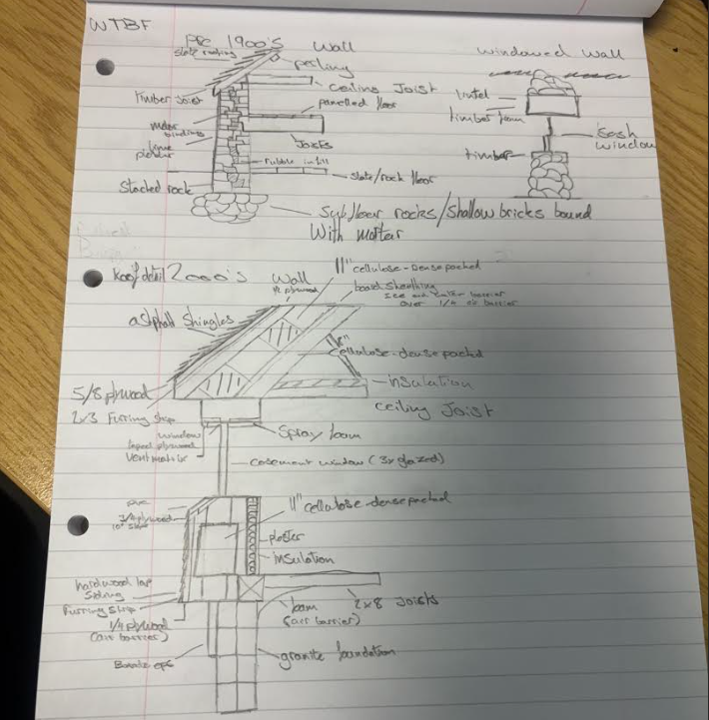
Wtbf.co.uk. (2019). Welsh Traditional Buildings Forum | Carmarthenshire | Pembrokeshire | Ceredigion | Denbighshire | Flintshire | Rhondda cynon taf | Monmouthshire. [online] Available at: https://www.wtbf.co.uk/old-building-information.php

ARCHITECTURE & CONSTRUCTION CTE PATHWAY. (2026). Wall Section. [online] Available at: https://ctearchitecturepathway.weebly.com/wall-section.html [Accessed 5 Jan. 2026].

Drawing includes: - 1950’s sketch



