MSc Digital Transformation
for the Health and Care Professions
BMDS7005

Evaluate the impact of Digital change on staff performance, health and wellbeing

Dissertation submitted in partial fulfilment of the award of
Master of Science in Digital Transformation for the Health and Care Professions

Helen Neal
2211943
6th May 2025

Declaration

This work has not previously been accepted in substance for any degree and is not being concurrently submitted in candidature for any degree.

I confirm this is my own original work and does not include text created by an artificial intelligence tool.


Signed……………………………………………

Date…………02/05/2025………………………

Abstract

The Welsh Ambulance (WAST) is undergoing significant digital transformation to support the people of Wales access healthcare services in an effective, efficient and safe way. At the forefront of the developments are the staff who interact with the public, instigating the transformation whilst safeguarding the patients.

A survey of WASTs call centre staff evaluated the impact of the digital transformation on performance, health and wellbeing resulting in areas of development required to simplify and support staff to enable a quality service.

Learning outcomes are discussed and recommendations are proposed to reduce resistance to change and enhance patient care whilst improving the work-life of the staff, with an introduction of protected time, a change intermediary or regent and utilisation of performance metrics.

Table of Contents

Declaration 2
Abstract 3
Table of Contents……………………………………………………………………………4
List of Figures 8
List of Tables 10
List of Abbreviations 11
Chapter 1: Introduction 13
1.1 The Welsh Ambulance Service 13
1.2 Accessing Welsh Ambulance 14
1.3 Health and Wellbeing 15
1.4 Performance 16
1.5 Aim 16
1.6 Scope of the Study 17
1.7 Structure of the Dissertation 17
Chapter 2: Literature Review 18
2.1 PRISMA and search strategy 18
2.2 The Review 22
2.3 Performance 22
2.3 Impact of digital transformation on health 30
2.4 Digital Transformation and Wellbeing 33
2.5 Resistance to change. 36
2.6 Technology and Human factors 38
2.7 Digital transformation & the impact on staff 40
2.8 Resistance to Change 41
2.9 Conclusions 43
Chapter 3: Methodology 44
3.1 Introduction 44
3.2 Project Planning and management 45
3.2 Ethical considerations and academic integrity 49
3.3 Data Collection 51
3.4 Population of the study 52
3.5 Data analysis 55
3.7 Limitations of the study 61
3.8 Validity and reliability 62
3.9 Conclusions 63
Chapter 4: Results 64
4.1 Introduction 64
4.2 Statistical analysis 64
4.3 Participant breakdown / Population 65
4.4 The quantitative data 65
4.5 Qualitative data analysis 83
4.6 SWOT analysis 89
4.7 Triangulation of qualitative and quantitative data 92
4.8 Conclusion 95
Chapter 5: Discussion 97
5.1 Introduction 97
5.2 Initial findings 97
5.3 Performance 98
5.4 Impact of digital transformation on health 102
5.5 Digital Transformation and Wellbeing 103
5.6 FITT for purpose 104
5.7 Resistance to change. 105
5.8 Human factors and Health 106
5.9 Digital transformation and the impact on staff 106
5.10 Limitations 107
Chapter 6: Recommendations and Conclusion 109
6.1 Recommendations 109
References 112
Appendices 130
Appendix I: MSc Dissertation Plan 130
Appendix II: MSc Dissertation Plan Final 133
Appendix III: Ethical application 136
Appendix IV: Ethical approval course Director 136
Appendix V WAST Not Research requiring WAST ethical approval. 136
Appendix VI: PRISMA 137
Appendix VII: Article review summary 138
Appendix VIII: Staff Email 140
Appendix IX: The Survey 140
Appendix X: Summary of Survey Results (MS Forms) 140
Appendix XI: Quantitative responses 141

List of Figures

Figure ‎1.1 Inverting the Triangle (WAST 2023) 13
Figure ‎2.1 Factors influencing performance. (Khan and Ramachandran, 2012) 13
Figure ‎2.2 Health and Care Quality Standards (NHS Wales Executive 2025). 13
Figure ‎2.3 Simons and Baldwin (2021) concept of Wellbeing 13
Figure ‎2.4 FITT framework (Ammenwerth et al 2006). 13
Figure ‎2.5 Comparing Kubler-Ross 5 stages of grief to resistance to change 13
Figure ‎2.6 Human factors (Neumann and Dul 2010). 13
Figure ‎2.7 Rich picture to support staff through digital change. 13
Figure ‎3.1 Gantt chart Plan 13
Figure ‎3.2 Gantt chart Revised Plan 13
Figure ‎3.3 Gantt chart Evaluated plan 13
Figure ‎3.4 The Box Plot (BBC 2025) 13
Figure ‎3.5 Using thematic analysis in psychology (Braun, V. and Clarke, V., 2006). 13
Figure ‎3.6 Template used for the SWOT analysis 13
Figure ‎3.7 Key to SWOT analysis 13
Figure ‎4.1 Responses overview. 15
Figure ‎4.2 Time taken to complete survey. 15
Figure ‎4.3 Participants gender 18
Figure ‎4.4 Age of respondents 18
Figure ‎4.5 Hours of work 19
Figure ‎4.6 Band response 21
Figure ‎4.7 Length of service 22
Figure ‎4.8 Opinion of self on technology, performance, Wellbeing and Health. 23
Figure ‎4.9 Staff opinion of colleagues’ views on technology, performance, Wellbeing and Health 24
Figure ‎4.10 I / They find technology easy to use. 25
Figure ‎4.11 I / They understand the software and processes. 26
Figure ‎4.12 I / They have time to learn and utilise the changes. 27
Figure ‎4.13 I / They are confident in being supported. 28
Figure ‎4.14 I / They are happy with the speed of changes. 29
Figure ‎4.15 I / They understand the why. 29
Figure ‎4.16 Performance, Health and Wellbeing. 30
Figure ‎4.17 Performance, Health and Wellbeing in relation to age. 31
Figure ‎4.18 Band and Wellbeing 32
Figure ‎4.19 Impact of work on health. 35
Figure ‎4.20 SWOT analysis of the results of thematic analysis. 39

List of Tables

Table ‎2.1 Initial search results 13
Table ‎2.2 Data search results 13
Table ‎2.3 Filters applied to the search 13
Table ‎2.4 Multiple search research results 13
Table ‎2.5 Performance searches 13
Table ‎2.6 FITT attributes 13
Table ‎3.1 Survey Population 13
Table ‎3.2 Definition of statistics used to analyse results (Saunders et al 2023). 13
Table ‎4.1 Proposed rationale for survey completion 17
Table ‎4.2 Band key principles. 20
Table ‎4.3 Thematic analysis process (Braun and Clarke 2006). 33
Table ‎4.4 Qualitative questions respondents and percentages. 33
Table ‎4.5 Question 8 Do you have any comments or feelings regarding question 6 & 7 responses. 34
Table ‎4.6 Question 12: Why do you feel your health is impacted in this way? 36
Table ‎4.7 Question 13: What would like / change / add to support your performance, health, and wellbeing? 37
Table ‎4.8 Summary of Themes identified through Thematic analysis 38

List of Abbreviations

A&E Accident and Emergency
BMA British Medical Association
CDSS clinical decision support system
CH Call Handler
CHC Call Handler co-ordinator
CSD Clinical Service Desk
Et al Latin for et alia meaning ‘and others’
GDPR General Data Protection Regulation
GP OOHs General Practitioner out of hours
GP General Practitioner
HCPC Health Care Professionals Council
HDL high-density lipoprotein
IBM Company name for International Business Machines Corporation
IMTP integrated medium-term plan
IT Information Technology
LDL low-density lipoprotein
LM Locality Manager
MIU Minor Injuries Unit
NHS National Health Service
NMC Nursing Midwifery Council
p probability (a statistical measurement)
PRISMA Preferred Reporting Items for Systemic Reviews and Meta-Analyses
p-score probability score
RICS Remote Integrated Care Service
SCA Senior Clinical Advisor
SNA Senior Nurse Advisor
SPSS Statistical Package for the Social Sciences
BBC British Broadcasting Corporation
SWOT Strengths, Weaknesses, Opportunities, Threats
TAN Triange and Assessment Nurse
TAP Triage and Assessment Paramedic
UWTSD University of Wales Trinity Saint David
VBHC Value-based health care
WAG Welsh Assembly Government
WHO World Health Organisation

Chapter 1: Introduction

The NHS has been under extreme pressure that has built steadily since the pandemic (Binci et al 2022; BMA 2024). The devolved nations have similar issues that each are tackling independently. In Wales, the NHS has a key principle:
'Good healthcare should be available to all' (NHS Wales 2025a)
set by the Welsh Government to be delivered by 7 local Health Boards, 3 NHS Wales Trusts, and 2 Special Health Authorities (NHS Wales 2024). The 3 Trusts and 2 Health Authorities are national service providers providing and supporting the 7 local health boards with patient care.

A move to balance quality care is proposed and discussed across the patient journey through horizontal management of service (Korhonen et al 2023), however, this is a policy driven and management strategy that is far beyond the remit of this work. Value-based healthcare (VBHC) is the strategy employed by Governments that would require this strategic management of co-ordination and collaboration (Korhonen et al 2023), can be surmised as not evidenced is today’s economic climates globally.

1.1 The Welsh Ambulance Service
NHS 111Wales is an integral part of the national Welsh Ambulance Service University NHS Trust (WAST), to 3.17 million people across 8,000 square miles of diverse topography from coast to rural, desolate mountains to cityscapes (WAST 2024e), working to provide:
‘the right care and advice, in the right place and time, every time…[via] quality driven, clinically led and value focussed services’ (WAST 2024, p3).
WAST is currently undergoing a ‘transformation’ to ease pressure on the NHS and ambulance service that has built year on year (BMA 2024; WAST 2024). A previous publication of the integrated medium-term plan (IMTP) (WAST 2023) presented the concept ‘Inverting the Triangle’ to ease some of this pressure (Figure 1.1).
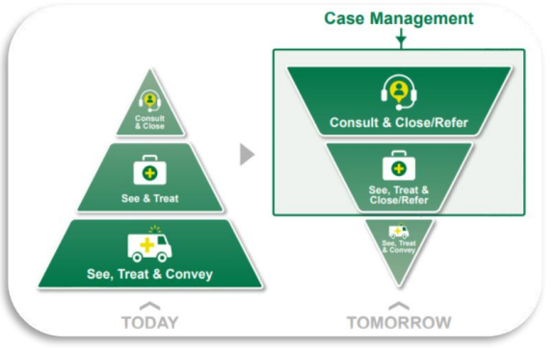

Figure ‎1.1 Inverting the Triangle (WAST 2023)

Inverting the Triangle refers to shifting the workload of the ambulance service from the majority of see, treat and convey to become the minimal, based on clinical need with consult, close or refer, taking precedence to safeguard essential services. Today, this has evolved and continues to develop with system wide changes planned for the nationwide Welsh ambulance service (WAST 2024).

1.2 Accessing Welsh Ambulance
Access to WAST is via 999 or 111. Both services are initially telephony based, with the 9’s lines dispatching emergency vehicles to callers categorised as requiring emergency lifesaving intervention and care. 111 provides remote clinical triage, similar to the 999 department, Clinical Service Desk (CSD) who focus on 999 calls to access services and transport patients other than via an emergency vehicle. 111 supports the public of Wales with non-life-threatening access to care and services such as General Practitioner out of hours (GP OOHs), 111First, district nurse, common ailments schemes through pharmacies, to name a few.

Both departments, provide a similar service however, functionality and extent of services available differs between the two. As part of the evolution of inverting the triangle, these two departments will be merging to develop a new service - the Remote Integrated Care Service (RICS). RICS will provide the same remote triage as 111 and CSD, together with several other services and pathways currently in development.
111 recently upgraded its clinical decision support system (CDSS), bringing it in line with the software utilised within CSD. Performance metrics are still being developed 10 months post implementation, following the abandonment of the previous CDSS software being developed with less than 12 months to adapt and implement the software to the needs of 111Wales.

1.3 Health and Wellbeing
The Covid-19 pandemic impacted the physical and psychological health of the population (Shaukat et al 2020; Simons and Baldwin 2021); and continues to impact through this unprecedented and rapidly evolving period in modern history (Alexandrova-Karamanova et al 2024). Workloads have increased substantially resulting in new strains that had previously not been experienced or expected, the term ‘unprecedented’ seemingly a staple in everyday speech.

Prior to Covid19, the service was rolling out the 111 service pan Wales, front ending Out of Hours General Practitioner (OOH GP) services for Welsh local health boards, together with a few other initiatives, such as the 111First; a referral to a physician to clarify if A&E, MIU or GP was the most appropriate pathway. The service developed from a health information / guidance service to a health information and local services front-end, triaging, advising and directing callers to the most appropriate service for their presenting needs, formalising and expanding the service previously undertaken.

The key concepts to be discussed, is the impact of digital change on physical and psychological health. Themes are to be sought through a literature review to identify any further concepts to be explored with staff through a questionnaire sent via Microsoft forms for anonymous completion, noting locality / area of Wales, role / Band, first- and third-party questioning enabling psychological distancing (Kundrát and Rojková 2021).

1.4 Performance
Performance is a key to providing care to the public and achieving the aims of the Organisation. To explore the impact of the digital transformation on the performance of the staff and how the digital changes influences health and wellbeing and if these have an effect on performance as well as the digital transformation itself.

1.5 Aim
It can be argued, the transformation in WAST, echoes value-based health care strategy. As integral providers of quality care to the people of Wales, the staff are central to enabling VBHC, as defined in Welsh Government and Welsh Ambulance policies and strategies (WAST 2024; NHS Wales, 2025a).

With such extensive change ongoing in the Welsh Ambulance service, the following is to evaluate the impact of Digital change on staff performance, health and wellbeing to enable quality healthcare to the people of Wales.

1.6 Scope of the Study
With such extensive transformations underway with Organisational and practice changing initiatives, the scope of this work is to focus on two areas that impact the staff and the patients, the callers, and the population of Wales. These two areas are Performance, Health and Wellbeing. Both are deemed to have a key impact on the quality of care provided.

Structure of the Dissertation
This work follows the IMRAD structure, Introduction, Methods, Results, Analysis, and Discussion to evaluate the impact of digital transformation on staff performance, health and wellbeing. The chapters also follow a similar more simplified version.

The Introduction provides background and the current situation with aims, scope and a literature review. The Methodology presents the how and why. The Results presents the results obtained from the survey introduced in the methodology. The analysis is presented within the Results section, how the results were obtained. The Discussion discusses the results inline with the Literature review. Recommendations and Limitations complete this work with potential solutions and limits to this work.

Chapter 2: Literature Review
To evaluate the impact of digital transformation on performance, Wellbeing and health, a literature review is deemed essential to explore the research available to narrow the focus to the research question (Creswell and Plano Clark 2018). Saunder et al (2023) identified that the literature review provides a background to the known and unknown of the research subject.

2.1 PRISMA and search strategy
An initial search utilising the phrase ‘impact of digital change on performance resulted in 20,342 results. The fields were filtered further by focusing on (Table 2.1):

Table ‎2.1 Initial search results
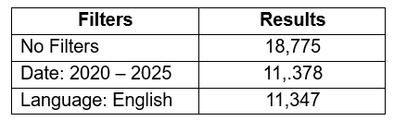

Focusing further on specific databases narrowed the list further (Table 2.2):
–
Table ‎2.2 Data search results
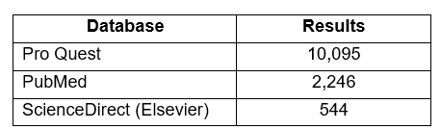

The University database search indicates ProQuest is reported to be the largest periodical resources available to Universities, encompassing areas including Business, Health and Medical, Language and Literature, Social Sciences, Education, Science and Technology, together with the Performing and Visual Arts and Philosophy (UWTSD 2025). PubMed addresses biomedical literature, Medline, life sciences; whilst ScienceDirect (Elsevier) explores scientific, technical and medical research incorporating psychology, Humanities, and Engineering (UWTSD 2025).

It was noted that changing the search terms from “change” to “transformation”, to search “Impact of digital transformation on performance”, with the above databases, resulted in fewer results (Table 2.3):

Table ‎2.3 Filters applied to the search
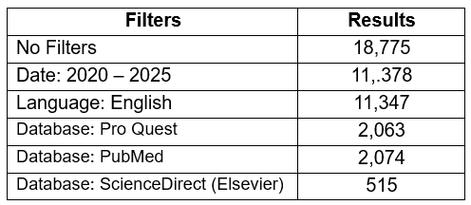

Further searches included using Boolean operators, words such as “AND” and “OR” and “NOT” in the advanced search page, combining “performance” “and” “health” or “Performance” “and” “Wellbeing” or “Performance, health and Wellbeing”:

Health and Wellbeing, again utilising the above filters with an additional filter of ‘full text online’; resulted in just 75 results. The date was expanded to 2010-2025 due to the slim results (Table 2.4).

Table ‎2.4 Multiple search research results
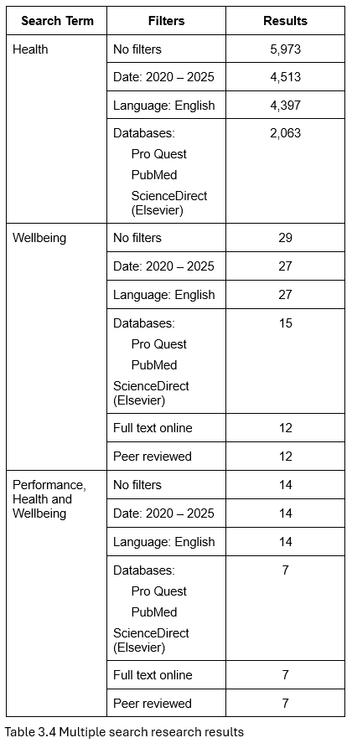

Further searches were undertaken focusing on the terms independently (Table 2.5).

Table ‎2.5 Performance searches
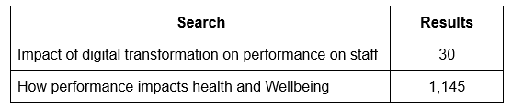

Additional searches to be considered are “change management”, however, this implies a more generalised change as opposed to digital transformation that is the focus of this work. The results for the term “change”, as opposed to “transformation” were considerable, in excess of 2.3 million results. Removing the words “staff”, also expanded the search considerable, to a more generic meaning resulting in manufacturing and financial results; the aim was for “employee” or “operational” as opposed to “organisational” or “strategic” results.

From skimming the titles and reading the abstracts, 46 articles were identified on first pass review. A further 15 articles were discovered through scouring the reference lists of appropriate articles.11 articles were discarded as of interest but not relevance to the subject and duplicated results. Further references were obtained to gain insight into specific headings of sections within the literature search self. These developed following a clearer understanding into the background and arena that the research question encompasses. Further articles and books were utilised during the writing of sections due to specific topics requiring coverage and analysis, expanding the reference list.

To present the results, the PRISMA (Preferred Reporting Items for Systemic Reviews and Meta-Analyses) guidelines have been utilised (Page et al 2021) as a table (Appendix VI), together with a summary sheet for the key articles reviewed in depth (Appendix VII).

2.2 The Review
There is limited academic research relating to the impact of digital transformation on performance, health and wellbeing, with the majority of the articles focusing on various aspects that impact one or occasionally two of these areas (Korhonen et al 2023). In light of this, it is acknowledged to be challenging to limit bias from one aspect overshadowing the others (Tiitola et al 2023). The Health and Social Care sector is a multi-actor, multi-factor, multi-faceted, and an emotionally charged, highly complex field that is both, public and private sector funded and influenced (Korhonen et al 2023; Tiitola et al 2023). It can be argued; a holistic overview is required to prevent the bias of some aspects overshadowing others in relation to staff who have a direct impact on the quality of care for patients (Tiitola et al 2023).

2.3 Performance
Performance has numerous definitions depending upon the scope and whether the focus is financial or non-financial; from a strategic organisational, business, social acceptance or public image or ‘green’ status, to the operational effectiveness and/or patient impact perspective (Chouaibi et al 2022, Alathamneh and Al-Hawary 2023).
The definitions available indicate the complexity of defining performance without a clear scope. Wardana (2023) defined performance as incorporating the achievement and effort in both quality and quantity within their authority and duties whilst remaining legal, ethical and moral. For healthcare and other industries, it is proposed that professional should be added. All terms used so far are generic and vast in their individual remit. In contrast, Khan and Ramachandran (2012) acknowledged the challenge of literature to define terms such as performance, noting it is a composite of cognitive, psychosocial, psychologically and emotionally influenced state, alongside multiple other factors such as communication, socialisation skills, situational awareness with environmental and physical influences (Figure 2.1). Performance is identified as both internal and external to an individual. In essence, it is not only the ability to adapt and utilise knowledge, but also to apply & practice that knowledge, regardless of internal or external influences, situations or environments. Performance can be seen to be a fluid concept without a defined scope or metrics for measurement.

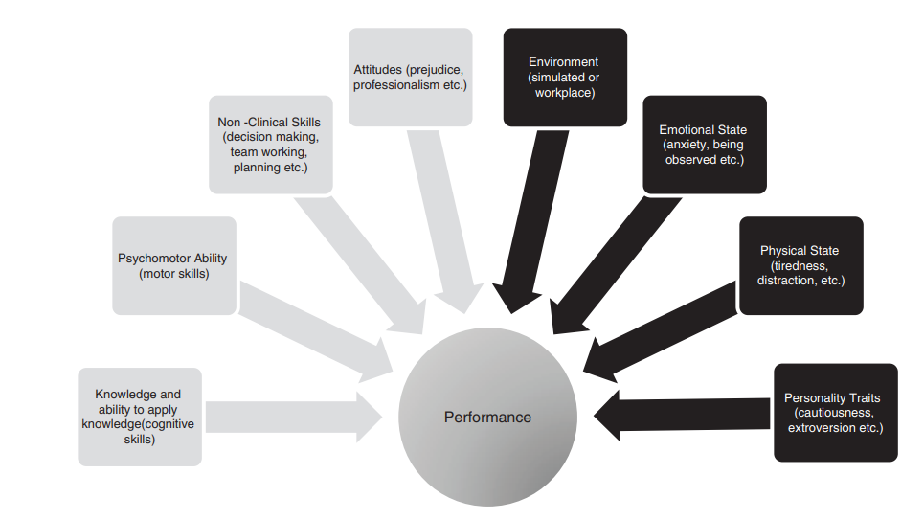
Figure ‎2.1 Factors influencing performance. (Khan and Ramachandran, 2012)

2.2.1 Performance and finance
A common theme in the literature, is the implication that performance is congruent with financial stability and gain. It is noted, strategic performance cost effectiveness may not align with performance effectiveness (Korhonen et al 2023), inferring a bias towards capitalism over performance, wellbeing or health of staff and patients which can be counterproductive and expensive (Crusoe et al 2024). It can also be argued, strategic cost effectiveness is common practice in Western society and healthcare, easier to calculate, superficial, effectively, just the tip of an iceberg above the ocean that is Health and Social Care.

Drummond et al (1988) present examples noting cost alone is multifaceted, although the true impact is often overlooked. Costs holistically defined, are not only financial with hardware and software concerns, but also broaches follow-up investigations and/or tests, knowledge, skill, time of the staff, with the impacts / outcomes on the patient often overlooked (Drummond et al 1988). Crusoe et al (2024) calls this ‘wilful ignorance’, citing strategic motives for evading accountability and/or responsibility.

Drummond et al (1988) expands the holistic costings to encompass both physical and psychological trauma of interventions can result in an impact on quality of life from short sighted health and social care, expanding both long-term as well as short-term costs. It can be surmised, negating a focus on performance, Wellbeing and health, for patients as well as staff, can increase hidden or holistic costs substantially.

In summary, improved compassionate and holistic performance, equates to effective global finance for the patient, the organisation, hard and soft resources, and staff combined (Wardana et al 2023).

2.2.2 Quality and Performance
In Wales, integrating quality is a legal requirement through the Health and Social Care Act 2023 (WAG 2020). The Duty of Quality refers to:
‘system-wide, safe, effective, person-centred, timely, efficient, equitable care’ with an aim to improve the health outcomes for the people of Wales (WAG 2020; WAG 2021a; NHS Wales Executive 2025); echoing the direction of the World Health Organisation (WHO 2020). Binci et al (2022) and Korhonen et al (2023) discuss value-based healthcare (VBHC) enabling balance and cost effectiveness across the patient journey through horizontal management of service, to maximise effective patient outcomes.

The Duty of Quality has twelve Health and Care Quality Standards that define quality for Welsh services, which can be viewed as localising value-based healthcare (VBHC); a high-level strategy to front-line services (Binci et al 2022 and Korhonen et al 2023).

The 12 Health and Care Quality Standards (Figure 2.2) have a core of six dimensions or domains for all staff and persons involved in the Health and Social Care sectors to prioritise and enact in their decision-making (WAG 2020 chapter 6). These are supported by a further six quality enablers, high level domains that support and empower decision-making to the benefit of the patient from a Health and Social Care perspective.

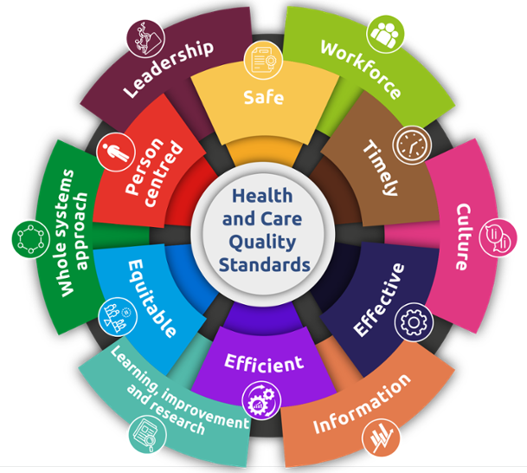
Figure ‎2.2 Health and Care Quality Standards (NHS Wales Executive 2025).

As an over-arching term, performance is integral to quality and vice versa (Saraiva et al 2023). Although synonymous at times, both are independent and reliant on context with immensely complex definitions (Solin and Curry 2023). Interestingly, the language to define both echoes each concept with intrinsic and extrinsic factors influencing the application. Solin and Curry (2023) were able to simplify the essence of quality to a state being fit for purpose and providing a favourable impression through defined combined metrics. WAG (2020), in the context of Health and Social Care, simplify the definition to 6 terms: ‘safe, timely, effective, efficient, equitable and person-centred’, essentially, the core of the Health and Care Quality Standards.

2.2.3 Performance management
As noted, both performance and quality can be said to echo the need for a measurement proforma, defined metrics, to be set and monitored (Solin and Curry 2023).

Performance management is central to adapting organisations to maintain a competitive edge, maintaining innovative and adaptive processes and practices to meet stakeholder demands whilst cost effectively managing resources, efficiently, safely and timely (Cosa and Torelli 2024). Cosa and Torelli (2024) identify flexible management is essential in today’s society. Flexible management being the ability for an organisation to adapt strategies, processes and resources to environmental and technological developments and situations (Cosa and Torelli 2024). It can be argued such heterogenous environments are commonplace for ambulance personnel, requiring dynamic or flexible management in real-time, for situations that vary, with the unique behaviours and responses of patients under stress, in a variety of environments.

Traditional performance metrics are noted to be frequently inadequate to accommodate new and future technologies (Adochitei et al 2024, Cosa and Torelli 2024). Failure to consider performance metrics can lead to pitfalls such as information overload, increased distractive risks, or an expense to the organisation, staff and customers, or patients in the case of the health and social care services (Adochitei et al 2024, Cosa and Torelli 2024). In summary. defined goals requiring achievement to constrain practice for the efficient, effective benefit of all.

For staff, without appropriate performance metrics, this can trigger stress or technostress as noted below (Maier et al 2015; Califf et al 2020). There appears to be limited research on performance metrics and the impact on staff.

Performance metrics can be said to be central to measuring and identifying areas for development or achievement when working towards organisational goals and success (Bayo-Moriones et al 2020; Willmington et al 2022; Vezi et al 2024). Performance metrics, also referred to as key performance indicators or benchmarking (Ishaq Bhatti et al 2014; Willmington et al 2022); are demarcated variables or elements, utilised to measure, compare and manage performance, the focus of which is individual to the organisation or the role contributing to the organisation’s goals (Khan and Ramachandran 2012; Ishaq Bhatti et al 2014).

Feedback to employees is an element of performance management (Memon et al 2020). It is noted that fairness and acceptability of feedback is central to the reception of feedback (Taneja et al 2024), whilst little is documented about which metrics should be used, performance variables or metrics are abundantly available with the ongoing digital transformation of services (Cosa and Torelli 2024).

Performance management can have a significant impact on employee stress and wellbeing if not seen as objective, evidence based, fair and achievable (Bayo- Moriones et al 2020; Memon et al 2020; Taneja et al 2024; Vezi et al 2024). Performance metrics can be said to provide the evidence to support feedback objectively, whilst it must be noted, feedback is essential for staff awareness and organisation performance and quality measuring.

2.2.4 Stress and Performance
Stress is noted to have a significant impact on performance, physical and mental health (Califf et al 2020; Iqbal et al 2024). Stress, like performance and quality, is a complex term. Tarafdar et al (2019), following a review of the literature, equates stress as a psychological process between the individual and the environment, where an individual may react differently to different situations, exposed to different stimuli, whilst considering the individuals’ intrinsic resources and their coping strategies, that can result in psychological, physical and behavioural responses. Alternatively, a state where an individual’s capabilities and resources are exceeded, when the rewards or costs of meeting compared to not meeting the demands are considered inadequate (Ragu-Nathan et al 2008). The ‘state’ or responses can result in a positive or negative reaction; constructive, creative, empowering and motivational or destructive, disheartening and oppressive (Tarafdar et al 2019; Califf et al 2020; La Torre et al 2020).

‘Dark’ stress has a negative impact on performance; whilst ‘bright’ or eustress, has a positive impact on performance (Ragu-Nathan et al 2008; Califf et al 2020). Historically, technostress, stress related to the use of technology (Califf et al 2020) has been a phenomenon, for the last 50+ years, yet the implications and failings of digital transformation, continue to this day (Ragu-Nathan 2008; Pfaffinger et al 2022; Crusoe et al 2024). Despite historical papers and the roll out of technology over the previous mid to current century, some authors identify technostress as an emergent or young phenomenon (Tarafdar et al 2019; La Torre et al 2020), implying much work remains in exploring this event.

Technostress is often regarded as a stress an individual experiences, when failing to cope with the increasing use of technology in their work (Ragu-Nathan 2008). Numerous authors break technostress down into components that can have varying impacts on an individual’s stress or technostress, with concerns heightened relating to various areas, such as techno-overload techno-invasion, techno-complexity, techno-insecurity, techno-uncertainty, techno-exhaustion (Maier et al 2015; Califf et al 2020).

2.3 Impact of digital transformation on health
There is a significant shortage of research addressing the impact of digital transformation on the health of staff / employees. Of the limited research available, very few, appear to examine the outcomes of digital transformation other than to note digitisation increases complexity, is cognitively more demanding requiring analytical tasks with work often incorporating increasingly complex, partially autonomous processes and tools, for instance, artificial intelligence; Internet of Things, and all Industry 4.0 technologies (Adochitei et al 2024; Arntz et al 2024).

An impact of digital transformation can include a number of issues, aside from technostress, such as the increased risk of obesity, Type II Diabetes Mellitus and some cancers from a more sedentary lifestyle that often accompany digital transformation (Adochitei et al 2024). Other notable risks include musculoskeletal disorders, sleep disorders from exposure to blue light, eye strain and deterioration from prolonged visual display equipment (Grzelak 2024). Many of these can be exasperated by ‘hot-desking’ and remote working, whilst specialised equipment such as adjustable workstations, ergonomic furniture, and anti-fatigue equipment to promote employee comfort and productivity are available (Adochitei et al 2024).

2.3.1 Impact of digital transformation on Physical heath
As already noted, the physical effects of desk-based occupations have contributed to an increase in multiple conditions and diseases, exacerbated by a sedentary lifestyle (Adochitei et al 2024; Grzelak 2024). Together with an aging population, a sedentary lifestyle can impact:
- Metabolism - increase ‘bad’ low-density lipoprotein (LDL) cholesterol whilst decreasing ‘good’ high-density lipoprotein (HDL)
- Weight gain - exacerbate / contribute to obesity with an imbalance in energy expenditure resulting in weight gain, contributing to poor cardiovascular health.
- Musculoskeletal degeneration – a reduction in muscle mass
- Deterioration / decrease in bone density / health, contributing to conditions such as osteoarthritis.
- Vascular disease – heightened risks of stroke (transient ischaemic attacks, cerebral vascular accidents)
- Cardiovascular disease – atherosclerosis, myocardial infarction.
(Riedl et al 2012; Adochitei et al 2024; Grzelak 2024; Iqbal et al 2024) .

Although mentioned in passing, back pain is a common problem within the workforce, made worse by being sedentary (Grzelak 2024). A multitude of physical complaints are not addressed, although fall under the context of an increased incidence of health conditions, such as constipation, muscle aches and strains, repetitive strain injuries, fibromyalgia, for instance. All can have independent causes, whilst all are exacerbated through being sedentary.

2.3.2 Impact of digital transformation on Psychological heath
Psychological health and digital transformation is widely documented in the literature, often under the guise of stress or technostress. Grzelak (2024) thoroughly expands psychological impact, reporting on studies noting an increased incidence of depression, dementia and sleep disorders. Primarily Grzelak’s (2024) paper is related to a sedentary lifestyle on health, although correlates with authors such as Maier et al (2015), Califf et al (2020), Hoehe and Thibaut 2020, Adochitei et al (2024), Hu et al (2024) to name a few.

Although some authors identify positives to a certain level of stress, all note, the ‘bright’ side or positive element of limited stress, as opposed to the ‘dark’ or negative impact. ‘Dark’ stress is widely documented and researched down to the bio-chemical reactions of the body releasing cortisol, the ‘stress’ hormone, together with its impact on health (Riedl et al 2012; Igbal 2024).

An extreme effect of poor psychological health is burn-out or Burn-out Syndrome. Burnout is defined as an occupational phenomenon not a medical condition or illness (WHO 2019). Some authors, link burnout to Wellbeing (Pfaffinger et al 2022; Marsh et al 2024), whilst others note uncontrolled stress (Sanchez-Segura et al 2023; Iqbal et al 2024) or a psychological state (Maier et al 2015). The World Health Organisation (WHO 2019) notes burn-out is solely related to an individual’s work-life, with three dimensions:
- exhaustion or lethargy (energy depletion)
- psychological distancing from job / role, can include cynicism or negativity.
- reduced professional efficacy.

Although it is noted, burnout has been a longstanding issue (Sanchez-Segura et al 2023), digital transformation can add to the likelihood of burnout (Iqbal et al 2024; Marsh et al 2024), or can contribute to prevent, monitor and remedy the consequences through Industry 4.0 technologies (Sanchez-Segura et al 2023).

Many of the contributing factors to burnout prior to digital transformation, include staff shortages, poor rewards / low pay, inadequate and unsafe working conditions, stressful environments and a lack of needed workplace safeguards, or even the perception of these (WHO 2024). Although these can be correlated to any occupation, health care services are noted to be particularly vulnerable to these working conditions (WHO 2024).

With digital transformation, the components of technostress add to the heightened risk of burnout if Wellbeing is not considered integral to any digital transformation (Marsh et al 2024). Digital transformation in health and social care heightens the risks of stress and burnout on staff within this area.

2.4 Digital Transformation and Wellbeing
Wellbeing is a concept that is a difficult to define (Simons and Baldwin 2021). Numerous articles and references to Wellbeing, are commonplace throughout the literature, yet few attempt a definition. Danna and Griffin (1999) relate Wellbeing to satisfaction in an area of life. A few authors expand and acknowledge Wellbeing as far more complex and multifaceted with multiple overlapping concepts contributing to the whole, a synergistic emergence contributing to a holistic state (Abdi et al 2018; Pfaffinger et al 2022). Simons and Baldwin (2021) conceptualise Wellbeing, Figure 2.3:
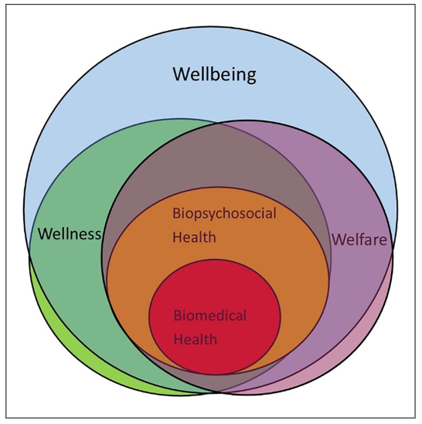
Figure ‎2.3 Simons and Baldwin (2021) concept of Wellbeing

Each ‘concept’ / state of can be taken individually or contribute positively or negatively to an individual, resulting in potentially, good health but poor general Wellbeing and vice versa, poor health but a positive Wellbeing (Abdi et al 2018).

Digital transformation can likewise impact Wellbeing positively or negatively. Authors identify the benefits of any transformation, need to outweigh the negatives or increased workload or pressures of any change (Califf et al 2020; Binci et al 2022).

Authors similarly reflect on an employee’s perception of digital transformation in terms of ease of use and usefulness, Figure 3.4 (Ammenwerth et al 2006; Binci et al 2022; Chrysikou et al 2023).

Numerous authors surreptitiously propose support for Wellbeing should be integral to the planning of digital transformation. Success is impacted by a failure to incorporate task, technology and user or individual (Ammenwerth et al 2006; Tarafdar et al 2019).

Ammenwerth et al (2006) created a framework similar to the works of numerous authors, who propose near identical components. These studies tend to focus on the success or risk of failure in digital projects as opposed to the health and Wellbeing of staff, although this often a noted consideration as part of the Individual component or tile (Figure 2.4).

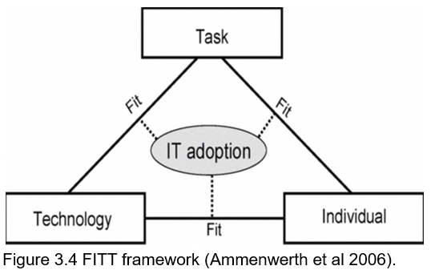
Figure ‎2.4 FITT framework (Ammenwerth et al 2006).

Ammenwerth et al (2006)’s seminal work developed the FITT framework to support technological adoption in healthcare. This framework focused on the attributes of the user, Individual, technology and the task with key focus on the socio-organisational-technical factors (Table 2.6).

Table ‎2.6 FITT attributes
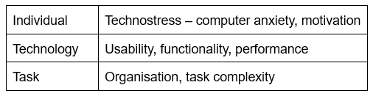
Likewise, multiple authors identify digital transformation has numerous factors that impact Wellbeing, focusing primarily on the detrimental effects (Chrysikou et al 2023; Crusoe et al 2024) as opposed to the potential positives (Califf et al 2020).

2.5 Resistance to change.
Resistance to change is a common area of concern for all transformation projects that can block success and ensure failure if not monitored, reviewed and addressed (Warrick 2023; Amin et al 2025).

Resistance to change is often viewed as negative, judgemental and obstructive (Dunford 2022; Warrick 2023). Warrick (2023) identifies resistance to change should be viewed positively, identifying planning, communication and support mechanisms are required by recipients - those affected by the change; to be addressed by the change agents - those who initiate and lead change.

The change process has been heavily researched through the years with multiple studies reviewing the why, what and how with the remedies to bridge the ‘threats’ and build upon ‘opportunities’ change poses to recipients (Dunford 2022; Sendrea 2023).

Many authors report threats, seemingly echoing many of the ‘components’ of technostress; concerns with change to routines, workflows, change to traditional methods of working, threat to job roles, etc. (Amin et al 2025). Responses to threats, are deemed to be emotive, stemming from an emotional base such as anxiety, fear, confusion and anger (Warrick 2023). The emotive response to change or transformation, has been controversially compared to Kubler-Ross’ 5 stages of grief, (Figure 2.5), deemed an inappropriate comparison with stages and emotions an unequal comparison (Persson and Karlsson 2020).

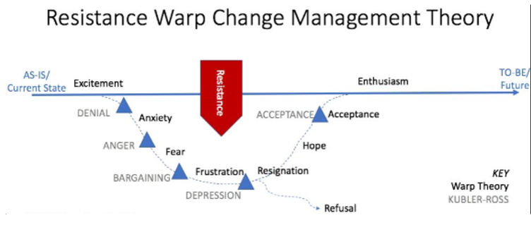
Figure ‎2.5 Comparing Kubler-Ross 5 stages of grief to resistance to change

Some recipients are reputed to experience some or all of the stages depending on personal or organisational influences as opposed to internal or external influences (Warrick 2023). It can be argued, there is a significant overlap between Warrick’s definitions of Internal or External influences together with the personal or organisational, echoing Khan and Ramachandran (2012) in their definition of performance; and Tarafdar et al (2019) characterisation of stress.

Amin et al (2025) notes resistance to change can be minimised through support, training, recipient participation, to name a few. Without careful consideration, the emotive impact of resistance to change can add immense negative, oppressive pressure on staff, impacting Wellbeing, health and performance (Tarafdar et al 2019; Califf et al 2020; La Torre et al 2020).

2.6 Technology and Human factors
In contrast to resistance to change, human factors are the complex interaction of humans with other systems with an aim to maximise wellbeing and performance (Neumann and Dul 2010; Braarud et al 2025). Neumann et al (2021) identifies human factors play a key role in organisational performance, productivity and quality although is often overlooked and underestimated (Neumann et al 2021). Braarud et al (2025) supports this definition noting performance is dependent on the human interaction with processes, operating procedures, staffing, roles and responsibilities, expanding the definition into the psychosocial aspect, as previously reported by Neumann and Dul (2010).

Echoing much of the literature discussed previously, Neumann and Dul (2010) summarised human factors as key to overall system performance through the adaption of system design to fit people as opposed to people adapting to fit systems (Figure 2.6).

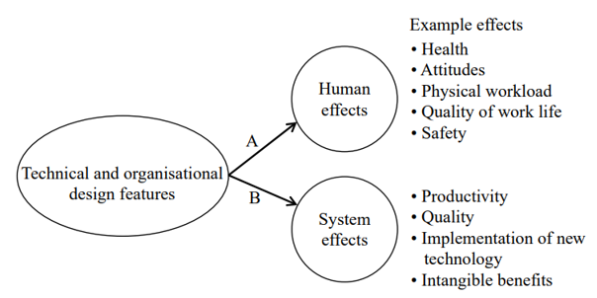
Figure ‎2.6 Human factors (Neumann and Dul 2010).

On review, a double headed arrow could be utilised to link health effects and system effects on the diagram above, as discussed in 2.2.3 Performance Management, 2.2.4 Stress and Performance and 2.3.2 Impact of digital transformation on Psychological heath. Alternatively, a parallel between human factors and Ammenwerth et al (2006) FITT between Individual, Task and Technology can be seen to overlap to many degrees.

Braarud et al (2025) note human factors is critical for the achievement of safety and efficiency targets within the nuclear industry. Although a nuclear disaster is less of a concern in the health services, patient safety, quality care, and performance is essential to avoid the pitfalls of compensation following failings (Neumann et al 2021), not to mention the harm and suffering experienced through poor quality care, the holistic cost of failings (Drummond et al 1988).

Neumann et al (2021) identified the cost of human factors consideration is hard to quantify although notable benefits such as improved wellbeing of staff, less errors, improved quality care, successful transformation and technology implementation can be bolstered through training and professional development with improved health. Much of this echoes the earlier discussions relating to costs in Chapter 2.2.1 and the study of Drummond et al (1988), although as opposed to relating to patients, Braarud et al (2025) and Neumann et al’s (2021) research relates to staff.

The addition of Industry 4.0 technology, which refers to the digitisation and integration of information technology, application of cloud-based systems, Internet of Things, big data analysis, artificial intelligence, augmented and virtual reality, robots and cyber-physical systems where humans, machines and products communicate; all add to the complexity of human factors application (Neumann et al 2021).

Failure to offset these advances with human factors consideration from the design phase to the implementation and daily working or business as usual phase, will impact wellbeing, health and productivity with quality and safety compromised. Communication and supporting autonomy are crucial to prevent a reduction in job satisfaction and attrition (Neumann et al 2021).

2.7 Digital transformation & the impact on staff
The pace of digital transformation can be said to have accelerated due to the Covid-19 pandemic in 2020 (Hoehe and Thibaut 2020). The need for the public to ‘stay at home,’ work from home, study, shop and exercise from home, resulted in a rapid role out of technology and remote working / communications platforms (Alsaffar et al 2020; Binci et al 2022).

The success or failure of digital transformation is heavily influenced by a multitude of factors, from a sound proposal and design phase to organisational implementation and practice (Ammenwerth et al 2006).

A failure to prepare a plan that supports Wellbeing from the outset, can lead to failure of a project or impact the performance, health and Wellbeing of staff resulting in high sickness, higher than expected staff turnover, significant stress and heightened risk of burnout (Who 2019; Pfaffinger et al 2022; Marsh et al 2024). Many of the topics addressed echo and overlap each other, all broaching the importance of prioritising the human factors to maximise quality whilst maintaining Wellbeing, health and amplifying performance with any digital transformation.

2.8 Resistance to Change
Resistance to change is reputed to be inevitable, although can be overcome through collaborative planning, design and support. Failure to prioritise the individual, performance, health and wellbeing can suffer resulting in an impact on staff, quality and patient care, with costs being both financial, emotional and extensive for all parties involved.

Guidance and legislation from the World Health Organisation to Local Government, to organisations prioritise quality and can be summarised in the following rich picture in Figure 2.7:
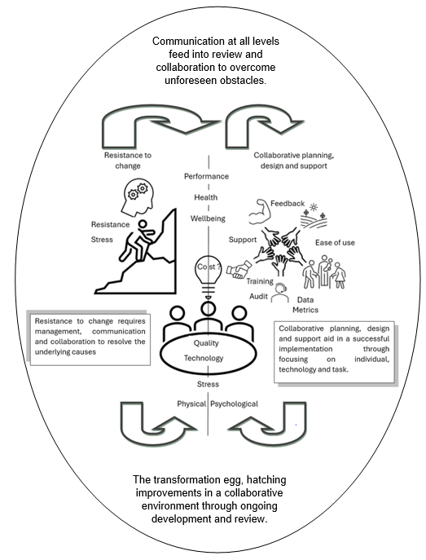
Figure ‎2.7 Rich picture to support staff through digital change.

Following a significant digital transformation with NHS Wales 111 service, an evaluation of the impact of digital transformation on the performance, health and Wellbeing of staff was assessed to identify a holistic view of the understanding and requirements of staff, with proposed areas of development.

2.9 Conclusions
The impact of digital transformation on performance, health and Wellbeing is highly complex, multifaceted and an immense topic that requires careful planning from the outset to safeguard staff and patients to achieve safe, efficient, effective quality care.

Numerous factors impact a successful digital transformation that can have a significant impact on the performance, health and wellbeing of staff that has both intrinsic and extrinsic factors, resulting in a direct impact on the care received by the patient.

Chapter 3: Methodology

3.1 Introduction
To evaluate the impact of digital transformation on performance, well-being and health, a mixed method study has been completed, enabling a multifaceted view of the staff perception of the impact of the changes on the staff themselves.

Creswell and Plano Clark (2010) identify mixed methods research as being intuitive, utilised in daily life, developing what we know with what we discover, together with its impact on an individual or a group, data to advise, guide or prescribe a course of action, behaviours or guidance beneficially. Numerous authors concur, succinctly identifying mixed methods research compares alternate views identifying the effect and the impact of a phenomena, enabling complex question/s to be explored in a meaningful and holistic style, whilst utilising more than one research methodology (Denscombe 2010; Gov.uk 2020; Dewadi et al 2021).

The benefits of mixed methods research are noted to excel with the strengths of both qualitative and quantitative research (Shorten and Smith 2017; Gov.UK 2020), exploring diverse perspectives (Shorten & Smith 20217); enable strong evidence and confidence in the findings, enhancing validity (Gov.UK 2020), whilst permitting a phenomenon to be evaluated in depth and breadth balancing divergent or complimentary views (Dewadi et al 2021).

The negative impact of a mixed methodology / strategy is the complexity of utilising more than one methodology, the expertise required to collect, analyse and interpret the data / results; together with the increased time and resources required to analyse and interpret the two sets of data (Shorten and Smith 2017; Gov.UK 2020; Dewaldi et al 2021; Saunders et al 2023). Dewadi et al (2021) noted sparse literature and support on the integration of the more than methodology, whilst the underlying philosophical frameworks are disparate requiring an experienced researcher to plan, utilise and successfully glean quality findings from a mixed-methods methodology. Superficially appearing to be in opposition to Creswell and Plano Clark (2010) of mixed methods being intuitive use in daily life.

3.2 Project Planning and management
To support completion of the study, a plan was devised to support the management and steps required. For ease of use, efficiency of creation and interpretation, a Gantt chart was developed to plan a timeline and key steps for the completion of the study. Gantt charts are a pictorial representation of tasks set via a timeline deemed to support efficient completion of projects (Tang et al 2024).

It is noted by authors, Gantt charts are simplistic and flawed, just one of many project management tools (Geraldi et al 2012; Tang et al 2024). Due to its simplistic intuitiveness, ease of use and clarity, for this short-term study, it is deemed appropriate, efficient and effective although notably, will require some amendment as time goes on to counteract the failings noted by some authors (Geraldi et al 2012).

The Gantt chart (Figure 3.1) illustrates the plan that aided completion this work (Appendix I).
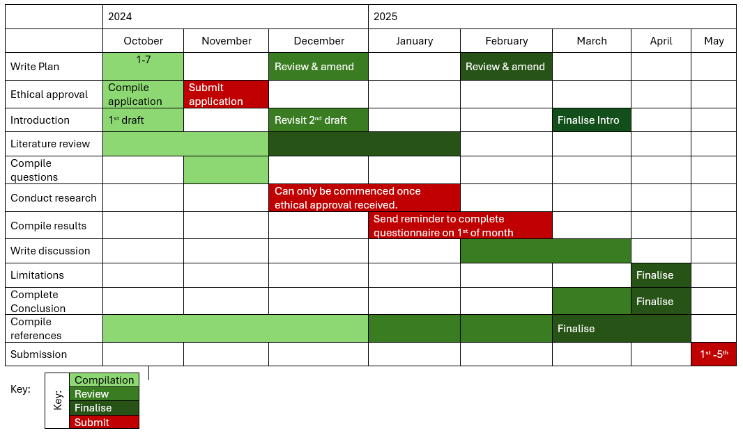
Figure ‎3.1 Gantt chart Plan

The key makes viewing and interpreting the plan easier to track progress with unique deadlines for each stage in the development of this work. Light green is the beginning, the compilation stage, gathering information and writing of first draft. The Mid green is the review periods where essential, identifying any tweaks, topics to be covered, anything missed previously and discovered during the Compilation stage. Finalise is the end stage, where that section is edited and filed ready for submission. The Red stages are the submission stages. Submission of the ethical approval, submission of the survey to staff, reminder with links; and finally, the final submission of all finalised work completed.

To counter some of the criticisms of the Gantt chart, three review periods were scheduled and planned, as seen in Figures 3.1, 3.2 and 3.3. External factors were not identified initially, although have impacted on the smooth progress of the study. For instance, pressures on the NHS over the Christmas period are renowned for increasing demand and stress on services and staff (WAST 2024c, Triggle 2025). A common side effect is the stress and strains on staff add to reduce time to support research projects such as this, impacting completion. Another potential criticism of completing research through this time of year, is the responses may well differ due to the stress, compared to if the research was completed during the summer months.

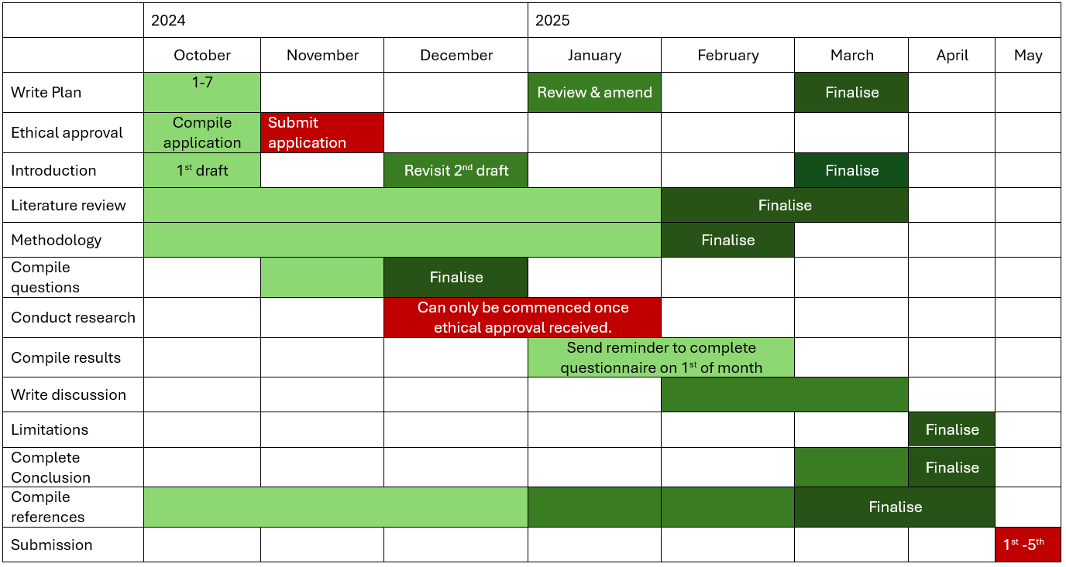
The revised plan (Figure 3.2), includes key changes and a correction of typos, extending the literature review period, whilst incorporating methodologies. It should be noted, compiling the results are impossible without ethical authorisation, despite the amendment to compile results on the revised plan.
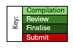
With a key: -

Figure ‎3.2 Gantt chart Revised Plan

The key remains the same as defined previously for Figure 3.1. Maintaining the colour code and key, aid in understanding and progressive development of this work.

Focusing on the research question, key areas for review have been how performance impacts health and Wellbeing and vice versa. Ideally the literature search should be completed prior to compiling the survey, however; due to the multiple factors mentioned previously, together with the limited time constraint of completing the study within an academic year, the strain of working full time in a service requiring 24-hour cover, whilst under extreme pressure, encompassing the Christmas period; this proved impractical and impossible to achieve. As such, and deeming the Gantt chart a pseudo-Live document, a document that is can be adjusted and expanded as required; a final review and amendment was noted to be essential, Figure 3.3 (Appendix II).
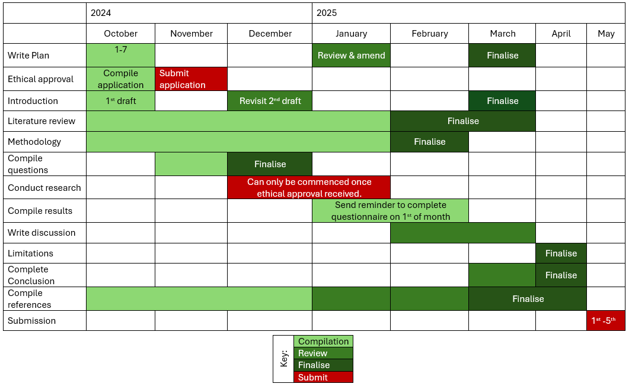
Figure ‎3.3 Gantt chart Evaluated plan

As the methodology and literature search progressed, it was evident areas of significance had not been considered but essential to the research underway, Figure 3.3 (Appendix II).

The key remains the same. Maintaining the colour code and plan, aid in development and tracking how this work progressed.

3.2 Ethical considerations and academic integrity
With all research projects, ethics can be defined as an umbrella concern, ensuring no harm is experienced from participating in the research (Denscombe 2010). It can be argued, this is a position underpinning all professional practice and their Governing bodies (HPCP 2014, NMC 2015) and employers (NHS Wales 2025a). WAST likewise has Organisation behaviours contributing / enhancing the Culture of the Organisation, although no longer specifically identify ‘Do no harm’, but instead is a positivist, supportive and equality-based philosophy underpinning the culture of the Organisation, focusing on quality and safety for staff and patients (Ambulance 2019; 2020; WAST 2024d), echoing the NHS ethos (NHS Wales 2025b).

This work is completed under the supervision of University of Wales Trinity Saint David (UWTSD). The ethical application, (Appendix III), was initially reviewed and approved following careful consideration (Appendix IV). The form comprehensively broaches ethical requirements in the following areas: -
- Internal and external guidance
- Details of the Research activity, purpose, the question, aims, proposed research methods, the location of the study,
- Consideration of Wellbeing in line with the Wellbeing of Future Generations (Wales) Act (2015),
- The scope of the study, the activities to be undertaken,
- The target population,
- Information to be shared with the population,
- Anticipated risks to the participants and the researcher, as well as the Organisations involved.
- The availability of feedback, consent and confidentiality,
- Data protection and storage in line with General Data Protection Regulation 2016 (GDPR); the where stored, who has access and where that access is possible.
- Any risk assessments required.
Many of these areas are discussed further below.

An email (Appendix VIII) was sent to all staff within the inclusion criteria, requesting their personal opinion in the first and third person, enabling cognitive distancing as a comparative tool to enable an honest, holistic opinion, safeguarding against psychological dissonance, any perceived judgement by individuals on their own behaviour, actions and perceptions that may be controversial or personally contemptuous (Kundrát and Rojková 2021). As the survey is anonymised, this will add to the psychological safety, enabling staff to be open and honest, without fear of recrimination.

The covering email identifies the survey is anonymous, requesting an individual’s band and site only, together with guidance on where to seek help and support, not only from local managers, but also from the Wellbeing team, Occupational Health and Speak up Freely Team, a confidential, anonymised service created to advocate for staff who feel unable to seek support through all other channels for whatever reason.

3.3 Data Collection
To evaluate the impact of digital transformation on performance, well-being and health, the data will be collected via a questionnaire which will enable both quantitative and qualitative analysis. The primary focus is to ascertain a holistic overview of a complex multi-component impact on the emotional, physical and psychological impact on staff performance for which a mixed methods is ideal (Busetto et al 2020). Whilst qualitative research is deemed low in the hierarchy of evidence, Busetto et al (2020) argue a methodology that does not address the research question effectively, is not fit for purpose.

In the survey, open questions were utilised to gather data for analysis through free text or, open, honest feedback, which enable raw unfiltered comments.

The use of Likert scales with defined variables such as Band, locality, age and experience; enable a quantitative or numerical perspective to the ‘softer’ side of the research question (Busetto et al 2020). Likert scales are comprehensively utilised within research (Anjaria 2022, South et al 2022). They are an effective, visually aesthetic, easy, and efficient to use providing quantitative data for analysis (South et al 2022), making them an ideal tool in a busy work environment. Likert scales are flexible to measure both objective and subjective data, although a common criticism, is the potential to bias responses through the terminology of questions to the number of options available to answer the question (South et al 2022).

Although ideal, a pilot study was viewed as outside the scope of this study, in part due to the limited timeframe, but also the close-knit sample population. The questionnaire was reviewed by a Lead University Lecturer / Supervisor and a Locality Manager within one of the Locality areas for appropriateness and reliability in addressing the research question.

3.4 Population of the study
The population of the study are all of the ‘frontline’ staff working within NHS111 Wales. This is the entire group of people to be included in the research (Grad Coach 2023). To gather the information required, a survey was sent via email to the population noting the following information or variables: -
- online staff Band 3-8a working within 111 Wales, either as a substantial contracted staff member or as a Bank worker working regular hours (at least monthly).
- The age of respondents
- Length of service in the field of telephone triage / remote working
- Locality of staff – North Wales, Central and West or South-East

The ‘frontline’ staff of NHS111 are those working daily with the public and have immediate management and direction of the service spanning 8 regions of Wales incorporating homeworkers. Summarised and presented in the Table 3.1 Survey Population.

Table ‎3.1 Survey Population
Population members | Role | Why
Call Handlers (CHs) | - Non clinicians  - Answer the calls into NHS 111  - Are Band 3 staff  - Process calls, completing a short triage to prioritise patients  - Refer appropriate calls onto appropriate Teams including NHS111 clinicians England and Wales; community services such as pharmacy, District Nursing services, General Practitioners; or 999 Emergency Services. | - The Team comprises of 248 call handlers  - The digital transformation has recently included a significant change to practice, with new roles and responsibilities.  - Are considered frontline staff
Clinicians  (known as triage and assessment nurses - TANs and TAPs). | - Clinicians are registrants of NMC (Nursing and Midwifery council) or HCPC (Health Care Professional Council)  - Are Band 6 staff  - Guide the call handling team with clinical queries  - Triage patients and callers  - Advise on healthcare interventions with outcomes of self-care to the immediate life-threatening requiring support of emergency services  - Referral to support agencies such as Accident and Emergency departments, 111 First and Minor Injuries Units, GPs – in and out of hours, Social services, Public Health Wales, Physiotherapy, Acute Care Teams, to name a few | - The Team comprises of 169 clinicians pan Wales.  - The digital transformation has recently included a significant change to practice, with new roles and responsibilities.  - Are considered frontline staff
Dental Nurses (DNs) dental qualified nurses | - Clinicians with specialist dental knowledge  - Triage, advise and guide callers to the appropriate dental care and actions  - Empowering callers where, when, and how to get further help as required, for dental concerns.  - Support call handling service, completing the same role as the CHs. | - The Team comprises of 6 clinicians pan Wales.  - The digital transformation has recently included a significant change to practice, with new roles and responsibilities.  - Are considered frontline staff
Call Handler co-ordinators (CHCs) | - Team Leads to the call handlers.  - Manage the NHS111 Wales service from an in-coming call perspective.  - Together with the SCA / SNA, the CHC are responsible for maximising call flow through the 111 service, together with real-time staff management with breaks and shifts times | - The Team comprises of 17 staff pan Wales.  - Are considered frontline staff.  - The digital transformation has recently included a significant change to practice, with new responsibilities.  - Are the initial support for all staff with any non-clinical queries.
Senior Nurse / Clinical Advisors (SCAs / SNAs) | - Team Leads of the clinicians  - Are Operationally responsibility for the performance and day to day management of the NHS111 Wales to support the people of Wales and the Welsh Ambulance Service. | - The Team comprises of 16 staff pan Wales.  - Are considered frontline staff.  - The digital transformation has recently included a significant change to practice, with new responsibilities.  - Are support for all staff with any clinical and non-clinical queries.
Locality Managers – (LMs) | - Team Leads of the SNA / SCA Team.  - LM’s lead and complete projects and Operational developments at local level. | - There are 3 LMs pan Wales
Total population: 459

The population were identified and targeted as a key group as the digital transformation directly impacts each in the performance of their role. It is proposed the population, as a key stakeholder, have little input into the changes or pre-training prior to Go Live of any changes. Many authors, note this is a recipe for failure (Ika & Pinto 2022).

3.5 Data analysis
3.5.1 Quantitative analysis
For quantitative analysis, a licenced software package IBM SPSS Statistics package version 29.0.1.0(171) was utilised. The software is reputed to be a comprehensive suite with advanced capabilities that are accessible for all levels of users, enabling insights to enhance decision making and support of staff in addressing a research question (IBM 2024). SPSS is classified as an ‘industry standard’ (Harrison 2021).

To aid in the analysis of the data, descriptive statistics was performed. Descriptive statistics focuses on describing the sample of the population, the respondents of the survey (Grad Coach 2023). Descriptive statistics enables a macro and micro view of the data, aid in identifying any errors, and inform as to which inferential statistics may be relevant (Grad Coach 2023). Inferential statistics enables conclusions about the population based on the data of the sample (Saunders et al 2023). It must be noted, the larger the sample of a population, the likely the data is to be representative of the population (Saunders et al 2023).

Using descriptive statistics to identify the mean, the median, the mode, and the standard deviation to report the statistics for each of the eight I / They statements. Table 3.2 defines the role and purpose of the statistics utilised.

Table ‎3.2 Definition of statistics used to analyse results (Saunders et al 2023).
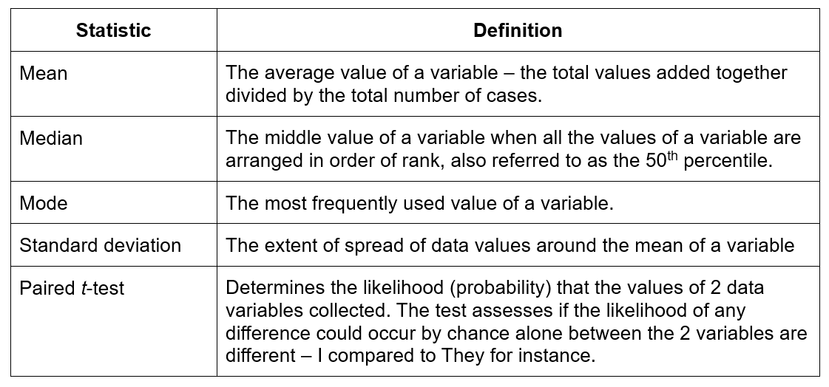

The mean responses, standard deviations were calculated to comprehensively understand the participants responses.
- Do certain variables have a significant impact on the responses for instance, does age impact performance, wellbeing, or health?
- Does band or job role impact the Wellbeing of staff?
- Is there a significant difference between first person and third person responses in question 6 and 7 of the survey.

When comparing multiple variables the box plot chart is utilised. The box plot is a pictorial representation of the data (Figure 3.4), ideal for comparing the distribution for two or more variables (Saunders et al 2023).
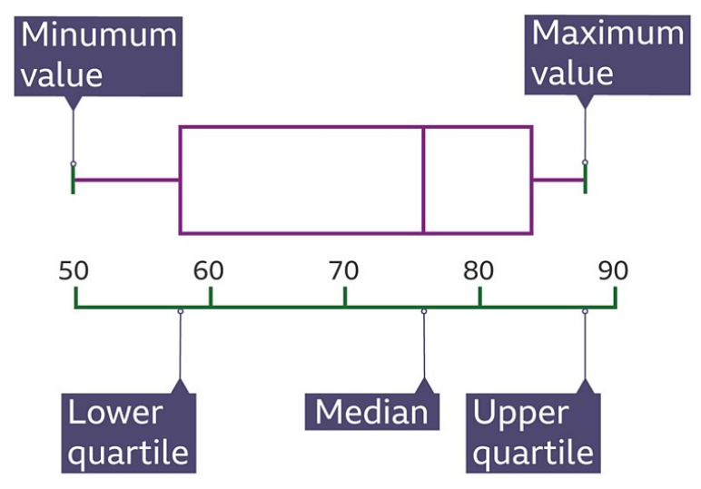
Figure ‎3.4 The Box Plot (BBC 2025)

The distribution of the statistics for each variable, present the median – middle value, the lower quartile – the value halfway between the minimum and the median, the upper quartile – the value midway between the median and the maximum value, and the highest and lowest values (Saunders et al 2023; BBC 2025; McLoed 2025). Box plots show 100% of the data with the whiskers (the lines from the lower quartile to the minimum) presenting 25% of the data, the box presenting the middle 50% of the data (McLoed 2025). The circles and stars outside of the box plot present outliers, a response that is numerically distant from the rest of the data, outside of the whiskers, impacting the average value for the dataset (McLoed 2025).

3.5.2 Qualitative analysis
The qualitative analysis is be undertaken via thematic analysis, utilising Braun and Clarke’s (2006) six-phase framework for thematic analysis (Figure 3.5). Thematic analysis seen as a foundational method for identifying, analysing and reporting themes or patterns from data obtained utilising qualitative research (Braun and Clarke 2006). It can be argued the work of Braun and Clarke (2006) is aged, however, deemed a seminal work, often referenced within the literature.

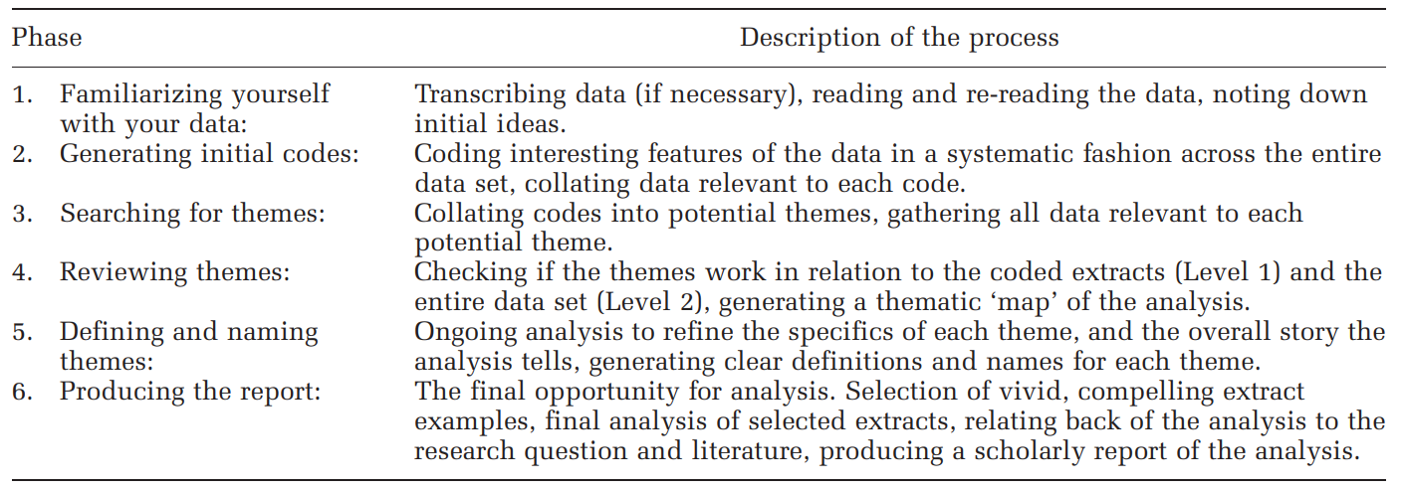
Figure ‎3.5 Using thematic analysis in psychology (Braun, V. and Clarke, V., 2006).

The thematic analysis was applied to the free text responses of the survey, coding key themes, analysing the frequency and strength of feeling, how often mentioned, terminology used, to aid reporting in the results description in Chapter 4 and later discussion in Chapter 5.

3.5.3 SWOT (Strengths, Weaknesses, Opportunities, Threats) analysis
A SWOT analysis was utilised to aid in the extrapolation of key themes and aid organisation of the results. Although heavily criticised by some authors (Cheng et al 2021), as lacking empirical validation, subjective, superficial and restricted by a snapshot of a specific time, it remains a longstanding, strategic planning tool, throughout the World (Cheng et al 2021; Puyt et al 2023).

Puyt et al (2023) argue the SWOT analysis has been overly simplified through the years, to represent the minimalistic tool that is represented by the 2x2 cube that is commonly utilised today (Figure 2.6).

The Figure 3.6 has its own key (Figure 3.7), themes are incorporated into 6 subjects.

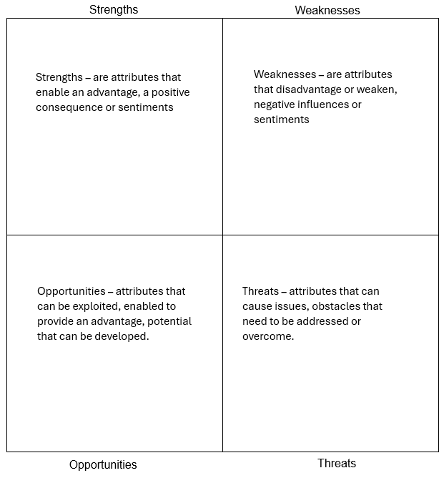
Figure ‎3.6 Template used for the SWOT analysis

Respondent’s comments have been categorised into shapes to identify the theme (Figure 3.7):
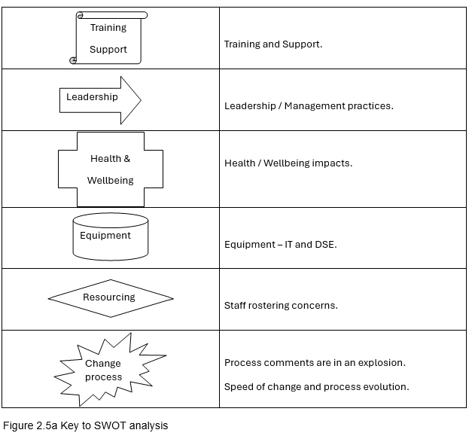
Figure ‎3.7 Key to SWOT analysis

The original SWOT analysis was seen as a conscientious, explicit, judicious tool that utilised data from 4 sources: -
- Practitioner expertise and judgement
- Evidence from a local context
- Critical evaluation of best available research
- Perspectives of those most affected by any strategic plan.
(Puyt et al 2023).

For this work, Braun and Clarke’s (2006) six-phase framework for thematic analysis together with a SWOT analysis were used for identifying the key points to be discussed in Chapter 5.

3.7 Limitations of the study
A limitation with the use of a survey sent via email, is the inability to clarify or explore concepts in greater detail, for which an interview or focus group would enable. Due to the pressures of the work environment, and the time of year conducted, this is not practical. A potential drawback of the methods in use is the limitation through interpretation of meaning with the scoring of individuals and their sentence structure, through which a focus group could discuss.

Bias was avoided through the use of data interpretation software such as SPSS for the quantitative data, and thematic analysis for the qualitative data. Whilst the thematic analysis is completed by the researcher alone, quotes and graphs created by SPSS were utilised together with oversight of the University Supervisor and Locality Manager.

Further drawbacks at present are noted in the short-term nature of the project. This is a snapshot, taken during a period of high stress, the change / digital transformation, and the season of the year. Winter in the NHS and particularly the Ambulance service is fraught with strains and pressures on the service that appear to increase exponentially, each year (BBC 2021; Triggle 2025).

Another limitation is the anonymity of the responses, follow up questions and review cannot be undertaken to clarify nor confirm interpretation. A comparison of any potential discrepancies between first and third person responses will also be lacking, although this could be argued to be a criticism of the questionnaire design.

3.8 Validity and reliability
Validity is defined as the degree to which the data collection methods accurately achieved what they intended to measure (Saunders et al 2023).

Internal validity and reliability of the data relates to the design of the questionnaire (Saunders et al 2023), the questions and the structure; are they open or leading questions, open to interpretation enabling a variety of responses; or biased leading the respondents to answer in a guided direction; essentially, do the questions reflect the reality of the phenomena being researched (Saunders et al 2023). Denzin and Lincoln (2013) refer this to be the authority of the text, avoiding a crisis of legitimation, fundamentally, researcher bias / influence.

To ascertain validity prior to sending to the population, the questionnaire was reviewed by a Locality Manager and the research supervisor, followed by sharing to the defined population.

Creswell and Plano Clark (2018) report quantitative validity denote the results received from the respondents are meaningful values of the variables being measured. The reliability of the data is demonstrated through consistent scores over time.

Qualitative validity comes from standards based on the researcher, the respondents and the reviewer (Creswell and Plano Clark 2018). Busetto et al (2020), argue there is no ‘Gold Standard’ for assessing quantitative data, with more than one coder of the data recommended. The intention to enable objectivity checks to be completed for reliability, is noted to be difficult to evidence.

To demonstrate validity and the reality of the examples, direct quotes of the lived experience are to be utilised to demonstrate the responses of the staff, both positive and negative, as submitted within the results section. A comparison of qualitative responses, free typed personal opinions, can be compared to quantitative responses, defined levels utilising Likert scales, and set data, such as site, age or band where possible.

3.9 Conclusions
Although this is a snapshot study undertaken at a time of intense stress and digital change, a mixed methods study is deemed to be the most appropriate to address a complex and multi-faceted research question. Stress and time constraints have proved a significant challenge impacting the researcher and the respondents, although during such times, can be argued to demonstrate the pressure and strains on staff positively or negatively, in relation to digital transformation and the impact on performance, health and wellbeing.

Chapter 4: Results

4.1 Introduction
The results of the survey completed in Microsoft Form was exported to excel and then imported into SPSS (v.29.0.1.0 (171)). Although deemed easy to use, with multiple training materials available on platforms such as youtube.com and LinkedIn.com, this proved to be a challenge to import, analyse and explore the data to present the quantitative data gained from the survey.

4.2 Statistical analysis
Prior to analysing the results, the questions proposed in Chapter 2: Methodology, was considered for reporting, together with the proposed statistics required, the mean responses and standard deviations being calculated to comprehensively understand the participants responses. The questions included were:
- If certain variables have a significant impact on the responses for instance, does age impact performance, wellbeing, or health?
- Does band or job role impact the Wellbeing of staff?
- Is there a significant difference between first person and third person responses in question 6 and 7 of the survey.

Comparing an independent variable, such as age and Band, to dependent variables such as performance, proved a challenge and required the use of box plots. These are explored later in section 4.4.3.

Using inferential statistics or statistical tests that permit conclusions to be drawn from the data (McAvoy and Brace 2017; Saunders et al 2023), a repeated measures t-test in SPSS was conducted comparing the participants view of first party (I) to third party (they) to observe and evaluate differences. The aim is to decipher if a difference exists between the first party opinion, the ‘I’ responses, pertaining to the individual; and the ‘They’ responses, the opinion of the staff member of how a colleague may feel. As discussed above, this supports psychological safety from psychological dissonance. It is proposed; this also offers an opinion of staff morale.

4.3 Participant breakdown / Population
Of the 459 staff the survey was emailed to, 75 responses were received from December 11th to February 22nd. The 16.3% of total staff respondents is proposed to be due to factors discussed in Chapter 3: Methodology, the time of year distributed, with the Winter and Yuletide seasons befalling, particularly challenging for staff and patients; and the lack of time permitted by the organisation to complete as surmised in Table 4.1 and referenced on occasion in Appendix XI.

4.4 The quantitative data
4.4.1 The Survey
The results of the study were reviewed following 125 days post email to the staff. The summarised results can be viewed in Appendix X. On average, it took 22 minutes 15 seconds to complete the 14 questions, as reported by Microsoft forms (Figure 4.1). It is unclear if this was influenced by the lack of allocated time to complete, with staff having to complete the questionnaire, whilst working in a busy call centre.

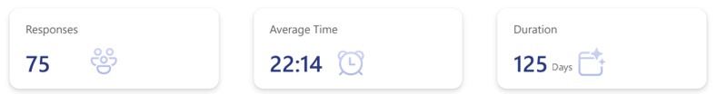
Figure ‎4.1 Responses overview.

On exploring the responses, it is evident that the survey itself took less than 10 minutes to complete. Several respondents completed the survey in less than 5 minutes. Unfortunately, as all respondents completed the survey whilst working, the time to complete is offet and interrupted by staff having to complete calls mid survey extending the completion time for some (Figure 4.2). The evidence is presented in the descriptive statistics after entering all data into SPSS. The data is presented in minutes in Microsft Forms and has been converted into seconds for accurate calculation.

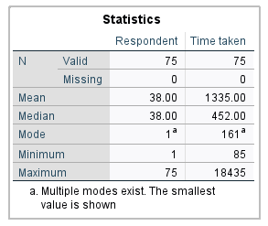
Figure ‎4.2 Time taken to complete survey.

The quickest completion was 1 minute 25 seconds, whilst the longest was 5 hours 7 minutes and 15 seconds, shifts can vary from 1 hour (3600 seconds) to 10.5 hours (216,300 seconds), with the majority being 8 hours (28,800) minus a 45 minutes (2,700 seconds) for breaks.

All of the 14 questions were answered to some degree, although not every question was answered by all respondents, a number of rationales are proposed although must be acknowledged to be partially supposition (Table 4.1).

Table ‎4.1 Proposed rationale for survey completion
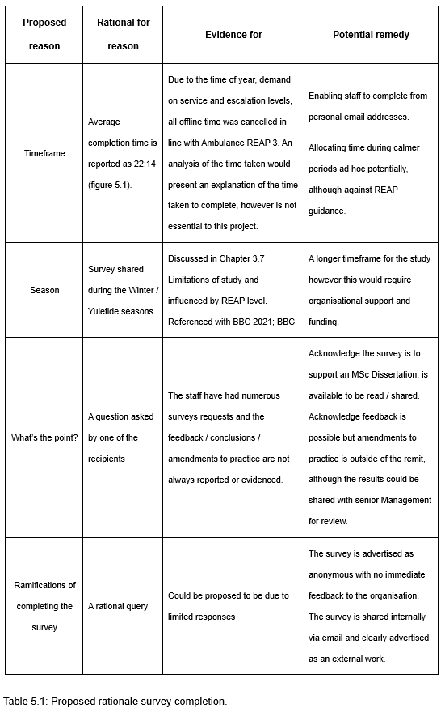

4.4.2 The survey questions / topics

Question 1 addressed gender, as a primarily female workforce, 89% of responses were from female employees (Figure 4.3). The question was presented as a multiple-choice selection offering Female, Male, Non-Binary and Prefer not to say.

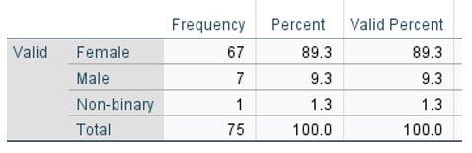
Figure ‎4.3 Participants gender

Each table calculates the Frequency (number of respondents, percent - the percentage of all respondents; and Valid Percent - the percentage of respondents included in the statistics who answered the question. Respondents who skipped or failed to respond were excluded from the calculations. The descriptive statistics also includes a Cumulative Percent, counting the percentage from the lowest value to the highest. This is of limited value if counting highest down, as discussed with length of service results pertaining to Figure 4.4 below.
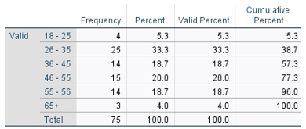
Figure ‎4.4 Age of respondents

Question 2 considered the age of respondents indicating 57.3% of respondents are under the age of 45 (Figure 4.4). Questions 3 explored the hours worked with the results presented in Figure 4.5. Two respondents selected other and included additional and overtime hours on top of the contracted hours, whilst another two respondents work outside of the contracted hours listed. For those contracted 18- or 24-hour contracts for instance, were amended to the nearest comparative group, 22.5 hours in these cases.

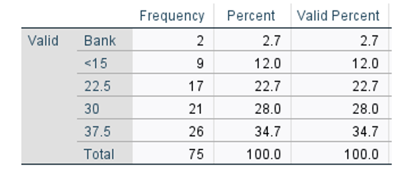
Figure ‎4.5 Hours of work

Question 4 identified the Band of staff primarily indicating level of organisational roles and responsibilities, summarised in Chapter 2: Table 2.1 and Table 4.5. Table 2.1 presents the Survey Population, an in-depth description of the population and their roles. Table 4.5 is a succinct summary. The options of multiple choice were Band 3, Band 5, Band 6, Band 7, and Band 8a, the Bands available for the population utilised. Table 2.1 breaks down the potential sample size for each Band. Figure 4.2 presents the responses received from each Band group. Band 8a is the smallest sample with just 3 participants, potentially resulting in the response level as proposed in Table 4.2.

Table ‎4.2 Band key principles.
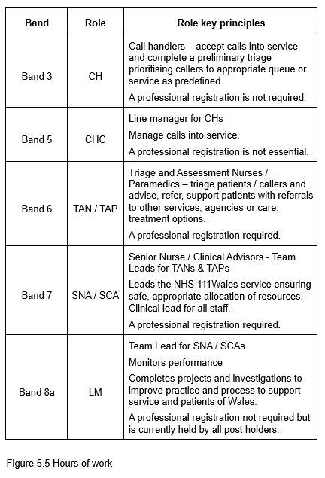

Interestingly, there was a non-response in the data, respondent 27 failed to answer this question resulting in 1 noted as missing. The histogram identifies the potential options for each variable, rounded to the nearest whole number. The descriptive statistics, in comparison, negates Band 8a as there were no respondents to include in the data. It is unlikely the missing variable was a Band 8a, as Respondent 27 works 30 hours, whilst all Band 8a’s are fulltime (37.5 hours).

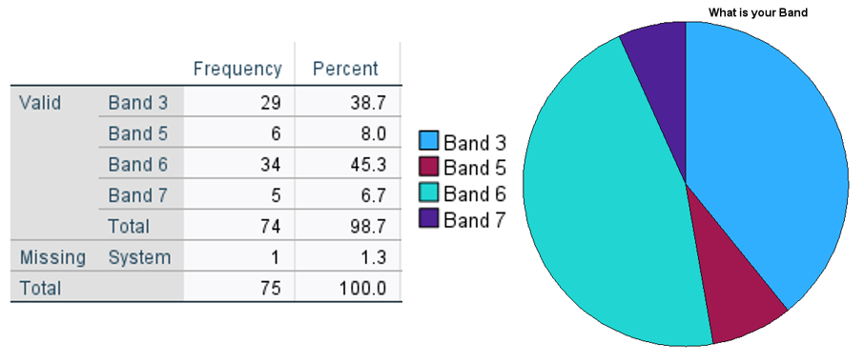
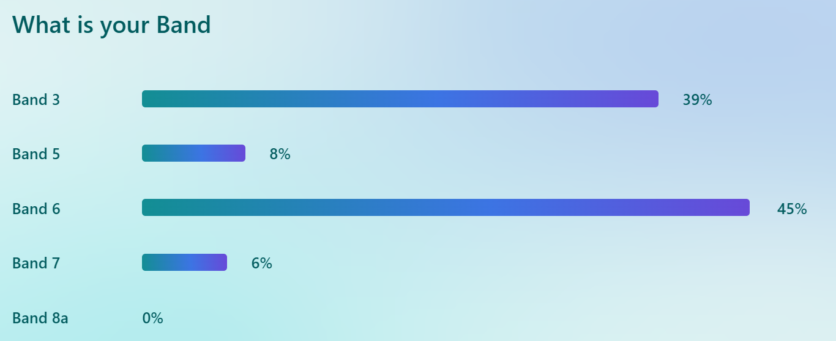

Figure ‎4.6 Band response

Question 5 relates to experience in NHS 111 Wales. The length of time in service has also been considered a significant factor for analysis as more than half of the staff have been in employment for more than 5 years and 64% of staff in post more than 3 years (Figure 4.7). 17.3% of respondents have Less than 18 months experience, this is significant as historically, staff are advised, it can take this time period to aclimate to the working practices and processes of NHS111 Wales. It is reputed to be more challenging for clinicians to work remotely, assessing without visual cues to assess and support patients. 18.7% of respondents have 18 months to 3 years experience, 13.3% have 3 to 5 years, 33.3% have 5-10 years and 17.3% have 10 plus years.

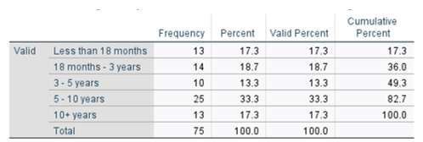

Figure ‎4.7 Length of service

Question 6 and 7 introduced Likert scales. Question 6 aimed to explore the individuals’ opinions of self, focusing on the technology, performance and the impacts on Wellbeing and health utilising a 5-point scale (Figure 4.8). The options available encompassed Definitely scoring 5, Usually scoring a 4, Sometimes scored a 3, Occasionally scored a 2, Rarely scored a 1, or I just don’t get it! Scored a 0.

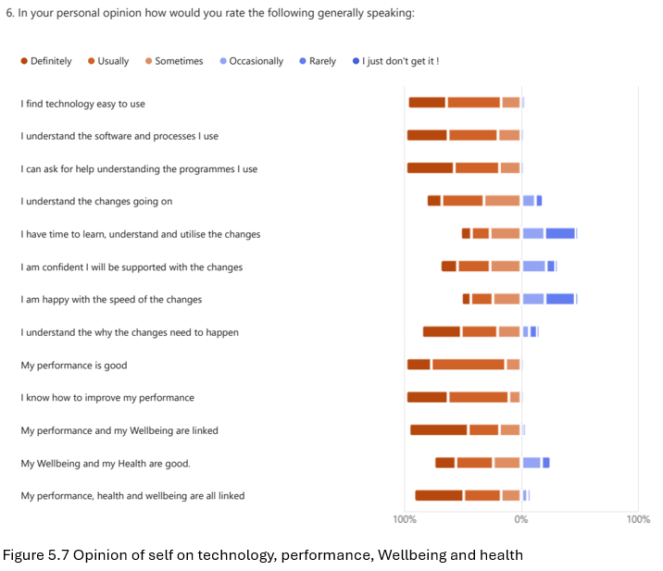

Figure ‎4.8 Opinion of self on technology, performance, Wellbeing and Health.

Question 7 (Figure 4.9) introduced psychological distancing. The question had two aims, enable an impression of the feeling of colleagues from the viewpoint of the staff member, but also to facilitate psychological distancing. All staff tend to communicate and support each other in times of collective challenge, potentially providing feedback on the morale of the workforce. Equally, this form of questioning is discussed in Chapter 2 to enable a psychological safety net of distancing an individual’s response from themselves, avoiding the psychological dissonance of a personal moral dilemma. Unfortunately, not all staff understood the purpose or benefit of this question, resulting five respondents not answering the question. Question 7 continued the scale and multiple-choice options of question 6.

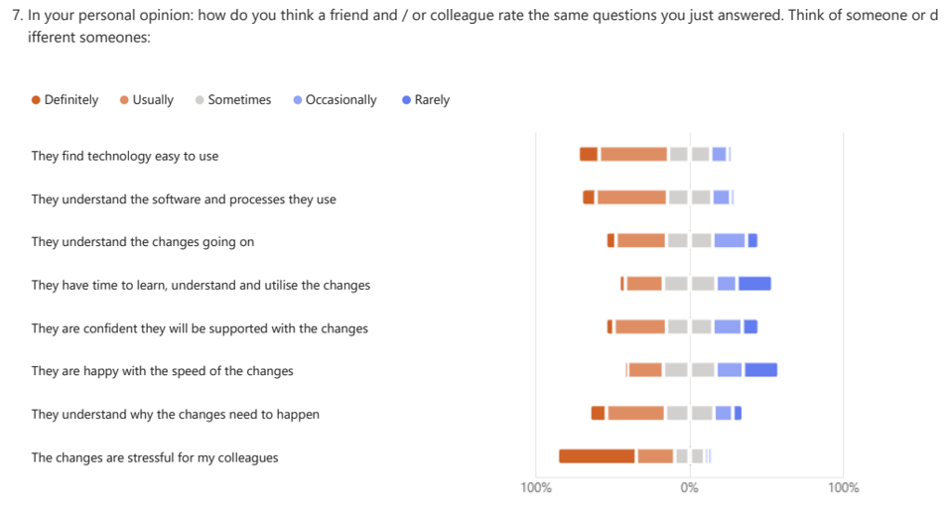
Figure ‎4.9 Staff opinion of colleagues’ views on technology, performance, Wellbeing and Health

Figures 4.10, 4.11, 4.12, 4.13, 4.14 and 4.15 report the results of ‘I / They’ questions in the Likert scales of question 6 and 7. The aim is to explore if there is a difference between first- and third-party opinion and if this is statistically significant. This process is repeated for the eight ‘I / They’ queries that overlap.

4.4.3 The Likert Scale results.
Figure 4.10 ‘I / They find technology easy to use’ compares the opinion of self against the opinion of a colleague’s abilities. NHS111 Wales is a remote triage service where all calls come in via a telephone call to 999 or 111 for clinical triage utilising a clinical decision support software to aid assessment and decision making.

The median and the mode are comparable for the first- and third-party results. The mean indicates the average of opinions for the third-party is lower than that of the first party – colleagues do not find technology as easy to use as the respondent.

A repeated measure t-test reported a probability (p-score) of <0.01 indicating the difference is significant (Figure 4.10).

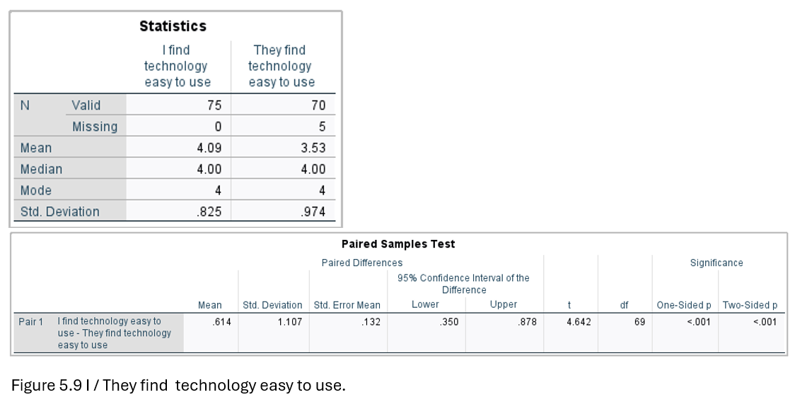

Figure ‎4.10 I / They find technology easy to use.

Figure 4.11 ‘I / They understand the software and processes’ relates to the technological processes NHS111 Wales utilises. A recent software upgrade completed in June 2024 with further amendments to the processing of ambulance calls completed mid-December 2024.
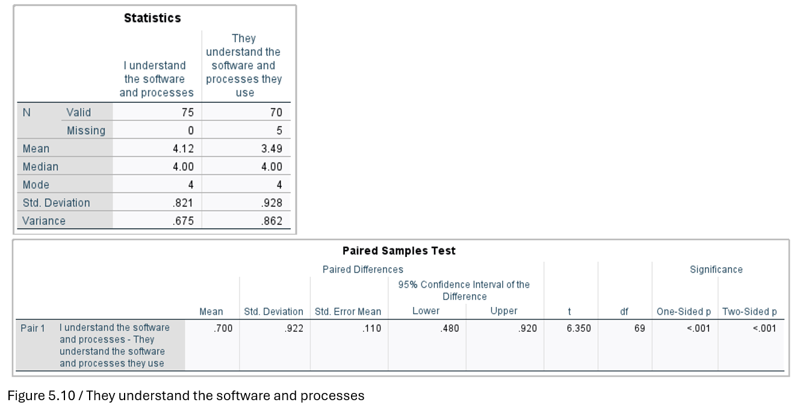

Figure ‎4.11 I / They understand the software and processes.

Similarly, Figure 4.11 also identifies a significant repeated measure t-test with a probability (p-score) of <0.01 indicating a difference between first- and third-party responses.

The p scores for the remainder of the Likert scale statements were not found to have a significant repeated measure t-test difference with p-score of >0.01, indicating no significant difference.

Figure 4.12 ‘I / They have time to learn and utilise the changes’ is an extension of the narrative above. Following the June 2024 update, the training team were available to support staff for a period thereafter 0800-2400. The system had been trained out in the months previously, with numerous updates prior to Go Live. The December 2024 updates were following a self-directed guidance, read and tested to confirm understanding.
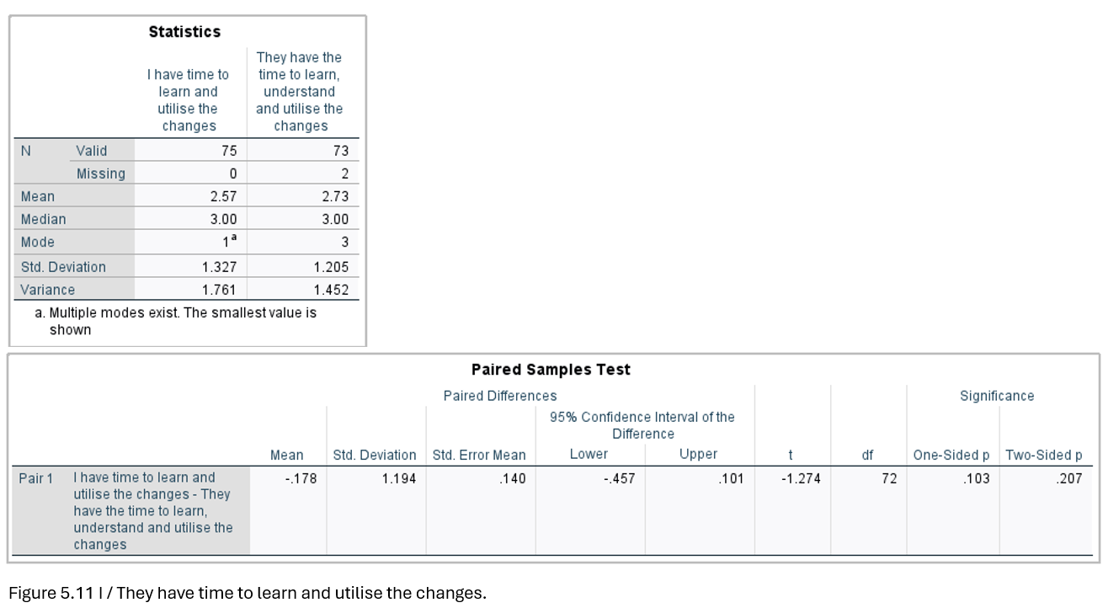

Figure ‎4.12 I / They have time to learn and utilise the changes.

Figure 4.13 pertains to the support available with digital transformation. As discussed, the support in June 2024 was invaluable. The support in December 2024 was vastly different. The question and data aim to review the impact of a first- and third-party viewpoint. The aim is to explore if morale has been impacted by recent changes and how staff convey the impact of the different approaches taken.

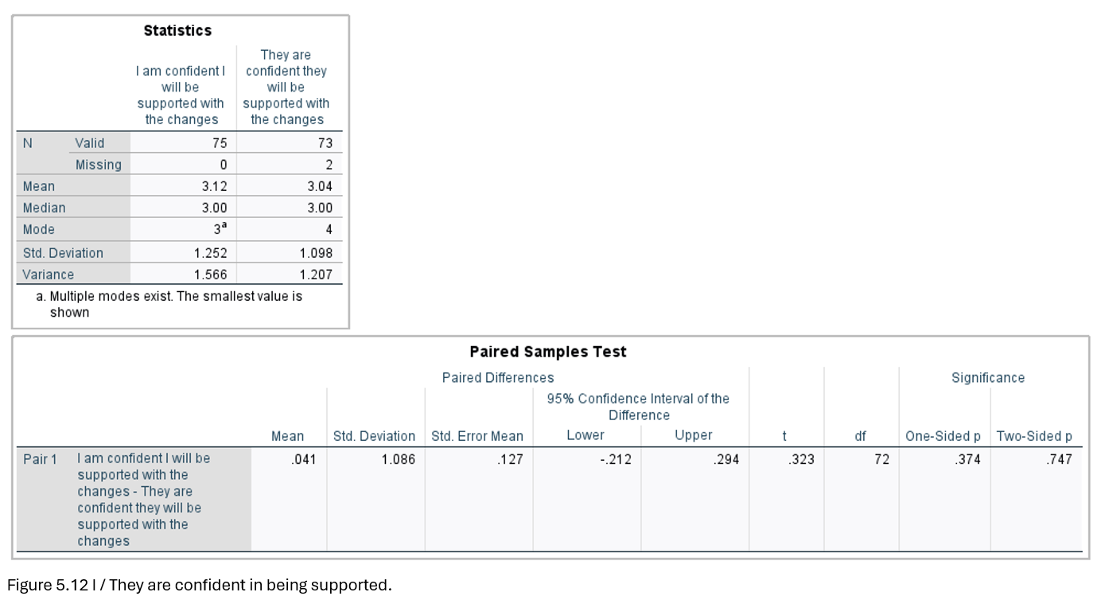

Figure ‎4.13 I / They are confident in being supported.

Figure 4.14 ‘I / They are happy with the speed of the changes’ follows on from the support received with the digital transformations. Although 6-months apart, the changes have been significant with new processes learned that could impact quality of care delivered and patient safety, if not completed correctly, as discussed in Chapter 3.5. Quality is integral to performance and safety as previously considered in Chapter 3.2.2.

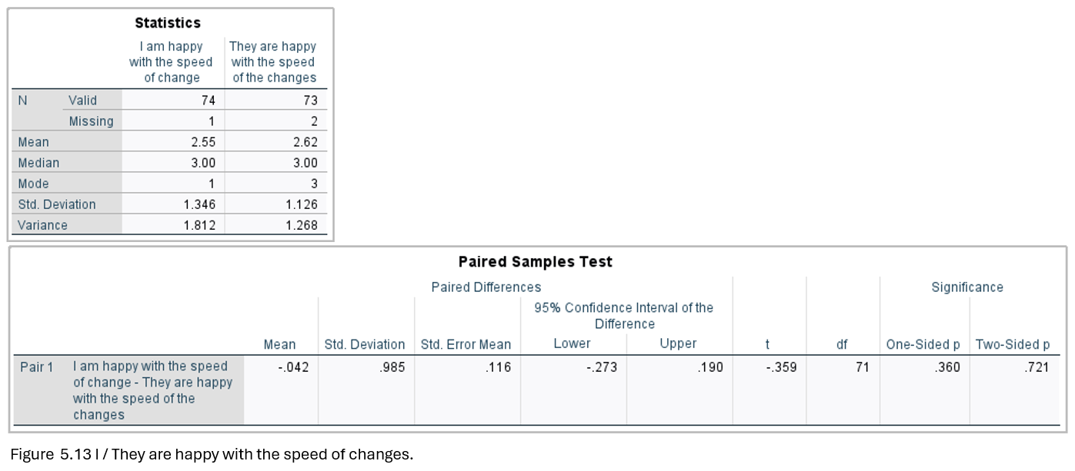
Figure ‎4.14 I / They are happy with the speed of changes.

Figure 4.15 ‘I / They understand the why’ pertains to the understanding of the underlying rationale for the changes. Communication is mentioned several times throughout Chapter 3 although not formally explored. The underlying understanding of the why can aid in off-setting resistance to change, just as the speed of change (Figure 4.14) and support available (Figure 4.13).

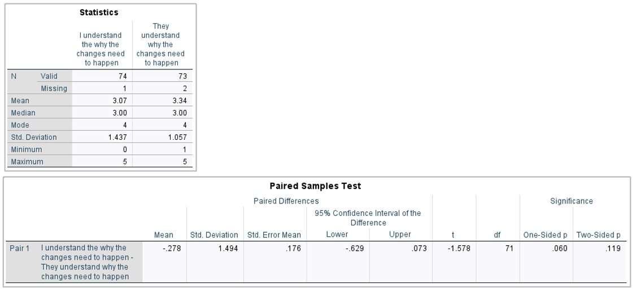
Figure ‎4.15 I / They understand the why.

Figure 4.16 Performance Health, and Wellbeing commences the focus on performance, health, and wellbeing. The descriptive statistics present a mean of 3 ‘Sometimes’, whilst the median is primarily 4 ‘Usually’, with one 3, ‘Sometimes’. In comparison, the mode is 4 ‘Usually’ with one 5 ‘Definitely’ indicating the data skews to the positive end of the scale.

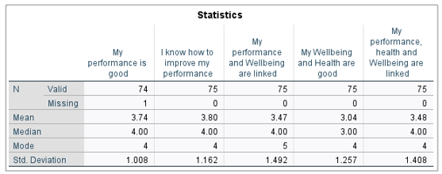
Figure ‎4.16 Performance, Health and Wellbeing.

Figure 4.17 presents the spread of the data, incorporating all responses, with 50% of the responses mostly 3 ‘Sometimes’. The box plot provides a panoramic inclusive view of the data including the outliers, the extreme values (McLoed 2025).
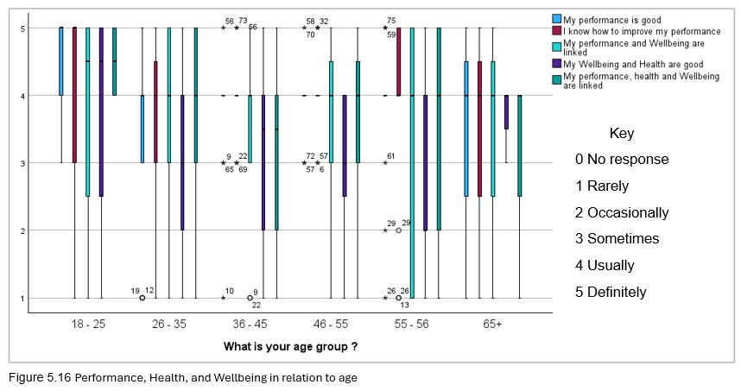
Figure ‎4.17 Performance, Health and Wellbeing in relation to age.

Factor 4.18 compares Band to Wellbeing. Variables associated with Wellbeing are happiness, stress and anxiety and ability to complete role. Seemingly the lower the band, the less au fait staff are with wellbeing. Bands 5 and 7 are happiest in their roles. Stress and anxiety are not always equally felt, with the Band 5 the least stressed and anxious of all. All Bands know what they are doing with Band 6 the most uncertain measuring 3-4 Sometimes to Usually. All Bands enjoy their work, with Band 3 the most varied, closely followed by Band 6.
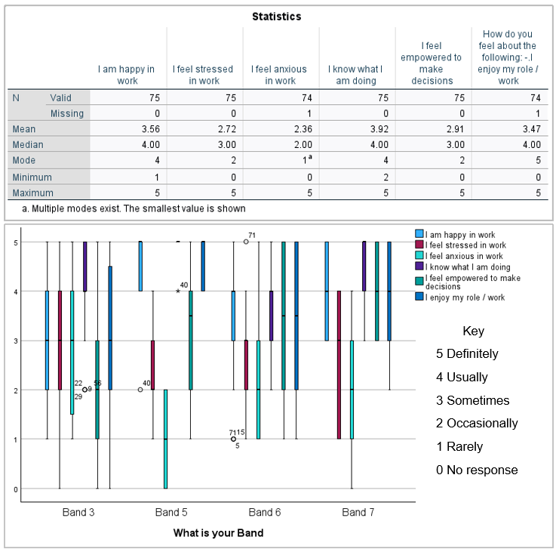
Figure ‎4.18 Band and Wellbeing

4.5 Qualitative data analysis
The data for the quantitative questions are included in the survey summary (Appendix X) with the full results presented in a table (Appendix XI). Tables 4.10, 4.11 and 4.12 presents a brief screen shot of the first few responses received for demonstration of the application of Braun and Clarke’s (2006) thematic analysis process.

Table 4.3 summarises the thematic analysis conducted utilising Braun and Clarke’s (2006) process. Following 6-steps produced a number of commonalities that on further review, were categorised into six distinct themes (Table 4.9).

Table ‎4.3 Thematic analysis process (Braun and Clarke 2006).
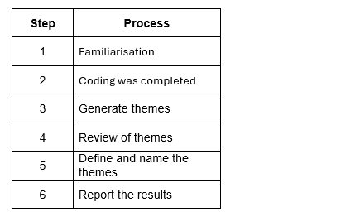

To aid reporting, a SWOT analysis (Figure 4.18) was completed to aid structuring and reporting. An overlap was noted through the responses of the qualitative questions, Questions 8, 12, 13 and 14. For ease of reporting and due to repetition, the results were consolidated. As with previous questions, not all respondents answered the 4 questions as reported in Table 4.4.

Table ‎4.4 Qualitative questions respondents and percentages.
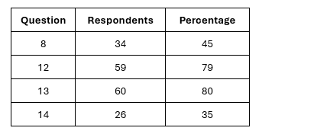

Some of the responses are noted to be in UPPERCASE with others in lowercase. The rationale is the staff document in UPPERCASE in the CDSS used, to enable entries to stand out from the software documentation. Many responses appear to have been completed in between calls whilst working.

Question 8 asked ‘Do you have any comments or feelings regarding question 6 & 7’ responses with questions 6 and 7 being the Likert scales asking first- and third-party opinions regarding performance, health and wellbeing.

The responses primarily relate to Training, Change management and Wellbeing (Table 4.5 and Appendix XI). Some of the responses voice anger, confusion, frustration, and anxiety at the transformations undertaken so far. Speed of change and time allocated for updates, reading SOPS, guidance and emails, together with time for and methods of learning are strong themes running throughout the 34 responses for 45% of respondents.

Table ‎4.5 Question 8 Do you have any comments or feelings regarding question 6 & 7 responses.
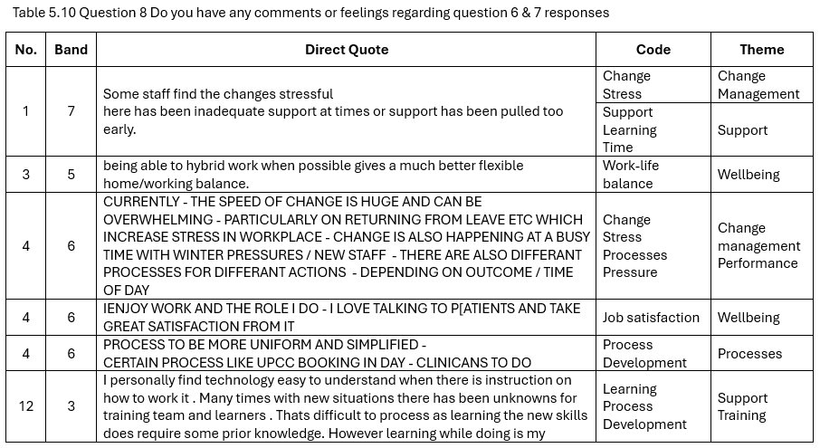

Question 12 ‘Why do you feel your health is impacted in this way?’ Followed Question 11 ‘My health is impacted by work positively’, which produced a negative score of -45 (Figure 4.19). The negative score indicating health is impacted by work negatively for the majority of respondents, offset by the 30 who feel work passively, may or may not, and those who feel work positively supports their health.

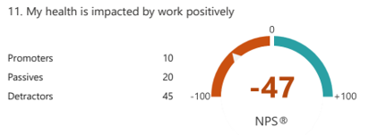
Figure ‎4.19 Impact of work on health.

Responses to Question 12 (Table 4.6) were negative, positive and passive, simply noting the role is sedentary, the complications of which are discussed in Chapter 3.3. The positives relate to the mental stimulation and the satisfaction of helping and supporting callers; the negatives relate to the pressures and stress of the roles, which aggravate a number of physical and mental health conditions, explored throughout Chapter 3. A number of responses echo the comments of Question 8, although many expand and raise new issues such as stress, demands of the roles, resources with the impact of the work-life balance and shifts, support from managers and shift leaders, the CHC’s, SNAs and the Locality Managers disclosing good and poor practices; service demands and concerns relating to patient care. Concerns relating to morale are also raised.

Table ‎4.6 Question 12: Why do you feel your health is impacted in this way?
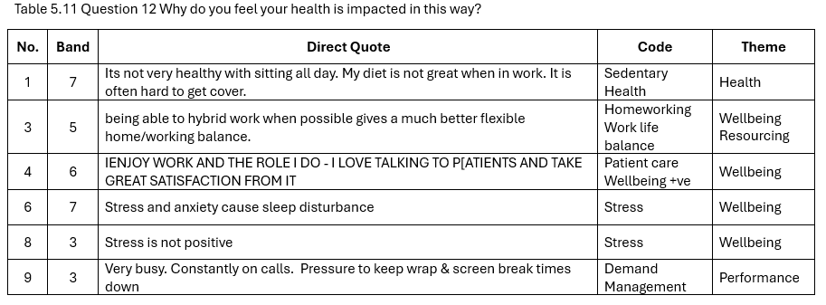

Question 13 ‘What would like / change / add to support your performance, health, and wellbeing?’. The responses focus on Training and Support with Management, Performance, and Resources headlining staff concerns. The complexity of some of the ‘new’ processes introduced through the digital transformation and the methods of training utilised with the limited or lack of support experienced by staff are considerable, with support and Wellbeing often appearing to be interchangeable. Terms such as ‘Less micromanaging’ are used with ‘Show all levels of staff that they are cared for’ and ‘do not want to feel pressurised to go faster/ do more/ hurry up’ comments are noted to impact Wellbeing, Support, Management and Performance themes several times throughout. Inequality / equity across departments relating to Performance and equipment is reported (Table 4.7).

Table ‎4.7 Question 13: What would like / change / add to support your performance, health, and wellbeing?
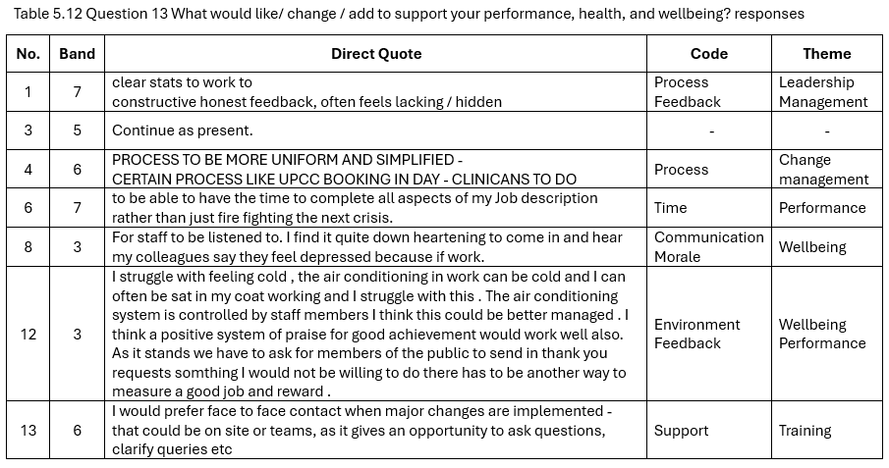

Question 14 ‘Many thanks for answering these questions. Anything you would like to add relating to Digital transformation and how this impacts your performance, health and Wellbeing in your current role?’ essentially repeats the responses of questions 8, 12 and 13. Wellbeing and Support are the main concerns together with the anxieties of the speed of changes, the limited time allocated to learn new processes, and the lack of support (Table 4.8).

Table ‎4.8 Summary of Themes identified through Thematic analysis
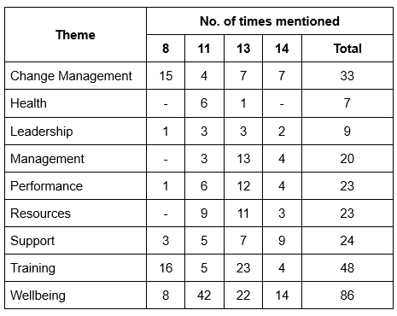

4.6 SWOT analysis
There are Strengths (positives), and a wealth of Opportunities gleaned from the thematic analysis (Figure 4.20). Some themes bridge more than one box, with Support the top theme throughout, both positive and negative, with good and poor practice reported. Many of the themes overlap and interlink, making interpretation complex similar to that explored in the Chapter 3: Literature Review.
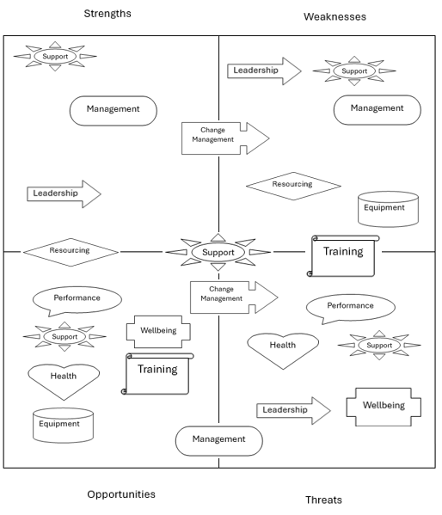
Figure ‎4.20 SWOT analysis of the results of thematic analysis.

Numerous frustrations or Weaknesses and Threats to the Wellbeing of staff are noted throughout with from the equity of equipment across departments:
‘computers don’t work, we have been months with no working pcs and CSD now have brand new computers? this is frustrating
computers are not fit for purpose, stressful coming in having to look for a pc when nothing works which makes you late logging in and then you get a row for logging in late’ Respondent 56.

To a requirement for more compassionate management and leadership with Support and training:
Respondent 35:
‘No support from management when unwell’;
Respondent 45:
‘SIGNIFICANT GUILT IF CALLING IN SICK - NOT ALL MANAGERS ARE CONSIDERATE’,
Respondent 42:
‘ALLOCATED OFF LINES SLOTS TO LEARN AND READ EMAILS/ ENCOURGEMENT WHEN REALLY BUSY, SMILE FROM A CHC DOES GO A LONG WAY. ‘
Respondent 45:
‘LESS PRESSURE FOR SERVICE DEMAND DUE TO LACK OF STAFFING / MORE COMPASSION FROM MANAGERS’
And Respondent 56:
‘a bit of appreciation for all staff on the shop floor, some CH don’t take hardly any calls and are not pulled up for sitting in wrap for ages or not doing hardly anything while others are doing double/triple calls, this is very annoying, I understand people have multi-calls and longer calls but when its double triple the calls that’s nothing to do with call capability that’s down to performance issues…staff that perform well don’t get appreciated at all and this is hard to want to come back into’

Support likewise overlaps a number of categories, training being the most popular, although also impinges onto Leadership and Management with both positive and negative feedback relating to line managers at all levels. For instance, Respondent 75 answered Question 13 saying:
‘Less scrutiny from SNAs’ during your shift / not being so closely monitored by SNAs’
Whilst respondent 66, Question 14 reports:
‘SNAs are supportive both on and off site’.

The above statements incorporate several key topics, Leadership / Management and performance in the former responses; whilst the latter bridges leadership / management, support and Wellbeing.

4.7 Triangulation of qualitative and quantitative data
Triangulation is a convergence of multiple perspectives to support each other enhancing confidence, accuracy and completeness of the interpretation of data (McLoed 2024). Also defined as converging and corroborating, two or more data collection methods to support the interpretation / presentation of the data (Creswell and Plano Clark 2018; Saunders et al 2023).

The quantitative data results of Figure 4.9 are supported by statements of respondent 12:
‘I personally find technology easy to understand when there is instruction on how to work it’.
Similar to respondent 13:
‘We live in a Digital world, so I am used to technology’.
In comparison to:
‘I would like to see that all my colleagues within my role be equally capable of completing all duties when required by the service’.
The above statement relates to more than the use of technology, encompassing the roles undertaken.

Likewise, Figure 4.11 understand the software and processes is another that is noted to be statistically significant in a difference between the first- and third-party responses although the quantitative results imply as many find understanding the software as challenging as their colleagues with numerous responses commenting on the training in relation to time allocated, method of teaching, learning styles and respondent’s age.

The remaining Likert scale results do not show a significant p score which is supported by the comments of the quantitative questions. Numerous statements support the quantitative data where the means and the medians are very similar.

Figure 4.11 ‘I / they have time to learn and utilise changes’. Respondent 17:
‘Some individuals/colleagues take longer to learn or feel comfortable with digital change, especially those over age 40.’
Respondent 74:
‘it’s hard to keep up with the processes and changes with little time to learn’.
Figure 4.12 I/ They are confident in being supported, Respondent 14:
‘More support in the call centre out of hours when new changes have been applied for example, the new process.’
Respondent 70 identified:
‘Not enough training or support.’
In comparison to Respondent 55:
‘Sense of worth, good peer support, pleasant and professional working environment.’
And Respondent 67 noting:
‘I do however feel very supported by my line manager.’

Figure 4.13 ‘I / They are happy with the speed of the changes’ is another example of the quantitative and qualitative data presenting similarly with the means and medians very similar if not exactly the same, whilst the respondents reported:
‘there have been too many changes in a short period of time no’ Respondent 31, with
‘The speed of change is huge and can be overwhelming’ Respondent 4.

Figure 4.14 ‘I / They understand the why’ pertains to the understanding of the underlying rationale for the changes presents a low mean score of 2 equating with Occasionally understanding with the quantitative results, as Respondent 4 stated:
‘Process to be more uniform and simplified’.
And Respondent 72:
‘explain to us why we need the changes. Why are these changes so complicated.’

Figure 4.15 Performance Health, and Wellbeing mirrors the results above with the quantitative and qualitative results echoing the majority of the Likert scale, with the mean, median and the mode being if not identical, very close. The Respondents report similarly, Respondent 12:
‘If I’m feeling well in myself then I’m able to work well efficiently and to the best of my ability. In situations where I have been feeling unwell but not unwell enough to not work it impacts my work. For example… I may need an extra break, or it may take me longer to complete a task.’
Respondent 15:
‘Pressures to make the right decisions. Hours worked also make me very tired.’
And Respondent 42:
‘I FEEL LIKE MY HEALTH IS IMPACTED IF EXTREMLY BUSY WITH LIIMTED OFFLINE TIME, NO TIME TO EVEN SAY HELLO TO YOUR COLLEGUE SITTING NEXT TO YOU, WORKING HARD AND GETTING LIMITED REWARD OR ACKNOWLEDGMENTS’.

Although some respondents report the strains and stresses of the roles, Respondent 16:
‘The mental stress and fatigue of this role really impacts my health and life inside and outside of work. I am always drained to the point where on my days off I don’t do anything’.
And Respondent 56:
‘staff are mentally and physically exhausted’.

4.8 Conclusion
The results of the survey are convoluted and complex, overlapping themes and concepts similar to those discussed in Chapter 3. It is evident from the results, further reading and exploration of Leadership and Communication when undertaking digital transformation should have been explored, although the results bridge operational management as well as change or transformation management.

Morale is reported to be low by several respondents with Performance, pressure and demands of the roles appearing to impact attrition, within a high stress environment that staff feel frustrated and unheard by the instigators of the digital transformation impacting performance, health and wellbeing.

The results are noted to be a small sample of the population (16.3%) with some of the questions and variables splitting the small sample too thin to represent the overall population.

Chapter 5: Discussion

5.1 Introduction
The research undertaken was to evaluate the impact of digital transformation on performance, well-being and health in NHS111 Wales on the Operational staff in the call centres. Three questions were to be addressed from completion of a survey emailed to staff utilising Microsoft Forms. The questions were:
- If certain variables have a significant impact on the responses for instance, does age impact performance, wellbeing, or health?
- Does band or job role impact the Wellbeing of staff?
- Is there a significant difference between first person and third person responses in question 6 and 7 of the survey.

It has been noted in Chapter 3 there is a gap in literature with scant research completed in encompassing the role of digital transformation on performance, health, and wellbeing.

The survey results reflected the literature search, with overlapping concepts. Strong emotion is evident throughout the comments in relation to patient care and the needs of the self (first-) and They (third-party), echoing Korhonen et al’s (2023) emotionally charged and complex field.

5.2 Initial findings
The goal of addressing all three concepts of ‘Performance’, ‘health’ and ‘wellbeing’ is multifaceted and highly complex with each overlapping and dependant on the focus and definitions utilised (Korhonen et al 2023; Tiitola et al 2023). This is demonstrated with the quantitative and qualitative responses received.

It can be argued, the survey was complicated further due to the number of variables surveyed, together with psychological distancing incorporated into the survey. It is clear some respondents did not understand the purpose of this approach, whilst limited statistical significance is identified (Chapter 4.4.3).

5.3 Performance
Respondents echo Wardana’s (2023) definition of performance with the impact on patient care a priority for healthcare staff, whilst incorporating multiple complex concepts such as quality and Wellbeing substantiates Khan and Ramachandran’s (2012) composite definition. Many of the factors influencing performance are noted by the staff, from the emotional to the physical, individual to social, management to leadership, communication to confusion.

Acknowledging that performance is both internal and external (Khan and Ramachandran 2012), the results initially support the benefit of utilising psychological distancing (Kundrát and Rojková 2021) as evidenced in Figure 4.10 and Figure 4.11 noting differences between first- (I), and third-party (They), responses in relation to finding technology easy to use and understand the software and processes. This is further supported by the respondents in Question 8, 12, 13 and 14.

This is not maintained with questions relating to process and understanding, the variables staff have no control over, it can be argued, these are the ‘external’ variables for which there is no significant difference between the individual (I) and their colleagues (They).

5.3.1 ‘Cost’ and Performance
Reference to finance is not addressed directly through the survey. The section is renamed Cost as this incorporates more than financial concerns.

Staff are concerned with the impact on patient care, seemingly not understanding the aims of the transformations are patient centred (WAST 2023; WAST 2024). There is criticism that staff are unaware of the rationales for change which incorporate the benefits to the patient. This ‘gulf’ of understanding between the change recipients, the staff, and the change agents, senior management, can be argued, to be bridged through email communication, for which the staff report little time to access. This is detrimental to the holistic cost of health care (Drummond et al 1988; Crusoe et al 2024).

Chapter 3.2.1 referred to ‘Western society’ and capitalism bias with a ‘wilful ignorance’ prioritising strategic motives (Crusoe et al 2024). The results imply a paternalistic ethos with a top-down digital transformation strategy that principally excludes the frontline staff from planning and liaising concerns. Wardana et al (2023) equates this with ineffective global ‘cost’ impacting the patient, staff, resources and the Organisation.

The ‘cost’, in line with Drummond et al (1998), has the potential to be measured through the monitoring of Datix, the complaints and adverse incidents / safety concerns reporting system, and the reports of serious adverse incidents (SADIs). whilst a value-based oversight on the impact on parallel services is required at a Governmental level. Locally, the impact on staff morale is reported to be poor with numerous comments reflecting such.

5.3.2 Quality and Performance
At the heart of quality is:
‘system-wide, safe, effective, person-centred, timely, efficient, equitable care’ (WAG 2020), with numerous legal and strategic documents supporting aims and goals for a healthier Wales (WAG 2020; WAG 2021a; NHS Wales 2025a; NHS Wales Executive 2025). It can be argued, without prioritising staff, quality and value-based health care will be compromised (Korhonen et al 2023; Saraiva et al 2023).

The respondents primarily report concerns with learning new changes, with learning styles, age and time key aspects hampering understanding and delivery, impacting quality and performance and raising concerns for patient care. Noting Chapter 3’s definition of performance and quality (Solin and Curry 2023; Saraiva et al 2023), the poor training and support extended to staff, impacts the ability of staff to adapt and utilise the knowledge and develop the skills required to enhance patient care, learning the use as practiced in a Live scenario, to a large degree, hampering quality care and patient safety (Khan and Ramachandran 2012; Ishaq Bhatti et al 2014).

It can be argued, the aim of the digital transformation and the respondents have the same goals, however, communication and leadership could be viewed as disconnected with current frontline practice non-conducive to supporting the digital transformations.

5.3.3 Performance management
Whilst it has been noted Leadership has not been fully explored in relation to digital transformation, management is noted to be an area of concern for many staff. Whilst noted to be central to organisations maintaining a competitive edge, effective resource management and flexible management (Cosa and Torelli 2024) appear to have been overlooked in the transformation.

A number of respondents comment on the lack of performance metrics. Performance metrics are a measurement proforma to demonstrate fit for purpose, maintain, measure and monitor efficiency, effectiveness, safety and timeliness (Ishaq Bhatti et al 2014; Willmington et al 2022; Solin and Curry 2023; Cosa and Torelli 2024).

Whilst a wealth of data will be available with the transformation (Adochitei et al 2024), analysing and interpreting the data, together with reporting and sharing can be akin to the inequalities reported across departments with limited IT staff available to support.

Without easy access to data, flexible management to adapt to the pressures experienced and reported by staff, are challenged, resulting with claims of inequity and imbalance, damaging morale (Bayo- Moriones et al 2020; Cosa and Torelli 2024; Vezi et al 2024). Respondents do report high anxiety and stress levels supporting the reports from Maier et al (2015) and Califf et al (2020), although this is just one aspect that impacts on the stress of the respondents.

Whilst performance metrics may not improve the criticisms of micromanagement, it may support the management team when challenging staff with long breaks or reduced call volumes. Respondents report concerns with feedback detrimental to performance, support and wellbeing with expressions concerning disharmony with the current practice adding to stress as discussed in Chapter 3 (Bayo-Moriones et al 2020; Memon et al 2020; Taneja et al 2024; Vezi et al 2024). Further work would be required to explore this further.

5.3.4 Stress and Performance
Stress is a theme coded into Wellbeing following the thematic analysis of the quantitative data. Numerous staff support Califf et al (2020) and Iqbal et al (2024) reporting performance, physical and mental health are compromised by stress. None acknowledge the positive side of stress as explored in Chapter 3.2.4 (Ragu-Nathan et al 2008; Califf et al 2020).

Both internal and external factors are reported to impact on stress. Wellness and demand, for instance, impact coping strategies demonstrating Tarafdar et al’s stance (2019). Technostress is exacerbated by the resources available with Information Technology (IT) support staff being another common theme of concern. Some respondents note the impact of resources (equipment) on health, whilst some have unrealistic and impractical wants. Many reports of techno-complexity, techno-uncertainty, techno-frustrations are all synonymous with reports from Ragu-Nathan (2008); Maier et al (2015) and Califf et al (2020), to name a few.

5.4 Impact of digital transformation on health
The physical and mental health of some staff is a cause for alarm with some respondents finding the sedentary lifestyle compromising; whilst others, their health is compounded by the pressures, demands and culture of the organisation, as previously discussed. It must be noted that some of these issues may be present regardless of the employer (Riedl et al 2012; Adochitei et al 2024; Grzelak 2024; Iqbal et al 2024), who aims to be supportive (WAST 2024d; NHS Wales 2025a).

Further work is required to clarify the balance between work practices and health of the staff. The organisation deals with the complexities of human physical and psychological health and wellbeing, directing callers and patients to the right place at the at the right time (WAST 2024), whilst juggling a multitude and varied availability of services available across the 7 Health Boards, whilst managing patient expectations. Challenges, stressors and certain demands on staff are to be expected.

Whilst Adochitei et al (2024) and Grzelak (2024) both note equipment to support comfort, and productivity is available, some staff report obstacles relating to equipment access, hampering health and performance. Some reports are unrealistic, whilst others, an ideal support measure to enhance health.

Burnout is referenced by staff and several others who describe typical presentation of symptoms as defined by WHO (2019). Further work is required to compare absence rates pre, peri and post transformation, together with a review of the rationales for the absences. Some absence is to be expected and will be exacerbated by the sedentary role (Riedl et al 2012; Adochitei et al 2024; Grzelak 2024; Iqbal et al 2024).

5.5 Digital Transformation and Wellbeing
As discussed in Chapter 3, and akin to performance and quality, this concept is difficult to define and underpins numerous concepts, themes and states (Simons and Baldwin 2021).

Wellbeing is the key theme that runs throughout the qualitative data (coded 86 times). Respondents, specifically refer to the satisfaction of supporting patients and achieving good quality care, with patient care a significant motivator to health care staff with an impact on Wellbeing, health and performance.

The descriptive statistics deliver a strong positive deviation to the impact of Wellbeing on all aspects of Respondents practice supporting a ‘bright’ side to work (Riedl et al 2012; Igbal 2024), with a few respondents substantiate these findings through a social and professional environment, reporting support and healthy psychological stimulation. Figure 4.18 supports both impressions, not positives ‘bright’ and negatives ‘dark’ side of work. Staff enjoy their roles, occasionally feel anxious and stressed, fully aware of what they are doing however, not always empowered to make the right decision.

A ’dark’ theme does prevail throughout the qualitative results with wellbeing impacted by all avenues. Exhaustion, anxiety, stress, sleep disorders and burn-out are all noted as concerns in line with WHO (2019), Pfaffinger et al (2022) and Marsh et al (2024).

5.6 FITT for purpose
FITT or Fit between Individuals, Task and Technology (Ammenwerth et al 2006) is one of numerous frameworks to minimise the failure rate of digital transformation projects (Ammenwerth et al 2006; Tarafdar et al 2019). Whilst it can be argued, many of the changes commenced in 111Wales, have to succeed, due to the benefits proposed for the patients of Wales, the current FITT is questionable based on the responses of the 16.3% of the population, both quantitatively and qualitatively.

Some respondents appear to understand the rationale for the changes (Figure 4.14), although introducing extensive changes during the busiest time of the year / season is a concern (BBC 2021; Triggle 2025).

Individual - Ease of use is a common issue (Figure 4.10 and Appendix XI) with the majority of Respondents commenting on the training of the transformations provided with technostress or anxiety impacting staff wellbeing throughout the results, as discussed in 5.6.

Technology - The technology has been discussed above with a respondents’ commenting on the equipment availability and operational effectiveness.

Task - Many Respondents are concerned with the understanding and ability to incorporate the digital transformations, although if the research is repeated, ongoing practice and use of the changes will ease this issue.

As noted, this information is shared regularly within the Organisation via email, a contentious issue reported by staff who have no time permitted to check emails.

5.7 Resistance to change.
Amin et al (2025) discussed breaking down the barriers to resistance to change through support and training. Respondents appear to agree, whilst it can be argued the digital transformation has been short sighted with inadequate training impacting performance, health and wellbeing. Crusoe et al (2024) would deem this ‘wilful ignorance’.

The Organisation shared information relating to the digital transformation via email. Unfortunately, numerous respondents report a lack of time to read emails hampering access to key information. Emotions of frustration, anger, anxiety and stress are all to be expected (Persson and Karlsson 2020), although limited time to stay updated are renowned to exacerbate emotions central to resistance to change (Warrick 2023; Amin et al 2025).

5.8 Human factors and Health
Human factors to a degree has been incorporated into FITT and Resistance to change. Chapter 3 discussed the complex interaction of humans and technology to maximise wellbeing and performance (Neumann and Dul 2010; Braarud et al 2025), reminiscent of Ammenwerth et al (2006). The Likert scales in Chapter 4, together with the quantitative questions 8, 12, 13 and 14 encompassed these factors as discussed above.

It can be surmised from the discussion so far, together with the summary of the responses, there is significant scope to improve the interaction of staff with the systems available. Processes have been added that have a complexity that challenge staff (Appendix X, Figure 4.10 and Figure 4.11).

5.9 Digital transformation and the impact on staff
Digital transformation can be evaluated to be a complex strategic process that has a broad spectrum impacting all substrata with planning, inclusivity and delivery a holistic schema towards a common goal. Whilst the NHS111 Wales digital transformation has the common goal, the holistic schema incorporating inclusivity and holistic planning appears to be lacking, with the respondents (I) and their colleagues (They), frustrated and angry attempting to assimilate and practice processes poorly delivered and inadequately and insufficiently supported impacting performance, health and wellbeing.

The foremost emotions related to the digital changes are anxiety, stress and frustration. Whilst positive to identify some staff fully support and are keen to support the digital changes, further work is required to support staff.

5.10 Limitations
A number of limitations of the survey and the research is to be noted. The study encompasses a number of highly complex concepts that overlap, integrate and diversify with definitions that are multifaceted whilst dependant on the focus and application of the concept. It can be argued the concepts explored are limited and should be expanded to incorporate leadership and communication. However, with such concepts already sighted, complex seems too simplistic a term to describe this subject and the impact on the quality of the service provided and the lived experience of staff navigating digital transformation, and the resultant experiences of the patient.

The response to the survey of just 16.3% of the population is small with some of the survey questions breaking down into miniscule sample numbers. Independently, the breakdown obscures the results, whilst considered overall, the sample can be seen to imply an impression of the low morale of the staff. A repeat of the survey with time allocated and with staff encouragement, a more robust response is anticipated.

The sheer volume of data available from this survey is confounding with careful planning and focused management required to ensure the research question is answered as best able with the responses received.

Chapter 6: Recommendations and Conclusion

The digital transformation of NHS111 Wales has had an impact on the Performance, Health and Wellbeing of staff. Whilst measures are in place to maintain open communication channels, the opportunity for staff to stay updated, reading emails, completing essential learning and assimilation of information, enhancing knowledge, practice and performance, is sadly lacking.

The training and support of staff requires review. A wealth of resources has been overlooked that may well support the roll out of transformation, the utilisation of the managers to support and lead the changes. Barriers have to be overcome to support the managers to support the staff, minimising the resistance to change that is inevitable.

Setting of performance metrics is essential to support improved performance and quality care in line with the Organisation and Government standards, enhancing patient care and enabling value-based health care at the frontline as well as strategically.

A more coherent interaction is required between senior management, operational management and staff to support and maximise quality together with the success of the digital changes on performance, health and wellbeing.

6.1 Recommendations

A number of recommendations are evident from the survey.
6.1.1 Communication and support
Creating a role to span the ‘gulf’ between change agents / recipients resolves many issues. The potential remedy to bridge the ‘gulf’ would be to have change regents or medians, individuals to liaise between the change agents, senior management, and recipients, the staff. These change regents or medians would require awareness prior to staff to support, train and any transformation negating challenges triggered, building upon ‘opportunities’ to negate resistance to change (Dunford 2022; Sendrea 2023).

This ‘bridge’ would offset many of the complaints and concerns relating to support and training highlighted throughout the survey. The best positioned personnel for this role, would be the Band 8As, 7s and the Band 5 managers breaking down barriers and minimising the challenges of ‘micromanagement’.

6.1.2 Performance standards
Performance metrics are key to monitoring, measuring, equity, equality and quality patient care. Whilst undoubtedly, some metrics are available, together with performance metrics require a level of performance time to accumulate standards, metrics should be part of the Big Data available from the reams of data available from the digital transformations completed so far.

Universal figures considering offline time, talk time, record open time, number of records completed and outcomes; should all be readily available to be fed back to individuals comparing like for like with call, weekly and monthly performance for an individual, for a defined Team, and also for the Organisation as a whole. Knowing how staff compare to themselves, to their colleagues and the Organisation can identify developmental and support avenues, easing stress, anxiety and claims of inequality that currently exist.

6.1.3 Protected time
A common complaint from the staff is the lack of time for reading emails, completing e-learning, meeting with Team Leads. An organisational edict defining protected time to safeguard staff and patients should be considered and evidenced for benefit.

References

Abdi, T.A., Peiró, J. M., Ayala, Y., and Zappalà, S. (2018) ‘Four Wellbeing Patterns and their Antecedents in Millennials at Work’, International journal of environmental research and public health, 16(1), pp. 25-. Available at: https://doi.org/10.3390/ijerph16010025.

Adochitei, N., Iacob, A., Mărgărita, I., Bobocea, M., Gheorghe, M. and Borda, C., (2024) The Impact of Digitalisation on Health and Safety in Retail, Fiability & Durability/Fiabilitate si Durabilitate, 33(1).

Alathamneh, F., F. and Al-Hawary, S., I., S. (2023) ‘Impact of digital transformation on sustainable performance’, International journal of data and network science, 7(2), pp. 911–920. Available at: https://doi.org/10.5267/j.ijdns.2022.12.020.

Alexandrova-Karamanova, A., Anita, L.K., Halama, P. and Baban, A., (2024) Long-Term Post–COVID-19 Health and Psychosocial Effects and Coping Resources Among Survivors of Severe and Critical COVID-19 in Central and Eastern Europe: Protocol for an International Qualitative Study. JMIR Research Protocols, 13.

Ambulance (2019) Being Our Best: Our People and Culture Strategy ambulance.nhs.wales/files/publications/strategies-and-plans/people-and-culture-strategy/ . (Accessed 31/01/2025).

Ambulance (2020) Health and Wellbeing Strategy 2020-2024 ambulance.nhs.wales/files/publications/strategies-and-plans/health-and-wellbeing-strategy-2020-2024-pdf/ (Accessed 31/01/2025).

Amin, S. M., El‐Gazar, H. E., Zoromba, M. A., El‐Sayed, M. M., and Atta, M. H. R. (2025) ‘Sentiment of Nurses Towards Artificial Intelligence and Resistance to Change in Healthcare Organisations: A Mixed‐Method Study’, Journal of advanced nursing, 81(4), pp. 2087–2098. Available at: https://doi.org/10.1111/jan.16435.

Ammenwerth, E., Iller, C. and Mahler, C. (2006) ‘IT-adoption and the interaction of task, technology and individuals: a fit framework and a case study’, BMC medical informatics and decision making, 6(1), pp. 3–3. Available at: https://doi.org/10.1186/1472-6947-6-3.

Anjaria, K. (2022) ‘Knowledge derivation from Likert scale using Z-numbers’, Information sciences, 590, pp. 234–252. Available at: https://doi.org/10.1016/j.ins.2022.01.024.

Arntz, M., Findeisen, S., Maurer, S. and Schlenker, O. (2024) Are we yet sick of new technologies? The unequal health effects of digitalization,. London School of Economics and Political Science, Centre for Economic Performance.

Barbieri, M., Micacchi, L., Vidè, F. and Valotti, G., 2023. The performance of performance appraisal systems: A theoretical framework for public organizations. Review of Public Personnel Administration, 43(1), pp.104-129.

Bayo-Moriones, A., Galdon-Sanchez, J.E. and Martinez-de-Morentin, S. (2020) ‘Performance appraisal: dimensions and determinants’, International journal of human resource management, 31(15), pp. 1984–2015. Available at: https://doi.org/10.1080/09585192.2018.1500387.

BBC (2021) What is being done to ease the ambulance 'crisis'? BBC News 21st September https://www.bbc.co.uk/news/uk-scotland-58588112 (Accessed: 28/09/2024).

BBC (2025) Box Plots https://www.bbc.co.uk/bitesize/articles/zdxcbqt#z6cjwnb (Accessed: 25/04/2025).

Binci, D., Palozzi, G., and Scafarto, F. (2022) ‘Toward digital transformation in healthcare: a framework for remote monitoring adoption’, TQM Journal, 34(6), 1772–1799, https://doi.org/10.1108/TQM-04-2021-0109 (Accessed: 10th October 2024).

BMA (2024) “An NHS under pressure”, Available at: https://www.bma.org.uk/advice-and-support/nhs-delivery-and-workforce/pressures/an-nhs-under-pressure. (Accessed 28/09/2024).

Braarud, P. Ø., Park, J., Kim, J., and Short, J. (2025) Human factors validation of complex human-technology systems – Need for updating the technical basis and improving the guides and standards. Safety Science, 181, 106697- https://doi.org/10.1016/j.ssci.2024.106697

Braun, V. and Clarke, V. (2006) Using thematic analysis in psychology. Qualitative research in psychology, 3(2), pp.77-101.

Busetto, L., Wick, W. and Gumbinger, C. (2020) ‘How to use and assess qualitative research methods’, Neurological research and practice, 2(1), pp. 14–14. Available at: https://doi.org/10.1186/s42466-020-00059-z.

Califf, C.B., Sarker, S. and Sarker, Suprateek (2020) ‘The Bright and Dark Sides of Technostress: A Mixed-Methods Study Involving Healthcare IT’, MIS quarterly, 44(2), pp. 809–856. Available at: https://doi.org/10.25300/MISQ/2020/14818.

Cheng, L.-C., Chen, K., Lee, M.-C., and Li, K.-M. (2021) ‘User-Defined SWOT analysis – A change mining perspective on user-generated content’, Information processing & management, 58(5), pp. 102613-. Available at: https://doi.org/10.1016/j.ipm.2021.102613.

Chouaibi, S., Festa, G., Quaglia, R., and Rossi, M. (2022) ‘The risky impact of digital transformation on organizational performance – evidence from Tunisia’, Technological forecasting & social change, 178, pp. 121571-. Available at: https://doi.org/10.1016/j.techfore.2022.121571.

Chrysikou, E., Papadonikolaki, E., Savvopoulou, E., Tsiantou, E., and Klinke C., A. (2023) ‘Digital technologies and healthcare architects’ wellbeing in the National Health Service Estate of England during the pandemic’, Frontiers in medical technology, 5. Available at: https://doi.org/10.3389/fmedt.2023.1212734.

Clarke, V. and Braun, V. (2013) Teaching thematic analysis: Overcoming challenges and developing strategies for effective learning, The psychologist, 26(2), pp.120-123.

Cosa, M. and Torelli, R. (2024) ‘Digital Transformation and Flexible Performance Management: A Systematic Literature Review of the Evolution of Performance Measurement Systems’, Global journal of flexible systems management, 25(3), pp. 445–466. Available at: https://doi.org/10.1007/s40171-024-00409-9.

Creswell, J.W. and Plano Clark, V.L. (2018) Designing and conducting mixed methods research. 3rd ed. Los Angeles; Sage.

Crusoe, J., Magnusson, J. and Eklund, J. (2024) ‘Digital transformation decoupling: The impact of willful ignorance on public sector digital transformation’, Government information quarterly, 41(3), pp. 101958-. Available at: https://doi.org/10.1016/j.giq.2024.101958.

Danna, K. and Griffin, R.W. (1999) Health and well-being in the workplace: A review and synthesis of the literature, Journal of management, 25(3), pp.357-384.

Dawadi, S., Shrestha, S. and Giri, R.A. (2021) Mixed-methods research: A discussion on its types, challenges, and criticisms. Journal of Practical Studies in Education, 2(2), pp.25-36.

Denscombe, M. (2010) The good research guide: for small-scale social research projects. 4th ed. Maidenhead, England: McGraw-Hill/Open University Press.

Denzin, N.K. and Lincoln, Y.S. (2013) The landscape of qualitative research, Fourth edition. Los Angeles: SAGE Publications.

Drummond, M.F., Stoddart, G.L. and Torrance, G.W. (1988) ‘Methods For The Economic Evaluation Of Health Care’, Canadian Public Policy. Guelph: Canadian Public Policy, pp. 226-.

Dunford, R. (2022) Resistance to change. London: Henry Stewart Talks.

Geraldi, J., Lechter, T. and Söderland, J. (2012) ‘Gantt charts revisited: A critical analysis of its roots and implications to the management of projects today’, International journal of managing projects in business, 5(4), pp. 578–594. Available at: https://doi.org/10.1108/17538371211268889.

Grad Coach ‘Sampling Methods 101: Probability and non-probability sampling explained simply’ YouTube, 23rd Feb 2023, Available at: https://www.youtube.com/watch?v=fSmedyVv-Us&t=80s (Accessed: 5th October 2024).

Gov.UK (2020) “Mixed methods study”, Available at: https://www.gov.uk/guidance/mixed-methods-study (Accessed: 01/01/2025).

Grzelak, A. (2024) The Detrimental Effects of Sedentary Lifestyle on Human Health. Journal of Education, Health and Sport, 76, 56522-. https://doi.org/10.12775/JEHS.2024.76.56473

Harrison, V. (2021) SPSS for psychologists. Seventh edition. London: Macmillan International Higher Education.

HCPC (2014) Paramedics Standards of Proficiency https://www.hcpc-uk.org/standards/standards-of-proficiency/paramedics/ (accessed 26 October 2022).

Hoehe, M. R., and Thibaut, F. (2020). Going digital: how technology use may influence human brains and behaviour. Dialogues in Clinical Neuroscience, 22(2), 93–97. https://doi.org/10.31887/DCNS.2020.22.2/mhoehe

Hu, Y., Yang, Y., Gao, Y., Zhao, L., Chen, L., Sui, W., and Hu, J. (2024) ‘The impact of chronic diseases on the health-related quality of life of middle-aged and older adults: the role of physical activity and degree of digitization’, BMC public health, 24(1), pp. 2335–13. Available at: https://doi.org/10.1186/s12889-024-19833-8.

IBM 2024, IBM SPSS Statistics https://www.ibm.com/products/spss-statistics (Accessed 22/05/2024).

Ika, L.A. and Pinto, J.K. (2022) ‘The “re-meaning” of project success: Updating and recalibrating for a modern project management’, International journal of project management, 40(7), pp. 835–848. Available at: https://doi.org/10.1016/j.ijproman.2022.08.001.

Iqbal, S. Howse, J., Banu, S., Lateef, A., Khan, S., Barlas, Z., Moon, S., Moukaddam, N., Shah, A. A. (2024) ‘The Effects of Stress on Health’, Psychiatric annals, 54(10), pp. E272-e276. Available at: https://doi.org/10.3928/00485713-20241004-02.

Ishaq Bhatti, M., Awan, H.M. and Razaq, Z. (2014) ‘The key performance indicators (KPIs) and their impact on overall organizational performance’, Quality & quantity, 48(6), pp. 3127–3143. Available at: https://doi.org/10.1007/s11135-013-9945-y.

Khan, K. and Ramachandran, S. (2012) ‘Conceptual framework for performance assessment: Competency, competence and performance in the context of assessments in healthcare - Deciphering the terminology’, Medical teacher, 34(11), pp. 920–928. Available at: https://doi.org/10.3109/0142159X.2012.722707.

Korhonen, T., Sillanpää, V. and Jääskeläinen, A. (2023) ‘Anchor practices that guide horizontal performance measurement: an interventionist case study of the financial aspect of new technology implementation in healthcare’, Journal of management and governance, 27(3), pp. 787–816. Available at: https://doi.org/10.1007/s10997-023-09675-8.

Koster, A., Caserotti, P., Patel, K. V., Matthews, C. E., Berrigan, D., Van Domelen, D. R., Brychta, R. J., Chen, K. Y., & Harris, T. B. (2012) ‘Association of sedentary time with mortality independent of moderate to vigorous physical activity’, PloS one, 7(6), pp. e37696-. Available at: https://doi.org/10.1371/journal.pone.0037696.

Kundrát, J. and Rojková, Z. (2021) ‘Psychological distance as a means of evaluation’, New ideas in psychology, 63, pp. 100900-. Available at: https://doi.org/10.1016/j.newideapsych.2021.100900.

La Torre, G., De Leonardis, V. and Chiappetta, M. (2020) ‘Technostress: how does it affect the productivity and life of an individual? Results of an observational study’, Public health (London), 189, pp. 60–65. Available at: https://doi.org/10.1016/j.puhe.2020.09.013.

Liang, P.J., Rajan, M. and Ray, K. (2016) ‘Performance monitoring by managerial teams’, Journal of CENTRUM cathedra, 9(2), pp. 92–119. Available at: https://doi.org/10.1108/JCC-09-2016-0011.

Maier, C., Laumer, S. and Eckhardt, A. (2015) ‘Information technology as daily stressor: pinning down the causes of burnout’, Zeitschrift für Betriebswirtschaft, 85(4), pp. 349–387. Available at: https://doi.org/10.1007/s11573-014-0759-8.

Marsh, E., Perez Vallejos, E. and Spence, A. (2024) ‘Mindfully and confidently digital: A mixed methods study on personal resources to mitigate the dark side of digital working’, PloS one, 19(2), pp. e0295631–e0295631. Available at: https://doi.org/10.1371/journal.pone.0295631.

McAvoy, J., and Brace, N. (eds) (2017) Investigating Methods 2nd edn. Milton Keynes, Open University.

McLoed, S. (2024) What is Triangulation in Qualitive Research? https://www.simplypsychology.org/what-is-triangulation-in-qualitative-research.html (Accessed 15/04/2025).

McLoed, S. (2025) Reading a Box and Whisker Plot https://www.simplypsychology.org/boxplots.html (Accessed: 25/04/2025).

Memon, M. A., Salleh, R., Mirza, M. Z., Cheah, J.-H., Ting, H., and Ahmad, M. S. (2020) Performance appraisal satisfaction and turnover intention: The mediating role of work engagement. Management decision. [Online] 58 (6), 1053–1066.

Neumann, W. P. and Dul, J. (2010) ‘Human factors: spanning the gap between OM and HRM’, International journal of operations & production management, 30(9), pp. 923–950. Available at: https://doi.org/10.1108/01443571011075056.

Neumann, W. P., Winkelhaus, S., Grosse, E. H., & Glock, C. H. (2021). Industry 4.0 and the human factor – A systems framework and analysis methodology for successful development. International Journal of Production Economics, 233, 107992- https://doi.org/10.1016/j.ijpe.2020.107992

NHS Wales (2024) “About Us” NHS Wales. Available at: https://www.nhs.wales/about-us/ (Accessed: 28/09/2024).

NHS Wales Executive (2025) Health and Care Quality Standards https://executive.nhs.wales/health-and-care-quality-standards/ Accessed 25/02/2025.

NHS Wales (2025a) Values and Standards of behaviours framework. Available at: https://nwssp.nhs.wales/a-wp/governance-e-manual/living-public-service-values/values-and-standards-of-behaviour-framework/ (Accessed: 10/01/2025).

NMC (2015) The Code https://www.nmc.org.uk/standards/code/read-the-code-online/ (Access 17/05/2024).

Page, M.J., McKenzie, J. E., Bossuyt, P. M., Boutron, I., Hoffmann, T. C., Mulrow, C. D., Shamseer, L., Tetzlaff, J. M., Akl, E. A., Brennan, S. E., Chou, R., Glanville, J., Grimshaw, J. M., Hróbjartsson, A., Lalu, M. M., Li, T., Loder, E. W., Mayo-Wilson, E., McDonald, S., McGuinness, L., A., Stewart, L., A., Thomas, J., Tricco, A., C., Welch, V., A., Whiting, P. and Moher, D. (2021) ‘The PRISMA 2020 statement: an updated guideline for reporting systematic reviews’, BMJ (Online), 372, pp. n71–n71. Available at: https://doi.org/10.1136/bmj.n71.

Peditto, K. (2018). Reporting Qualitative Research: Standards, Challenges, and Implications for Health Design. HERD, 11(2), 16–19. https://doi.org/10.1177/1937586718772615

Persson, M. and Karlsson, J.C. (2020) ‘The Pursuit of the Source, or The Inevitability of Death’, Nordic journal of working life studies, 10(4), pp. 103-. Available at: https://doi.org/10.18291/njwls.122195.

Pfaffinger, K.F., Reif, J.A.M. and Spieß, E. (2022) ‘When and why telepressure and technostress creators impair employee well-being’, International journal of occupational safety and ergonomics, 28(2), pp. 958–973. Available at: https://doi.org/10.1080/10803548.2020.1846376.

Puyt, R.W., Lie, F.B. and Wilderom, C.P.M. (2023) ‘The origins of SWOT analysis’, Long range planning, 56(3), pp. 102304-. Available at: https://doi.org/10.1016/j.lrp.2023.102304.

Ragu-Nathan, T.S. Tarafdar, M., Ragu-Nathan, B. S., and Tu, Q. (2008) ‘The Consequences of Technostress for End Users in Organizations: Conceptual Development and Empirical Validation’, Information systems research, 19(4), pp. 417–433. Available at: https://doi.org/10.1287/isre.1070.0165.

Riedl, R., Kindermann, H., Auinger, A., and Javor, A. (2012) ‘Technostress from a Neurobiological Perspective: System Breakdown Increases the Stress Hormone Cortisol in Computer Users’, Business & information systems engineering, 4(2), pp. 61–69. Available at: https://doi.org/10.1007/s12599-012-0207-7.

Sanchez-Segura, M-I., Dugarte-Peña, G-L., Medina-Dominguez, F., Seco, A. A., and Viso, R. M. (2023) Digital transformation in organizational health and safety to mitigate Burnout Syndrome, Frontiers in Public Health, 11. https://doi.org/10.3389/fpubh.2023.1080620

Saraiva, M., Alfaiate, C., Gomes, L. P., Correia, A. R., and Jorge, F. (2023) ‘The Perception of quality and the performance in primary health Care of central Alentejo – Portugal’, Cogent business & management, 10(1), pp. 1–16. Available at: https://doi.org/10.1080/23311975.2023.2208423.

Saunders, M.N.K., Lewis, P. and Thornhill, A. (2023) Research methods for business students. Ninth edition. Harlow, England: Pearson.

Sendrea, M. (2023) ‘Study and Synthesis of Concepts and Practices of Resistance to Organizational Change’, Economica, 1(123), pp. 45–55. Available at: https://doi.org/10.53486/econ.2023.123.045.

Shaukat, N., Ali, D.M. and Razzak, J. (2020) ‘Physical and mental health impacts of COVID-19 on healthcare workers: a scoping review’, International journal of emergency medicine, 13(1), pp. 1–8. Available at: https://doi.org/10.1186/s12245-020-00299-5.

Shorten, A. and Smith, J. (2017) ‘Mixed methods research: expanding the evidence base’, Evidence-based nursing, 20(3), pp. 74–75. Available at: https://doi.org/10.1136/eb-2017-102699.

Simons, G. and Baldwin, D.S. (2021) ‘A critical review of the definition of “wellbeing” for doctors and their patients in a post Covid-19 era’, International Journal of Social Psychiatry, 67(8), pp. 984–991. Available at: https://doi.org/10.1177/00207640211032259.

Solin, A. and Curry, A. (2023) ‘Perceived quality: in search of a definition’, TQM journal, 35(3), pp. 778–795. Available at: https://doi.org/10.1108/TQM-09-2021-0280.

South, L., Saffo, D., Vitek, O., Dunne, C., and Borkin, M. A. (2022) ‘Effective Use of Likert Scales in Visualization Evaluations: A Systematic Review’, Computer graphics forum, 41(3), pp. 43–55. Available at: https://doi.org/10.1111/cgf.14521.

Taneja, S., Srivastava, R. and Ravichandran, N. (2024) ‘Employees’ fairness perception towards performance appraisal system: antecedents and consequences’, Review of managerial science, 18(8), pp. 2163–2196. Available at: https://doi.org/10.1007/s11846-023-00680-7.

Tang, J., Yang, F., Wu, J., Wang, Y., Zhou, J., Cai, X., Yu, L. and Wu, Y. (2024) ‘A Comparative Study on Fixed-Order Event Sequence Visualizations: Gantt, Extended Gantt, and Stringline Charts’, IEEE transactions on visualization and computer graphics, 30(12), pp. 7687–7701. Available at: https://doi.org/10.1109/TVCG.2024.3358919.

Tarafdar, M., Cooper, C.L. and Stich, J. (2019) ‘The technostress trifecta ‐ techno eustress, techno distress and design: Theoretical directions and an agenda for research’, Information systems journal (Oxford, England), 29(1), pp. 6–42. Available at: https://doi.org/10.1111/isj.12169.

Tarnoff, K.A., Bostwick, E.D. and Barnes, K.J. (2021) Assessment resistance: using Kubler-Ross to understand and respond. Organization Management Journal, 18(5), pp.176-186.

Tiitola, V., Marek, M., Korhonen, T., and Laine, T. (2023) ‘Enabling value-in-use with digital healthcare technologies: combining service logic and pragmatic constructivism’, Journal of management and governance, 27(3), pp. 841–871. Available at: https://doi.org/10.1007/s10997-022-09631-y.

Triggle, N. (2025) Winter pressure causing strain as bad as pandemic, NHS bosses say BBC News 9th January. Available at: https://www.bbc.co.uk/news/articles/c4g3gyxm0kvo#:~:text=The%20pressures%20in%20accident-and-emergency%20units%20are%20as%20bad,were%20under%20%22exceptional%20pressure%22%20and%20facing%20%22mammoth%20demand%22. (Accessed: 23/01/2025).

UWTSD (2025) Database Search
https://librarysearch.uwtsd.ac.uk/discovery/dbsearch?vid=44WHELF_UWTSD:44WHELF_UWTSD_VU1&lang=en (Accessed 31/03/2025).

Vezi, P. T., Rajlal, A., Chitamba, A., and Muchowe, R. (2024) Examining the nexus between staff development practices and employee performance at a selected Municipality in KZN. International Journal of Business Ecosystem & Strategy, 6(6), 91–101. https://doi.org/10.36096/ijbes.v6i6.654

WAG (2020) The Health and Social Care (Quality and Engagement) (Wales) Act: summary https://www.gov.wales/sites/default/files/pdf-versions/2023/8/2/1690888276/health-and-social-care-quality-and-engagement-wales-act-summary.pdf Accessed 25/02/2025. (Accessed 2025/02/2025).

WAG (2021) Quality and Safety Framework: Learning and Improving. Available at: https://www.gov.wales/sites/default/files/publications/2021-09/quality-and-safety-framework-learning-and-improving_0.pdf (Accessed 22/02/2025).

WAG (2021a) A Healthier Wales https://gov.wales/sites/default/files/publications/2021-09/a-healthier-wales-our-plan-for-health-and-social-care.pdf (access 26 October 2022).

WAG (2024) Sickness absence in the NHS: January to March 2024. Available at: https://www.gov.wales/sickness-absence-nhs-january-march-2024-html (Accessed: 26/09/2024).

Wang, X. and Yan, Y. (2024) ‘A Study on the Impact of Digital Transformation on Enterprise Performance: The Mediating Role of Dual Innovation and the Moderating Role of Management Power’, Sustainability, 16(21), pp. 9298-. Available at: https://doi.org/10.3390/su16219298.

Wardana G. D. W., Agustin N. L. P. I. B. Negara, I. G. N. M. K., and Yusniawati, Y.N.P. (2023) ‘Digitalization of Leadership communication, work motivation and nurse performance: A literature review’, Nurse and Health, 12(2). Available at: https://doi.org/10.36720/nhjk.v12i2.539.

Warrick, D. D. (2023). Revisiting resistance to change and how to manage it: What has been learned and what organizations need to do. Business Horizons, 66(4), 433–441. https://doi.org/10.1016/j.bushor.2022.09.001

WAST (2023) Welsh Ambulance Services NHS Trust Integrated Medium-Term Plan 2023-2026. Welsh Ambulance Service.

WAST (2024) Welsh Ambulance Services NHS Trust Integrated Medium-Term Plan 2024-2027. Welsh Ambulance Service.

WAST (2024b) MIQPR May/June 24. Available at: nhswales365.sharepoint.com/sites/AMB-Intranet-Performance/SPP MIQPR/Forms/AllItems.aspx?id=%2Fsites%2FAMB-Intranet-Performance%2FSPP MIQPR%2FMIQPR 2024 05 %28May June%29%2Epdf&parent=%2Fsites%2FAMB-Intranet-Performance%2FSPP MIQPR. (Accessed: 26/09/2024).

WAST (2024c) Welsh Ambulance Service declares Critical Incident https://ambulance.nhs.wales/news/nhs/2024/welsh-ambulance-service-declares-critical-incident/ (Accessed 23/01/2025).

WAST (2024d) WAST Behaviours https://nhswales365.sharepoint.com/sites/AMB-Intranet-HR/SitePages/WAST-Behaviours.aspx (Accessed 31/01/2025).

WAST (2024e) About Us. Available at: https://ambulance.nhs.wales/about-us/ Accessed 09/11/2024).

Willmington, C., Belardi, P., Murante, A. M., & Vainieri, M. (2022) ‘The contribution of benchmarking to quality improvement in healthcare. A systematic literature review’, BMC health services research, 22(1), pp. 139–139. Available at: https://doi.org/10.1186/s12913-022-07467-8.

WHO (2019) Burn-out an "occupational phenomenon": International Classification of Diseases https://www.who.int/news/item/28-05-2019-burn-out-an-occupational-phenomenon-international-classification-of-diseases Accessed 19/03/2025.

WHO (2020) Fact sheet: Quality health services. https://www.who.int/news-room/fact-sheets/detail/quality-health-services Accessed 09/03/2025.

WHO (2024) Protecting health and care workers’ mental health and well-being: Technical Consultation Meeting. https://www.who.int/news/item/25-04-2024-202404_protecthw_mentalhealth Accessed 19/03/2025.

Appendices

Appendix I: MSc Dissertation Plan

- Timeframe

Introduction 750 words
- Context
- Aims
Scope 500 words
- Problem Summary
- Study objectives
Literature Search 4500 words
- Prisma
- The psychology of digital change
  - Cognitive burden
  - Psychological distancing
- Human factors
- Performance management
- Impact of digital change on health
  - Physical
  - Psychological
- AI / machine learning
- Digital change & the impact on staff
Methods 1500 words
- Primary Research methods
- Review Who what why
- Ethics
Results 2000 words
- Write up as presented
- What does the data say
Discussion 4500 words
- Comparing Literature search & results
- Fears / benefits
Limitations 500 words
Conclusion 750 words
- Impact on staff
- Suggestions for improvement
- Development opportunities
- Areas for improvement / next steps

Appendices
- PRISMA flow diagram
- Ethical Approval (University)
- WAST non research form
- Covering email for survey
- survey / questionnaire

Timeframe Plan 1
 | 2024 |  |  | 2025
 | October | November | December | January | February | March | April | May
Write Plan | 1-7 |  | Review & amend |  | Review & amend
Ethical approval | Compile application | Submit application
Introduction | 1st draft |  | Revisit 2nd draft |  |  | Finalise Intro
Literature review
Compile questions
Conduct research |  |  | Can only be commenced once ethical approval received.
Compile results |  |  |  | Send reminder to complete questionnaire on 1st of month
Write discussion
Limitations |  |  |  |  |  |  | Finalise
Complete Conclusion |  |  |  |  |  |  | Finalise
Compile references |  |  |  |  |  | Finalise
Submission |  |  |  |  |  |  |  | 1st -5th
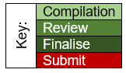

Appendix II: MSc Dissertation Plan Final

- Timeframe
Chapter 1: Introduction 1000 words
- Context - WAST
- Aims
- Scope
- Problem Summary
- Study objectives
Chapter 2: Methodology 1500 words 3,399
- Project planning
- Ethics
- Data
  - Quantitative
  - Qualitative
  - Population
  - Collection
  - Analysis
  - SWOT
  - Limitations
  - Validity and reliability
Chapter 3: Literature Search 4500 words 2,328
  - Prisma
3.2Performance
    - The Cost of Performance
    - Quality and Performance
    - Performance Management
    - Stress and Performance
  - The Impact of digital change on Health
    - Physical
    - Psychological
      - Cognitive burden
  - Wellbeing
  - Resistance to change
  - Human factors
  - Digital change & the impact on staff
  - Emergent and Future Technology
Chapter 4: Results 2000 words
  - Statistical analysis
  - Population
  - The Quantitative data
    - The survey
    - Question by question presentation
  - Quantitative results
  - Descriptive Statistics
  - Likert Scales
  - Qualitative results
    - key themes presented.
  - SWOT
  - Trianglulation – combining qualitative & quantitative results
Chapter 5: Discussion 4500 words
  - Comparing Literature search & results
  - Population
  - Performance
  - Quality
  - Performance management
  - Phealth Physical & Psychological
  - Wellbeing
  - FITT
  - Resistance
  - Human factors
Chapter 6: Limitations 500 words
- Areas for improvement / next steps
Chapter 7: Conclusion 750 words
  - Fears / benefits
Chapter 8 References
Chapter 9: Appendices
- Plan1
- Plan final
- Ethical application
- Ethical approval
- WAST non research form
- PRISMA flow diagram
- Article review summary
- Covering email for survey
- survey / questionnaire
- Results

Timeframe Plan
 | 2024 |  |  | 2025
 | October | November | December | January | February | March | April | May
Write Plan | 1-7 |  |  | Review & amend |  | Finalise
Ethical approval | Compile application | Submit application
Introduction | 1st draft |  | Revisit 2nd draft |  |  | Finalise
Literature review |  |  |  |  | Finalise
Methodology |  |  |  |  | Finalise
Compile questions |  |  | Finalise
Conduct research |  |  | Can only be commenced once ethical approval received.
Compile results |  |  |  | Send reminder to complete questionnaire on 1st of month
Write discussion
Limitations |  |  |  |  |  |  | Finalise
Complete Conclusion |  |  |  |  |  |  | Finalise
Compile references |  |  |  |  |  | Finalise
Submission |  |  |  |  |  |  |  | 1st -5th

Appendix III: Ethical application

Appendix IV: Ethical approval course Director

Appendix V WAST Not Research requiring WAST ethical approval.

Appendix VI: PRISMA

Appendix VII: Article review summary
Author | Date | Country of Origin | Topics | Sample | Relevance | Scored for effectiveness
Alathamneh, Al-Hawary | 2023 | Jordan | Digital transformation  Performance |  | High | High
Alsaffar et al | 2020 | Oman & Manchester | Diverse use of telemedicine  Continuous medical support is readily available  Minimises unnecessary hospital admissions |  | Low | Low
Baliozian | 2024 |  |  |  | Low | Low
Bernberg et al | 2024 | German | Digitisation – pros & cons.  Digital stressors |  | High | High
Binci et al | 2022 |  | Purpose & benefits of DT  Transformation process  Developments big data, IoT…  Def. telemedicine  Barrier to change/ DT
Califf et al | 2020 | USA | Positives & negatives of IT on nurses
Chouaibi et al | 2022 | Tunisia | DT impacts Risk |  | Low | Low
Chrysikou et al | 2023 | UK | Digital Transformation & Wellbeing  Benefits  Negatives  Stress & wellbeing  Health impacts |  | High | High
Crusoe, Magnusson & Eklund | 2024 | Swiss | Ignorance -wilful or otherwise  Pros & cons of…  Avoids accountability !! |  | High | High
Drummond | 1998 | - | Book review  Technology can add to workloads, duplication & costs |  | Med | Med
Korhhonen et al | 2023 | Finland | Strategic viewpoint  Performance management  Health care  Digitalisation, Technology  Social stability  Focuses on patient wellbeing  New skills required by HCPs |  | High | High
La Torre et al | 2020 | Italy | Technostress def  Impact on health / wellbeing  Relevance of age, education, gender  Reports conflicting research  Impacts of technostress. |  | High | High
Marsh et al | 2024 | UK | Mindfully digital  Digital confidence  Mindfulness  FOMO  Technostress  Eustress  Dark & bright side of technology  Psych social resilience |  | Med high | Med high
Pfaffinger, Reif & Spieß | 2022 | German | Telepressure  Technostress  Wellbeing |  | High | High
Ragu-Nathan, Tarafdar & Ragu-Nathan | 2008 | USA | Def.  Stress & strain  Impact & implications |  | Med | Med
Wardana et al | 2023 | Indonesia | Communication styles & leadership  Motivation & Psychology  Impact of digitalisation on communication & relationships. |  | Med | Med

Appendix VIII: Staff Email

Appendix IX: The Survey

Appendix X: Summary of Survey Results (MS Forms)

Appendix XI: Quantitative responses
Quantitative responses for questions 8, 12, 13 and 14 are encapsulated in the tables. The staff write in capitols in the computerised decision support software resulting in some of the responses being in capitols and some in lower case, many of these cases were completed mid shift whilst working with no time allocated to complete the survey.

Table 5.10 Question 8 Do you have any comments or feelings regarding question 6 & 7 responses
No. | Band | Direct Quote | Code | Theme
1 | 7 | Some staff find the changes stressful  here has been inadequate support at times or support has been pulled too early. | Change  Stress | Change Management
1 | 7 |  | Support  Learning  Time | Support
3 | 5 | being able to hybrid work when possible gives a much better flexible home/working balance. | Work-life balance | Wellbeing
4 | 6 | CURRENTLY - THE SPEED OF CHANGE IS HUGE AND CAN BE OVERWHELMING - PARTICULARLY ON RETURNING FROM LEAVE ETC WHICH INCREASE STRESS IN WORKPLACE - CHANGE IS ALSO HAPPENING AT A BUSY TIME WITH WINTER PRESSURES / NEW STAFF - THERE ARE ALSO DIFFERANT PROCESSES FOR DIFFERANT ACTIONS - DEPENDING ON OUTCOME / TIME OF DAY | Change  Stress  Processes  Pressure | Change management  Performance
12 | 3 | I personally find technology easy to understand when there is instruction on how to work it . Many times with new situations there has been unknowns for training team and learners . Thats difficult to process as learning the new skills does require some prior knowledge. However learning while doing is my personal way of doing things . I still think there’s so many more opportunities for development and enjoy learning more . | Learning  Process  Development | Support  Training
13 | 6 | The responses will be very different depending on the persons age, background, clinical knowledge & previous experience | Wellbeing
17 | 6 | Some individuals/colleagues take longer to learn or feel comfortable with digital change. especially those over age 40. | Learning | Training
27 | ? | SOME THINGS TAKE LONGER TO LEARN THAN OTHERS AND THE OLDER YOU ARE THE HARDER IT GETS TO ADJUST AND LEARN NEW THINGS | Learning | Training
28 | 5 | Some of the changes have been difficult to incorporate into a flowing protocol. | Training | Training
29 | 3 | WHAT IS THE PINT IN QUESTION 7 | - | -
32 | 6 | WOULD APPRECIATE MORE INVOLVEMENT IN CONSULTATION PHASE OF INTRODUCING CHANGE. | Change management | Change management
34 | 3 | I FEEL THAT EVERYONE IS EXPECTED TO LEARN NEW SYSTEMS AND CHANGES AT THE SAME PACE BUT A LOT OF COLLEAGES STRUGGLE TO LEARN THINGS QUICKLY | Learn | Training
42 | 3 | I RARELY HAVE TIMKE TO READ EMAILS AND SIGN OFF TO LEARN / UNDERSTAND CHANGES WHILE WORKING OOH SHIFTS . ONLY ON DAY SHIFTS DO I MANAGE TO LEARN AND TAKE THINGS IN PROPERLY | Time  Resourcing  Learn | Wellbeing  Training
43 | 6 | I feel that the older I get the harder it is to absorb information and the current trend for only learning online is not conducive to learning for me | Learning | Training
44 | 3 | change the 0-5yrs breathing questions | Process | Change Management
54 | 6 | things are being thrown out at a daily basis, very little time to look at it and let it sink in. we are either told to read the email and then get on with the day or have 30 mins -1hr to read the information. its very confusing and stressful sometimes i feel over whelmed with all the changes! unsure if we are doing right or wrong! | Change  Learn  Process  Stress  Feedback | Change Management  Wellbeing  Leadership
56 | 6 | there are so many changes that are going on recently and there is no time for staff to be able to understand these changes. we have to read a email or look at a power point and are expected to manage the changes from this,  taking on green 3 calls as a ch which used to be a band 7 job is beyond shocking, there has not been enough time for staff to process this change and is very stressful to ch when the details are not correct and the calls are not appropriate for 111, especially non clinical members of staff to manage | Change management  Time  Learn  Communication  Process | Change Management  Training
65 | 6 | I was always led to believe that change management was to be to plan, present, get feed back evaluate and then launch - i feel that no clinical staff are asked to trial run any system changes or asked for 360 review before they're launched and its us they affect- change is needed- but directional strategic reinforced change- not us having an email about a SOP - having 1 hr to read it and then get on - that's not enough, and I fear for my PIN | Change management  Process  Learning  Anxiety | Change Management  Training  Wellbeing
66 | 6 | For staff that have been working at 111 prior to changes they were provided just 3 days of stressful, complicated training, the staff that have started since the changes are given 4-6 weeks training plus 121 preceptoring | Training  Equity | Training
67 | 3 | I do often feel anxious about new changes to any of the systems we use. I strongly believe that health and well-being are very much linked. I do however feel very supported by my line manager. | Anxiety  Support +ve | Wellbeing  Support
69 | 6 | Personally I feel there have been too many changes for us to keep up with. Millions of emails with updated info. Bulletins stating one thing (i.e we phone green 3 failed contacts through) and ops telling us we don't. we dont have time to read the emails to take them in. There is just so much info, about what to do in some areas if they are in a care home (cwm taf) and need ed- and not in others. Trying to remember everything is really difficult. | Speed of change  Information overload  Learn  Processes | Change management  Training  Wellbeing
70 | 6 | A lot of changes recently in a small period of time. Not enough training or support. | Speed of change  Support | Change management  Training  Wellbeing
71 | 6 | Guidance and SOPS's not always clear or up to date and rarely given enough time to read through them to un derstand the changes and processes fully. | Time  Learn  Process | Training  Change Management
72 | 6 | WILL THESE RESPONSES BE TAKEN SERIOUSLY AND APPROPRIATE ACTION BE TAKEN | Wellbeing | Wellbeing
74 | 6 | It's hard to keep up with the processes and changes with little time to learn. Also finding it hard reading all the information, I would prefer to be taught it and try the changes and be able to ask questions | Speed of change  Learning | Change management  Training

Table 5.11 Question 12 Why do you feel your health is impacted in this way?
No. | Band | Direct Quote | Code | Theme
1 | 7 | Its not very healthy with sitting all day. My diet is not great when in work. It is often hard to get cover. | Sedentary  Health | Health
3 | 5 | being able to hybrid work when possible gives a much better flexible home/working balance. | Homeworking  Work life balance | Wellbeing  Resourcing
4 | 6 | IENJOY WORK AND THE ROLE I DO - I LOVE TALKING TO P[ATIENTS AND TAKE GREAT SATISFACTION FROM IT | Patient care  Wellbeing +ve | Wellbeing
6 | 7 | Stress and anxiety cause sleep disturbance | Stress | Wellbeing
8 | 3 | Stress is not positive | Stress | Wellbeing
9 | 3 | Very busy. Constantly on calls. Pressure to keep wrap & screen break times down | Demand  Management | Performance
12 | 3 | If I’m feeling well in myself then I’m able to work well efficiently and to the best of my ability. In situations where I have been feeling unwell but not unwell enough to not work it impacts on my work . For example… I may need an extra break or it may take me longer to complete a task . | Health  Performance | Health  Performance
13 | 6 | I enjoy my role  I work Bank hours, so to a degree I can mange my time and shift patter  I have lovely colleagues | Wellbeing  Resourcing | Wellbeing
14 | 6 | AS STRESS/ANXIETY CAN CAUSE MANY HEALTH PROBLEMS | Wellbeing | Wellbeing
15 | 6 | Pressures to make the right decisions. Hours worked also make me very tired | Pressure / demand  Resourcing | Performance
16 | 3 | The mental stress and fatigue of this role really impacts my health and life inside and outside of work. I am always drained to the point where on my days off I don't do anything | Health | Health
18 | 3 | LITTLE TO NO WORK/LIFE BALANCE | Work-life balance | Wellbeing
19 | 6 | EASY TO BURN OUT | Stress | Wellbeing
22 | 3 | When the enviroment is very low on morale, and people take this into every area of work, it seeps out and affects everyone. the ripples travel wide. being scared to drink too much because it may mean i need to take an extra screen break to go the toilet, being worried that if i come to work when i have a period may mean explaining that i did infact need to take 10 minutes to clean myself up enough to come back into the call centre, having to apologise that i have IBS and having a 'bad day'. This doesn't even take into account when a call has affected me, when i see a colleague struggling and i need to support them with how to complete the call, or i can see they are struggling with their call and they need to have a chat or a bit of a check in before they carry on. I have in the past had arguments with CHC remotely due to them being unhappy that i was over on my wrap time due to supporting a colleague working her first bank holiday, very new to the role and was completely overwhelmed. this situation is not unique - it is constant, it affects mine and my colleagues physical and mental health hugely. | Wellbeing  Management  Peer Support  Management | Wellbeing  Peer Support  Leadership  Management
24 | 7 | Work keeps my mind active - it distracts me from difficulties at home as I care for my husband | Wellbeing | Wellbeing
25 | 5 | I don't feel work has a positive impact on health | Wellbeing | Wellbeing
26 | 5 | bad day equals poor mental health | Wellbeing | Wellbeing
27 | ? | I GET ANXIOUS WHEN I DONT FEEL CONFIRDENT WITH A TASK | Anxiety  Learning | Wellbeing  Training
28 | 5 | I have ongoing back problems and have difficulty finding suitable desks to enable a comfortable working position | Health  Equipment | Health  Resources
29 | 3 | IF YOU ARE STRESSED YOU CANNOT FUNCTION AS WELL AS BEING IN CONROL OF WHAT YOIU ARE DOING. NO ONME CAN WORK WITHOUT INFORMATION AND TOO MANY QUESATIONS WHY AND WHAT FOR DO NOT ASSIST IN GOOD WORK/ PERSONAL HOME LIFE | Wellbeing  Support  Work-life balance | Wellbeing  Support  Training
30 | 6 | POOR DSE REQUIREMENTS | Equipment  Support | Resources
31 | 6 | BECAUSE THERE HAVE BEEN TOO MANY CHANGES IN A SHORT PERIOD OF TIME NO SUFFICENT TRAINING. NO TRAINING WHEN IT COMES TO DIFFERENT TYPES OF PEOPLE FOR EXAMPLE IM AN ADULT NURSE AND DOING CHILD CALLS AND I DONT BELIEVE THAT I SHOULD WITH NO FORMAL TRAINING ON PEADS. | Speed of change  Time  Training  Training / support | Change management  Resources  Training
32 | 6 | PATIENT SATISFACTION.  DELIVERY OF TIMELY, QUALITY CARE. | Patient care | Wellbeing
34 | 3 | WORK CAN BE VERY STRESSFUL AT TIMES ESPECIALLY DURING THE OUT OF HOURS PERIOD. I FEEL IF IM STRESSED FROM WORK, TIRED ETC THIS IMPACTS MY MENTAL AND PHYSICAL HEATLH | Stress | Wellbeing
35 | 3 | No support from management when unwell | Support  Compassionate Leadership | Support  Management
37 | 6 | I am able to work the shifts that suit me | Work-life balance | Resourcing
40 | 5 | The can be times where workload can be strenuous | Stress | Wellbeing
41 | 6 | INCREASED STRESS | Stress | Wellbeing
42 | 3 | I FEEL LIKE MY HEALTH IS IMPACTED IF EXTREMLY BUSY WITH LIIMTED OFF LINE TIME, NO TIME TO EVEN SAY HELLO TO YOUR COLLEGUE SITTING NEXT TO YOU, WORKING HARD AND GETTING LIMITED REWARD OR ACKNOWLEDGMENTS | Demand  Management | Performance  Management
43 | 6 | Being stressed in work definitely impacts me out of work, as much as I try to disassociate from work I cannot | Stress  Work-life balance | Wellbeing
44 | 3 | added stress | Stress | Wellbeing
45 | 3 | LACK OF STRUCTURE WITH ROSTERING OR PAITENT DEMAND CAUSING STRESS / LACK OF STAFFING / SIGNIFICANT GUILT IF CALLING IN SICK - NOT ALL MANAGERS ARE CONSIDERATE | Resourcing  Stress  Compassionate Leadership | Resources  Wellbeing  Management
48 | 6 | My role is very sedentary. | Health | Wellbeing
50 | 3 | swapping between roles | Career development | Wellbeing
51 | 7 | Work is a stressful environment, working long hours, no time to have a work life balance. | Stress  Resourcing  Work-life balance | Wellbeing  Resources
53 | 5 | I enjoy where I work, however I do not feel that work heavily impacts on my health & I try not to allow it to. If I have a particularly difficult run of shifts (Nights/late) I simply adjust my home life as best I can to accommodate this. | Wellbeing | Wellbeing
54 | 6 | stress | Stress | Wellbeing
55 | 6 | SENSE OF WORTH, GOOD PEER SUPPORT, PLEASANT AND PROFESSIONAL WORKING ENVIRONMENT | Peer support  Wellbeing | Wellbeing
56 | 3 | green 3 calls for ch is shocking, this used to be a job for a nurse band 7 and now expecting and band 3 non clincal member of staff to do this. all of the calls have to use caln which again delays care. ch are not clinical but we are now expecting to act clinical  call volumes are so high, especially overnight, 7-9 ch for the whole of wales and now green 3 added ontop of this too, caln is rammed all the time which again delays care for the patients. Staff are expected to tackle the large call volume and we just cant manage it.  staff are mentally and physically exhausted, and now green 3 calls ontop of our already busy load just seems so unfair for a band 3 role. its added pressure constantly and is stressful to staff and affecting mental health for staff | Demands  Communication  Wellbeing | Performance  Change management  Wellbeing
57 | 6 | WHEN WORK IS STRESSFUL THIS HAS A NEGATIVE EFFECT ON MY HEALTH. | Stress | Wellbeing
58 | 7 | in a pressurised role service comes before health and often breaks missed | Demand | Wellbeing  Management
60 | 6 | Stress has a cumulative effect, and time constraints of the role are such that it is not feasible/possible to take as many screen breaks as informally advised. Things like getting a call from CHC after being on a screen break for 6 mins can and does exacerbate workplace stress and anxiety and happens very frequently according to colleagues. Staff wellbeing is the first to fall at the wayside when things get busy, which is often. | Stress  Time  Anxiety  Demands | Wellbeing  Leadership
61 | 3 | I feel over whelmed and this is causing anxiety with both mental and physical symptom. insomnia, elevated blood pressure, gut issues. | Anxiety  Health | Wellbeing
62 | 6 | causes my mood to change | Wellbeing  Health | Wellbeing
63 | 3 | its a stressful role, trying to get to what is wrong, having someone who has queued for 40 minutes with an obvious 999 call, stressful | Stress | Wellbeing  Support
64 | 6 | I enjoy the routine and a sense of purpose that work provides me with. I also enjoy the social aspect of being amongst colleagues. | Wellbeing | Wellbeing
65 | 6 | I feel anxious about the changes- that I could make an uniformed decision from reading a SOP - that is open to my interpretation, that could cause a massive impact on a persons access to health | Anxiety  Process | Wellbeing  Training / Support
66 | 6 | I frequently feel anxious about coming to work, worried that more changes will have been made, often with little notice | Anxious | Wellbeing  Change Management
67 | 3 | I have a health condition that impacts my daily life at certain times of the month which is significantly impacted in a negative manner whilst being at work but this would be the case for most job roles due to the nature of the condition. | Health | Wellbeing
68 | 3 | I am not as active therefore not burning the calories I intake causing weight gain. Back + leg ache from sitting down. Eye ache, strain and headaches from staring at the screen | Health  Equipment | Health  Resources
69 | 6 | work doesnt affect my health apart from making me tired doing the later shifts- | Shift work | Resources
70 | 6 | I become anxious & stressed very quickly. | Anxiety  Stress | Wellbeing
71 | 6 | A lot of changes that have been introduced quickly and not a lot of time to get used to processes due to demand on service. Not a lot of training on new systems and processes and SOP's and guidance not always clear and not given a lot of time to fully read and understand these in a shift. Ambulance processes are confusing at times as there are different processes per different outcome e.g. amber 1,s or green 3's. Things do not seem streamlined to be effective. Long waits to pass ICCTP calls back to CSD add to concerns regarding new processes. | Speed of change  Training  Process  Demands | Change management  Training  Performance
72 | 6 | STRESS RELATED HEALTH ISSUES, ANXIETY FOR EXAMPLE, FEELIGN YOU ARE FAILING PATIENTS | Stress  Anxiety  Patient care | Wellbeing  Health
74 | 6 | Stress at work can cause me to feel worn down and in turn can effect my health | Stress | Wellbeing
75 | 6 | KEEPS ME ACTIVE ABD ENGAGED | Health | Wellbeing

Table 5.12 Question 13 What would like/ change / add to support your performance, health, and wellbeing? responses
No. | Band | Direct Quote | Code | Theme
1 | 7 | clear stats to work to  constructive honest feedback, often feels lacking / hidden | Process  Feedback  Compassionate Leadership | Leadership  Management  Performance
3 | 5 | Continue as present. |  | -
4 | 6 | PROCESS TO BE MORE UNIFORM AND SIMPLIFIED -  CERTAIN PROCESS LIKE UPCC BOOKING IN DAY - CLINICANS TO DO | Process | Change management
6 | 7 | to be able to have the time to complete all aspects of my Job description rather than just fire fighting the next crisis. | Time | Performance
8 | 3 | For staff to be listened to. I find it quite down heartening to come in and hear my colleagues say they feel depressed because if work. | Communication  Morale | Wellbeing
12 | 3 | I struggle with feeling cold , the air conditioning in work can be cold and I can often be sat in my coat working and I struggle with this . The air conditioning system is controlled by staff members I think this could be better managed . I think a positive system of praise for good achievement would work well also. As it stands we have to ask for members of the public to send in thank you requests somthing I would not be willing to do there has to be another way to measure a good job and reward . | Environment  Feedback | Wellbeing  Performance
13 | 6 | I would prefer face to face contact when major changes are implemented - that could be on site or teams, as it gives an opportunity to ask questions, clarify queries etc | Support | Training
14 | 6 | MORE SUPPORT IN THE CALL CENTRE OUT OF HOURS WHEN NEW CHANGES HAVE BEEN APPLIED FOR EXAMPLE THE NEW PROCESS THAT WAS IMPLEMENTED FOR NURSES TO BE ABLE TO CATERGORISE 999 CALLS. WE WERE GIVEN 90 MINUTES TO READ A POWERPOINT THEN THEY DAY AFTER WE WENT LIVE I WAS THE ONLY NURSE IN THE CALL CENTRE THAT EVENING AND FELT VERY STRESSED/ANXIOUS AS IT WAS NOT VERY CLEAR WHAT WE NEEDED TO DO IN CERTAIN SIUTATIONS. | Support  Stress  Anxiety | Change management  Leadership  Training  Wellbeing
15 | 6 | Better more flexible working hours and more training | Work-life balance  Training | Wellbeing  Resources
16 | 6 | For there to be more staff on during the working days. With winter pressures coming up we understand the service is going to be busy, but to come into work and have calls queueing for the 10 hours of the shift on weekdays when before it wouldn't be like this is affecting all of the above in the question. | Staffing  Demand  Stress | Resources  Performance  Wellbeing
17 | 6 | I ( clinicians) do not want to feel pressurised to go faster/ do more/ hurry up or be performance managed on call times. - this will negatively impact performance and wellbeing.  The call will take ME ( the clinician) as long as it takes to complete.  Only exception is a trend of inappropriately long calls. ( Team leader to support).  It is me navigating the triage process and digital add ons and new processes and not my non call taking/non triaging Band 7. (for the most part),  It can be a lot.  You would never hear a GP working for OOH telling a GP colleague - are you ok , you have been stuck on that call for xxxx time in a negative tone.... calls are breaching..  So digital transformation to aid patient journey, patient safety, achieve clinical excellence and help the clinician.  IT wise - we may need an extra screen soon to manage all processes.  Screen breaks to be encouraged, | Performance  Wellbeing  Patient care  Management  Equipment  Support  Wellbeing | Performance  Wellbeing  Management  Resources  Support  Wellbeing
18 | 3 | UPADTES ON POLICIES I.E. SICKNESS  NOT BEING MICROMANAGED TO WITHIN AN INCH OF OUR LIVES  MORE OF A WORK/LIFE BALANCE | Performance  Management  Work-life balance | Performance  Management  Wellbeing
20 | 6 | Praise when you do something good rather than only hearing the negative. Less pressure on call times and more focus on safe and appropriate outcomes and providing a positive patient experience. | Feedback  Pressure  Patient care | Management  Performance
22 | 3 | Less micro managing - allowing time for Wellbeing support even if we are in higher reap levels. All 1:1 with CHC being protected time that isn't cancelled. Some people on certain contracts are going years at a time without a meaningful check in. Allowing more of the call handling staff to participate in the online training sessions about wellbeing, finance, training etc. ensuring that everyone can see the bigger picture. going into December we all know its going to be busy - so encourage everyone to try and be positive, not just in and work like a robot for hours. Show all levels of staff that they are cared for by simply allowing that time to be human - get the extra drink, go the bathroom, and a few minutes conversation with a colleague. | Management  Communication  Feedback  Training  Compassionate leadership  Support | Management  Support  Training  Wellbeing
23 | 3 | If big changes face to face training | Training | Training
24 | 7 | I would like more IT training | Training | Training
25 | 5 | Better/more interactive/in depth training for band 3 staff would improve the ease of my job and reduce some stress. | Training  Stress | Training  Wellbeing
26 | 5 | handover time at start of shift - more coaching and support provided. | Time  Support | Support  Wellbeing
27 | ? | AT BUSY TIMES ENSURE THERE IS A PERSON FLOOR WALKING THAT CAN HELP AS OFTEN CHC IS BUSY AND YOU CANT GET THROUGH ON THE TELEPHONE, ITS STRSSFUL WHEN YOU ARE STUCK AND THERE IS NOBODY TO ASK. | Support  Stress | Wellbeing  Performance
28 | 5 | more desks which can be moved up and down | Equipment | Resources
29 | 3 | AS A CALL HANDLER WE HAVE A LOT OF CHANGES WITHOUT EXPLANATIONS. WE DO A FANTSTIC JOB. WITHOUT CALL HANDLERS 111 WOULD NOT HAVE NURSES, CHC, SNA, MANAGERS AND SO ON. THE PEOPLE AT THE BOTTOM ARE THE MOST IMPORTANT AS EVERYONE ELSE RESTS ON THEIR SHOULDERS. | Support | Wellbeing
30 | 6 | MORE AUTONAMY AND FEED BACK LINKED TO KNOWLEDGE AND CLINICAL RATIONAL NOT TICK BOX AUDITS. | Feedback | Wellbeing  Process
31 | 6 | LONGER SCREEN BREAKS AND LONGER BREAKS AT NIGHT. MORE TRAINING. | Wellbeing  Training | Wellbeing  Training
32 | 6 | MAY BE BENEFICIAL TO BE ABLE TO LOG OFF 15 MINS BEFORE END OF SHIFT TO BE ABLE TO CATCH UP ON EMAILS/NEW PROCESSES. | Time | Wellbeing  Support
33 | 3 | Having an allocated space to sit everytime I attend work. | Equipment | Resources
34 | 3 | MORE TIME TO LEARN NEW SYSTEMS/CHANGES | Learning | Training
35 | 3 | A more supportive management team for call handlers | Compassionate Leadership | Management
37 | 6 | More time for learning when processes change and guided support for homeworkers who are prepared to do office based shifts, shift requests given on rota for instance 10 shift requests not given for jan | Time  Learning  Shiftwork | Training  Resources
40 | 5 | study / improve my understanding of policies and procedures | Learning | Training
41 | 6 | MORE TIME TO DO TRAINING - READ UPDATES - CPD - COURSES - | Training  Time | Training
42 | 3 | ALLOCATED OFF LINES SLOTS TO LEARN AND READ EMAILS/ ENCOURGEMENT WHEN REALLY BUSY, SMILE FROM A CHC DOES GO A LONG WAY. | Learning  Compassionate Leadership | Training  Management
43 | 6 | More face to face training sessions, training teams on site and available to help, when concerns are raised that these are taken forward and we are kept up to date with outcomes | Training  Feedback | Training  Change management
44 | 3 | more pay | Resources | Resources
45 | 3 | LESS PRESSURE FOR SERVICE DEMAND DUE TO LACK OF STAFFING / MORE COMPASSION FROM MANAGERS | Demand  Staffing | Resources  Performance
48 | 6 | Desk with treadmill. I feel sitting at a desk all day is bad for my back and weight! | Equipment | Resources  Health
50 | 3 | face to face support/training | Support  Training | Training
51 | 7 | Support from a line manager, bounce ideas off someone. Currently in a position where there is no support, working alone and completing work and changes alone. | Support  Management  Learning | Management  Training
54 | 6 | To be regarded as being an equal in the work place, and not over watched and micro managed from the others. there is no time to talk and reflect on a call as we are reprimanded often. | Equality  Feedback | Performance  Management
55 | 6 | I WOULD PREFER TRAINING SESSIONS RATHER THAN FLO CHARTS OR ON LINE LEARNING OF NEW SOPS | Training | Training
56 | 3 | stop piling so much work on staff, ch deal with whole of wales and now green 3 calls which are coming through incorrect and 999 dont know how to pass them though correct which is added stress for 111 ch, winter desk is now also taking staff away from ch so is more calls again for ch  abit of appreciation for all staff on the shop floor, some ch dont take hardly any calls and are not pulled up for sitting in wrap for ages or not doing hardly anything while others are doing double/triple calls, this is very annoying, i understand people have multicalls and longer calls but when its double triple the calls thats nothing to do with call capability thats down to performance issues  little things like well done message, something little to keep staff going and up moral,  stop expecting ch to do band 7 job its not right we are not clinical, its stressful for ch to be doing a band 7 job  just appreciate staff in general, so many staff are leaving and the answer is its ok we can get more staff but your not listening as to why staff are leaving in the first place.  zen room for staff has been dumped with desks and chairs, this is not fair meant to be a chill space for staff but is now a dumping ground with no care for staff relaxing space  staff that perform well dont get appreciated at all and this is hard to want to come back into | Anger  Stress  Staffing  Equity  Compassionate Leadership  Morale  Communication  Attrition  Equipment | Wellbeing  Resources  Performance  Management  Leadership
57 | 6 | MORE TIME TO LEARN, ABSORB AND PRACTICE NEW PROCESSES, READ EMAILS AND UPDATES, ESPECIALLY WHEN BEEN ON LEAVE. | Time  Learning  Support | Wellbeing  Training  Support
58 | 7 | ensure changes are shared with the clinicians in a timely manner so they have time to digest the upcoming changes | Time  Learning | Change management  Training
60 | 3 | Revised system of time constraints for all staff taking live incoming calls, reassessing priority of staff wellbeing above sheer statistical numbers | Time  Performance metrics  Wellbeing | Performance  Wellbeing
61 | 6 | Allow change to embed before adding new initiatives. Make 999 staff participate in change. Stop adding work in for clinicians. have more floor walkers when new things come in. Stop the digital xfer in favour of calling 999 and advising them what resource and time scale you need. We are getting the flack for long waits x 2. once for 111 then when advising 8+ hours for an ambulance get the same again. | Learning  Equity  Support  Wellbeing | Change Management  Training  Support  Wellbeing
62 | 3 | more time to absorb new info- more patience from chc'c | Learning  Compassionate management | Training  Management
63 | 3 | you really have to be careful about putting time constraints on calls, and time between calls,  taking a 999 calls, as above, can be stressful, you sometimes need time just to take a breath , sometimes talk to someone else about the call, and then start again | Time  Wellbeing  Support | Performance  Wellbeing  Management
64 | 6 | I would suggest further training on management of ambulance calls as we begin to integrate further. I feel like an online training session where we were unable to ask questions/clarify is not sufficient, especially now that we have had further changes. Myself, and colleagues, are confused regarding the different ways ambulance calls enter 111 and how we're managing them. | Training  Wellbeing | Training  Wellbeing  Change management
65 | 6 | have approachable, present and available team leaders- I feel at Vantage Point- I only see Gemma if I have an issue- no one else is supportive or present | Management  Support | Management  Support
66 | 6 | regular PC sessions to support CA's | Training  Support | Training  Support
67 | 3 | A better understanding of certain health conditions - although i do feel very well supported by my line manager | Support  Management | Support  Management
68 | 3 | longer screen breaks, | Wellbeing | Wellbeing
69 | 6 | I feel some training days- face to face or teams so we can ask qs and learn from each other is really needed- | Training  Support | Training  Support
70 | 6 | Extra training - in the process of being arranged. Work from home 1 of my shifts | Training  Work-life balance | Training  Resources
71 | 6 | More time to read guidance and understand processes. Updates on SOP's such as taxi SOP exclusion criteria. More in person training and guidance on new systems and processes. More understandable guidance for different ambulance processes and clinical hub. | Learning  Time  Training | Training  Support
72 | 6 | ENOUGH TIME TO LEARN ABOUT THE CHANGES, EXPLAIN TO US WHY WE NEED THE CHANGES. WHY ARE THESE CHANGES SO COMPLICATED. | Time  Learning  Communication  Processes | Training  Change management
74 | 6 | occasional classroom teaching to keep up to date with changes or workshops on some medical conditions to support my decision making process. e.g paediatrics | Training  Support  Patient care | Training  Support
75 | 6 | LESS SCRUTINY FROM SNAS' DURING YOUR SHIFT / NOT BEING SO CLOSELY MONITORED BY SNAS | Wellbeing  Compassionate management  Demand | Wellbeing  Management  Performance

Question 14 Many thanks for answering these questions. Anything you would like to add relating to Digital transformation and how this impacts your performance, health and Wellbeing in your current role? responses
No. | Band | Direct Quote | Code | Theme
1 | 7 | there is a lot of change, appreciate why. but there is inadequate support for the staff / myself often with well ask for help - often I just need times & space to complete work, less | Support  Time | Support  Performance
6 | 7 | Our IT infrastructure s fragile, we have poor access to IT support 24/7. The organisation can only move as fast as IT allows. the organisation implements new processes without the IT infrastructure being ready. We are dependent on a few IT professionals who understand the system as a whole causing bottle necks for demands on their expertise. We have too many eggs in to few baskets. This causes huge amounts of real time stress when things go wrong | Equipment / Resources  Staffing  Stress | Resources  Change management  Wellbeing
8 | 3 | More laptops with more work from hone opportunities for call handlers who are experiencing life changing issues instead picking and choosing when staff can work from home. It's unfair as some staff have serious family events going on and being able to work from home would make a huge positive impact for them and their family. | Equipment  Homeworking  Support | Resources  Support  Wellbeing
12 | 3 | Digital transformation dose cause stress but I do believe this is the unknown and coming across issues and not having the answer . However with the correct support and being show how to overcome it I think it’s a rewarding feeling in learning that new skill that can be passed onto another . | Stress  Support  Learning | Wellbeing  Support  Training
13 | 6 | We live in a Digital world so I am used to technology. In health care you can glean far more information with face to face contact - non verbal cues etc. Screen time / time away is important and I probably don't mange that as well as I should due to volume of work, having said that it is something I need to manage as I have never been discouraged from taking screen breaks or formal breaks | Patient care  Self-care  Demand  Time | Wellbeing  Performance  Support
17 | 6 | The digital transformation in 111/999 = information. eg - call times, wrap times, break times, call audit, sorting of clinical outcomes etc. policies, siren updates, teams chat, email etc.  Care should be taken not to use this information to overly micromanage clinicians.  It is ok to briefly discuss calls with colleagues, be reassured , receive guidance and sometimes decompress before taking another call.  Staff should not feel anxious that they not managing digitally/taking too long. | Performance metrics  Management  Support  Wellbeing  Anxious | Performance  Management  Support  Wellbeing
22 | 3 | All updates to be on a simple to access system. CH not allowed to check emails at the sort of shifts (this is a historical issue that has been argued for years) you are to check it at the end of the shift, or if you have a break in-between calls, which you don't necessarily get. Put into place a certain amount of time for each shift (5 mins) and a phone code so that you have the opportunity to get up to date and understand before being rushed online. If were not online in sufficient time then you are contacted and asked why are you not live, go live please.....again I reiterate this is not on occasion, this is the culture. | Access to information  Time  Wellbeing  Compassionate management  Communication | Change management  Wellbeing  Management
23 | 3 | Frequent changes cause a lot of anxiety and worry to staff | Anxiety | Change Management  Wellbeing
30 | 6 | TRANSFORMATION IS UNDERSTANDABLY REQUIRED BUT GIVING ONE LEARNING OPTION IN A TIGHT TIMESCALE ADDS TO STRESS AS TRAINING ISNT FACILITATED TO MAKE USER FEEL KNOWLEDGEABLE AND COMPETENT TO USE SYSTEMS. | Learning  Training  Stress | Training  Wellbeing  Support
33 | 3 | Things are happening too fast, and it is hard to keep up, even as someone that learns quickly. | Speed of change | Wellbeing  Change management
53 | 5 | You are welcome. I think for me I would like to see that all of my colleagues within my role be equally capable of completing all duties when required by the service and make it fair when asked to support. | Training  Support  Equity | Training  Wellbeing  Support
56 | 3 | being a staff member at 111 currently is just draining on our mental health, every staff are saying the same and we are burnt out  rammed constantly with no reward for the job.  staff will all be off sick with stress before long and its the service which needs to be looked at and changed  we are not robots we can only do what we can do  the call board seems to be more of a priority than staffs mental health and this is a disappointment  computers dont work, we have been months with no working pcs and csd now have brand new computers ? this is frustrating  computers are not fit for purpose, stressful coming in having to look for a pc when nothing works which makes you late logging in and then you get a row for logging in late | Wellbeing  Demands  Stress  Compassionate changes  Support  Equipment  Equity  Compassionate management | Wellbeing  Performance  Leadership  Management  Resources  Support  Change management
65 | 6 | too much - too fast- giving me anxiety | Speed of change  Anxiety | Wellbeing  Change management
66 | 6 | SNA's are supportive when both on and off site  staff morale is generally low, I'm not sure a few visiting animals will do anything to improve this | Management  Morale | Management  Support  Wellbeing
69 | 6 | I feel the constant changes have been quite difficult to keep up with- they have been positive im sure, in a lot of ways. but i have noticed a lot of staff looking for different jobs and feel overwhelmed | Speed of change  Communication  Morale | Change management  Leadership  Wellbeing
72 | 6 | HAVING APPROPRIATE TRAINING AND A UNDESTANDING OF WHAT OUR ROLE IS IN WAST, 111 | Training  Communication | Training  Wellbeing  Change management

