Assessment 1

Blogging to communicate

Student name: Diana Tincul

Student ID: 2028613

Module number: LCBB4004

Module name: Marketing Fundamentals

Lecturer name: Tushara Balendran

Table of Contents
Blog 1: About the company 3
History of the brand 3
Product 3
Blog 2: Market Mix Approach 5
Blog 3: Pricing strategy of Boots, UK 6
Blog 4: Advertising strategy of Boots, UK 7
Blog 5: Product Strategy of Boots, UK 9
Blog 6: Place and distribution 10
Blog 7: Market segmentation of Boots 13
Blog 8: Targeting and positioning of Boots 13
Reference list 15

Blog 1: About the company

History of the brand
Boots is a renowned health and beauty product retailer which also deals in pharmacy also. The company has a multinational presence with retail shops in Ireland, Norway, Netherlands, Thailand, Italy and Indonesia. The company was founded in 1849 by John Boot and there are about 60,000 people who works in the company’s various branches. The mission statement of the brand is “Be the first choice for pharmacy, well-being and beauty - caring for people and communities around the world”.

Product
Boots deals in various products like healthcare products, medicines, beauty and skincare products, fragrance, baby and child products, electrical grooming instruments, wellness, toiletries and so on. For example, the products like Boots biodegradable cucumber cleansing wiper (Price: £1.00), Boots expert sensitive shampoo (Price: £4.00), Boots expert orthodontic wax (Price: £3.20), Boots expert hand and nail cream (Price: £2.75) and so on. These are pictures of products that are currently being sold in Boots in the beauty and healthcare department.
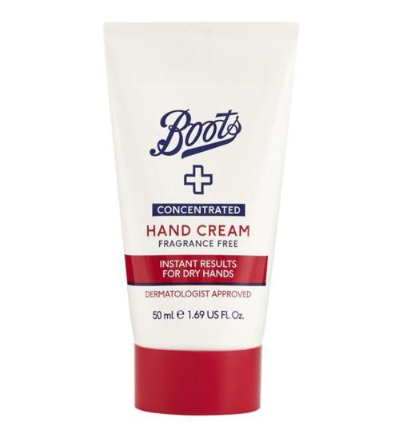
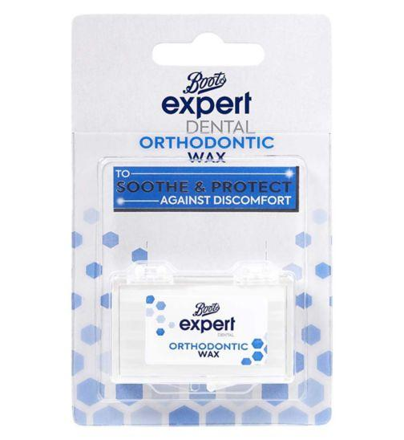
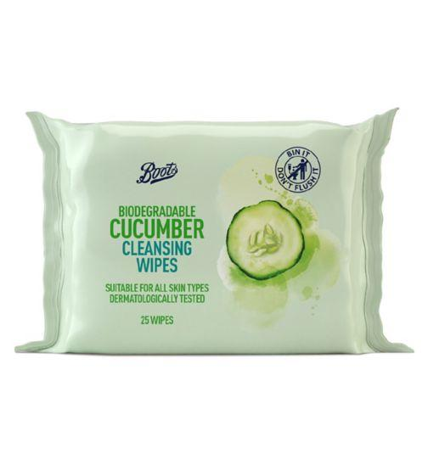
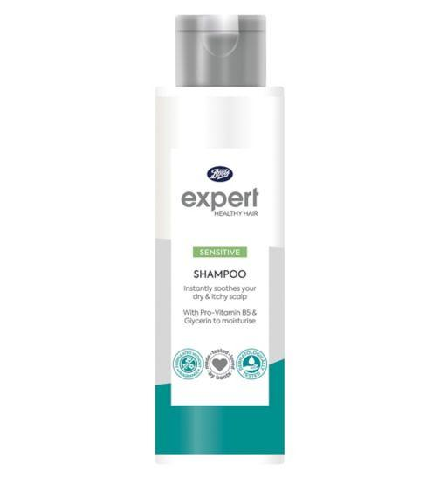
Image 1: Boots Products
(Source: Boots, 2022)

Blog 2: Market Mix Approach
This blog is about Boots' market mix approach. Promoting is the interaction and process of increasing openness and interest for an item or administration. It's a befuddling now fundamental cycle that is basic for accomplishing progress inside an association. By and large, all together for an organization to develop and flourish, they should unmistakably recognize their promoting blend. The conventional publicizing blend includes the four P's of showcasing: Price, Product, Promotion, and Place (JORAN, 2021). They are viewed as the wide levels of an association's publicizing blend and fill in as the setting up segments around which an advancing framework rotates. An item mix alludes to the all outnumber of merchandise or authoritative lines that an organization offers to its clients. The product mix of a firm may change contingent upon the scope of products or organizations that the business needs to supply. The item blend will be dictated by the association's marking framework and the type of clientele it intends to attract.
Boots' advertising strategy investigates the brand using a showcase mix structure that encompasses all four Ps (Product, Price, Place, Promotion). There are a few showcasing procedures, like item creation, assessment system, and progression arranging, to give some examples. Considering the Boots promoting blend, these business approaches help the brand's prosperity (MBA Skool Team, 2021). The Boots advancing framework helps the brand/association in setting up a good foundation for itself as a genuine competitor and accomplishing its business points and destinations. The following describes the item strategy and mix in the Boots advertising system: Boots is a critical multi-brand corporate store organized in the United Kingdom. As a part of its appearance mix thing system, Boots stores sell an assortment of wellbeing and excellent things. Lunchtime deals are the organization's own food and beverage line. They also offer certain types of assistance, such as optician care and hearing aids, in their stores and through other causes. There are around 2500 stores located north of multiple sites.

Blog 3: Pricing strategy of Boots, UK
The value blend is a fundamental component of an organization's displaying blend. It is the expense of a thing or administration for which a customer will pay. The estimating of an item or administration ought not really to be set in stone so that it addresses the issues of both the purchaser and the dealer. It is a delicate balancing act between gratifying the client and the business providing goods or services. The cost-benefit ratio may be a sensitive subject for both buyers and businesses, and as such, it should be approached with caution while developing an estimation method. When developing a showcasing attempt, the evaluating blend must be carefully considered in circumstances where customers are value sensitive and cases where buyers have a high-saw value esteem.

Boots' contributions encompass a wide range of commodities, resulting in a wide range of respect. The market for pharma, greatness, and clinical advantages items is teeming with comparable organisations giving essentially identical features. The items were carefully scrutinised in order to ensure their authenticity. Boots also made its products exceptional and paid high prices for a restricted number of products. This was accomplished by confining with cosmetologists and transporting items under their photo names. These materials were organised and improved together with cosmetologist markings before being sent out on the search. Among these brands were Tony & Guy, Trevor Sorbie, and others. A jug of cleaner usually costs around £4. Every year, the Walgreens Boots Alliance makes more than $130 billion.

Item or administrative cost is the variable that has the most direct impact on an organization's income and benefits. Estimating has always been an important feature of traditional advertising; just estimating generates revenue (Kienzler and Kowalkowski, 2017). As a result, as a company, you must tailor the marketing strategies to the obvious worth the item or administration. It's anything but a simple choice, and it regularly adopts cautious strategy, testing, exploration, and execution. The following are some of the assessing blend's components and procedures:
- Choosing the prices of all creative and inventive work
- Examining competitor evaluation process and costs
- Developing comparable estimation methods and strategies for goods and services
- Choosing the least expensive option and aiming for net revenue
- Markdown structure for loyal customers
- Clients can choose between credit, charge, cash, or check as payment terms.
- Deals Periods and Discount Levels

Blog 4: Advertising strategy of Boots, UK
A limited time blend is a group of strategies used by a business to advertise a product or service. It should be consistent with the company's ideology and ensure that the advancement is even for advertising. Each company has its own preferred advertising mix. Some advertising blends contain four Ps, while others have seven (Mahmoud, 2018). The essential objective of the custom mix is to raise brand mindfulness and consideration with expectations of producing business for an organization. A unique blend's three primary goals are to:
- Data should be presented to potential customers.
- Increment mindfulness, interest, and excitement for an item or administration.
- Included in the feature and showcase brand or the item is

The particular mix must be meticulously created to modify people's interests to that of the item or administrations that an organisation delivers to the table. If they don't change, it will have a direct impact on an organization's sales and development. The unique mix consists of components and procedures designed to aid a firm in acquiring new consumers and retaining existing ones. The three most well-known approaches of the unique mix are as follows:
Deal Promotion, Public Relations, Marketing. Marketing with the help of social media can be seen in the Boots. In the present era social media platforms can be the most effective way of marketing products and services. The company is available in every renowned social media platform and the links of three of them have been attached here.
Facebook: https://www.facebook.com/BootsUK/
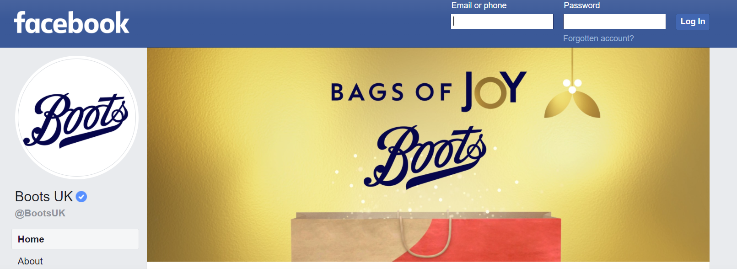

Instagram: https://instagram.com/bootsuk?utm_medium=copy_link
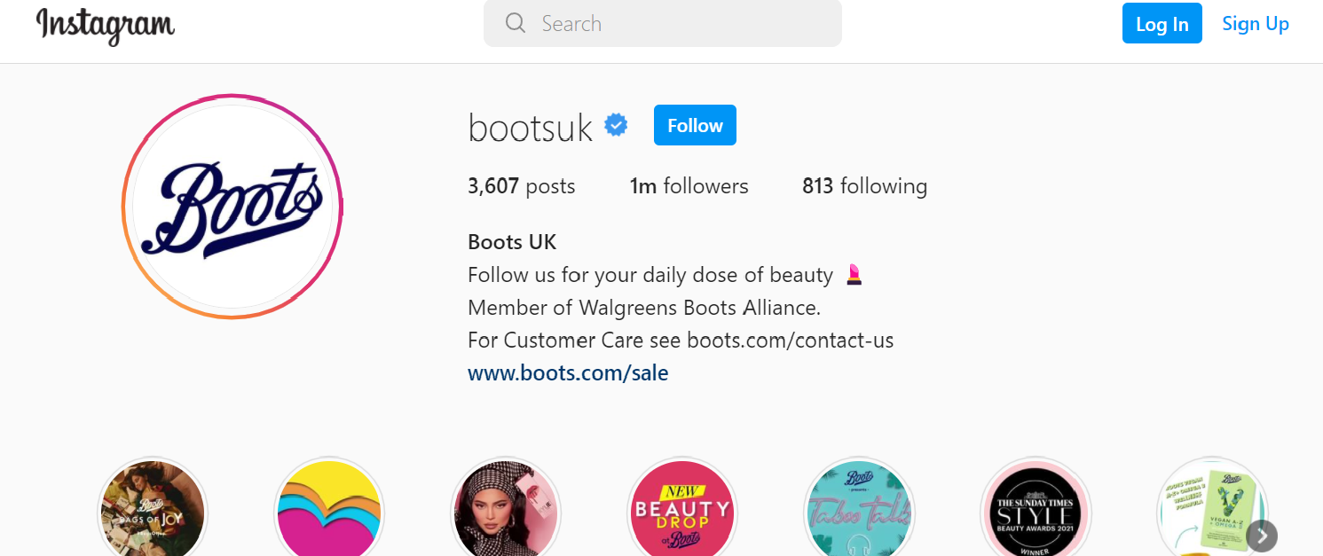

Twitter: https://twitter.com/BootsUK?t=ZHOZaUmf5AVdeQEmNFQS7g&s=09
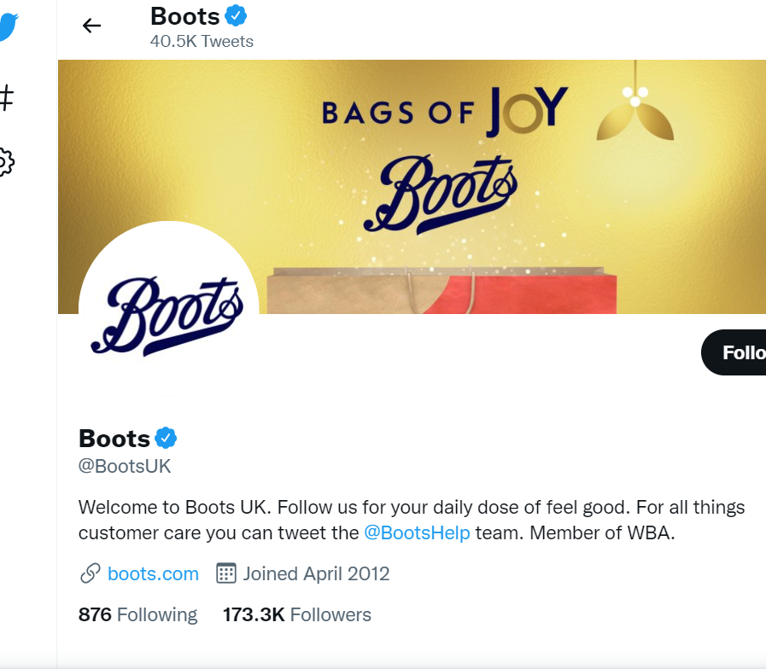
Even though there are other alternative limited time systems, they are regarded as the building blocks for creating a unique blend. The following is the restricted time and publicising method in the Boots showcasing procedure:
to keep current consumers and attract new ones The Boots advantage card is a loyalty card programme offered by Boots. Administration quality refers to the ability to satisfy the clients' expectations and determine their requirements and demands (Shi and Methavasaraphak, 2020). To outperform the competition, Boots responded with simple and inventive commercial objectives, VIP support, and beautician organisations. Boots anticipated a positive link between purchasers and the brand. Boots has enlisted the help of well-known beauticians such as Charles Worthington, Nicky Clarke, Trevor Sorbie, John Freida, and Lee Stafford.
Significant collusions the market for pharma, greatness, and clinical advantages things is loaded with comparable associations offering basically indistinguishable characteristics. The things were reasonably assessed at making legitimate. These things were organized by and large. It similarly upheld cosmetologists since things with their names on them were shown in 2500 display places around the UK. To extend its pay, the affiliation besides gave blueprints like purchase three to the detriment of two, outfit gives the obtaining of things from the Boots shop and give half-off coupons. The 3 at the expense of 2 headways was routinely used, coming to fruition in a 300 per cent increase in bargains, the development of new customers to the business, and augmentation in advantages of 0.3 GBP per bottle. The association has moreover upheld a couple of general events like the Women's World Cup, Euro Cup, and so forth Since this is help propel a brand, here are the other three Ps to adjust the Boots 7Ps showing blend.

Blog 5: Product Strategy of Boots, UK
The fourth and last P in the promoting blend is the place where the items or administrations will be given to clients. An effective concept for making marketing look simply to manage, allowing marketing to be separated from other business activities, delegating showcasing tasks to subject matter specialists, and changing a company's dire position by beginning the components (Thabit and Raewf, 2018). A corporation should cultivate a solid proclivity for contemplating all of the superior regions where it has its goods or administrations. A move or growth in a better location may frequently result in an increase in income for a company, and who would choose to prevent that?
When contemplating the spot blend of a business's products or services, there are several approaches and components to consider. It is critical to consider while implementing a comprehensive marketing strategy. The following are some of the most well-known strategies for a spot blend:
- Inclusion of a market or part
- Agents
- Actual Shops Online Shop
- Direct business transactions

The organization's pharmacy store chains may be found in the United Kingdom, Thailand, Ireland, Norway, and other countries. In these regions, there are around 2000 retailers, wellness centres, and beauty salons. The advertising concept emphasises that benefit reflects the organization's business via the demands and needs of the partners provided; by obtaining a benefit, it will recall the organization's ability to expand and create, as well as provide a higher degree of satisfaction to work partners (Asdi and Putra, 2020). Boots likewise has a retail site where clients might shop on the web and have their buys conveyed to their homes. Nearly everything is accessible by means of web purchasing through the electronic business entrance. In excess of 90% of the UK, populace lives within 10 minutes of a Boots shop.

Blog 6: Place and distribution
The company used the wholesale and retail strategy for the distribution of the product in their stores. In this process, they have connected various distributors who can distribute their products in various stores. Boots has over 2200 stores worldwide through which they use to sell their products in various categories (Boots, 2022). It is important for the brand to recognise and stick to one distribution strategy which is retail shops here. The company is thinking of expanding the number of shops and after that, an online platform can also be built with the help of logistics partners. Thus, the place and distribution strategy can be fulfilled by the brand in the United Kingdom and other markets.
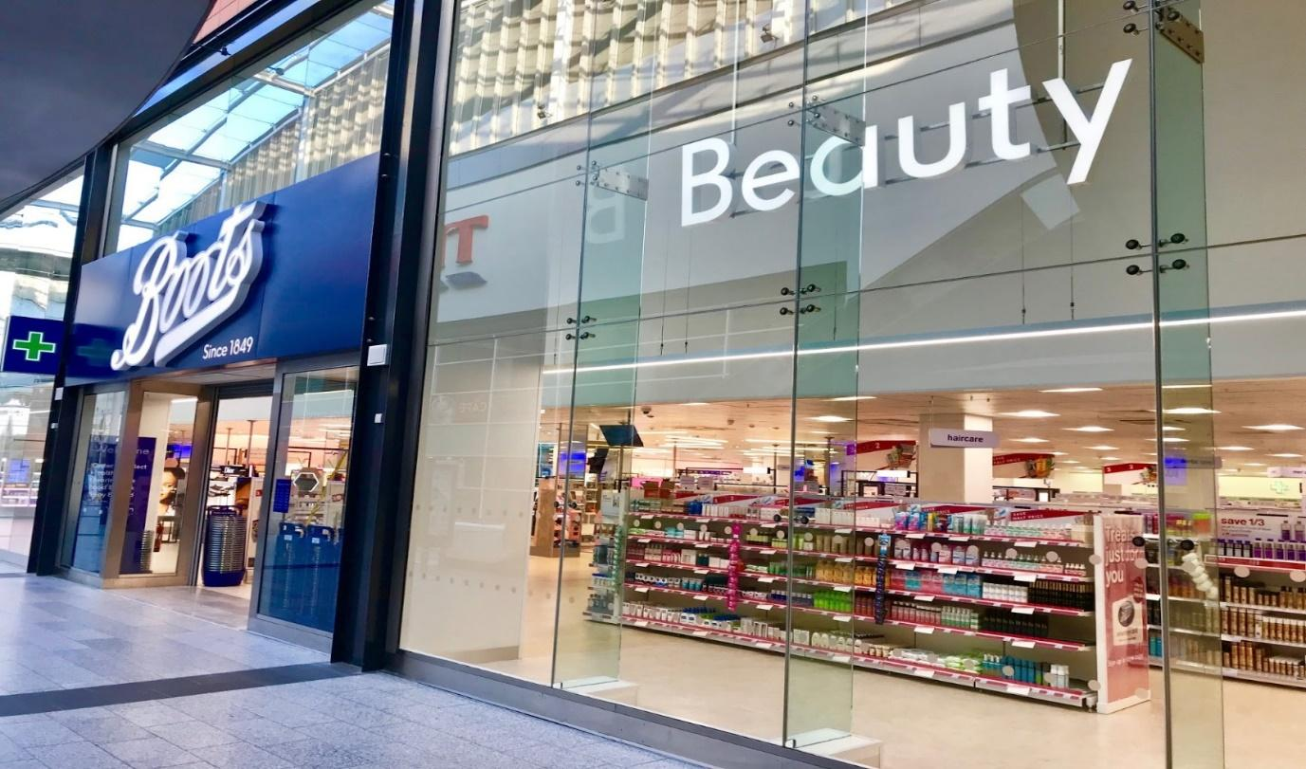
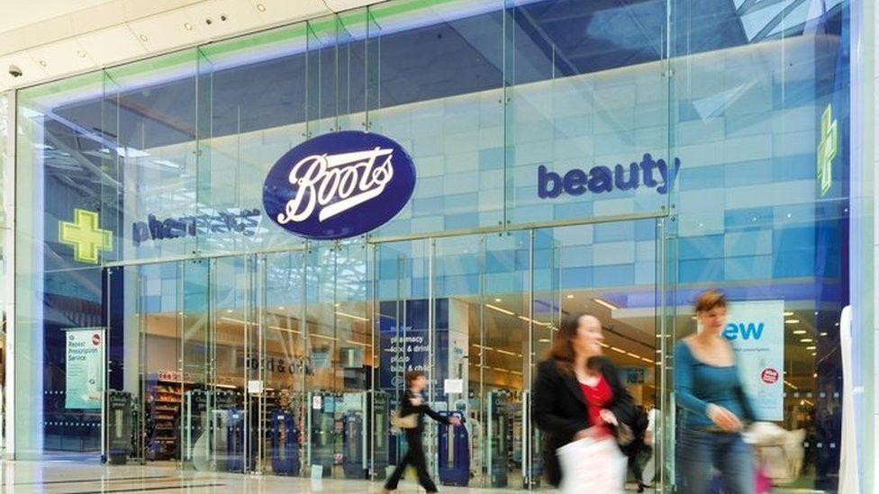
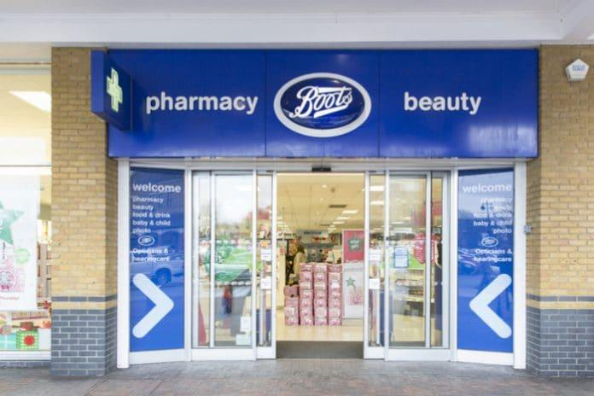
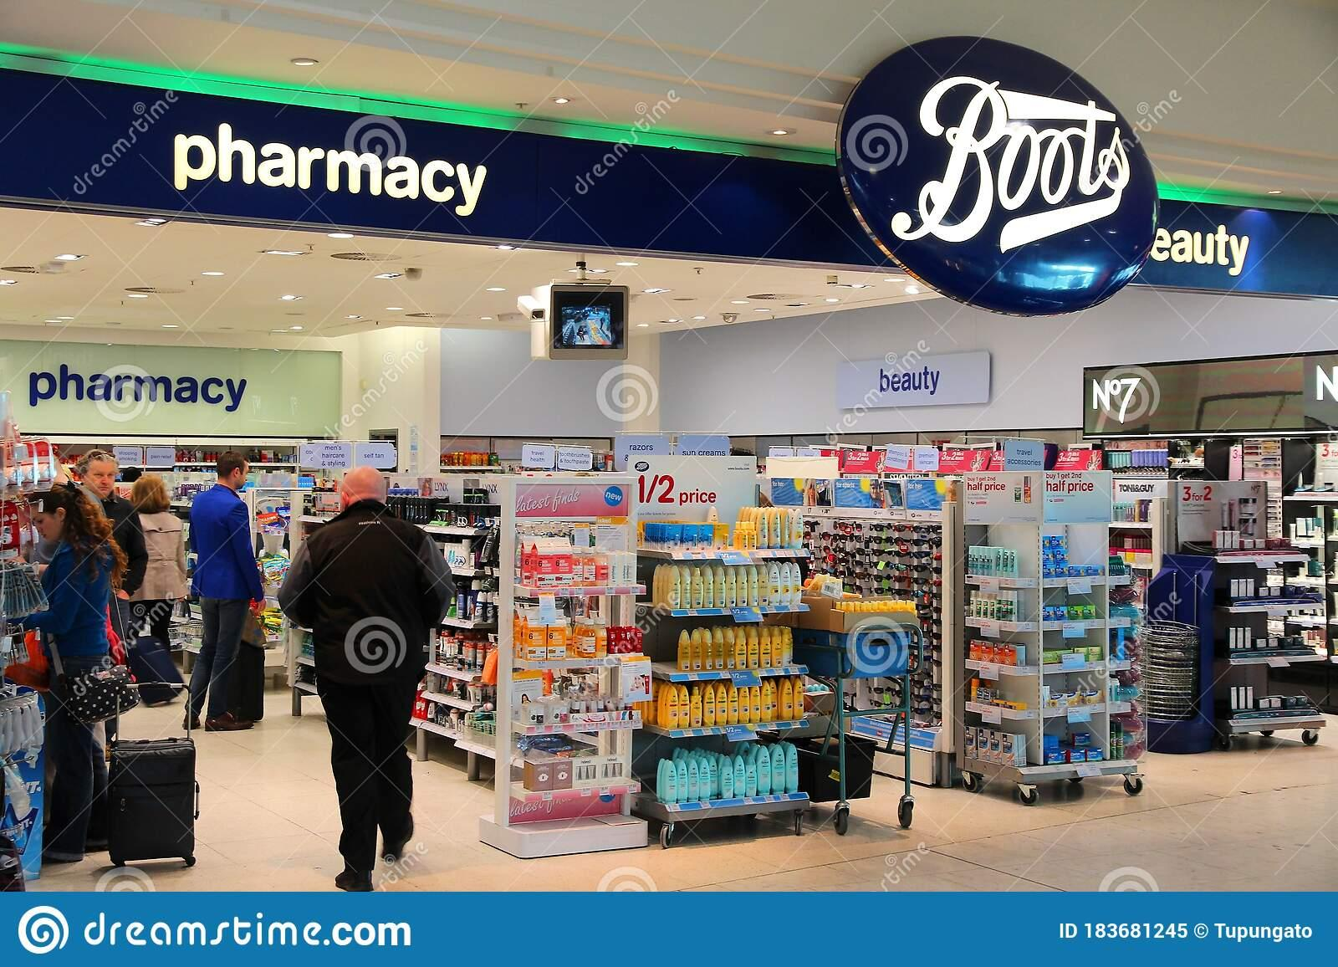
Image 2: Boots Stores
(Source: Boots, 2022)

Blog 7: Market segmentation of Boots
In order to develop the communication level between Boots and its targeted audiences, it is required to focus on explaining the segmentations.
Demographic- It has been seen that due to the massive rate of female employees in the UK most of the women after 30 faced issues with their face skin such as fine lines and dark circles due to massive work pressure. Communicating with customers about the product effectiveness and providing evidence is the responsibility of every brand (Pomarici et al., 2017). Boots has strategically launched its eye cream product to reduce the issues which are facing the targeted audiences in the UK.
Psychographic- In the UK most women are aware of their skin and their beauty. While choosing any brand they focus on the product quality and its effectiveness. Boots has increased the awareness regarding its new eye cream product among the population of the UK to gather customer beliefs.
Behavioural- The literacy rate of these women is 78% and they can navigate the online shopping position. All beauty product brands need to understand the demand and requirements of the targeted customers (Sarti, Darnall and Testa, 2018). Boots has strategically put its unique eye cream product in its e-commerce market to reach its targeted audience.
Geographic- UK has an oceanic climate that has harsh effects on the human skin such as patches and also skin dryness. Boots has strategically launched its moisturizers that can prevent the issues regarding skin ageing and its reduced moisture.

Blog 8: Targeting and positioning of Boots
Boots has chosen female customers in the UK who are after 30-year-old and have massive pressure regarding their careers. These women have such an imbalanced diet and irregular sleeping times. Due to these issues, these women often deal with ageing lines and dark circles under their eyes. Product brands need to understand the effectiveness of their communications ways regarding introducing their new products to their targeted audiences (Li et al., 2019). Boots has targeted this audience to introduce its products for increasing its sales rate. Boots need to apply strategic communication that can impact its effort to manipulate its target market in the UK.
It has been seen that Boots has less competition for its newly launched eye cream product. The position of the brand and its product has been discussed below. It can be claimed after examining the competitiveness of the new eye cream product of Boots that it has high chances to grab the UK market with a massive population of 30-year-old women. Beauty brands like MAC and L'Oréal Paris have no products like healing the under-eye area related issues of the face. Product industries are required to focus on modifying their product quality and its pricing to influence the purchase desire of their targeted audiences (Kharub, Mor and Sharma, 2019). The differentiation has been found according to the effectiveness of the skincare product of Boots and other brands in the UK. Boots has strategically achieved the top position regarding its skincare products and its demand in the UK market by its targeted audiences.

Reference list
Asdi, A. and Putra, A.H.P.K., 2020. The Effect of Marketing Mix (4P) on Buying Decision: Empirical Study on Brand of Samsung Smartphone Product. Point Of View Research Management, 1(4), pp.121-130. Available at :http://journal.accountingpointofview.id/index.php/POVREMA/article/view/93
Boots, 2022. All products | Boots. [online] Boots.com. Available at: <https://www.boots.com/boots-beauty-toiletries/boots-all products#facet:&productBegin Index:0&orderBy:&pageView:grid&minPrice:&maxPrice:&pageSize: &> [Accessed 5 January 2022].
JORAN, 2021. Understanding the Marketing Mix | The 4 P's of Marketing For Growth and Strategy - Sales Loves Marketing. [online] Sales Loves Marketing. Available at <https://saleslovesmarketing.co/blog/marketing-mix/> [Accessed 18 December 2021].
Kharub, M., Mor, R. S., and Sharma, R., 2019. The relationship between cost leadership competitive strategy and firm performance: A mediating role of quality management. Journal of Manufacturing Technology Management. Available at: https://doi.org/10.1108/JMTM-06-2017-0116
Kienzler, M., and Kowalkowski, C., 2017. Pricing strategy: A review of 22 years of marketing research. Journal of Business Research, 78, pp.101-110. Available at: https://www.diva-portal.org/smash/get/diva2:1095413/FULLTEXT01.pdf
Li, G., Li, L., Sethi, S. P., and Guan, X., 2019. Return strategy and pricing in a dual-channel supply chain. International Journal of Production Economics, 215, pp.153-164. Available at: http://dx.doi.org/10.1016/j.ijpe.2017.06.031
Mahmoud, T.O., 2018. Impact of green marketing mix on purchase intention. International Journal of Advanced and applied sciences, 5(2), pp.127-135. Available at: https://www.researchgate.net/profile/Thoria-Mahmoud/publication/322865212_Impact_of_green_marketing_mix_on_purchase_intention/links/5a817dc6a6fdcc0d4bad5a52/Impact-of-green-marketing-mix-on-purchase-intention.pdf
MBA Skool Team, 2021. Boots Marketing Strategy & Marketing Mix (4Ps) | MBA Skool. [online] MBA Skool. Available at <https://www.mbaskool.com/marketing-mix/services/17505-boots.html> [Accessed 18 December 2021].
Pomarici, E., Lerro, M., Chrysochou, P., Vecchio, R., and Krystallis, A., 2017. One size does (obviously not) fit all: Using product attributes for wine market segmentation. Wine Economics and policy, 6(2), pp.98-106. Available at: https://doi.org/10.1016/j.wep.2017.09.001
Sarti, S., Darnall, N., and Testa, F., 2018. Market segmentation of consumers based on their actual sustainability and health-related purchases. Journal of Cleaner Production, 192, pp.270-280. Available at: http://dx.doi.org/10.1016/j.jclepro.2018.04.188
Shi, N., and Methavasaraphak, P., 2020. A STUDY OF CUSTOMER’S SATISFACTION TOWARDS BOOTS PHARMACY. In AU Virtual International Conference Entrepreneurship and Sustainability in the Digital Era (Vol. 1, No. 1, pp. 359-370). Available at: http://www.assumptionjournal.au.edu/index.php/icesde/article/view/4995
Thabit, T., and Raewf, M., 2018. The evaluation of marketing mix elements: A case study. International Journal of Social Sciences & Educational Studies, 4(4). Available at: https://www.researchgate.net/profile/Thabit-Thabit/publication/324923406_The_Evaluation_of_Marketing_Mix_Elements_A_Case_Study/links/5aeb827a458515f59981df6e/The-Evaluation-of-Marketing-Mix-Elements-A-Case-Study.pdf

