Marketing Fundamentals

Assessment 2

Student Name: George Nitulescu
Student ID: 2123688

Table of Contents
Introduction 3
Organizational background 3
Definition of marketing 3
The main stages in the marketing process such as: situational analysis, objectives, strategy implementation and control 3
Macro environment or PESTLE factors to Nissan 4
Porters 5 Forces model to Nissan 6
Segmentation, targeting and positioning 7
The marketing mix elements of Nissan 9
Recommendations 10
Conclusion 11
References 13

Introduction
Marketing, the modern tool of distribution of products and services in the market by boosting the performance of an organization. The utilization of strengths of the market factors are conducted with the marketing analysis. The marketing analysis of any organization are conducted with the consideration of several factors of an organization (Kotler et al., 2017). The factors of market have been demonstrated through this report. The whole report has been designed with the explanation of the market factors like macro environment analysis, main stages of marketing, porter’s five forces and SWOT analysis of an organization. The whole report has been conducted with the use of organizational scenario of the company Nissan.

Organizational background
The company Nissan is a Japanese automobile company that serves with automobile vehicles around the world. The company started its journey in 26 December 1933 by the partners Masujiro Hashimoto, DAT line, Kenjiro Den, Rokuro Aoyama, Meitaro Takeuchi, Yoshisuke Aikawa and William R. Gorham. The multinational company has been traded as Nissan Motor Corporation, TYO: 7201, Nikkei 225 component (7201), and TOPIX Core30 component (7201). The headquarter of the company is located in Nishi-ku, Yokohama, Japan. Being a multinational company, the company have reached the revenue goals of US$90.863 billion. Currently there are about 136,134 employees working for the company.

Definition of marketing
Marketing can be defined as the activities of distribution and promotion of products and services in the market. From the explanation of Blythe (2014), marketing is considered as those activities which are involved in market to boost the sales and enhance the performance by an organization in the market. The marketing initiatives are more concentrated to the organizational contribution to the market where the quality preference in the market beats the competition in the market and survive in the competition. The enhancement of revenue and performance in the market is the motive of an organization with its marketing initiation.
According to Baines, Fill and Page (2014), the process of making the boost in sales volume, attracting the customers, building a value of brand and managing the brand value are all forms the marketing segment of an organization. The marketing activities and operations are done in line activities and operations are done in line with the marketing initiatives of an organization. There are different functions of marketing that relates with the organization such as Promotion, Selling, Product/service management, Marketing information management, Pricing, Financing and Distribution. All these are taken care within the department of marketing.

The main stages in the marketing process such as: situational analysis, objectives, strategy implementation and control
The organizational process and progress in an organization relates with the marketing activities and operations of an organization. The functions of marketing follows some specific stages of actions. Here in this portion of the report, the main actions and functions of the company Nissan is presented with its marketing objectives, situational analysis, strategy implementation and control.
Situational analysis
The situational analysis of marketing is about the analysis of the marketing components along with the explanation of market size, competitors, market share, cost and benefits by the company in the market. While talking about the situational analysis the major five considerations are:
- Company: The company its type and brand in the market is considered as the major factors for the market and its performance. For the company Nissan, the brand value of the company higher in the market as automobile company. Being a larger company, it has the potentiality to capture the global market.
- Customers: The customers are the prime asset for any organization who are targeted to be attracted and satisfied (Housden, 2010). For the company there are different models of cars and automobiles which are targeted as per different levels of people based on their income. The different size and attractive features are added as per requirements of the people from mid-range to higher range.
- Competitors: The competition in the market is always considered perfect where the organizations present in the market with the similar service and products are considered as competitors (Aaker, 2012). For the company Nissan, the competitors in the market can be considered as BMW, Ford, Toyota, Suzuki, Volkswagen, Hyundai, Honda and so on. There are also some local organizations which manufactures for specific countries which are also considered as competitors for the company in that specific location.
- Collaborators: The collaboration in an organization is happened to be with different team of operations which contribute to the supply chain management of the company. The whole operations of the organization relate with the collaboration among the finance, management, design, manufacturing, advertising, and research team in the company Nissan.
- Climate: Climate for an organization plays an important role to formulate the organizational operations in the target locations (Johnson et al., 2009). For the company the climate, geography, roads and demographic location are considerable factors.
Objectives:
The marketing objective of the company is to enhance the brand value and secure the market position of the company with the attainment of higher efficiency of earning customer satisfaction. The company has been working to develop its branding situation and making the growth of the organization.
Strategy implementation
There are different strategies that are applied in an organization. The company Nissan is an automobile company which deals with the production and sales of automobiles. The company initiates the call-to-action marketing strategy where the company gets instant response to its and initiate immediate sales in the market. The application of call to action requires strong promotion of products and services to the customer while introducing a new model of car.
Control
Control of the operations and activities by the organization relates with the activities and operations relating to the marketing activities of an organization. The marketing control has four major steps that are initiated by the company Nissan such as:
- Strategic marketing analysis: The strategic marketing analysis allows to analyze all the strategies that implied in the marketing section by an organization (Baines, Fill and Page, 2013).
- Marketing-mix planning: The marketing mix planning is all the considerations of the all the elements of marketing including product, price, place, promotion, process, people and physical evidence. All these are planned with proper control of actions and defining each of the actions.
- Marketing implementation: the marketing implementation refers to the strategic implementation in progress to the marketing initiation of control (Hair, Block and Roering, 2015). Different strategies are implied in the market such as market penetration, market analysis, market differentiation, and product portfolio by the company Nissan.
- Marketing control: The marketing control of the market relates with the control of activities by the people involved in marketing activities. All the activities and operations done in the company are reported to the marketing manager who plans and controls the activities and operations in the marketing department.

Macro environment or PESTLE factors to Nissan
The analysis of macro environment for any organization means to explain the impact of external environmental factors. There are different factors of external environment of an organization. With the analysis of PESTLE factors, the external factors of the company Nissan can be demonstrated. The elements of PESTLE analysis are the following:
Political factors: The political factors relate with the political condition of any country or state. The regulation of politics, governmental support to business organization, political violence and political relationship with other countries and nation are the influencing factors (Harris, 2017). The company Nissan faces the political fair relation of Japan with all other countries of the world. The Brexit limits the transportation of products in the UK and EU.
Economic factors: The economic factors possess the most important consideration among the external factors. It includes the consideration of resources available in the economy, availability of loans, interest rates, inflation rate and the employment opportunity in the economy (Hollensen, 2012). The company utilizes the strengths factors of UK economy to recruit efficient people from the economy, collect resources in the UK branch and operate its production and service with its cars.
Social factors: The social factors are mostly related with the consumer behaviour. The consumer behaviour in the society helps to target the audience. Apart from these the consideration of social values, norms, culture, and tradition also influence the company with its audience and target nation.
Technological factors: The technological factor in an organization recalls the economic activities in technical way where the production and service organization have more influence with their manufacturing and promotional activities using technological help (Kress, Still and Cundiff, 2017). The digital marketing promotion, technological assistance to serve the customers and attain higher efficiency is attained with the technological factors for the company. The company can operate smoothly in the country which is developed with technology.
Legal factors: The legal factors are related with the documentation process, formalities of contract and transaction. The contractual relationship with other organization regarding the manufacturing in the company are handled by the administrative department of the company. It also handles the customs and other requirements for operating in different countries of the world.
Environmental factors: The natural resources, climate, weather and other requirements are considered while planning for operations in any specific area (Lamb, Hair and McDaniel, 2012). For the company Nissan, the automobiles in Middle east countries are designed differently with its air conditioning features than that of the western countries since middle east countries are hotter with their climate.

Porters 5 Forces model to Nissan
Michael Porter introduced a competitive model in the market to analyze the forces of different competitive factors that gives a specific framework to consider the competition in the market for any organization. The porter’s five forces model is based on five different forces in the market. The detailed analysis of these factors give proper idea about the organizational competition. For the company Nissan, the competitive factor is explained in this portion of the report.
Industrial rivalry: The industrial rivalry encompasses with the competition with other organizations involved in service with similar product or service (McCarthy and Perreault, 2017). For the company Nissan, the competition within the industry are with the companies that are also involved in manufacturing automobiles. The companies like BMW, Ford, Toyota, Suzuki, Volkswagen, Hyundai, and Honda are the major competition for the company. In the industry the number of organizations have been increased with time which increased the volume of competition in the market. The rivalry in the industry with such scenario can be said to be competitive market.
Bargaining power of the buyers: The buyers have a major power over the organizational service in the market. The buyer while like the products and services would be loyal to the organization making it more potential product in the market (Still and Cundiff, 2016). For the company Nissan, the buyers have the power to recommend other buyers to purchase the automobiles. The competitive factors for the company Nissan make it to promote quality product to the buyers so that they are satisfied in the market and contribute to the effective way of the organization.
Bargaining power of the suppliers: The suppliers of any organization control the production and its relative activities (Wirtz and Lovelock, 2016). The suppliers of raw materials, production materials, machines and equipment have the control to influence the production in the organization. For the company Nissan, the supplier and their bragging power relates with the supply of technologies and the equipment used in the automobiles are more crucial that are controlled by the suppliers.
Threats of new entrants: The new entrant in the market means while a new organization enter in the market, it contribute to the competition. The new entrance of organization tries the attract the customers in the market with comparatively lower price and standard quality that makes it threat for the existing organizations to accomplish a new position in the market (Zikmund and Babin, 2016). For the company the competition is not only in the global market with the existing organizations but also with the new organizations performing in the local market. The new entrants raises the competition for the company.
Threats of substitute products: The substitute products are those which can be used instead of using the main product, but these products are not similar. For the company Nissan, the increment of bikes, bicycles, buses or train would increase the substitute competition in the market.

Segmentation, targeting and positioning
The term STP marketing represents the marketing through segmentation, targeting and positioning. These aspects of market relate with the analysis and planning for the marketing growth and development.
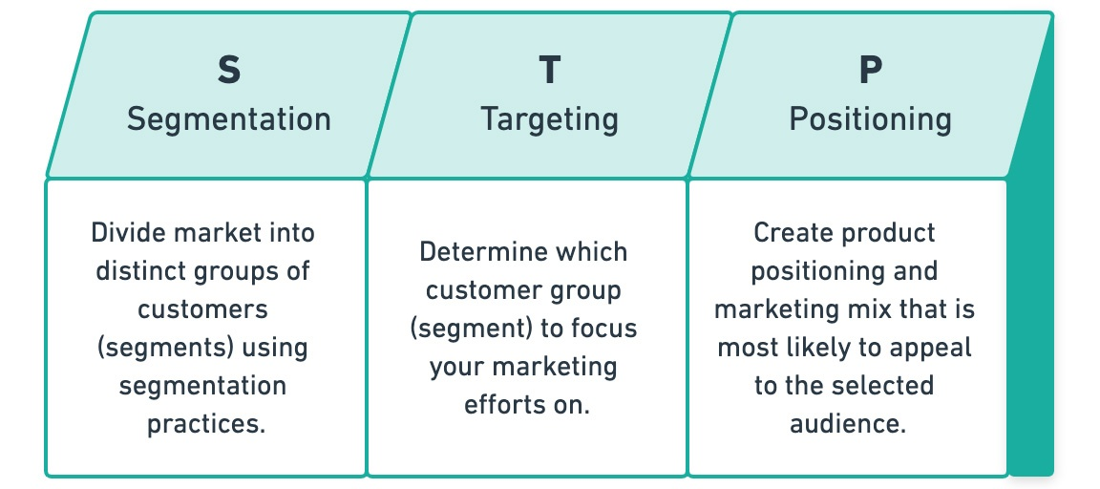
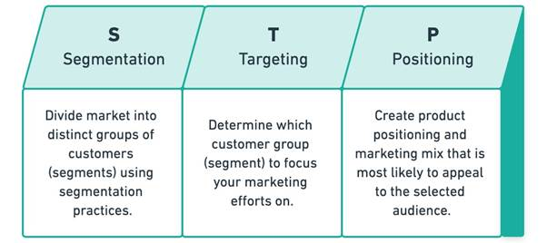
There are three different stages of STP marketing where:
Segmentation refers to the grouping of the customers with proper segmentation. The segmentation in the customers are conducted with several observation. The major considerable factors include the income, power in the society, sex, age, race, marital status, occupation, level of education and different other factors (Harris, 2004). For the company Nissan, the segmentation of the customers are made based on the level of income. Since automobiles are not affordable for all level of people, the affordable prices are targeted for the different levels. The automobiles are also segmented for different taste and caste of people.
Targeting of the customers of customers can lead to generate more response on the products and service in the market. Targeting is a marketing strategy where the determination of the customer group based on the initiation of planning for the customers and clients are done in line with the consideration of the organizational planning. The target for the company are with different race and nation.
Positioning is an influential process of marketing where the customers are process with the activities and operations of the organizational target. The positioning in the company Nissan works with the customization of the design and features based on the targeted audience (McDaniel and Gates, 2006). For instance, the company have planned extra facility with air conditioning in the middle east countries since those countries are hotter compared to the western countries.

The marketing mix elements of Nissan
The marketing mix is considered as the major planning consideration for the marketing activities of any organization. The marketing mix model represents all the factors of marketing including product and market situation. There are 7 different elements of marketing mix as per 7ps of marketing which deals with all the major consideration for marketing planning and activities to review. For the company Nissan, the consideration of the marketing plan can be attained with the explanation of the factors of 7ps of marketing:
Product: The product is the main thing for consideration in the market with which the customers are provided with values in exchange for their values (Nystrom and Converse, 2007). The product and service offered to the market should be introduced properly to the customers with their initiation. For the company the products are automobiles. There are different models of automobiles produced for the customers in the company to offer.
Price: The price is a remarkable consideration for the customers. Higher the price, higher the profit, but lower the price higher the customers revenue. So, price should be selected with standard that considers both revenue and profit. The average price of automobiles in the company range between $54,847 - $73,248 which is considered standard price.
Place: The place of target for the marketing team are defined to make it potential for the company to attain higher efficiency of the organization. For the company Nissan, the place is around the world since, it is a global company. Being a global company, the company specific target is on the countries where the mid range automobiles are demandable.
Promotion: The promotion of organizational product in the market introduces the products and manages the brand value in the market (Puddle, 2015). For the company Nissan, the promotional activities for the products are taken into consideration with the advertisement in television, digital media advertisements, sponsorships and blog posts.
Process: The process of distribution channel is a major consideration for any organization. The process involved in the distribution channel for the company Nissan is faced with direct marketing where the products are shown in its outlet or showroom from where the customers can check their automobiles and chose among them.
People: The people in an organization are the employees and staffs who are involved in conducting the marketing activities (Rose, 2006). In the marketing team of the company there are huge number of employees. According to reports, there are about 40% of the employees involved in marketing and distribution of the organizational products. The company has also started using pre-book system through its website.
Physical evidence: The term physical evidence relates with the connection of the customers to assure them with the products quality. The physical outlets, website of the company, and buildings of the company are considered as physical evidence of the existence of brand in the market.

Recommendations
Based on the analysis of different marketing initiatives, here are some recommendations to the company Nissan:
- The brand value of the company in the market is established, so it needs to boost its brand value and manage it properly.
- The promotional activities should be more acute in the digital marketing sector.
- The company marketing management team can be initiated with innovative ideas of positioning and targeting.
- The company can use efficient monitoring system over its marketing activities.

Conclusion
Marketing is a crucial department of an organization that deals with the promotion of the products and services in the market along with the motive to boost the revenue in the market. The fundamentals of marketing are built with the concept of performing better in the market, attaining better brand value and maintaining a revenue growth in the market. This report has been conducted based on the fundamentals of marketing where the detailed aspects of marketing factors have been demonstrated. The whole report has been conducted to show the examples of marketing management from the company Nissan.

References
Aaker, D., 2012. Win the Brand Relevance Battle and then Build Competitor Barriers. California Management Review, 54(2), pp.43-57.
Baines, P., Fill C., Page, K., (2014) Marketing, Oxford, 2nd edition
Baines, P., Fill, C. and Page, K., 2013. Essentials of marketing. Oxford: Oxford University Press.
Blythe, J., (2014), Principles and Practice of Marketing, 3rd edition, Sage
Hair, J., Block, C. and Roering, K., 2015. Essentials of Consumer Behavior. Journal of Marketing, 41(1), p.126.
Harris, J., 2004. Essentials of Marketing Research. Australasian Marketing Journal (AMJ), 12(2), pp.73-75.
Harris, J., 2017. Essentials of Marketing Research. Australasian Marketing Journal (AMJ), 12(2), pp.73-75.
Hollensen, S., 2012. Essentials of global marketing. Harlow [etc.]: Pearson Education.
Housden, M., (2010), Marketing Information and Research, Butterworth Heinemann
Johnson, G., Whittington, R., Scholes, K., Angwin, D. and Regner, P., 2009. Fundamentals of Strategy. 3rd ed. Pearson, p.50.
Kotler P, Armstrong G, Harris, L, Piercy, N., (2017), Principles of Marketing, 7th Edition, Pearson
Kress, G., Still, R. and Cundiff, E., 2017. Essentials of Marketing. Journal of Marketing, 37(1), p.109.
Lamb, C., Hair, J. and McDaniel, C., 2012. Essentials of marketing. Australia: South-Western Cengage Learning.
McCarthy, E. and Perreault, W., 2017. Essentials of marketing. Homewood, Ill.: Irwin.
McDaniel, C. and Gates, R., 2006. Marketing research essentials. 1st ed. Hoboken, N.J.: John Wiley.
Nystrom, P. and Converse, P., 2007. Essentials of Distribution. Journal of Marketing, 1(2), p.171.
Puddle, T., 2015. Marketing essentials for veterinary practices. In Practice, 37(5), pp.259-261.
Rose, A., 2006. Marketing your dental practice: the essentials. Dental Nursing, 2(10), pp.522-524.
Still, R. and Cundiff, E., 2016. Essentials of marketing. Englewood Cliffs, N.J.: Prentice-Hall.
Wirtz, J. and Lovelock, C., 2016. Essentials of services marketing.
Zikmund, W. and Babin, B., 2016. Essentials of marketing research. [Erscheinungsort nicht ermittelbar]: South-Western.

